redis集群docker化

1.制作redis镜像

1.1.拉取镜像
官方镜像：docker pull redis:4.0

1.2.启动镜像
docker run -d -it --name redis redis:4.0

1.3.提交镜像
退出容器
docker commit redis 10.1.8.15:5000/paas_public/nl.paas.redis:latest
上传到私服：docker push 10.1.8.15:5000/paas_public/nl.paas.redis:latest

注：制作redis镜像，只为了将官网镜像制作为内网镜像。

制作ruby镜像

拉取镜像
官方镜像：docker pull ruby

启动镜像
docker run -d -it --name ruby ruby

安装redis
进入启动好的容器中：docker exec -it 6f17e481a76f92469bda516d30 /bin/bash
执行：gem install redis
下载redis-trib.rb：wget http://download.redis.io/redis-stable/src/redis-trib.rb

提交镜像
退出容器
docker commit ruby 10.1.8.15:5000/paas_public/nl.paas.ruby-redis-trib:latest
上传到私服：docker push 10.1.8.15:5000/paas_public/nl.paas.ruby-redis-trib:latest

搭建redis集群

创建本地目录和配置文件
将会启动6个redis节点，3主3从，端口8001~8006
mkdir -p /home/bdp_pjd/redis/redis-docker-cluster3/8001/conf
mkdir -p /home/bdp_pjd/redis/redis-docker-cluster3/8001/data
mkdir -p /home/bdp_pjd/redis/redis-docker-cluster3/8002/conf
mkdir -p /home/bdp_pjd/redis/redis-docker-cluster3/8002/data
mkdir -p /home/bdp_pjd/redis/redis-docker-cluster3/8003/conf
mkdir -p /home/bdp_pjd/redis/redis-docker-cluster3/8003/data
mkdir -p /home/bdp_pjd/redis/redis-docker-cluster3/8004/conf
mkdir -p /home/bdp_pjd/redis/redis-docker-cluster3/8004/data
mkdir -p /home/bdp_pjd/redis/redis-docker-cluster3/8005/conf
mkdir -p /home/bdp_pjd/redis/redis-docker-cluster3/8005/data
mkdir -p /home/bdp_pjd/redis/redis-docker-cluster3/8006/conf
mkdir -p /home/bdp_pjd/redis/redis-docker-cluster3/8006/data

/home/bdp_pjd/redis/redis-docker-cluster3/8001/confredis.conf:
例如8001节点：
port 8001
protected-mode no
cluster-enabled yes
cluster-config-file nodes.conf
cluster-node-timeout 5000
cluster-announce-ip 10.1.8.8
cluster-announce-port 8001
cluster-announce-bus-port 18001
appendonly yes

其他节点配置文件以此类推。

启动redis节点
例如8001节点，需要暴露两个端口，8001和对应的10000 + 8001：
docker run -d -ti -p 8001:8001 -p 18001:18001 -v /home/bdp_pjd/redis/redis-docker-cluster3/8001/conf/redis.conf:/usr/local/etc/redis/redis.conf -v /home/bdp_pjd/redis/redis-docker-cluster3/8001/data:/data --restart always --name redis-8001 --sysctl net.core.somaxconn=1024 10.1.8.15:5000/paas_public/nl.paas.redis redis-server /usr/local/etc/redis/redis.conf

8002节点：
docker run -d -ti -p 8002:8002 -p 18002:18002 -v /home/bdp_pjd/redis/redis-docker-cluster3/8002/conf/redis.conf:/usr/local/etc/redis/redis.conf -v /home/bdp_pjd/redis/redis-docker-cluster3/8002/data:/data --restart always --name redis-8002 --sysctl net.core.somaxconn=1024 10.1.8.15:5000/paas_public/nl.paas.redis redis-server /usr/local/etc/redis/redis.conf

8003节点：
docker run -d -ti -p 8003:8003 -p 18003:18003 -v /home/bdp_pjd/redis/redis-docker-cluster3/8003/conf/redis.conf:/usr/local/etc/redis/redis.conf -v /home/bdp_pjd/redis/redis-docker-cluster3/8003/data:/data --restart always --name redis-8003 --sysctl net.core.somaxconn=1024 10.1.8.15:5000/paas_public/nl.paas.redis redis-server /usr/local/etc/redis/redis.conf

8004节点：
docker run -d -ti -p 8004:8004 -p 18004:18004 -v /home/bdp_pjd/redis/redis-docker-cluster3/8004/conf/redis.conf:/usr/local/etc/redis/redis.conf -v /home/bdp_pjd/redis/redis-docker-cluster3/8004/data:/data --restart always --name redis-8004 --sysctl net.core.somaxconn=1024 10.1.8.15:5000/paas_public/nl.paas.redis redis-server /usr/local/etc/redis/redis.conf

8005节点：
docker run -d -ti -p 8005:8005 -p 18005:18005 -v /home/bdp_pjd/redis/redis-docker-cluster3/8005/conf/redis.conf:/usr/local/etc/redis/redis.conf -v /home/bdp_pjd/redis/redis-docker-cluster3/8005/data:/data --restart always --name redis-8005 --sysctl net.core.somaxconn=1024 10.1.8.15:5000/paas_public/nl.paas.redis redis-server /usr/local/etc/redis/redis.conf

8006节点：
docker run -d -ti -p 8006:8006 -p 18006:18006 -v /home/bdp_pjd/redis/redis-docker-cluster3/8006/conf/redis.conf:/usr/local/etc/redis/redis.conf -v /home/bdp_pjd/redis/redis-docker-cluster3/8006/data:/data --restart always --name redis-8006 --sysctl net.core.somaxconn=1024 10.1.8.15:5000/paas_public/nl.paas.redis redis-server /usr/local/etc/redis/redis.conf

启动ruby来实现集群
echo yes | docker run -i --rm 10.1.8.15:5000/paas_public/nl.paas.ruby-redis-trib sh -c 'ruby redis-trib.rb create --replicas 1 10.1.8.8:8001 10.1.8.8:8002 10.1.8.8:8003 10.1.8.8:8004 10.1.8.8:8005 10.1.8.8:8006'
输出：

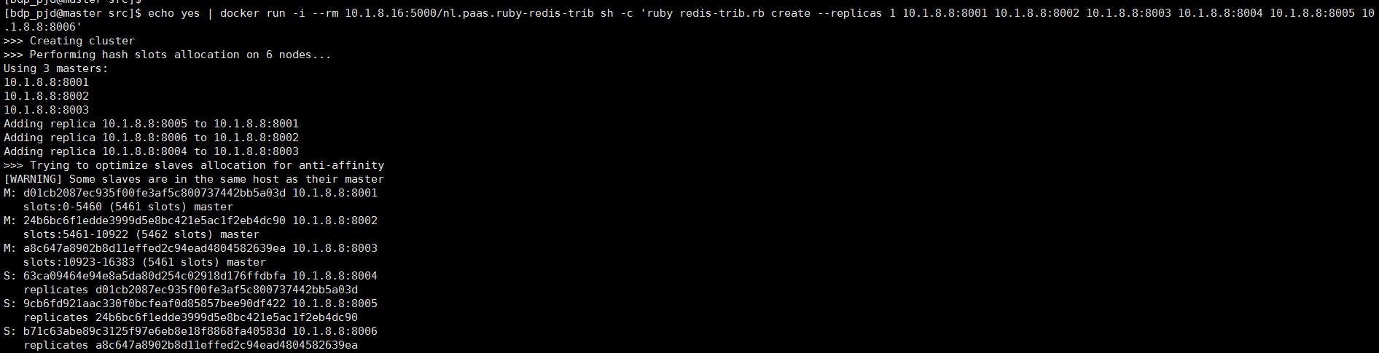
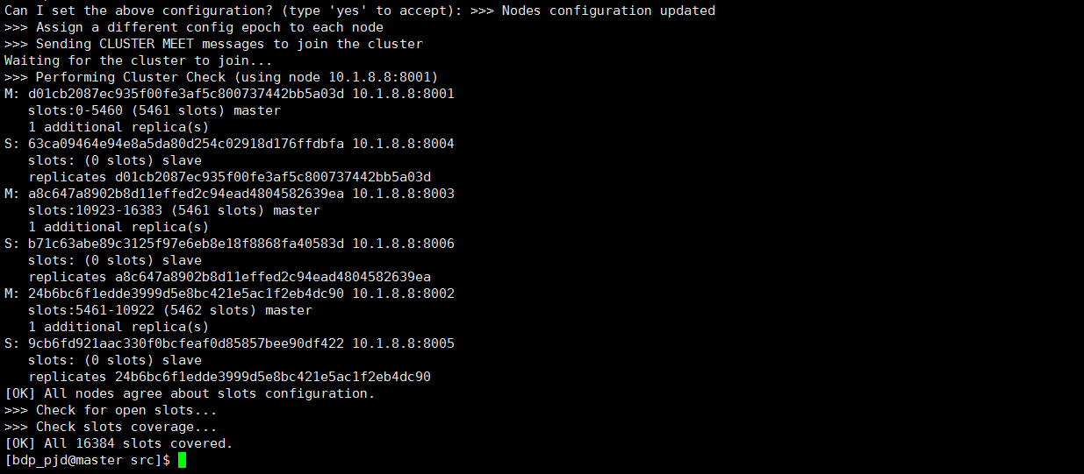

参考文献
https://www.cnblogs.com/lianggp/articles/8136222.html

