spring-boot整合redis集群

redis配置文件
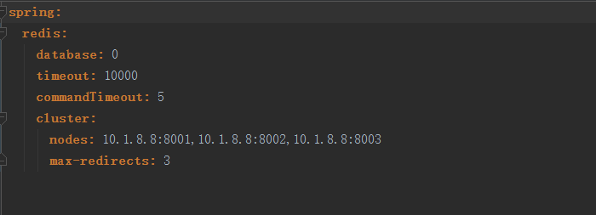
cluster.nodes:配置redis集群地址

pom依赖
<dependency>
<groupId>org.springframework.boot</groupId>
<artifactId>spring-boot-starter-data-redis</artifactId>
</dependency>

主类注解
使用内存：@EnableCaching

redis配置
package com.newland.paas.resources.config;
import com.fasterxml.jackson.annotation.JsonAutoDetect;
import com.fasterxml.jackson.annotation.PropertyAccessor;
import com.fasterxml.jackson.databind.ObjectMapper;
import org.springframework.beans.factory.annotation.Autowired;
import org.springframework.beans.factory.annotation.Value;
import org.springframework.boot.autoconfigure.data.redis.RedisProperties;
import org.springframework.cache.CacheManager;
import org.springframework.cache.annotation.CachingConfigurerSupport;
import org.springframework.cache.annotation.EnableCaching;
import org.springframework.context.annotation.Bean;
import org.springframework.context.annotation.Configuration;
import org.springframework.data.redis.cache.RedisCacheManager;
import org.springframework.data.redis.connection.RedisConnectionFactory;
import org.springframework.data.redis.core.RedisTemplate;
import org.springframework.data.redis.core.StringRedisTemplate;
import org.springframework.data.redis.serializer.Jackson2JsonRedisSerializer;
import redis.clients.jedis.HostAndPort;
import redis.clients.jedis.JedisCluster;
import redis.clients.jedis.JedisPoolConfig;
import java.util.HashSet;
import java.util.List;
import java.util.Set;
/**
* Created by WRP on 2018/7/20.
*/
@Configuration
@EnableCaching
public class RedisConfig extends CachingConfigurerSupport {
@Autowired
private RedisProperties redisProperties;
@Value("${spring.redis.commandTimeout}")
private int commandTimeout;
@Bean
public JedisCluster getJedisCluster() {
List<String> cNodes = redisProperties.getCluster().getNodes();
Set<HostAndPort> nodes = new HashSet<>();
//分割出集群节点
for (String node : cNodes) {
String[] hp = node.split(":");
nodes.add(new HostAndPort(hp[0], Integer.parseInt(hp[1])));
}
//创建集群对象
return new JedisCluster(nodes, commandTimeout);
}
//缓存管理器
@Bean
public CacheManager cacheManager(@SuppressWarnings("rawtypes") RedisTemplate redisTemplate) {
RedisCacheManager cacheManager = new RedisCacheManager(redisTemplate);
//设置缓存过期时间
cacheManager.setDefaultExpiration(10000);
return cacheManager;
}
@Bean
public RedisTemplate<String, String> redisTemplate(RedisConnectionFactory factory) {
StringRedisTemplate template = new StringRedisTemplate(factory);
setSerializer(template);//设置序列化工具
template.afterPropertiesSet();
return template;
}
private void setSerializer(StringRedisTemplate template) {
@SuppressWarnings({"rawtypes", "unchecked"})
Jackson2JsonRedisSerializer jackson2JsonRedisSerializer = new Jackson2JsonRedisSerializer(Object.class);
ObjectMapper om = new ObjectMapper();
om.setVisibility(PropertyAccessor.ALL, JsonAutoDetect.Visibility.ANY);
om.enableDefaultTyping(ObjectMapper.DefaultTyping.NON_FINAL);
jackson2JsonRedisSerializer.setObjectMapper(om);
template.setValueSerializer(jackson2JsonRedisSerializer);
}
}

基本使用
Service类中注入JedisCluster
@Autowired
private JedisCluster jedisCluster;

// jedisCluster.exists()//判断某个键是否存在
// jedisCluster.set()//新增
// jedisCluster.setex()//新增键值对并设置有效时间
// jedisCluster.get()//获取
// jedisCluster.del()//删除键
// jedisCluster.expire()//设置键的过期时间为10s
// jedisCluster.ttl()查看键的剩余生存时间
// jedisCluster.persist()移除键的生存时间
// jedisCluster.type()//查看键所存储的值的类型

注：参考项目
http://10.1.8.66:7080/SRI/PAAS/paas2.2/SourceCode/Code/nl-paas/java/paas-service/template

