**Modeling a Health Service Department**

Stochastic Modeling

Supervisor: Dr. Nomesh Bolia

Kshitij Tulsyan(2008MT50454)

Piyush Ahuja(2008MT50454)

Tarun Jain(2008MT50464)

**Introduction**

This paper intends to model the Emergency Department of a certain Hospital using OR techniques to improve its overall efficiency. Though we will be focusing mainly on the Pediatric Department as if now, we aspire to extend the same model for the entire hospital.

The Emergency department utilizes certain resources like nurses, equipment etc. for providing service to various categories of patients. Our model and analysis will be based primarily on the observation and information gathered from our visits to the hospital. We will be using Arena – from Rockwell Automation, to implement the model and use simulation for analysis.

Though it is impossible to incorporate all the nuances and complexities of the real life model, yet our approximate model we will serve as an idealized model that can serve our purpose.

**POLICIES**

Here we will introduce certain Hospital and Emergency Department policies, which are specific to model under consideration and requires special contemplation:

* Emergency department is open 24 hours a day. Various categories of patients arrive to the hospital at certain distribution. There are three types of emergency departments: Surgical, Pediatric and General Emergency Department. Besides its internal capacity each department shares other resources with other departments, such as X rays, ventilators etc.
* OPD department services closes after 5pm daily. Afterwards, the load is directed towards the Emergency Departments for treatment.
* Hospital Emergency Department has a strict of policy of not attending to critical patients arriving on ventilators in ambulances. Such patients are directed to other hospitals for treatment.
* Emergency Department operates with the policy of the 3 shifts: 6am – 2pm, 2pm – 8pm and 8pm – 6am.
* Pediatric Department has a certain guideline of assigning one bed to only one patient.
* A patient, once treated and examined in the Emergency treatment room, is to be either discharged or to be admitted to the ward, as soon as possible.

**Emergency Department High Level Process View**

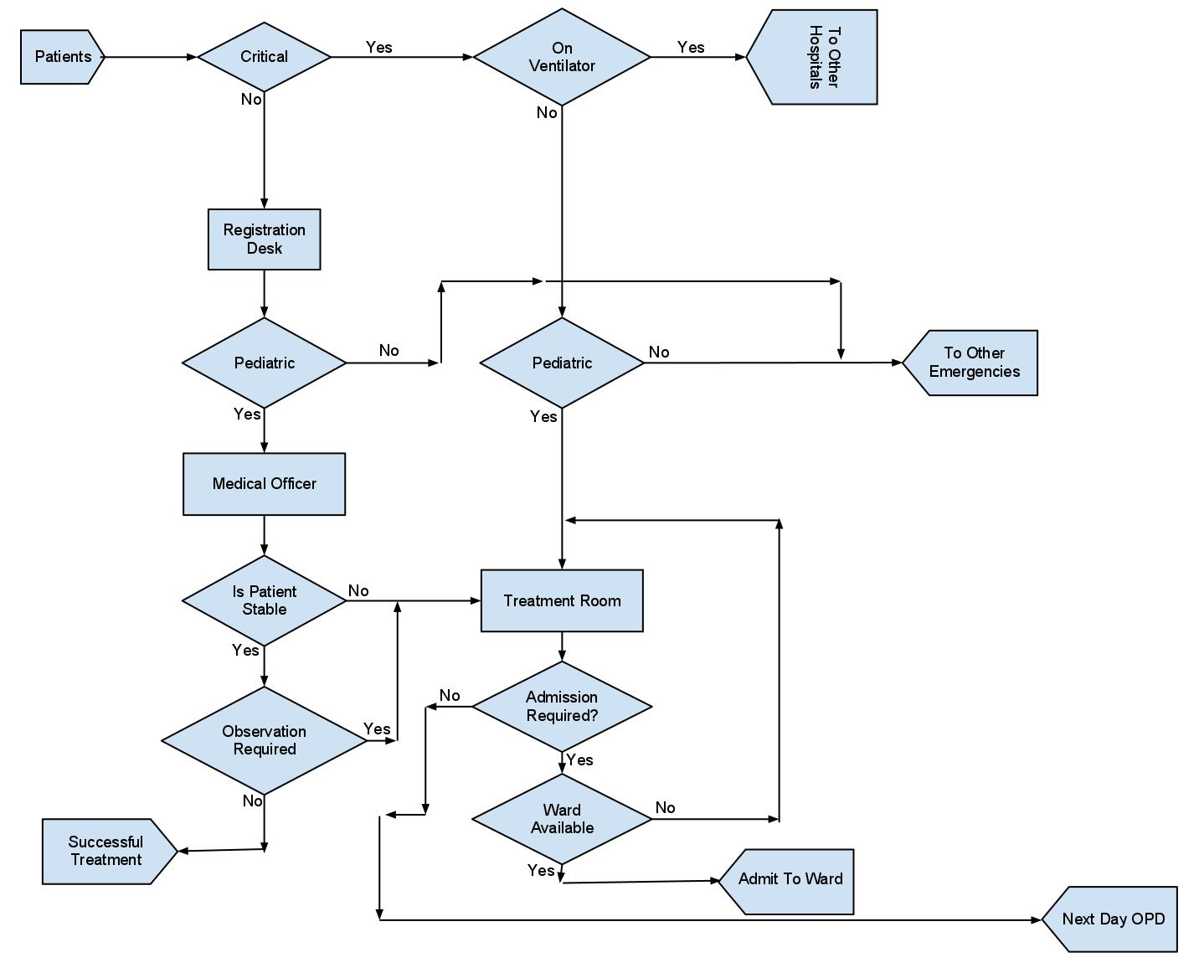

**SYSTEM DESCRIPTION**

We classify the incoming patients into the critically ill, and the not-so-critically ill. Not all those who are critically ill are catered to - those already on life support are not catered to. Those taken in for treatment are moved to the treatment area of the appropriate emergency, without going through the reception area or the preliminary examination phases.

The other kind of patients have to visit the reception, where they are directed the appropriate emergency, and then wait for their turn to see the medical officer. The medical officer determines diagnoses the patient’s disease and determines whether further treatment is needed. If the person is stable and does not need anything else, he/she is considered successfully treated and is free to leave.

In case a the person is stable, but still under observation, he/she is transferred to the treatment bay, as are those who are in need of further treatment.

A patient in the treatment bay is kept there till he either becomes stable enough to go home and reappear in the OPD the next day, or his condition deteriorates forcing him to be admitted to the hospital (subject to availability for assignment to the person). If no room is available, the person’s treatment is continued in the treatment area until a ward becomes available.

The various resources used at the phases in the system are:

Reception: Receptionist

Preliminary Examination: Medical Officer

Treatment Bay: Medical Officer, Nurses, Physical Equipment such as beds, ventilators, and any other equipment the treatment may require.

**Question tackled**

All this modeling allows us to take a jab at the following questions of interest:

1. What is the optimal staff allocation, the constraints being budget and maximum waiting time?
2. Given the current allocation, what is the optimal throughput, and how can it be achieved.
3. What are the bottlenecks in the process, and to what degree of impact do these have on the system?