数字图像处理作业
电信2303-樊博文-8207230322

目录
作业一、用百度识图识别校内的一朵花 2
作业二、在matlab中用函数imread、imshow读入并显示一幅图 3
作业三、在matlab中对lena图进行右移5个像素、下移10个像素处理 4
作业四、图像逆时针选择45°，编程实现 6
作业五、编写一个快速二维傅里叶变换，分析一幅图的幅值、相位角 9
作业六、matlab中编程小波变换实现lena人像与反变换 12
作业七、用3sigma法则设计一个图像增强算法 15
作业八、试设计一个高斯带通滤波器，对一个图像进行增强（要有f'、要标注不同参数下的输出效果） 19
作业九、在lena图生成三种以上的噪声图 23
作业十、模板匹配法实现左侧到右侧的结果 28
作业十一、自动找分隔线切图 + 计算 MSE/PSNR/SSIM计算一下校园图两幅图和标准图的指标 29
作业十二、用sobel算子和LoG算子设计二个程序对lena图进行边缘检测 33
作业十三、已知原始图，画出T=5的矩阵 39
作业十四、腐蚀膨胀 40
作业十五、求C和D的欧拉数 42

作业一、用百度识图识别校内的一朵花
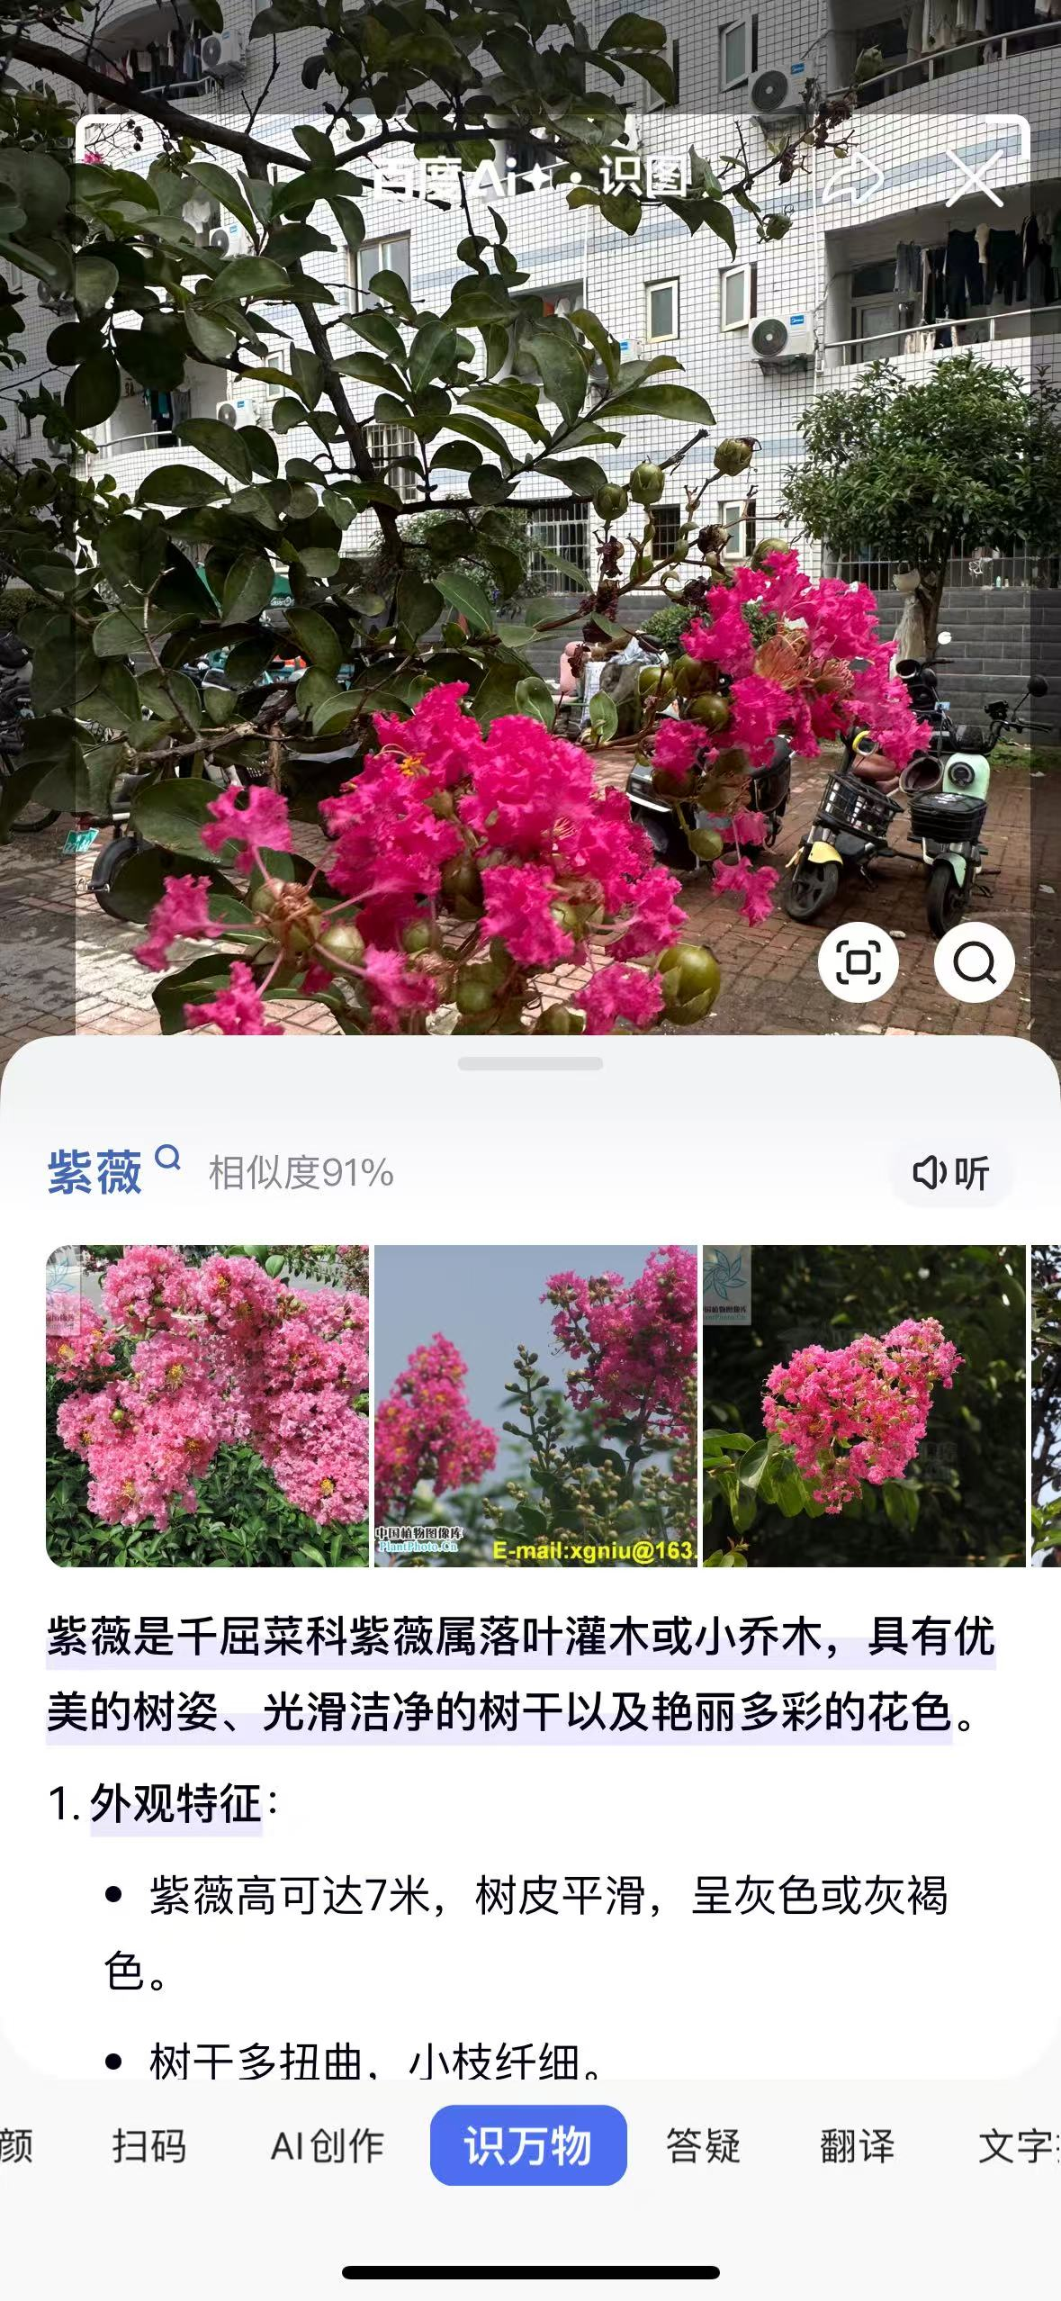

作业二、在matlab中用函数imread、imshow读入并显示一幅图
% 作业二：在 MATLAB 中用 imread、imshow 读入并显示一幅图

clc;
clear;
close all;

% 1) 读入图像

filename = '..\len.png';

I = imread(filename);

% 2) 显示图像
figure;
imshow(I);
title('读入并显示的图像');

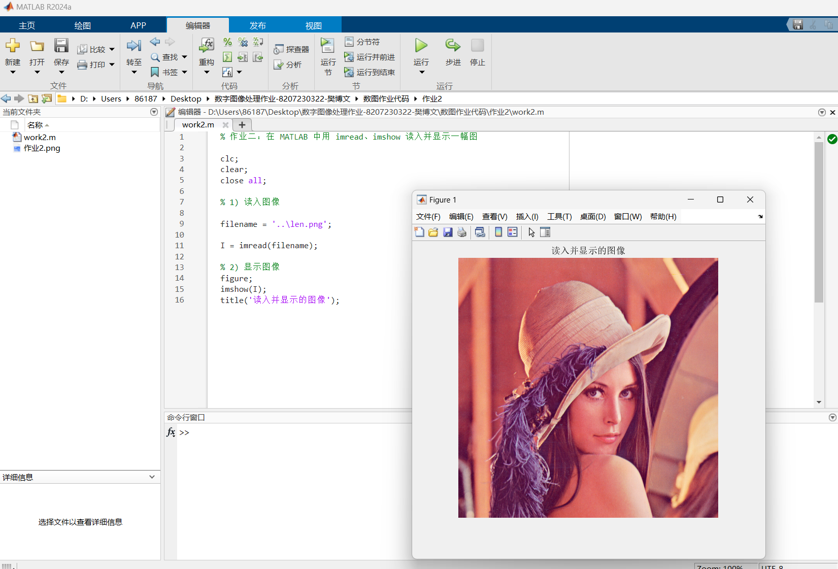

作业三、在matlab中对lena图进行右移5个像素、下移10个像素处理
% 作业3：图像平移
clc; clear; close all;

f = '..\len.png';
I = imread(f);

dx = 5; % 右移
dy = 10; % 下移

J = myShift(I, dx, dy);

imshow(J);
title('右移5像素，下移10像素');

function J = myShift(I, dx, dy)
% dx>0 右移，dx<0 左移；dy>0 下移，dy<0 上移
[h,w,c] = size(I);
J = zeros(h,w,c, 'like', I);

for y = 1:h
for x = 1:w
ys = y - dy; % 反向映射：目标(y,x)来自原图(ys,xs)
xs = x - dx;

if ys >= 1 && ys <= h && xs >= 1 && xs <= w
for k = 1:c
J(y,x,k) = I(ys,xs,k);
end
end
end
end
end

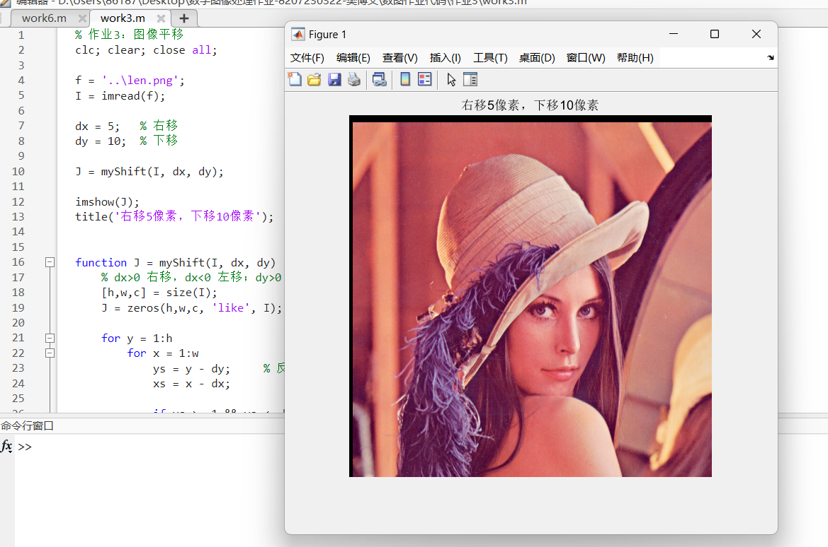

作业四、图像逆时针选择45°，编程实现
clc; clear; close all;

filename = '..\len.png';
I = imread(filename);

theta = 45;
rad = deg2rad(theta);

I = im2double(I);
[H, W, C] = size(I);

% 原图中心
cx = (W+1)/2;
cy = (H+1)/2;

corners = [1,1; W,1; 1,H; W,H];
x = corners(:,1) - cx;
y = corners(:,2) - cy;

xr = x*cos(rad) - y*sin(rad);
yr = x*sin(rad) + y*cos(rad);

minx = min(xr); maxx = max(xr);
miny = min(yr); maxy = max(yr);

W2 = ceil(maxx - minx + 1);
H2 = ceil(maxy - miny + 1);

% 新图中心
cx2 = (W2+1)/2;
cy2 = (H2+1)/2;

J = zeros(H2, W2, C);

% 输出图坐标
[XX, YY] = meshgrid(1:W2, 1:H2);
x2 = XX - cx2;
y2 = YY - cy2;

% 逆变换（映射回原图）
x1 = x2*cos(rad) + y2*sin(rad);
y1 = -x2*sin(rad) + y2*cos(rad);

Xsrc = x1 + cx;
Ysrc = y1 + cy;

% 双线性插值
for k = 1:C
J(:,:,k) = bilinearSample(I(:,:,k), Xsrc, Ysrc);
end

J8 = im2uint8(J);

figure;
imshow(J8);
title('逆时针旋转45°');

% ===== 双线性采样函数 =====
function out = bilinearSample(img, X, Y)
[H, W] = size(img);
out = zeros(size(X));

valid = (X >= 1) & (X <= W) & (Y >= 1) & (Y <= H);
Xv = X(valid); Yv = Y(valid);

x1 = floor(Xv); x2 = min(x1 + 1, W);
y1 = floor(Yv); y2 = min(y1 + 1, H);

dx = Xv - x1;
dy = Yv - y1;

Ia = img(sub2ind([H,W], y1, x1));
Ib = img(sub2ind([H,W], y1, x2));
Ic = img(sub2ind([H,W], y2, x1));
Id = img(sub2ind([H,W], y2, x2));

out(valid) = (1-dx).*(1-dy).*Ia + dx.*(1-dy).*Ib + (1-dx).*dy.*Ic + dx.*dy.*Id;
end

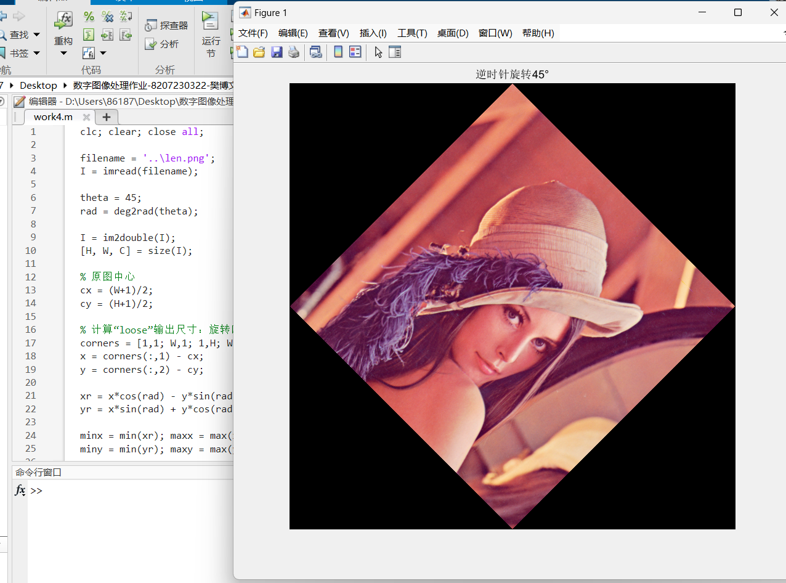

作业五、编写一个快速二维傅里叶变换，分析一幅图的幅值、相位角
clc; clear; close all;

f = '..\len.png';
img = imread(f);
if ndims(img)==3, img = rgb2gray(img); end
img = im2double(img);

% 补零到 2 的幂
[m,n] = size(img);
p = 2^nextpow2(m);
q = 2^nextpow2(n);
x = zeros(p,q);
x(1:m,1:n) = img;

% 二维 FFT：先行后列
F = myfft2(x);
Fs = fftshift(F);

A = log(1 + abs(Fs));
P = angle(Fs);
P = (P + pi) / (2*pi);

figure; imshow(A,[]); title('幅值');
figure; imshow(P,[]); title('相位');

function Y = myfft2(X)
% 2D FFT = 对每行做 1D FFT，再对每列做 1D FFT
[h,w] = size(X);
Y = complex(zeros(h,w));
for i = 1:h
Y(i,:) = myfft1(X(i,:));
end
for j = 1:w
Y(:,j) = myfft1(Y(:,j).').';
end
end

function X = myfft1(x)

x = complex(x(:));
N = length(x);
X = x(bitrev_idx(N));

m = 2;
while m <= N
h = m/2;
W = exp(-2i*pi*(0:h-1)/m).'; % 旋转因子
for k = 1:m:N % 蝶形运算
u = X(k:k+h-1);
t = W .* X(k+h:k+m-1);
X(k:k+h-1) = u + t;
X(k+h:k+m-1) = u - t;
end
m = m*2;
end
X = X.';
end
function idx = bitrev_idx(N)

b = log2(N);
idx = zeros(1,N);
for i = 0:N-1
r = 0; v = i;
for t = 1:b
r = bitshift(r,1) + bitand(v,1);
v = bitshift(v,-1);
end
idx(i+1) = r + 1;
end
end
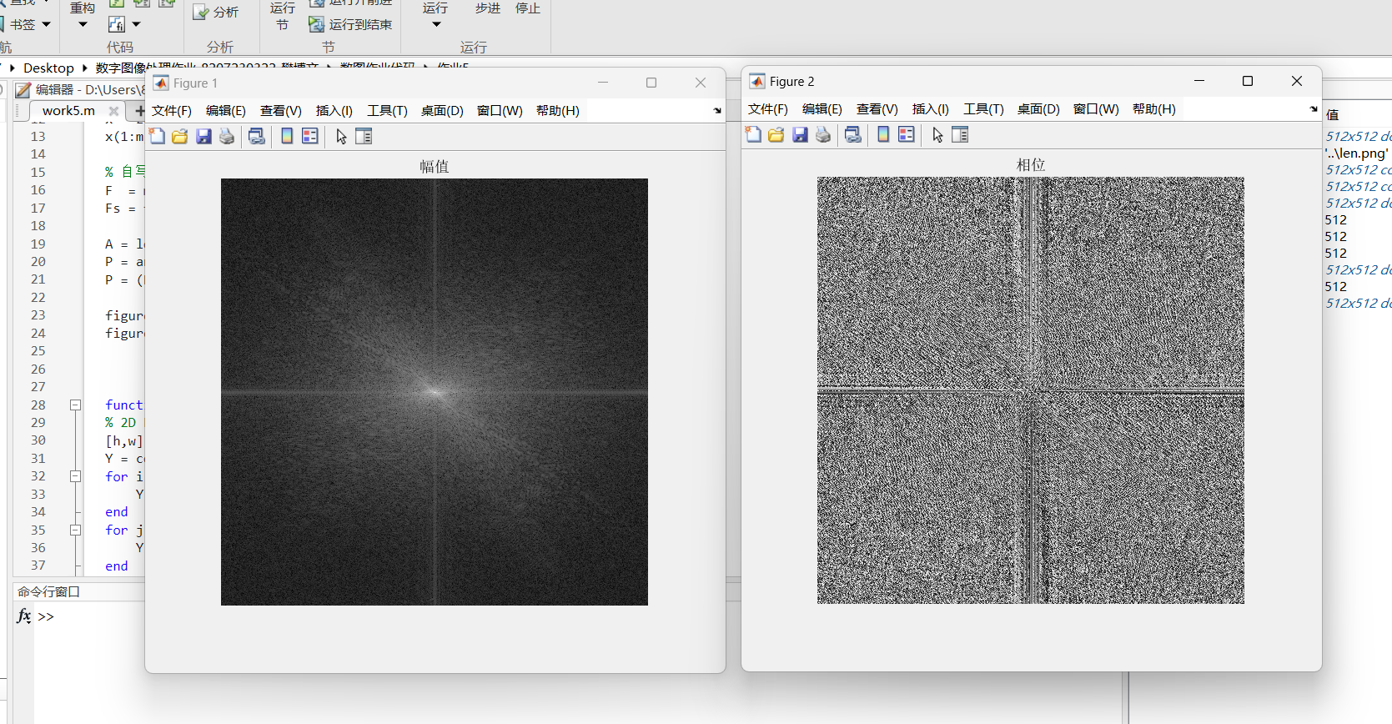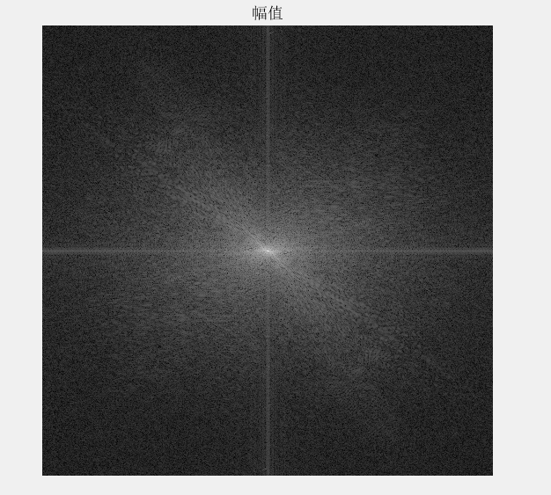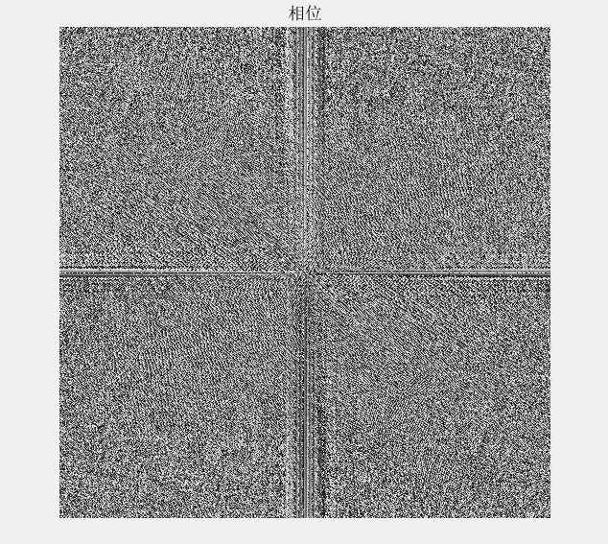

作业六、matlab中编程小波变换实现lena人像与反变换
clc; clear; close all;

f = '..\len.png';
img = imread(f);
if ndims(img)==3, img = uint8(0.299*img(:,:,1) + 0.587*img(:,:,2) + 0.114*img(:,:,3)); end
img = double(img) / 255;

% 2D 小波分解
[LL, LH, HL, HH] = haar_dwt2(img);
figure;
subplot(2,2,1); imagesc(LL); axis image off; colormap gray; title('LL');
subplot(2,2,2); imagesc(LH); axis image off; colormap gray; title('LH');
subplot(2,2,3); imagesc(HL); axis image off; colormap gray; title('HL');
subplot(2,2,4); imagesc(HH); axis image off; colormap gray; title('HH');
% 反变换重建
rec = haar_idwt2(LL, LH, HL, HH);

figure;
imagesc(rec); axis image off; colormap gray; title('反变换重建');

function [LL, LH, HL, HH] = haar_dwt2(x)
[m,n] = size(x);

if mod(m,2)==1, x(end+1,:) = x(end,:); m = m+1; end
if mod(n,2)==1, x(:,end+1) = x(:,end); n = n+1; end

s = sqrt(2);

a = x(:,1:2:end);
b = x(:,2:2:end);
Lr = (a + b) / s;
Hr = (a - b) / s;
a = Lr(1:2:end,:);
b = Lr(2:2:end,:);
LL = (a + b) / s;
LH = (a - b) / s;
a = Hr(1:2:end,:);
b = Hr(2:2:end,:);
HL = (a + b) / s; % 高行低列
HH = (a - b) / s; % 高行高列
end

function x = haar_idwt2(LL, LH, HL, HH)
s = sqrt(2);

Lr = inv_haar_col(LL, LH, s);
Hr = inv_haar_col(HL, HH, s);

x = inv_haar_row(Lr, Hr, s);
end

function y = inv_haar_col(L, H, s)

[k, w] = size(L);
y = zeros(2*k, w);
y(1:2:end,:) = (L + H) / s;
y(2:2:end,:) = (L - H) / s;
end

function y = inv_haar_row(L, H, s)

[h, k] = size(L);
y = zeros(h, 2*k);

y(:,1:2:end) = (L + H) / s;
y(:,2:2:end) = (L - H) / s;
end
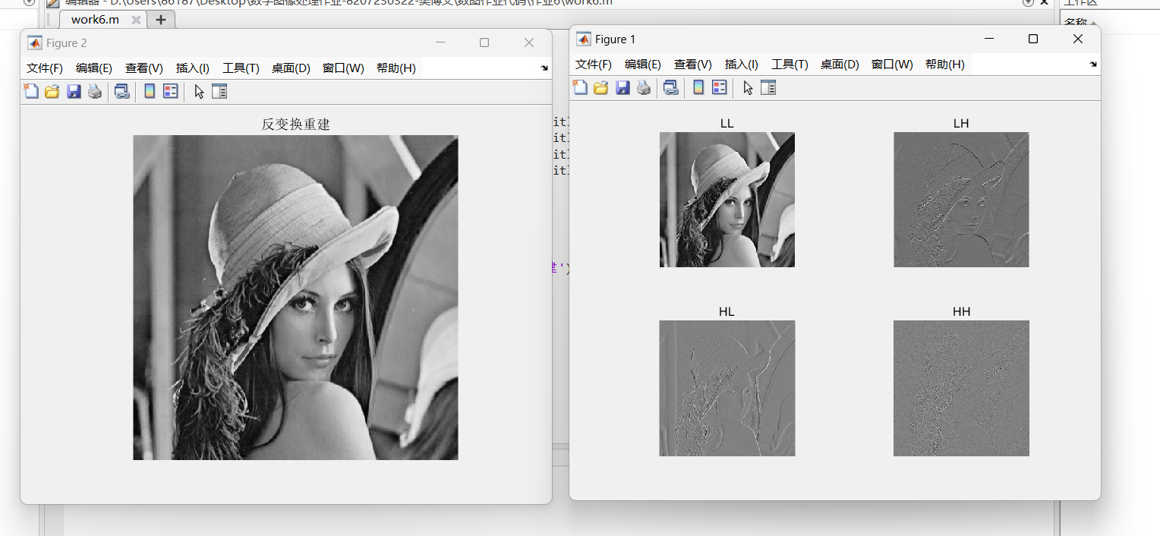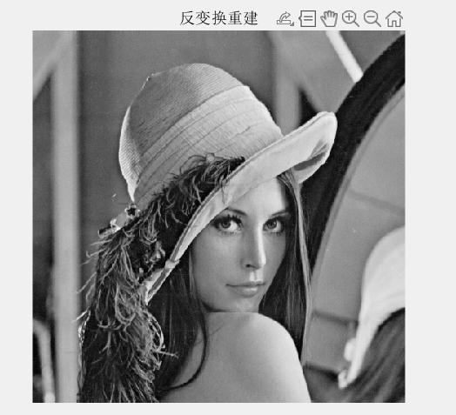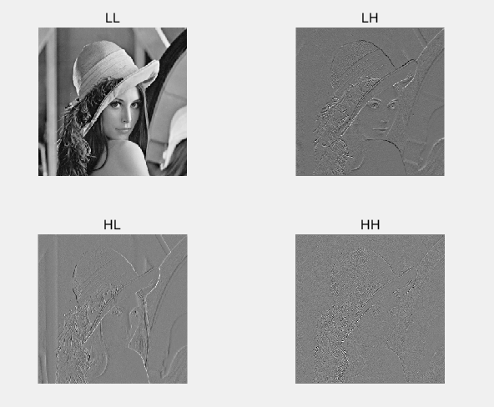

作业七、用3sigma法则设计一个图像增强算法
clc; clear; close all;

f = 'test.png';
img = imread(f);

out = enhance3sigma(img);

figure;
cmp = cat(2, img, out); % 横向拼接
imshow(cmp);
title('左：原图 右：3\sigma增强');

function out = enhance3sigma(img)
cls = class(img);

x = to01(img);

if ndims(x) == 2
y = stretch3sigma_gray(x);
out = from01(y, cls);
return;
end

R = x(:,:,1); G = x(:,:,2); B = x(:,:,3);
Y = 0.299*R + 0.587*G + 0.114*B;

Ye = stretch3sigma_gray(Y);

epsv = 1e-8;
ratio = Ye ./ (Y + epsv);

Re = clamp01(R .* ratio);
Ge = clamp01(G .* ratio);
Be = clamp01(B .* ratio);

out = from01(cat(3, Re, Ge, Be), cls);
end

function y = stretch3sigma_gray(x)
% x in [0,1]
[h,w] = size(x);
n = h*w;

% 计算均值
s = 0;
for i = 1:h
for j = 1:w
s = s + x(i,j);
end
end
mu = s / n;

% 计算标准差
s2 = 0;
for i = 1:h
for j = 1:w
d = x(i,j) - mu;
s2 = s2 + d*d;
end
end
sigma = sqrt(s2 / n);

a = mu - 3*sigma;
b = mu + 3*sigma;

% 防止阈值越界
if a < 0, a = 0; end
if b > 1, b = 1; end

% 防止除 0
if b <= a
y = x;
return;
end

% clip + stretch
y = zeros(h,w);
for i = 1:h
for j = 1:w
v = x(i,j);
if v < a, v = a; end
if v > b, v = b; end
y(i,j) = (v - a) / (b - a);
end
end
end

function x = to01(img)
if isa(img,'uint8')
x = double(img) / 255;
elseif isa(img,'uint16')
x = double(img) / 65535;
else
x = double(img);
% 若输入本来不是[0,1]，简单归一化到[0,1]
mn = min(x(:)); mx = max(x(:));
if mx > mn
x = (x - mn) / (mx - mn);
else
x = zeros(size(x));
end
end
x = clamp01(x);
end

function out = from01(x, cls)
x = clamp01(x);
if strcmp(cls,'uint8')
out = uint8(round(x * 255));
elseif strcmp(cls,'uint16')
out = uint16(round(x * 65535));
else
out = cast(x, cls);
end
end

function y = clamp01(x)
y = x;
y(y < 0) = 0;
y(y > 1) = 1;
end

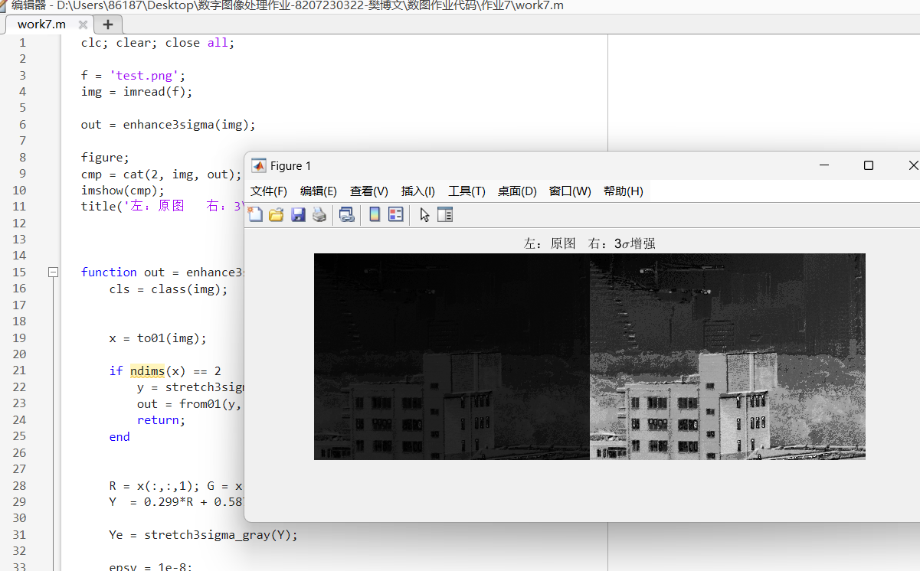

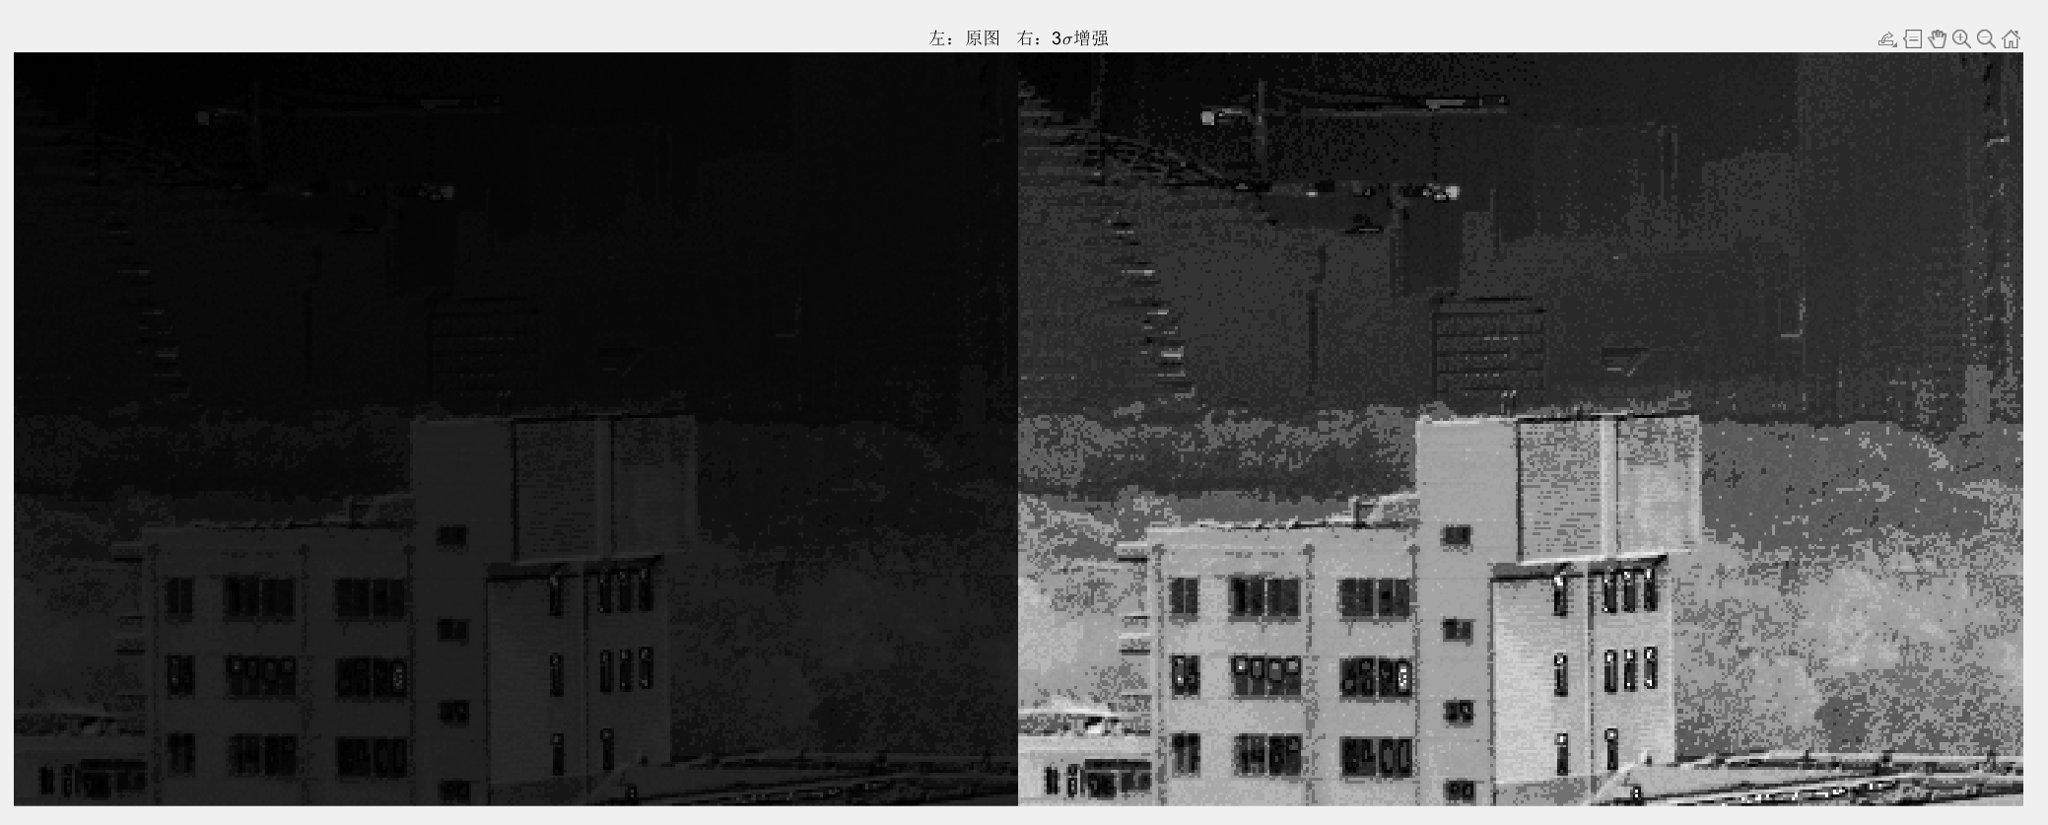

作业八、试设计一个高斯带通滤波器，对一个图像进行增强（要有f'、要标注不同参数下的输出效果）
clc; clear; close all;

% 输入图像
fpath = '..\test.png';
f = imread(fpath);
if ndims(f) == 3
f = uint8(0.299*f(:,:,1) + 0.587*f(:,:,2) + 0.114*f(:,:,3));
end
f = double(f) / 255;

[M,N] = size(f);
D = freqRadius(M,N);

F = fftshift(fft2(f));

mnd = min(M,N);
params = [
0.02*mnd 0.08*mnd 1.0
0.04*mnd 0.12*mnd 1.0
0.06*mnd 0.16*mnd 1.0
0.04*mnd 0.12*mnd 1.8
];

K = size(params,1);

% 展示：每组参数两张图（上：带通分量 下：增强结果 f'）
figure;
tiledlayout(2, K, 'Padding','compact','TileSpacing','compact');

for i = 1:K
s1 = params(i,1);
s2 = params(i,2);
a = params(i,3);

H = gaussBP(D, s1, s2); % 高斯带通
G = F .* H;
g = real(ifft2(ifftshift(G)));

fp = f + a*g;
fp = clamp01(fp);

gv = vis01(g);

nexttile(i);
imagesc(gv); axis image off; colormap gray;
title(sprintf('GBP分量 \\sigma1=%.0f \\sigma2=%.0f', s1, s2));

nexttile(K+i);
imagesc(fp); axis image off; colormap gray;
title(sprintf('f'' \\alpha=%.1f', a));
end

figure;
tiledlayout(1, K, 'Padding','compact','TileSpacing','compact');
for i = 1:K
s1 = params(i,1); s2 = params(i,2);
H = gaussBP(D, s1, s2);
nexttile(i);
imagesc(H); axis image off; colormap gray;
title(sprintf('H(u,v) \\sigma1=%.0f \\sigma2=%.0f', s1, s2));
end

function D = freqRadius(M,N)

u = (-floor(M/2)):(ceil(M/2)-1);
v = (-floor(N/2)):(ceil(N/2)-1);
[V,U] = meshgrid(v,u);
D = sqrt(U.^2 + V.^2);
end

function H = gaussBP(D, s1, s2)

H2 = exp(-(D.^2) / (2*s2*s2));
H1 = exp(-(D.^2) / (2*s1*s1));
H = H2 - H1;
end

function y = clamp01(x)
y = x;
y(y<0) = 0;
y(y>1) = 1;
end

function y = vis01(x)
% 把带通分量可视化到[0,1]：按均值±3σ压缩显示
mu = mean(x(:));
sg = std(x(:));
a = mu - 3*sg; b = mu + 3*sg;
if b <= a
y = zeros(size(x));
return;
end
y = (x - a) / (b - a);
y = clamp01(y);
end

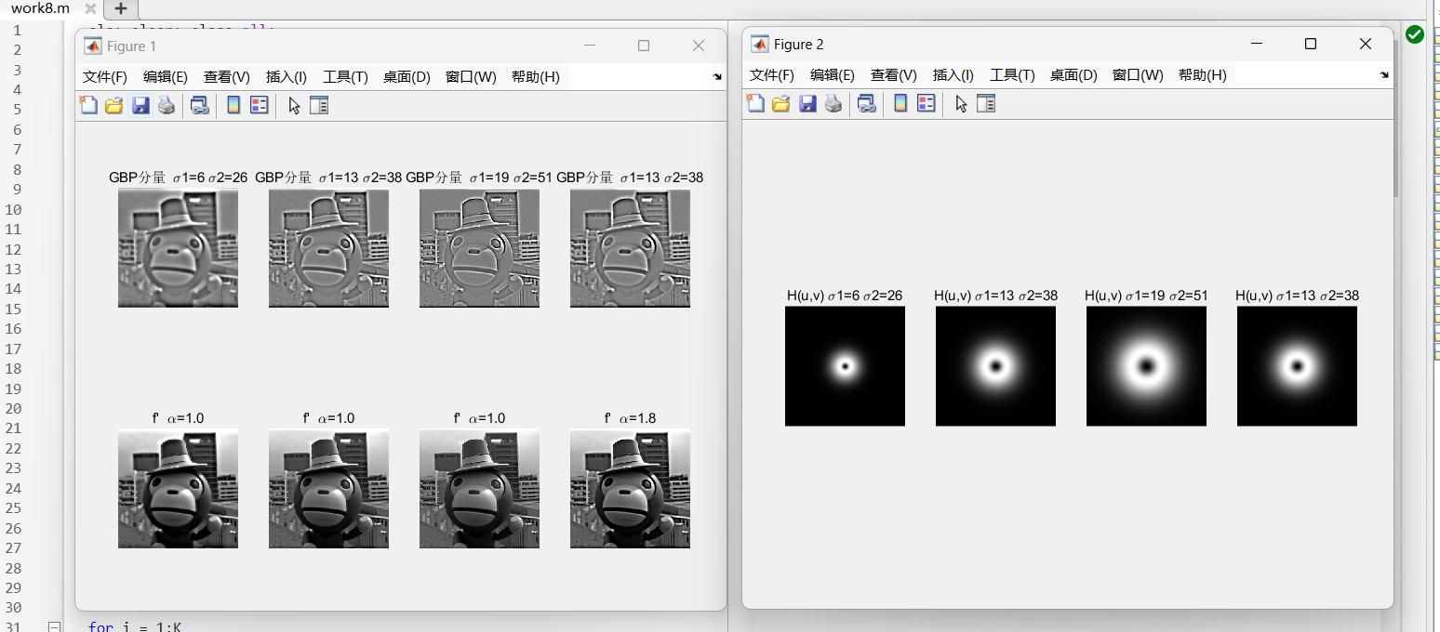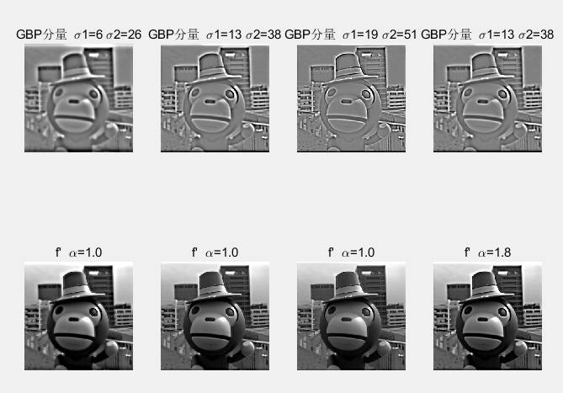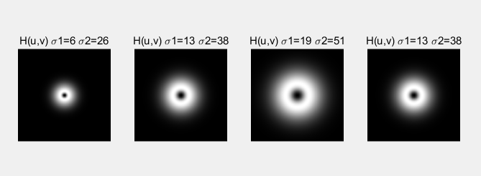

作业九、在lena图生成三种以上的噪声图
clc; clear; close all;

f = '..\len.png';
img = imread(f);

% 转灰度
if ndims(img)==3
img = uint8(0.299*img(:,:,1) + 0.587*img(:,:,2) + 0.114*img(:,:,3));
end
x = double(img)/255;

% 参数
sig = 0.08; % 高斯噪声标准差
peak = 30; % 泊松噪声
d = 0.03; % 椒盐噪声密度
A = 0.12; % 均匀噪声幅度

g = addGaussian(x, sig);
p = addPoisson(x, peak);
sp = addSaltPepper(x, d);
u = addUniform(x, A);

% 显示并标注参数
figure;
tiledlayout(2,2,'Padding','compact','TileSpacing','compact');

nexttile; imagesc(g); axis image off; colormap gray;
title(sprintf('高斯噪声 ', sig));

nexttile; imagesc(p); axis image off; colormap gray;
title(sprintf('泊松噪声 ', peak));

nexttile; imagesc(sp); axis image off; colormap gray;
title(sprintf('椒盐噪声', d));

nexttile; imagesc(u); axis image off; colormap gray;
title(sprintf('均匀噪声', A));

% 保存
imwrite(uint8(round(g*255)), 'lena_gaussian.png');
imwrite(uint8(round(p*255)), 'lena_poisson.png');
imwrite(uint8(round(sp*255)), 'lena_saltpepper.png');
imwrite(uint8(round(u*255)), 'lena_uniform.png');

function y = addGaussian(x, sigma)
y = x + sigma*randn(size(x));
y = clamp01(y);
end

function y = addUniform(x, A)
y = x + (2*rand(size(x)) - 1)*A; % [-A, +A]
y = clamp01(y);
end

function y = addSaltPepper(x, d)
y = x;
r = rand(size(x));
y(r < d/2) = 0; % pepper
y(r > 1-d/2) = 1; % salt
y = clamp01(y);
end

function y = addPoisson(x, peak)

lam = x * peak;
y = zeros(size(x));

small = lam < 30;
y(small) = poisson_knuth(lam(small)) / peak;

big = ~small;
if any(big(:))
lb = lam(big);
k = round(lb + sqrt(lb).*randn(size(lb))); % 近似 Poisson
k(k<0) = 0;
y(big) = k / peak;
end

y = clamp01(y);
end

function k = poisson_knuth(lam)

k = zeros(size(lam));
for idx = 1:numel(lam)
L = exp(-lam(idx));
p = 1;
c = 0;
while p > L
c = c + 1;
p = p * rand();
end
k(idx) = c - 1;
end
end

function y = clamp01(x)
y = x;
y(y<0) = 0;
y(y>1) = 1;
end
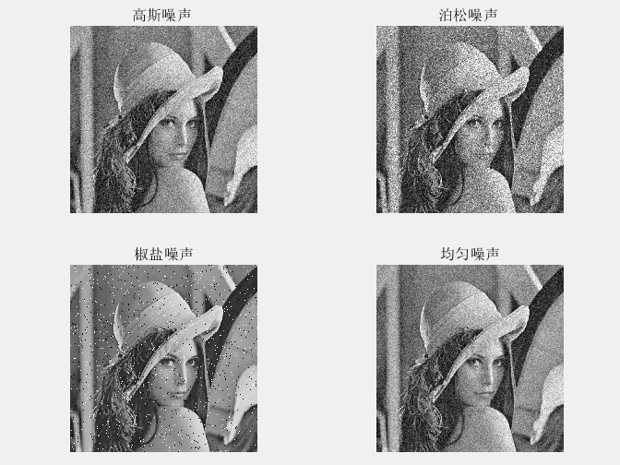
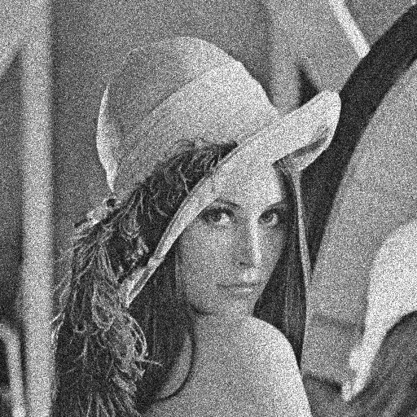
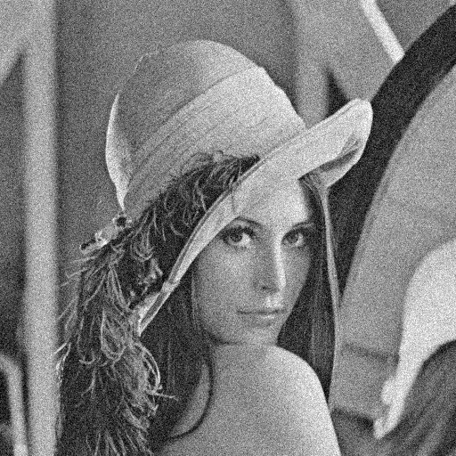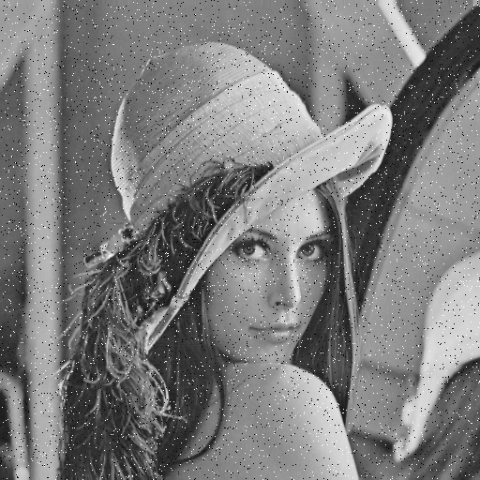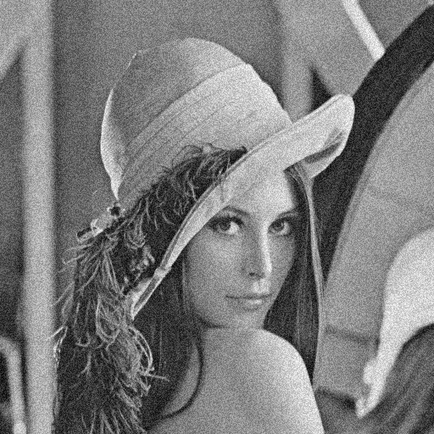

作业十、模板匹配法实现左侧到右侧的结果
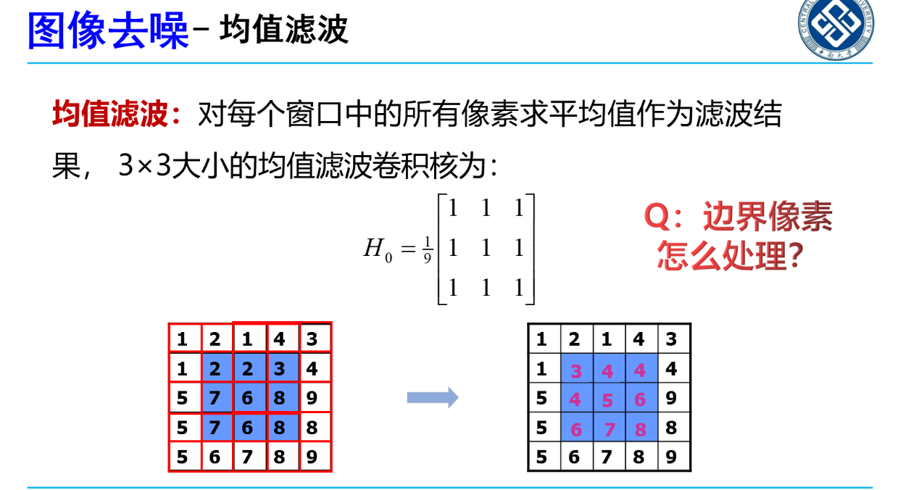

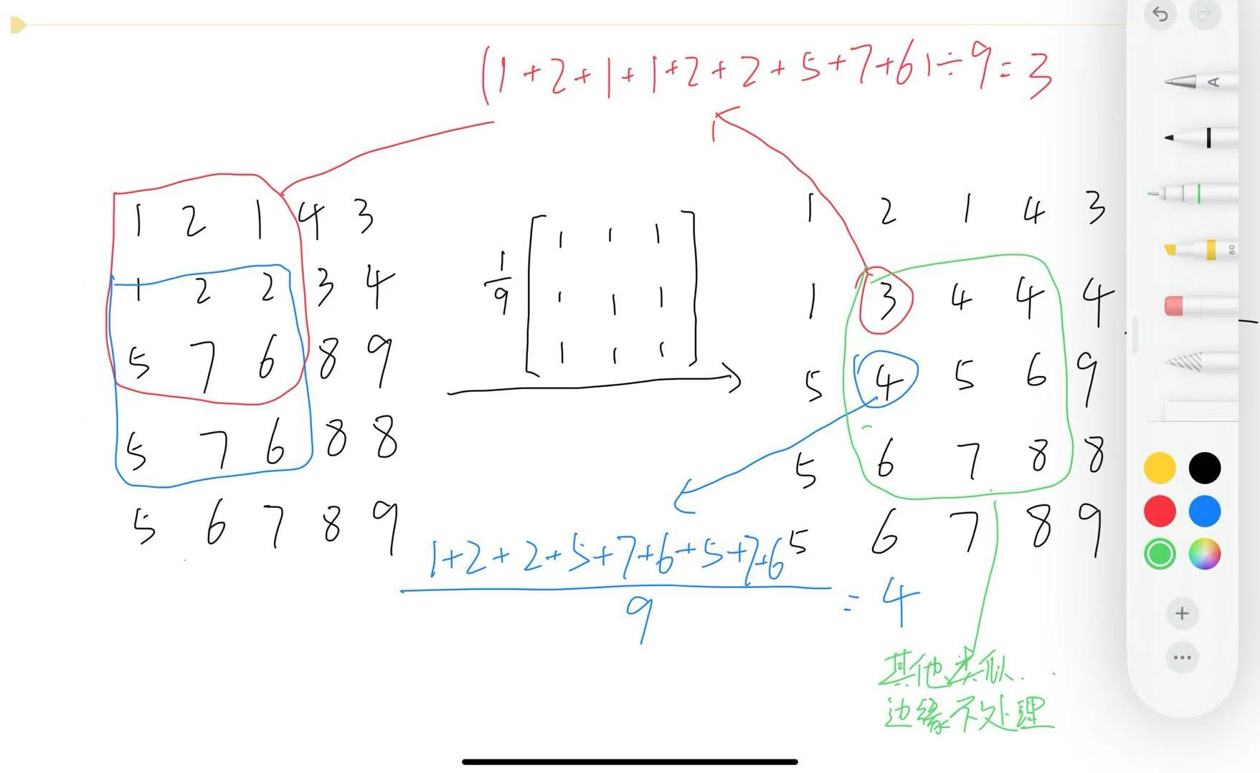

作业十一、自动找分隔线切图 + 计算 MSE/PSNR/SSIM计算一下校园图两幅图和标准图的指标
%% 作业11：自动找分隔线切图 + 计算 MSE/PSNR/SSIM
clc; clear; close all;

imgPath = 'work11.png';
I = imread(imgPath);
if size(I,3) == 1, I = repmat(I,[1 1 3]); end

[H,W,~] = size(I);

[s1, s2] = findSeparators(I);

L = I(:, 1:s1-1, :);
M = I(:, s1:s2-1, :);
R = I(:, s2:end, :);

L = imresize(L, [size(R,1), size(R,2)]);
M = imresize(M, [size(R,1), size(R,2)]);

[mseL, psnrL, ssimL] = calcMetrics(L, R);
[mseM, psnrM, ssimM] = calcMetrics(M, R);

fprintf('自动分隔位置：s1=%d, s2=%d (图像宽度W=%d)\n', s1, s2, W);
fprintf('左图 vs 右标准: MSE=%.6f, PSNR=%.6f dB, SSIM=%.6f\n', mseL, psnrL, ssimL);
fprintf('中图 vs 右标准: MSE=%.6f, PSNR=%.6f dB, SSIM=%.6f\n', mseM, psnrM, ssimM);

% 切割结果
figure; imshow(L); title('Left (resized)');
figure; imshow(M); title('Middle (resized)');
figure; imshow(R); title('Right (Reference)');

function [s1, s2] = findSeparators(I)

[~,W,~] = size(I);

G = rgb2gray(I);
colMean = mean(double(G), 1);
colMean = colMean / max(colMean + eps);

thr = max(0.92, prctile(colMean, 99));
bright = colMean >= thr;

edge = max(5, round(0.03 * W));
bright(1:edge) = false;
bright(end-edge+1:end) = false;

idx = find(bright);
if isempty(idx)

s1 = floor(W/3);
s2 = floor(2*W/3);
return;
end

breaks = [true, diff(idx) > 1, true];
cutPos = find(breaks);
segs = {};
for k = 1:numel(cutPos)-1
seg = idx(cutPos(k):cutPos(k+1)-1);
segs{end+1} = seg;
end

cand = [];
for i = 1:numel(segs)
seg = segs{i};
w = numel(seg);
c = mean(seg);

if w <= round(0.05*W)
cand = [cand; w, c];
end
end

if size(cand,1) < 2

s1 = floor(W/3);
s2 = floor(2*W/3);
return;
end

t1 = W/3; t2 = 2*W/3;

[~, i1] = min(abs(cand(:,2) - t1));
c1 = cand(i1,2);

dist2 = abs(cand(:,2) - t2) + 1e6*(abs(cand(:,2) - c1) < 0.1*W);
[~, i2] = min(dist2);
c2 = cand(i2,2);

s = sort([round(c1), round(c2)]);
s1 = s(1);
s2 = s(2);

s1 = max(2, min(W-2, s1));
s2 = max(s1+2, min(W-1, s2));
end

function [mseVal, psnrVal, ssimVal] = calcMetrics(testImg, refImg)

if ~isa(testImg,'uint8'), testImg = im2uint8(testImg); end
if ~isa(refImg,'uint8'), refImg = im2uint8(refImg); end

mseVal = immse(testImg, refImg);
psnrVal = psnr(testImg, refImg);
ssimVal = ssim(testImg, refImg);
end
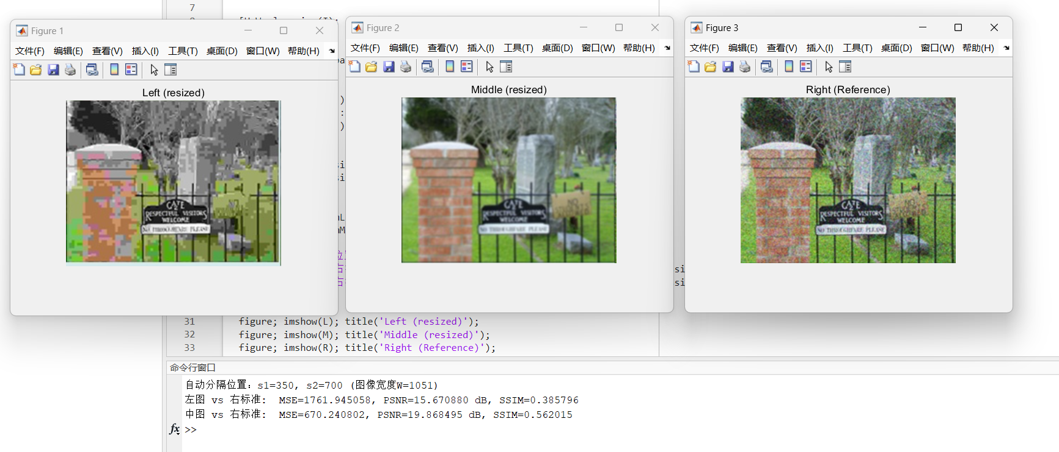

自动分隔位置：s1=350, s2=700 (图像宽度W=1051)
左图 vs 右标准: MSE=1761.945058, PSNR=15.670880 dB, SSIM=0.385796
中图 vs 右标准: MSE=670.240802, PSNR=19.868495 dB, SSIM=0.562015

作业十二、用sobel算子和LoG算子设计二个程序对lena图进行边缘检测

clc; clear; close all;
f = '..\len.png';
img = imread(f);

% 转灰度并归一化到[0,1]
x = toGray01(img);

% Sobel 边缘
th = 0.25;
[mag, edge] = sobelEdge(x, th);

% 显示
figure('Color','w');
tiledlayout(1,3,'Padding','compact','TileSpacing','compact');

nexttile; imagesc(x); axis image off; colormap gray; title('原图(灰度)');
nexttile; imagesc(mag); axis image off; colormap gray; title('Sobel 幅值');
nexttile; imagesc(edge); axis image off; colormap gray;
title(sprintf('Sobel 边缘(阈值=%.2f)', th));

% 保存
imwrite(uint8(round(mag*255)), 'lena_sobel_mag.png');
imwrite(uint8(edge*255), 'lena_sobel_edge.png');

function x = toGray01(img)
if ndims(img)==3
img = 0.299*double(img(:,:,1)) + 0.587*double(img(:,:,2)) + 0.114*double(img(:,:,3));
else
img = double(img);
end
x = img / 255;
x = clamp01(x);
end

function [mag, edge] = sobelEdge(x, th)
% Sobel核
kx = [-1 0 1; -2 0 2; -1 0 1];
ky = [-1 -2 -1; 0 0 0; 1 2 1];

gx = myConv2(x, kx);
gy = myConv2(x, ky);

mag = sqrt(gx.^2 + gy.^2);

mag = mag / (max(mag(:)) + 1e-12);

edge = mag >= th; % 二值边缘
end

function y = myConv2(x, k)

[H,W] = size(x);
[kh,kw] = size(k);
ph = floor(kh/2);
pw = floor(kw/2);

xp = padReplicate(x, ph, pw);

y = zeros(H,W);
for r = 1:H
for c = 1:W
s = 0;
for i = 1:kh
for j = 1:kw
s = s + xp(r+i-1, c+j-1) * k(i,j);
end
end
y(r,c) = s;
end
end
end

function xp = padReplicate(x, ph, pw)
[H,W] = size(x);
xp = zeros(H+2*ph, W+2*pw);

for r = 1:(H+2*ph)
rr = r - ph;
if rr < 1, rr = 1; end
if rr > H, rr = H; end
for c = 1:(W+2*pw)
cc = c - pw;
if cc < 1, cc = 1; end
if cc > W, cc = W; end
xp(r,c) = x(rr,cc);
end
end
end

function y = clamp01(x)
y = x;
y(y<0) = 0;
y(y>1) = 1;
end
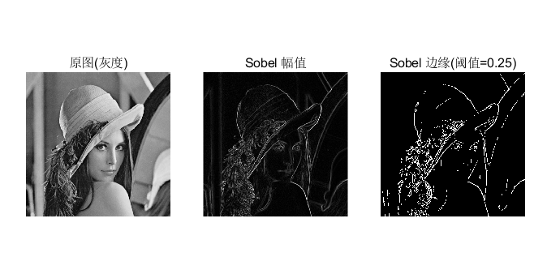

clc; clear; close all;

f = '..\len.png';
img = imread(f);

% 转灰度并归一化
x = toGray01(img);

sigma = 1.4;
ksize = 9;
zc_th = 0.03;

% LoG 边缘
[resp, edge] = logEdge(x, sigma, ksize, zc_th);

% 显示
figure('Color','w');
tiledlayout(1,3,'Padding','compact','TileSpacing','compact');

nexttile; imagesc(x); axis image off; colormap gray; title('原图(灰度)');
nexttile; imagesc(resp); axis image off; colormap gray;
title(sprintf('LoG 响应(\\sigma=%.1f, k=%d)', sigma, ksize));
nexttile; imagesc(edge); axis image off; colormap gray;
title(sprintf('LoG 零交叉边缘(阈值=%.3f)', zc_th));

resp_vis = resp;
mn = min(resp_vis(:)); mx = max(resp_vis(:));
resp_vis = (resp_vis - mn) / (mx - mn + 1e-12);

imwrite(uint8(round(resp_vis*255)), 'lena_log_resp.png');
imwrite(uint8(edge*255), 'lena_log_edge.png');

function x = toGray01(img)
if ndims(img)==3
img = 0.299*double(img(:,:,1)) + 0.587*double(img(:,:,2)) + 0.114*double(img(:,:,3));
else
img = double(img);
end
x = img / 255;
x = clamp01(x);
end

function [resp, edge] = logEdge(x, sigma, ksize, zc_th)
k = makeLoGKernel(ksize, sigma);
resp = myConv2(x, k);

edge = zeroCrossing(resp, zc_th);
end

function k = makeLoGKernel(ksize, sigma)
r = floor(ksize/2);
s2 = sigma^2; s4 = s2^2;

k = zeros(ksize, ksize);
sumk = 0;
for y = -r:r
for x = -r:r
rr = x*x + y*y;
val = ((rr - 2*s2)/s4) * exp(-rr/(2*s2));
k(y+r+1, x+r+1) = val;
sumk = sumk + val;
end
end

k = k - sumk/(ksize*ksize);
end

function edge = zeroCrossing(resp, th)
[H,W] = size(resp);
edge = false(H,W);

for r = 2:H-1
for c = 2:W-1
nb = resp(r-1:r+1, c-1:c+1);
mn = min(nb(:));
mx = max(nb(:));

if (mn < 0) && (mx > 0) && ((mx - mn) >= th)
edge(r,c) = true;
end
end
end
end

function y = myConv2(x, k)
[H,W] = size(x);
[kh,kw] = size(k);
ph = floor(kh/2);
pw = floor(kw/2);

xp = padReplicate(x, ph, pw);

y = zeros(H,W);
for r = 1:H
for c = 1:W
s = 0;
for i = 1:kh
for j = 1:kw
s = s + xp(r+i-1, c+j-1) * k(i,j);
end
end
y(r,c) = s;
end
end
end

function xp = padReplicate(x, ph, pw)
[H,W] = size(x);
xp = zeros(H+2*ph, W+2*pw);

for r = 1:(H+2*ph)
rr = r - ph;
if rr < 1, rr = 1; end
if rr > H, rr = H; end
for c = 1:(W+2*pw)
cc = c - pw;
if cc < 1, cc = 1; end
if cc > W, cc = W; end
xp(r,c) = x(rr,cc);
end
end
end

function y = clamp01(x)
y = x;
y(y<0) = 0;
y(y>1) = 1;
end
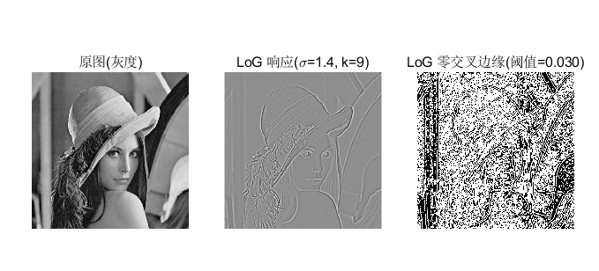

作业十三、已知原始图，画出T=5的矩阵

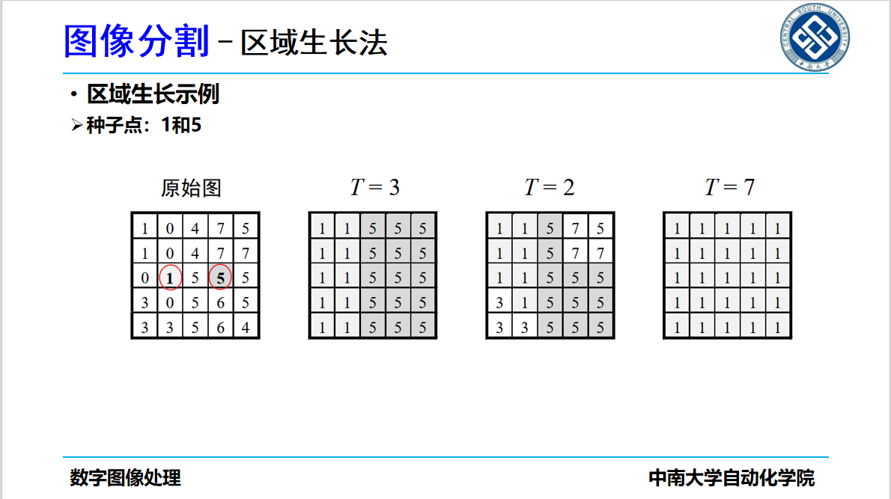

先用种子点 1 判断：$∣I-1∣<T$ 就标成 1；没被标到的再用种子点 5 判断：$∣I-5∣<T$ 就标成 5；都不满足则保留原值，当 T = 5 时结果为：
$$\begin{matrix}1 & 1 & 1 & 5 & 5 \\ 1 & 1 & 1 & 5 & 5 \\ 1 & 1 & 5 & 5 & 5 \\ 1 & 1 & 5 & 5 & 5 \\ 1 & 1 & 5 & 5 & 5\end{matrix}$$

作业十四、腐蚀膨胀

1

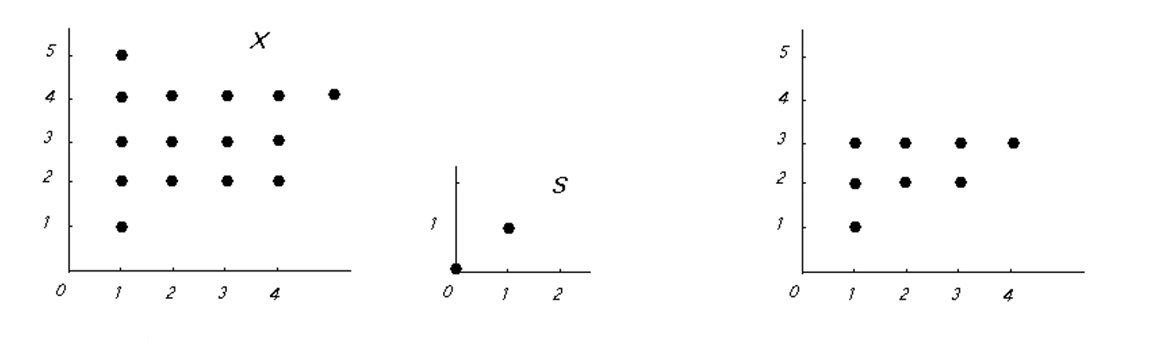

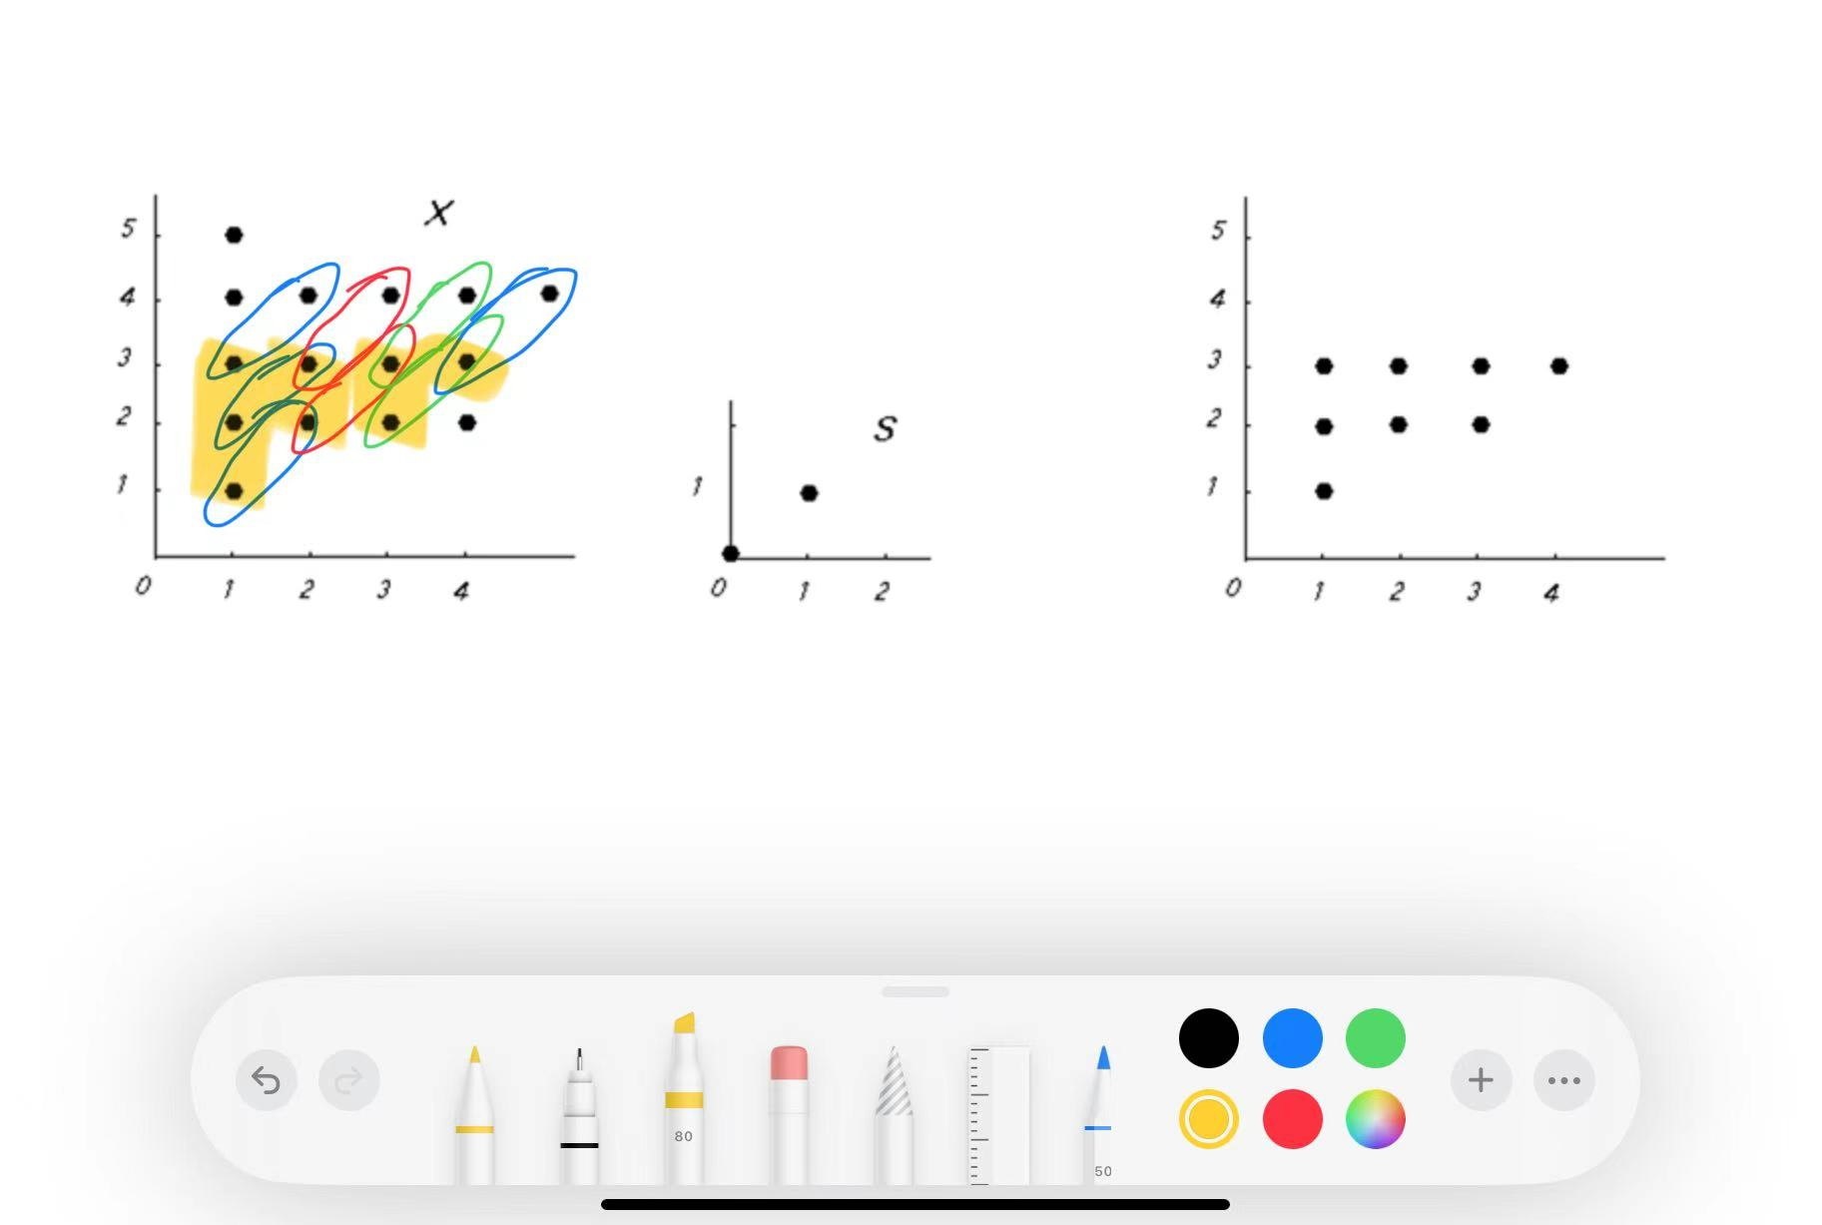

2
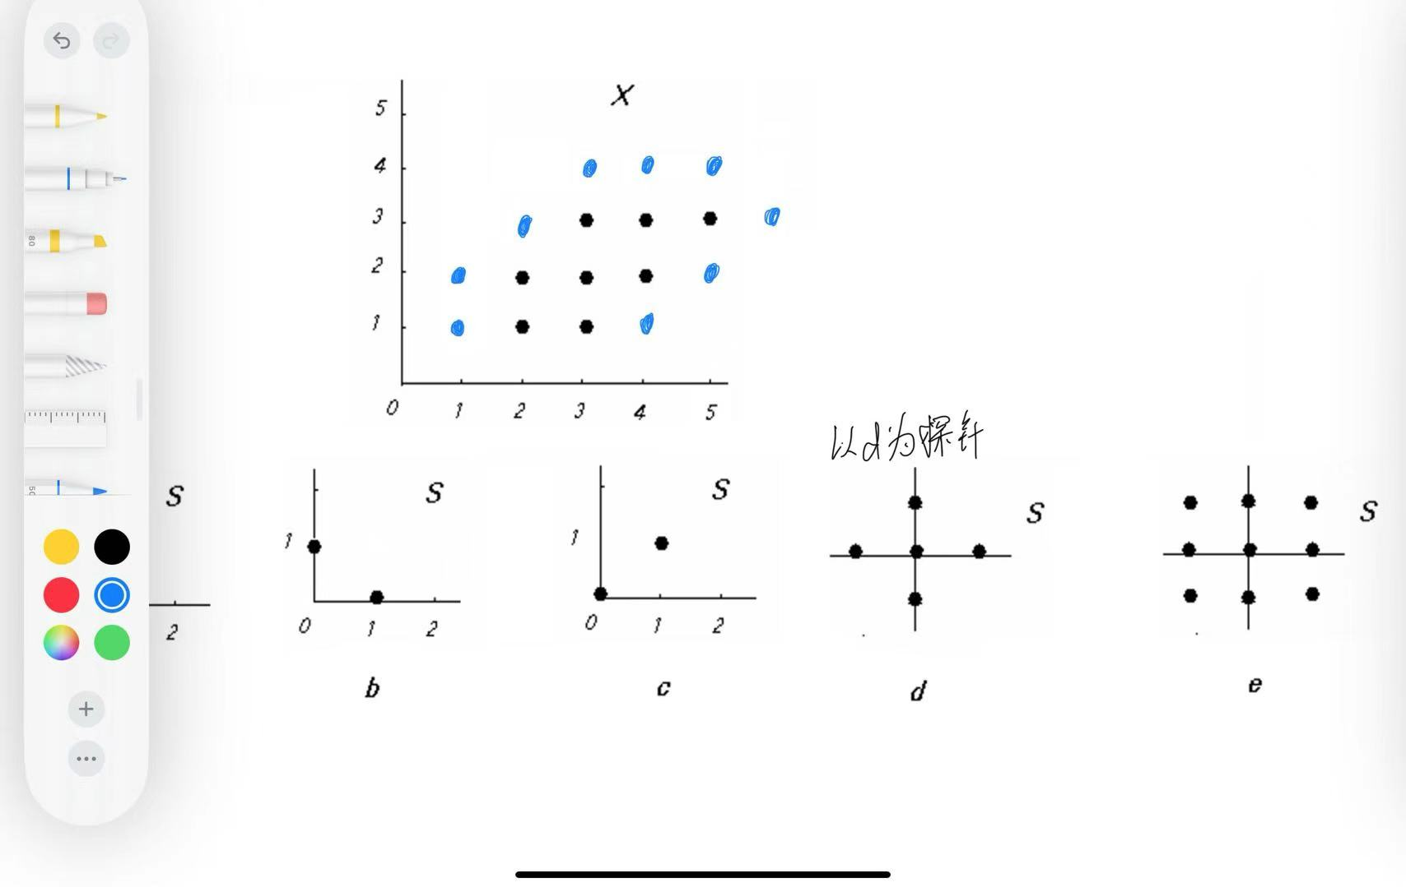

3
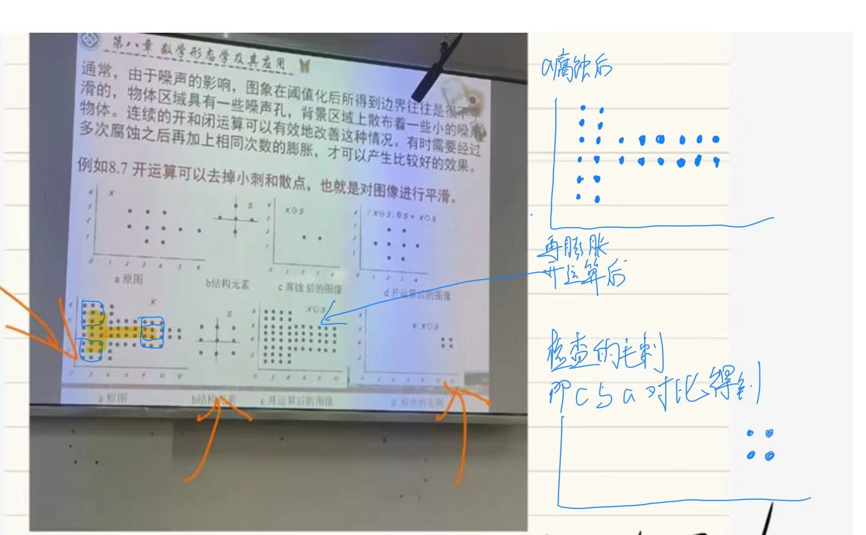

作业十五、求C和D的欧拉数
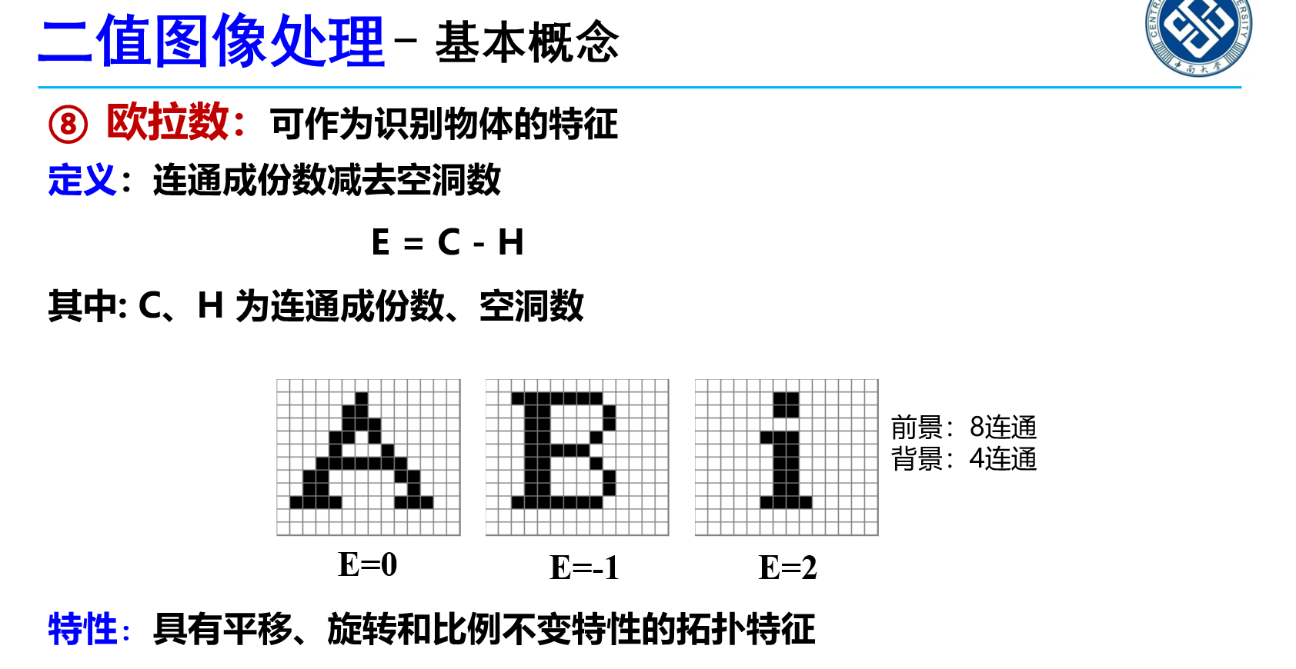

欧拉数公式：$E=C-H$（$C$：连通域个数；$H$：孔洞个数）
字母 C：一般是 1 个连通域、0 个孔洞
$$E=1-0=1$$
字母 D：一般是 1 个连通域、1 个孔洞（中间那一圈是孔洞）
$$E=1-1=0$$
所以：C 的欧拉数 = 1，D 的欧拉数 = 0。

