# Introduction

There is a great deal of interests in the development of viable green technologies aimed at the enhancement of biodegradable and biocompatible polymer materials, such as the blend of poly $ε$-caprolactone (PCL) and poly lactide (PLA) Blending is a low cost, easy implement process for modification of polymer mixture. Mixing several immiscible polymer with different physical and chemical properties has possibility to improve the overall constituents’ performance.

Nowadays, the blending material of poly $ε$-caprolactone (PCL) and poly lactide (PLA) shows a wide application in many areas. PLA has excellent biocompatibility, biodegradability and dynamic property, which shows broad prospects for tissue engineering development and other areas. But pure PLA has some drawbacks, including poor toughness, low degradation rate.

Moreover, the crystallinity of PLA is low. These drawbacks severely restrain the application of PLA material. Researchers have attempted some polymer to make blends with PLA. PHB, PCL, PP and other material which has good performance has been attempted in recent years.

Physical property improvement has been found in some researchers’ blending experiments. PCL The blend of PCL and PLA shows high degradation rate, better tensile strength, which is the properties originated from PLA, while PCL with much slower degradation rate and better toughness. The blend of PCL and PLA is a promising material which can meet the requirement of environment and physical conditions. Qiaolian Lv et al. used an injection molding blend of PCL and PLA. They got a maximum $σ=29.8±0.9$ MPa and $E=922.5±9.8$ MPa. For electrospun process, Pisani et al. got a maximum $E=49.10±0.12$ Mpa.

The physical property of PCL-PLA blend depends on the super molecular structure, which is dominated by the crystallization condition. The melting point ($T_{m}$) and glass transient temperature ($T_{g}$) of PCL are far lower than those of PLA, and the crystallization temperature ($T_{c}$) of PCL is even lower than the $T_{g}$ of PLA. Someone’s research manifests that the presence of minor PCL phase favors cold crystallization of PLA in their blend system because PCL is in its molten state during PLA crystallization, reducing system viscosity as a result, or acts as additional substrates.

The goal of this research work to improve the physical properties of the blend. Stretching of the electrospun mat induces the inner fibers to align in one direction. The unmolten PLA fibers offer crystallization loci for PCL phase. On the other hand, the molten PCL phase favors cold crystallization of PLA fibers. The present works lack this kind research method. Does this process improve the performance of blends? This question interests the author. Therefore, in this work electrospinning, stretching and hot pressing experiments are carried. Lots of morphology, microstructure, dynamic and thermal properties are characterized. [sec:introduction]

# Experiment

## Sample Preparation

Firstly, electrospinning process was carried out. PLA was supplied by 20 wt% PCL solution and 20 wt% PLA solution were prepared. 2 nozzles containing PCL solution and 1 nozzle containing PLA solution were used in the electrospinning process, so the mass ratio of PLA : PCL was 33:67. The electrospinning voltage was set at 8 Nev. The humidity of electrospun environment was 40%, the temperature was 25 $​^{o}C$. The electrospun mats were made as standard size samples.

On the next stage, the electrospun mat was stretched by a mechanical tester. The electrospinning mats were stretched to a series of elongation ratios. The velocity of the tensile process was 4 mm/minute, which is a low speed to avoid the fracture of the samples. 25%, 50%, 75%, 100% and 125% elongation ratio mats were made. After that the mats’ double edges were fixed by heat-resistant tape in order to keep the elongation status since the mats had a rebound trend. Subsequently, the extended mats were put between two foils which stuck to 300 $​^{o}C$-resistant film. The mats were deposited in a heat oven which kept an 80 $​^{o}C$ environment lasting 1 hour for PCL’s melting. After 1 hour, the mats were transferred into another heat oven which kept a 30 $​^{o}C$ environment lasting 30 minutes for isothermal crystallization.

Finally, the sample was tailored into a dimension of 10 mm $×$ 5 mm, and the thickness was recorded by a film thickness gauge. Abundant standard sample with same length and width were prepared for the following characterizations.

## Morphology and microstructure characterizations

### Polarized Optical Microscope (POM)

POM is an effective facility to observe the microstructure of polymer material. With Maltese cross phenomenon in birefringence polymer crystals, the amorphous and crystallization zone can be clearly distinguished. A Linkam heating stage was used to handle the electrospinning films with the same heat treatment process as the experiment in . The melting and the cold crystallization process of different elongation samples were observed and recorded by a Leica POM.

### Small Angle X-ray Scattering(SAXS)

Small Angle X-ray Scattering(SAXS) experiment was carried on beamline BL16B1, Shanghai Synchrotron Radiation Facility. A Pilatus 2M detector(1475 $×$ 1679 pixels with a pixel size of 172 mm) was performed to collect the SAXS pattern. The X-ray wavelength was 0.103 nm, and the sample to detector distance was set at 2131 mm. Considering the scale of X-ray pattern on BL19U2 is much larger than the diameter of PLA fibers inside the samples. It was essential to focus the X-ray pattern. A beryllium compound reflective lens(CRL) was deployed to get a 5 $μm$ diameter X-ray pattern. Besides a portable POM was placed on the light path in order to determine location on blends characterized by the SAXS method.

### Wide Angle X-ray Scattering(WAXS)

WAXS experiment was carried on beamline BL16B1, Shanghai Synchrotron Radiation Facility, Pilatus 2M detector (1475 $×$ 1679 pixels with a pixel size of 172 mm). The X-ray wavelength was 0.124 nm, and the sample to detector distance was set at 178.5 mm.

## Dynamic Property Characterization

The dynamic properties of the neat PCL and its blends with various annealing histories were determined by a mechanical tester at a crosshead speed of 50 $mm⋅min^{−1}$) at 25 $​^{o}C$ using the dog-bone shaped specimens. Strength and modulus values reported here represent an average of the results for tests run on 6 specimens.

## Thermal Property Characterization

### Thermogravimetric Analysis (TGA)

TGA measurements were carried out in a Mettler Toledo TGA 2 thermal analyzer. The experiments were performed under nitrogen atmosphere(flow rate of 50 $mL⋅min^{−1}$). Each sample was heated from 0 $​^{o}C$ to 600 $​^{o}C$ at 10 $​^{o}C⋅min^{−1}$. The initial degradation temperatures ($T_{0}$) were determined at 5% mass loss, whereas temperatures at the maximum degradation rate ($Tmax$) were calculated from the first derivative of the TGA curves (DTG).

### Differential Scanning Calorimetry (DSC)

DSC’s experiments were performed in a Mettler Toledo DSC 3+ under nitrogen atmosphere (flow rate of 50 $mL⋅min^{−1}$). Sample weights of 2 mg were sealed in aluminum pans and heated from 0 $​^{o}C$ to 200 $​^{o}C$ at 10 $​^{o}C⋅min^{−1}$. The degree of crystallinity($χ_{c}$) was calculated through

$$χ_{c}=100\%×[​\frac{ΔH_{m}−Δ_{cc}}{ΔH_{m}^{c}}]\frac{1}{W_{PCL}}$$

[sec:experiment]

# Result and Analysis

As shown in, a is the melting and isothermal crystallization of 0 % elongation sample, b is the same process of 125 % elongation sample. Compare the evolution of two samples, it can be remarkably noticed that the stretching force make PLA fibers inside samples present a certain degree of orientation. During the isothermal crystallization process at 30 $​^{o}C$, the PCL grain firstly appears on the surface of PLA fiber. After a short time, the grain is fill the entire matrix.

## Crystallization behavior

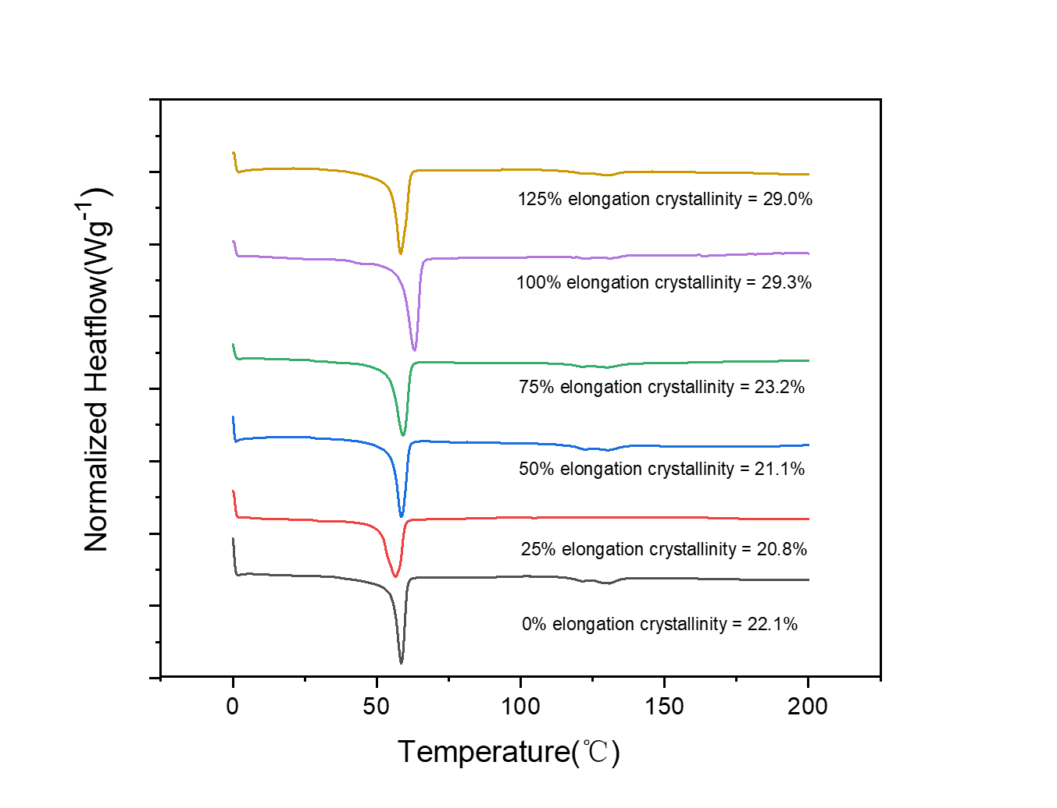

[sec:result_and_Analysis]

Crystallinity of components in PCL/PLA blends

|  |  |  |  |
| --- | --- | --- | --- |
| Sample | Crystallinity (%) of PCL phase | Crystallinity (%) of PLA phase | Melting point($​^{o}C$) of PCL phase |
| 0% | 22.1 | - | 58.7 |
| 25% | 20.8 | - | 56.6 |
| 50% | 21.1 | - | 58.6 |
| 75% | 23.2 | - | 59.1 |
| 100% | 29.3 | - | 63.0 |
| 125% | 29.0 | - | 58.5 |
| [DSC_result_table] |  |  |  |

$χ_{c}$ calculated using $Δ_{m}^{c}$ of PCL of 139.5($J⋅g^{−1}$)

# Conclusion

# Acknowledgement