**Homework 3**

**Team member: Fan Zhang, Zhiqi Chen**

**Q 5.2 :**

1. Douglas-Pucker algorithm to discretize arcs: n*log(n)
2. Compute area of a simple polygon: linear
3. Compute centroid of a polygon: linear
4. Point in polygon: linear
5. Intersection or a polygon-pair, each with N vertices : polynomial
6. Depth-first or breadth-first graph traversal : polynomial
7. Single-pair shortest path in a graph : polynomial
8. All-pair shortest paths in a graph: polynomial
9. Hamiltonian circuit (or Traveling salesman problem): exponential

**Q 5.4 :**

1. NAA is the closest to the GML Simple Features. Because they are both composed by the points and directed arcs. Also, each area is bounded by one or more directed arcs.
2. Spagetti is the closest to ESRI shapefile, since both of them store primitive geometrical data types of points, lines, and polygons.

**Q 6.2**

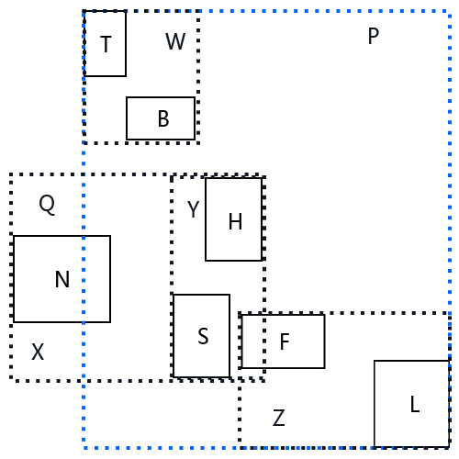 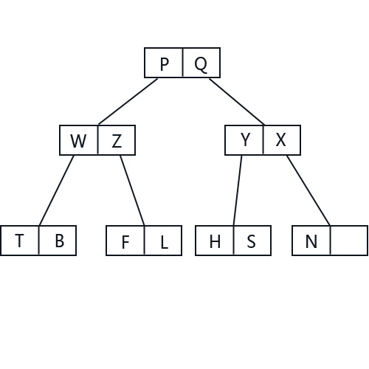

For the R+ tree, we find it’s very tricky to draw the R+ tree since the R+ tree don’t allow overlapping between any non-leaf nodes. The orthogonal bounding rectangle for rectangle T and L just cross the rectangle N. So the minimum bounding box for N become the most tricky part for this problem. In order to keep the tree as height balance, we choose a fan-out ratio of three.

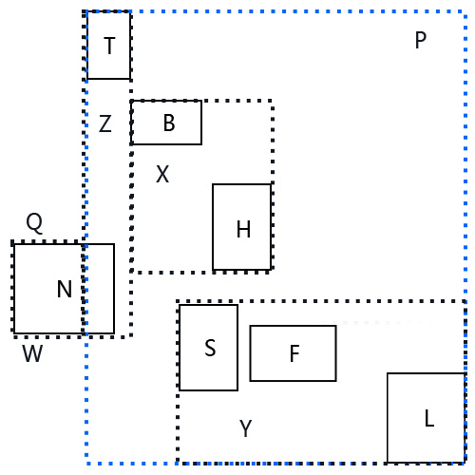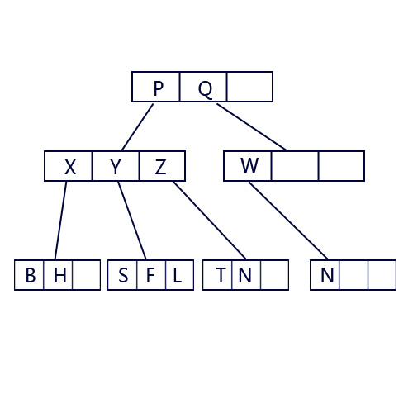

**Q6.4**

1. Point object structures like grid file could be used.
2. R tree or R+ tree could be used.
3. Single level index.


7. Voronoi diagram.