Neural-initialised static condensation with equilibrium correction for the analysis and thickness design of cut thin-walled TPMS lattices

Abstract
Structures of geometrically varying components, such as graded and cut lattices, are too large to resolve at every design change, yet lose the scale separation homogenisation needs: for a cell layer clamped on its cut, homogenisation underestimates compliance by 27%. Exact condensation needs an interior factorisation per geometry; learned substructures keep few boundary degrees of freedom, and component reduced-basis methods a shared discrete space. Here a learned model acts on all box-face and cut-band degrees of freedom, tens of thousands per cell, of a component whose discrete space changes with geometry, yet keeps the structure of static condensation. A geometry-conditioned network, exactly linear in the retained displacement, computes the interior extension; one network serves every retained set; no matrix is formed. The extension's energy defines a Ritz approximation of the condensed stiffness, bounded below by the exact Schur complement, with error quadratic in the interior error. A fixed two-grid correction inside that energy keeps these properties and, under stated conditions, cannot increase the error. Compliance accuracy does not imply sensitivity accuracy: the error reaches sensitivity through the stiffness derivative. For cut Schwarz-P cells discretised by stabilised cut finite elements, the construction reaches, relative to that model, a mean energy error of 0.074% and assembled compliance and sensitivity errors below 0.28% and 1.5%; eight-cell lattice analysis with sensitivities is about ten times faster than whole-lattice direct solution. Thickness optimisation closely reproduces the exact-condensation design and, on the cut-clamped plate, yields a design 2.4% stiffer, by exact condensation, than a homogenisation design.
Keywords: learned substructures; static condensation; Schur complement; Ritz approximation; cut finite elements; TPMS lattices; thickness optimisation.

1. Introduction
Many engineered structures are assembled from a large number of components of the same kind but of different geometry: graded lattices whose cells vary in wall thickness Yu et al. (2019), architected materials trimmed to the shape of a part, cellular cores supported and loaded along cut boundaries. Their analysis, and still more their design, must reconcile two opposing demands. The structure as a whole is too large to resolve again at every design change, which favours replacing each component by something cheaper; yet the quantities that drive the design, such as the stiffness of a cut cell next to a support or the sensitivity to a wall thickness, are local, which favours keeping each component's detail. Homogenisation resolves this tension in favour of economy, and the design of graded lattices commonly rests on it Li et al. (2018). It is accurate where the cells are small compared with the variation of the field and loses that accuracy where they are not: at supports, at loads and in cells cut by the boundary. For the plate of Section 5.10, a single layer clamped on its cut, it underestimates the compliance by 27%. Resolving every wall of every cell settles the tension in favour of fidelity, at a cost that each design iteration, since it changes every cell, pays again in full (Section 5.9). Substructuring takes the middle course. Each component is condensed onto the degrees of freedom it shares with its surroundings and returns the forces conjugate to their displacement, so that the structure can be assembled; the interior field, from which local design quantities are evaluated, is recovered afterwards. Static condensation does this exactly Guyan (1965), Irons (1965), but at the price of an interior factorisation for every geometry. Learned component models seek to remove this price: some map nodal displacements directly to forces Capuano & Rimoli (2019), and learned substructures evaluate learned shape functions in the energy form and assemble like finite elements Huang et al. (2023), Guo et al. (2026a).
To replace static condensation in analysis and design, a learned component model must meet four requirements. It must be symmetric and positive semidefinite with the rigid-body kernel, so that it can be assembled. It must apply to every new geometry without an interior factorisation, even when the cut changes the discrete space. Its error must be traceable to the compliance and to the local sensitivities that design requires. And it should be improvable at deployment without retraining. This paper shows that a learned component model can meet these requirements while keeping every degree of freedom on the faces of the cell box and on the band of elements cut by the boundary (the cut band). It obtains the structure of static condensation from where its approximation is placed and how its condensed stiffness is formed, and its improvability from a fixed correction of its interior field.
For cut thin-walled cells the retained space is large: the box-face degrees of freedom carry exterior loads and intercell coupling, and those of the cut band carry virtual work on the cut surface, so each cell here retains a median of $2.4×{10}^{4}$ degrees of freedom (2,679 to 45,900 over the 80 validation geometries). Forming the Schur complement explicitly needs one interior solve per retained degree of freedom, and applying it needs an interior factorisation for every geometry. An approximation can reduce the retained set or approximate the interior extension. Reducing the retained degrees of freedom, as in port reduction Eftang & Patera (2013), Smetana & Patera (2016), Ballani et al. (2018) and in learned substructures, restricts the displacement patterns that substructures can exchange and leaves a boundary model error that no improvement of the interior removes. Approximating the interior extension on the complete retained space, as in Huynh et al. (2013), alters only the interior response to each pattern. We place the approximation in the interior extension, learned and conditioned on the geometry of each cell, and keep every box-face degree of freedom and the whole cut band. Keeping the cut band also keeps loads and supports on the cut surface available: the plate of Section 5.10 is clamped on its cut without retraining.
An interior error enters the compliance weighted by the energy the cell carries, but it enters the thickness sensitivity through the stiffness derivative, so a cell with a small energy share can leave the compliance accurate while its sensitivity remains inaccurate. This is the distinction on which goal-oriented error estimation rests Becker & Rannacher (2001), Oden & Prudhomme (2001); it has been observed for approximate reanalysis and inexact solves in topology optimisation Amir et al. (2009), Amir et al. (2010), Gogu (2015). We quantify it for learned substructures and adopt joint accuracy of compliance and local sensitivity as the criterion for design use.
The construction combines three ingredients. The energy form supplies the structure: any admissible extension that reproduces rigid-body motion, evaluated in the energy form, yields a symmetric positive semidefinite condensed stiffness with the rigid-body kernel, bounded below by the exact Schur complement with an error quadratic in the interior error Toselli & Widlund (2005); this holds for static condensation itself, for multiscale finite elements Hou & Wu (1997), for component reduced-basis methods Huynh et al. (2013) and for learned shape functions evaluated as $N^{T}KN$ Huang et al. (2023). Learning supplies the trial field. An extension matrix formed for every geometry would cost one interior solve per retained degree of freedom, and a network with an output for each retained degree of freedom cannot serve retained sets that change with the cut. A geometry-conditioned network, nonlinear in the geometry and exactly linear in the retained displacement, therefore computes the interior field of each cell by local interactions and a multilevel latent hierarchy whose weights act on stencils, channels and grid levels rather than on individual degrees of freedom. Its size, about $6×{10}^{5}$ parameters, does not grow with the number of retained degrees of freedom, one network serves cells whose retained sets differ, and neither the extension nor the condensed matrix is ever formed. A fixed correction supplies the improvability: a geometry-specific two-grid cycle, Chebyshev smoothing around a coarse-grid Galerkin correction with a prescribed number of steps Xu (1992), reduces the interior equilibrium residual at fixed retained displacement, much as smoothing improves a tentative prolongation in smoothed-aggregation multigrid Vaněk et al. (1996). Because the correction is a fixed linear map inside the condensed energy, the corrected condensed stiffness keeps every property above. Its error cannot exceed that of the uncorrected one when the coarse solve is exact and the upper end of the smoothing interval bounds the spectrum Golub & Varga (1961), Xu & Zikatanov (2002), and the transpose of the complete corrected extension returns the force conjugate to that energy. The network is trained through the correction, and the two are complementary: under the same correction a deterministic harmonic start leaves 7 to 290 times the error of the learned field (Section 5.5). We call the construction neural-initialised condensation with equilibrium correction (NICE).
Learned substructures have been developed furthest as problem-independent machine learning (PIML), which predicts substructure shape functions for a few boundary degrees of freedom, imposes rigid-body motion constraints and, in its self-consistent form, evaluates the stiffness as $N^{T}KN$ Huang et al. (2022), Huang et al. (2023). Its variants train without labelled shape functions by minimum potential energy Huang et al. (2024), enrich the boundary with Bézier functions Guo et al. (2026a), join oversampled bases by an overlapping partition of unity and correct the reconstructed fine-scale field by a few Jacobi-preconditioned conjugate-gradient iterations on the global equilibrium equations Guo et al. (2026b), impose symmetry equivariance Jiang, C. et al. (2026), treat isoparametric substructures Zhang, L. et al. (2024), transfer them to complex three-dimensional design domains Zhang et al. (2026) and optimise lattices Xu et al. (2025). A few boundary degrees of freedom per substructure give coarse models small enough for very large structures, with the boundary model error controlled by refining the partition, enriching the interpolation or oversampling.
Closest to the present construction are component models that keep a mechanical structure. They differ from NICE in the retained space, in how the component is represented and in where its approximation is improved. In the retained space, component reduced-basis methods keep the complete interface in their condensation and construct interior reduced bases offline Huynh et al. (2013); they are built on a discrete space shared by the parameter family, and for unfitted discretisations solutions on varying active sets have been extended to a common background space before reduction Chasapi et al. (2023). NICE keeps the complete retained space although that space itself changes with the cut, and therefore conditions its network on the discrete geometry of each cell rather than on parameters of a shared discretisation.
For the representation of a component, lattice methods have condensed cells into super-elements whose stiffness, interpolated in a density parameter by a reduced-order surrogate, supplies explicit stiffness derivatives for optimisation without scale separation Wu et al. (2019); have replaced the cell-wise local solves of inexact finite element tearing and interconnecting, dual–primal (FETI-DP) methods by reduced-order cell operators for lattices built by spline composition Hirschler et al. (2024); and, for unfitted two-dimensional lattices, have combined balancing domain decomposition by constraints (BDDC) with full cell stiffness matrices whose trimmed-cell integrals are approximated by matrix discrete empirical interpolation Bonilla Moreno et al. (2027). Each keeps one discretisation across cells: respectively, a common lattice pattern, a composed parametric cell and one high-order unfitted element per cell. For unfitted coarse elements, numerical shape functions have also been conditioned against small cuts Chen & Li (2026). Learned elements condense an embedded inner domain into a symmetric positive semidefinite interface stiffness Parish et al. (2024), and convex neural energy elements learn boundary energies from Schur-complement targets and recover interior fields by exact lifting Jiang, H. et al. (2026). In NICE the learned object is the interior extension itself: one corrected extension, built without an interior factorisation and applied without forming a matrix, defines the assembled operator, the recovered field and the thickness sensitivities.
Where the approximation is improved differs as well. Inexact substructuring methods Dohrmann (2007), Li & Widlund (2007), Klawonn & Rheinbach (2007) improve approximate subdomain and coarse solves inside a preconditioner, whose iteration converges to the exact discrete solution (Section 6.3). Convex neural energy elements, for a nonlinear example, refine the exact lifting by Newton steps through which they differentiate Jiang, H. et al. (2026). Component reduced-basis methods bound the error of the component or assembled solution a posteriori Huynh et al. (2013), where NICE provides a computable residual (Eq. (5)) instead of a certified bound. NICE corrects the interior field of each component at fixed retained displacement, inside the condensed energy, so the correction changes the operator that is assembled.
Learning has also been combined with multilevel and domain-decomposition solvers, through learned multigrid prolongations Greenfeld et al. (2019), Luz et al. (2020), machine-learning-assisted adaptive FETI-DP coarse spaces Heinlein et al. (2021), hybrid neural solvers that combine learned predictions with relaxation, learned inverse actions or coarse spaces Zhang, E. et al. (2024), Kopaničáková & Karniadakis (2025), Xing et al. (2026) and networks trained through the solver Um et al. (2020). Geometry-aware neural operators and graph networks Li et al. (2023a), Li et al. (2023b), Pfaff et al. (2021), multigrid-structured operators He et al. (2024), learned Green's functions Boullé & Townsend (2023) and Ritz-type training E & Yu (2018) instead learn solution maps of the whole problem. Spectral multiscale coarse bases Efendiev et al. (2013) have likewise served in optimisation without scale separation as the coarse space of a two-level preconditioner for the fully resolved problem Alexandersen & Lazarov (2015). These methods accelerate a global solve or approximate the solution of the whole problem; here the learned map is a per-cell extension, exactly linear in the retained displacement, so that its energy defines a condensed operator per cell that can be assembled, differentiated and improved.
The contributions of this work are fourfold. (i) The learned object: condensation on the complete retained space of a component whose active and retained degrees of freedom change with its geometry. The deformation exchanged between cells is not restricted, and supports and loads on the cut surface need no retraining (Sections 2, 5.7 and 5.10). (ii) Its computational representation: one network of about $6×{10}^{5}$ parameters serves retained sets of 2,679 to 45,900 degrees of freedom without forming the extension or the condensed matrix, which for a cell of median retained size would take 4.3 GiB in double precision (Sections 4.4 and 4.6). (iii) A correction of each component's condensed operator, valid for any discrete model with a symmetric positive semidefinite stiffness and a positive definite interior block. It keeps the properties of static condensation, remains design-differentiable on design intervals on which the discrete model does not switch, and improves a deployed network without retraining (Sections 4.1–4.3 and 5.5). (iv) An error chain from the component to the design (Section 3). Beyond the quadratic error of the Ritz approximation, the interior error enters the compliance weighted by each cell's energy share, but it enters the thickness sensitivity through the stiffness derivative, with a linear term that the energy error does not control. Joint accuracy of compliance and local sensitivity is therefore the design criterion. Factorising the energy error into a squared relative displacement error and a stiffness-amplification ratio ($ε=δ^{2}κ$) shows how interior displacement errors of about one percent become energy errors of 1.8–35% in the cut cells examined (Sections 5.4 and 5.6).
Section 2 states the discrete cut-cell model, exact condensation and the requirements on an approximate condensed stiffness; Section 3 derives the error relations that hold for any admissible extension; Section 4 constructs NICE. Section 5 realises it for cut thin-walled Schwarz-P cells in a stabilised cut finite element model and verifies it on 80 validation geometries and two-cell assemblies of them, on eight-cell lattices of cells unseen in training and checkpoint selection, by an ablation of the retained representation, in cost against the whole-lattice direct solution and conventional exact condensation, and in thickness optimisations checked against exact condensation and compared with a homogenised model. Section 6 discusses the results and states the limitations; Section 7 concludes.

2. Discrete substructures and static condensation
The error relations of Section 3 and the construction of Section 4 apply to any discrete model with a symmetric positive semidefinite stiffness whose interior block is positive definite once the retained degrees of freedom are prescribed. The cut thin-walled triply periodic minimal surface (TPMS) cell of this section is the instance on which they are realised and tested: its retained space is large, and its active elements and retained set change with the cut.

2.1. Geometry and discrete elastic problem
We consider three-dimensional thin-walled TPMS cells in the reference box $B=[0,1]^{3}$. Their material domain is defined by a Schwarz-P-type trigonometric level-set field, a spatially varying band parameter, and an optional planar cut:
&ϕ(x)=a=13cos(2πxa), τ(x)=c∈{0,1}3​NcQ1(x)τc,&Ω(η)={x∈B:|ϕ(x)|≤τ(x), n⋅x≤bcut}. (1)
The eight parameters $τ_{c}$, interpolated by the trilinear functions $N_{c}^{Q_{1}}$, control the implicit band width and hence the material distribution; we call them corner thickness parameters (band parameters, not pointwise wall thicknesses) and derivatives with respect to them thickness sensitivities. When the eight corner values are collected in vectors, such as $τ$ or the sensitivity vector $s$, the corners are numbered $c=1,…,8$. The cut plane $n⋅x=b_{cut}$ has unit normal $n$, pointing away from the retained material, and offset $b_{cut}$; the half-space constraint is omitted for an uncut cell, and $η$ collects geometry, material and discretisation parameters.
The elastic problem uses continuous tensor-product $Q_{2}$ displacement functions on a Cartesian background mesh. A background element is active if its intersection with $Ω(η)$ has positive measure, which is certified by interval enclosures of the level-set and band functions over the element (Appendix A.1); the displacement degrees of freedom (DOFs) of the nodes of active elements are the active DOFs. Integration over the material domain supplies the bulk stiffness, and ghost-penalty stabilisation Burman (2010) couples neighbouring active elements to control small-cut effects Burman et al. (2015). The symmetric matrix $K$ defines the stabilised discrete energy $1/2u^{T}Ku$, and the reference in this work is the equilibrium of this discrete system: all errors are measured against it, not against the continuum problem. Figure 1 shows representative geometries; Table 1 (Section 5.1) lists the settings of the examples, and Appendix A gives the integration and assembly details.
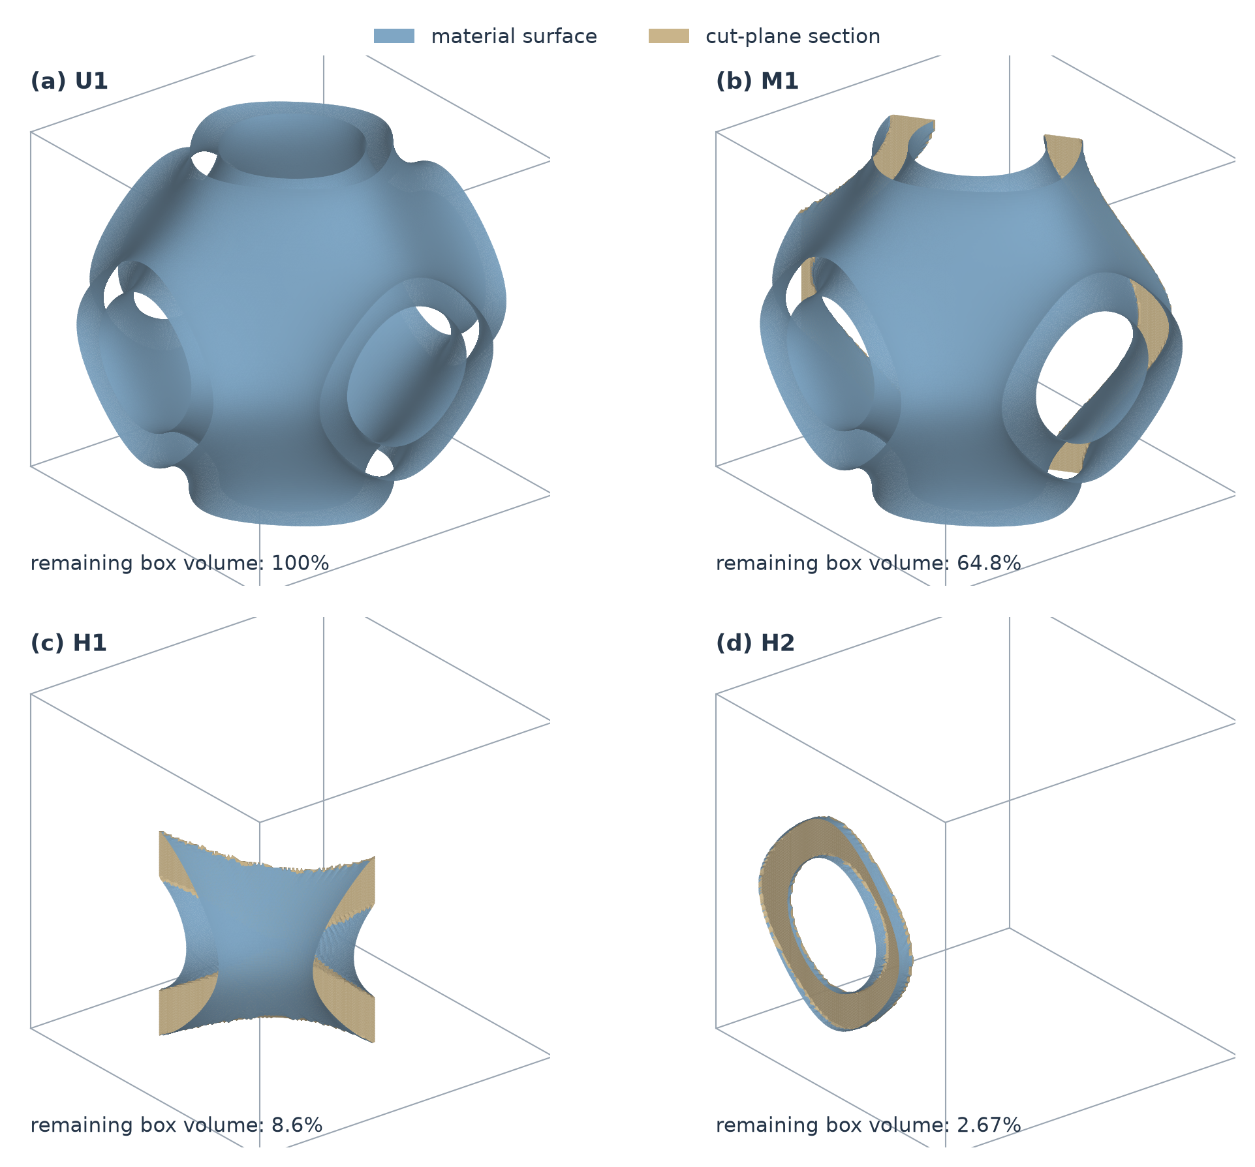
Figure 1. Representative validation geometries. The same unit-box scale and viewing direction are used for (a) uncut U1, (b) moderately cut M1, and (c,d) heavily cut H1 and H2. Blue denotes the material surface and sand the section on the cut plane. Percentages indicate the box volume remaining after the cut, relative to the unit box, before intersection with the thin-wall material. Surfaces are reconstructed from Eq. (1) on a grid of 129 positions per axis, for visualisation only.

2.2. Retained degrees of freedom and equilibrium extension
For each cell, the retained DOFs, collected in the set $P$, are the active box-face displacement DOFs and all displacement DOFs of active elements carrying a positive-area cut-surface patch. These elements, the layer of active elements intersected by the cut plane, form the cut band: although some of its nodes lie away from the cut plane, their basis functions contribute to displacement and virtual work on that plane. This full retained space, with both intercell and exterior-boundary DOFs, is used throughout prediction and assembly.
Let $I$ denote the remaining interior DOFs, $p=|P|$, $i=|I|$, and $n_{a}=p+i$. The selectors $J_{P}$ and $J_{I}$ extract the two sets from the active displacement vector, and $q=J_{P}u$ is the retained displacement. Boundary loads act through $q$; interior body loads are zero. In the displayed $(P,I)$ ordering, static condensation gives
$$\begin{aligned}&K=\left[\begin{matrix}K_{PP} & K_{PI} \\ K_{IP} & A\end{matrix}\right], A=K_{II}, E=\left[\begin{matrix}I_{p} \\ −A^{−1}K_{IP}\end{matrix}\right], \\ &S=K_{PP}−K_{PI}A^{−1}K_{IP}=E^{T}KE.\end{aligned} (2)$$
We assume $K≽0$ and $A≻0$, so prescribing $q$ removes every interior zero-energy motion. The equilibrium displacement extension $u=Eq$ uniquely minimises the discrete energy over $J_{P}u=q$, and $Sq$ is its work-conjugate retained force. For a connected free substructure, we additionally assume that $K$ has exactly six rigid-body modes, the columns of $R∈R^{n_{a}×6}$, whose restriction $R_{P}=J_{P}R$ has rank six. This assumption rests on the connectivity of the stabilised discrete model, which is ensured because the geometry generator accepts only cells whose active elements form a single face-connected set; material connected only through partially filled elements is coupled through shared basis functions and the ghost penalty (Appendix A.1).

2.3. Assembly and response measures
For substructure $m$, the Boolean assembly map $B_{m}$ extracts $q_{m}=B_{m}U$ from the free global retained displacement $U$. Coincident box-face DOFs, identified by their background-grid position, are shared; retained cut-band DOFs outside the box faces remain local to their substructure. Because the thickness field on a shared face depends only on its four corner values and $ϕ$ is periodic, the material patches of two neighbours coincide on every face not intersected by a cut; where a cut removes material from one side only, the unmatched face DOFs remain DOFs of the cell that carries them. Fixed homogeneous supports are incorporated into $B_{m}$. The reference and approximate assembled systems, which use the same maps $B_{m}$, are
K=m​BmTSmBm, K=m​BmTSmBm, KU=fg, KU=fg. (3)
Here ${\hat{S}}_{m}$ is the approximate condensed stiffness of Section 4 and $f_{g}$ the prescribed force on the free retained DOFs. Local condensation commutes with assembly because the interior sets are disjoint, and the supported reference matrix $K$ is assumed positive definite.
Compliance is $C=f_{g}^{T}U$, with $\hat{C}=f_{g}^{T}\hat{U}$ and relative error $e_{C}=|\hat{C}/C−1|$. The local accuracy of the condensed stiffness is measured by the relative directional energy error of Section 3.1. Thickness sensitivities use the eight-component vector of Section 3.3, with relative Euclidean error $e_{s}=∥\tilde{s}−s∥_{2}/∥s∥_{2}$.
Of the requirements stated in Section 1, two can now be made precise. ${\hat{S}}_{m}$ must be symmetric and positive semidefinite with the retained rigid-body modes as its only null space, so that the supported $\hat{K}$ of Eq. (3) is positive definite; and its error must be traceable to $e_{C}$ and $e_{s}$, which weight it differently. Section 3 derives what any admissible extension gives towards these two; Section 4 constructs a condensed stiffness that meets all four.

3. Error of an approximate extension in analysis and design
With the retained DOFs fixed, the local approximation lies in the interior field. For any admissible linear extension, learned or not, we relate its departure from equilibrium to the condensed stiffness and examine how assembly and thickness differentiation weight it; the relations are stated for a single substructure and apply to every cell of an assembly. Appendix B.1 collects the assumptions. The Ritz identity (4), the residual form (5), the energy orthogonality behind Eq. (6), the residual-corrected functional underlying Eq. (8) and the self-adjoint compliance sensitivity are classical Fraeijs de Veubeke (1965), Toselli & Widlund (2005), Becker & Rannacher (2001), Haftka & Gürdal (1992), Bendsøe & Sigmund (2004); the share-weighted bounds of Eq. (7) and Appendix C.1, the sensitivity relations (9)–(10) with their bounds (Appendices H.1 and H.2) and the identity $ε=δ^{2}κ$ of Appendix B.3 (applied in Section 5.4) are derived here for approximate extensions.

3.1. Variational energy error
For the specified symmetric stiffness $K≽0$, with $A=K_{II}≻0$ and zero interior body loads, $Eq$ minimises the energy at prescribed $q$. Any admissible linear extension $F$, with $J_{P}F=J_{P}E=I_{p}$, differs from it only in the interior DOFs. Writing $H=J_{I}(F−E)$, interior equilibrium $J_{I}KE=0$ eliminates the cross terms in the condensed stiffness $\hat{S}=F^{T}KF$ of $F$ and gives the discrete Ritz identity
$$\boxed{\hat{S}−S=H^{T}AH≽0.} (4)$$
An approximate extension therefore adds stiffness in proportion to the energy of its interior error; the absence of a first-order term follows from equilibrium of the reference field. For $u=Eq$, $\hat{u}=Fq$ and $d_{I}=Hq$, the interior residual $r_{I}=(K\hat{u})_{I}$ satisfies $r_{I}=Ad_{I}$. The relative directional energy error $ε(q)=q^{T}(\hat{S}−S)q/(q^{T}Sq)$, which measures the excess of the condensed strain energy over the exact one and is nonnegative by Eq. (4), can consequently be written as
$$ε(q)=\frac{d_{I}^{T}Ad_{I}}{q^{T}Sq}=\frac{r_{I}^{T}A^{−1}r_{I}}{q^{T}Sq}. (5)$$
The interior residual is available without the reference extension, and its squared $A^{−1}$-norm, which needs one interior solve per direction, is the stiffness-error measure. Appendix B gives the all-direction energy error $ε_{*}$ (Eq. (B.4)). The largest error over a finite direction set bounds it from below; an upper bound follows only from the coverage of the direction set (Appendix G.4).

3.2. Assembled compliance and energy share
Consider the exact equilibria of the two supported systems in Eq. (3), with the same local matrices, assembly maps and homogeneous supports, and the same nonzero retained load. Writing $u_{m}=E_{m}B_{m}U$, ${\hat{u}}_{m}=F_{m}B_{m}\hat{U}$ and a(v,v)=m​vmTKmvm, global equilibrium and local energy orthogonality give (Appendix C)
C−C=a(u−u,u−u)=∥U−U∥K2+m​∥HmBmU∥Am2. (6)
Compliance underestimation is therefore the total reconstructed error energy, with orthogonal contributions from the changed retained solution and from the interior departure from equilibrium at that solution.
The influence of a local approximation depends on how much energy that substructure carries under the applied load. At the exact assembled traces $q_{m}=B_{m}U$, define the energy shares $w_{m}=q_{m}^{T}S_{m}q_{m}/C$ and β=m​wmεm(qm), with contributions of zero-energy rigid-body responses defined as zero. The energy shares $w_{m}$ sum to one, and
$$0≤\frac{C−\hat{C}}{C}≤\frac{β}{1+β}≤β. (7)$$
A small energy share can thus attenuate a substructure's effect on compliance even when its local field remains inaccurate (Appendix C.1).
The energy relation (6) also separates the operator error from the error of an incomplete assembled solve. For an approximate solution $\overset{‾}{U}$, define the recomputed residual $ρ=f_{g}−\hat{K}\overset{‾}{U}$ using the stated variational operator and the recovered fields ${\overset{‾}{u}}_{m}=F_{m}B_{m}\overset{‾}{U}$. Then
$$C−f_{g}^{T}\overset{‾}{U}=a(\overset{‾}{u}−u,\overset{‾}{u}−u)+{\overset{‾}{U}}^{T}ρ. (8)$$
The signed residual work ${\overset{‾}{U}}^{T}ρ$ determines how an incomplete solution affects the compliance comparison. Appendix C.2 gives the residual-corrected functional and the additional consistency term required when the numerical action differs from the energy operator.

3.3. Field-based sensitivity and the complete design derivative
On a differentiable design interval with fixed active and retained DOFs, assembly maps, homogeneous supports and a design-independent load, the exact compliance sensitivity is $s_{c}=−u^{T}K_{,c}u$, where $K_{,c}=∂K/∂τ_{c}$; contributions are summed over affected substructures. Interior equilibrium gives $S_{,c}=E^{T}K_{,c}E$, eliminating the design derivative of the exact extension from the force-controlled compliance derivative Giles & Pierce (2000), Haftka & Gürdal (1992).
The field-based sensitivity estimate ${\tilde{s}}_{c}=−{\hat{u}}^{T}K_{,c}\hat{u}$ uses the same stiffness derivative with the reconstructed field. Over the eight corners these form the thickness sensitivity vectors $s=(s_{c})_{c=1}^{8}$ and $\tilde{s}=({\tilde{s}}_{c})_{c=1}^{8}$. At the same retained displacement,
$${\tilde{s}}_{c}−s_{c}=−2d^{T}K_{,c}u−d^{T}K_{,c}d, u=Eq, d=Fq−Eq. (9)$$
Interior equilibrium sets $(Ku)_{I}=0$ but generally leaves $(K_{,c}u)_{I}≠0$, so the linear cross term survives, and decreasing energy error need not decrease sensitivity error monotonically. Because the trilinear shape functions are nonnegative, thickening a corner enlarges the material domain monotonically; with basis, material and ghost contribution held fixed, the exact stiffness derivative is therefore positive semidefinite, $K_{,c}≽0$ (Eq. (H.6)). The quadratic term of Eq. (9) is then nonpositive, but the cross term can have either sign (Appendix H.2). A numerical derivative inherits $K_{,c}≽0$ only while its quadrature preserves the nesting (Appendix H.2).
The derivative of the surrogate compliance also contains the design dependence of the extension. For a parameter affecting one substructure, differentiation at fixed retained DOFs gives
$${\hat{C}}_{,c}=−{\hat{u}}^{T}K_{,c}\hat{u}−2{\hat{q}}^{T}F_{,c}^{T}K\hat{u}={\tilde{s}}_{c}−2(F_{I,c}\hat{q})^{T}r_{I}, \hat{u}=F\hat{q}. (10)$$
Here $\hat{q}$ is the assembled retained solution obtained with $\hat{S}$, $r_{I}=(KF\hat{q})_{I}$ and $F_{I,c}=J_{I}∂F/∂τ_{c}$; affected-substructure contributions are summed. The second term couples the extension's design dependence to its interior imbalance and vanishes for an equilibrated extension. All sensitivities reported in this paper are the field-based estimates ${\tilde{s}}_{c}$, the first term: they estimate the exact sensitivity and are not the derivative of the surrogate compliance. Energy accuracy alone does not control the complete derivative (Appendix H.2, Section 6.2). Appendix H specifies the numerical stiffness derivatives.
These derivatives hold on intervals where the discrete choices listed in Appendix B.1 (active elements, ghost faces, retained DOFs, the network's binary node indicators and the correction's discrete choices) are fixed; a change of any of them is a switch of the discrete model. Across a switch the discrete reference compliance itself can jump, as it does for exact condensation on the same background mesh; because $0≤C−\hat{C}≤βC$ at every design (Eq. (7)), any jump that the surrogate compliance adds is bounded by its own error level (Supplementary Note S4.3).
For the construction of Section 4, these relations turn the requirements of Sections 1 and 2.3 into three conditions on the extension: its interior error energy must be small in the directions that the assembled solution selects, which Eq. (5) expresses through the interior residual; a correction applied at deployment must not increase that energy, so that Eq. (4) places the corrected condensed stiffness between the uncorrected one and the exact Schur complement (Section 4.3); and, since the energy error does not control the sensitivity error of Eq. (9), the sensitivity must be verified independently of the compliance (Sections 5.6 and 5.10).

4. Neural-initialised condensation with equilibrium correction
The construction has three parts. A learned extension supplies the trial interior field (Section 4.4); the energy form, applied with the transpose of the complete extension, supplies the mechanical structure (Section 4.1); and the correction $W$ supplies the improvability (Sections 4.2 and 4.3). Figure 2 shows how the three parts define both the condensed action and the displacement recovered after assembly. We present the mechanical object first, then the correction that improves it, and then the network that initialises it.
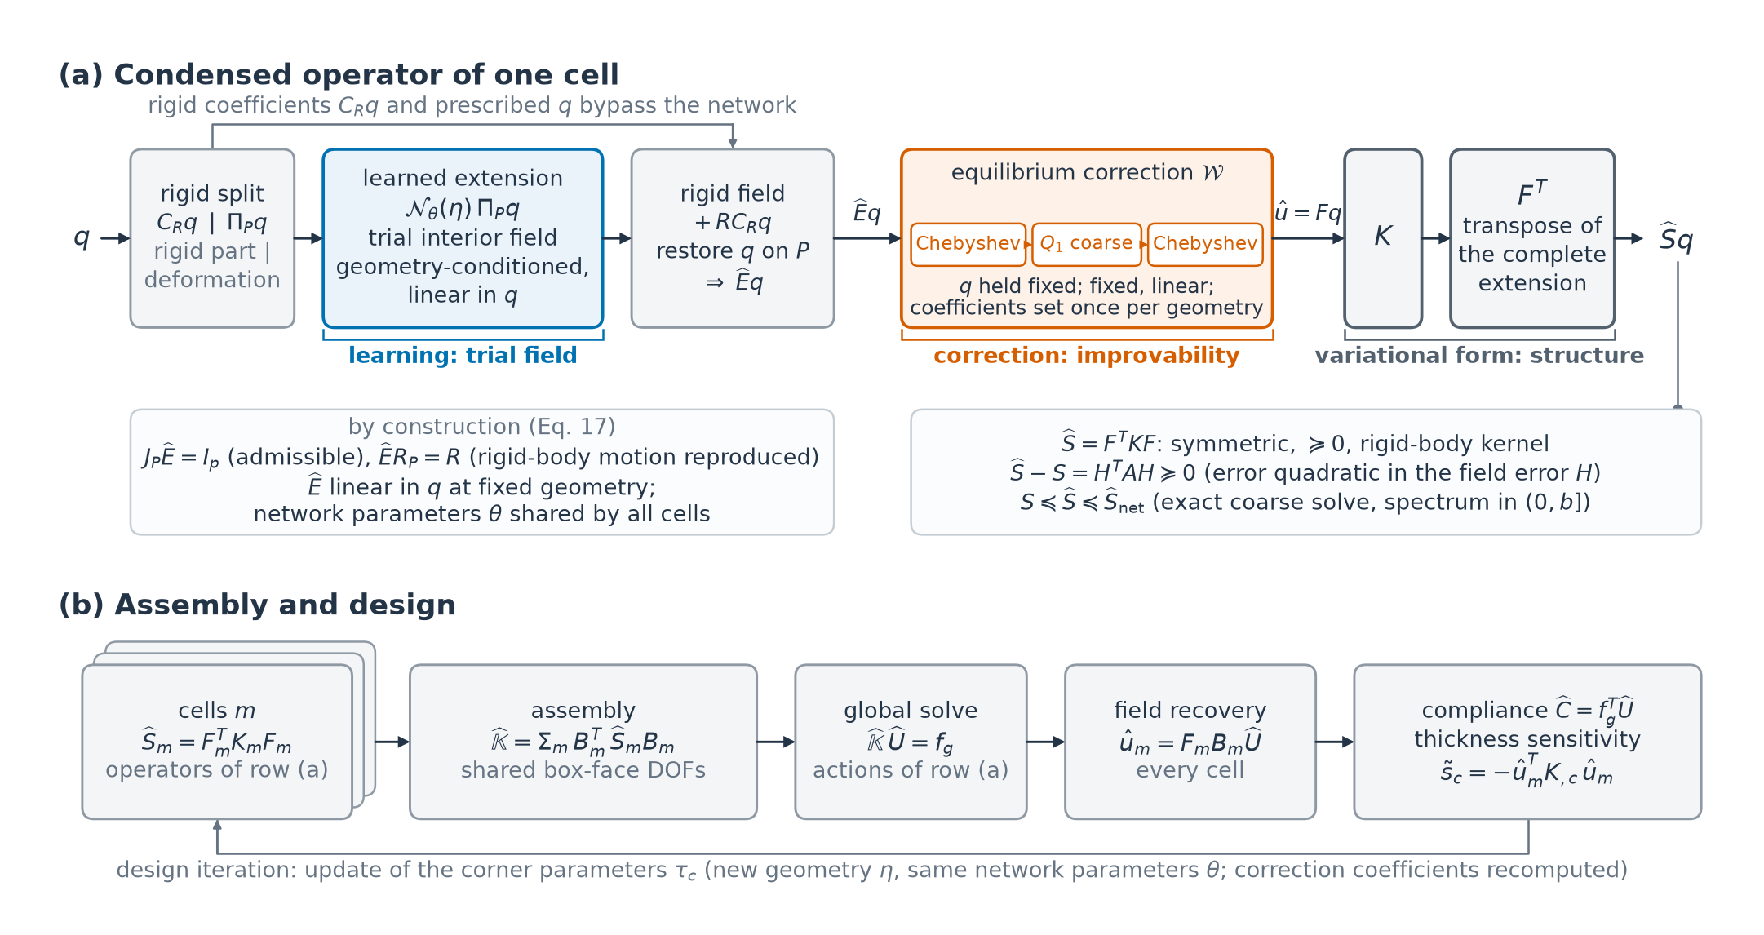
Figure 2. Learned displacement extension, equilibrium correction and variational assembly. (a) Rigid-body motion is separated from the retained displacement before the deformation is extended by the network. The rigid field is reconstructed and the prescribed retained values are restored; the correction $W$ then reduces interior imbalance at fixed retained displacement, and applying the local stiffness and the transpose $F^{T}$ of the complete extension gives the work-conjugate retained force. The ordering in (a) assumes an exact coarse-grid correction and a smoothing interval whose upper end bounds the spectrum; it orders the energy error, not the sensitivity error. (b) The cell operators are assembled on the shared box-face DOFs and the assembled system is solved; the assembled solution supplies the inputs for local field recovery, the compliance and the field-based thickness sensitivity. A design iteration updates the corner thickness parameters and so regenerates every cell's geometry; the network parameters stay the same and the coefficients of $W$ are recomputed.

4.1. Variational condensed stiffness
Let $\hat{E}$ be an admissible extension, $J_{P}\hat{E}=I_{p}$, that reproduces rigid-body motion, $\hat{E}R_{P}=R$ for the rigid-body modes $R$ of Section 2.2; Section 4.4 constructs it with a geometry-conditioned network (Eq. (17)). The extension becomes a mechanical operator through the energy, under the original stiffness, of the field it produces. Let the interior correction $W$ be one two-grid cycle (Chebyshev smoothing, coarse-grid Galerkin correction and smoothing; Sections 4.2 and 4.3) at fixed retained displacement; it is the equilibrium correction of the method's name. It is linear and preserves retained values, and the identity corresponds to no correction. For each geometry, the correction schedule and its coefficients are fixed independently of the retained displacement. The final extension and its condensed stiffness are
$$F=W\hat{E}, \hat{S}=F^{T}KF, \hat{U}(q)=1/2q^{T}\hat{S}q, {\hat{f}}_{P}=\hat{S}q. (11)$$
For a virtual retained displacement $δq$, the corresponding full virtual field is $Fδq$, and $δ\hat{U}=(Fδq)^{T}KFq=δq^{T}F^{T}KFq$. Applying the condensed operator therefore requires, after the stiffness action, the transpose $F^{T}$ of the complete extension (rigid reconstruction, retained-value restoration and correction included). With $F_{I}=J_{I}F$, the condensed action has the block form
$$\hat{S}q=(KFq)_{P}+F_{I}^{T}(KFq)_{I}. (12)$$
The second term transfers the work of the interior residual to the retained DOFs. It vanishes for an equilibrated field; otherwise it is needed for the returned force to be the derivative of the stated energy. Symmetry and positive semidefiniteness follow from $K=K^{T}≽0$, without requiring symmetry of the learned gather, scatter or grid-transfer maps. Under the assumption of Section 2.2 on the rigid-body kernel and $FR_{P}=R$, the only null modes of $\hat{S}$ are the retained rigid-body modes (Appendix B); Appendix E derives the transpose $F^{T}$, and Appendix B.2 shows why it makes the operator error quadratic. By Eq. (4), $\hat{S}−S=H^{T}AH$ with $H=J_{I}(F−E)$: the operator error is the energy of the interior error of $F$, which Sections 4.2 and 4.3 reduce. After an assembled solve, $F_{m}B_{m}\hat{U}$ supplies the local reconstructed displacement for response and sensitivity evaluation.

4.2. Error spectrum and Chebyshev smoothing
Equations (5) and (6) suggest reducing the interior imbalance of the learned field at fixed retained motion; polynomial smoothing Adams et al. (2003) and coarse energy minimisation address different components of it.
Set $D=diag(A)$ and order the generalised eigenvectors by increasing eigenvalue, $Av_{j}=λ_{j}Dv_{j}$, with $v_{j}^{T}Dv_{k}=δ_{jk}$. For $c_{j}=v_{j}^{T}Dd_{I}$,
dITAdI=j​λjcj2, χℓ(q)=j=1ℓλjcj2dITAdI. (13)
The fraction $χ_{ℓ}$ locates the error energy in the first $ℓ$ Jacobi-scaled interior modes (the exact-field fraction uses $u_{I}^{T}Au_{I}$).
The learned field is an initial approximation to $Au_{I}=−K_{IP}q$, improved by Jacobi-preconditioned Chebyshev semi-iteration Golub & Varga (1961) with $q$ fixed; a prescribed iteration count and geometry-dependent coefficients keep the corrected extension linear. Pairing a learned start with smoothing in this way mirrors smoothed-aggregation prolongation Vaněk et al. (1996) and of hybrid solvers in which relaxation removes the high-frequency error that a learned prediction leaves Zhang, E. et al. (2024).
A degree-$k$ error polynomial maps $d_{I}$ to $Φ_{k}d_{I}$, $Φ_{k}=p_{k}(D^{−1}A)$, multiplying each coefficient in Eq. (13) by $p_{k}(λ_{j})$. The Chebyshev polynomial targets $[a,b]$, $0<a<b$, and is nonexpansive in the $A$-energy norm if the actual positive spectrum of $D^{−1/2}AD^{−1/2}$ lies in $(0,b]$. Modes below $a$ can decay slowly, which motivates a complementary coarse-grid correction. The correction sequences use $a=b/30$, with $b$ from a power estimate increased by 5%; Section 5.2 reports its verification, and Appendix D gives the polynomial, recurrence, interval estimator and contraction bound.

4.3. Coarse-grid correction
Let $V∈R^{i×n_{c}}$ have full column rank, $A_{c}=V^{T}AV$, and $b_{r}=V^{T}r_{I}$. Minimising the energy over ${\hat{u}}_{I}+rangeV$, with ${\hat{u}}_{I}$ the current approximate interior field (the learned field or a smoothed iterate) and $r_{I}=(K\hat{u})_{I}$ its interior residual, gives
$${\hat{u}}_{I}^{c}={\hat{u}}_{I}−VA_{c}^{−1}b_{r}, d_{I}^{c}=(I_{i}−VA_{c}^{−1}V^{T}A)d_{I}, ∥d_{I}∥_{A}^{2}−∥d_{I}^{c}∥_{A}^{2}=b_{r}^{T}A_{c}^{−1}b_{r}. (14)$$
The coarse-grid (Galerkin) correction enforces equilibrium against the coarse variations, and the last equality measures the energy removed by that projection Xu (1992). The principal coarse basis, denoted $Q_{1}(17)$, consists of trilinear vector functions on a ${17}^{3}$-vertex grid restricted to interior DOFs (Appendix F.1); all coarse spaces act on interior DOFs only, so the retained values stay fixed.
Placing the coarse-grid correction between two $k$-step smoothing stages combines these corrections into one two-grid cycle, the correction $W$ of Section 4.1. With $C_{V}=I_{i}−VA_{c}^{−1}V^{T}A$ and $H_{net}=J_{I}(\hat{E}−E)$, the two-grid error operator $Φ_{k}C_{V}Φ_{k}$ Hackbusch (1985), Trottenberg et al. (2001), Xu & Zikatanov (2002), Falgout et al. (2005) gives the interior error of $F$ and, by Eq. (4), the operator error
$$H=Φ_{k}C_{V}Φ_{k}H_{net}, \hat{S}−S=H^{T}AH. (15)$$
If the coarse-grid correction is exact and $∥Φ_{k}∥_{A}≤1$, then $S≼\hat{S}≼{\hat{S}}_{net}$, where ${\hat{S}}_{net}={\hat{E}}^{T}K\hat{E}$ is the uncorrected condensed stiffness. The correction therefore cannot increase the error in the $A$-energy norm, and by the order reversal of Appendix C it moves the assembled compliance toward the reference (Appendix D.1). The ordering is guaranteed; the size of the reduction is not (Appendix D), and Section 5.5 measures it. The ordering does not extend to the sensitivity error of Eq. (9) (Appendix D.1), and changing the smoothing degree changes the polynomial, so the reduction need not be monotone in $k$.

4.4. Geometry-conditioned multilevel displacement extension
The learning target is the interior equilibrium map $q↦E_{I}q=−A^{−1}K_{IP}q$, whose approximation provides both a displacement field and, through its energy, the condensed operator on the complete retained space. The architecture must adapt to the material and support of each cell and respect superposition at fixed geometry. The retained set has 2,679 to 45,900 DOFs and changes with the cut, so neither an extension matrix formed for every geometry, at one interior solve per retained DOF, nor a network with an output for each retained DOF is available. This leads to a nonlinear geometry branch coupled to a linear, multilevel displacement branch whose weights act on stencils, channels and grid levels (Figure 3).
Rigid-body motion is separated before learning. We take for the columns of $R$ three translations and three rotations about a common centre. The coefficient extractor $C_{R}=(R_{P}^{T}R_{P})^{−1}R_{P}^{T}$ and projector $Π_{P}=I_{p}−R_{P}C_{R}$ decompose the input into rigid coefficients $C_{R}q$ and retained deformation $q_{d}=Π_{P}q$. The network extends only $q_{d}$, so rigid reconstruction is independent of training accuracy.
In the geometry branch, element moments resolve the material distribution within each background element, and node features identify retained and cut-band membership, weak support (a diagonal stiffness block below 1% of the median over active nodes; Appendix G), local stiffness magnitude and position. Encoders form element and node feature vectors, which exchange information in two rounds; coefficient heads (small output networks) then assign weights to prescribed element and ghost-face incidences, to transfers between latent grids and to coarse-grid convolutions. These coefficients are fixed for all displacement directions on the same geometry.
The displacement branch lifts the three components of $q_{d}$ to 32 channels on retained nodes, with the interior features set to zero, defining $X^{0}(q)$. Local interactions propagate these values through the element and ghost-face neighbourhoods: each gathers the features on a 27-slot stencil into four weighted heads, mixes the channels within each head and scatters the result back to the incident nodes. With interior and retained masks $M_{I},M_{P}$ acting on nodal rows, an interaction updates the latent field by
Xℓ+1=MIXℓ+h​Sℓh(η)(Gℓh(η)XℓWℓh)+MPX0(q). (16)
Here $G_{ℓh}$ and $S_{ℓh}$ are geometry-weighted gather and scatter maps, $W_{ℓh}$ mixes channels, and the final term restores the retained features. A U-shaped latent hierarchy through grids with 65, 33, 17 and 9 positions per axis supplies longer-range communication; pairs of local interactions before and after it, and further pairs on stencils containing weakly supported nodes, complete the branch, and a linear map reconstructs nodal displacement (Figure 3b,c). The weights act on stencils, channels and grid levels rather than on individual DOFs, so the same network, of about $6×{10}^{5}$ parameters (Table ST15), serves every retained set. Appendix G gives the complete order of operations and coefficient definitions.
Every displacement operation is linear, and the nonlinear encoders act only on geometry, so the raw map $N_{θ}(η)$, with network parameters $θ$, obeys superposition at fixed $η$. Adding back the rigid field and restoring the original retained values gives
$$\hat{E}q=J_{P}^{T}q+J_{I}^{T}J_{I}\left[RC_{R}q+N_{θ}(η)Π_{P}q\right]. (17)$$
Consequently, $J_{P}\hat{E}=I_{p}$ and $\hat{E}R_{P}=R$: admissibility and rigid reproduction hold by construction.
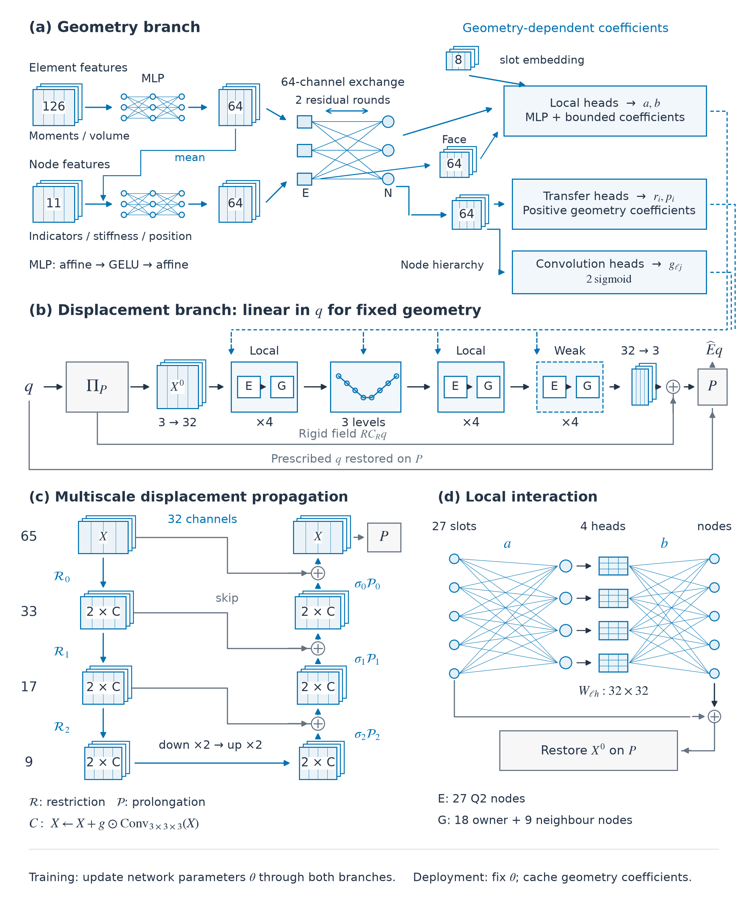
Figure 3. Geometry-conditioned neural displacement architecture. (a) Element and node encoders produce 64-channel geometry feature vectors, followed by two rounds of residual exchange; coefficient heads condition the local interactions, grid transfers and convolutions. (b) The displacement branch propagates the nonrigid retained input through four local interaction pairs, the multilevel block, four further local pairs and four pairs on weakly supported stencils; linear maps connect the three displacement components to 32 latent channels, and deterministic bypasses reconstruct rigid-body motion and restore the retained values. (c) Restriction and prolongation connect grids with 65, 33, 17 and 9 background positions per axis; each coarse level has two residual convolutions on each pass. (d) A local interaction uses geometry-weighted gathering, four channel-mixing heads and scattering, followed by residual addition and retained-value restoration. E and G denote element and ghost-face interactions. Blue dashed arrows carry geometry-dependent coefficients; solid arrows carry features or displacement states. For fixed geometry, the complete displacement path is linear.

4.5. Training directions and objective
Training probes the extension through retained displacement directions: prescribed polynomial and multiscale displacements supply broad spatial content, and responses to equilibrated nodal loads, consistent tractions, spring supports and neighbouring cells supply mechanically generated directions. Rigid components are removed and each direction is normalised to $q_{j}^{T}Sq_{j}=1$ with the reference solution. For a batch of $B$ directions, the objective is
L(θ)=1Bj=1Blog(qjTSqj)+ws1|Js|j∈Js​∥sj−sj∥22∥sj∥22. (18)
The energy term is the mean logarithm of the predicted-to-reference energy ratio. For an admissible extension, the variational identity of Section 3.1 makes its minimum correspond to the equilibrium field on each sampled direction, a Ritz principle. The sensitivity term compares the field-based thickness sensitivities (eight-component vectors) on the set $J_{s}$ of directions with reference sensitivity labels; the reported configurations use $w_{s}=1$. Gradients with respect to $θ$ pass through the reconstructed field to the geometry encoders, coefficient heads and linear displacement maps. Directions with large energy ratios, found by a block search on the rigid complement, are added during training, and geometry augmentation uses the 48 cube symmetries (Appendix G). Table 2 identifies the variants and Table ST01 records the training and model-selection settings.
NICE is trained on the operator that is deployed: Eq. (18) is evaluated on the corrected extension $F=W\hat{E}$, with eight Chebyshev steps before and after the $Q_{1}(17)$ coarse-grid correction of Section 4.3 (written 8 / $Q_{1}(17)$ / 8; Table 1). Because $W$ is linear and fixed for a given geometry, the gradient passes through the smoothing recurrence and the coarse-grid correction to the network parameters, as in solver-in-the-loop training Um et al. (2020). The smoothing interval and coarse factorisation depend only on $K$ and are recomputed per geometry, so no trainable parameters are added.

4.6. Application of the condensed operator
Geometry-dependent quantities are prepared once per geometry and reused across retained inputs: the element moments, the network's geometry encoding, coefficients and maps, the smoothing interval and the coarse factorisation (Table ST13 gives their cost). Each application of $\hat{S}$ then requires one network pass, $2k$ smoothing steps, one coarse solve and the transposed sequence (Appendices E–F). Neither $\hat{E}$ nor $\hat{S}$ is formed: a cell stores its geometry-dependent coefficients and coarse factorisation, whereas a dense $\hat{S}$ of a cell of median retained size, $2.4×{10}^{4}$ DOFs, would take 4.3 GiB in double precision.
Algorithm 1. Corrected condensed stiffness action.
- Extend $q$ with $\hat{E}$ and apply the prescribed pre-smoothing, coarse-grid correction and post-smoothing sequence at fixed retained values to obtain $\hat{u}=Fq$.
- Form $y=K\hat{u}$ and return $F^{T}y$: transpose the complete correction in reverse order, followed by the transposed learned extension.
- Assemble these actions through Eq. (3); after the global solve, recover $F_{m}B_{m}\hat{U}$ for field and sensitivity evaluation.

5. Numerical examples
The examples follow the error of the learned extension from single cells, through its correction, to the assembled response and to design. Sections 5.1 and 5.2 define the geometries, variants and loads and verify the discrete reference and the deployed operator. Sections 5.3–5.5 examine the operator of a single cell: its dependence on geometry and loading, the components of its error, and what the correction removes at fixed network parameters. Sections 5.6–5.7 examine the assembled response: compliance and local sensitivity in two-cell configurations, energy share, and an ablation of the retained representation. Sections 5.8 and 5.9 assemble lattices in which every cell is learned and compare their cost with the whole-lattice direct solution and conventional exact condensation, and Section 5.10 optimises thickness fields with the operator and verifies the designs against exact condensation.

5.1. Geometries, variants and loading conditions
The 80 validation geometries comprise 20 uncut, 20 lightly, 20 moderately and 20 heavily cut cells, with uniform, affine or mixed trilinear thickness fields and corner parameters from 0.1762 to 0.6983 (Table ST02). Each carries at most one planar cut with normal $(cosϑ,sinϑ,0)$, $0<ϑ<π/4$; heavy cuts retain less than one third of the volume of the cell box, moderate cuts between one and two thirds, and light cuts more than two thirds. U, L, M and H identify the uncut, lightly, moderately and heavily cut cells used for detailed comparisons (U1, U2, L1, M1, M2 and H1–H3; Supplementary R1). Table 1 lists the discretisation and correction settings.
Each validation geometry is probed with retained displacement directions from the nine validation classes of Table ST03 (defined in Appendix G.2): imposed polynomial and multiscale displacements, equilibrated nodal forces and consistent tractions on all faces or on a single face, spring-supported responses and traces induced by a neighbouring cell. Consistent tractions (64 directions per geometry), which represent surface loads and neighbour tractions, are the principal loading class; equal nodal forces also load weakly supported nodes and serve as a stress test of the stabilised problem: in the five cells of Table ST04 the ghost penalty carries on average less than 0.05% of the exact field energy under consistent tractions, but 49–81% under equal nodal forces.
Table 1. Discretisation and correction settings
Quantity | Setting
Reference geometry | Unit box; Schwarz-P-type implicit band with trilinear corner parameters and an optional planar cut
Displacement approximation | Continuous tensor-product $Q_{2}$ solid elements on a Cartesian background mesh
Background resolution, validation geometries | $n=32$ elements per axis; $65$ Q2 nodes per axis
Isotropic material, validation geometries | Normalised Young's modulus $E_{Y}=1$, Poisson's ratio $ν=0.3$
Ghost-penalty coefficient, validation geometries | $γ={10}^{−4}$
Retained space | Active box-face DOFs and all DOFs of active elements carrying a positive-area cut-surface patch
Standard volume integration | $4^{3}$ initial subcells; one local refinement of partial subcells; clipped Kuhn tetrahedra with quadrature-rule parameter 4
Smoothing interval | $[b/30,b]$, with $b$ equal to 1.05 times a 40-step power-iteration estimate of $λ_{max}(D^{−1}A)$ (Section 4.2)
Principal interior coarse space | Trilinear vector functions on a ${17}^{3}$-vertex grid, restricted to the interior DOFs
Thickness-difference step | $h_{c}={10}^{−5}τ_{c}$, with fixed active DOFs and ghost contribution
Correction of NICE | 8 Chebyshev steps, $Q_{1}(17)$ coarse-grid Galerkin correction, 8 Chebyshev steps; same sequence in training and evaluation
Arithmetic | Network in single precision; stiffness actions and energies in double precision; correction in double precision in the accuracy studies and in single precision in the timed route of Table 5 and in the optimisations of Section 5.10 (Appendix F.2)
The mesh, material and stabilisation entries apply to all 80 validation geometries; lengths are relative to the unit box and the modulus is normalised. Coarse dimensions and smoothing counts of other correction sequences are reported with their comparisons.
Four variants are compared (Table 2). The base network was trained without correction. Three networks continue it for 15,000 training steps: with the complete correction $W$ of Sections 4.2 and 4.3 inside the training loop (NICE, Section 4.5), with eight smoothing steps and no coarse-grid correction in every training step (Smoothing-trained), or without correction (Uncorrected, referred to in the text as the Uncorrected continuation).
Table 2. Variants compared in the numerical examples
Variant | Network parameters | Training set (geometries) | Correction in training | Correction at evaluation
NICE | Base network continued for 15,000 training steps | 591 | 8 / $Q_{1}(17)$ / 8 | 8 / $Q_{1}(17)$ / 8
Smoothing-trained | Base network continued for 15,000 training steps | 591 | 8 smoothing steps | 8 smoothing steps
Uncorrected | Base network continued for 15,000 training steps | 591 | None | None
Base network | 40,000 training steps, selected at 30,000 | 305 | None | None
The base network with the correction $W$ applied at deployment, without retraining, is also evaluated and denoted 'Base network, corrected' (Sections 5.3, 5.5 and 5.6).
All variants share the architecture of Section 4 (about $6×{10}^{5}$ trainable parameters; Table ST15). The three continuations draw from the same set of 591 geometries, which contains 304 of the base network's 305 training geometries, and see the same geometries in the same order (Table ST01). On one RTX 5090 GPU, training the base network took 4.6 h and NICE's continuation 3.5 h, and generating the directions and exact sensitivities of the 691 training and validation geometries took about 42 GPU-hours; data generation, training and model selection together took about 60 GPU-hours (Table ST01).
Twenty of the 80 validation geometries (6 uncut, 14 cut) were used for checkpoint selection (Table ST01); statistics are therefore also given for the 60 geometries outside selection. The target cells of the two-cell assemblies of Section 5.6 belong to these 20 selection geometries; nine further cells outside selection are assembled there as an independent check. Population statistics average the directional energy error within each geometry and loading class and weight geometries equally (Appendix A.1), so the population maximum is the largest geometry mean.

5.2. Verification of the discrete reference and of the corrected operator
The $n=32$ reference was verified by refinement on seven cells, to $n=40$ for U1 and to $n=48$ for M1 and M2 (Figure S01), and to $n=64$ for H1, H2 and two further validation cells (Table ST10; Supplementary Note S1): the compliance of uncut and moderately cut cells changes by at most 0.14% and their thickness sensitivities by at most 0.23%, whereas for the heavily cut cells the changes reach up to about 1% in compliance and 3.6% in sensitivity, both in H2. Varying the ghost-penalty coefficient between ${10}^{−5}$ and ${10}^{−3}$ and refining the volume integration change compliance and sensitivities by at most 0.12%, and the finite-difference stiffness derivative and its step are verified in Supplementary Note S1 (Figure S01(c)). All comparisons that follow are made against this discrete reference (Section 2.1).
We checked the deployed operator on U2, M1, M2, H1 and H2 with the arithmetic of Table 1, over the first eight consistent-traction validation directions of each cell. The bilinear form $q_{i}^{T}\hat{S}q_{j}$ is symmetric to a relative $9×{10}^{−9}$. The returned work $q^{T}\hat{S}q$ agrees with the recovered-field energy $q^{T}F^{T}KFq$ to $5×{10}^{−9}$. The deployed operator reproduces the training-time field to $1.1×{10}^{−7}$. Normalised rigid-body modes carry at most $2×{10}^{−11}$ of a typical deformation energy. Over the first eight nodal-force directions, the asymmetry, the work–energy difference and the rigid-body energy ratio are at most $3×{10}^{−8}$, $2×{10}^{−8}$ and $1×{10}^{−10}$ (Table ST04).
The nonexpansiveness of Section 4.2 requires $b≥λ_{max}(D^{−1}A)$. On all 80 validation geometries the power-iteration endpoint exceeds the converged largest eigenvalue by 2.1–5.0% (Appendix D), whereas the guaranteed Gershgorin bound is 4.7 to 19.4 times larger (median 18.4) and would place the smoothing interval far above the actual spectrum. The spectral condition is thus supported numerically on these geometries; it was not checked for the cells of the lattices and optimisations of Sections 5.8–5.10, which use the same power-iteration estimate. Symmetry, positive semidefiniteness and $\hat{S}≽S$ do not depend on it.

5.3. Dependence on geometry and loading
NICE's stratum-mean errors are 64 to 102 times lower than those of the Uncorrected continuation, although its error still grows about sevenfold from uncut to heavily cut cells (Figure 4). Under consistent tractions, NICE's mean directional energy errors in the uncut, lightly, moderately and heavily cut strata are 0.016%, 0.079%, 0.091% and 0.109%, and those of the Uncorrected continuation 1.03%, 5.33%, 7.82% and 11.2% (Supplementary Table ST03b). Over all 80 geometries the mean is 0.074% for NICE, 6.33% for the Uncorrected continuation and 6.89% for the base network, and the largest geometry means are 0.65%, 42% and 48.6%. Taken direction by direction, NICE's errors over the 5,120 sampled consistent-traction directions have a 95th percentile of 0.33%, a 99th percentile of 0.69% and a maximum of 1.24% (0.35%, 0.73% and 1.24% on the 60 geometries outside checkpoint selection).
Under the other loading classes, NICE's mean is 0.060% for neighbour-induced displacements (largest 0.38%) and 0.057% for stiffness-scaled spring supports (0.47%); for single-face nodal forces its largest geometry mean is 0.72% (Table ST03; per-geometry distributions in Figure S02). Under nodal forces, the base network's mean rises from 0.908% in uncut to 11.3% in heavily cut cells (largest 70.1%), whereas NICE's stratum means stay between 0.013% and 0.090% (largest 0.325%). On the 60 geometries outside selection, NICE's overall means are essentially unchanged (0.077% under consistent tractions, 0.059% under nodal forces), but under consistent tractions its cut-stratum means are higher (0.105% moderate, 0.126% heavy) and the five largest geometry means all belong to these 60 geometries (Supplementary Table ST03).
The intermediate variants locate this improvement. Continuing the base network without correction changes its mean only from 6.89% to 6.33%, and Smoothing-trained reaches 1.28% (largest 7.8%). Applying the correction to the base network without retraining already gives 0.0965% (largest 0.91%), so most of the improvement comes from the correction itself; the NICE continuation, which also adds training and widens the training pool, lowers the mean by a further factor of 1.31 (95% bootstrap interval over geometries 1.20–1.40; Supplementary Table ST03).
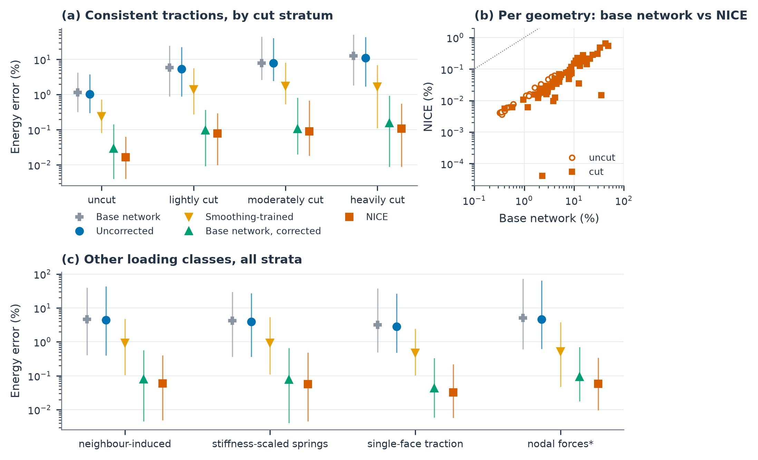
Figure 4. Directional energy error of the learned substructures on the 80 validation geometries. Each observation is a geometry's mean directional energy error $q^{T}(\hat{S}−S)q/(q^{T}Sq)$ over the validation directions of a loading class. (a) Consistent tractions, 20 geometries per cut stratum: markers give the mean over geometries and bars the range from the 10th percentile to the maximum. (b) Geometry means of the base network and of NICE under consistent tractions, open markers for uncut and filled markers for cut geometries; the dotted line denotes equality. (c) Neighbour-induced retained displacements, stiffness-scaled spring supports, single-face consistent tractions and equal nodal forces (75 geometries for the first two classes, 80 for the others); the asterisk marks the nodal-force stress test. Twenty geometries (6 uncut, 14 cut) were used for checkpoint selection. Variants as in Table 2; 'Base network, corrected' is the base network with the correction applied at deployment.

5.4. Components of the extension error
Before the correction is applied, the error of the learned extension is examined in four ways: where it lies in the interior spectrum, where it lies in space, why an interior displacement error of about one percent becomes an energy error of several percent, and how its effect on the sensitivity divides between the linear and quadratic terms of Eq. (9). The base network's error occupies different parts of the Jacobi-scaled interior spectrum in different cells (Figure 5). Under consistent tractions on M1, the lowest 200 modes contain 24.5% of the error energy but only 4.87% of the exact-field energy, and all lie below the lower endpoint $a=0.173$ of the smoothing interval ($a=b/30$, Table 1); in H2 only 66 of the 200 modes lie below $a=0.138$. Smoothing damps these modes slowly, which leaves them to the coarse-grid correction (Section 5.5, Table ST05b).
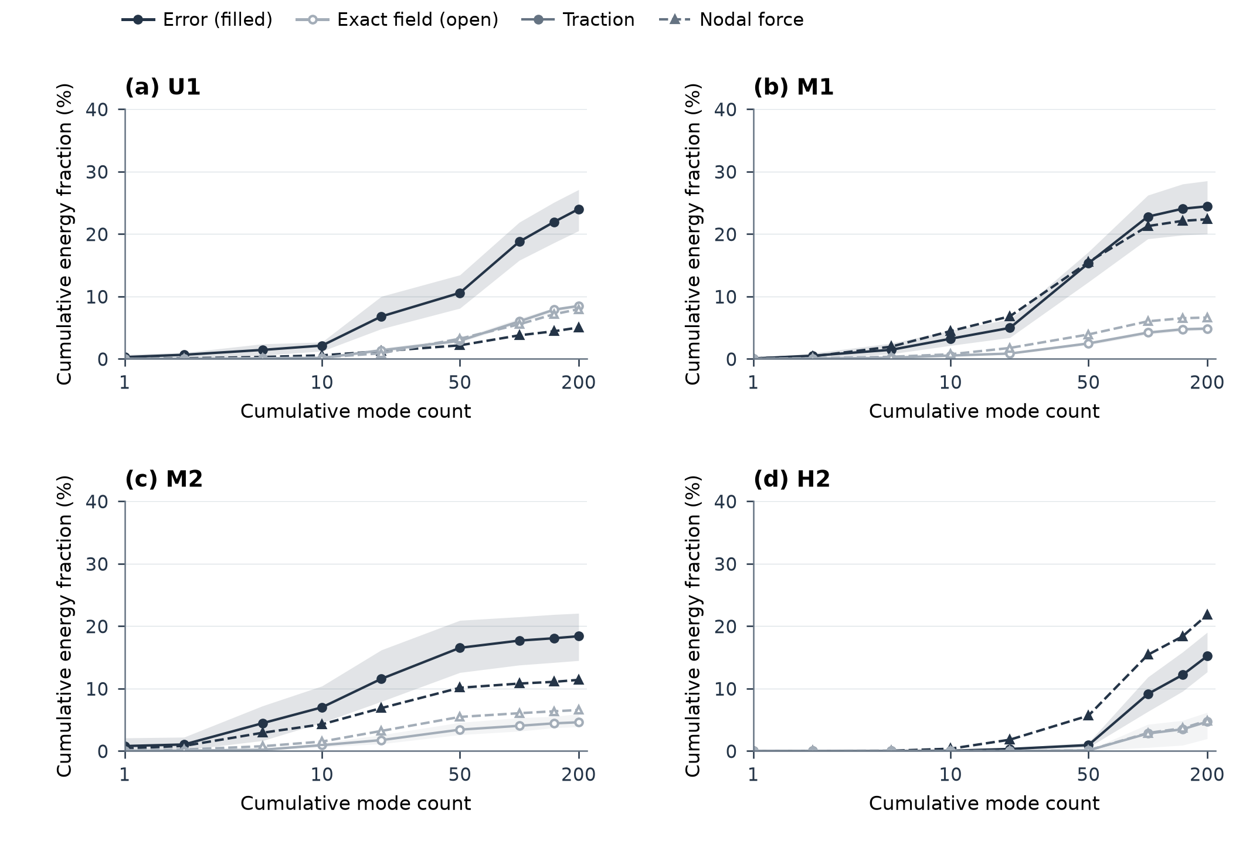
Figure 5. Spectral distribution of the base network's extension error. Panels show U1, M1, M2 and H2 for the base network. Modes solve $Av=λDv$, with $D=diag(A)$, ordered by increasing eigenvalue. Filled dark markers represent the extension error and open light-grey markers the exact interior field; solid circles correspond to consistent tractions and dashed triangles to nodal forces. Curves are directional means; bands give the 10th–90th directional percentiles under consistent tractions. Each cumulative fraction uses the total interior energy of its own field or error.
Spatially (Figure 6), for the plotted consistent-traction direction the exact field of M1 places 8% of its energy in the elements within two element widths of the cut plane, which are 13% of the elements; over the four directions evaluated, 39–43% of the base network's error energy lies there, next to the retained cut-band DOFs whose values the extension must propagate. Relative to the base network, NICE reduces the total error energy by about two orders of magnitude (113–138 times) and the element error energies by roughly 25 to 300 times (10th–90th percentiles), and halves the share of this layer to 19–22%.
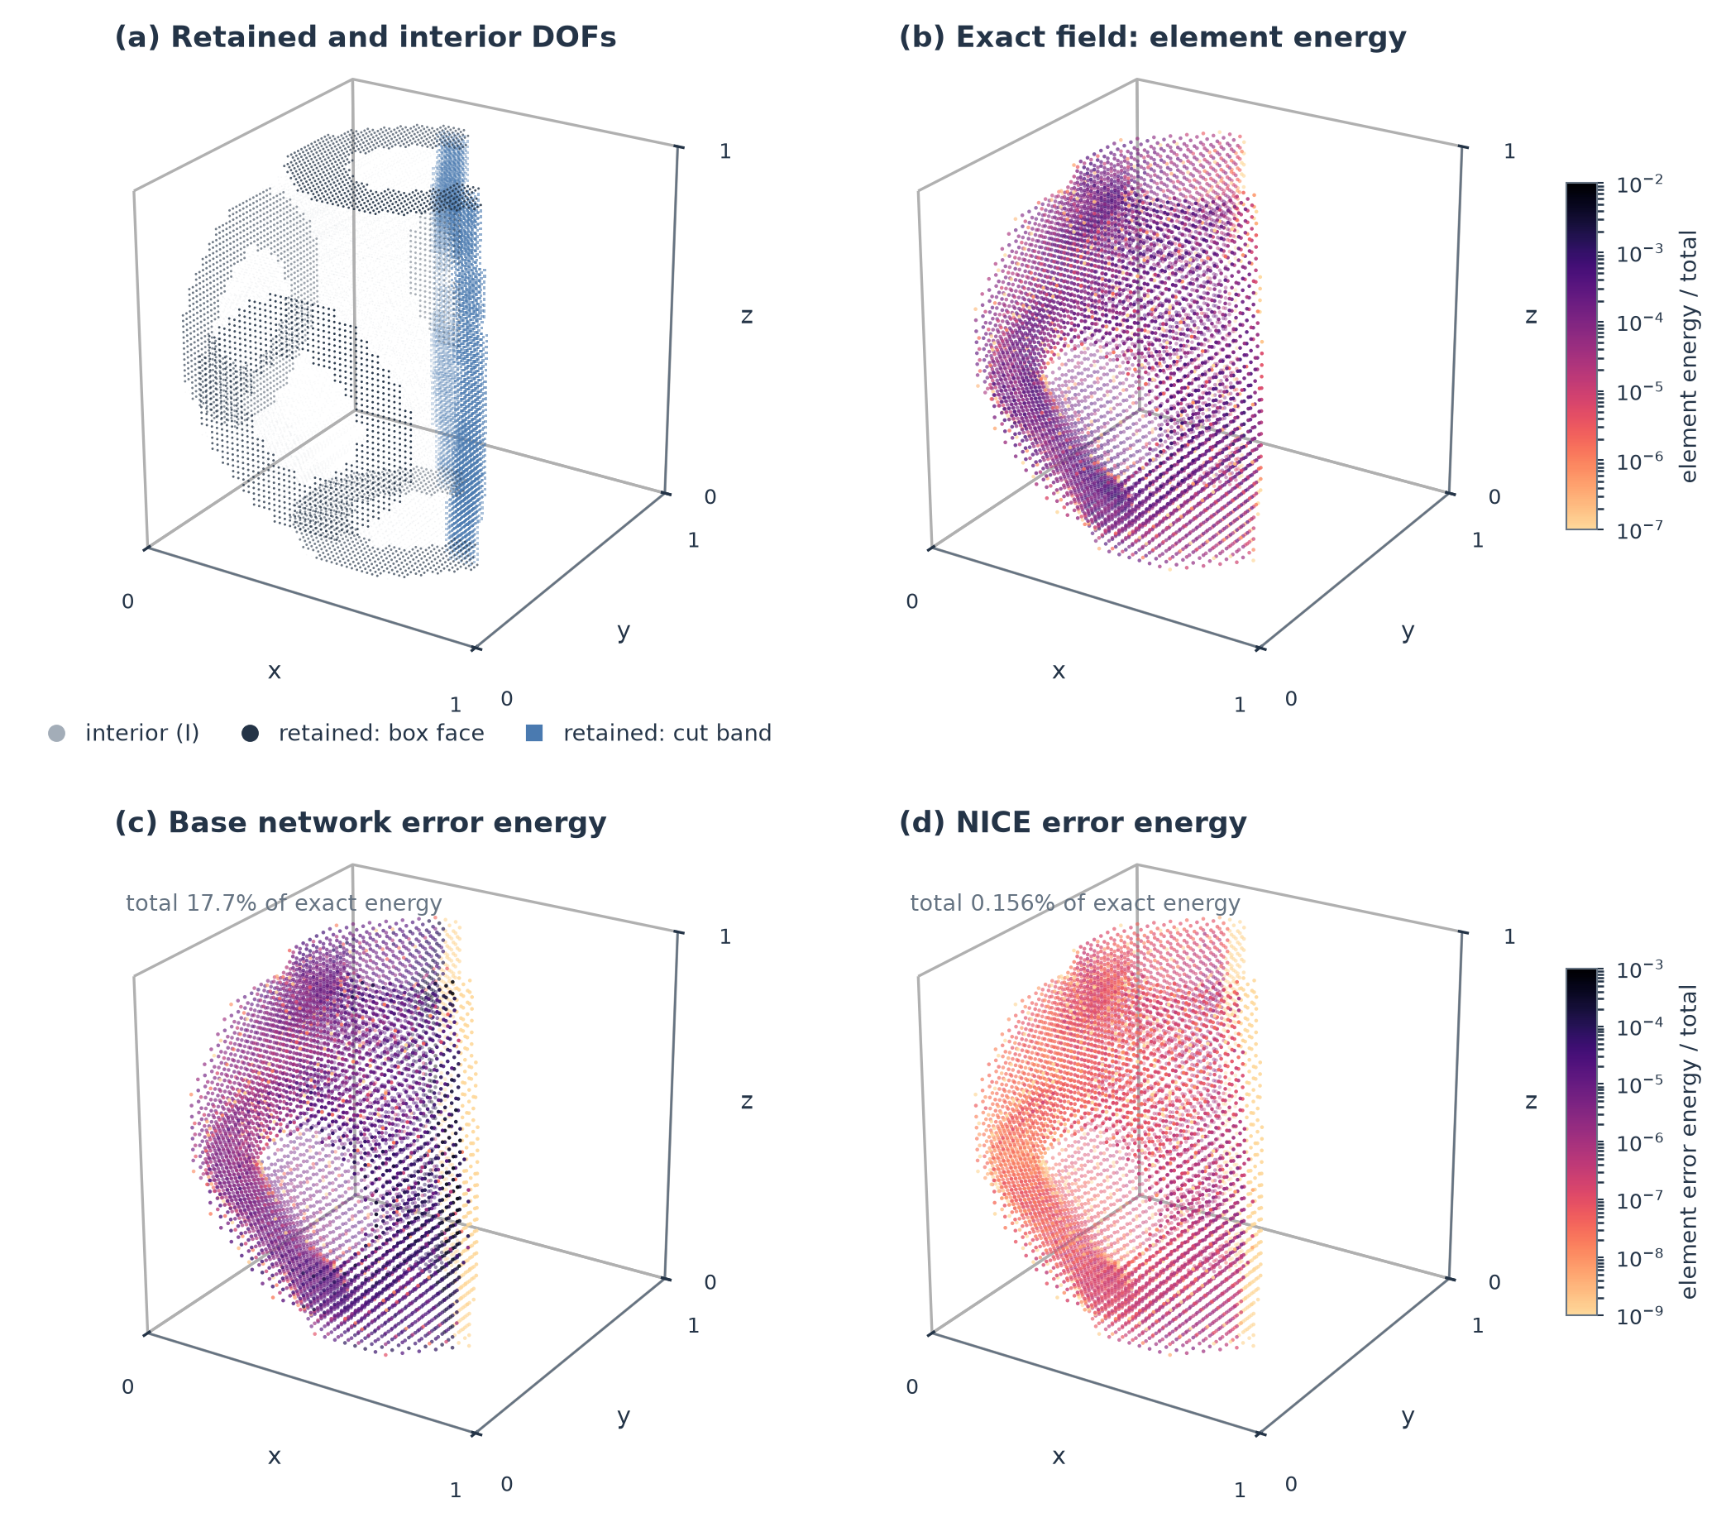
Figure 6. Retained DOFs and spatial distribution of the extension error in M1. (a) Retained box-face DOFs, retained cut-band DOFs and interior DOFs. (b) Bulk element energies of the exact field under one consistent-traction direction, relative to its total. (c,d) Bulk element energies of the error of the base network and of NICE for the same retained displacement, relative to the total energy of the exact field in (b), on a common colour scale. Cut-band elements carry no error because their DOFs are retained.
The size of these energy errors reflects a measurable amplification. For interior error $d_{I}$ and exact interior field $u_{I}$, let $δ^{2}=d_{I}^{T}Dd_{I}/u_{I}^{T}Du_{I}$ be the Jacobi-weighted relative displacement error and $κ=(d_{I}^{T}Ad_{I}/d_{I}^{T}Dd_{I})/(u^{T}Ku/u_{I}^{T}Du_{I})$ the ratio of the Rayleigh quotients of the interior error and of the exact field. Then $ε=δ^{2}κ$ holds exactly in every direction with nonzero interior error and nonzero exact interior field (Appendix B.3; values in Supplementary Table ST04). Under consistent tractions, the base network's fields in M1, M2, H1 and H2 have mean $δ$ of 0.7–1.3% but mean $κ$ of 124 to 7089: the displacement error is small but lies in directions far stiffer, relative to their amplitude, than the exact field, so that energy errors of 1.8–35% result. In the uncut U2 a similar $δ$ of 0.74% meets $κ=85$ and gives 0.40%; because $δ$, $κ$ and $ε$ are averaged over directions separately, the product of the means need not equal the mean error (0.47% against 0.40% here). NICE's fields have $δ$ of 0.05–0.19% and $κ$ of 33 to 582 in the cut cells (0.11% and 47 in U2).
Where the base network's errors are large, the quadratic term of Eq. (9) dominates. At fixed retained displacement, its mean energy and field-based sensitivity errors are 13.5% and 14.1% in M1 and 35.0% and 75.1% in H2, and the linear term contributes only 7.2% (M1) and 0.79% (H2) of the sum of the linear- and quadratic-term norms. The linear term is not negligible elsewhere: it contributes 28–43% under consistent tractions in U1, U2 and H1, whose energy errors are below 2%, and 24–72% under nodal forces in all six cells examined (U1, U2, M1, M2, H1 and H2); being first order in the field error, it dominates as that error tends to zero (Table ST05, Figure S03).

5.5. Reducing interior error with fixed network parameters
Holding the base network fixed isolates the effect of the correction (Figure 7). Eight Chebyshev steps at fixed retained displacement reduce the mean energy error everywhere, but unevenly (Table ST05a): under consistent tractions H2 falls from 35.0% to 0.205%, whereas M1 falls only from 13.5% to 4.69% (2.95% after 32 steps), because much of its error lies in modes below the smoothing interval (Section 5.4). M1's sensitivity error falls from 14.1% to 2.76%, whereas U1's sensitivity error varies non-monotonically with the number of steps although its energy error decreases at every step (Figure 7a,b).
A trilinear coarse-grid correction before the same eight steps brings M1 to 0.230%, and eight further pre-smoothing steps to 0.186%, with 5,601 coarse DOFs for 165,927 interior DOFs. Two, four and eight steps per stage give 1.02%, 0.422% and 0.186% on M1, and the eight-step cycle about 0.027% on M2 and U1 (Table ST07); other coarse spaces are compared in Table ST06.
Table 3 applies the same correction to four starting fields at the same retained displacements: a zero interior, a graph-harmonic extension (a volume-weighted graph Laplacian on the element connectivity, with the same exact rigid-body split), the base network's field and NICE. A zero interior leaves 28–1100% energy error and the harmonic start 0.08–17%, whereas the base network's field ends at 0.004–0.19%, lower by factors of 7 to 290 than the harmonic start and 2,400 to 12,000 than the zero interior. Even with 64 steps per stage, eight times the smoothing work, the harmonic start remains 2.6 to 50 times above the base network's eight-step result under consistent tractions in five of the six cells of Table ST07 (those of Table 3 and U1); only in H2 does it reach that result. The learned field thus supplies the part of the interior equilibrium that smoothing and the coarse space do not reach at a practical budget.
Table 3. Mean energy error (%) after the same 8 / $Q_{1}(17)$ / 8 correction applied to different starting fields (consistent tractions, 32 directions)
Cell | Base network, no correction | Zero interior | Harmonic | Base network, corrected | NICE
M1 | 13.5 | 1097 | 17.2 | 0.186 | 0.131
M2 | 3.64 | 324 | 6.72 | 0.0273 | 0.0358
H1 | 1.81 | 39.9 | 1.28 | 0.0131 | 0.0115
H2 | 35.0 | 28.3 | 0.0806 | 0.0117 | 0.0148
U2 | 0.402 | 47.2 | 1.23 | 0.00424 | 0.00465
The first column gives the base network's error without correction. Results with 16 to 64 smoothing steps per stage are given in Table ST07.
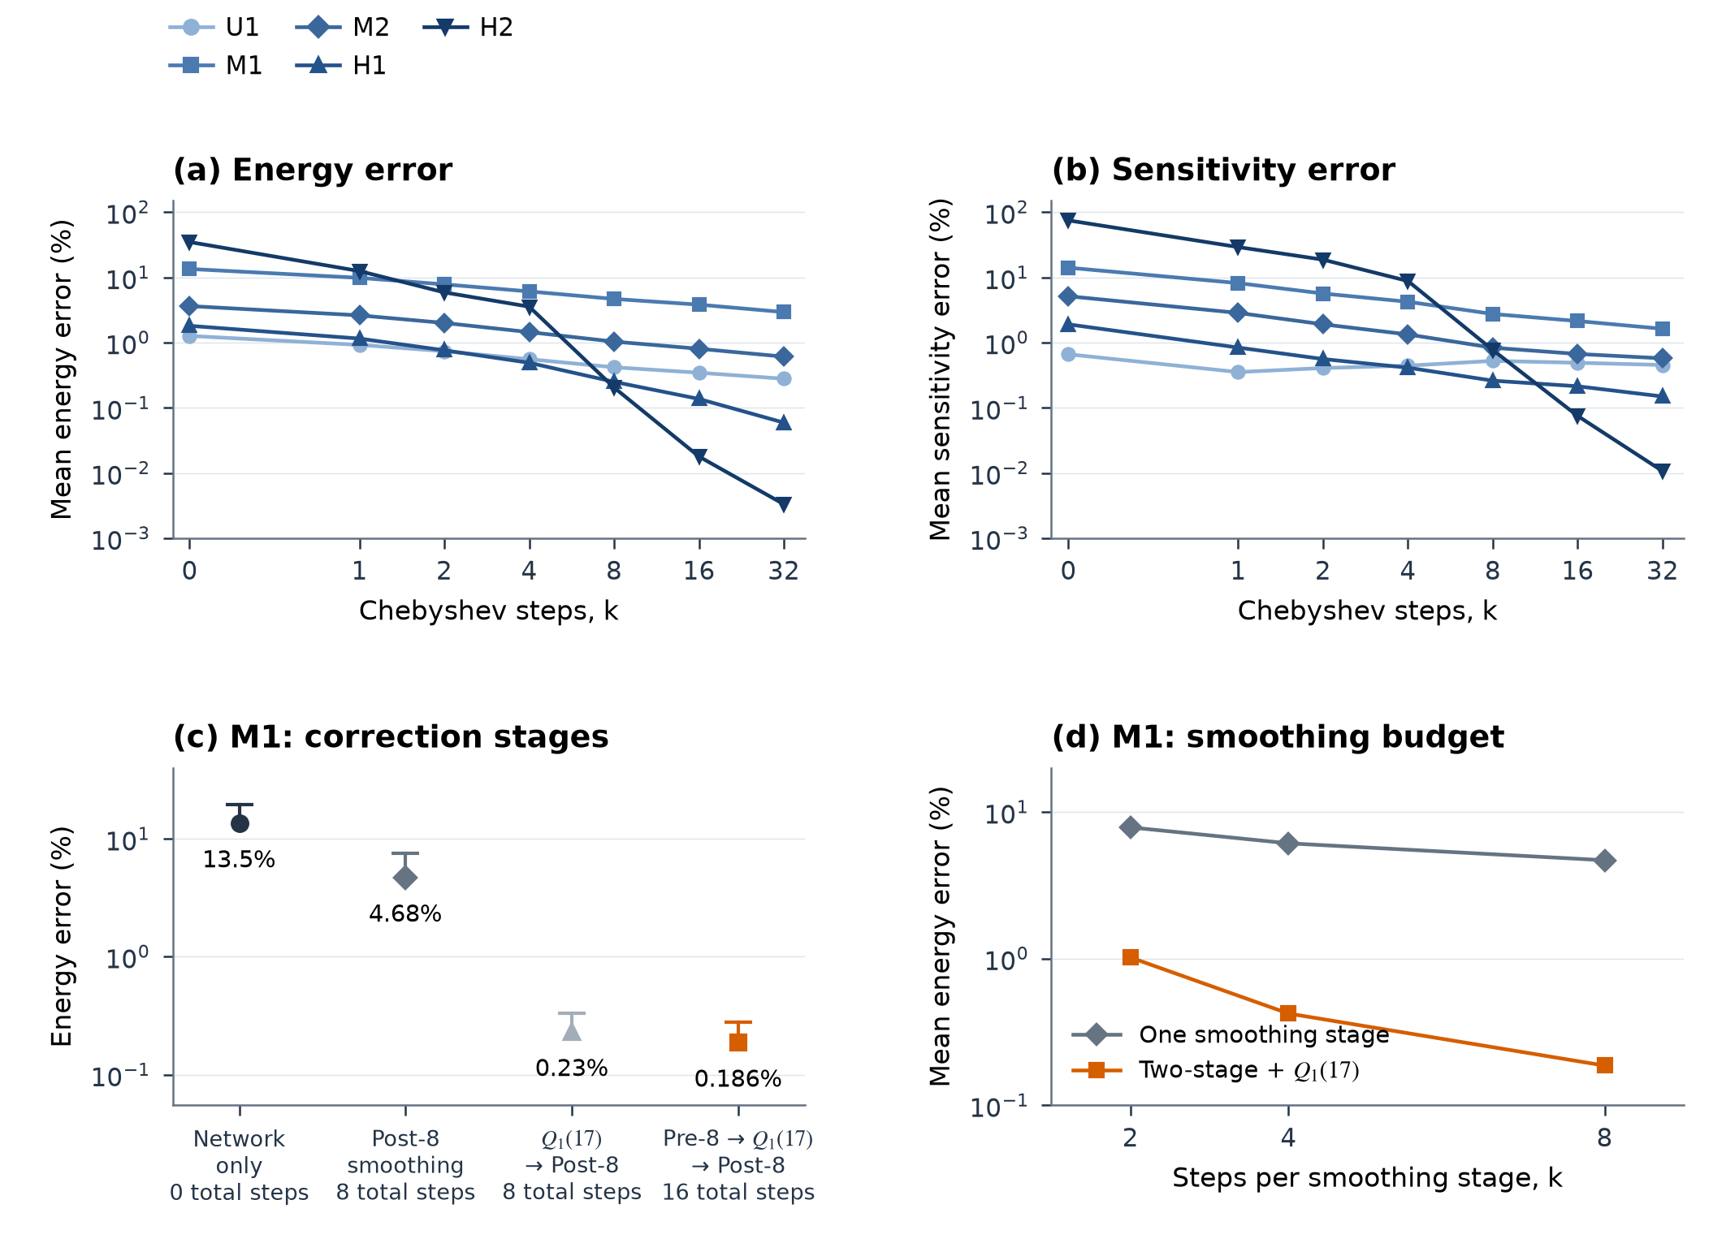
Figure 7. Accuracy gained by correcting the base network at fixed network parameters. (a,b) Mean directional energy error and field-based sensitivity error during Chebyshev smoothing on five cells. (c) M1 with no correction, eight smoothing steps, coarse-grid correction followed by eight steps, and eight steps on each side of the coarse-grid correction; dots show means and caps the 90th percentile. (d) M1: mean energy error against the number $k$ of steps per smoothing stage, for one smoothing stage alone and for $k$ pre-smoothing steps, the $Q_{1}(17)$ coarse-grid correction and $k$ post-smoothing steps. All panels use consistent tractions, fixed retained displacements and $a=b/30$; in (a,b) the step axis is linear from zero to one and logarithmic thereafter.

5.6. Compliance, local sensitivity and energy share after assembly
Do the small single-cell energy errors of Sections 5.3–5.5 yield accurate compliance and local sensitivity once cells are assembled? The two-cell assemblies join a learned target to an exact, uncut neighbouring cell whose thickness is continuous across the interface (Figure 8). The seven targets from the selection geometries are U1, U2, L1, M1, M2, H1 and H3, each in configurations x and y; 'M1/x' denotes target M1 in configuration x. Each configuration has six face loads, the three Cartesian traction directions applied separately to the target and neighbour faces. For each load, compliance and each cell's thickness sensitivity, an eight-component vector, are compared with their exact counterparts, with the nodal load fixed at its base-design value (load normalisation and pair solver: Supplementary Note S4.2). We use 3% as a common reference tolerance for compliance and for each cell's sensitivity vector, drawn as a 3% line in the figures, and report maxima over the six loads and, for sensitivity, over both cells. Three tractions on a target cut face are considered separately.
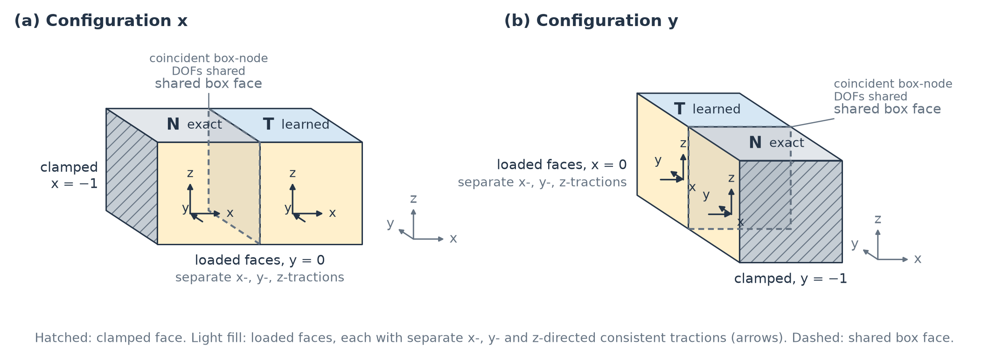
Figure 8. Supports and loading of the two-cell assemblies. (a) Configuration x: the neighbour is translated by $(−1,0,0)$, the face $x=−1$ is clamped, and face tractions act at $y=0$. (b) Configuration y: the translation is $(0,−1,0)$, the face $y=−1$ is clamped, and tractions act at $x=0$. Each target (T) and neighbour (N) face carries separate x-, y- and z-directed consistent-traction loads. Coincident box-node DOFs are shared across the interface; non-box cut-band DOFs remain local. Cut targets also receive three cut-surface tractions, analysed separately.
Figure 9 compares the variants in these configurations. NICE stays below both 3% lines in all fourteen configurations of the seven selection cells: its largest compliance error over the six face loads is 0.056% (M1/x), and its largest sensitivity error, taken over both cells, is 0.67% (U1/y). The directions of the thickness sensitivity vectors are reproduced more closely than their magnitudes: in these fourteen configurations, NICE's vectors have cosines of at least 0.999998 with the exact ones (Supplementary Note S4.3).
On nine validation cells outside checkpoint selection, the five geometries with NICE's largest single-cell errors and one randomly chosen cell in each of the uncut, lightly, moderately and heavily cut strata, the eighteen configurations give maxima of 0.27% in compliance and 1.49% in sensitivity, both on the geometry with the largest single-cell error (Supplementary Table ST08b). The five largest-error geometries account for all compliance errors above 0.02%; the four stratum cells stay below 0.011% and 0.22%. All held-out configurations stay below both 3% lines.
The Uncorrected continuation exceeds the 3% sensitivity line in four of the eleven configurations on which it was evaluated (U1/x, U1/y, M1/x, M1/y, up to 11.4%; Table ST08) and, on M1, also the compliance line (up to 4.1%). Smoothing-trained reduces these errors but still exceeds the line in the same four configurations (3.15–4.43%): smoothing without the coarse-grid correction leaves the slowly damped low-mode error of Section 5.4, consistent with the sensitivity errors that remain in U1 and M1. 'Base network, corrected' also stays below both lines (largest sensitivity error 0.95%, U1/x), so the correction is what brings the assembled responses below them.
Under the cut-face tractions, NICE reaches at most 0.10% in compliance (M1/y) and 0.16% in sensitivity, whereas the Uncorrected continuation exceeds the 3% line in four of its seven configurations, including M2/x (3.3%) and L1/y (3.7%), which stay below it under the face loads; its largest errors are 14.1% in sensitivity and 6.9% in compliance on M1/y (Table ST09).
Table 4 shows why both quantities are needed. Without the complete correction, an accurate compliance does not guarantee an accurate local sensitivity: under a neighbour-face load on U1/x, the Smoothing-trained compliance error is 0.00109% while the target-cell sensitivity error is 3.15%, with the target carrying 0.13% of the exact assembled energy. NICE reduces both errors: the target-cell sensitivity error of that load falls to 0.598%, and on M1/x under the target-face y load NICE gives 0.0481% and 0.145% instead of the Uncorrected continuation's 3.44% and 11.4%. The separation remains visible in NICE, whose sensitivity error exceeds its compliance error by a factor of about two on H1 and by four orders of magnitude for the U1 target, whose energy share is small, but both lie far below the 3% line.
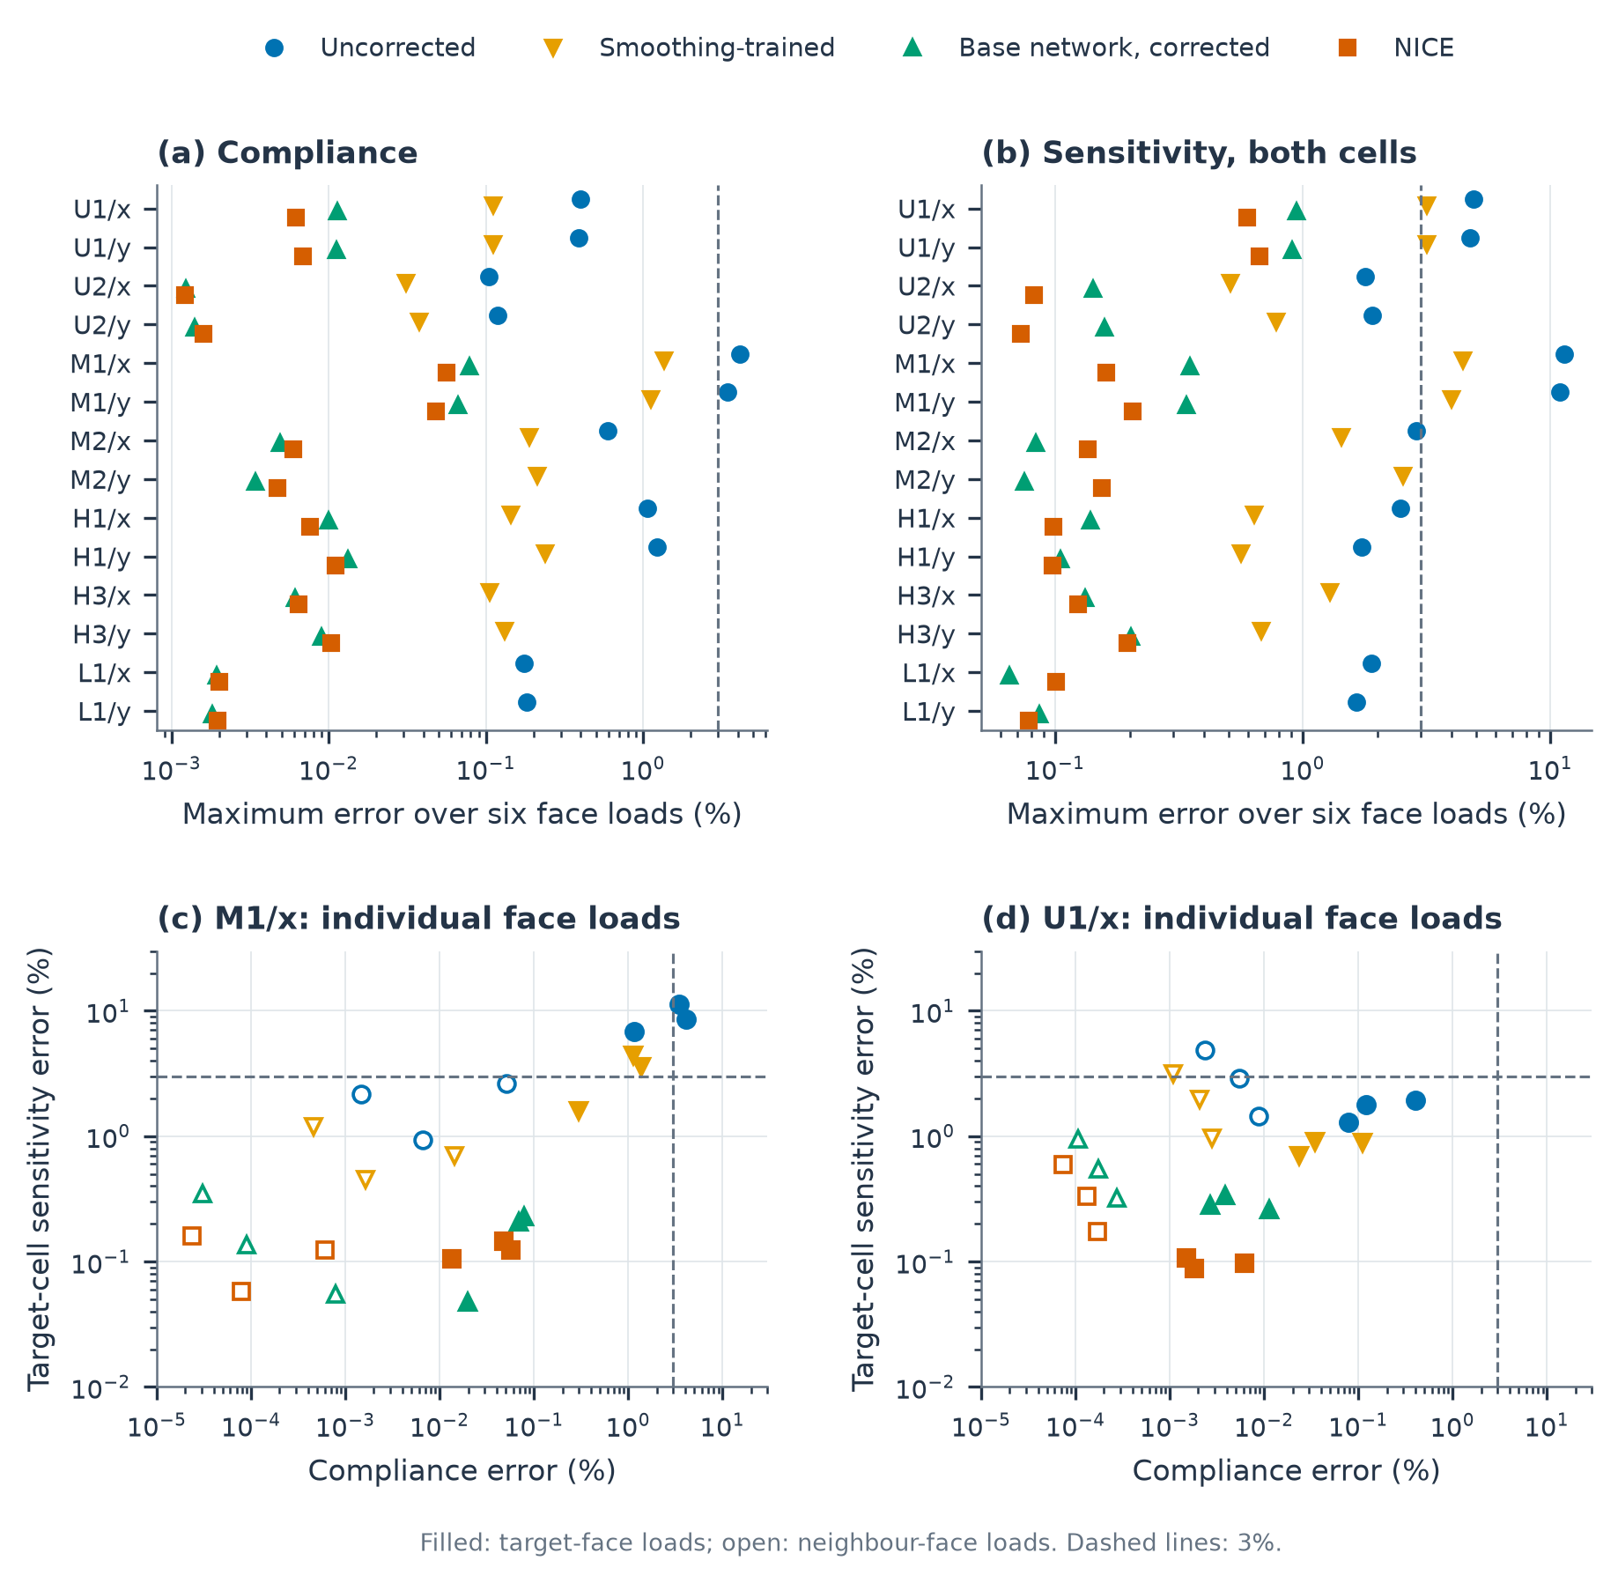
Figure 9. Compliance and thickness sensitivity in two-cell assemblies. The target cell is represented by a learned substructure and the neighbour by exact condensation. (a,b) Maximum errors over the six face loads in each configuration; the sensitivity error is also maximised over both cells. (c,d) Compliance and target-cell sensitivity errors of the individual face loads on M1/x and U1/x; filled markers denote target-face loads and open markers neighbour-face loads. Dashed lines mark the 3% lines. The base network is not shown, and not every variant was evaluated on every configuration; all results are in Table ST08. Variants as in Table 2; 'Base network, corrected' is the base network with the correction applied at deployment, without retraining.
Table 4. Compliance and target-cell sensitivity under individual face loads
Target / configuration | Load | Uncorrected: compliance / sensitivity (%) | Smoothing-trained: compliance / sensitivity (%) | NICE: compliance / sensitivity (%) | Target energy share
H1/x | T-x | 1.06 / 2.47 | 0.144 / 0.636 | 0.0076 / 0.0133 | 0.643
U1/x | N-z | 0.0023 / 4.89 | 0.00109 / 3.15 | 7.3×10⁻⁵ / 0.598 | 0.0013
M1/x | T-y | 3.44 / 11.4 | 1.14 / 4.43 | 0.0481 / 0.145 | 0.311
T and N identify the loaded face of the target or neighbour; x, y and z give the traction direction. The last column gives the target cell's share of the exact assembled energy.
The target's energy share (Table 4) explains how a local stiffness error can have little effect on compliance. Under the neighbour-face z load in U1/x, the base network's target cell carries 0.127% of the exact assembled energy and has a local energy error of 2.31%; their product $β=wε$ gives a relative compliance bound of 0.00295%, close to the observed 0.00283%, whereas the target-cell sensitivity error is 5.83%. Figure 10 shows this weighting across variants and loads. For the sensitivity at fixed retained displacement, Appendix H.1 bounds the error by a term linear in the interior error and one quadratic in it; the relative error is further divided by the local reference value, which is small for a cell that carries little of the assembled energy.
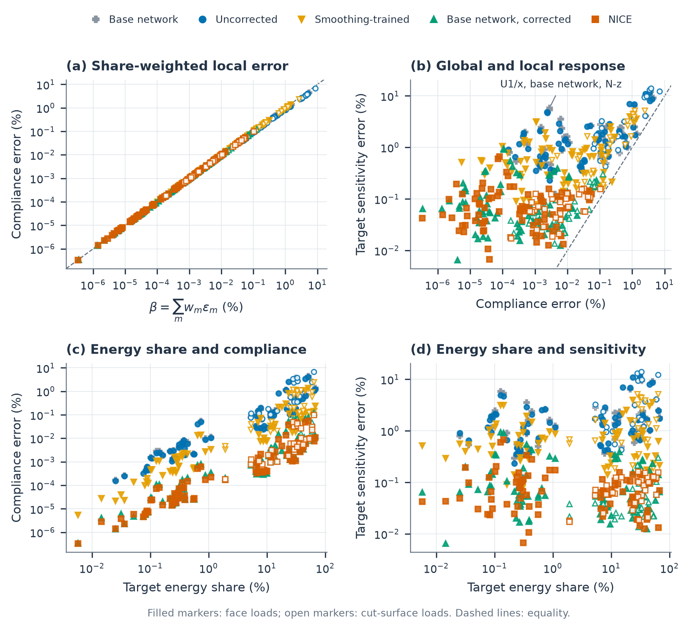
Figure 10. Share-weighted compliance error and local sensitivity. Each point is one load of one variant–configuration combination; the maxima over the loads are given in Tables ST08 (face loads) and ST09 (cut-surface loads). Filled markers denote face loads and open markers cut-surface loads. (a) Compliance error against β=m​wmεm, with the energy shares $w_{m}=q_{m}^{T}S_{m}q_{m}/C$ and energy errors $ε_{m}=q_{m}^{T}({\hat{S}}_{m}−S_{m})q_{m}/(q_{m}^{T}S_{m}q_{m})$, evaluated at the exact assembled retained displacement; only the learned target contributes to $β$. (b) Compliance and target-cell sensitivity errors under the same loads; the annotation identifies the base network on U1/x under the neighbour-z load. Dashed lines denote equality. (c,d) The two response errors versus the target's exact energy share. Variants as in Table 2 and Figure 9.

5.7. Ablation: restricting the retained box-face representation
To isolate the role of the complete retained space, pairs in configuration x are solved with exact cell operators while the box-face displacements of each cell are restricted to tensor Bernstein polynomials of degree $r$; the non-box cut-band DOFs remain unrestricted. The ablation restricts only the retained representation of the present cells at fixed cell size; reduced-boundary learned substructures control the resulting error by partition refinement, boundary enrichment or oversampling Huang et al. (2024), Guo et al. (2026a), Guo et al. (2026b) and are not reproduced here (Supplementary Note S2). With every box face restricted, degree one gives compliance errors of 78–85% on U1, M1, M2 and H1, decreasing to about 4% at $r=5$ and 0.49–0.74% at $r=8$, where the H1 pair has 14,001 retained DOFs instead of 32,991 (Figure 11).
The local sensitivity converges more slowly: at $r=8$ the target-cell sensitivity error is 1.3–4.5% under target-face loads and 24–64% when neighbour-face loads are included. Restricting only the shared interface removes most of the compliance error (0.17–0.44% at $r=3$ on U1, M1 and M2), but the sensitivity error under neighbour loads remains 8–21% at $r=3$ and 2.2–3.4% at $r=5$. A restricted interface is thus adequate for compliance at low degree but not for local sensitivity under neighbour loads; keeping the complete retained space removes this component of the error, at the cost of the larger coarse model (Table ST11).
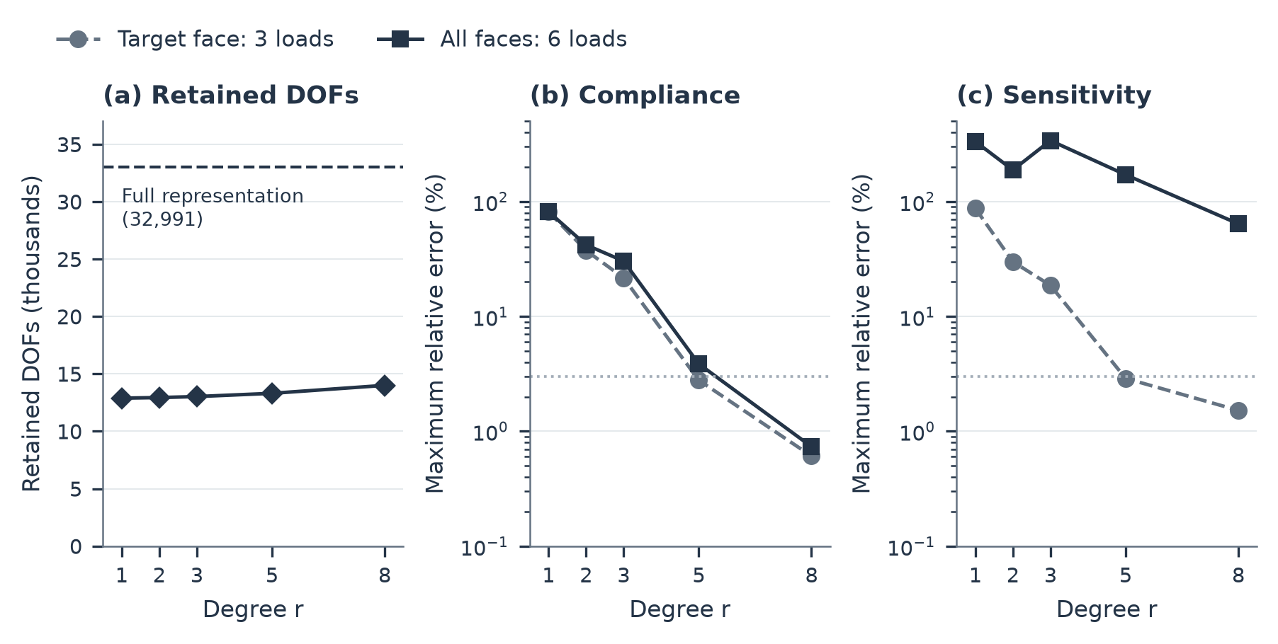
Figure 11. Response errors caused by restricting box-face displacements. Both cells of H1/x use exact operators and Bernstein degree $r$ on every box face, with unrestricted non-box cut-band DOFs. (a) Number of retained DOFs; the dashed line denotes the 32,991 DOFs of the full representation. (b,c) Maximum compliance and target-cell sensitivity errors over the three target-face loads or all six target- and neighbour-face loads; cut-surface tractions are excluded. Errors are relative to the full retained-space solution; horizontal lines mark 3%.

5.8. Heterogeneous lattices with every cell learned
In a design every cell is learned, and the errors of neighbouring cells enter the same assembled solution. Two lattices with a continuous graded thickness field and a planar boundary cut test this: a $2×2×2$ block of eight distinct cells, four of them cut with retained volumes of 62% and 25%, and a $3×3×1$ layer of eight cells, three of them cut, with one corner position left empty. Neighbouring cells share their face corners, and the corner parameters of the block range from 0.25 to 0.54. The sixteen cells were generated for these examples and entered neither training nor checkpoint selection. The lattices are clamped on one face and loaded by unit consistent tractions in the three Cartesian directions on the opposite face (the face loads) and by three random load vectors; for the sensitivities, the nodal load is held at its value for the evaluated design (Appendix H). Every cell uses NICE; the reference assembles the dense exact condensed matrices and solves to a recomputed relative residual of at most $1.3×{10}^{−10}$. The learned lattices are solved by preconditioned conjugate gradients on the free retained DOFs with a balanced two-level preconditioner: the fine action is the inverse of the assembled retained stiffness block KPP=m​BmTKPP,mBm, factorised once per design iteration, and the coarse space consists of trilinear lattice-vertex functions multiplied by the six rigid-body modes (Supplementary Note S4.1).
In the $2×2×2$ block, the lattice compliance errors under the three face loads are 0.014%, 0.011% and 0.0094% (at most 0.069% under the random loads), the largest thickness-sensitivity error over all cells is 0.14% (0.45% under the random loads), and the assembled retained solution differs from the exact one by 0.13% (relative Euclidean norm over all six loads). The $3×3×1$ layer gives 0.015%, 0.013% and 0.010% (at most 0.056%), 0.14% (0.43%) and 0.12%. The lattice errors are below the largest two-cell errors because Eq. (7) bounds the lattice compliance error by the sum of the cells' energy errors at the exact traces, weighted by their shares of the assembled energy. These cell energy errors range from 0.006% to 0.026% in the block and 0.005% to 0.052% in the layer under the face loads (0.02% to 0.12% under the random loads), largest in the cut cells. The weighted sum $β$ exceeds the lattice compliance error by less than 0.4% of $β$ under the face loads and by about 4–5% under the random loads, because the assembled solution adapts to the stiffer learned cells whereas $β$ evaluates the errors at the exact traces.
The learned solves reach the prescribed tolerance on the recursively updated residual, while the recomputed residual $∥f_{g}−\hat{K}\overset{‾}{U}∥/∥f_{g}∥$ stagnates at $3.6×{10}^{−4}$ (block) and $3.2×{10}^{−3}$ (layer), consistent with rounding in the single-precision network: in the block, running the correction in single instead of double precision changes it by less than 1%, so the correction is not its source. The residual work ${\overset{‾}{U}}^{T}ρ$ at the final iterate is at most $2.5×{10}^{−8}$ of the compliance. Together with the dual-norm bound and the action–energy discrepancy (Supplementary Note S4.3, Table ST14), this shows that the errors above are those of the operator, not of the incomplete solve. Aggregated over the shared corner parameters, the field-based sensitivities give the lattice gradient to 0.04–0.09% under the face loads and 0.22–0.28% under the random loads, with cosines above 0.999999.

5.9. Computational cost of a lattice analysis with sensitivities
Cost is compared for one lattice analysis with sensitivities, from cell setup to the solution, on the two eight-cell lattices of Section 5.8 and on two four-cell lattices, the $2×2×1$ layers of the block. Each layer has two uncut cells and two cut cells of 62% and 25% retained volume, and keeps the block's retained DOFs, clamp and loads. Table 5 compares three routes.
Route (a), the whole-lattice direct solution, assembles the full cut finite element model of the lattice, retained and interior DOFs of every cell, and factorises it once by a sparse Cholesky factorisation (MKL PARDISO with 16 threads on one AMD EPYC 9654 CPU); its recomputed relative residuals are below $3×{10}^{−9}$, so for the four-cell lattices it is also the exact reference.
Route (b), conventional exact condensation, condenses every cell on the same CPU by a Cholesky factorisation of its interior with PARDISO's Schur-complement option and solves the assembled condensed system by a block Cholesky factorisation that eliminates each cell's private retained DOFs before the shared interface (16 threads); its compliance agrees with (a) to $7×{10}^{−10}$.
Route (c), NICE on the GPU, prepares the learned substructure of every cell, solves the assembled system by the preconditioned conjugate gradients of Section 5.8 to a relative residual of ${10}^{−6}$ and computes the field-based sensitivities; the correction runs in single precision.
All routes include cell setup and stiffness assembly, and none includes the one-off cost of data generation and training (Section 5.1). The routes run on different processors, one GPU against 16 CPU threads; the comparison is between the routes as each is deployed, not between hardware-equivalent amounts of work.
Table 5. Cost of one lattice analysis with sensitivities. (a) Whole-lattice direct solution by sparse Cholesky factorisation (MKL PARDISO, 16 threads on the CPU): time from cell setup to the solution of six loads (three consistent-traction, three random); peak process memory. (b) Every cell condensed with PARDISO's Schur-complement option, then the condensed lattice system solved by block Cholesky factorisation, 16 threads: total time, peak process memory. (c) Cell preparation, preconditioner setup, conjugate gradients for the three consistent-traction loads to ${10}^{−6}$ and field-based sensitivities; peak GPU memory, CPU memory after cell preparation; compliance error against (a) for four cells and against the exact condensation of Section 5.8 for eight cells. Memory in GiB. All phases: Supplementary Note S3 and Table ST12.
Lattice (cut / cells) | DOFs: total / free retained | (a) Whole-lattice direct, 16 threads: time (s) / memory (GiB) | (b) Conventional exact condensation, 16 threads: time (s) / memory (GiB) | (c) NICE (one GPU): time (s) / iterations | (c) NICE memory (GiB): GPU / CPU | (c) NICE compliance error (%)
$2×2×1$, $z=0$ (2 / 4) | 957,888 / 77,310 | 484 / 35.1 | 589 / 27.9 | 39.4 / 114 | 6.3 / 2.4 | 0.015, 0.012, 0.010
$2×2×1$, $z=1$ (2 / 4) | 884,940 / 71,046 | 349 / 32.0 | 632 / 24.7 | 37.3 / 119 | 6.1 / 2.4 | 0.022, 0.016, 0.014
$2×2×2$ (4 / 8) | 1,833,474 / 139,002 | 868 / 71.1 | 950 / 40.1 | 79.2 / 129 | 8.5 / 3.9 | 0.014, 0.011, 0.0097
$3×3×1$ (3 / 8) | 2,113,611 / 143,685 | 1,042 / 85.9 | 1,218 / 42.2 | 105.5 / 164 | 9.2 / 4.7 | 0.015, 0.014, 0.015
For the four-cell lattices, a NICE analysis takes 37 to 39 s, against 349 to 484 s for the whole-lattice direct solution with 16 threads and 589 to 632 s for conventional exact condensation, and the learned compliance agrees with the direct solution within 0.022%. For the two eight-cell lattices, NICE takes 79 and 105 s per analysis; the whole-lattice direct solution takes 868 and 1,042 s, about ten times as long, and conventional exact condensation 950 and 1,218 s. With 32 threads the direct solution still takes 341 to 956 s, only slightly less than with 16, because cell setup and assembly do not speed up (Supplementary Table ST12b). Run on a single thread, as full-scale comparisons are often reported, the direct solution takes 2,131 to 8,131 s, 57 to 77 times as long as NICE (Supplementary Table ST12b). In route (a), cell setup and stiffness assembly on the CPU take 41 to 53% of the time. Excluding them, the direct solution takes 165 to 610 s; excluding NICE's cell preparation on the GPU, which besides setup and assembly contains the network encoding and the correction setup, NICE takes 31 to 93 s, five to eight times less. For the eight-cell lattices, the timed compliance errors include the algebraic error of the ${10}^{−6}$ solve (Eq. (8)) and exceed the operator errors of Section 5.8 by up to 0.005 percentage points.
The Cholesky factor grows slightly faster than the number of DOFs, from 29 to 32 GiB for four cells to 66 and 81 GiB for eight, and the process peak of the direct solution reaches 71 and 86 GiB; conventional exact condensation needs 40 and 42 GiB, most of it for the condensed cell matrices held until their elimination (Supplementary Table ST12). NICE peaks at 9.2 GiB of GPU memory and keeps 4.7 GiB of CPU memory after cell preparation. Per cell, NICE's stored state takes 0.25 to 1.37 GiB, against 0.60 to 9.4 GiB for the interior Cholesky factor of conventional exact condensation (Supplementary Note S3, Table ST13).
In a design iteration the geometry of every cell changes, so every cell's preparation (its interior factorisation, or its network encoding and correction setup) is repeated, as in the analyses of Table 5; the assembled solve can start from the previous solution, and the conventional routes can reuse their symbolic factorisation while the active-element pattern is unchanged.

5.10. Thickness design optimisation
Two cases are optimised: case A, the $2×2×2$ block of Section 5.8, and a cut plate supported on its cut, both described below. The corner thickness parameters at the lattice vertices, collected in the global vector $τ_{g}$ and mapped to each cell's corners by $τ_{m}=τ_{m}(τ_{g})$, are optimised for minimum compliance under one unit consistent face traction subject to $V≤V^{*}=0.8 V(τ^{0})$, with $V$ the material volume of the discrete model. The parameters at the vertices in the plane of the loaded face (9 of 27 in case A, 10 of 74 in the plate) are fixed, which keeps the nodal load independent of the design and removes the load-derivative term $2f_{g,c}^{T}\hat{U}$ of Appendix H. The optimiser receives the field-based estimates of Eq. (9) summed over the cells at each vertex, m​(∂τm/∂τg)Tsm. The bounds $0.18≤τ≤0.69$ and limits of 0.45 on each cell's corner span and gradient norm keep every cell inside the trained domain ([0.175, 0.699], at most 0.47; Section 6.4). Each design iteration regenerates every cell's geometry and learned substructure, solves the lattice by the preconditioned conjugate gradients of Section 5.8 from the previous solution and takes one step of the method of moving asymptotes Svanberg (1987), in the variant of Svanberg (2007), with a move limit of 5% of the parameter range and no line search (Table ST16).
Case A, the $2×2×2$ block of Section 5.8 loaded by a normal traction on the face opposite the clamp, is optimised from its graded design with NICE and, for comparison, with exact condensation (the twin run; Table 6, Figure 12a). NICE stops after 24 design iterations and exact condensation after 23, both when the relative change of the objective has stayed below ${10}^{−4}$ in three consecutive iterations (Table ST16); no Karush–Kuhn–Tucker (KKT) residual is used for stopping, since the discrete model, and with it the objective, changes between design iterations (Section 3.3, Supplementary Note S6.1). Both lower the compliance by 2.0% with 20% less material; their final corner parameters differ by at most 0.0051, and the exact compliances of their final designs by $1.25×{10}^{−5}$ of their value. At iterations 0, 12 and 23, the NICE compliance lies 0.011%, 0.018% and 0.028% below the exact one, the sign given by Eq. (7), and the lattice gradient has errors of 0.069%, 0.17% and 0.33%, cosines of at least 0.999996, 95th-percentile per-variable errors of at most 0.28% of the largest component and the exact sign in every component (Table ST17). Both errors grow as the design approaches the bounds, yet the final NICE design still matches the twin design to 0.0051 in every corner parameter.
The plate supported on its cut is a single layer of $8×4$ cells from which a planar cut removes eight, leaving 16 uncut and eight cut cells (Supplementary Note S6.3). It is clamped on its cut: every DOF of the cut band of every cut cell is fixed, a support that lies within one element ($h=1/32$) of the cut surface and that the retained cut band represents without retraining. Its end face, four cells wide, carries a consistent traction of unit resultant in the plane of the plate and normal to its long side, so that the plate acts as an in-plane cantilever supported along the oblique cut (Figure 13a). The cut normal ($ϑ={33.7}^{∘}$) lies in the orientation in which NICE was mainly evaluated ($0<ϑ<π/4$, Sections 5.1 and 6.4).
From the uniform $τ=0.40$, NICE stops after 24 design iterations by the objective-change rule (Figure 12b). The compliance rises from 75.59 to 110.49 while the volume is reduced to $V^{*}$ and then falls to 78.26; the final design reaches both bounds and the span and gradient limits, with its thickest walls near the end of the support closest to the loaded face and along the opposite free edge, and the cells far from the load thinned to the lower bound (Figure 13a). Checked with exact condensation (Table ST21), the NICE compliance lies 0.011% below the exact one at the uniform start and 0.030% below it at the final design; the lattice gradient has errors of 0.029% and 0.30%, cosines of at least 0.999996, 95th-percentile per-variable errors of at most 0.27% of the largest component and the exact sign in all 64 components.
A homogenised model, as in homogenisation-based graded design Li et al. (2018), with the tensor of the uniform-thickness cell from periodic homogenisation on the same discrete model (Table ST18b), is clamped on the plane of the cut and optimised with the same variables, bounds, limits, volume bound and optimiser; its volume, from the homogenised material volume fraction $V^{H}(τ)$, equals the discrete material volume at the uniform start to $1.2×{10}^{−7}$. It underestimates the exact compliance of the uniform start by 27.0%, consistent with the single layer offering no separation of scales through its thickness, and lies 27–33% below the NICE compliance along its own optimisation path; up to iteration 3 the two runs analyse the same designs (Figure 12b). Analysed on the cut geometry, the homogenisation design uses 0.18% less material and has a compliance 2.44% above that of the NICE design; the difference is the same whether both are evaluated with NICE or with exact condensation (exact compliances 80.198 and 78.287; Tables ST18c and ST21). Its corner parameters differ from those of the NICE design by up to 0.26 (correlation 0.95; Table ST18c, Figure 13b). The homogenised model thus misjudges the response of the cut layer by 27% and leads to a design that is less stiff on the cut geometry; predicting the response of the cut layer, and optimising it, requires the cut-cell model.
The discrete model switched (Section 3.3) between every pair of consecutive design iterations, in at least 3 of the 8 cells of case A and at least 11 of the 24 cells of the plate (Table ST19b), and the residual work of Eq. (8) stayed at most $5.4×{10}^{−8}$ of the compliance. In four design iterations over all runs the geometry generator required a perturbation of at most $5.8×{10}^{−4}$ in a corner parameter (Supplementary Table ST19a and Note S6.4). A NICE design iteration took 74 s on average for case A and 200 s for the plate (155–270 s), whose 24 iterations took 1.3 h (Table 6, Supplementary Table ST18a).
To examine how the cost grows with the size of the lattice, the design iteration was timed on plates with the proportions and cut of this plate and 24, 51, 88 and 110 cells, clamped along the uncut long side and loaded in plane on the opposite face (Figure 13c, Table ST20). They have 8 to 18 cut cells and 6.5 to 32.7 million DOFs in the cut finite-element model, condensed to 0.39 to 1.62 million free retained DOFs; each was run over its first four design iterations, with the learned substructures beyond 4 GiB of GPU memory streamed from CPU memory. A design iteration took 4.0, 9.1, 16.0 and 19.4 min, in proportion to the number of cells (10.1 to 10.9 s per cell), with 138 to 173 conjugate-gradient iterations. CPU memory, which holds the streamed state of the learned cells, grew by about 0.7 GiB per cell; with the learned cells held on the GPU within a fixed 4 GiB, the GPU memory grew with the assembled retained system, whose stiffness $K_{PP}$ the preconditioner factorises directly (Table ST20).
Table 6. Thickness optimisation cases. Compliance under a unit consistent face traction. Start: initial design, whose volume exceeds $V^{*}$ by 25% in every run; final: last design iteration. Compliances are NICE values except where marked. Exact verification: exact discrete compliance of the designs, with the amount by which the NICE compliance lies below it in parentheses. Iterations: design iterations. Time: mean time of a design iteration, including geometry generation for every cell. Unlike the analyses of Table 5, a design iteration regenerates every cell's geometry and solves for one load (Supplementary Note S6.1). Hom: homogenised macroscale model (4,464 trilinear elements). Details: Supplementary Note S6 and Tables ST16–ST21.
Case | Cells (cut) | Support and load | Iterations | Start $C$ | Final $C$ | Exact verification | Time (s)
A, NICE | 8 (4) | Clamped face; normal traction on the opposite face | 24 | 24.5908 | 24.1038 | 24.5936 (0.011%), 26.0063 (0.018%), 24.1105 (0.028%) at iterations 0, 12, 23 | 74
A, exact condensation | 8 (4) | As A | 23 | 24.5936$​^{a}$ | 24.1108$​^{a}$ | Exact throughout; final design 0.0013% above the NICE design | 469
Plate, NICE | 24 (8) | Clamped cut band; in-plane traction on the end face | 24 | 75.591 | 78.264 | 75.599 (0.011%), 78.287 (0.030%) at iterations 0, 23 | 200
Plate, Hom | Macroscale | As plate | 23 | 55.19$​^{b}$ (NICE 75.59) | 55.27$​^{b}$ (NICE 80.17) | Final design: 80.198 (0.032%) | 4$​^{b}$
Scale: plates of 24, 51, 88, 110 cells | 24–110 (8–18) | Clamped long side; in-plane traction on the opposite face | 4 timed | 94.34, 89.12, 86.75, 85.38 | — | Not checked | 242; 547; 962; 1,164
$​^{a}$ Exact compliance. $​^{b}$ Homogenised macroscale model (time on the CPU); in parentheses the NICE compliance of the same design on the cut geometry.
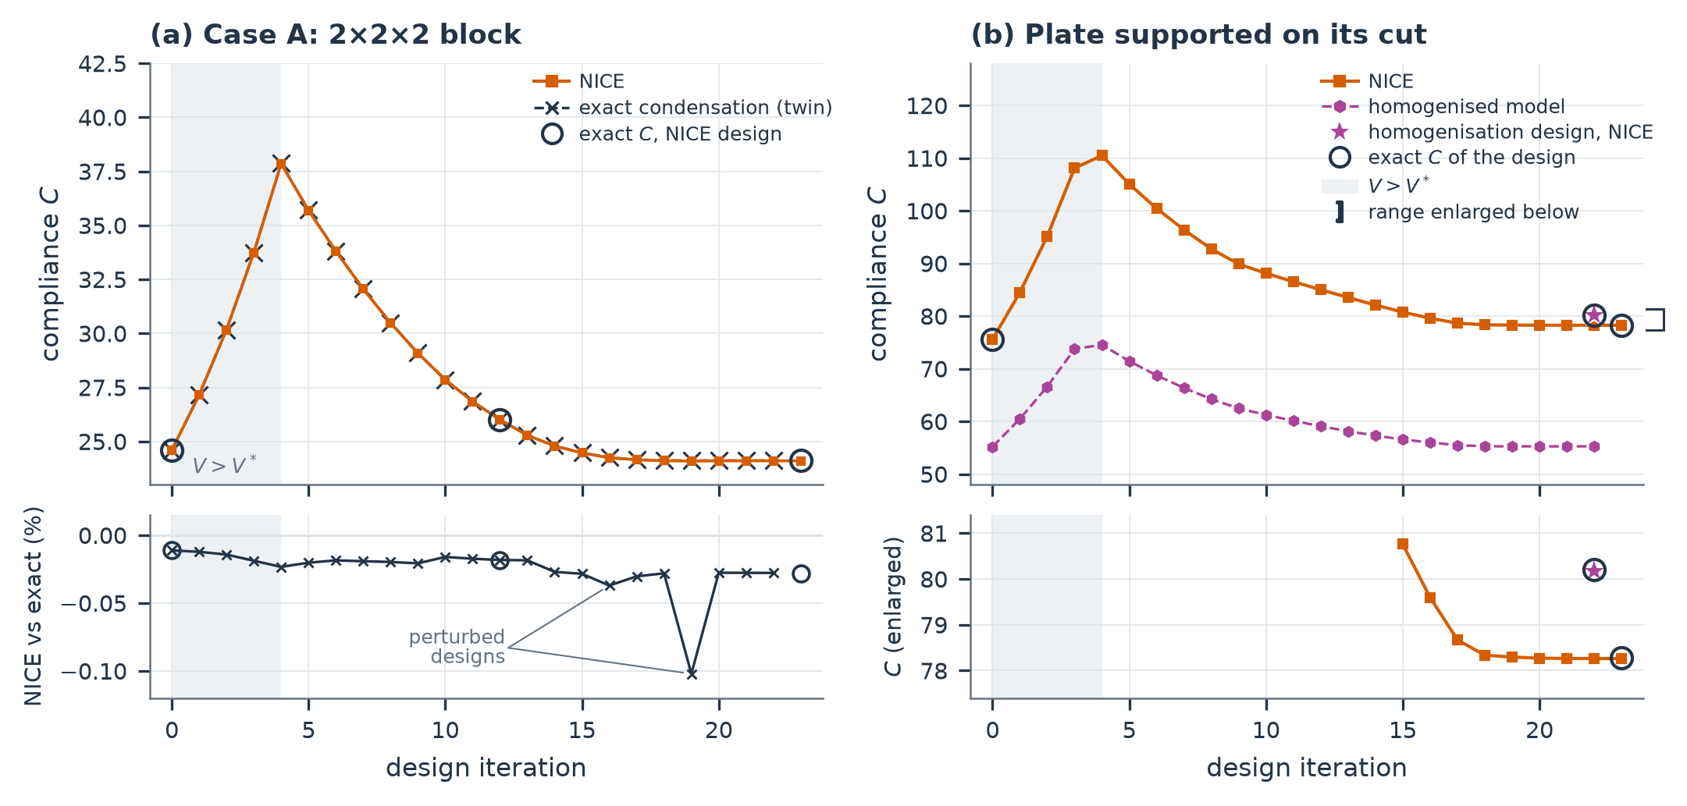
Figure 12. Thickness optimisation with NICE. (a) Case A: compliance histories of the NICE optimisation and of the twin optimisation with exact condensation, with the exact compliance of the NICE designs at iterations 0, 12 and 23 (open circles); the compliance first rises while the volume is reduced from $1.25V^{*}$ to $V^{*}$ (shading, iterations 0–3). Lower strip: NICE compliance relative to the twin run at the same design iteration (line; the designs of the two runs coincide at iterations 0–4 and differ afterwards) and to the exact compliance of the same design (circles: −0.011%, −0.018%, −0.028%); at iterations 16 and 19 (labelled 'perturbed designs') the geometry-generation fallback had perturbed the NICE design (Supplementary Note S6.4, Table ST19a). (b) Plate supported on its cut: NICE compliance from the uniform start, compliance of the homogenised macroscale model along its own optimisation (dashed), the homogenisation design analysed with NICE on the cut geometry (star, at the last macroscale iteration) and the exact compliance of the uniform start, the final NICE design and the homogenisation design (open circles). Shading: design iterations with $V>V^{*}$. Lower strip: the range marked by the bracket, enlarged, from iteration 15.
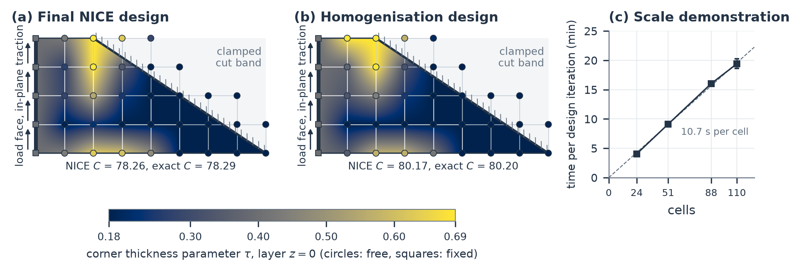
Figure 13. Plate designs and scale demonstration. (a,b) Corner thickness parameters of the final NICE design and of the homogenisation design, drawn with the long side horizontal, layer $z=0$; circles: design variables; squares: vertices in the plane of the loaded face, held fixed; vertices drawn in the removed region are corners of cut cells. Thick line with hatching: the clamped cut band; arrows: load face and direction of the in-plane traction. (c) Scale demonstration on plates with the proportions and cut of the plate in (a,b), clamped along the uncut long side and loaded in plane on the opposite face: time per design iteration (mean; bars: range over the timed iterations) against the number of cells; dashed: proportionality at the mean time per cell; memory in Table ST20. Compliances in (a,b): NICE and exact values of the same design (Table ST21).

6. Discussion

6.1. What is retained, how it is represented and what is corrected
Fixing the retained DOFs separates two decisions that a reduced substructure model otherwise combines: which displacement patterns neighbouring cells may exchange, and how accurately the interior responds to each of them. Learning and correction alter only the second. The ablation of Section 5.7 shows the role of the first: even with exact interiors, restricting box-face displacements changes the assembled response, and a degree that gives accurate compliance can leave appreciable sensitivity error. In the cut cells examined, at fixed cell size and without the partition refinement or enrichment that reduced-boundary methods use, restricting the box-face representation produced larger local-sensitivity errors than NICE's interior approximation (Sections 5.6 and 5.7, for two-cell assemblies). The retained cut band keeps cut-surface loads and supports available without retraining: in the lattices, whose cut surfaces are traction-free, its DOFs off the box faces account for 37 to 50% of the free retained DOFs (Table ST12a), and the plate of Section 5.10 is clamped through it, a support for which the homogenised model needs a separate constraint on the plane of the cut.
The representation is what makes the complete retained space learnable. Weights that act on stencils, channels and grid levels let one network of about $6×{10}^{5}$ parameters serve retained sets of 2,679 to 45,900 DOFs; exact linearity in the retained displacement gives superposition, admissibility and rigid-body reproduction by construction (Eq. (17)); and since the operator is applied without being formed, a cell stores what its geometry determines rather than a dense matrix on its retained DOFs (Section 4.6). The price of this generality is that the network is tied to the discretisation on which it was trained: its latent hierarchy of 65, 33, 17 and 9 positions per axis matches $n=32$, and another resolution requires new training (Section 6.4).
Within the interior, prediction and correction are complementary, and the division of labour between them is what the variational structure makes visible. An interior correction that does not increase the $A$-energy error for any retained input yields a condensed stiffness between the uncorrected condensed stiffness and the exact Schur complement, independently of the network (Section 4.3). A displacement error of about one percent becomes an energy error of 1.8 to 35% because the error is stiffer than the solution (Section 5.4); smoothing removes the components with large Rayleigh quotients of the scaled interior operator, and the coarse-grid correction the smooth components that smoothing reaches slowly. The learned field supplies what neither reaches at a practical budget: under the same correction, a harmonic start leaves 7 to 290 times the error of the learned field on the five cells of Table 3, and eight times the smoothing work closes the gap in only one of six cells. Conversely, the correction relieves the network of what it represents poorly: a base-network error of 13.5% on M1 becomes 0.19% without any change of network parameters, and 'Base network, corrected' already stays below the 3% lines in the two-cell configurations, so an existing network need not be retrained to benefit from the correction. Training through the correction adds less than the correction itself, a further factor of 1.31 (Section 5.3).

6.2. What the guarantees cover
The variational properties hold for every input and, with an exact or nonnegatively shifted coarse solve (Appendix F.1), the ordering for every geometry whose spectrum lies below the upper end of the smoothing interval (Section 5.2). Design differentiation adds a requirement that the energy error does not control. At a common retained vector $q$, with $H=J_{I}(F−E)$ as in Eq. (4), $E_{I,c}=J_{I}E_{,c}$, $H_{,c}=∂H/∂τ_{c}$ and $K_{II,c}=J_{I}K_{,c}J_{I}^{T}$, Eqs. (9) and (10) give (Appendix H.2, Eq. (H.5))
$${\tilde{s}}_{c}−s_{c}=2(Hq)^{T}AE_{I,c}q−(Hq)^{T}K_{II,c}Hq, −q^{T}{\hat{S}}_{,c}q−s_{c}=−2(H_{,c}q)^{T}A Hq−(Hq)^{T}K_{II,c}Hq,$$
the first at the common $q$ and the second at the assembled $\hat{q}$ of Eq. (10). The residual term of Eq. (10) thus removes the linear field-error term and replaces it by one weighted by the design derivative of the extension error. Which of the two is the more accurate gradient depends on whether $∥H_{,c}q∥_{A}$ is small compared with $∥E_{I,c}q∥_{A}$. A central-difference check of ${\hat{C}}_{,c}$ could not resolve this question: at least one of the discrete choices listed in Section 3.3 switches in 21 to 48 of the 49 rebuilds of each lattice cell and the difference quotient grows as the step decreases (Supplementary Note S4.3, Table ST14). The field-based estimate needs no difference quotient and gives the shared-variable gradient of the two eight-cell lattices of Section 5.8 and the two four-cell layers of the block (Section 5.9) to 0.02–0.13% under the face loads and 0.22–0.35% under the random loads (Table ST14). The optimisations of Section 5.10 take steps of the method of moving asymptotes without a line search; an optimiser with a line search would compare the surrogate objective with a field-based gradient that is not its derivative (Section 3.3).

6.3. Computational value
A correction budget adequate for compliance can leave local sensitivity inaccurate, so the relevant cost is the total work needed to reach the prescribed accuracy of both. For the lattices examined, a NICE lattice analysis with sensitivities takes less time and memory than the whole-lattice direct solution and conventional exact condensation (Section 5.9). Unlike inexact BDDC and FETI-DP methods Li & Widlund (2007), Klawonn & Rheinbach (2007), Hirschler et al. (2024), which use approximate subdomain and coarse solves only inside the preconditioner and therefore converge to the exact discrete solution, its lattice solve iterates on the assembled condensed stiffnesses $\hat{S}$ of the learned substructures, so that the approximation lies in the operator itself. Its output is a condensed operator per cell with a quantified and reducible error; whole-lattice iterative solvers are a different route (Section 6.4). A smaller smoothing budget would lower the cost of an application, at the loss of accuracy quantified in Section 5.5.

6.4. Limitations
The construction and the error relations apply to any discrete model with a symmetric positive semidefinite stiffness and a positive definite interior block. The trained network has a narrower scope, the setting in which it was trained and tested: Schwarz-P-type cells of Eq. (1) with eight corner parameters in [0.175, 0.699], corner span and gradient norm at most 0.47 (Table ST02), and at most one planar cut whose normal is a cube-symmetry image of $(cosϑ,sinϑ,0)$. It is tied to one discretisation ($n=32$, $E_{Y}=1$, $ν=0.3$, $γ={10}^{−4}$), to which the 65/33/17/9 latent hierarchy is matched. Other TPMS families were not tested. They, like cells with several cuts or curved boundaries, other resolutions and other materials, require new training data and network parameters, at the cost reported in Section 5.1. The network is not equivariant under the cube symmetries, as symmetry-decoupled shape functions are for voxel substructures Jiang, C. et al. (2026), and NICE was evaluated mainly in the identity orientation: in a second cube-symmetry orientation of the 80 validation geometries (an orientation also used in checkpoint selection), its mean directional energy error over the seven load classes evaluated in both orientations is 4% higher in relative terms, and 12% higher under consistent tractions (Supplementary Table ST03c).
The variational properties of Section 4.1 hold for any input, but the accuracy does not: no certified error bound is provided (Appendix G.4). The interior residual of Eq. (5) is available at run time, but the energy error it determines needs one interior solve per direction, and the label-free lower bound of Appendix I can detect a large error in a direction but cannot confirm a small one. Accuracy is measured against the discrete reference, whose deviation at $n=32$ from the $n=64$ refinement is at most 0.28% in compliance and 0.44% in sensitivity except in the heavily cut H2, where it reaches about 1% and 3.6% (Section 5.2, Supplementary Table ST10).
The assembled evidence comprises fourteen two-cell configurations of selection cells, eighteen of held-out cells, two eight-cell lattices and the two four-cell layers of the block (Sections 5.8 and 5.9), three exact-checked designs of the block (case A) and three of a cut 24-cell plate (Section 5.10); all training comparisons use one seed, and the effect of the sensitivity term in Eq. (18) was not isolated. The reported sensitivities are field-based estimates that omit the design dependence of the extension in Eq. (10). On one GPU, the size of lattice that can be analysed is at present set by the direct factorisation of $K_{PP}$ in the preconditioner, whose memory grows with the assembled retained system while that of the learned cells is held within a fixed budget; larger lattices require it to be replaced, for instance by a further level of the multilevel correction or an iterative coarse solve, which was not tested.
Fine-scale iterative solvers of the whole lattice, such as algebraic multigrid Vaněk et al. (1996), Henson & Yang (2002), Falgout & Yang (2002) or BDDC and FETI-DP preconditioners Dohrmann (2003), Farhat et al. (2001), were not compared. An optimiser must keep designs inside the parameter domain above, as the bounds and limits of Section 5.10 do; the optimisations there are local, and the accuracy of NICE was not verified on plates of more than 24 cells.

7. Conclusions
A learned reduced model of a structural component acquires the structure of a mechanical model from where its approximation is placed and how its condensed stiffness is formed. Approximating only the interior extension on the complete retained space, evaluating it in the energy form with its transpose $F^{T}$ and adding a fixed, geometry-specific two-grid correction gives a condensed operator that is symmetric and positive semidefinite with the rigid-body kernel, bounded below by the exact Schur complement with an error quadratic in the interior error, assemblable and differentiable. It is also improvable at deployment: a correction with an exact coarse solve and a smoothing interval that bounds the spectrum from above cannot increase the error, and in every example examined (Table ST07) a larger correction budget reduced the energy error further, whether the correction started from the base network's field or from a deterministic field. The representation of the extension makes the complete retained space learnable: exactly linear in the retained displacement and acting on stencils, channels and grid levels, one network of about $6×{10}^{5}$ parameters serves retained sets of 2,679 to 45,900 degrees of freedom without forming a matrix. Learning supplies the trial field, the variational form the structure and the correction the improvability. The three are complementary: under the same correction a harmonic start leaves 7 to 290 times the error of the learned field on the five cells examined. Conversely, the correction alone, applied to the base network without retraining, lowers its mean energy error under consistent tractions on the 80 validation geometries from 6.89% to 0.0965% and keeps its compliance and sensitivity errors below 1% in all fourteen two-cell configurations of the selection cells, on each of which it was evaluated.
The error relations fix what such a model must be checked against. The interior error enters the assembled compliance weighted by the energy the cell carries, so that a cell with a small energy share can leave the compliance accurate; it enters the thickness sensitivity through the stiffness derivative with a linear term that the energy error does not control; and in the cut cells examined a displacement error of about one percent lies in stiff directions and becomes an energy error of 1.8 to 35%. Accurate compliance therefore does not imply accurate local sensitivity, and joint accuracy of both is the criterion for design use.
Realised for cut thin-walled Schwarz-P cells, with tens of thousands of retained degrees of freedom and a discrete space that changes with the cut, NICE keeps the mean energy error under consistent tractions at 0.074% on 80 validation geometries and the compliance and sensitivity errors below 0.28% and 1.5% in every two-cell configuration and below 0.02% and 0.15% in lattices of eight learned cells under face loads. An eight-cell lattice analysis with sensitivities takes 79–105 s on one GPU against 868–1,042 s for the whole-lattice direct solution on 16 CPU threads. Driven by the field-based sensitivities, the method of moving asymptotes reproduces on an eight-cell lattice the design obtained with exact condensation to within 0.0051 in every corner parameter. On a 24-cell plate clamped on its cut, a support that the retained cut band represents directly, the exact checks give compliance errors below 0.04% and gradient errors below 0.33%; a homogenised model underestimates the compliance by 27%, and its design, analysed on the cut geometry, is 2.4% less stiff than the NICE design, in the NICE and in the exact model alike. A design iteration of a 110-cell plate with 32.7 million degrees of freedom takes 19 min.
Between homogenisation, which loses accuracy where scales do not separate, and the resolution of every wall, whose cost each design iteration pays again, NICE thus provides a component model that keeps the structure of static condensation without its interior factorisation, with an error that can be checked against it. The construction applies to other component families that satisfy the stated assumptions; its accuracy and cost there remain to be established.

Code and data availability
The implementation of the neural extension, the equilibrium correction and its transpose, the cut-cell preprocessing and reference condensation, and the assembly, benchmark and figure scripts will be archived as a cleaned, frozen snapshot, together with the trained network parameters of the variants of Table 2, the parameter files of all validation and lattice geometries and the result records from which every table and figure is generated, in a public Zenodo repository upon acceptance. Training data are available from the corresponding author on reasonable request.

Appendix A. Discrete construction and metric definitions

A.1. Active degrees of freedom and element integration
A background element is active if its intersection with $Ω(η)$ has positive measure. This is decided with closed-form interval enclosures of $ϕ$ and $τ$ over the element clipped by the cut plane: the element is excluded if an enclosure shows that a constraint is violated everywhere, accepted if both constraints hold strictly at its centre or a vertex, and subdivided otherwise. The active background elements use tensor-product $Q_{2}$ displacements, with 27 nodes and 81 displacement degrees of freedom per element. The retained box set is the union of the nine face nodes of every certified positive-area material patch. The cut set is the union of all 27 nodes of each active element carrying a positive-area cut-surface patch. Their union is deduplicated in active-node order. The off-plane cut-band DOFs are retained because their basis functions determine displacement and virtual work on the cut plane.
The discrete stiffness is assembled as
K(η)=e​LeTKe(η)Le+γf∈Fg​LfTGfTGfLf, Ke(η)=α∈{0,…,4}3​Meα(η)Tα. (A.1)
Here $L_{e},L_{f}$ extract element and ghost-face DOFs. The fixed elasticity templates $T_{α}∈R^{81×81}$ use the physical basis derivatives and isotropic Lamé constants $λ_{L}=E_{Y}ν/[(1+ν)(1−2ν)]$ and $μ_{L}=E_{Y}/[2(1+ν)]$. The 125 moments $M_{eα}$ integrate local monomials with coordinatewise exponents from zero to four over the material part of an element. The ghost-face set, its factors and coefficient specify the stabilisation contribution. The sum defines the stabilised discrete energy, including its ghost-penalty contribution.
The ghost-face set $F_{g}$ consists of interior background faces whose two neighbouring elements are active and are not both certified as completely filled with material. These faces lie within each substructure. For background-element width $h=1/n$, the unit-coefficient stabilisation bilinear form is
gh(v,u)=(λref+2μref)f∈Fg​j=12h2j−1f​[∂nfjv]⋅[∂nfju] dA.
The derivative uses a common positive coordinate normal on both neighbouring elements, and the jump is the value on the first element minus that on the second. Integration covers the complete background face. The stabilisation form $g_{h}$, and hence $G_{f}$, uses fixed reference values $E_{ref}=1$, $ν_{ref}=0.3$ and their Lamé constants $λ_{ref},μ_{ref}$; these equal the material values $E_{Y},ν$ of the 80 validation geometries. Each face integral uses a tensor-product three-point Gauss rule in its two tangential coordinates. Stacking the square-root-weighted jump evaluations for both derivative orders and all three displacement components gives $G_{f}∈R^{54×135}$, acting on the 45 distinct nodes of the two-element patch. Thus the second term in Eq. (A.1) is the matrix representation of $γg_{h}$.
The moments are integrated by initialising $4^{3}$ subcells per active background element and refining partially occupied subcells once into $2^{3}$ children, so that the finest subcell width near the material boundary is $h/8$; refinement is local to partial subcells and does not uniformly subdivide every active element. Fully occupied subcells contribute analytic tensor-product monomial moments. At the finest partial level, each subcell is divided into six Kuhn tetrahedra, clipped successively by the three interpolated inequalities defining the band and the cut plane, and integrated with the tetrahedral quadrature rule of parameter four. The accumulated moments are multiplied by the physical Jacobian $(2n)^{−3}$.
Geometry generation accepts a cell only if its active background elements form a single face-connected set carrying retained box-face DOFs, which establishes connectivity of the stabilised discrete model, in which material connected only through partially filled elements is coupled through shared basis functions and the ghost penalty; every training, validation, neighbour and lattice cell used in this work passes this check. This check yields the rigid-body kernel assumed in Section 2.2, provided the element integration is exact and the elasticity tensor is positive definite. Suppose $v^{T}Kv=0$. Both terms of Eq. (A.1) are positive semidefinite, so each vanishes. On every active element the material part has positive measure, so the $Q_{2}$ field $v_{h}$ has zero symmetric gradient on a set of positive measure. Since $∇^{s}v_{h}$ is polynomial, it then vanishes on the whole element, and $v_{h}$ is rigid there. Two face-adjacent active elements share the nine nodes of their common face, which are not collinear, so their rigid motions coincide. Face-connectivity therefore makes $v_{h}$ one global rigid motion. Conversely, a global rigid field is affine, so it has zero strain and zero jumps of its first and second normal derivatives, and the ghost term vanishes on it. Hence $kerK=rangeR$. With numerical moments, the same conclusion requires the discrete element matrices to keep this kernel. That is an assumption, supported by the rigid-body energy ratios of Table ST04.
For the population statistics of Section 5, a geometry-level energy score averages over the evaluated directions in one class; population means then give equal weight to each available geometry.

Appendix B. Variational identity, rigid-body kernel, and directional norms

B.1. Assumptions
In Appendices B and C, $f≡f_{g}$ denotes the assembled retained load.
For each cell, $K=K^{T}≽0$, the retained and interior DOF sets $P,I$ are fixed, and $A=K_{II}≻0$. The exact extension is defined by $E_{P}=I_{p}$ and $E_{I}=−A^{−1}K_{IP}$. A linear extension $F$ has $F_{P}=I_{p}$. Set $H=F_{I}−E_{I}$, so $F=E+J_{I}^{T}H$, $S=E^{T}KE$, and $\hat{S}=F^{T}KF$. All transposes include the entire extension and correction. Interior body loads are zero; equivalently, the load functional factors through the retained DOFs. Consistent boundary loads have this property when all DOFs with nonzero boundary virtual work are retained.
The cell interiors are disjoint, all intercell couplings act through the retained DOFs, and the assembly maps $B_{m}$ include fixed homogeneous supports. The supported exact assembled stiffness K=m​BmTSmBm is positive definite. The same local stabilised matrices define both the reference and the learned assemblies. The applied global load $f≠0$ is fixed.
Design statements additionally use a differentiable design interval on which the following discrete choices are fixed: the active elements; the ghost-face set $F_{g}$; the retained and interior DOF sets $P,I$; the assembly maps $B_{m}$ and the supports; the load; the network's binary node indicators and the sets of weak-region element and face stencils (Appendix G.1); and the coarse-column support screen and the coarse-factor shift $ξ$ (Appendix F.1). A change in any of them is a switch of the discrete model, and derivatives are not taken across it. Stiffness derivatives include every varying term in the chosen discrete specification. In the sensitivities reported here, moment differences vary the body stiffness while the selected ghost matrix and its coefficient are fixed.

B.2. Variational identity, transpose of the complete extension and rigid-body kernel
Let the selectors satisfy $J_{P}^{T}J_{P}+J_{I}^{T}J_{I}=I_{n_{a}}$, and assume the symmetric stiffness in Eq. (2) has $A≻0$. For any field $v$ with $J_{P}v=q$, there is a unique $w∈R^{i}$ such that $v=Eq+J_{I}^{T}w$. Since $J_{I}KE=0$,
$$v^{T}Kv=q^{T}Sq+w^{T}Aw. (B.1)$$
This proves the energy-minimising property and uniqueness of $Eq$. Applying the same expansion to a linear admissible extension $F=E+J_{I}^{T}H$ yields Eq. (4). At fixed $q$, the stabilised discrete strain energy of $Fq$ therefore exceeds that of $Eq$ by one half of $q^{T}H^{T}AHq$; the reported energy error uses the quadratic energy without the factor one half. Moreover, $r_{I}=J_{I}KFq=AHq$, proving both expressions in Eq. (5).
Suppose additionally that $kerK=rangeR$, $R_{P}$ has rank six, and $FR_{P}=R$. The exact field associated with $R_{P}a$ is $Ra$, because it has that retained trace and satisfies interior equilibrium. Thus $ER_{P}=R$ and $HR_{P}=0$. Rigid reproduction gives $\hat{S}R_{P}=F^{T}KR=0$. Conversely, if $q^{T}\hat{S}q=0$, positive semidefiniteness implies $Fq∈kerK$. Write $Fq=Ra$; selecting the retained entries gives $q=R_{P}a$. Hence
$$kerS=ker\hat{S}=rangeR_{P}. (B.2)$$
Rigid reproduction and symmetry give
$$\hat{S}R_{P}=0, R_{P}^{T}\hat{S}=0. (B.3)$$
For the construction in Eq. (17), $C_{R}R_{P}=I_{6}$ and $Π_{P}R_{P}=0$, and a linear raw displacement map sends zero to zero, so $\hat{E}R_{P}=R$. Corrections driven by the interior residual leave this field unchanged, so $FR_{P}=R$ and Eq. (B.3) holds for the corrected extension.
Let $Z∈R^{p×(p−6)}$ have orthonormal columns spanning the retained rigid complement, and define $S_{*}=Z^{T}SZ≻0$. The all-direction energy error on this space is
$$ε_{*}=\sup_{q⟂R_{P}, q≠0}ε(q)=∥A^{1/2}HZS_{*}^{−1/2}∥_{2}^{2}, μ_{*}=1+ε_{*}. (B.4)$$
Let $q=Za$, with $Z^{T}Z=I$ spanning the rigid complement. Its relative energy error is
$$\frac{a^{T}Z^{T}H^{T}AHZa}{a^{T}S_{*}a}=\frac{∥A^{1/2}HZS_{*}^{−1/2}b∥_{2}^{2}}{∥b∥_{2}^{2}}, b=S_{*}^{1/2}a. (B.5)$$
Taking the supremum proves Eq. (B.4).
The retained block of the unbalanced discrete force, used alone, would be
$$(KF)_{P}=S+K_{PI}H.$$
The additional variational reaction is $F_{I}^{T}(KF)_{I}=(E_{I}+H)^{T}AH$. Since $E_{I}^{T}A=−K_{PI}$, its term $E_{I}^{T}AH$ cancels $K_{PI}H$. Thus
$$(KF)_{P}+F_{I}^{T}(KF)_{I}=S+H^{T}AH. (B.6)$$
The transpose $F^{T}$ supplies both reciprocity and cancellation of the first-order stiffness error. A retained-force extraction without this term generally has an $O(H)$ error and need not be symmetric.
For any global vector, the quadratic error is the sum of nonnegative local errors in Eq. (C.1). Consequently $\hat{K}≽K≻0$, which proves supported solvability even if some local cells are only semidefinite.

B.3. Displacement magnitude and directional stiffness
The energy metric assigns different significance to displacement errors of equal magnitude. To make that dependence explicit, fix the retained rigid gauge by taking $q⟂R_{P}$, let $d=Fq−Eq$, and introduce a displacement norm induced by $W≻0$:
$$δ_{W}(q)=\frac{∥d∥_{W}}{∥Eq∥_{W}}, R_{K,W}(v)=\frac{v^{T}Kv}{v^{T}Wv}, κ_{W}(q,d)=\frac{R_{K,W}(d)}{R_{K,W}(Eq)}. (B.7)$$
For nonzero field error and nonzero reference energy, cancellation of $d^{T}Wd$ and $u^{T}Wu$, with $u=Eq$, gives
$$\boxed{ε(q)=δ_{W}(q)^{2}κ_{W}(q,d).} (B.8)$$
Section 5.4 and Table ST04 use $W=diag(0,D)$ with $D=diag(K_{II})$, i.e. a Jacobi-weighted interior norm. This weighting is only positive semidefinite, but the identity still holds because $d$ vanishes on the retained DOFs, provided $d_{I}≠0$ and $u_{I}≠0$, and the rigid gauge is then not needed. The factor $κ_{W}$ compares the stiffness content of the error and the equilibrium response; it is not a matrix condition number. An error concentrated in stiffer deformation than the loaded response has a large $κ_{W}$, making even a small relative displacement error mechanically significant.
The denominator of $κ_{W}$ measures the physical response in the chosen trace direction, whereas the smoothing acts on the spectrum of $Av=λDv$ with the trace fixed, so the two notions of softness are distinct: $A=diag(ϵ_{0},1)$ with $0<ϵ_{0}≪1$, for example, has a very soft unscaled direction, while $D^{−1/2}AD^{−1/2}=I$. Cumulative Jacobi-scaled low-mode error energy (Eq. (13)) therefore identifies components that the smoothing reduces slowly, but does not determine the measured $κ$.

Appendix C. Assembly and compliance ordering
For a global retained vector $U$, minimising the sum of substructure energies over their disjoint interior DOFs separates into the individual minimisations in Eq. (B.1). The minimised quadratic form is m​UTBmTSmBmU. This proves the equivalence of local condensation followed by assembly and elimination from the modular assembled system under the coupling assumptions in Section 2.3.
Let $D=\hat{K}−K$. From Eq. (4),
UTDU=m​∥HmBmU∥Am2≥0. (C.1)
If homogeneous supports make $K≻0$, then both global systems are invertible and matrix inversion reverses their order. For any fixed nonzero load,
$$\hat{C}=f_{g}^{T}{\hat{K}}^{−1}f_{g}≤C=f_{g}^{T}K^{−1}f_{g}. (C.2)$$
The order reversal follows by setting $Q=K^{−1/2}\hat{K}K^{−1/2}≽I$. Its eigenvalues are at least one, so $Q^{−1}≼I$; a congruence gives the inverse inequality.

C.1. Compliance error as the reconstructed error energy
Let $U=K^{−1}f$, $\hat{U}={\hat{K}}^{−1}f$, $q_{m}=B_{m}U$, ${\hat{q}}_{m}=B_{m}\hat{U}$, $u_{m}=E_{m}q_{m}$, and ${\hat{u}}_{m}=F_{m}{\hat{q}}_{m}$. The matrix $D=\hat{K}−K$ of Eq. (C.1) equals m​BmTHmTAmHmBm.
For conforming cell fields, use the energy form a(v,v)=m​vmTKmvm. Shared retained DOFs are counted through their separate cell energy contributions. Exact local equilibrium and the global equation give $a(u,v)=f^{T}Y$, where $Y$ denotes the free assembled retained trace of $v$. At the equilibrium $\hat{K}\hat{U}=f$, $a(\hat{u},\hat{u})=f^{T}\hat{U}=\hat{C}$. Hence
C−C=a(u−u,u−u)=∥U−U∥K2+m​∥Hmqm∥Am2.
The second equality follows from ${\hat{u}}_{m}−u_{m}=E_{m}({\hat{q}}_{m}−q_{m})+J_{I,m}^{T}H_{m}{\hat{q}}_{m}$. The two terms are $K_{m}$-orthogonal because $J_{I,m}K_{m}E_{m}=0$. Thus compliance underestimation measures the total energy error of the reconstructed field, whereas the retained-solution error accounts for only one part of it.
Define
β=UTDUC=m:qmTSmqm>0​wmεm(qm), wm=qmTSmqmC.
For zero-energy cells with exact rigid reproduction, the corresponding numerator is also zero and its contribution is defined directly as zero. Insert $Y=αU$ in the maximum principle
$$\hat{C}=\max_{Y}\{2f^{T}Y−Y^{T}\hat{K}Y\}.$$
Since $U^{T}\hat{K}U=(1+β)C$, optimising the scalar gives $α=(1+β)^{−1}$ and $\hat{C}≥C/(1+β)$, i.e. $(C−\hat{C})/C≤β/(1+β)≤β$. With Eq. (C.2), this proves Eq. (7). This is a load-specific statement: $w_{m}$ and $ε_{m}$ are evaluated at the same exact assembled trace.

C.2. Inexact assembled solves
Let $\overset{‾}{U}$ be an approximate solution of the same fixed variational operator, $ρ=f−\hat{K}\overset{‾}{U}$, $\overset{‾}{C}=f^{T}\overset{‾}{U}$, and ${\overset{‾}{u}}_{m}=F_{m}B_{m}\overset{‾}{U}$. The exact identity becomes
$$\boxed{C−\overset{‾}{C}=a(\overset{‾}{u}−u,\overset{‾}{u}−u)+{\overset{‾}{U}}^{T}ρ, J(\overset{‾}{U})=\overset{‾}{C}+{\overset{‾}{U}}^{T}ρ≤\hat{C}≤C.}$$
The error of the corrected functional is $\hat{C}−J(\overset{‾}{U})=ρ^{T}{\hat{K}}^{−1}ρ$, and $\hat{C}−\overset{‾}{C}={\hat{U}}^{T}ρ$. Thus the work $f^{T}\overset{‾}{U}$ can violate the variational compliance ordering if the algebraic residual is appreciable, while the concave work functional retains a quadratic residual error.
If an applied action $y(\overset{‾}{U})$ is not numerically identical to the variational energy, define ω=UTy(U)−m​umTKmum and $ρ=f−y(\overset{‾}{U})$. Then the first identity acquires an additional $+ω$. This separates solve residual from action/energy inconsistency. A recursive Krylov residual need not equal this applied-action residual. Evaluating the terms in Eq. (8) additionally requires the signed residual work and $ω$. For the pair configurations and lattices, both are recorded together with the dual-norm bound $|{\overset{‾}{U}}^{T}ρ|≤\sqrt{{\overset{‾}{U}}^{T}K\overset{‾}{U}}\sqrt{ρ^{T}K^{−1}ρ}≤\sqrt{{\overset{‾}{U}}^{T}y(\overset{‾}{U})−ω} \sqrt{ρ^{T}K^{−1}ρ}$, the second step because $\hat{K}≽K$ (Supplementary Note S4.3).

Appendix D. Polynomial smoothing and coarse projections
For $0<a<b$, the degree-$k$ Chebyshev error polynomial and its energy bound are
$$p_{k}(t)=\frac{T_{k}((a+b−2t)/(b−a))}{T_{k}((a+b)/(b−a))}. (D.1)$$
$$d_{I}^{sm}=p_{k}(D^{−1}A)d_{I}, ∥d_{I}^{sm}∥_{A}^{2}≤ψ_{k}^{2}∥d_{I}∥_{A}^{2}, ψ_{k}=\max_{λ∈σ(D^{−1/2}AD^{−1/2})}|p_{k}(λ)|. (D.2)$$
Here $D=diag(A)$.
Write $\overset{‾}{λ}=(a+b)/2$, $η_{s}=(b−a)/2$, and $ζ=\overset{‾}{λ}/η_{s}>1$ for the centre and half-width of the target interval and their ratio. Starting from $u_{0}$, keep its retained entries fixed and define the interior residual with the sign convention $r_{j}=(Ku_{j})_{I}$. A recurrence producing the polynomial in Eq. (D.1) is
$$\begin{aligned}ρ_{0}&=1/ζ,&z_{0}&=−D^{−1}r_{0}/\overset{‾}{λ}, \\ u_{j+1}&=u_{j}+J_{I}^{T}z_{j},&ρ_{j+1}&=(2ζ−ρ_{j})^{−1}, \\ z_{j+1}&=ρ_{j+1}ρ_{j}z_{j}−\frac{2ρ_{j+1}}{η_{s}}D^{−1}r_{j+1}.\end{aligned} (D.3)$$
The last line is evaluated only when another step is needed. Zero steps return the initial field. To verify the polynomial, observe that $ρ_{j}=T_{j}(ζ)/T_{j+1}(ζ)$, and apply $T_{j+2}(x)=2xT_{j+1}(x)−T_{j}(x)$. After the first step the error is $d_{1}=(I−D^{−1}A/\overset{‾}{λ})d_{0}$, and the same recurrence gives $d_{k}=p_{k}(D^{−1}A)d_{0}$.
The matrices $D^{−1}A$ and $D^{−1/2}AD^{−1/2}$ are similar, $p_{k}(D^{−1}A)$ is self-adjoint in the $A$-inner product, and
∥pk(D−1A)d∥A2=j​λjpk(λj)2cj2, cj=vjTDd. (D.4)
This proves Eq. (D.2). If $a≤λ≤b$, the argument of $T_{k}$ lies in $[−1,1]$, where $|T_{k}|≤1$. For $0<λ<a$, it lies between 1 and $ζ$, where $T_{k}$ increases from 1 to $T_{k}(ζ)$. Hence $|p_{k}(λ)|≤1$ throughout $(0,b]$, so the polynomial is nonexpansive in the $A$-energy norm when the actual positive spectrum is contained in $(0,b]$. Modes below $a$ can contract slowly, and eigenvalues above $b$ can be amplified.
The operational upper endpoint is estimated using a random power vector, 40 iterations of $D^{−1}A$, Euclidean normalisation, and a factor of 1.05; the interval is computed once per geometry. The estimate sets the polynomial, while the result in Eq. (D.2) is conditional on its actual spectral values: a finite power estimate multiplied by a safety factor is an estimate of the endpoint, not the containment used above. For the 80 validation geometries the operational endpoint was therefore compared with $λ_{max}(D^{−1}A)$ computed by Lanczos iteration with full reorthogonalisation on $D^{−1/2}AD^{−1/2}$ (78–150 steps; relative Ritz residual at most $9.6×{10}^{−4}$, median $2.2×{10}^{−6}$). The operational endpoint exceeds the converged value by 2.1–5.0% (median 3.9%) on every geometry, which supports the containment required by Eq. (D.2) on all evaluated cells; a converged Ritz value is a numerical estimate, not a certified bound. The strict Gershgorin bound maxij​|Aij|/Aii is 4.7–19.4 times the operational endpoint (median 18.4); used as $b$, it would stretch the targeted interval by that factor and slow the contraction of the upper spectrum accordingly.
For a full-column-rank coarse basis $V$, with $A_{c}=V^{T}AV≻0$, define $Q_{V}=VA_{c}^{−1}V^{T}A$. Direct multiplication gives $Q_{V}^{2}=Q_{V}$ and $Q_{V}^{T}A=AQ_{V}$. Thus $Q_{V}$ is an $A$-orthogonal projection and $C_{V}=I−Q_{V}$ is its complementary projection. With $b_{r}=V^{T}Ad$,
$$∥d∥_{A}^{2}=∥C_{V}d∥_{A}^{2}+∥Q_{V}d∥_{A}^{2}, ∥Q_{V}d∥_{A}^{2}=b_{r}^{T}A_{c}^{−1}b_{r}. (D.5)$$
This proves Eq. (14). Applying Eq. (D.2) before and after this projection yields $∥Φ_{k}C_{V}Φ_{k}d∥_{A}≤ψ_{k}^{2}∥d∥_{A}$. Because $ψ_{k}<1$ whenever the positive spectrum lies in $(0,b]$, the cycle is an energy contraction, which gives the operator ordering of Eq. (15) (Appendix D.1). For the spectra of U1, M1 and M2 ($λ_{1}≈4$–$9×{10}^{−4}$ against $a≈0.17$; Supplementary Table ST05b), however, the energy contraction factor $ψ_{8}^{4}$ of the cycle is 0.97–0.99, so the estimate guarantees little more than non-expansion; it uses no approximation property of the coarse space, and the reductions by one to three orders of magnitude in Section 5.5 are empirical. A two-grid convergence estimate would require an approximation property of the $Q_{1}$ space for walls about one element thick Xu & Zikatanov (2002). This is the standard energy-projection mechanism of subspace correction Xu (1992).

D.1. Corrections, orderings and approximate coarse inverses
A geometry-fixed linear correction acts on $H$ through $H_{new}=ΘH$. If $Θ^{T}AΘ≼A$, then
$$S≼{\hat{S}}_{new}≼{\hat{S}}_{old}.$$
Thus exact assembled compliance increases monotonically toward the reference, and Eq. (6)'s total reconstructed energy error decreases; in particular, repeating a fixed cycle cannot increase the energy error. Changing the smoothing degree, or stopping the recurrence of Eq. (D.3) at an intermediate step, changes the polynomial, so the energy error need not decrease monotonically in $k$. The field-based sensitivity error is not ordered by this matrix inequality. For example, take $K=I_{3}$, $P=\{1\}$, $u=(1,0,0)^{T}$ and the positive semidefinite derivative $K_{,c}=vv^{T}$, $v=(1,1,−1)^{T}$, of the nested family $K(τ)=I+τvv^{T}$. Projecting the second component out of the interior error $d=(0,t,t)^{T}$ halves its energy from $2t^{2}$ to $t^{2}$, whereas the sensitivity discrepancy of Eq. (9) changes from zero to $2t−t^{2}$ against a reference sensitivity of $−1$ (0.19 at $t=0.1$).
For a symmetric approximate inverse $G$ in place of $A_{c}^{−1}$ in the coarse-grid correction $C_{V}=I−VA_{c}^{−1}V^{T}A$ of Eq. (D.5), the precise condition is
$$∥d∥_{A}^{2}−∥d−VGV^{T}Ad∥_{A}^{2}=b_{r}^{T}(2G−GA_{c}G)b_{r}, b_{r}=V^{T}Ad. (D.6)$$
Consequently $2G−GA_{c}G≽0$ suffices for nonexpansiveness. A nonnegative shift $G=(A_{c}+Λ)^{−1}$, with $Λ≽0$ and $A_{c}+Λ≻0$, satisfies this condition, since $2G−GA_{c}G=G(A_{c}+2Λ)G$, although it is not the exact projection. Neither Eq. (D.6) nor this condition requires $V$ to have full column rank. If $A_{c}$ is singular because the columns of $V$ are dependent, a shift $Λ=ξdiag(A_{c})$ with $ξ>0$ still gives $A_{c}+Λ≻0$, because every retained column carries positive energy. This statement concerns the coarse inverse while the prescribed fine-grid stiffness $K$ remains fixed. If a probed matrix differs from $A_{c}$, contraction depends on the approximate inverse relative to the true $A_{c}$.

Appendix E. Transpose of the complete extension
All transposes below use the Euclidean pairing of the stored displacement and nodal-force vectors. Write $M_{I}=J_{I}^{T}J_{I}$. Transposing Eq. (17) gives
$${\hat{E}}^{T}y=J_{P}y+C_{R}^{T}R^{T}M_{I}y+Π_{P}^{T}N_{θ}(η)^{T}M_{I}y. (E.1)$$
The overwrite therefore selects the direct retained contribution and masks the field sent through the network transpose. The geometry coefficients are held fixed during this displacement transpose.
Set $φ_{k}(t)=[1−p_{k}(t)]/t$, with the polynomial continuation at zero. The full-field smoothing map $T_{k}$ has the block representation
$$T_{k}=\left[\begin{matrix}I_{p} & 0 \\ −φ_{k}(D^{−1}A)D^{−1}K_{IP} & p_{k}(D^{−1}A)\end{matrix}\right], T_{k}^{T}y=\left[\begin{matrix}y_{P}−K_{PI}φ_{k}(D^{−1}A)D^{−1}y_{I} \\ Dp_{k}(D^{−1}A)D^{−1}y_{I}\end{matrix}\right]. (E.2)$$
Indeed, the final interior field is its equilibrium value plus $p_{k}(D^{−1}A)$ times the initial error. Replacing $(I−p_{k}(D^{−1}A))A^{−1}$ by $φ_{k}(D^{−1}A)D^{−1}$ yields the first expression. The second follows from $(D^{−1}A)^{T}D=A=D(D^{−1}A)$, which implies $p_{k}(D^{−1}A)^{T}=Dp_{k}(D^{−1}A)D^{−1}$ and the corresponding identity for $φ_{k}$. Although the forward map preserves retained displacement, its transpose contributes a retained force through the upper block in Eq. (E.2).
For the full-field coarse-grid correction,
$$W_{c}=I_{n_{a}}−J_{I}^{T}VA_{c}^{−1}V^{T}J_{I}K, W_{c}^{T}=I_{n_{a}}−KJ_{I}^{T}VA_{c}^{−1}V^{T}J_{I}. (E.3)$$
A cycle $W=T_{post}W_{c}T_{pre}$ therefore uses the reverse sequence $W^{T}=T_{pre}^{T}W_{c}^{T}T_{post}^{T}$. The complete reaction is
$$\hat{S}q={\hat{E}}^{T}W^{T}KW\hat{E}q. (E.4)$$
The same formulas hold for the symmetric shifted inverse of Appendix F.1 when it replaces the coarse inverse consistently in both actions.

Appendix F. Coarse space, factorisation, and arithmetic

F.1. Coarse basis and factorisation
The principal coarse basis $V$ consists of trilinear ($Q_{1}$) vector shape functions on a ${17}^{3}$-vertex grid over the reference box, with three displacement DOFs per vertex, evaluated at the active background-node coordinates and restricted to the interior DOFs $I$; columns with an absolute interior-support sum at most ${10}^{−14}$ are removed. Alternative coarse spaces ($Q_{1}$ on $9^{3}$ and ${33}^{3}$ vertices, $Q_{2}$ on ${17}^{3}$ nodes and enriched partition-of-unity spaces) are compared in Supplementary Table ST06.
The coarse matrix $V^{T}AV$ is recovered from coloured stiffness probes. With a stencil reach of four fine-grid node spacings and $h_{g}$ fine-node spacings per coarse-vertex spacing, the probe radius is $R_{g}=2+⌈4/h_{g}⌉$; colours use vertex coordinates modulo $2R_{g}+1$ and the displacement component, and the resulting colour separation resolves every interacting coarse pair. The recovered matrix is Jacobi scaled, with the corresponding column scaling of $V$, and factorised by Cholesky, trying diagonal shifts $ξ$ in the order $0,{10}^{−12},{10}^{−10},{10}^{−8},{10}^{−6},{10}^{−4}$; the selected value is stored with the geometry factorisation (the coarse-factor shift). With the correction in single precision, as in the optimisation runs of Section 5.10, a factor is accepted only if its smallest squared pivot is at least ${10}^{−7}$ of the unit diagonal, and otherwise the next shift is tried; this keeps the forward and transposed coarse solves consistent for cut cells near the lower thickness bound. A shift replaces the exact projection by the approximate inverse $G_{s}=(A_{s}+ξI)^{−1}$ of the scaled Galerkin matrix $A_{s}$. In the unscaled basis this is the shift $Λ=ξdiag(V^{T}AV)$ of Appendix D.1. The support screen removes only columns that are numerically zero, so $V$ need not have full column rank. A positive shift then still gives $A_{s}+ξI≻0$. Since $2G_{s}−G_{s}A_{s}G_{s}=G_{s}(A_{s}+2ξI)G_{s}≽0$, Eq. (D.6), with the scaled basis in place of $V$, shows that the shifted coarse-grid correction still does not increase the $A$-energy error, with or without full column rank. This requires the forward and transposed actions to use the same solve.

F.2. Arithmetic
The learned displacement extension, rigid-body reconstruction and prescribed retained entries use single precision (float32); quadratic energies and sparse stiffness products use double precision (float64), and convolutions use true float32 arithmetic, without TF32 or lower precisions. The correction, smoothing and coarse algebra alike, runs in double precision in training and in the accuracy studies of Sections 5.2–5.8, and in single precision in the timed lattice route of Table 5 and in the optimisations of Section 5.10. The fixed-network correction studies of Section 5.5 (Table 3 and Supplementary Tables ST05a, ST06 and ST07) apply the same correction in double precision to the single-precision network field; for the base network they estimate the smoothing interval from their own power-iteration start, which is also the interval compared with the spectrum in Section 5.4 (Supplementary Table ST05b). Sensitivity contractions use float32 element products with float64 accumulation. These arithmetic choices approximate the real linear maps of the preceding derivations.

Appendix G. Network coefficients and directional training

G.1. Geometry features and displacement maps
The architecture in Figure 3 separates geometry-dependent coefficient generation from displacement propagation. The displacement features carry 32 latent channels per node on the fine grid (level $k=0$, 65 positions per axis) and on the coarse latent levels $k=1,2,3$ (33, 17 and 9 positions per axis), for each of the simultaneous displacement directions; geometry embeddings, the 64-component element and node feature vectors of Section 4.4 (Figure 3a), carry no displacement-direction dimension. Element, face, retained-node and grid-transfer incidences are constructed before the network is evaluated.
Geometry encoding. Each element has 126 input features: material volume fraction, its logarithm, and the remaining 124 moments normalised by material volume. The 11 node features contain retained, box, cut-band and weak-support indicators, a normalised logarithmic stiffness diagonal, and six sine/cosine coordinate entries. The stiffness summary is the Frobenius norm of the node's diagonal $3×3$ block. A node is designated weakly supported when this norm is less than 0.01 times its median over active nodes.
The element encoder maps 126 inputs to a 64-component embedding. Mean aggregation of incident element embeddings, concatenated with the 11 node features, supplies the 75-input node encoder. Two residual message-passing rounds (the two rounds of exchange in Section 4.4) then update elements from the mean embeddings of their 27 nodes and update nodes from their incident elements. Each update uses the current embedding and the aggregated neighbouring embedding as a 128-component input. A ghost-face embedding is formed from the two adjacent element embeddings and a three-component indicator of the face axis. All encoders and coefficient heads use two affine layers separated by GELU, with hidden width 64.
Local linear interactions. The three retained displacement components are lifted by a shared matrix $W_{in}∈R^{3×32}$, while interior features are initially zero. Denote this initial feature field by $X^{0}(q)$, with its dependence on $q$ occurring through $q_{d}$. For each element or face stencil $t$, local node slot $s$ and head $h$, the interaction first gathers and mixes channels:
Zth=s=127atsh(η)Xi(t,s)Wℓh, ΔXi=(t,s):i(t,s)=i​h=14ωts btsh(η)Zth.
Here $W_{ℓh}∈R^{32×32}$ is a shared learned channel map for layer $ℓ$ and head $h$. The scalar gather and scatter coefficients $a$ and $b$ are generated separately from the element or face embedding, the incident node embedding and an eight-dimensional slot embedding, a learned $27×8$ table indexed by the local slot (one table for element stencils and one for face stencils). Their 136-component concatenation identifies both the local material context and the position within the stencil. The four heads provide distinct gather--mix--scatter contributions on the same fixed incidence. Equation (16) adds their update to the incoming state and restores the prescribed retained features after every local interaction.
The element stencil contains all 27 $Q_{2}$ nodes. The learned ghost-face stencil contains 18 owner-side nodes and nine neighbour-side nodes, ordered consistently by face direction. It defines a learned communication map on a face neighbourhood; the full mechanical ghost-penalty contribution remains in $K$.
The node scatter accounts for the number and relative stiffness of incident contributions. If $k_{es}$ is the Frobenius norm of the element's diagonal $3×3$ block at slot $s$, the element weights are
πes=kes(e′,s′)↦i​ke′s′, ωes=1−λmixdeg(i)+λmixπes, (e,s)↦i. (G.1)
The face weights use the corresponding ghost-contribution diagonal blocks and face incidences. When all incident stiffness norms at a node vanish, the stiffness share is defined by inverse incidence count. Each layer has its own learned $λ_{mix}$, initialised at zero (plain incidence averaging). For the additional weak-region layers, a stencil is selected when it contains a weak node; its weights retain the normalisation of the full element or face incidence set.
Multilevel propagation. The latent hierarchy enlarges the spatial range of communication while retaining the fine field through additive skips. Let $t_{ia}$ be the fixed trilinear incidence weight between a fine node $i$ and a coarse vertex $a$. Positive geometry coefficients $r_{i}$ and $p_{i}$ define restriction and prolongation componentwise:
(RX)a=i​tiariXii​tiari, (PXc)i=pia​tiaXc,aa​tia.
Only coarse vertices reached by the stored trilinear incidences participate. The denominators depend on geometry alone, so both maps are linear in displacement. Restriction and prolongation are separately parameterised. The network transpose $N_{θ}(η)^{T}$ in Eq. (E.1), and hence the condensed action of Eq. (12), is therefore obtained by transposing the complete composition of operations, not by identifying one transfer map with the transpose of the other.
On each coarse level, a residual convolution takes the form
$$X←X+g_{j}^{(k)}(η)⊙{Conv}_{j}^{(k)}(X).$$
Each convolution has a $3×3×3$ kernel, 32 input and output channels, unit padding and no bias or displacement activation. Participating latent nodes are inserted into the corresponding background grid, with unused positions set to zero; the convolution output is sampled back at those nodes. The geometry branch supplies one multiplicative coefficient per participating node, channel and convolution. Its coarse embeddings are obtained by fixed trilinear weighted averaging.
The full displacement sequence is specified below. Grid sizes count background positions per axis, whereas the participating node counts depend on geometry. Every row carries 32 displacement channels until the final projection.
Stage | Operations in execution order
Fine input, 65 grid | Lift $q_{d}$ on retained nodes, set interior features to zero; apply four element-then-face interaction pairs; save $Y^{(0)}$.
Downward, 33 grid | Restrict 65→33; apply two residual convolutions; save $Y^{(1)}$.
Downward, 17 grid | Restrict 33→17; apply two residual convolutions; save $Y^{(2)}$.
Downward, 9 grid | Restrict 17→9; apply two residual convolutions.
Upward, 9 grid | Apply two residual convolutions; prolong 9→17; add $Y^{(2)}$.
Upward, 17 grid | Apply two residual convolutions; prolong 17→33; add $Y^{(1)}$.
Upward, 33 grid | Apply two residual convolutions; prolong 33→65; add $Y^{(0)}$.
Fine output, 65 grid | Restore retained features; apply four element-then-face interaction pairs, then four weak-region element-then-face pairs; project 32→3.
At the upward step that returns to level $k∈\{0,1,2\}$, the combination is $X=Y^{(k)}+σ^{(k)}P^{(k)}X_{c}$, where $X_{c}$ is the field on level $k+1$ and $σ^{(k)}$ is a learned scalar. Thus convolution precedes prolongation, the skips are additive, and the 9-position grid receives two downward and two upward convolutions. There are twelve coarse convolution updates in total. The fine retained values are restored after the hierarchy returns to the active nodes.
Coefficient bounds and output. The local heads produce separate gather/scatter values for eight ordinary element layers, twelve face layers and four additional weak-region element layers, each with four heads and 27 slots. Raw head outputs are multiplied by 0.2. For a finite positive group bound $a_{max}$, the coefficient map is
$$C(z)=\left\{\begin{matrix}z, & |z|≤k_{b}a_{max}, \\ sgn(z)\left[k_{b}a_{max}+(1−k_{b})a_{max}tanh​\left(\frac{|z|−k_{b}a_{max}}{(1−k_{b})a_{max}}\right)\right], & |z|>k_{b}a_{max}.\end{matrix}\right.$$
All variants of Table 2 set $k_{b}=0.5$; each $a_{max}$ is twice the largest magnitude of its coefficient group recorded in a calibration pass over training geometries, so the map is the identity up to that recorded maximum. Table ST15 (Supplementary Note S5) lists the groups, the initialisation and the parameter count of every block. Positive transfer coefficients apply the corresponding bound to $softplus(z)$ and add ${10}^{−3}$; convolution coefficients use $2sigmoid(z)$.
A bias-free matrix $W_{out}∈R^{32×3}$ returns the fine features to nodal displacement in the prescribed coordinate order. Rigid reconstruction and retained-value restoration then produce Eq. (17).
Frame consistency. Geometry augmentation in training samples the 48 cube symmetries. For an orthogonal cube transformation, the deterministic signed permutation maps satisfy
$$K^{′}=T_{a}KT_{a}^{T}, E^{′}=T_{a}ET_{P}^{T}, S^{′}=T_{P}ST_{P}^{T}. (G.2)$$
Here $T_{a}∈R^{n_{a}×n_{a}}$ and $T_{P}∈R^{p×p}$ are the signed permutation matrices that the cube transformation induces on the active and the retained DOFs of the cell, and primes denote quantities of the transformed cell. The augmented geometry and vector field are passed through the network and the predicted displacement is returned to the original frame for mechanical evaluation.

G.2. Direction sets
The normalised retained directions are
$$q_{j}=\frac{Π_{P}q_{j}^{raw}}{\sqrt{(Π_{P}q_{j}^{raw})^{T}S(Π_{P}q_{j}^{raw})}}, (G.3)$$
where $q_{j}^{raw}$ is the direction produced by its class before rigid-body removal and energy normalisation.
The direction classes used by the trainer have the following mechanical definitions.
Class | Construction before rigid removal and energy normalisation
force | Equilibrated nodal loads from smooth plane waves or localised Gaussian patches, with a subset loading the cut boundary.
force_c | Consistently integrated self-equilibrated tractions on material box faces; a subset also loads the cut face. Equilibrium is imposed in traction-quadrature space.
face / face_c | Single-face equilibrated nodal loads or consistently integrated tractions.
support | Responses with soft spring support on one box face and equilibrated loads on other faces.
support_k | Consistent loads with springs scaled by the local stiffness diagonal and a logarithmically sampled factor in $[0.3,3]$; the cut face remains unloaded.
macro | Equal sampling of uniform strain, quadratic, and cubic imposed displacement fields.
grf | Multiscale displacement fields spanning 0.5–24 spatial cycles across the reference box.
glued | Traces induced by a neighbouring cell with shared interface degrees of freedom and far-face clamping or springs; one quarter of samples load only the neighbour.
adv | Directions selected by the generalised-energy search described below.
Glued responses supply a contextual direction, while the energy and sensitivity labels refer to the isolated target cell's operator, with the direction normalised by Eq. (G.3).

G.3. Difficult-direction search
Directions with large energy ratios $q^{T}\hat{S}q/q^{T}Sq$ are found by a block search on the retained rigid complement, which initialises eight candidate directions and performs four block iterations whenever a geometry enters the training rotation. Applying $S_{⟂}^{−1}=ZS_{*}^{−1}Z^{T}$, the inverse of $S$ on the retained rigid complement (with $Z$ and $S_{*}$ as in Eq. (B.4)), uses an equilibrated Neumann solve: six deterministically selected displacement pins remove the rigid-body motion, and the result is projected into the retained rigid complement. Candidate energy ratios remain directional observations; their maximisation does not supply an all-direction upper bound. Training settings: Supplementary Table ST01.

G.4. Direction coverage
With $Z$ and $S_{*}=Z^{T}SZ≻0$ as in Eq. (B.4), let $T_{*}=S_{*}^{−1/2}Z^{T}H^{T}AHZS_{*}^{−1/2}$. For an energy-normalised direction, $x_{j}=S_{*}^{1/2}Z^{T}q_{j}$ has unit Euclidean norm and, by Eq. (B.5), $ε_{j}=x_{j}^{T}T_{*}x_{j}$. For $N_{q}$ sampled directions, define the coverage matrix $M_{N_{q}}=N_{q}^{−1}\sum_{j=1}^{N_{q}}{x_{j}}x_{j}^{T}$. Then
$$\overline{ε}=tr(T_{*}M_{N_{q}}), M_{N_{q}}≽αI,α>0 ⇒ ε_{*}≤tr(T_{*})≤\overline{ε}/α. (G.4)$$
If the directions do not span the complement, choose a unit $v$ orthogonal to them and $T_{*}=Θ vv^{T}$ with $Θ>0$. Every sampled error is zero and the worst error is $Θ$, arbitrarily large. Such a PSD perturbation can be realised as $H^{T}AH$ if there is at least one interior degree of freedom. Thus retaining all DOFs in P defines the approximation target, while adequate direction coverage controls its learned accuracy. The coverage condition $M_{N_{q}}≽αI$, $α>0$, on the $(p−6)$-dimensional complement requires $N_{q}≥p−6$, i.e. thousands to tens of thousands of directions per geometry here. The sampled direction sets do not satisfy it, so Eq. (G.4) is not applied and no upper bound on $ε_{*}$ is claimed.

Appendix H. Sensitivity identities and design intervals
The exact condensed derivative and the fixed-displacement energy derivative are
$$S_{,c}=E^{T}K_{,c}E, \frac{∂}{∂τ_{c}}\left(1/2q^{T}Sq\right)=1/2(Eq)^{T}K_{,c}(Eq). (H.1)$$
On a differentiable interval with fixed active topology and fixed selectors $J_{P}$ and $J_{I}$, differentiating $J_{P}E=I_{p}$ gives $J_{P}E_{,c}=0$. Since $J_{I}KE=0$, both terms $E_{,c}^{T}KE$ and $E^{T}KE_{,c}$ vanish. Differentiating $S=E^{T}KE$ therefore proves Eq. (H.1).
For a supported equilibrium, differentiating $KU=f_{g}$ at a fixed load gives $U_{,c}=−K^{−1}K_{,c}U$ and hence $C_{,c}=−U^{T}K_{,c}U$. With fixed gathers and Eq. (H.1), this becomes the sum of $−u_{m}^{T}K_{m,c}u_{m}$ over affected cells. The sensitivity labels hold the base-design nodal load fixed, including loads generated from consistent tractions.
Expanding the field-based quadratic estimate at $u+d$ proves Eq. (9).
For the condensed stiffness $\hat{S}=F^{T}KF$, direct differentiation gives
$${\hat{S}}_{,c}=F_{,c}^{T}KF+F^{T}K_{,c}F+F^{T}KF_{,c}. (H.2)$$
Apply the equilibrium compliance derivative to the assembly of learned substructures and use $J_{P}F_{,c}=0$. With $F_{I,c}=J_{I} ∂F/∂τ_{c}$, so that $F_{,c}=J_{I}^{T}F_{I,c}$, the two extension terms become $2(F_{I,c}\hat{q})^{T}r_{I}$, proving Eq. (10). If the load depends on design, the full compliance derivative also contains $2f_{g,c}^{T}\hat{U}$, and correspondingly $2f_{g,c}^{T}U$ for the exact assembly; changes of the DOF selectors, assembly maps or support maps contribute their own chain-rule terms, including the derivatives of $B_{m}^{T}S_{m}B_{m}$ when $B_{m}$ varies.
In the reference computation, moment derivatives are approximated by
$$M_{eα,c}≈\frac{M_{eα}(τ+h_{c}e_{c})−M_{eα}(τ−h_{c}e_{c})}{2h_{c}}, h_{c}={10}^{−5}τ_{c}. (H.3)$$
The active set is fixed for this calculation, and the elasticity templates and ghost contribution are held constant. The moment quadrature is recomputed at each perturbed thickness, so its clipping and integration branches may change. The resulting matrices represent a numerical design derivative on that prescribed topology. The field-based sensitivities of the NICE lattice analyses and optimisations (Sections 5.9 and 5.10) are instead obtained by reverse-mode differentiation of the moment integrals at the fixed recovered field.

H.1. Sensitivity error bounds
For a fixed retained $q$, set $u=Eq$, $d=J_{I}^{T}Hq$, and $E=d^{T}Kd=(Hq)^{T}A(Hq)$. The derivatives $K_{,c}$, $c=1,…,8$, are symmetric. Define the reference vector $s$ with components $s_{c}=−u^{T}K_{,c}u$, and assume $∥s∥_{2}>0$. Eq. (9) then reads
$${\tilde{s}}_{c}−s_{c}=−2d^{T}K_{,c}u−d^{T}K_{,c}d.$$
Let $b_{c}=J_{I}K_{,c}u$, $K_{II,c}=J_{I}K_{,c}J_{I}^{T}$, and let the rows of $B_{s}∈R^{8×i}$ be $b_{c}^{T}A^{−1/2}$. Define
$$L=∥B_{s}∥_{2}, Q={\left(\sum_{c=1}^{8}{∥}A^{−1/2}K_{II,c}A^{−1/2}∥_{2}^{2}\right)}^{1/2}.$$
Cauchy–Schwarz and the quadratic-form operator bound give
$$\boxed{∥\tilde{s}−s∥_{2}≤2L\sqrt{E}+QE, e_{s}≤\frac{2L\sqrt{q^{T}Sq}}{∥s∥_{2}}\sqrt{ε}+\frac{Qq^{T}Sq}{∥s∥_{2}}ε.} (H.4)$$
All eight components are included, and the denominator is the norm of the exact sensitivity vector for that particular direction. The constants distinguish derivative coupling, interior coercivity, and reference sensitivity scale. For fixed $q$ and $H=tH_{0}$, the linear coefficient vanishes precisely when $(H_{0}q)^{T}b_{c}=0$ for every corner. It vanishes for all interior errors if $J_{I}K_{,c}Eq=0$ for every corner. A useful special case is $K_{,c}=α_{c}K$: interior equilibrium removes the linear term and the relative sensitivity error equals the energy error when the reference vector is nonzero.

H.2. The complete design derivative and the sign of the thickness derivative
With fixed selectors, differentiating $J_{I}KE=0$ gives $AE_{I,c}=−J_{I}K_{,c}E$. With $K_{II,c}$ as in Appendix H.1, differentiating the variational stiffness error gives
$$\boxed{(\hat{S}−S)_{,c}=H_{,c}^{T}AH+H^{T}K_{II,c}H+H^{T}AH_{,c}.} (H.5)$$
Its norm is bounded by $2∥A∥∥H∥∥H_{,c}∥+∥K_{II,c}∥∥H∥^{2}$. Thus a value error $H=O(t)$ by itself does not imply a quadratic derivative error. For example, with $f=1$, $K=I_{2}$, $E=(1,0)^{T}$ and $F_{t}(τ)=(1,t+τ)^{T}$, the compliance gap at $τ=0$ is $C−{\hat{C}}_{t}=t^{2}/(1+t^{2})$, whereas the derivative error is $∂_{τ}({\hat{C}}_{t}−C)=−2t/(1+t^{2})^{2}$; with $H_{t}(τ)=tsin(τ/t^{2}+π/4)$ the gap is $O(t^{2})$, but the derivative error tends to $−1$. Neither family is uniformly $C^{1}$-small. A uniformly $C^{1}$-small extension error, $H=tH_{0}(τ)$ with bounded $H_{0},H_{0,c}$, gives $(\hat{S}−S)_{,c}=O(t^{2})$. With uniformly bounded exact solutions and inverse stiffnesses, this also yields ${\hat{C}}_{,c}−C_{,c}=O(t^{2})$.
The $O(t)$ field-estimate term can cancel against the residual term. At the same trace, $J_{I}K_{,c}Eq=−AE_{I,c}q$. For $H=tH_{0}$, the linear field-estimate error is $+2t(H_{0}q)^{T}AE_{I,c}q$, while the linear residual-chain contribution is $−2t(E_{I,c}q)^{T}AH_{0}q$. A first-order field estimate and a second-order complete derivative can therefore coexist, also with a positive semidefinite stiffness derivative: for $K(τ)=\left[\begin{matrix}1+τ & τ \\ τ & 1+τ\end{matrix}\right]$, $E=(1,−τ/(1+τ))^{T}$, $F_{t}=E+(0,t)^{T}$ and $f=1$ at $τ=0$, the exact derivative is $−1$, the field estimate $−(1+t)^{2}/(1+t^{2})^{2}$ and the residual-chain term $2t/(1+t^{2})^{2}$; their sum $−1/(1+t^{2})$ has error $t^{2}/(1+t^{2})$.
Under a fixed basis and exact integration, increasing one band parameter $τ_{c}$ with nonnegative $Q_{1}$ shape functions enlarges the material domain. With fixed ghost stabilisation, this gives $K_{,c}≽0$, $S_{,c}≽0$, and $C_{,c}≤0$. The field estimate is then also nonpositive for any field; the quadratic term in the signed sensitivity discrepancy of Eq. (9) is nonpositive, while the cross term can have either sign. Pointwise variational stiffness dominance does not itself enforce monotonicity of the surrogate compliance with respect to design: the residual-chain term can change the sign of its complete derivative. For a scalar design parameter $γ_{1}>0$, $K(γ_{1})=γ_{1}I_{2}$, $E=(1,0)^{T}$ and $F=(1,g(γ_{1}))^{T}$, one has $\hat{S}=γ_{1}(1+g^{2})≥S=γ_{1}$; at $γ_{1}=1$, $g=0.1$ and $g^{′}=−10$, ${\hat{S}}^{′}=−0.99$, so ${\hat{C}}^{′}>0$ for $f=1$ although $C^{′}=−1$, while the field estimate remains negative.
More explicitly, for $h>0$, $N_{c}^{Q_{1}}(x)≥0$ implies $Ω(τ)⊆Ω(τ+he_{c})$. For any discrete coefficient vector $v$, with interpolated displacement field $v_{h}$,
vT[K(τ+hec)−K(τ)]v=Ω(τ+hec)\Ω(τ)​∇svh:C:∇svh dx≥0. (H.6)
Here $∇^{s}$ is the symmetric gradient, the elasticity tensor $C$ and the basis are fixed, and the ghost contribution cancels. Taking the differentiable limit proves positive semidefiniteness of the thickness derivative. A centred difference of stiffness matrices assembled from exactly nested domains is also PSD. Changes of adaptive integration subdivision, approximate moments, or independently selected stabilisation can interrupt that discrete nesting relation; fixed active topology alone does not verify its numerical preservation. A step study of the central difference and an element-level check of the moment derivatives (Supplementary Note S1, Figure S01(c)) show that the numerical derivative is accurate on the fixed active set, but that the discrete moments preserve the nesting only approximately: some partially filled elements have indefinite derivative matrices. Eq. (H.6) therefore describes exact integration; the reference sensitivities of this study are derivatives of the discrete model and are compared as such.

Appendix I. A computable lower bound on the energy error
For any nonzero interior test vector $z$, Cauchy–Schwarz applied to $A^{1/2}z$ and $A^{−1/2}r_{I}$ gives
$$Δ(q):=q^{T}(\hat{S}−S)q=r_{I}^{T}A^{−1}r_{I}≥L_{z}:=\frac{(z^{T}r_{I})^{2}}{z^{T}Az}. (I.1)$$
A preconditioned residual, a coarse approximation, or a Krylov iterate can supply $z$. Evaluating the final one-vector quotient with the original $A$ makes the inequality independent of how that vector was generated. Let $q∉rangeR_{P}$ and $e_{h}={\hat{u}}^{T}K\hat{u}=q^{T}\hat{S}q$. Then $e_{h}−Δ(q)=q^{T}Sq>0$, so $e_{h}−L_{z}>0$. Moreover $ε(q)=Δ/(e_{h}−Δ)$, and the map $x↦x/(e_{h}−x)$ is increasing on $[0,e_{h})$. Rigid reproduction gives $HR_{P}=0$ and $SR_{P}=0$ (Appendix B.2), so $ε(q)=ε(Π_{P}q)≤ε_{*}$. Therefore
$$ε(q)≥\frac{L_{z}}{e_{h}−L_{z}}, μ_{*}≥1+\frac{L_{z}}{e_{h}−L_{z}}. (I.2)$$
If the exact reference energy is known, $L_{z}/(q^{T}Sq)$ gives a sharper lower estimate. A large value detects an inaccurate direction; a small value alone does not bound the error from above. These are real-arithmetic inequalities, with numerical evaluation requiring the stated original quadratic forms.

References
Adams, M., Brezina, M., Hu, J., Tuminaro, R. (2003). Parallel multigrid smoothing: polynomial versus Gauss–Seidel. Journal of Computational Physics, 188(2), 593–610.
Alexandersen, J., Lazarov, B. S. (2015). Topology optimisation of manufacturable microstructural details without length scale separation using a spectral coarse basis preconditioner. Computer Methods in Applied Mechanics and Engineering, 290, 156–182.
Amir, O., Bendsøe, M. P., Sigmund, O. (2009). Approximate reanalysis in topology optimization. International Journal for Numerical Methods in Engineering, 78(12), 1474–1491.
Amir, O., Stolpe, M., Sigmund, O. (2010). Efficient use of iterative solvers in nested topology optimization. Structural and Multidisciplinary Optimization, 42(1), 55–72.
Ballani, J., Huynh, D. B. P., Knezevic, D. J., Nguyen, L., Patera, A. T. (2018). A component-based hybrid reduced basis/finite element method for solid mechanics with local nonlinearities. Computer Methods in Applied Mechanics and Engineering, 329, 498–531.
Becker, R., Rannacher, R. (2001). An optimal control approach to a posteriori error estimation in finite element methods. Acta Numerica, 10, 1–102.
Bendsøe, M. P., Sigmund, O. (2004). Topology Optimization: Theory, Methods, and Applications, 2nd edn. Springer, Berlin, Heidelberg.
Bonilla Moreno, G., Guarino, G., Antolin, P. (2027). A ROM-based BDDC solver for unfitted p-FEM level-set-based two-dimensional lattice structures. Computer Methods in Applied Mechanics and Engineering, 463, 119304.
Boullé, N., Townsend, A. (2023). Learning elliptic partial differential equations with randomized linear algebra. Foundations of Computational Mathematics, 23(2), 709–739.
Burman, E. (2010). Ghost penalty. Comptes Rendus Mathématique, 348(21–22), 1217–1220.
Burman, E., Claus, S., Hansbo, P., Larson, M. G., Massing, A. (2015). CutFEM: Discretizing geometry and partial differential equations. International Journal for Numerical Methods in Engineering, 104(7), 472–501.
Capuano, G., Rimoli, J. J. (2019). Smart finite elements: A novel machine learning application. Computer Methods in Applied Mechanics and Engineering, 345, 363–381.
Chasapi, M., Antolin, P., Buffa, A. (2023). A localized reduced basis approach for unfitted domain methods on parameterized geometries. Computer Methods in Applied Mechanics and Engineering, 410, 115997.
Chen, W., Li, M. (2026). Conditioned numerical shape functions on unfitted reduced coarse elements for robust analysis of complex solid structures. Computer-Aided Design, 193, 104038.
Dohrmann, C. R. (2003). A preconditioner for substructuring based on constrained energy minimization. SIAM Journal on Scientific Computing, 25(1), 246–258.
Dohrmann, C. R. (2007). An approximate BDDC preconditioner. Numerical Linear Algebra with Applications, 14(2), 149–168.
E, W., Yu, B. (2018). The Deep Ritz method: a deep learning-based numerical algorithm for solving variational problems. Communications in Mathematics and Statistics, 6(1), 1–12.
Efendiev, Y., Galvis, J., Hou, T. Y. (2013). Generalized multiscale finite element methods (GMsFEM). Journal of Computational Physics, 251, 116–135.
Eftang, J. L., Patera, A. T. (2013). Port reduction in parametrized component static condensation: approximation and a posteriori error estimation. International Journal for Numerical Methods in Engineering, 96(5), 269–302.
Falgout, R. D., Vassilevski, P. S., Zikatanov, L. T. (2005). On two-grid convergence estimates. Numerical Linear Algebra with Applications, 12(5–6), 471–494.
Falgout, R. D., Yang, U. M. (2002). hypre: A library of high performance preconditioners. In Computational Science — ICCS 2002, Lecture Notes in Computer Science, 2331, 632–641. Springer, Berlin, Heidelberg.
Farhat, C., Lesoinne, M., LeTallec, P., Pierson, K., Rixen, D. (2001). FETI-DP: a dual–primal unified FETI method—part I: A faster alternative to the two-level FETI method. International Journal for Numerical Methods in Engineering, 50(7), 1523–1544.
Fraeijs de Veubeke, B. (1965). Displacement and equilibrium models in the finite element method. In Zienkiewicz, O. C., Holister, G. S. (eds.), Stress Analysis, Chapter 9, 145–197. John Wiley & Sons. Reprinted in International Journal for Numerical Methods in Engineering, 52(3) (2001), 287–342, doi:10.1002/nme.339.
Giles, M. B., Pierce, N. A. (2000). An Introduction to the Adjoint Approach to Design. Flow, Turbulence and Combustion, 65(3–4), 393–415.
Gogu, C. (2015). Improving the efficiency of large scale topology optimization through on-the-fly reduced order model construction. International Journal for Numerical Methods in Engineering, 101(4), 281–304.
Golub, G. H., Varga, R. S. (1961). Chebyshev semi-iterative methods, successive overrelaxation iterative methods, and second order Richardson iterative methods. Part I. Numerische Mathematik, 3(1), 147–156.
Greenfeld, D., Galun, M., Basri, R., Yavneh, I., Kimmel, R. (2019). Learning to optimize multigrid PDE solvers. In Proceedings of the 36th International Conference on Machine Learning, PMLR 97, 2415–2423.
Guo, Y., Liu, C., Du, Z., Jia, Y., Jiang, C., Guo, X., Shen, C. (2026a). High-Generalization AI-Enhanced Mechanical Analysis and Topology Optimization via Cubic Bézier Interpolation of Substructure Boundary Displacements. Computer Methods in Applied Mechanics and Engineering, 456, 118955.
Guo, Y., Liu, C., Du, Z., Liu, J., Feng, J., Zhang, X., Li, Y., Yang, T., Shen, C., Guo, X. (2026b). PIML-OFEM: A New Large-Scale Structural Analysis Method Based on Problem-Independent Machine Learning and Overlapping Finite Element Technique. arXiv:2607.22019v1 [Preprint].
Guyan, R. J. (1965). Reduction of stiffness and mass matrices. AIAA Journal, 3(2), 380.
Hackbusch, W. (1985). Multi-Grid Methods and Applications. Springer, Berlin.
Haftka, R. T., Gürdal, Z. (1992). Elements of Structural Optimization, 3rd edn. Kluwer, Dordrecht.
He, J., Liu, X., Xu, J. (2024). MgNO: Efficient parameterization of linear operators via multigrid. In International Conference on Learning Representations (ICLR 2024), 53409–53428. OpenReview: 8OxL034uEr.
Heinlein, A., Klawonn, A., Lanser, M., Weber, J. (2021). Combining machine learning and adaptive coarse spaces—a hybrid approach for robust FETI-DP methods in three dimensions. SIAM Journal on Scientific Computing, 43(5), S816–S838.
Henson, V. E., Yang, U. M. (2002). BoomerAMG: A parallel algebraic multigrid solver and preconditioner. Applied Numerical Mathematics, 41(1), 155–177.
Hirschler, T., Bouclier, R., Antolin, P., Buffa, A. (2024). Reduced order modeling based inexact FETI-DP solver for lattice structures. International Journal for Numerical Methods in Engineering, 125(8), e7419.
Hou, T. Y., Wu, X.-H. (1997). A Multiscale Finite Element Method for Elliptic Problems in Composite Materials and Porous Media. Journal of Computational Physics, 134(1), 169–189.
Huang, M., Du, Z., Liu, C., Zheng, Y., Cui, T., Mei, Y., Li, X., Zhang, X., Guo, X. (2022). Problem-independent machine learning (PIML)-based topology optimization—A universal approach. Extreme Mechanics Letters, 56, 101887.
Huang, M., Cui, T., Liu, C., Du, Z., Zhang, J., He, C., Guo, X. (2023). A Problem-Independent Machine Learning (PIML) enhanced substructure-based approach for large-scale structural analysis and topology optimization of linear elastic structures. Extreme Mechanics Letters, 63, 102041.
Huang, M., Liu, C., Guo, Y., Zhang, L., Du, Z., Guo, X. (2024). A mechanics-based data-free Problem Independent Machine Learning (PIML) model for large-scale structural analysis and design optimization. Journal of the Mechanics and Physics of Solids, 193, 105893.
Huynh, D. B. P., Knezevic, D. J., Patera, A. T. (2013). A static condensation reduced basis element method: approximation and a posteriori error estimation. ESAIM: Mathematical Modelling and Numerical Analysis, 47(1), 213–251.
Irons, B. (1965). Structural eigenvalue problems—elimination of unwanted variables. AIAA Journal, 3(5), 961–962.
Jiang, C., Liu, C., Guo, Y., Du, Z., Zhang, W., Guo, X. (2026). Mechanically consistent equivariant machine learning for substructural analysis. Composite Structures, 397, 120865.
Jiang, H., Zhan, J., Zhang, C., Wang, F. (2026). Convex Neural Energy Elements: Monolithic Finite-Element Assembly of Geometry-Parameterized Neural Operators with Stability and Error Guarantees. arXiv:2608.02036v1 [Preprint].
Klawonn, A., Rheinbach, O. (2007). Inexact FETI-DP methods. International Journal for Numerical Methods in Engineering, 69(2), 284–307.
Kopaničáková, A., Karniadakis, G. E. (2025). DeepONet Based Preconditioning Strategies for Solving Parametric Linear Systems of Equations. SIAM Journal on Scientific Computing, 47(1), C151–C181.
Li, D., Liao, W., Dai, N., Dong, G., Tang, Y., Xie, Y. M. (2018). Optimal design and modeling of gyroid-based functionally graded cellular structures for additive manufacturing. Computer-Aided Design, 104, 87–99.
Li, J., Widlund, O. B. (2007). On the use of inexact subdomain solvers for BDDC algorithms. Computer Methods in Applied Mechanics and Engineering, 196(8), 1415–1428.
Li, Z., Huang, D. Z., Liu, B., Anandkumar, A. (2023a). Fourier neural operator with learned deformations for PDEs on general geometries. Journal of Machine Learning Research, 24(388), 1–26.
Li, Z., Kovachki, N., Choy, C., Li, B., Kossaifi, J., Otta, S., Nabian, M. A., Stadler, M., Hundt, C., Azizzadenesheli, K., Anandkumar, A. (2023b). Geometry-informed neural operator for large-scale 3D PDEs. In Advances in Neural Information Processing Systems 36 (NeurIPS 2023), 35836–35854.
Luz, I., Galun, M., Maron, H., Basri, R., Yavneh, I. (2020). Learning algebraic multigrid using graph neural networks. In Proceedings of the 37th International Conference on Machine Learning, PMLR 119, 6489–6499.
Oden, J. T., Prudhomme, S. (2001). Goal-oriented error estimation and adaptivity for the finite element method. Computers & Mathematics with Applications, 41(5–6), 735–756.
Parish, E., Lindsay, P., Shelton, T., Mersch, J. (2024). Embedded symmetric positive semi-definite machine-learned elements for reduced-order modeling in finite-element simulations with application to threaded fasteners. Computational Mechanics, 74(6), 1357–1381.
Pfaff, T., Fortunato, M., Sanchez-Gonzalez, A., Battaglia, P. W. (2021). Learning mesh-based simulation with graph networks. In International Conference on Learning Representations (ICLR 2021).
Smetana, K., Patera, A. T. (2016). Optimal Local Approximation Spaces for Component-Based Static Condensation Procedures. SIAM Journal on Scientific Computing, 38(5), A3318–A3356.
Svanberg, K. (1987). The method of moving asymptotes—a new method for structural optimization. International Journal for Numerical Methods in Engineering, 24(2), 359–373.
Svanberg, K. (2007). MMA and GCMMA – two methods for nonlinear optimization. Technical report, Department of Mathematics, KTH Royal Institute of Technology, Stockholm.
Toselli, A., Widlund, O. B. (2005). Domain Decomposition Methods — Algorithms and Theory. Springer, Berlin.
Trottenberg, U., Oosterlee, C. W., Schüller, A. (2001). Multigrid. Academic Press, San Diego. ISBN 0-12-701070-X.
Um, K., Brand, R., Fei, Y., Holl, P., Thuerey, N. (2020). Solver-in-the-loop: learning from differentiable physics to interact with iterative PDE-solvers. In Advances in Neural Information Processing Systems 33 (NeurIPS 2020), 6111–6122.
Vaněk, P., Mandel, J., Brezina, M. (1996). Algebraic multigrid by smoothed aggregation for second and fourth order elliptic problems. Computing, 56(3), 179–196.
Wu, Z., Xia, L., Wang, S., Shi, T. (2019). Topology optimization of hierarchical lattice structures with substructuring. Computer Methods in Applied Mechanics and Engineering, 345, 602–617.
Xing, Y., Liu, Y., Xue, T., Lu, L. (2026). GMT: A Geometric Multigrid Transformer Solver for Microstructure Homogenization. ACM Transactions on Graphics, 45(4), 1–15.
Xu, J. (1992). Iterative Methods by Space Decomposition and Subspace Correction. SIAM Review, 34(4), 581–613.
Xu, J., Zikatanov, L. (2002). The method of alternating projections and the method of subspace corrections in Hilbert space. Journal of the American Mathematical Society, 15(3), 573–597.
Xu, W., Liu, C., Guo, Y., Huang, M., Guo, X. (2025). Problem-Independent Machine Learning (PIML) enhanced 3D lattice composite structures optimization via moving morphable components approach. Composite Structures, 369, 119330.
Yu, S., Sun, J., Bai, J. (2019). Investigation of functionally graded TPMS structures fabricated by additive manufacturing. Materials & Design, 182, 108021.
Zhang, E., Kahana, A., Kopaničáková, A., Turkel, E., Ranade, R., Pathak, J., Karniadakis, G. E. (2024). Blending neural operators and relaxation methods in PDE numerical solvers. Nature Machine Intelligence, 6(11), 1303–1313.
Zhang, L., Huang, M., Liu, C., Du, Z., Cui, T., Guo, X. (2024). Problem-independent machine learning-enhanced structural topology optimization of complex design domains based on isoparametric elements. Extreme Mechanics Letters, 72, 102237.
Zhang, L., Liu, C., Guo, Y., Jiang, C., Guo, X. (2026). Problem-independent transfer learning for complex-domain 3D topology optimization. International Journal of Mechanical Sciences, 328, 112007.

