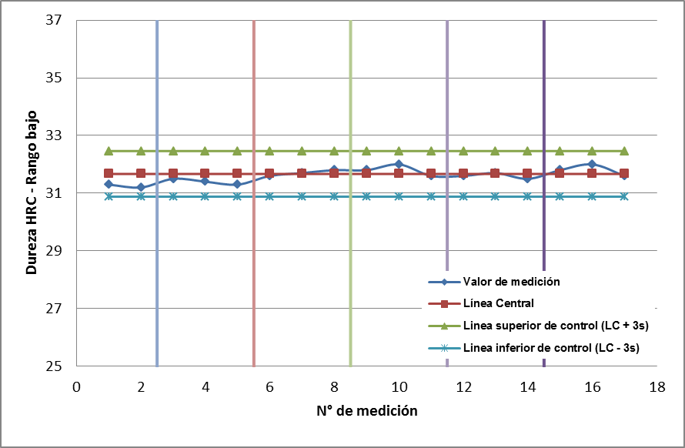

25-03-15

18-04-16

03-11-16

20-06-17

20-11-17

23-05-18

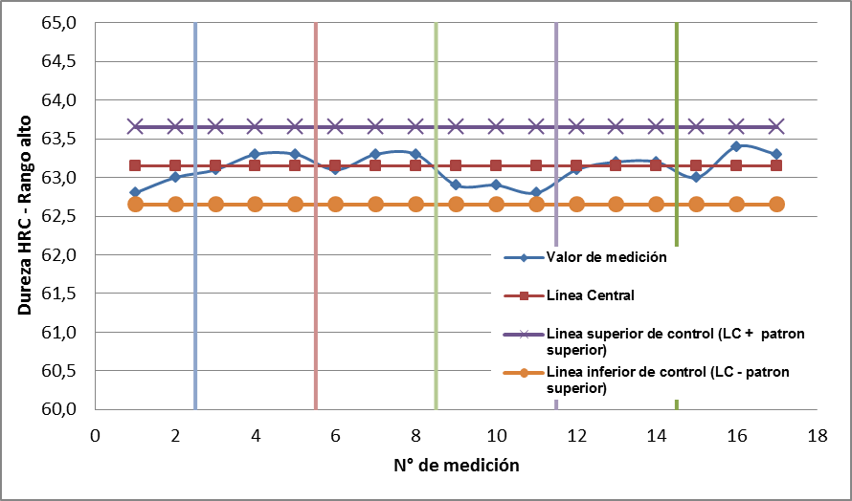

25-03-15

18-04-16

03-11-16

20-06-17

20-11-17

23-05-18

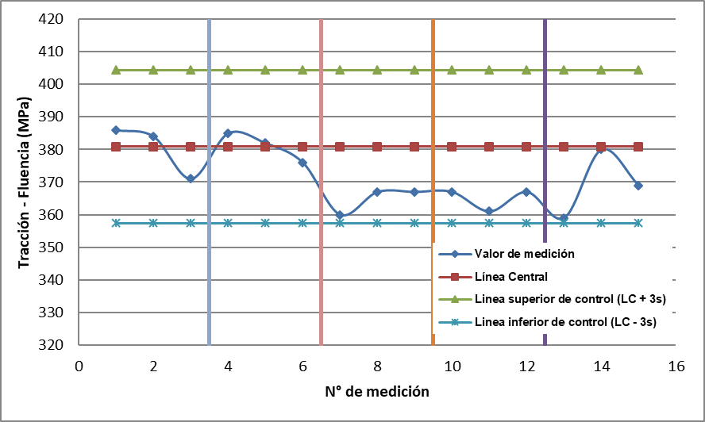

21-12-16

20-06-17

06-12-17

13-07-18

18-07-18

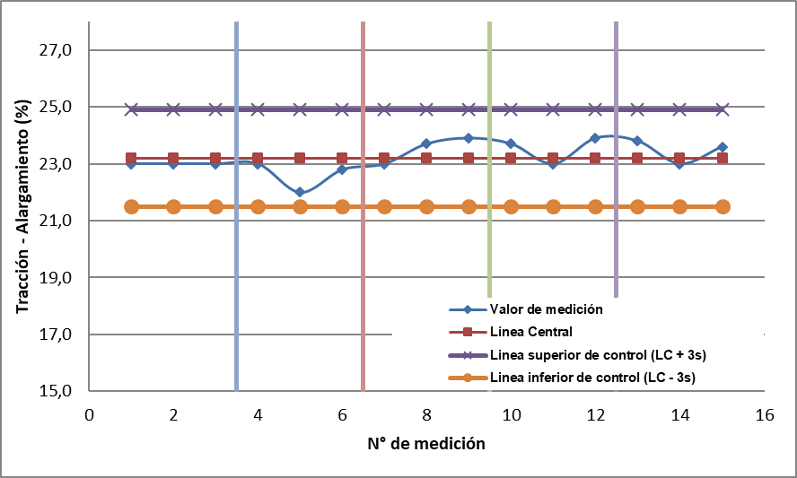

21-12-16

20-06-17

06-12-17

13-07-18

18-07-18

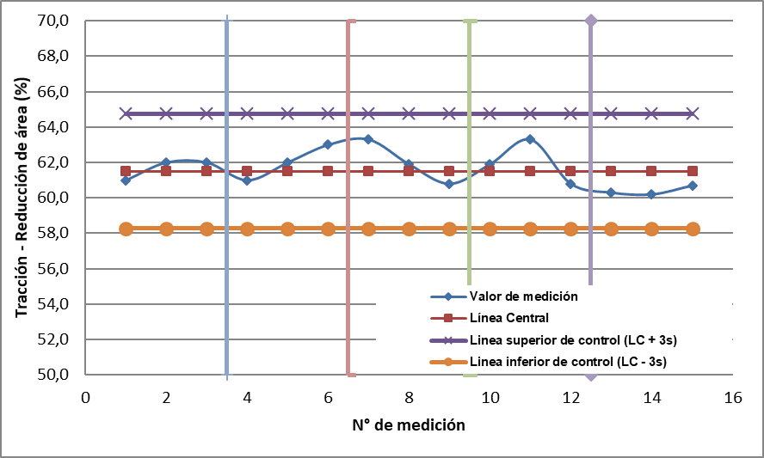

21-12-16

20-06-17

06-12-17

13-07-18

18-07-18

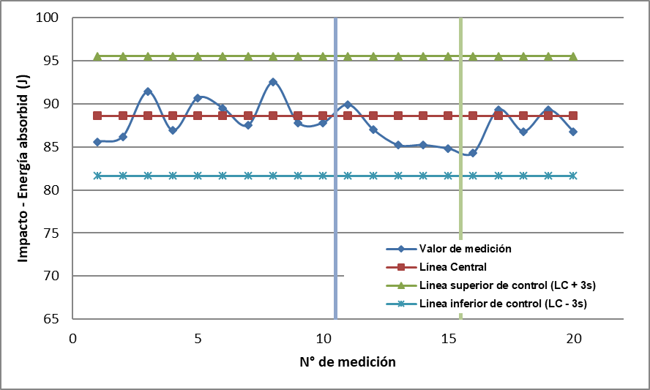

15-11-17

05-06-18

17-07-18