Membuat File Aplikasi Mycroft Precise pada Ubuntu 16.04 LTS

Note : Metode pemasangan berlaku umum sehingga dapat diterapkan pada OS  
Ubuntu berbagai arsitektur termasuk Ubuntu Arm dan Ubuntu Aarch64

1. Pastikan bahwa terminal sedang berjalan dalam Virtual Environment Python:



1. Buat folder baru:

|  |
| --- |
| $ mkdir mycroft-precise  $ cd mycroft-precise |

1. Buat script Python (terlampir):

|  |
| --- |
| $ nano mycroft-precise.py |

1. Buat file spec pyinstaller (terlampir):

|  |
| --- |
| $ nano mycroft-precise.spec |

1. Build aplikasi Mycroft Precise:

|  |
| --- |
| $ pyinstaller --clean -y mycroft-precise.spec |

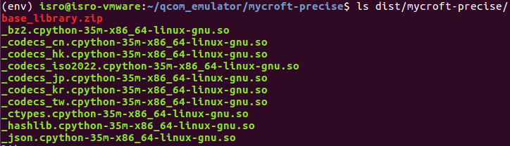

Perhatikan bahwa hasil build tersimpan pada folder mycroft-precise di dalam folder dist. Salin satu folder mycroft-precise secara utuh untuk dapat menjalankan aplikasi mycroft-precise di dalam folder tersebut.

Script Python Aplikasi Mycroft Precise

|  |
| --- |
| from precise_runner import PreciseEngine, PreciseRunner  from subprocess import call  import json  import logging  import sys  waiting = 1  def on_act():  global waiting  waiting = 0  def main():  try:  # load configuration file  with open("/data/mycroft-precise.json", "r") as json_file:  gva_config = json.load(json_file)  engine_path = gva_config["engine_path"]  model_path = gva_config["model_path"]  trigger_level = gva_config["trigger_level"]  sensitivity = gva_config["sensitivity"]  command = gva_config["command"]  except Exception as e:  logging.error("Error loading mycroft-precise.json: %s", e)  sys.exit(-1)  try:  # initiate precise engine with mycroft model  engine = PreciseEngine(engine_path, model_path)  # initiate precise runner that will listen, predict, and detect wakeword  runner = PreciseRunner(engine,  on_activation=on_act,  trigger_level=trigger_level,  sensitivity=sensitivity)  # start runner  runner.start()  except Exception as e:  logging.error("Wake Word Engine Error: %s", e)  sys.exit(-1)  # keep main thread active until user interrupt  try:  wait_for_user_trigger = True  global waiting  while True:  if wait_for_user_trigger:  logging.info("Waiting Wake Word")  while waiting == 1:  pass  if not command:  logging.info("Wake Word Detected")  else:  call(command)  waiting = 1  except Exception as e:  runner.stop()  logging.error("Mycroft Precise Error: %s", e)  sys.exit(-1)  if __name__ == "__main__":  main() |

Perhatikan bahwa '/data/mycroft-precise.json' adalah letak file konfigurasi.

File Spec PyInstaller Aplikasi Mycroft Precise

|  |
| --- |
| # -*- mode: python ; coding: utf-8 -*-  block_cipher = None  a = Analysis(['mycroft-precise.py'],  pathex=['.'],  binaries=[('/usr/lib/x86_64-linux-gnu/libxcb.so.1','.')],  datas=[],  hiddenimports=['_portaudio'],  hookspath=[],  runtime_hooks=[],  excludes=[],  win_no_prefer_redirects=False,  win_private_assemblies=False,  cipher=block_cipher,  noarchive=False)  pyz = PYZ(a.pure, a.zipped_data,  cipher=block_cipher)  exe = EXE(pyz,  a.scripts,  [],  exclude_binaries=True,  name='mycroft-precise',  debug=False,  bootloader_ignore_signals=False,  strip=False,  upx=True,  console=True )  coll = COLLECT(exe,  a.binaries,  a.zipfiles,  a.datas,  strip=False,  upx=True,  upx_exclude=[],  name='mycroft-precise') |

Perhatikan bahwa letak file '/usr/lib/x86_64-linux-gnu/libxcb.so.1' akan berbeda untuk arsitektur sistem yang berbeda, yaitu:

* Ubuntu Desktop (x86_64) : '/usr/lib/x86_64-linux-gnu/libxcb.so.1'
* Ubuntu Arm (ARM 32) : '/usr/lib/arm-linux-gnueabihf/libxcb.so.1'
* Ubuntu Aarch64 (ARM 64) : '/usr/lib/aarch64-linux-gnu/libxcb.so.1'