Membuat File Aplikasi Google Assistant (GVA) terintegrasi Mycroft Precise pada Ubuntu 16.04 LTS

Note : Metode pemasangan berlaku umum sehingga dapat diterapkan pada OS  
Ubuntu berbagai arsitektur termasuk Ubuntu Arm dan Ubuntu Aarch64

1. Pastikan bahwa terminal sedang berjalan dalam Virtual Environment Python:



1. Buat folder baru:

|  |
| --- |
| $ mkdir google-assistant $ cd google-assistant |

1. Pasang paket library Python terkait google-assistant:

|  |
| --- |
| $ python -m pip install --upgrade google-assistant-sdk[samples] google-api-core |

1. Modifikasi file sounddevice pada paket library Python sounddevice  
   (file ini perlu diubah untuk menghindari penggunaan library PortAudio yang tidak sesuai):

|  |
| --- |
| $ nano ../env/lib64/python3.5/site-packages/sounddevice.py |

Atau:

|  |
| --- |
| $ nano ../env/lib/python3.5/site-packages/sounddevice.py |

Perhatikan bahwa sistem 32bit hanya memiliki folder env/lib dan tidak memiliki folder env/lib64.

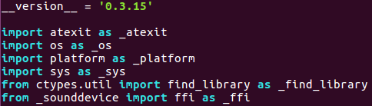

Untuk modifikasi pertama, hapus find_library dari file:

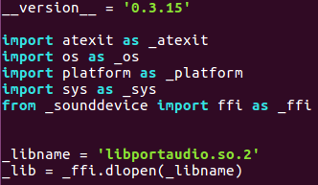

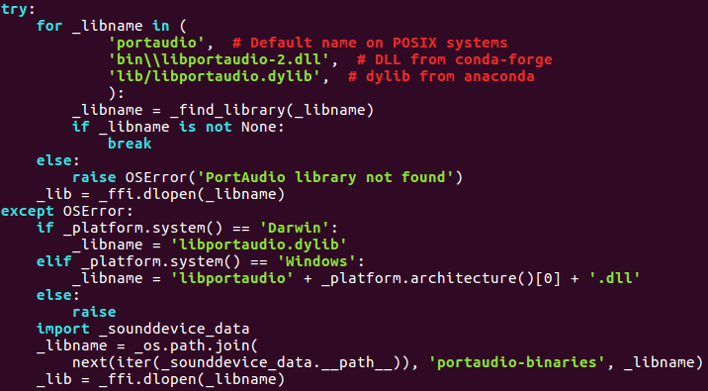

Untuk modifikasi kedua, hapus proses deteksi library PortAudio:



1. Buat script Python (terlampir):

|  |
| --- |
| $ nano gva-mycroft.py |

1. Buat file spec pyinstaller (terlampir):

|  |
| --- |
| $ nano gva-mycroft.spec |

1. Build aplikasi Google Assistant terintegrasi Mycroft Precise:

|  |
| --- |
| $ pyinstaller --clean -y gva-mycroft.spec |

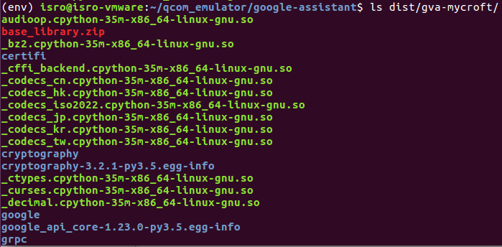

Perhatikan bahwa hasil build tersimpan pada folder gva-mycroft di dalam folder dist. Salin satu folder gva-mycroft secara utuh untuk dapat menjalankan aplikasi gva-mycroft di dalam folder tersebut.

Script Python Aplikasi Google Assistant terintegrasi Mycroft Precise

|  |
| --- |
| from precise_runner import PreciseEngine, PreciseRunner  from subprocess import call  import json  import logging  import os  import os.path  import pathlib2 as pathlib  import sys  import uuid  import grpc  import google.auth.transport.grpc  import google.auth.transport.requests  import google.oauth2.credentials  from google.assistant.embedded.v1alpha2 import embedded_assistant_pb2  from google.assistant.embedded.v1alpha2 import embedded_assistant_pb2_grpc  from googlesamples.assistant.grpc import assistant_helpers  from googlesamples.assistant.grpc import audio_helpers  ASSISTANT_API_ENDPOINT = 'embeddedassistant.googleapis.com'  END_OF_UTTERANCE = embedded_assistant_pb2.AssistResponse.END_OF_UTTERANCE  DIALOG_FOLLOW_ON = embedded_assistant_pb2.DialogStateOut.DIALOG_FOLLOW_ON  CLOSE_MICROPHONE = embedded_assistant_pb2.DialogStateOut.CLOSE_MICROPHONE  PLAYING = embedded_assistant_pb2.ScreenOutConfig.PLAYING  DEFAULT_GRPC_DEADLINE = 60 * 3 + 5  waiting = 1  class SampleAssistant(object):  """Sample Assistant that supports conversations and device actions.  Args:  device_model_id: identifier of the device model.  device_id: identifier of the registered device instance.  conversation_stream(ConversationStream): audio stream  for recording query and playing back assistant answer.  channel: authorized gRPC channel for connection to the  Google Assistant API.  deadline_sec: gRPC deadline in seconds for Google Assistant API call.  """  def __init__(self, language_code, device_model_id, device_id, conversation_stream, channel, deadline_sec):  self.language_code = language_code  self.device_model_id = device_model_id  self.device_id = device_id  self.conversation_stream = conversation_stream  # Opaque blob provided in AssistResponse that,  # when provided in a follow-up AssistRequest,  # gives the Assistant a context marker within the current state  # of the multi-Assist()-RPC "conversation".  # This value, along with MicrophoneMode, supports a more natural  # "conversation" with the Assistant.  self.conversation_state = None  # Force reset of first conversation.  self.is_new_conversation = True  # Create Google Assistant API gRPC client.  self.assistant = embedded_assistant_pb2_grpc.EmbeddedAssistantStub(channel)  self.deadline = deadline_sec  def __enter__(self):  return self  def __exit__(self, etype, e, traceback):  if e:  return False  self.conversation_stream.close()  def is_grpc_error_unavailable(e):  is_grpc_error = isinstance(e, grpc.RpcError)  if is_grpc_error and (e.code() == grpc.StatusCode.UNAVAILABLE):  logging.error('grpc unavailable error: %s', e)  return True  return False  def assist(self):  """Send a voice request to the Assistant and playback the response.  Returns: True if conversation should continue.  """  continue_conversation = False  self.conversation_stream.volume_percentage = 100  self.conversation_stream.start_recording()  logging.info('Recording audio request.')  call(["adk-message-send", "led_indicate_direction_pattern{pattern:1,direction:50}"])  def iter_log_assist_requests():  for c in self.gen_assist_requests():  assistant_helpers.log_assist_request_without_audio(c)  yield c  logging.debug('Reached end of AssistRequest iteration.')  # This generator yields AssistResponse proto messages  # received from the gRPC Google Assistant API.  for resp in self.assistant.Assist(iter_log_assist_requests(), self.deadline):  assistant_helpers.log_assist_response_without_audio(resp)  if resp.event_type == END_OF_UTTERANCE:  logging.info('End of audio request detected.')  logging.info('Stopping recording.')  call(["adk-message-send", "led_start_pattern{pattern:16}"])  self.conversation_stream.stop_recording()  if resp.speech_results:  logging.info('Transcript of user request: "%s".', ' '.join(r.transcript for r in resp.speech_results))  if len(resp.audio_out.audio_data) > 0:  if not self.conversation_stream.playing:  self.conversation_stream.stop_recording()  self.conversation_stream.start_playback()  logging.info('Playing assistant response.')  call(["adk-message-send", "led_start_pattern{pattern:2}"])  self.conversation_stream.write(resp.audio_out.audio_data)  if resp.dialog_state_out.conversation_state:  conversation_state = resp.dialog_state_out.conversation_state  logging.debug('Updating conversation state.')  self.conversation_state = conversation_state  if resp.dialog_state_out.volume_percentage != 0:  volume_percentage = resp.dialog_state_out.volume_percentage  logging.info('Setting volume to %s%%', volume_percentage)  self.conversation_stream.volume_percentage = volume_percentage  if resp.dialog_state_out.microphone_mode == DIALOG_FOLLOW_ON:  continue_conversation = True  logging.info('Expecting follow-on query from user.')  elif resp.dialog_state_out.microphone_mode == CLOSE_MICROPHONE:  continue_conversation = False  logging.info('Finished playing assistant response.')  call(["adk-message-send", "led_indicate_direction_pattern{pattern:17,direction:0}"])  self.conversation_stream.stop_playback()  return continue_conversation  def gen_assist_requests(self):  """Yields: AssistRequest messages to send to the API."""  config = embedded_assistant_pb2.AssistConfig(  audio_in_config=embedded_assistant_pb2.AudioInConfig(  encoding='LINEAR16',  sample_rate_hertz=self.conversation_stream.sample_rate,  ),  audio_out_config=embedded_assistant_pb2.AudioOutConfig(  encoding='LINEAR16',  sample_rate_hertz=self.conversation_stream.sample_rate,  volume_percentage=self.conversation_stream.volume_percentage,  ),  dialog_state_in=embedded_assistant_pb2.DialogStateIn(  language_code=self.language_code,  conversation_state=self.conversation_state,  is_new_conversation=self.is_new_conversation,  ),  device_config=embedded_assistant_pb2.DeviceConfig(  device_id=self.device_id,  device_model_id=self.device_model_id,  )  )  # Continue current conversation with later requests.  self.is_new_conversation = False  # The first AssistRequest must contain the AssistConfig  # and no audio data.  yield embedded_assistant_pb2.AssistRequest(config=config)  for data in self.conversation_stream:  # Subsequent requests need audio data, but not config.  yield embedded_assistant_pb2.AssistRequest(audio_in=data)  def on_act():  global waiting  waiting = 0  def main():  """Samples for the Google Assistant API.  Examples:  Run the sample with microphone input and speaker output:  $ python -m googlesamples.assistant  Run the sample with file input and speaker output:  $ python -m googlesamples.assistant -i <input file>  Run the sample with file input and output:  $ python -m googlesamples.assistant -i <input file> -o <output file>  """  # Google Assistant Setting.  api_endpoint = ASSISTANT_API_ENDPOINT  lang = 'en-US'  grpc_deadline = DEFAULT_GRPC_DEADLINE  # Audio Setting.  audio_sample_rate = audio_helpers.DEFAULT_AUDIO_SAMPLE_RATE  audio_sample_width = audio_helpers.DEFAULT_AUDIO_SAMPLE_WIDTH  audio_iter_size = audio_helpers.DEFAULT_AUDIO_ITER_SIZE  audio_block_size = audio_helpers.DEFAULT_AUDIO_DEVICE_BLOCK_SIZE  audio_flush_size = audio_helpers.DEFAULT_AUDIO_DEVICE_FLUSH_SIZE  # Setup logging.  verbose = False  logging.basicConfig(level=logging.DEBUG if verbose else logging.INFO)  # Load OAuth 2.0 credentials.  try:  with open('/data/gva-mycroft.json', 'r') as json_file:  gva_config = json.load(json_file)  project_id = gva_config["project_id"]  device_model_id = gva_config["device_model_id"]  device_id = gva_config["device_id"]  credentials = gva_config["credentials"]  device_config = gva_config["device_config"]  engine_path = gva_config["engine_path"]  model_path = gva_config["model_path"]  trigger_level = gva_config["trigger_level"]  sensitivity = gva_config["sensitivity"]  except Exception as e:  logging.error("Error loading gva-mycroft.json: %s", e)  sys.exit(-1)  try:  with open(credentials, 'r') as f:  credentials = google.oauth2.credentials.Credentials(token=None, **json.load(f))  http_request = google.auth.transport.requests.Request()  credentials.refresh(http_request)  except Exception as e:  logging.error('Error loading credentials: %s', e)  logging.error('Run google-oauthlib-tool to initialize new OAuth 2.0 credentials.')  sys.exit(-1)  # Create an authorized gRPC channel.  grpc_channel = google.auth.transport.grpc.secure_authorized_channel(credentials, http_request, api_endpoint)  logging.info('Connecting to %s', api_endpoint)  # Configure audio source and sink.  audio_device = None  audio_source = audio_device = (  audio_device or audio_helpers.SoundDeviceStream(  sample_rate=audio_sample_rate,  sample_width=audio_sample_width,  block_size=audio_block_size,  flush_size=audio_flush_size  )  )  audio_sink = audio_device = (  audio_device or audio_helpers.SoundDeviceStream(  sample_rate=audio_sample_rate,  sample_width=audio_sample_width,  block_size=audio_block_size,  flush_size=audio_flush_size  )  )  # Create conversation stream with the given audio source and sink.  conversation_stream = audio_helpers.ConversationStream(  source=audio_source,  sink=audio_sink,  iter_size=audio_iter_size,  sample_width=audio_sample_width,  )  if not device_id or not device_model_id:  try:  with open(device_config) as f:  device = json.load(f)  device_id = device['id']  device_model_id = device['model_id']  logging.info("Using device model %s and device id %s", device_model_id, device_id)  except Exception as e:  logging.warning('Device config not found: %s' % e)  logging.info('Registering device')  if not device_model_id:  logging.error('Option --device-model-id required when registering a device instance.')  sys.exit(-1)  if not project_id:  logging.error('Option --project-id required when registering a device instance.')  sys.exit(-1)  device_base_url = ('https://%s/v1alpha2/projects/%s/devices' % (api_endpoint, project_id))  device_id = str(uuid.uuid1())  payload = {  'id': device_id,  'model_id': device_model_id,  'client_type': 'SDK_SERVICE'  }  session = google.auth.transport.requests.AuthorizedSession(credentials)  r = session.post(device_base_url, data=json.dumps(payload))  if r.status_code != 200:  logging.error('Failed to register device: %s', r.text)  sys.exit(-1)  logging.info('Device registered: %s', device_id)  pathlib.Path(os.path.dirname(device_config)).mkdir(exist_ok=True)  with open(device_config, 'w') as f:  json.dump(payload, f)  try:  # initiate precise engine with mycroft model  engine = PreciseEngine(engine_path, model_path)  # initiate precise runner that will listen, predict, and detect wakeword  runner = PreciseRunner(engine, on_activation=on_act, trigger_level=trigger_level, sensitivity=sensitivity)  # start runner  runner.start()  except Exception as e:  logging.error("Wake Word Engine Error: %s", e)  sys.exit(-1)  # keep main thread active until user interrupt  try:  with SampleAssistant(lang, device_model_id, device_id, conversation_stream, grpc_channel, grpc_deadline) as assistant:  wait_for_user_trigger = True  global waiting  call(["adk-message-send", "led_start_pattern{pattern:7}"])  while True:  if wait_for_user_trigger:  logging.info("Waiting Wake Word")  while waiting == 1:  pass  continue_conversation = assistant.assist()  wait_for_user_trigger = not continue_conversation  waiting = 1  except Exception as e:  runner.stop()  logging.error("Google Assistant Error: %s", e)  sys.exit(-1)  if __name__ == '__main__':  main() |

Perhatikan bahwa '/data/gva-mycroft.json' adalah letak file konfigurasi.

File Spec PyInstaller Aplikasi Google Assistant terintegrasi Mycroft Precise

|  |
| --- |
| # -*- mode: python ; coding: utf-8 -*-  block_cipher = None  from PyInstaller.utils.hooks import collect_data_files  grpc_datas = collect_data_files('grpc')  a = Analysis(['gva-mycroft.py'],  pathex=['.'],  binaries=[('/usr/lib/x86_64-linux-gnu/libxcb.so.1','.')],  datas=grpc_datas,  hiddenimports=[],  hookspath=[],  runtime_hooks=[],  excludes=[],  win_no_prefer_redirects=False,  win_private_assemblies=False,  cipher=block_cipher,  noarchive=False)  pyz = PYZ(a.pure, a.zipped_data,  cipher=block_cipher)  exe = EXE(pyz,  a.scripts,  [],  exclude_binaries=True,  name='gva-mycroft',  debug=False,  bootloader_ignore_signals=False,  strip=False,  upx=True,  console=True )  coll = COLLECT(exe,  a.binaries,  a.zipfiles,  a.datas,  strip=False,  upx=True,  upx_exclude=[],  name='gva-mycroft') |

Perhatikan bahwa letak file '/usr/lib/x86_64-linux-gnu/libxcb.so.1' akan berbeda untuk arsitektur sistem yang berbeda, yaitu:

* Ubuntu Desktop (x86_64) : '/usr/lib/x86_64-linux-gnu/libxcb.so.1'
* Ubuntu Arm (ARM 32) : '/usr/lib/arm-linux-gnueabihf/libxcb.so.1'
* Ubuntu Aarch64 (ARM 64) : '/usr/lib/aarch64-linux-gnu/libxcb.so.1'