HOMEWORK-01
GPIO, Timers, Interrupts
Debouncing & OLED Display
Embedded IoT Systems | Fall 2026 | BSCS 5th B
Student Name | M Faqi Ul Hassnain | Registration No. | 24-NTU-CS-FL-1061
Class / Section | BSCS-B_5TH Semester | Submission Date | 14-10-2026

Learning Outcomes
- Explain ESP32 GPIO configuration and safe digital input/output handling.
- Differentiate polling, hardware interrupts/ISR, and timer-based event handling.
- Explain switch bounce and implement non-blocking debouncing.
- Interface and update an SSD1306 OLED display over I²C.
- Build, simulate, test, and document one integrated embedded system in Wokwi and on a physical kit.

Part A — Technical Theory
Q1. GPIO configuration and operation
Explain the difference between INPUT, INPUT_PULLUP, and OUTPUT modes on the ESP32. Describe how a push button should be wired when using INPUT_PULLUP, what logic level is read when the button is pressed, and why GPIO selection and voltage limits matter.
Answer: A GPIO (General Purpose Input/Output) pin on the ESP32 can be configured in software with pinMode() to either read a digital voltage or drive one. The three common modes are compared below.
Mode | What the pin does | Typical use
INPUT | High-impedance input. The pin only senses the voltage on it and has no internal pull resistor, so if nothing drives it the pin "floats" and reads random 0/1 values. | Reading a sensor or module that already drives a clean HIGH/LOW (or a button with an external pull-up/pull-down resistor).
INPUT_PULLUP | Input with an internal pull-up resistor (about 45 kΩ on ESP32) connected to 3.3 V. With nothing connected the pin reads HIGH, so it never floats. | Push buttons and switches connected between the pin and GND, with no extra resistor needed.
OUTPUT | The pin is actively driven to 3.3 V (HIGH) or 0 V (LOW) using digitalWrite(). It can source or sink a small current. | Driving an LED (through a resistor), a transistor/relay driver, or a buzzer.

Button wiring with INPUT_PULLUP: One leg of the push button goes to the chosen GPIO (e.g. GPIO 18) and the other leg goes to GND. No external resistor is required because the internal pull-up is enabled with pinMode(18, INPUT_PULLUP).
3V3
|
[ R_pullup ~45k ] <- inside the ESP32 (enabled by INPUT_PULLUP)
|
+-------------------- GPIO 18
|
( BUTTON )
|
GND

Logic level: When the button is NOT pressed the pin is pulled up to 3.3 V, so digitalRead() returns HIGH (1). When the button is pressed it connects the pin directly to GND, so digitalRead() returns LOW (0). This is called active-low logic: pressed = LOW, released = HIGH.
Why GPIO selection and voltage limits matter:
- 3.3 V logic: ESP32 pins work at 3.3 V and are not 5 V tolerant. Connecting a 5 V signal directly can permanently damage the pin or the chip. A level shifter or voltage divider is needed for 5 V signals.
- Current limits: Each pin can only supply or sink a few tens of mA at most (about 10–12 mA is a safe working value), so LEDs need series resistors and heavy loads need a transistor or driver.
- Pin capabilities differ: GPIO 34–39 are input-only and have no internal pull-up/pull-down, so INPUT_PULLUP does not work on them. GPIO 6–11 are connected to the on-board flash and must not be used.
- Strapping pins: GPIO 0, 2, 5, 12 and 15 affect boot mode at reset. A button or device holding them at the wrong level during boot can stop the ESP32 from starting or uploading properly. This is why a safe general-purpose pin such as GPIO 18 is chosen for the button.
Q2. Timers and non-blocking design
What is the purpose of a timer in an embedded system? Compare delay()-based timing with millis()-based or timer-driven non-blocking timing. Give one practical example where non-blocking timing allows the display, button, and another task to remain responsive.
Answer: A timer is a hardware counter driven by a clock. Its purpose is to measure time and to trigger actions at precise moments or intervals (blinking an LED every 500 ms, sampling a sensor every second, generating PWM, timing out a debounce window, or creating a periodic interrupt) without the program having to waste CPU effort counting. The Arduino functions millis() and micros() are built on such a hardware timer: they return the time elapsed since boot.
Feature | delay()-based (blocking) | millis() / timer-based (non-blocking)
How it works | delay(500) halts the program on that line for 500 ms; the CPU does nothing useful meanwhile. | The code stores a start time and, on every pass of loop(), checks if (millis() - lastTime >= interval). If not, it simply moves on.
Responsiveness | Buttons, sensors and display are ignored during the delay. A short press can be missed completely. | loop() keeps running thousands of times per second, so all tasks are serviced quickly.
Multitasking | Only one timed activity at a time is practical. | Many independent timers can run together with separate variables.
Code style | Very simple, good only for tiny demos. | Slightly longer but scalable; suited to real IoT firmware.

Practical example: In this lab project the ESP32 must (1) blink a heartbeat LED every 500 ms, (2) read the push button, and (3) refresh the OLED when the count changes. With delay(500) for the LED, the button would be unresponsive for half a second and presses would be lost. With millis(), the code checks the LED timer, the button state and the display update flag in every loop pass:
unsigned long lastBlink = 0;
void loop() {
if (millis() - lastBlink >= 500) { // Task 1: heartbeat LED
lastBlink = millis();
digitalWrite(LED_PIN, !digitalRead(LED_PIN));
}
readButtonWithDebounce(); // Task 2: button always checked
if (needRedraw) { updateOLED(); } // Task 3: display refreshed on demand
}

Because nothing blocks, the LED keeps blinking, the button reacts instantly and the OLED updates immediately after a valid press.
Q3. Interrupts and ISR
Define an interrupt and an Interrupt Service Routine (ISR). Explain the sequence from an interrupt event to ISR execution. State at least three good ISR practices for ESP32 Arduino code, and explain why lengthy display updates or Serial printing should generally not be performed inside an ISR.
Answer: Interrupt: a hardware (or software) signal that tells the CPU to temporarily pause the code it is running because an event needs urgent attention, for example a GPIO edge, a timer overflow or received UART data. ISR: the special function that runs in response to that interrupt, then returns control to the interrupted code. Unlike polling, where the CPU repeatedly checks a pin in loop(), an interrupt lets the hardware notify the CPU only when something happens.
Sequence from event to ISR execution:
- The event occurs (e.g. the button pin goes from HIGH to LOW) and the peripheral sets an interrupt flag.
- The interrupt controller checks that this interrupt is enabled (attachInterrupt(pin, isr, FALLING)) and its priority.
- The CPU finishes the current instruction and saves its context (program counter, registers) so it can resume later.
- The CPU jumps to the ISR address through the interrupt vector table.
- The ISR runs (short code, usually setting a flag or incrementing a counter).
- The ISR returns, the context is restored and the main program continues exactly where it stopped.
Button edge --> Interrupt flag --> CPU saves context --> ISR runs --> Context restored --> loop() resumes

Good ISR practices on ESP32 Arduino:
- Keep the ISR very short and fast: only record that the event happened (set a flag, increment a counter, store a timestamp) and do the real work in loop().
- Use IRAM_ATTR: declare the function as void IRAM_ATTR isr() so that it is placed in internal RAM and can execute even while flash cache is disabled.
- Declare shared variables volatile: variables changed in the ISR and read in loop() must be volatile so the compiler does not cache them; use a critical section (portENTER_CRITICAL_ISR / portMUX) for multi-byte values.
- Avoid blocking and unsafe calls: no delay(), no Serial.print(), no I²C/SPI transfers, no malloc/new and no long loops inside an ISR.
- Handle bounce: a mechanical button can trigger the ISR many times for one press, so record the time with millis() and ignore triggers within the debounce interval.
Why display updates and Serial printing should not be in an ISR: An ISR must finish in microseconds because while it runs, other tasks and often other interrupts are delayed. Updating an SSD1306 means sending about 1 KB of data over I²C (roughly 20–25 ms at 400 kHz), which is extremely long for an ISR. The I²C driver and Serial/UART functions also use buffers, locks, timeouts and interrupts of their own, and delay()/millis()-based waiting does not work normally inside an ISR. Calling them can cause missed events, corrupted display data, deadlocks, a watchdog timer reset or a "Guru Meditation Error" crash. The correct approach is: ISR sets a flag, loop() sees the flag and then updates the OLED and prints to Serial.
Q4. Switch debouncing
Explain mechanical switch bounce and why one physical press may be detected as multiple presses. Compare delay-based debouncing with timer/millis()-based debouncing. Describe a reliable state-based method that accepts one press only after the input has remained stable for a chosen debounce interval.
Answer: A mechanical push button contains metal contacts and a spring. When the contacts close they do not make one clean connection; they physically bounce against each other for a few milliseconds (typically 1–20 ms) before settling. During this time the electrical signal rapidly flips between HIGH and LOW. Since the ESP32 reads pins in microseconds, it sees every one of these flips as a separate transition, so a single human press can be counted as 2, 5 or even 10 presses.
Timing diagram (INPUT_PULLUP, active-low):
Ideal press : HIGH ______________|‾‾‾‾‾‾‾‾‾‾‾‾‾‾|______________ HIGH
(LOW while pressed)

Real signal : HIGH ____ |‾|_|‾|__|‾|_|‾‾‾‾‾‾‾‾‾‾‾‾‾‾‾|_|‾|_|‾|___ HIGH
^^^^^^^^^^^ ^^^^^^^^
press bounce (~5-20 ms) release bounce

Debounced : HIGH ___________________|_____________ LOW ____________ HIGH
accepted only after signal stays stable for DEBOUNCE_MS

Method | delay()-based debounce | millis()/timer-based debounce
Idea | Detect the first change, then call delay(50) and read again. | Remember when the input last changed and accept it only if it has stayed the same for 50 ms.
CPU behaviour | Blocks the whole program for the delay; OLED, Serial and other tasks freeze. | Non-blocking; loop() keeps running while the time window is being measured.
Reliability | Can miss fast presses, and a release during the delay is not seen. | Tracks press and release correctly and can handle several tasks at once.
Use | Only for very small demos. | Preferred for real embedded/IoT code (and required in this homework).

Reliable state-based method:
- Read the raw pin value every pass of loop() (reading).
- If reading is different from lastReading, the signal just changed: store lastChangeTime = millis() and update lastReading. This restarts the debounce timer on every bounce.
- If millis() - lastChangeTime >= DEBOUNCE_MS (e.g. 50 ms), the signal has been stable long enough, so it is considered a real level.
- Compare this stable level with the previously accepted stableState. Only if it is different, update stableState (a genuine state change).
- If the new stableState is LOW (pressed with INPUT_PULLUP), increment the press counter exactly once and set the display-update flag. When it changes back to HIGH, the button is considered released.
Because a new press is accepted only on a stable state change, contact bounce cannot create extra counts, and one physical press always gives one count.
Q5. OLED display and I²C
Describe how an SSD1306 OLED communicates with the ESP32 using I²C. Identify the purpose of SDA, SCL, VCC, and GND; state the usual ESP32 connections and address used in our lab; and explain the roles of display initialization, drawing text, and display.display() (or the library's equivalent refresh call).
Answer: I²C (Inter-Integrated Circuit) is a two-wire serial bus. The ESP32 acts as the master and generates the clock; the SSD1306 OLED is a slave device identified by a 7-bit address. Both lines are open-drain with pull-up resistors (usually already present on the OLED module), and many devices can share the same two wires. The master starts a transfer, sends the slave address, then sends command or data bytes, which the OLED acknowledges.
OLED pin | ESP32 connection | Purpose
VCC | 3V3 | Power supply of the display module (3.3 V; many modules also accept 5 V, but 3.3 V is used here).
GND | GND | Common ground reference shared by ESP32 and OLED; required for correct signal levels.
SDA | GPIO 21 | Serial Data line: carries address, commands and pixel data in both directions.
SCL | GPIO 22 | Serial Clock line: clock generated by the ESP32 to synchronise each data bit.

Address used in lab: 0x3C is the usual I²C address of a 128×64 SSD1306 module (some modules use 0x3D). It is passed to display.begin(SSD1306_SWITCHCAPVCC, 0x3C). The I²C bus is started with Wire.begin(21, 22), which are also the default ESP32 SDA/SCL pins.
Roles of the main steps:
- Initialization (display.begin): starts communication with the OLED at its address and sends the setup command sequence (display size, charge pump/voltage, contrast, scan direction, etc.) and allocates the frame buffer in ESP32 RAM. If it returns false, the wiring or address is wrong.
- Drawing text: functions such as clearDisplay(), setTextSize(), setTextColor(), setCursor() and println() only draw into the frame buffer stored in the ESP32's RAM (1024 bytes for 128×64). Nothing changes on the physical screen yet.
- display.display(): sends the whole frame buffer to the OLED over I²C so the pixels actually light up. Without calling it, the screen keeps showing the old content. It should be called only when something has changed (e.g. after a valid button press) to avoid wasting time on the I²C bus.

Part B — Practical Lab

Task: ESP32 OLED status display with a debounced push button
This project displays a title, the button status (PRESSED / RELEASED) and a press counter on an SSD1306 OLED. The button uses INPUT_PULLUP and a non-blocking millis()-based state debounce, so each physical press increases the counter exactly once. The same logic is run in Wokwi (VS Code/PlatformIO) and on the physical ESP32 kit.

1. Wiring / Pin table
Component / Pin | ESP32 connection | Notes
SSD1306 OLED VCC | 3V3 | 3.3 V supply
SSD1306 OLED GND | GND | Common ground
SSD1306 OLED SDA | GPIO 21 | I²C data line
SSD1306 OLED SCL | GPIO 22 | I²C clock line
Push button (leg 1) | GPIO 18 | Configured as INPUT_PULLUP; pressed reads LOW
Push button (leg 2) | GND | Completes the circuit when pressed

2. Implementation explanation
- Setup: Serial starts at 115200 baud, GPIO 18 is set to INPUT_PULLUP, I²C starts on GPIO 21/22 and the OLED is initialised at address 0x3C. The first screen shows the title, "Button: RELEASED" and "Count: 0".
- Debounce logic: loop() reads the pin each pass. Whenever the reading changes, the timestamp lastChangeTime is refreshed. Only when the reading has stayed unchanged for DEBOUNCE_MS (50 ms) is it accepted as the new stable state.
- Counting: The counter is increased only when the stable state changes from HIGH to LOW (a valid press). Holding the button down or bouncing does not add counts.
- Display and Serial: The OLED is redrawn only when the stable state changes (press and release), and the accepted press count is printed to the Serial Monitor for debugging.

3. Source code (src/main.cpp)
#include <Arduino.h>
#include <Wire.h>
#include <U8g2lib.h>

// Assignment
// Timer Interrupt + Button Debounce + I2C OLED
// Embedded IoT System Fall-2026
// Name: M Faqi
// Reg#: 24-NTU-CS-FL-1061

#define LED 4
#define BUTTON_PIN 5

// SSD1306 128x64 I2C OLED
U8G2_SSD1306_128X64_NONAME_F_HW_I2C display(
U8G2_R0,
U8X8_PIN_NONE
);

hw_timer_t *debounceTimer = NULL;

volatile bool debounceActive = false;
volatile bool ledState = false;
volatile bool buttonPressed = false;

unsigned long pressCount = 0;
bool previousButtonState = false;

// Button interrupt: starts debounce timer
void IRAM_ATTR onButtonISR()
{
if (!debounceActive)
{
debounceActive = true;
timerWrite(debounceTimer, 0);
timerAlarmEnable(debounceTimer);
}
}

// Timer callback: confirms valid button press
void IRAM_ATTR onDebounceTimer()
{
if (digitalRead(BUTTON_PIN) == LOW)
{
ledState = !ledState;
digitalWrite(LED, ledState);
buttonPressed = true;
}

debounceActive = false;
}

// Update OLED display
void updateDisplay()
{
display.clearBuffer();

display.setFont(u8g2_font_6x12_tr);
display.drawStr(0, 12, "BUTTON COUNTER");
display.drawHLine(0, 16, 128);

display.setCursor(0, 32);
display.print("Button: ");
display.print(previousButtonState ? "PRESSED" : "RELEASED");

display.setCursor(0, 46);
display.print("Press Count: ");
display.print(pressCount);

display.setCursor(0, 61);
display.print("LED: ");
display.print(ledState ? "ON" : "OFF");

display.sendBuffer();
}

void setup()
{
pinMode(LED, OUTPUT);
digitalWrite(LED, LOW);

pinMode(BUTTON_PIN, INPUT_PULLUP);

// I2C pins: SDA 21, SCL 22
Wire.begin(21, 22);
display.begin();

// Show initial screen
pressCount = 0;
previousButtonState = false;
updateDisplay();

// Timer setup (Arduino-ESP32 2.x API)
debounceTimer = timerBegin(1, 80, true);

timerAttachInterrupt(
debounceTimer,
&onDebounceTimer,
true
);

// 50 ms one-shot timer
timerAlarmWrite(debounceTimer, 50000, false);

attachInterrupt(
digitalPinToInterrupt(BUTTON_PIN),
onButtonISR,
FALLING
);
}

void loop()
{
// Read confirmed button event from timer callback
if (buttonPressed)
{
noInterrupts();
buttonPressed = false;
interrupts();

pressCount++;
previousButtonState = true;
updateDisplay();
}

// Show RELEASED when button is released
if (digitalRead(BUTTON_PIN) == HIGH &&
previousButtonState)
{
previousButtonState = false;
updateDisplay();
}
}

4. platformio.ini
[env:esp32dev]
platform = espressif32
board = esp32dev
framework = arduino
lib_deps = olikraus/U8g2

5. wokwi.toml
[wokwi]
version = 1
firmware = '.pio/build/esp32dev/firmware.bin'
elf = '.pio/build/esp32dev/firmware.elf'

6. diagram.json
{
"version": 1,
"author": "FAQI",
"editor": "wokwi",
"parts": [
{
"type": "board-esp32-devkit-c-v4",
"id": "esp",
"top": 0,
"left": 0,
"attrs": {}
},
{
"type": "wokwi-led",
"id": "led1",
"top": -100,
"left": 210,
"attrs": {
"color": "green"
}
},
{
"type": "wokwi-resistor",
"id": "r1",
"top": -45,
"left": 215,
"rotate": 90,
"attrs": {
"value": "330"
}
},
{
"type": "wokwi-pushbutton",
"id": "btn1",
"top": 130,
"left": 220,
"attrs": {
"color": "green"
}
},
{
"type": "board-ssd1306",
"id": "oled1",
"top": -190,
"left": 400,
"attrs": {
"i2cAddress": "0x3c"
}
}
],
"connections": [
["esp:TX", "$serialMonitor:RX", "", []],
["esp:RX", "$serialMonitor:TX", "", []],

["esp:4", "r1:1", "green", ["h50"]],
["r1:2", "led1:A", "green", ["v-20"]],
["led1:C", "esp:GND.1", "black", ["v20", "h-80"]],

["esp:5", "btn1:1.l", "blue", ["h60"]],
["btn1:2.l", "esp:GND.2", "black", ["h-30"]],

["esp:21", "oled1:SDA", "blue", ["h100", "v-160"]],
["esp:22", "oled1:SCL", "yellow", ["h120", "v-180"]],
["esp:3V3", "oled1:VCC", "red", ["h140", "v-200"]],
["esp:GND.3", "oled1:GND", "black", ["h160", "v-220"]]
],
"dependencies": {}
}

Evidence and Proof
All evidence is in the same order as the evidence table. Replace each box with the original screenshot/photo and keep the caption under it. File naming: StudentRegNo_W1_WokwiCircuit.png, StudentRegNo_W2_WokwiOutput.png, StudentRegNo_W3_Build.png, StudentRegNo_H1_HardwareSetup.jpg, StudentRegNo_H2_HardwareOutput.jpg, StudentRegNo_H3_SerialMonitor.png.
W1 — Wokwi circuit
Must be visible: ESP32, OLED, button, visible wiring, and component labels.
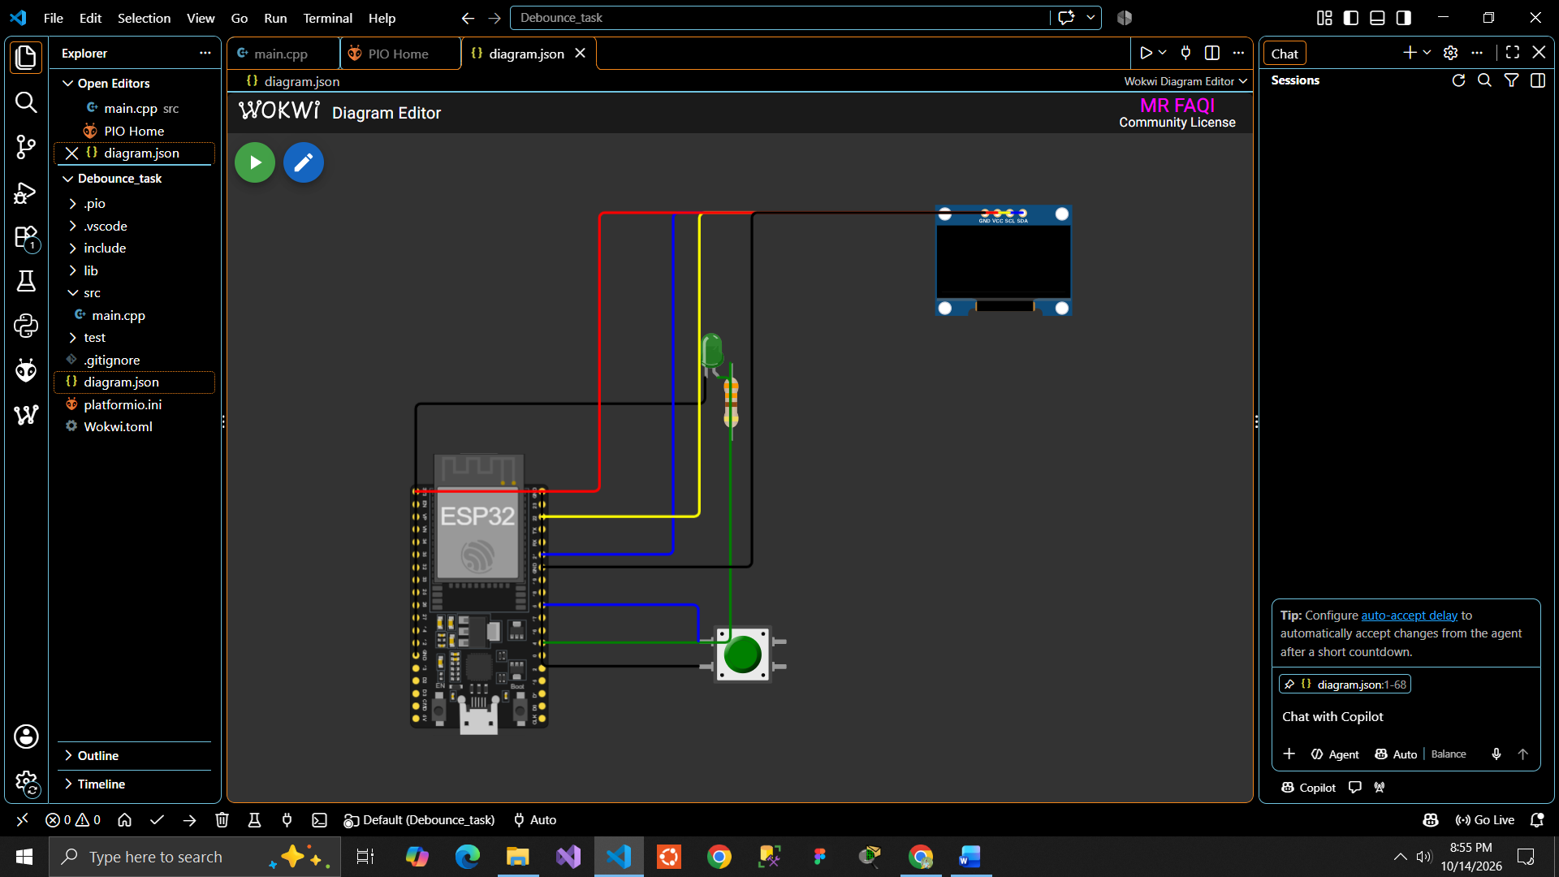
Caption: Complete Wokwi circuit showing ESP32, SSD1306 OLED and push button with all wires connected.
W2 — Wokwi output
Must be visible: OLED output and simulated circuit; count/status readable and non-zero.
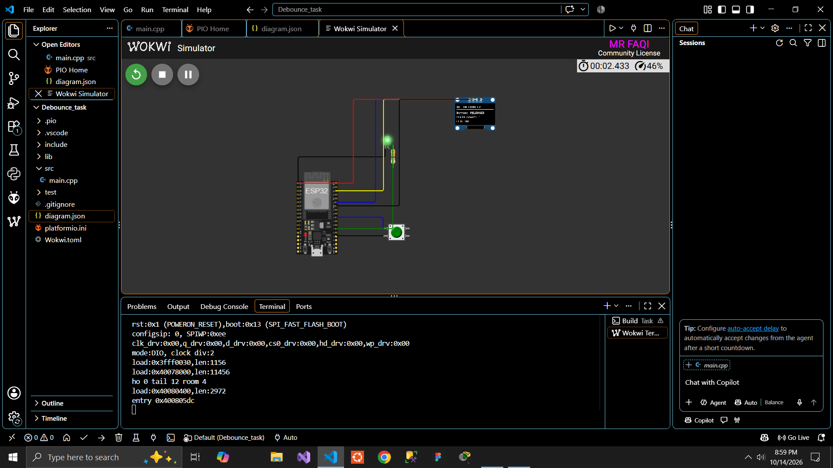
Caption: Running Wokwi simulation with the OLED showing the title, button status and a non-zero press count.
W3 — VS Code / PlatformIO
Must be visible: Project files and successful build result.
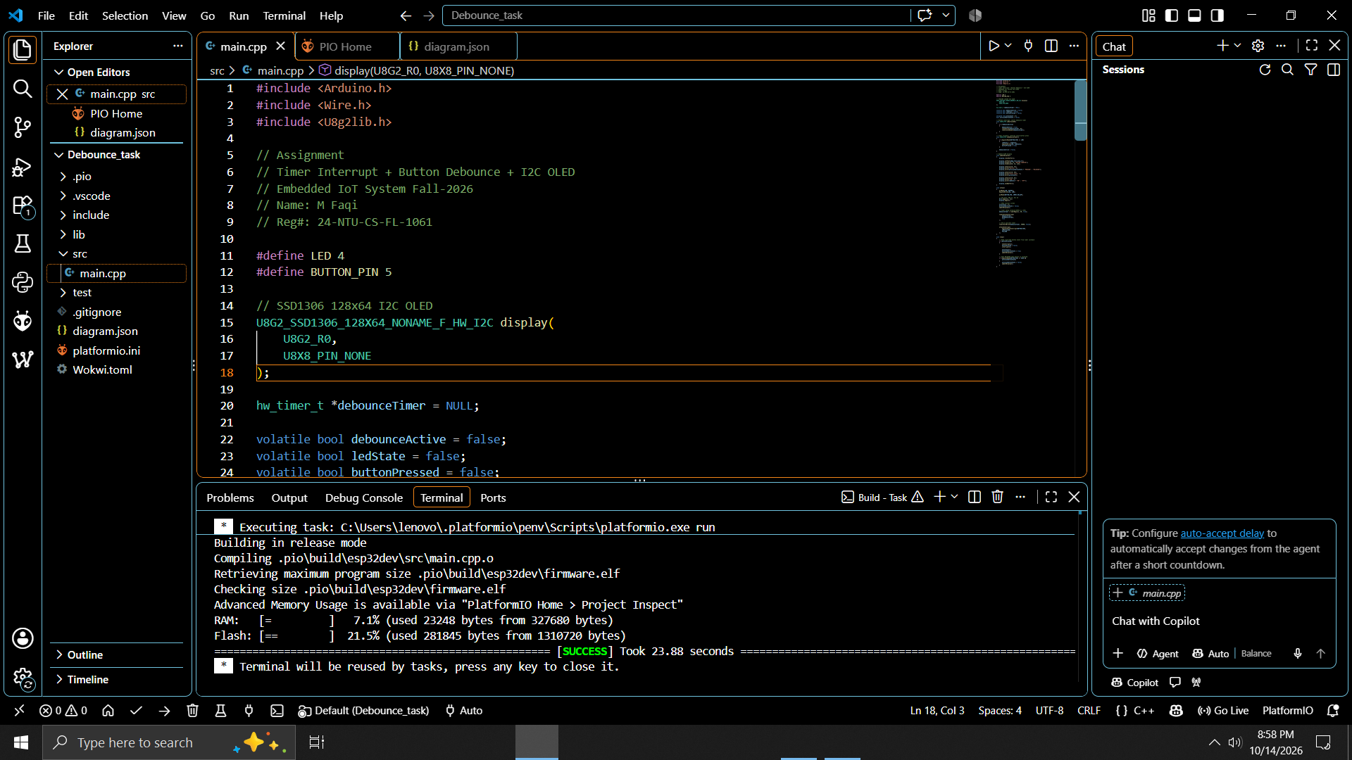
Caption: VS Code project structure with a successful PlatformIO build (SUCCESS) message.
H1 — Hardware setup
Must be visible: Physical ESP32 kit, OLED, and button wiring clearly visible.
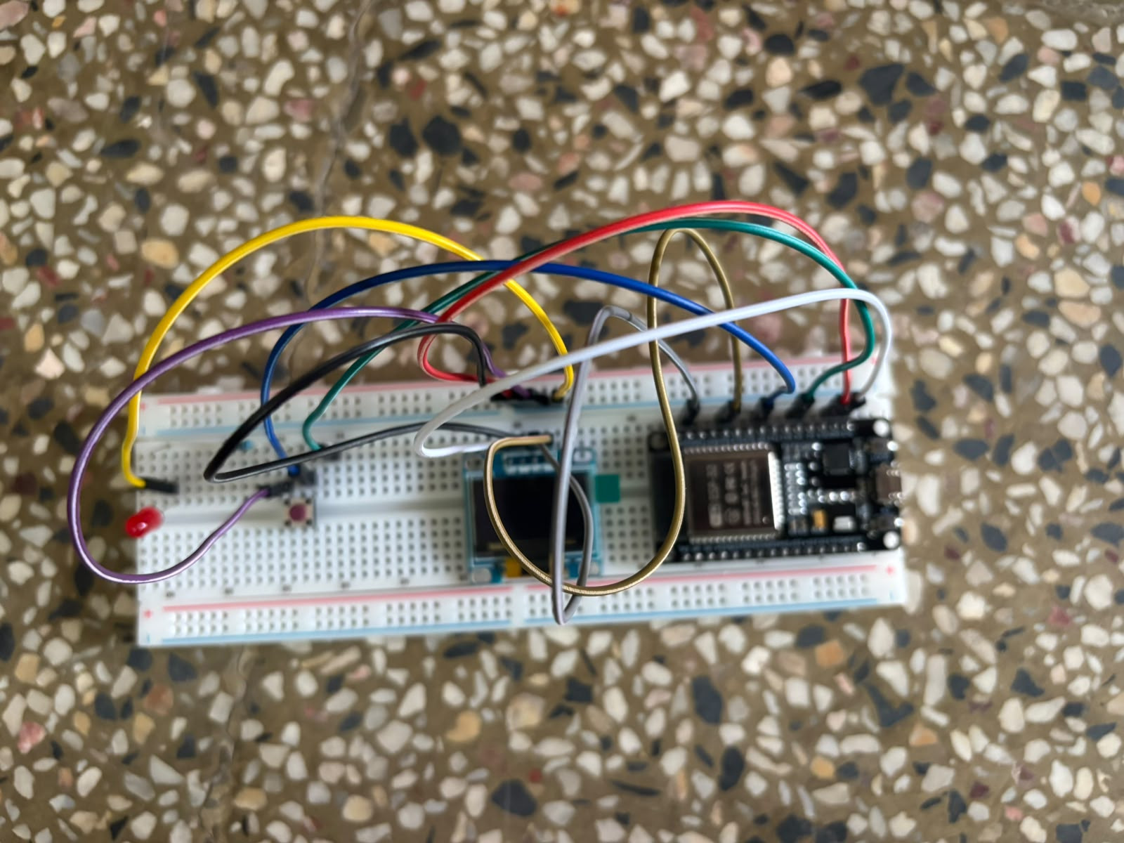
Caption: Real ESP32 kit with OLED and push button wired as per the pin table.
H2 — Hardware output
Must be visible: Real OLED showing the running project with non-zero count.
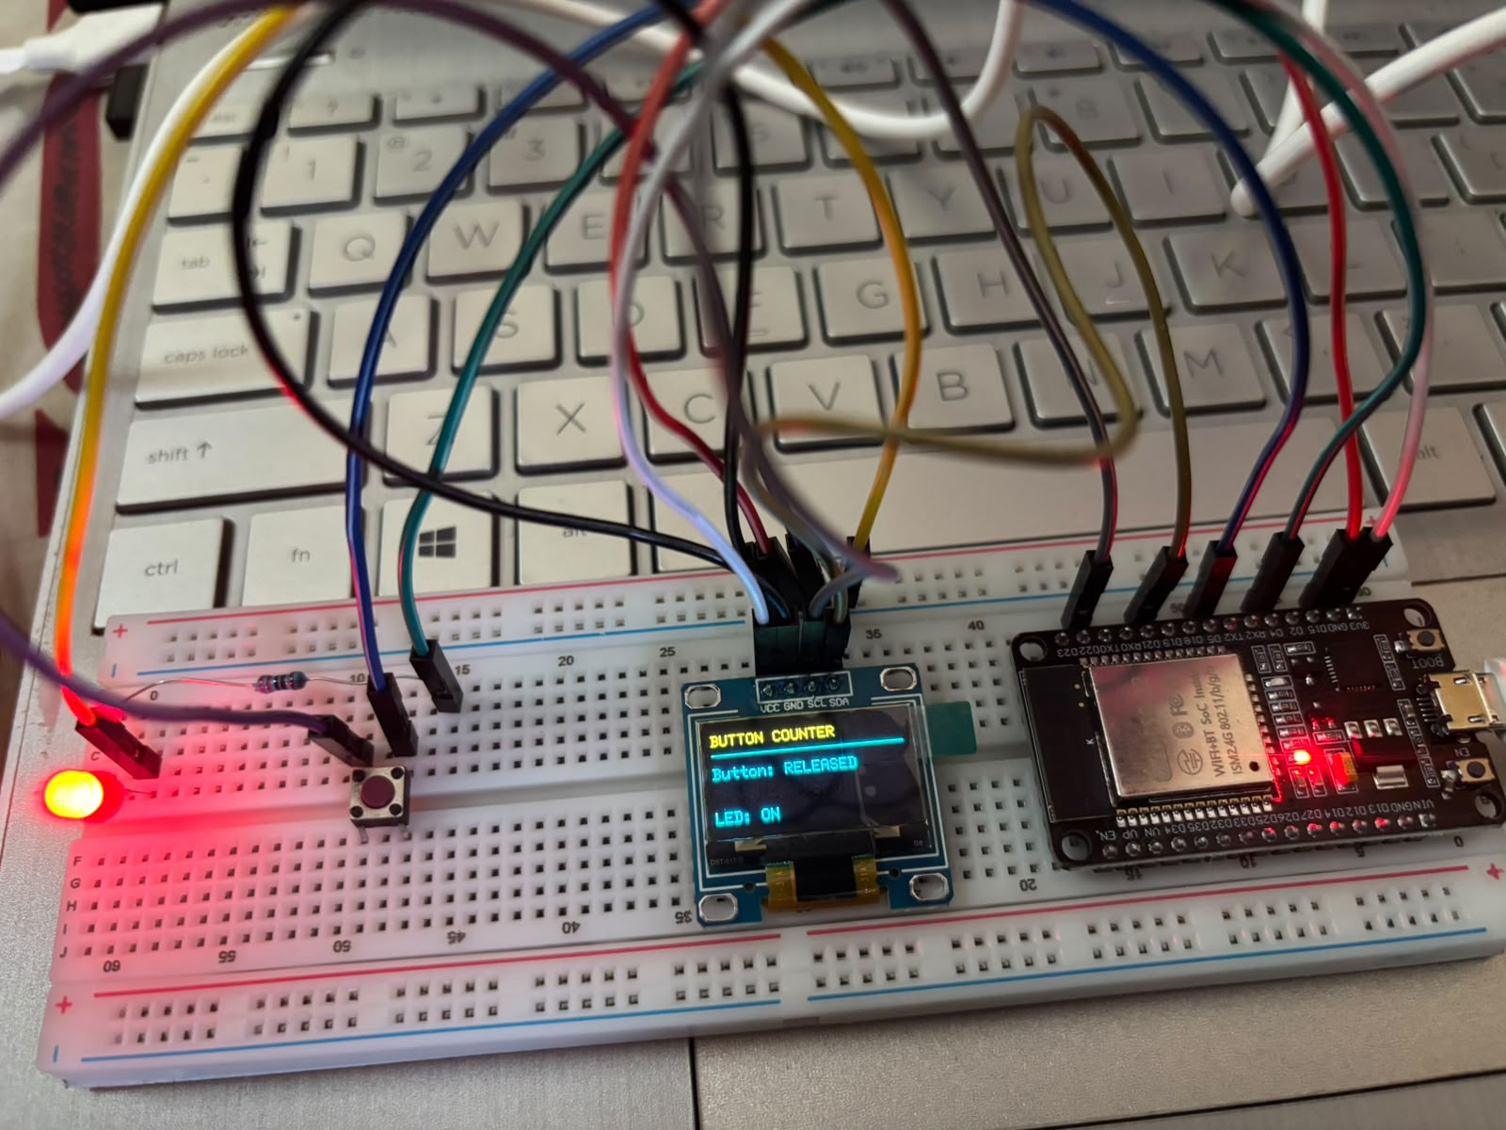
Caption: Physical OLED displaying the project title, status and a non-zero press count.
H3 — Hardware test (Serial Monitor)
Must be visible: Accepted press count / debug output after several presses.
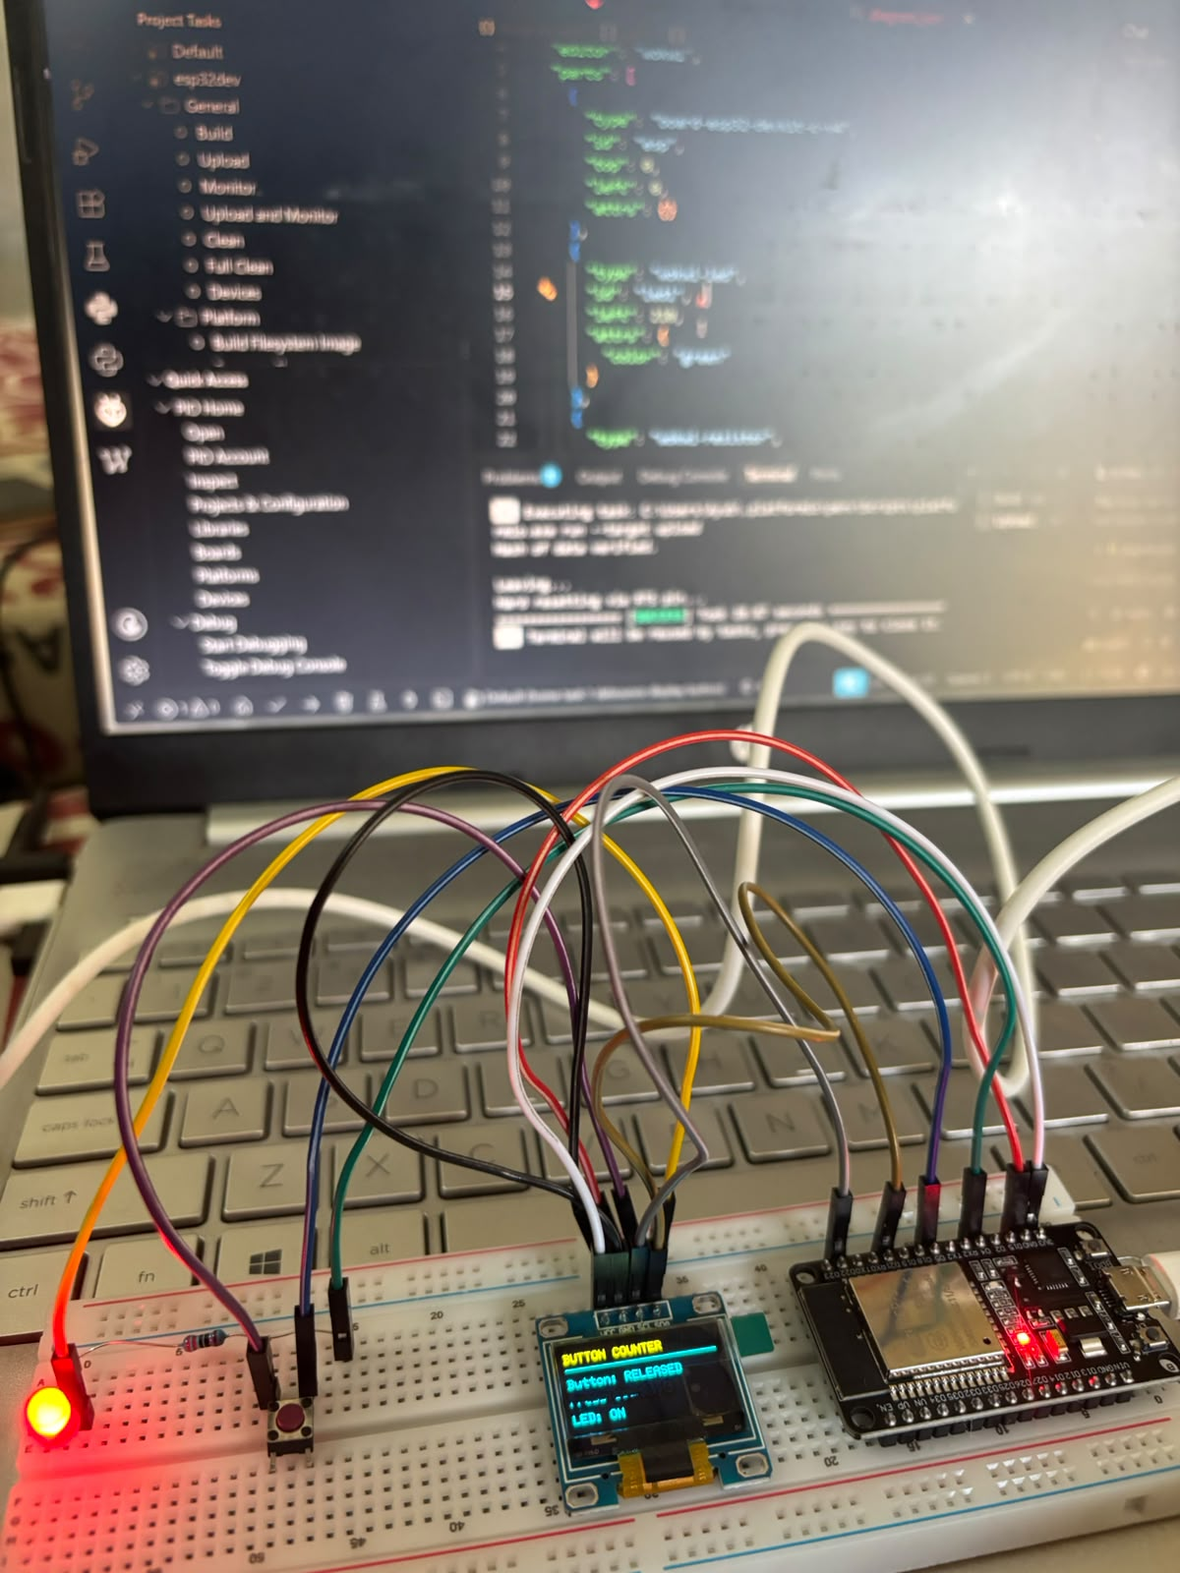
Caption: Serial Monitor output showing accepted press counts after several button presses.

Test Results

Summary test record
Environment | Number of presses | Expected final count | Observed final count / Pass?
Wokwi | 10 | 10 | 10
Hardware | 10 | 10 | 10

Detailed press-by-press table
Press # | Expected (Wokwi) | Observed (Wokwi) | Pass? (Wokwi) | Expected (HW) | Observed (HW) | Pass? (HW)
1 | 1 | 1 | Yes | 1 | 1 | Yes
2 | 2 | 2 | Yes | 2 | 2 | Yes
3 | 3 | 3 | Yes | 3 | 3 | Yes
4 | 4 | 4 | Yes | 4 | 4 | Yes
5 | 5 | 5 | Yes | 5 | 5 | Yes
6 | 6 | 6 | Yes | 6 | 6 | Yes
7 | 7 | 7 | Yes | 7 | 7 | Yes
8 | 8 | 8 | Yes | 8 | 8 | Yes
9 | 9 | 9 | Yes | 9 | 9 | Yes
10 | 10 | 10 | Yes | 10 | 10 | Yes

Comparison of simulation and hardware
(Write 3–4 lines here about your own results: whether both environments gave one count per press, and any wiring, timing or library issue you faced and how you solved it, e.g. wrong OLED address, SDA/SCL swapped, missing library in platformio.ini, or loose breadboard connection.)

Academic Integrity and Final Checklist
☐ I answered all five theory questions in my own words.
☐ My code compiles and I tested it in Wokwi and on the physical kit.
☐ The button count increases exactly once for each valid press.
☐ I included all required Wokwi screenshots and original hardware photos.
☐ Every evidence image has a caption and follows the requested file naming convention.
☐ I included the complete project folder and checked that files open correctly.

