HOMEWORK 2

Dual-LED PWM Control with OLED Monitoring
Wokwi Simulation • Physical Hardware • GitHub Submission
Student name: Muhammad Faqi Registration number: 24-NTU-CS-FL-1061
Course: Embedded IoT Systems Date: 30-OCT-2026

1. Objective
Design and test an ESP32-based system that independently fades two LEDs at different PWM frequencies, then displays their current duty-cycle percentages and configured frequencies on an SSD1306 I²C OLED.

2. Task 1 — Dual-LED fading with different PWM frequencies
Two LEDs are driven from GPIO 18 and GPIO 19 using separate LEDC channels. LED 1 uses 10,000 Hz and LED 2 uses 5,000 Hz. Both use 8-bit PWM (0–255 duty). The non-blocking millis() timers change brightness in opposite directions at the endpoints; LED 1 updates every 12 ms and LED 2 every 20 ms.

Task 1 source code (src/main.cpp)
//Task 1 — Dual-LED fading with different PWM frequencies

#include <Arduino.h>

// LED pins
const int LED1_PIN = 18;
const int LED2_PIN = 19;

const int LED1_CHANNEL = 0;
const int LED2_CHANNEL = 1;

// Different PWM frequencies
const int LED1_FREQ = 10000; // 10 kHz
const int LED2_FREQ = 5000; // 5 kHz

// 8-bit resolution: duty cycle 0-255
const int PWM_RESOLUTION = 8;
const int MAX_DUTY = 255;

// Duty-cycle values
int duty1 = 0;
int duty2 = 0;

// Fading directions
int direction1 = 1;
int direction2 = 1;

// Non-blocking timers
unsigned long lastFade1 = 0;
unsigned long lastFade2 = 0;

const unsigned long FADE_INTERVAL_1 = 12;
const unsigned long FADE_INTERVAL_2 = 20;

void updateFade(int &duty, int &direction, int channel) {
duty += direction;

if (duty >= MAX_DUTY) {
duty = MAX_DUTY;
direction = -1;
}
else if (duty <= 0) {
duty = 0;
direction = 1;
}

ledcWrite(channel, duty);
}

void setup() {
Serial.begin(115200);

// Configure separate PWM channels
ledcSetup(LED1_CHANNEL, LED1_FREQ, PWM_RESOLUTION);
ledcAttachPin(LED1_PIN, LED1_CHANNEL);

ledcSetup(LED2_CHANNEL, LED2_FREQ, PWM_RESOLUTION);
ledcAttachPin(LED2_PIN, LED2_CHANNEL);

ledcWrite(LED1_CHANNEL, 0);
ledcWrite(LED2_CHANNEL, 0);

Serial.println("Task 1: Dual LED PWM started");
Serial.println("LED 1: GPIO 18, Frequency: 10000 Hz");
Serial.println("LED 2: GPIO 19, Frequency: 5000 Hz");
Serial.println("Resolution: 8-bit");
}

void loop() {
unsigned long now = millis();

if (now - lastFade1 >= FADE_INTERVAL_1) {
lastFade1 = now;
updateFade(duty1, direction1, LED1_CHANNEL);
}

if (now - lastFade2 >= FADE_INTERVAL_2) {
lastFade2 = now;
updateFade(duty2, direction2, LED2_CHANNEL);
}
}

3. Task 2 — Display PWM parameters on OLED
The SSD1306 128 × 64 OLED uses I²C address 0x3C, SDA GPIO 21 and SCL GPIO 22. It displays both live duty percentages and configured frequencies. OLED updates occur every 150 ms. In this version LED 1 uses 1,000 Hz (changed from Task 1), while LED 2 remains at 5,000 Hz.

Task 2 source code (src/main.cpp)
// Task 2 - Dual LED PWM with OLE

#include <Arduino.h>
#include <Wire.h>
#include <Adafruit_GFX.h>
#include <Adafruit_SSD1306.h>

// LED pins
const int LED1_PIN = 18;
const int LED2_PIN = 19;

// PWM channels for ESP32 2.x
const int LED1_CHANNEL = 0;
const int LED2_CHANNEL = 1;

// Different PWM frequencies
const int LED1_FREQ = 1000;
const int LED2_FREQ = 5000;

// 8-bit resolution: duty values 0-255
const int PWM_RESOLUTION = 8;
const int MAX_DUTY = 255;

// OLED settings
#define SCREEN_WIDTH 128
#define SCREEN_HEIGHT 64
#define OLED_RESET -1
#define OLED_ADDRESS 0x3C

Adafruit_SSD1306 display(
SCREEN_WIDTH, SCREEN_HEIGHT, &Wire, OLED_RESET
);

// Current duty-cycle values
int duty1 = 0;
int duty2 = 0;

// Fading directions
int direction1 = 1;
int direction2 = 1;

// Update timers
unsigned long lastFade1 = 0;
unsigned long lastFade2 = 0;
unsigned long lastOLED = 0;

const unsigned long FADE_INTERVAL_1 = 12;
const unsigned long FADE_INTERVAL_2 = 20;
const unsigned long OLED_INTERVAL = 150;

// Display OLED information
void updateOLED() {
display.clearDisplay();
display.setTextColor(SSD1306_WHITE);
display.setTextSize(1);

display.setCursor(0, 0);
display.println("DUAL PWM MONITOR");

display.setCursor(0, 16);
display.print("LED1: ");
display.print((duty1 * 100 + 127) / 255);
display.print("% F:");
display.print(LED1_FREQ);
display.println("Hz");

display.setCursor(0, 32);
display.print("LED2: ");
display.print((duty2 * 100 + 127) / 255);
display.print("% F:");
display.print(LED2_FREQ);
display.println("Hz");

display.setCursor(0, 50);
display.println("PWM: 8-bit");

display.display();
}

// Update LED brightness
void updateFade(
int &duty,
int &direction,
int channel
) {
duty += direction;

if (duty >= MAX_DUTY) {
duty = MAX_DUTY;
direction = -1;
}
else if (duty <= 0) {
duty = 0;
direction = 1;
}

ledcWrite(channel, duty);
}

void setup() {
Serial.begin(115200);
delay(200);

// Initialize I2C: SDA = GPIO 21, SCL = GPIO 22
Wire.begin(21, 22);

// Configure LED1 PWM
ledcSetup(LED1_CHANNEL, LED1_FREQ, PWM_RESOLUTION);
ledcAttachPin(LED1_PIN, LED1_CHANNEL);

// Configure LED2 PWM
ledcSetup(LED2_CHANNEL, LED2_FREQ, PWM_RESOLUTION);
ledcAttachPin(LED2_PIN, LED2_CHANNEL);

// Start LEDs at zero brightness
ledcWrite(LED1_CHANNEL, 0);
ledcWrite(LED2_CHANNEL, 0);

// Initialize OLED
if (!display.begin(
SSD1306_SWITCHCAPVCC, OLED_ADDRESS
)) {
Serial.println("ERROR: OLED initialization failed!");

while (true) {
delay(1000);
}
}

display.clearDisplay();
updateOLED();

Serial.println("Dual LED PWM and OLED monitor ready.");
Serial.println("LED1 Frequency: 1000 Hz");
Serial.println("LED2 Frequency: 5000 Hz");
Serial.println("PWM Resolution: 8-bit");
}

void loop() {
unsigned long now = millis();

// Fade LED1
if (now - lastFade1 >= FADE_INTERVAL_1) {
lastFade1 = now;
updateFade(duty1, direction1, LED1_CHANNEL);
}

// Fade LED2
if (now - lastFade2 >= FADE_INTERVAL_2) {
lastFade2 = now;
updateFade(duty2, direction2, LED2_CHANNEL);
}

// Refresh OLED display
if (now - lastOLED >= OLED_INTERVAL) {
lastOLED = now;
updateOLED();
}
}

4. Technical explanation

Duty cycle and brightness
PWM rapidly switches the LED on and off. Duty cycle is the fraction of each cycle spent ON. With 8-bit resolution, a value of 0 represents 0% and 255 represents 100%. Increasing duty cycle generally increases perceived brightness. The OLED percentage is calculated as (duty × 100 + 127) / 255, rounded to the nearest whole percent.

PWM frequency and fading speed
PWM frequency is the number of switching cycles per second. Higher frequency shortens the PWM period and generally reduces visible flicker; it does not directly determine the fade speed. Fade speed is controlled by the 12 ms and 20 ms duty-update intervals. Each full up-and-down fade takes approximately 6.12 seconds for LED 1 and 10.2 seconds for LED 2.

LEDC resource limitation
The supplied code uses the Arduino-ESP32 2.x LEDC API (ledcSetup, ledcAttachPin, ledcWrite). Distinct channels must use compatible timer assignments to achieve different frequencies; actual LEDC timer sharing depends on the ESP32 variant and core. Verify both frequencies on the chosen board. Arduino-ESP32 3.x uses a changed LEDC API, so this code requires adaptation there.

5. Wiring and components
Component | Connection
LED 1 | GPIO 18 → current-limiting resistor → LED → GND
LED 2 | GPIO 19 → separate current-limiting resistor → LED → GND
OLED SDA | GPIO 21
OLED SCL | GPIO 22
OLED VCC / GND | Compatible supply voltage / common GND; check module specifications
Safety: Use a separate resistor for each LED, confirm the OLED module voltage/pinout, and disconnect power before changing connections.

6. Part A — Wokwi simulation evidence

Screenshot 1 — Complete Wokwi circuit (wokwi_circuit.png)
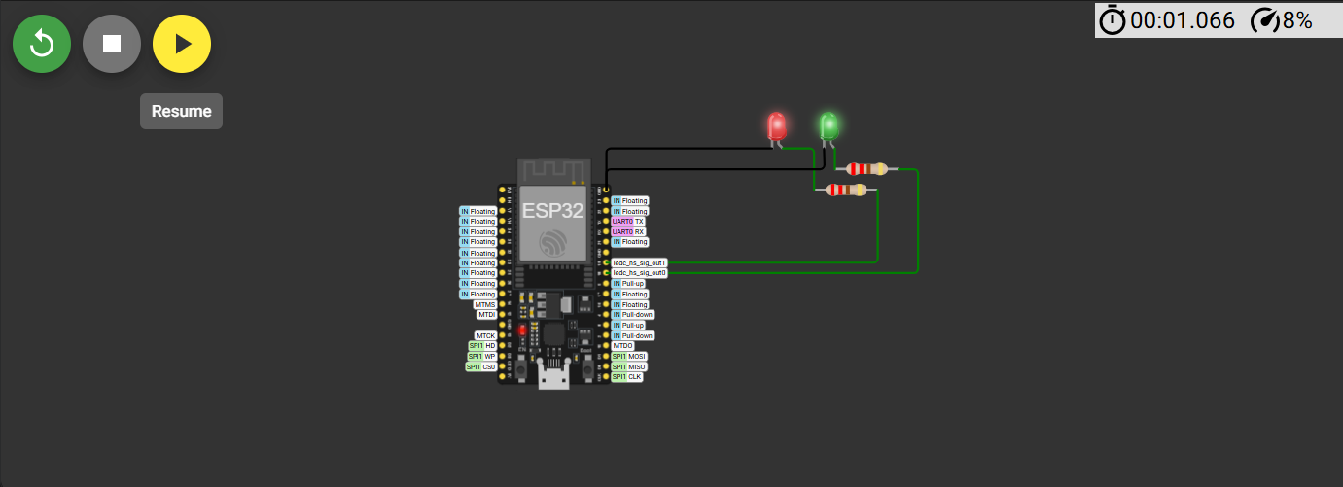

Screenshot 2 — Running Wokwi simulation with OLED visible (wokwi_running_oled.png)
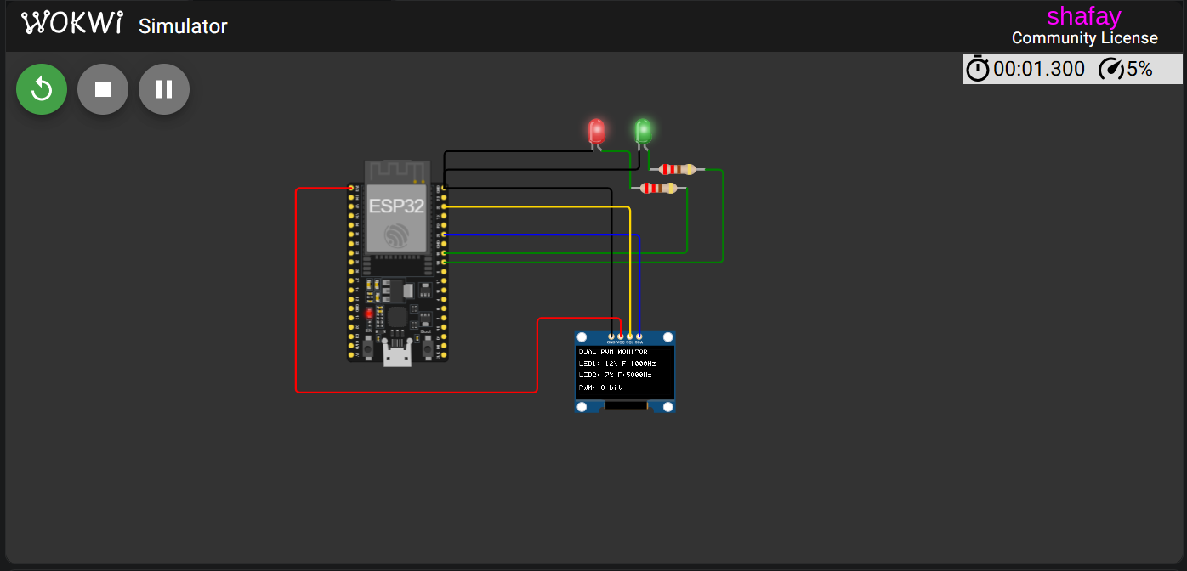
Wokwi project link: ______________________________________________________________
Simulation test notes (fill in after running): _____________________________________________

7. Part B — Physical hardware evidence

Photograph 1 — Complete hardware circuit (hardware_circuit.jpg)
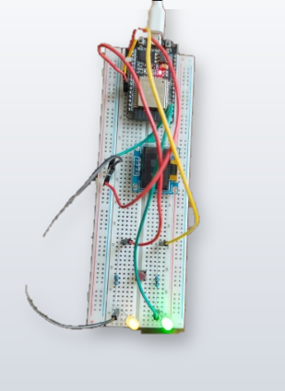

Photograph 2 — Hardware OLED output (hardware_oled_output.jpg)
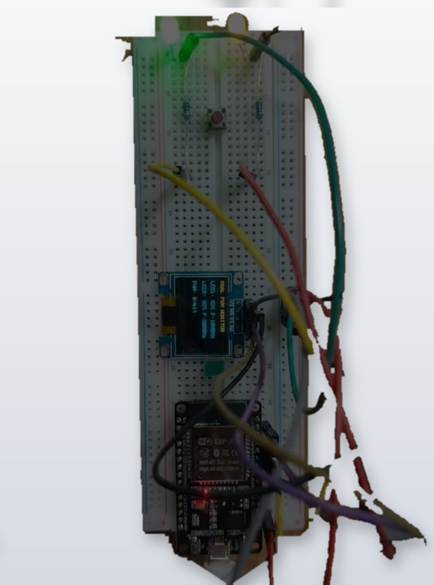
Hardware test notes (fill in after testing): ______________________________________________

8. Wokwi versus physical hardware comparison
Parameter | Wokwi result | Hardware result
LED 1 fading | To be verified | To be verified
LED 2 fading | To be verified | To be verified
OLED duty-cycle display | To be verified | To be verified
Configured frequencies | To be verified | To be verified
Differences / observations | To be verified | To be verified

9. Part C — GitHub submission
Repository link: ______________________________________________________________
Commit 1 (Task 1): task1 completed
Commit 2 (final OLED project): complete homework
Include diagram.json, wokwi.toml, platformio.ini, src/main.cpp, README.md, screenshots, photographs, and the Wokwi link in the same course repository.

10. Final submission checklist
☐ Updated diagram.json and final src/main.cpp
☐ Wokwi circuit screenshot
☐ Wokwi running OLED screenshot
☐ Working Wokwi project link
☐ Hardware circuit photograph
☐ Hardware OLED photograph
☐ GitHub repository link and both required commits
☐ README.md with wiring, frequencies, implementation, tests
☐ Short comparison of simulation and hardware
Submission: Provide screenshots/photographs and a brief technical explanation through Microsoft Teams, as specified in the assignment.

