**Nama : Faqih Zada Ikhsan  
NIM : 18090127  
Kelas : 5B**

1. **Source Code**

Latihan1.php : application/controllers

Latihan2.php : application/controllers

latihan2.php : view-application/views

Model1.php : application/models

1. **URL**

<http://localhost/pustaka_booking/index.php/Latihan1>

<http://localhost/pustaka_booking/index.php/Latihan1/penjumlahan/3/4>

<http://localhost/pustaka_booking/index.php/Latihan2/penjumlahan/3/4>

1. **Capture Hasil**

**Latihan 1**

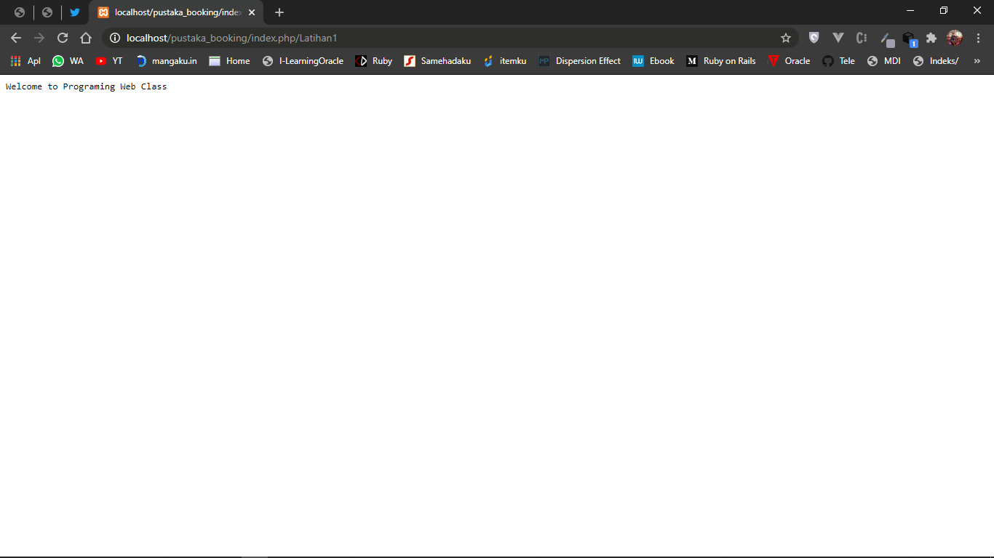

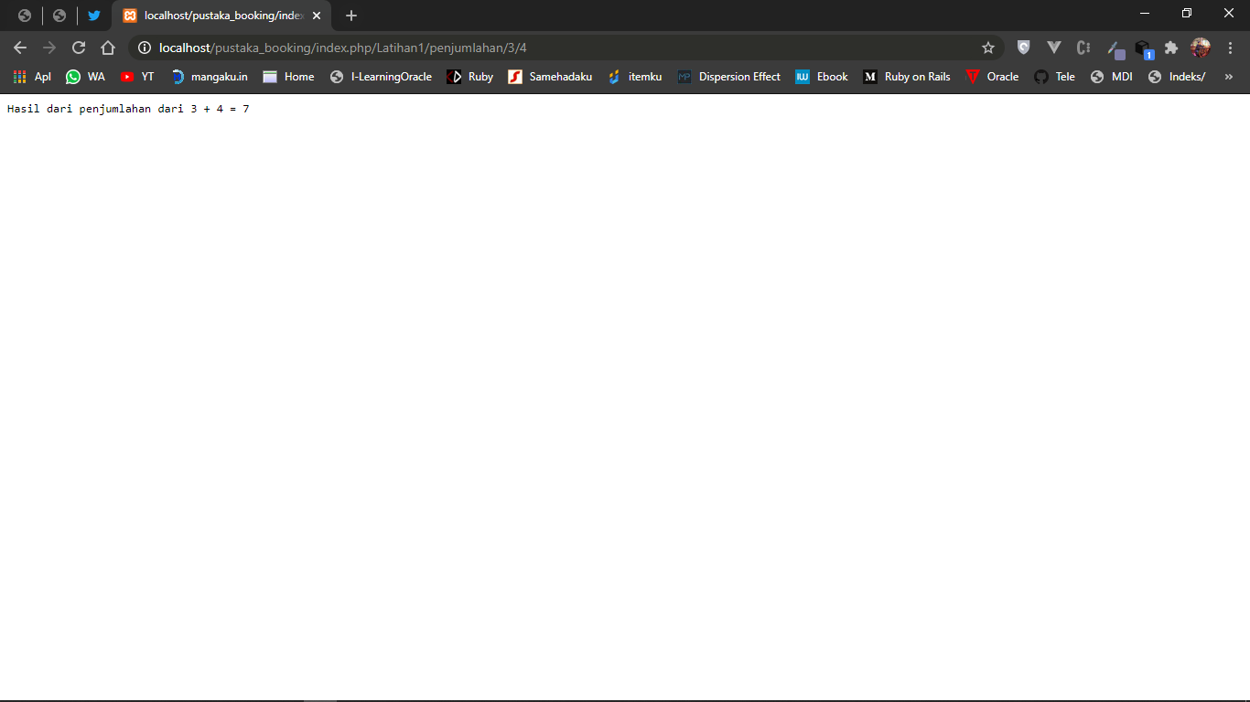

**Latihan 2**

