**Farhan Naufal**

**065117209**

**Kelas G**

1. **Laplacian Filter**

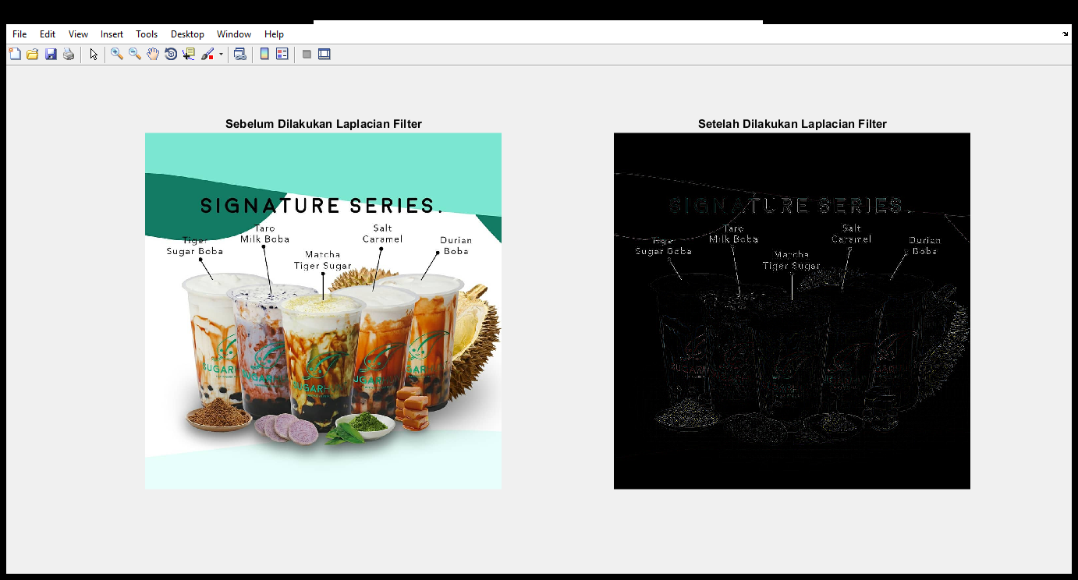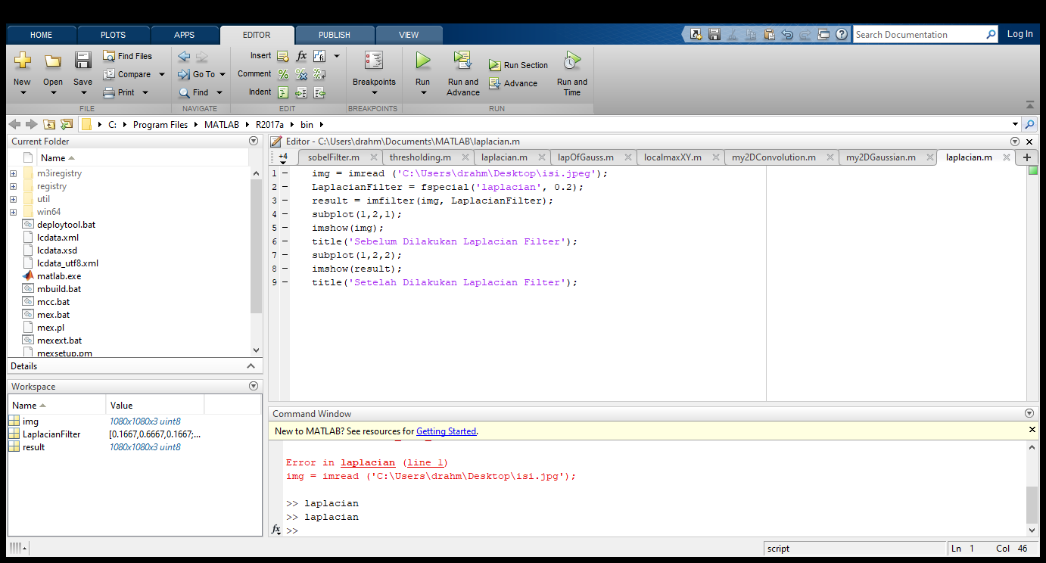

1. **Sobel Filter**

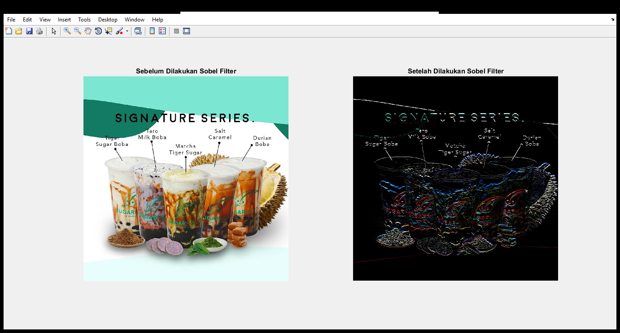

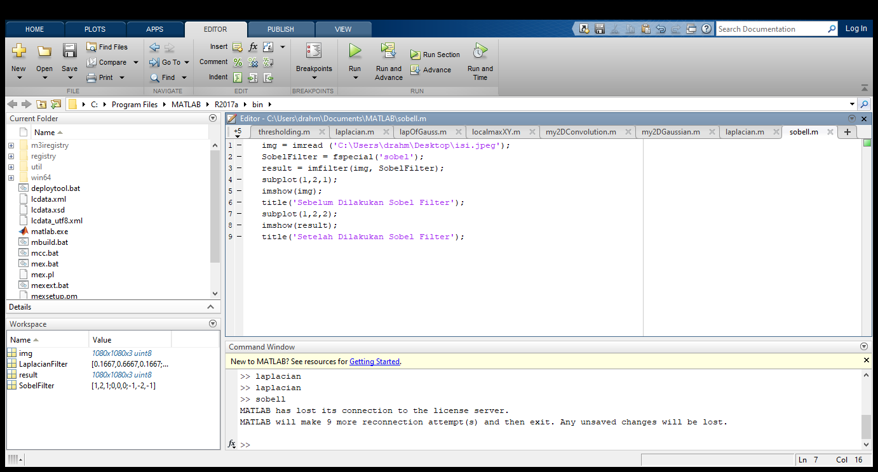

1. **Canny Filter**



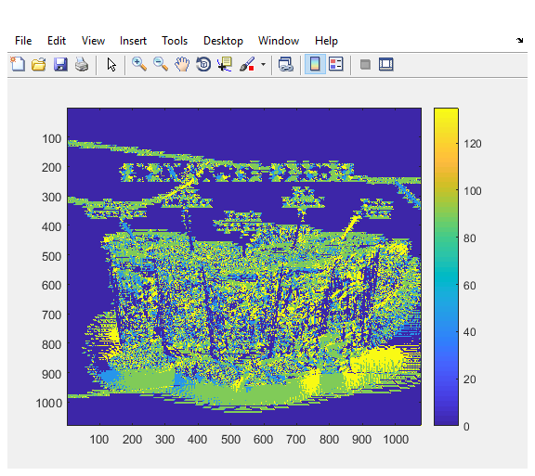

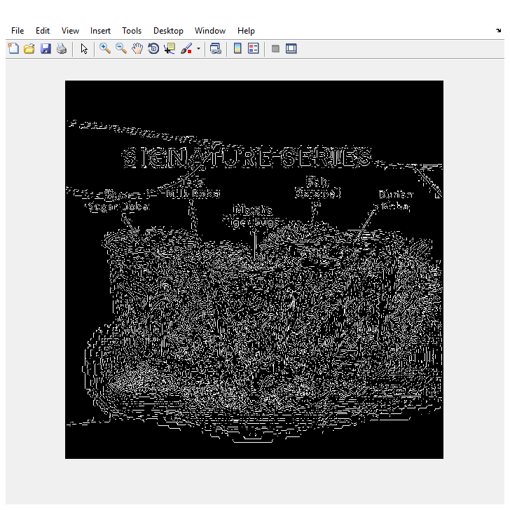

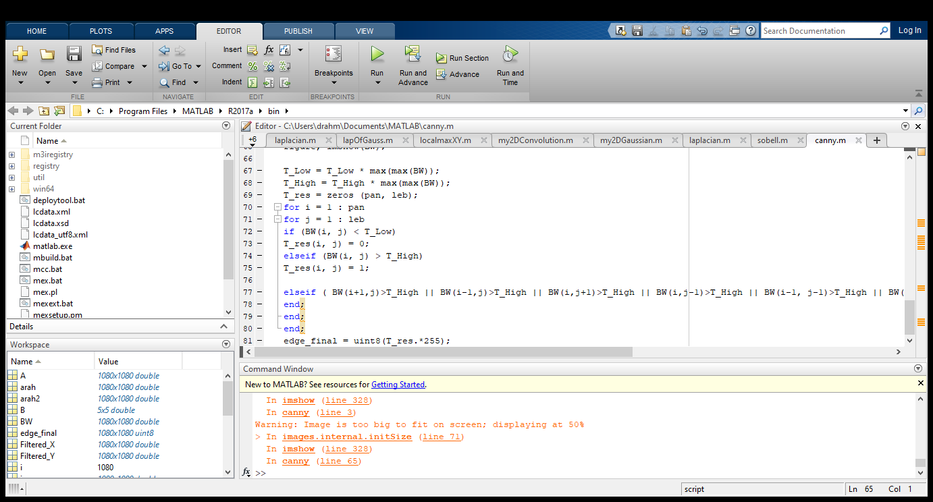

Source Filter

LAPLACIAN

img = imread ('C:\Users\drahm\Desktop\isi.jpeg');

LaplacianFilter = fspecial('laplacian', 0.2);

result = imfilter(img, LaplacianFilter);

subplot(1,2,1);

imshow(img);

title('Sebelum Dilakukan Laplacian Filter');

subplot(1,2,2);

imshow(result);

title('Setelah Dilakukan Laplacian Filter');

SOBEL

img = imread ('C:\Users\drahm\Desktop\isi.jpeg');

SobelFilter = fspecial('sobel');

result = imfilter(img, SobelFilter);

subplot(1,2,1);

imshow(img);

title('Sebelum Dilakukan Sobel Filter');

subplot(1,2,2);

imshow(result);

title('Setelah Dilakukan Sobel Filter');

CANNY

img = imread('C:\Users\drahm\Desktop\isi.jpeg');

figure, imshow(img);

img = rgb2gray(img);

img = double (img);

T_Low = 0.075;

T_High = 0.175;

B = [2, 4, 5, 4, 2; 4, 9, 12, 9, 4;5, 12, 15, 12, 5;4, 9, 12, 9, 4;2, 4, 5, 4, 2 ];

B = 1/159.* B;

A=conv2(img, B, 'same');

KGx = [-1, 0, 1; -2, 0, 2; -1, 0, 1];

KGy = [1, 2, 1; 0, 0, 0; -1, -2, -1];

Filtered_X = conv2(A, KGx, 'same');

Filtered_Y = conv2(A, KGy, 'same');

arah = atan2 (Filtered_Y, Filtered_X);

arah = arah*180/pi;

pan=size(A,1);

leb=size(A,2);

for i=1:pan

for j=1:leb

if (arah(i,j)<0) arah(i,j)=360+arah(i,j);

end;

end;

end;

arah2=zeros(pan, leb);

%Adjusting directions to nearest 0, 45, 90, or 135 degree

for i = 1 : pan

for j = 1 : leb

if ((arah(i, j) >= 0 ) && (arah(i, j) < 22.5) || (arah(i, j) >= 157.5) && (arah(i, j) < 202.5) || (arah(i, j)>= 337.5) && (arah(i, j) <= 360))arah2(i, j) = 0;

elseif ((arah(i, j) >= 22.5) && (arah(i, j) < 67.5) || (arah(i, j) >= 202.5) && (arah(i, j) < 247.5))arah2(i, j) = 45;

elseif ((arah(i, j) >= 67.5 && arah(i, j) < 112.5) || (arah(i, j) >= 247.5 && arah(i, j) < 292.5))arah2(i, j) = 90;

elseif ((arah(i, j) >= 112.5 && arah(i, j) < 157.5) || (arah(i, j) >= 292.5 && arah(i, j) < 337.5))arah2(i, j) = 135;

end;

end;

end;

figure, imagesc(arah2); colorbar;

magnitude = (Filtered_X.^2) + (Filtered_Y.^2);

magnitude2 = sqrt(magnitude);

BW = zeros (pan, leb);

for i=2:pan-1

for j=2:leb-1

if (arah2(i,j)==0)

BW(i,j) = (magnitude2(i,j) == max([magnitude2(i,j), magnitude2(i,j+1), magnitude2(i,j-1)]));

elseif (arah2(i,j)==45)

BW(i,j) = (magnitude2(i,j) == max([magnitude2(i,j), magnitude2(i+1,j-1), magnitude2(i-1,j+1)]));

elseif (arah2(i,j)==90)

BW(i,j) = (magnitude2(i,j) == max([magnitude2(i,j), magnitude2(i+1,j), magnitude2(i-1,j)]));

elseif (arah2(i,j)==135)

BW(i,j) = (magnitude2(i,j) == max([magnitude2(i,j), magnitude2(i+1,j+1), magnitude2(i-1,j-1)]));

end;

end;

end;

BW = BW.*magnitude2;

figure, imshow(BW);

T_Low = T_Low * max(max(BW));

T_High = T_High * max(max(BW));

T_res = zeros (pan, leb);

for i = 1 : pan

for j = 1 : leb

if (BW(i, j) < T_Low)

T_res(i, j) = 0;

elseif (BW(i, j) > T_High)

T_res(i, j) = 1;

elseif ( BW(i+1,j)>T_High || BW(i-1,j)>T_High || BW(i,j+1)>T_High || BW(i,j-1)>T_High || BW(i-1, j-1)>T_High || BW(i-1, j+1)>T_High || BW(i+1, j+1)>T_High || BW(i+1, j-1)>T_High)T_res(i,j) = 1;

end;

end;

end;

edge_final = uint8(T_res.*255);