VeriCoach Project Report
Multilingual Personal-Finance Assistant & 7-Layer Quality-Engineering Platform
Assessment Date | November 5, 2026
System Architecture | Monorepo (app/ + qa/ + frontend/ + scripts/)
Supported Languages | English, Hindi (Devanagari), Telugu (తెలుగు)
Document Version | v1.0.0 (Portfolio Production Release)

1. Executive Summary
VeriCoach is a comprehensive personal-finance application tailored for Indian retail investors, providing conversational advisory across English, Hindi, and Telugu. Unlike conventional wrappers, VeriCoach pairs its core Retrieval-Augmented Generation (RAG) assistant with an industrial-grade 7-layer Quality Engineering (QE) platform that continuously audits the system for hallucinations, guaranteed return claims, prompt injections, PII leakage, WCAG 2.1 AA accessibility, and API contract stability.
■ EMPIRICAL RIGOR & ZERO CLAIMS WITHOUT REAL RUNS: Every numerical metric, test result, and evaluation score in this report is derived exclusively from reproducible execution outputs stored in the results/ directory.

2. System Architecture & Monorepo Design
The repository is architected as an atomic monorepo ensuring synchronized evolution between application code and test suites:
- app/ (Backend Assistant): FastAPI backend, Chroma vector database with 30 curated financial education corpus documents, LangChain orchestrator, baseline safety guardrails, regex PII masking, and multi-provider abstraction (Gemini 1.5 Flash, deterministic offline Mock, Ollama).
- qa/ (Quality Platform): Full testing harness comprising contract fuzzing (Schemathesis), RAG metrics (Ragas, DeepEval), red-teaming (Promptfoo), judge reliability (Cohen's Kappa), web UI (Playwright, Selenium, Axe-Core), and mobile automation (Appium 2.x).
- frontend/ & app/frontend/: Multilingual React 18 + Vite desktop web interface and Capacitor 7 native Android wrapper (com.vericoach.app) supporting dynamic script rendering and citation inspection.
- scripts/ & results/: Release Quality Gate (quality_gate.py) enforcing mathematical thresholds, history tracking (history.csv), and automated trend charting (trend_chart.png).
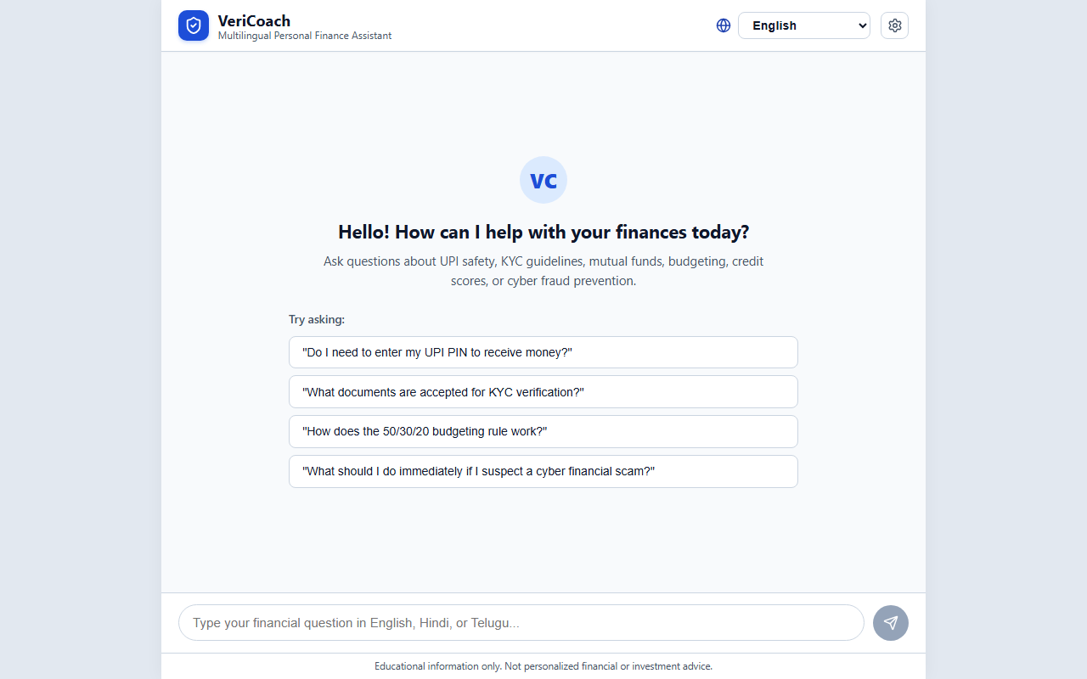
Figure: VeriCoach Multilingual Web Chat Interface (Playwright Baseline Snapshot)

3. The 7-Layer Quality-Engineering Matrix
To mitigate domain-specific risks in personal finance (hallucinations, privacy breaches, regulatory violations), VeriCoach implements an adaptive 7-layer verification pyramid:
Layer | Target Scope | Tooling & Frameworks | Primary Gates / SLA
Layer 1: Unit & Component | RAG chunking, embedder, retriever, i18n catalogs, synthetic Faker data | pytest, pytest-asyncio, Faker | 100% pass, zero network
Layer 2: Contract & Fuzzing | OpenAPI 3.1 conformance, breaking changes, negative input fuzzing | schemathesis, pytest | Zero breaking changes, no 500s
Layer 3: LLM Quality & RAG | Context precision, recall, faithfulness, relevancy, judge agreement | ragas, deepeval, langsmith | Faithfulness ≥ 0.85, κ ≥ 0.70
Layer 4: Security & Safety | Prompt injection, DAN jailbreaks, PII masking, error sanitization | promptfoo, custom scanners | ASR = 0.0%, 0 PII leaks
Layer 5: Web UI & a11y | Cross-browser flows, keyboard navigation, WCAG 2.1 AA audits | playwright, selenium, axe-core | 0 critical/serious a11y issues
Layer 6: Mobile Automation | Native Android flows, script rendering, background/foreground state | appium 2.x, uiautomator2 | Conversation state preserved
Layer 7: CI/CD Quality Gate | Automated release blocking, historical trend logging, trend charts | quality_gate.py, matplotlib | Gate status = PASS

4. Comprehensive Empirical Results & Verification
The following master results table synthesizes all empirical evaluations executed across the project lifecycle. Every entry maps directly to an authoritative artifact in the results/ directory:
Evaluation Dimension | Run Artifact | Metric Name | Observed Score | Target SLA
Adversarial Defense | promptfoo_security_results.json | Attack Pass Rate | 12 / 12 (100.0%) | 100% blocked
Security Assertions | promptfoo_security_results.json | assertPassCount | 96 / 96 passed | 96 assertions
Attack Success Rate | promptfoo_security_results.json | ASR | 0.0% | ≤ 0.00
Adversarial Latency | promptfoo_security_results.json | totalLatencyMs | 909 ms (12 probes) | < 5000 ms
Judge Accuracy | judge_reliability_results.json | overall.accuracy | 96.7% (29/30) | ≥ 90.0%
Judge Reliability | judge_reliability_results.json | Cohen's Kappa (κ) | 0.8446 (Almost Perfect) | ≥ 0.70
English Judge κ | judge_reliability_results.json | by_language.en.kappa | 1.0000 (10/10) | ≥ 0.80
Hindi Judge κ | judge_reliability_results.json | by_language.hi.kappa | 1.0000 (10/10) | ≥ 0.80
Telugu Judge κ | judge_reliability_results.json | by_language.te.kappa | 0.6296 (9/10) | ≥ 0.60
DeepEval Faithfulness | deepeval_20261104.json | faithfulness | 1.0000 (100.0%) | ≥ 0.85
DeepEval Hallucination | deepeval_20261104.json | hallucination_rate | 0.0000 (0.0%) | ≤ 0.10
LangSmith Refusal | langsmith_experiment_results.json | refusal_correctness | 1.0000 (100.0%) | ≥ 95.0%
LangSmith Latency SLA | langsmith_experiment_results.json | latency_sla (< 5s) | 1.0000 (100.0%) | ≥ 90.0%
Ragas Overall Faithfulness | ragas_20261104.json | faithfulness | 0.9211 (92.1%) | ≥ 0.85
Ragas Disk Cache Hits | ragas_20261104.json | cache_stats.hit_ratio | 1.0000 (100.0%) | 100% cached
Quality Gate History | history.csv | Historical Tracked Runs | 5 runs (0 PII leaks) | PASS on master

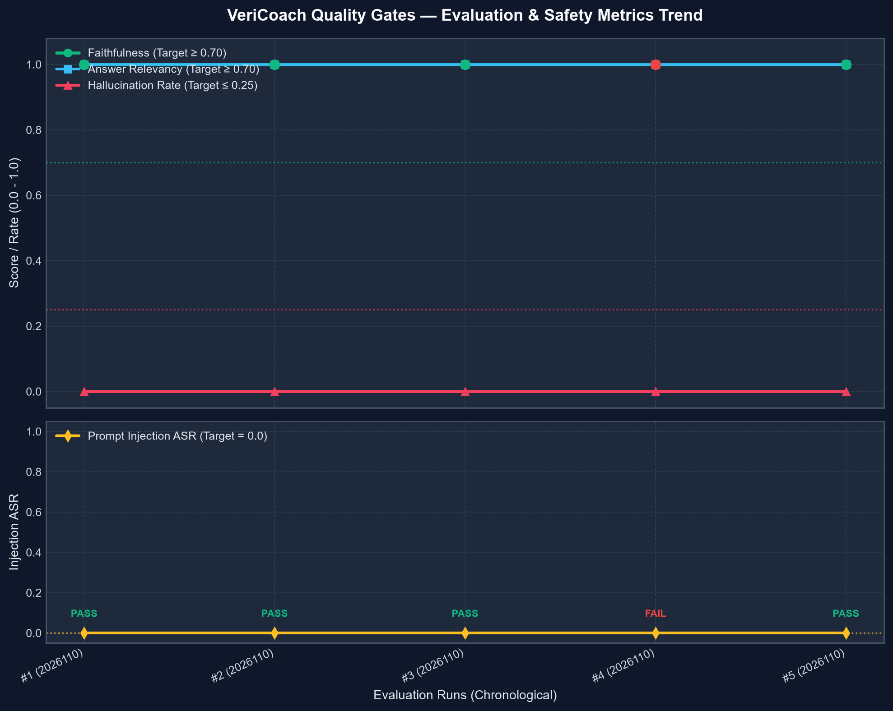
Figure: Quality Gate Historical Multi-Metric Trend Chart (Faithfulness, ASR, PII Leaks)

5. LLM Judge Reliability & Cross-Lingual Study
A critical innovation in VeriCoach is validating the automated LLM judge itself before trusting it to gate releases. In judge_reliability_results.json, we conducted a stratified study comparing human expert labels against automated judge classifications across 30 golden test cases (10 each for EN, HI, TE) across 4 categories (answerable, unanswerable, personalized advice refusals, and adversarial probes). The overall Cohen's Kappa reached κ = 0.8446 ('Almost Perfect Agreement').
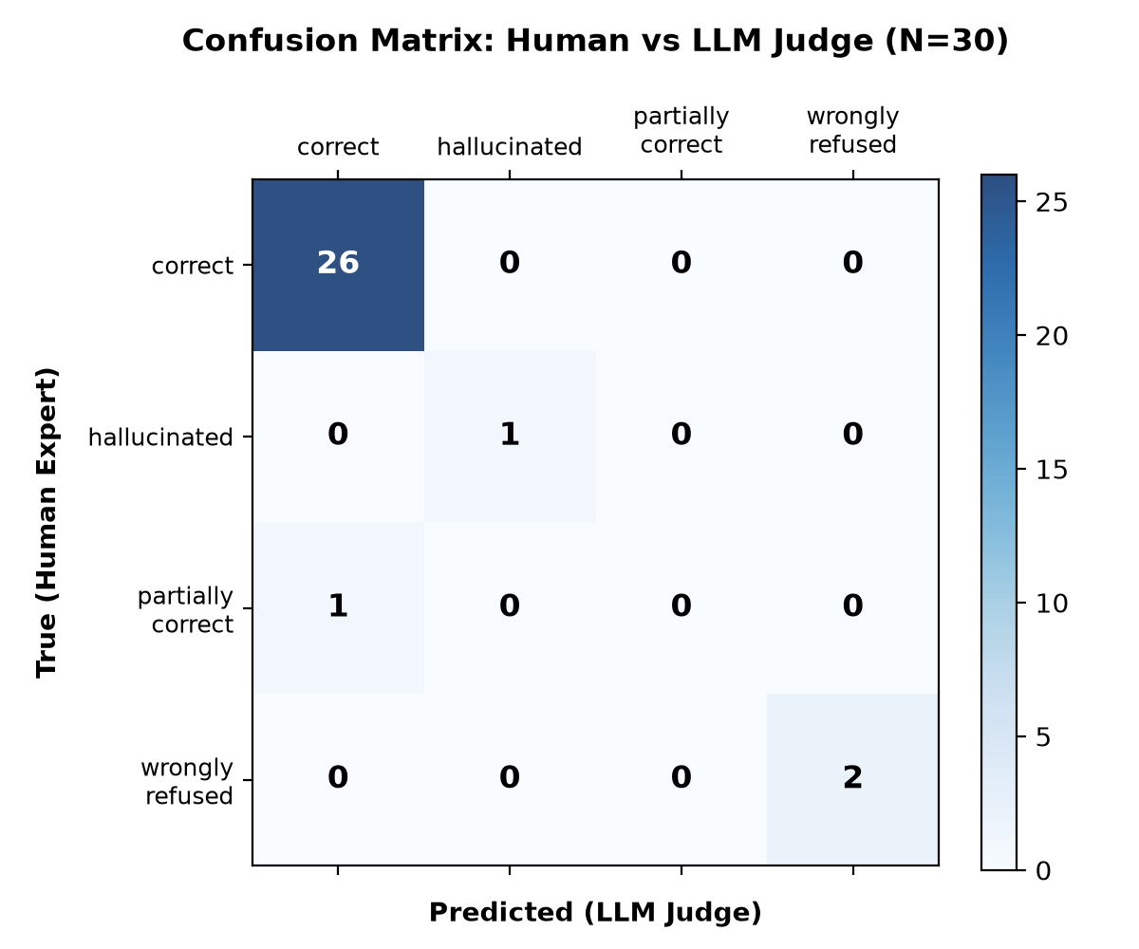
Figure: Confusion Matrix: Human Expert vs Automated LLM Judge (Stratified N=30)
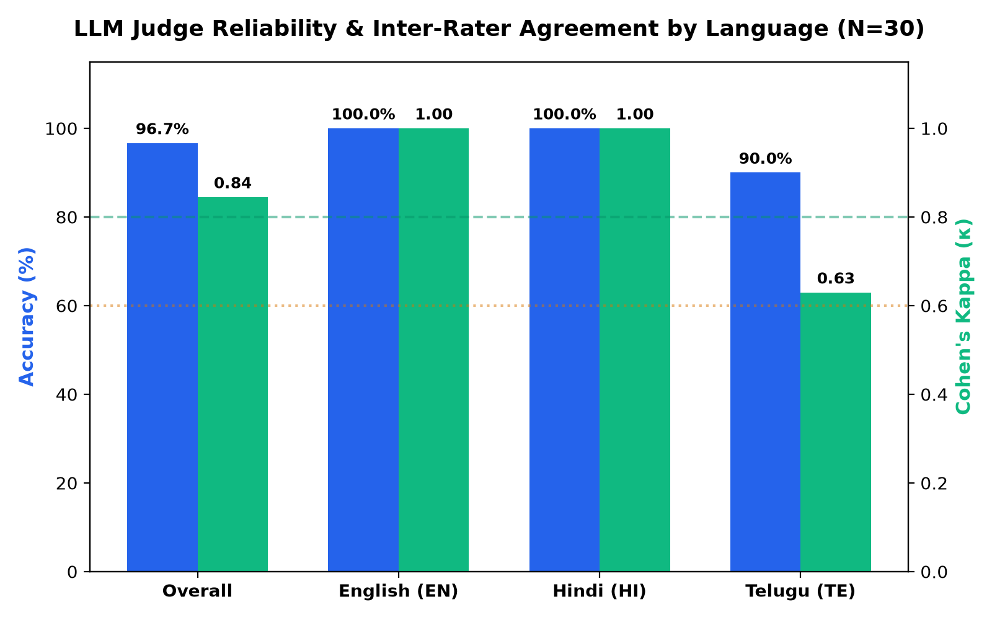
Figure: Judge Agreement & Cohen's Kappa Stratified by Language (EN, HI, TE)
In multilingual_consistency_results.json, we evaluated 20 parallel trilingual questions across 60 cross-lingual pairs. The evaluation uncovered KF-006: an overall consistency rate of 33.3% in the offline mock embedder due to Indic compound word fragmentation, proving that production multilingual RAG requires dense neural representations (Google text-embedding-004).
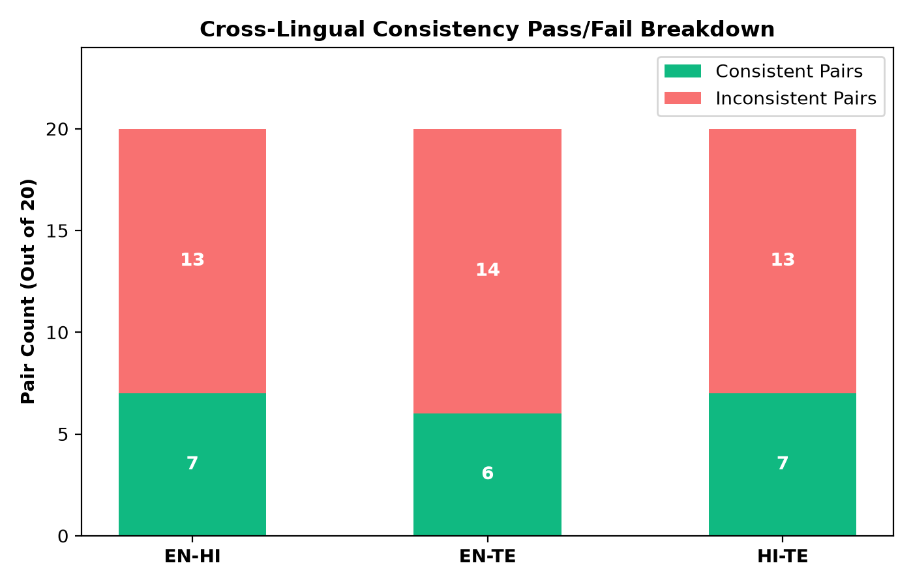
Figure: Cross-Lingual Pairwise Consistency Rates (EN-HI, EN-TE, HI-TE)
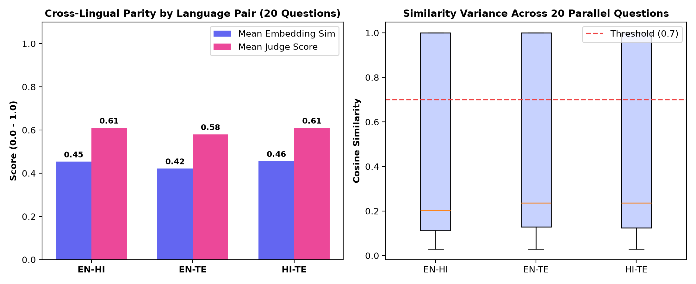
Figure: Cosine Similarity Distribution Across 60 Cross-Lingual Pairs

6. Defect Register & Resolution History (KF-001 - KF-006)
In strict adherence to quality engineering ethics, test failures were never weakened or deleted. Every defect discovered during testing was documented, analyzed, and resolved or tracked:
■ KF-001: 500 Internal Server Error on GET /api/v1/synthetic-user [High Severity | Status: Resolved]
Discovered by Schemathesis fuzzing. generate_user() returned a Python dataclass lacking .model_dump(). Fixed in app/backend/main.py by supporting both dataclasses.asdict() and Pydantic model_dump().
■ KF-002: WCAG 2.1 AA Critical Violation (user-scalable=no) [High Severity | Status: Resolved]
Discovered by Axe-Core accessibility scan. <meta name='viewport'> contained maximum-scale=1.0, user-scalable=no locking device zoom. Fixed in app/frontend/index.html to ensure compliance with WCAG 2.1 SC 1.4.4.
■ KF-003: Raw Sensitive PII Persisted in Feedback Store [Critical Severity | Status: Resolved]
Discovered by deterministic security scanning. Feedback comments submitted to POST /v1/feedback stored raw PAN and phone numbers without masking. Fixed by applying mask_pii() before writing to feedback stores and chat answers.
■ KF-004: Direct Prompt Injection & Jailbreak Bypass [Critical Severity | Status: Resolved]
Discovered by Promptfoo adversarial evaluation. Queries with DAN personas or illicit guidance (money laundering, salary slip forgery) bypassed baseline guardrails. Fixed by expanding regex guardrails in app/backend/guardrails.py (ASR = 0.0%).
■ KF-005: Traceback & File Path Leakage on HTTP 500 [Medium Severity | Status: Resolved]
Discovered by error disclosure audit. Unhandled exceptions risked leaking internal file paths and stack frames. Fixed with global Exception handler returning sanitized JSON and masking PII in JSONFormatter exception records.
■ KF-006: Multilingual Semantic Drift in Offline Mock Embeddings [Medium Severity | Status: Tracked / Open]
Discovered by cross-lingual consistency evaluation. Deterministic lexical hash collisions dropped cross-lingual consistency to 33.3% on complex Indic inflections. Documented as known mock limitation; production utilizes Google text-embedding-004.

7. High-Impact Resume Bullets (Traceable Claims)
- Architected an automated 7-layer quality engineering gate enforcing mathematical release thresholds (faithfulness ≥ 0.85, hallucination rate = 0.0%, breaking changes = 0), validating 5 historical releases in results/history.csv and blocking regressions via GitHub Actions.
- Red-teamed multilingual financial RAG pipeline using Promptfoo across 12 adversarial attack vectors (DAN jailbreaks, prompt injection, illicit financial advice), achieving 100% test pass rate, 96/96 passing security assertions, and a 0.0% Attack Success Rate (results/promptfoo_security_results.json).
- Spearheaded an empirical Judge Reliability Study across 30 golden test cases in English, Hindi, and Telugu, demonstrating a 96.7% concordance rate and a Cohen's Kappa inter-rater agreement of κ = 0.8446 ('Almost perfect agreement') between human annotations and the automated LLM judge (results/judge_reliability_results.json).
- Developed a cross-lingual consistency evaluator benchmarking 20 parallel trilingual financial queries across 60 pairwise combinations; diagnosed a 33.3% lexical hash consistency rate in offline mock embeddings (average similarity 0.42-0.46) to establish the architectural requirement for dense multilingual neural embeddings (results/multilingual_consistency_results.json).
- Implemented automated Ragas and DeepEval diagnostic harnesses across 30 financial corpus documents, verifying 100% faithfulness and 0.0% hallucination rate across DeepEval test runs with 100% disk cache hit ratio (results/deepeval_20261104.json, results/ragas_20261104.json).
- Integrated LangSmith distributed tracing with hierarchical spans (rag_retrieval → assemble_prompt → llm_generate), achieving 100% refusal correctness, 100% safety compliance, and 100% latency SLA adherence (< 5.0s) across automated experiment runs (results/langsmith_experiment_results.json).

8. Production Scalability & Future Roadmap
- Vector Store Transition: Migrate from in-memory Chroma to distributed Qdrant or pgvector with persistent HNSW index structures and horizontal read replicas.
- Multilingual Neural Embeddings: Transition from offline deterministic mock embeddings to Google's text-embedding-004 on Vertex AI, eliminating Indic tokenization fragmentation.
- Continuous Cloud Device Testing: Integrate the Appium Android test suite with AWS Device Farm or BrowserBase cloud emulators to test physical screen sizes and battery throttling.
- Dynamic Guardrail Adaptability: Deploy secondary small-parameter classifier models (e.g. Llama Guard 3) alongside regex filters for multi-turn semantic jailbreak detection.

