MediMate Interface Design Submission
  - Step 14 1 November 2026
We designed six main interfaces for MediMate, with two assigned screens per member. Each screen supports the agreed prescription, medicine information or caregiver workflow. The package includes desktop and mobile layouts, validation and outcome states, and a separate browser prototype for interaction review.

Team and assigned screens
Member | First screen | Second screen
Ihfaz Rashid Sadat | A1 Prescription review | A2 Schedule builder
Faraaz Jamil Chowdhury | B1 Medicine cabinet | B2 Medicine information
Sahir Jawad Chowdhury | C1 Caregiver tasks | C2 Today’s doses

Open the editable MediMate Figma file

How to read this submission
The Figma page named Step 14 — Detailed submission contains 24 editable frames: six desktop screens, six mobile screens, six error states and six success states. The original wireframes are preserved. These are proposed interfaces, not implemented medical features.
Figure A1 uses a captured Figma screenshot. Other figures are supplemental vector renderings of the same design specification because the Figma Starter tool allowance ended before their exports. They are labelled accordingly and are not presented as Figma exports. Native prototype wiring and final visual checks for all Figma frames remain unverified.
The supplied HTML prototype offers navigation, success and failure walkthroughs, manual entry, task transitions, dose recording and a simulated SOS flow. It uses temporary data and makes no live API or emergency requests. Its JavaScript syntax was checked; browser execution could not be verified in this environment.

A1 Prescription review
  - Ihfaz Rashid Sadat Desktop design
Open this desktop frame in Figma
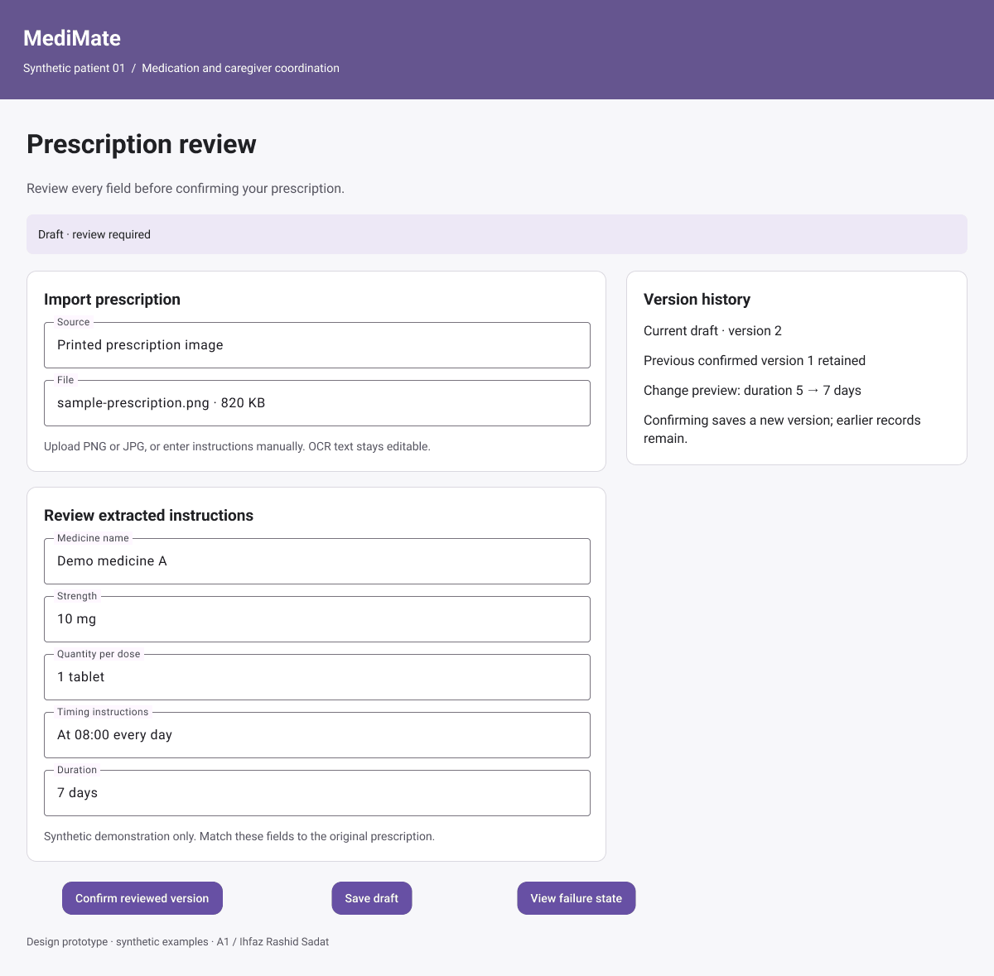
A1 desktop Figma screenshot
Main action: Confirm reviewed version. The reviewed instructions were saved. Version 1 is still available in history. You can now preview a schedule.
Validation and failure: Quantity per dose is missing. Enter a positive quantity and its unit before confirming. Your draft is retained.

A1 Mobile and failure state
  - Supplemental vector renderings 390 pixel mobile layout
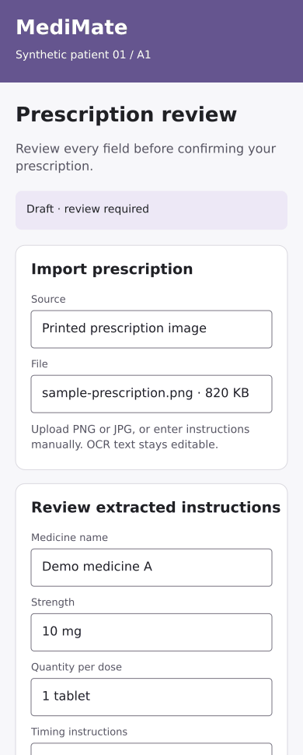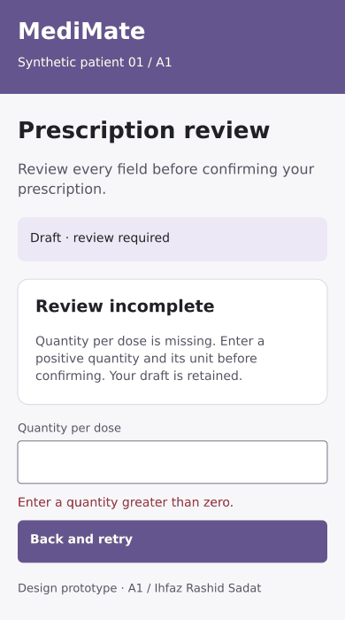
Left Mobile viewport Right Failure state
The mobile page scrolls vertically; the figure shows its upper portion. Cards stack in one column and primary actions remain full width. All content is editable in the linked Figma frame.
Open mobile frame
Loading: Extracting text… You can switch to manual entry. Empty: No prescription yet. Upload an image or start manual entry.
Recovery: Image extraction failed. Keep the image and enter or correct the draft manually.

A2 Schedule builder
  - Ihfaz Rashid Sadat Desktop design
Open this desktop frame in Figma
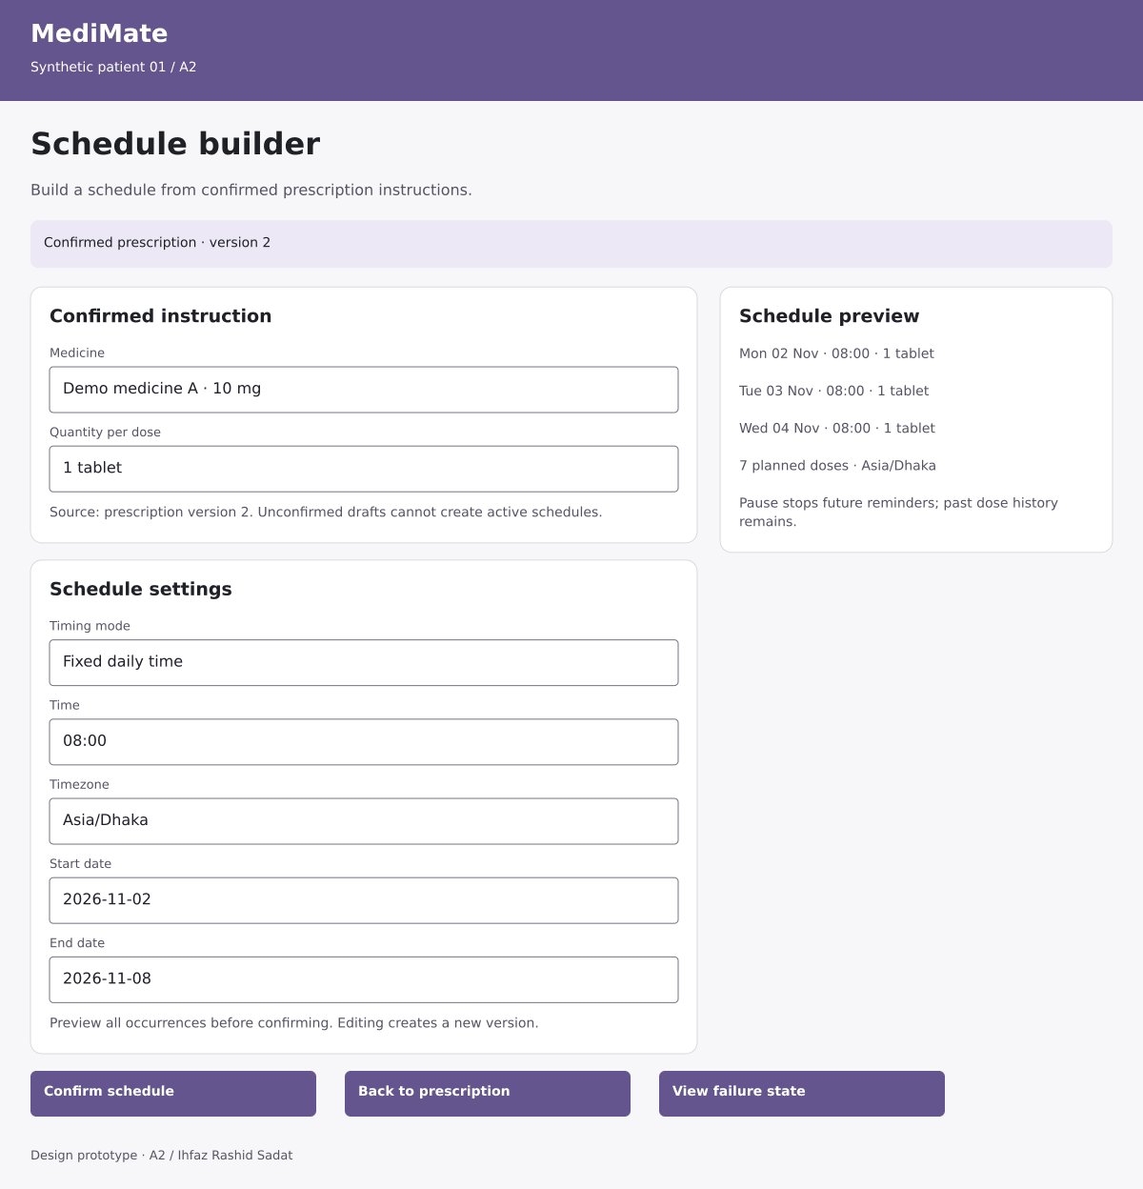
A2 desktop supplemental vector rendering
Main action: Confirm schedule. Seven planned occurrences were saved for 2–8 November. Reminders use Asia/Dhaka. You can pause or revise future scheduling.
Validation and failure: The end date is before the start date. Correct the date range and preview again. No schedule was activated.

A2 Mobile and failure state
  - Supplemental vector renderings 390 pixel mobile layout
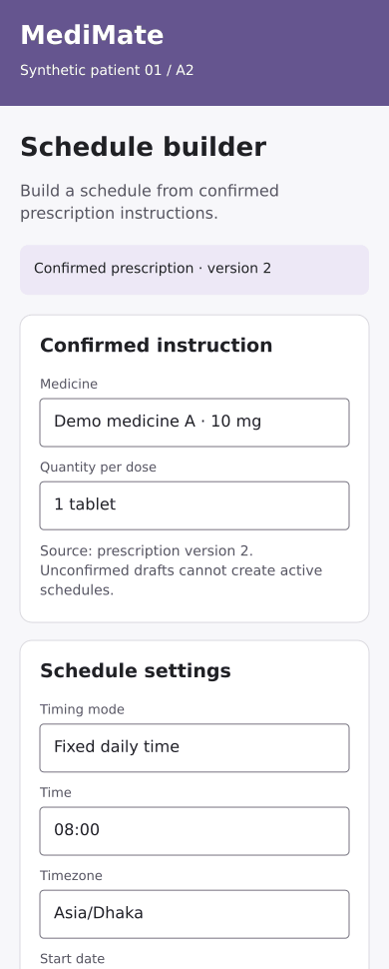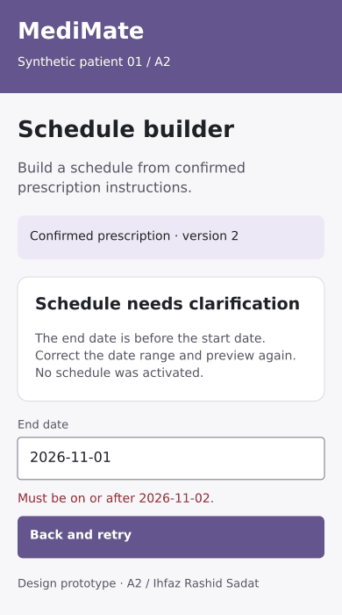
Left Mobile viewport Right Failure state
The mobile page scrolls vertically; the figure shows its upper portion. Cards stack in one column and primary actions remain full width. All content is editable in the linked Figma frame.
Open mobile frame
Loading: Generating schedule preview… Empty: No confirmed prescription. Review and confirm instructions first.
Recovery: Preview could not load. Your inputs remain; retry before confirming.

B1 Medicine cabinet
  - Faraaz Jamil Chowdhury Desktop design
Open this desktop frame in Figma
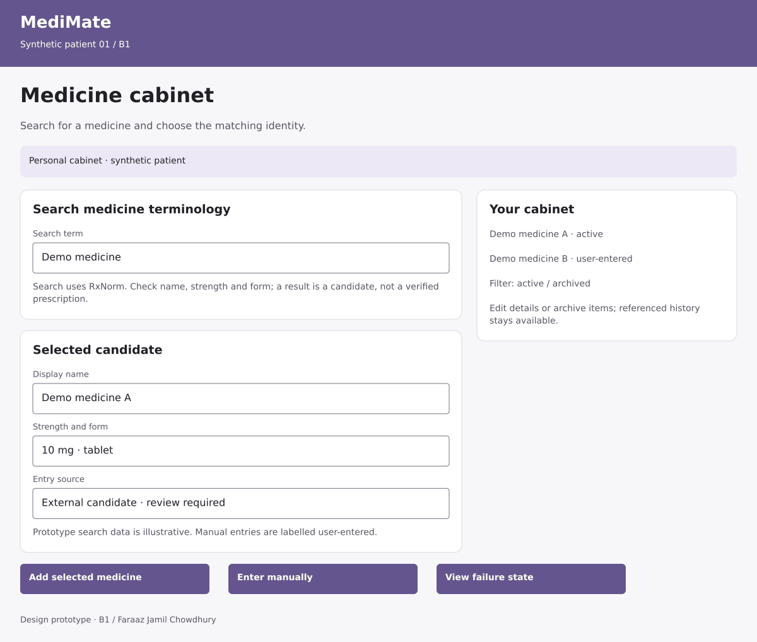
B1 desktop supplemental vector rendering
Main action: Add selected medicine. The selected identity and source reference were saved. You can open its information card, edit details or archive it later.
Validation and failure: The terminology service did not respond. Retry the search or enter a clearly labelled manual medicine. No candidate was silently selected.

B1 Mobile and failure state
  - Supplemental vector renderings 390 pixel mobile layout
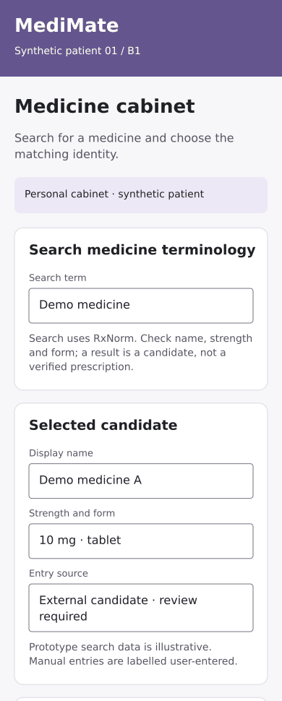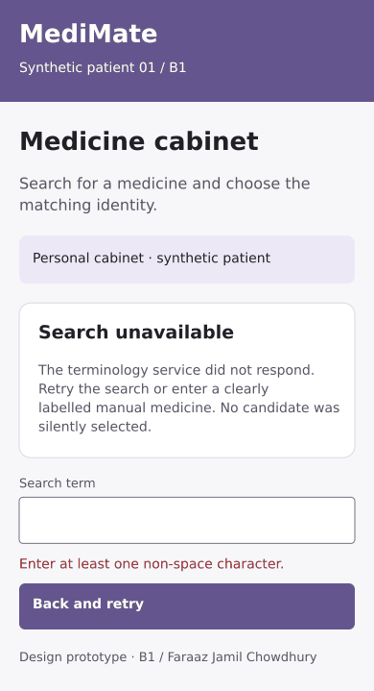
Left Mobile viewport Right Failure state
The mobile page scrolls vertically; the figure shows its upper portion. Cards stack in one column and primary actions remain full width. All content is editable in the linked Figma frame.
Open mobile frame
Loading: Searching medicine identities… Empty: No matching candidate. Try another term or enter medicine details manually.
Recovery: Search timed out. Retry or use manual entry.

B2 Medicine information
  - Faraaz Jamil Chowdhury Desktop design
Open this desktop frame in Figma
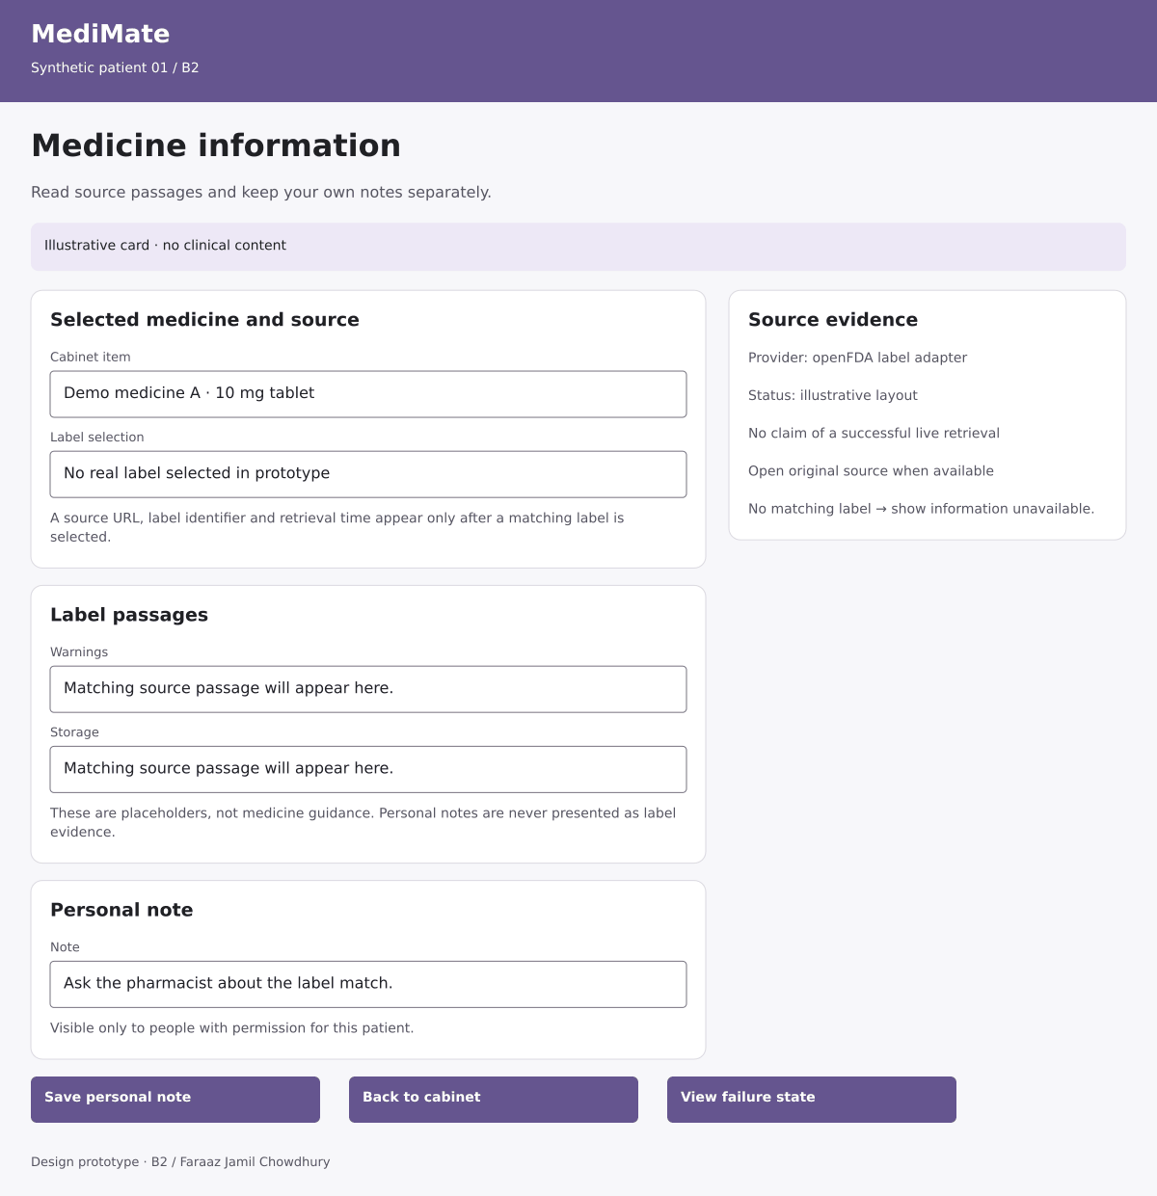
B2 desktop supplemental vector rendering
Main action: Save personal note. Your note was saved separately from source passages. Saving a note does not validate a label match or change medicine instructions.
Validation and failure: No suitable source label was found. No warnings or storage instructions are inferred. You can retry or return to the cabinet.

B2 Mobile and failure state
  - Supplemental vector renderings 390 pixel mobile layout
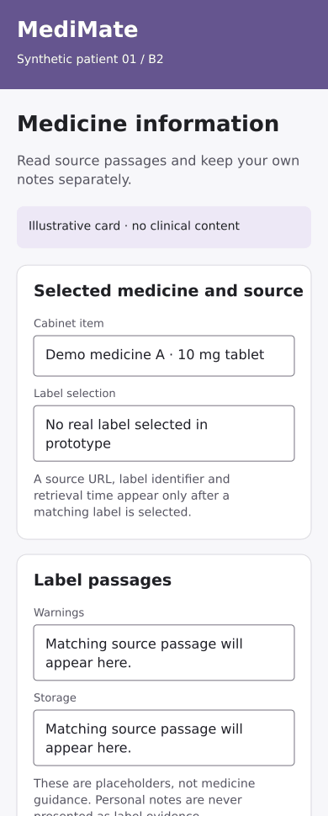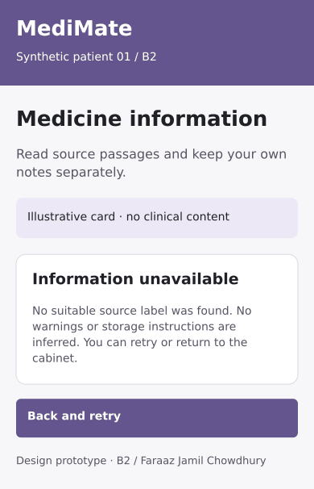
Left Mobile viewport Right Failure state
The mobile page scrolls vertically; the figure shows its upper portion. Cards stack in one column and primary actions remain full width. All content is editable in the linked Figma frame.
Open mobile frame
Loading: Retrieving matching label passages… Empty: No matching source label. Information unavailable.
Recovery: Label service unavailable. Keep the note and retry source retrieval.

C1 Caregiver tasks
  - Sahir Jawad Chowdhury Desktop design
Open this desktop frame in Figma
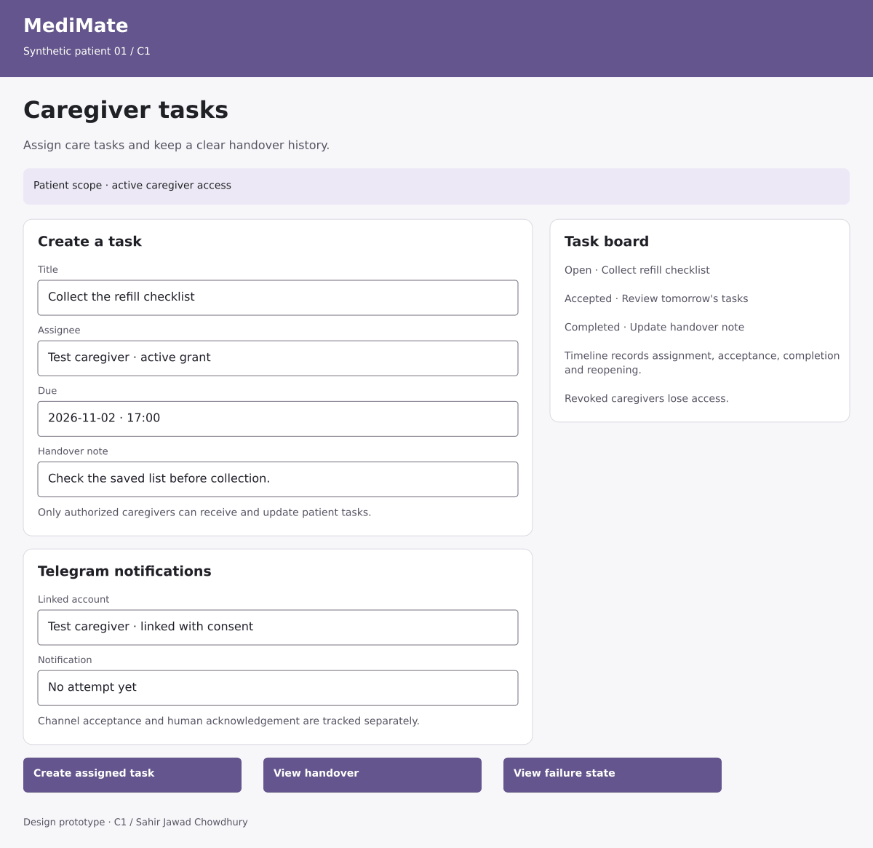
C1 desktop supplemental vector rendering
Main action: Create assigned task. The open task and its handover note were saved. A notification job is queued; delivery and acknowledgement remain separate.
Validation and failure: This assignee no longer has access. Select an active authorized caregiver. The task was not assigned and no notification was sent.

C1 Mobile and failure state
  - Supplemental vector renderings 390 pixel mobile layout
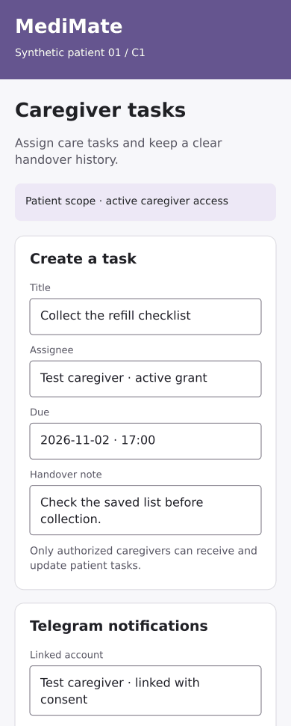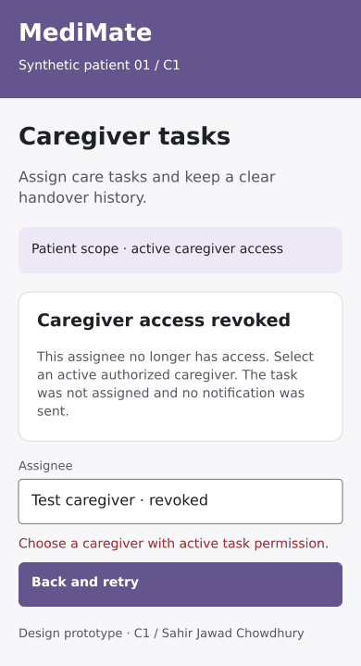
Left Mobile viewport Right Failure state
The mobile page scrolls vertically; the figure shows its upper portion. Cards stack in one column and primary actions remain full width. All content is editable in the linked Figma frame.
Open mobile frame
Loading: Loading task board… Empty: No tasks yet. Create one for an authorized caregiver.
Recovery: Task board could not load. Retry; do not assume a task was saved.

C2 Today’s doses
  - Sahir Jawad Chowdhury Desktop design
Open this desktop frame in Figma
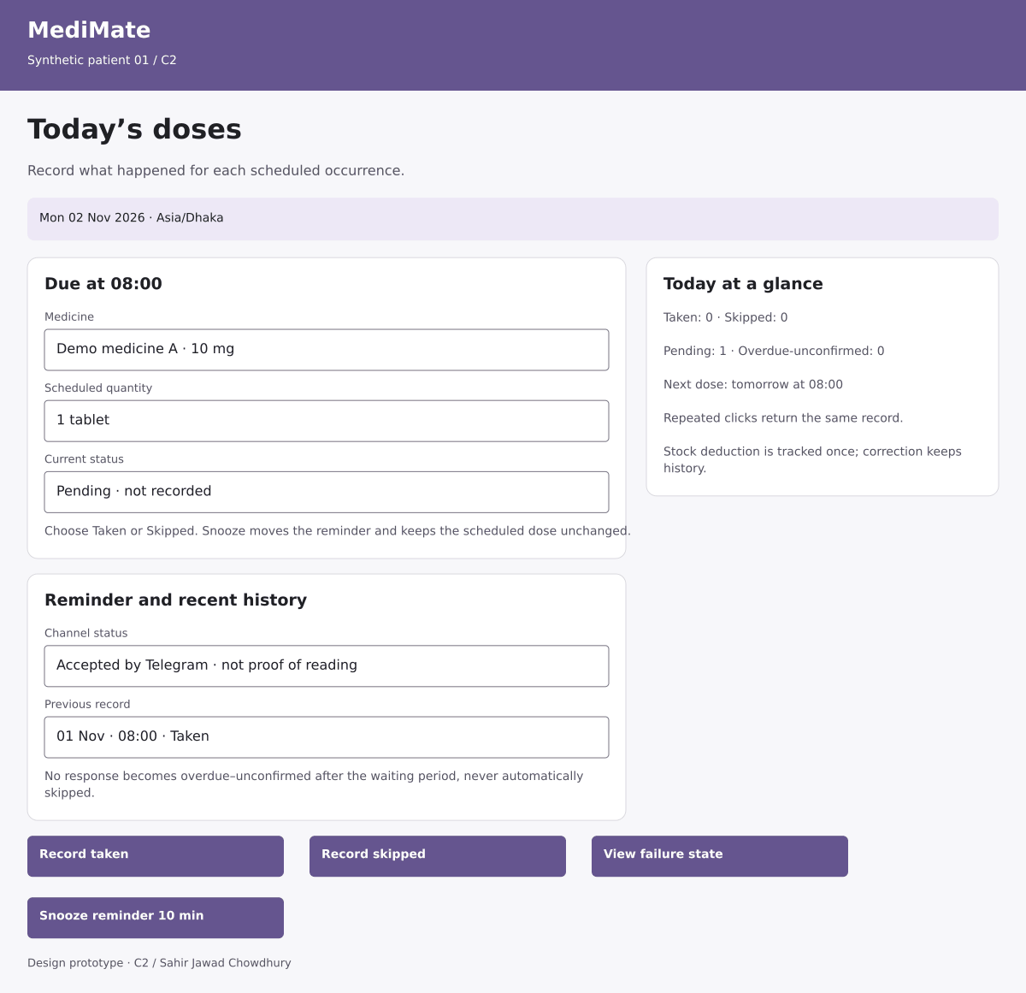
C2 desktop supplemental vector rendering
Main action: Record taken. The 08:00 occurrence is now Taken. A repeated request does not create another action or stock deduction. Corrections require a reason.
Validation and failure: The connection failed before confirmation. Check the latest dose status and retry using the same request. Do not display Taken until the server confirms.

C2 Mobile and failure state
  - Supplemental vector renderings 390 pixel mobile layout
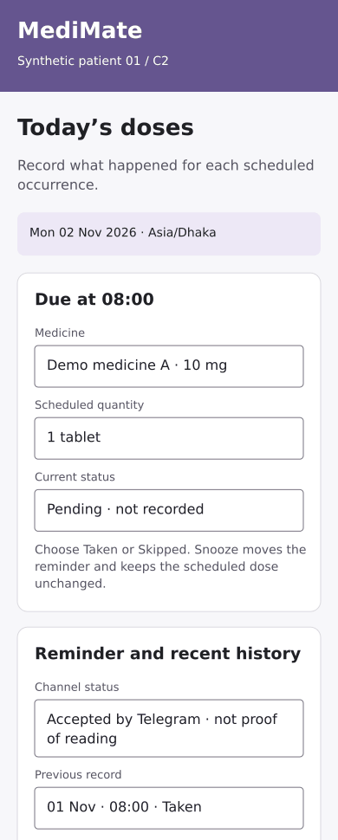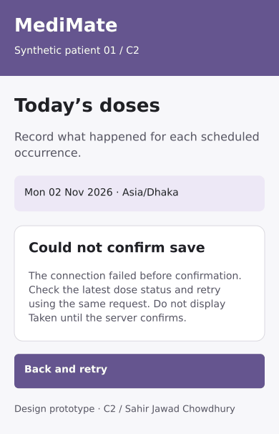
Left Mobile viewport Right Failure state
The mobile page scrolls vertically; the figure shows its upper portion. Cards stack in one column and primary actions remain full width. All content is editable in the linked Figma frame.
Open mobile frame
Loading: Loading scheduled doses… Empty: No doses scheduled today. Open the confirmed schedule to review future doses.
Recovery: Dose records unavailable. Retry; reminder delivery is not proof a dose was taken.

Interaction and accessibility specification
Navigation links connect A1, A2, B1, B2, C1 and C2 in the HTML prototype. Each screen includes a main action, a secondary action and a failure example. The state selector switches between ready, loading, empty and failure views. These controls are for design review and are not part of the proposed production interface.

Prescription review
Confirm only after required medicine, dose and duration fields have been reviewed. Preserve drafts on failure and confirmed versions after replacement.

Schedules
Validate start and end dates, quantity, timing and timezone before preview and confirmation. Keep historical events when future scheduling changes.

Medicine information
Keep external candidates and manual entries distinguishable. Show source identifier, URL and retrieval time only when real matching evidence exists. Missing evidence stays unavailable.

Caregiver coordination
Validate active access before assignment. Keep a history of acceptance, completion and reopening. Track notification acceptance separately from acknowledgement.

Dose recording
Keep Taken, Skipped and pending states distinct. Repeated requests must not duplicate a dose action. Snooze moves the reminder, not the prescribed time.

Responsive and accessible behavior
Desktop designs use a two-column content area; mobile designs stack the workflow and support cards. Use visible labels, keyboard focus, text status labels, explicit error messages and at least 48 pixel action targets. Errors must be announced and focus moved to the affected field. Loading states disable duplicate submission; retries preserve entered values. Check actual contrast and keyboard behavior during implementation.

Emergency SOS extension
  - C5 Sahir Jawad Chowdhury Module 3
C5 supplements the six assigned screens; it does not replace C3 or any other agreed function. The HTML prototype includes the following complete demonstration flow. Native SOS frames were not added before the Figma tool limit.

Confirm the alert
Show consenting recipients, contact details and location availability. A deliberate confirmation reduces accidental activation. Location denial must not block sending to linked contacts.

Active incident
Create one incident and show separate channel acceptance and contact acknowledgement. Display the provider dashboard as SIMULATED. Awaiting confirmation is not ambulance dispatch.

Cancel or resolve
Stop unsent alerts, preserve history and notify only still-consenting recipients who were previously alerted. Display a closed incident state.

Prototype walkthrough
- Open MediMate_Step14_Prototype.html in a browser.
- Select Emergency SOS test, then Confirm test SOS. No real message is sent.
- Review the location-unavailable state, contact responses and simulated provider wording.
- Select Resolve test incident or Cancel accidental alert, then verify the closed-incident message.

Submission status
The six detailed Figma designs and their mobile and outcome frames have been created. This Word document and supplemental prototype are prepared. Final export and visual review of every native frame, and completion and checking of native Figma interactions, remain blocked by the Starter tool allowance. No faculty approval or user testing is claimed.

