CROSS PLATFORM MOBILE DEVELPOMENT

INSTRUCTOR – HUABO LU  
TEAM : Hamza  
TEAM MEMBERS:  
• Mir Farazuddin Hamza(M384A988)

Extending a Calculator App In this project we extended a dotnet Maui’s sample app: Calculator https://github.com/dotnet/maui- samples/tree/main/6.0/Apps/Calculator This calculator is extended on both UI Design and functionalities.

UI COMMITS FOR SIMPLE CALCULATOR:

1. Screenshot of view history of calculations with other options available on the simple calculator.

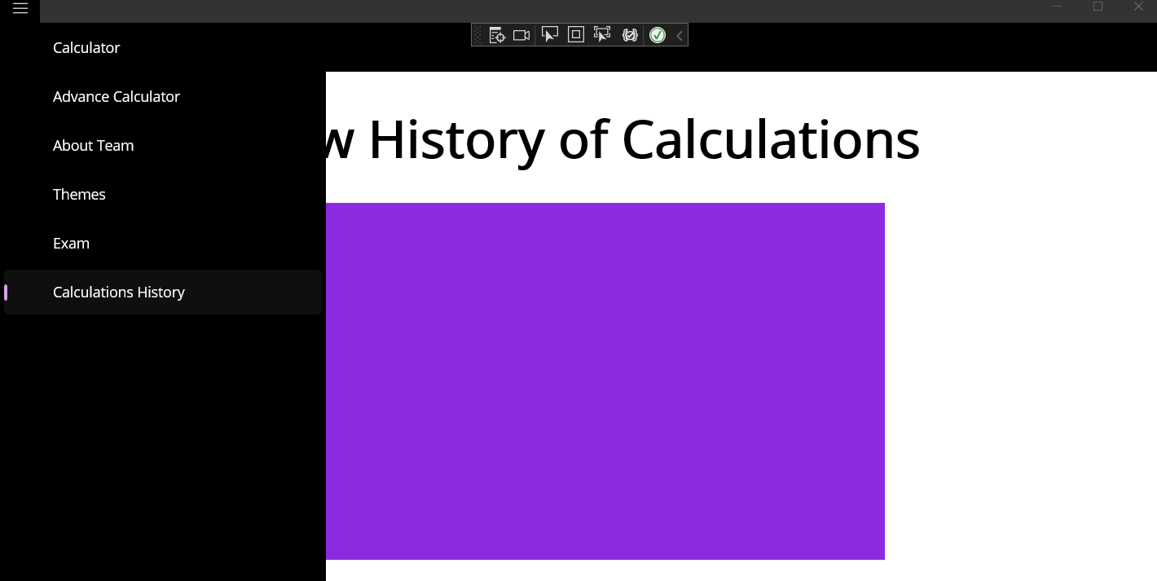

2. Screenshot of few calculations in the view history of calculations option on the simple calculator.



3. Screenshot of simple calculator which does various calculations.

