Command Injection: To learn how command injection attacks work Tools: DVWA, Burp Suite, custom vulnerable web application.

Command Injection vulnerabilities occur when a web application executes system commands with un-sanitized user input. This lab will demonstrate how to exploit and understand these vulnerabilities using DVWA hosted on Metasploitable.
Metasploitable is a purposely vulnerable virtual machine created for cybersecurity training. It behaves like a real server but contains many known security weaknesses. Instead of attacking real systems, students practice on Metasploitable in a safe, isolated environment to learn how cyberattacks work and how to defend against them.

This experiment teaches students how a small coding mistake can allow a hacker to make a server perform unintended actions, and how secure coding practices prevent such attacks.

Objective
  - Understand how Command Injection vulnerabilities work.
  - Exploit the vulnerability to execute system commands.
  - Analyse risks and discuss mitigation strategies.
Step 1: Download Metasploitable2-Linux.zip.
Open a web browser on your Windows system.
Go to:

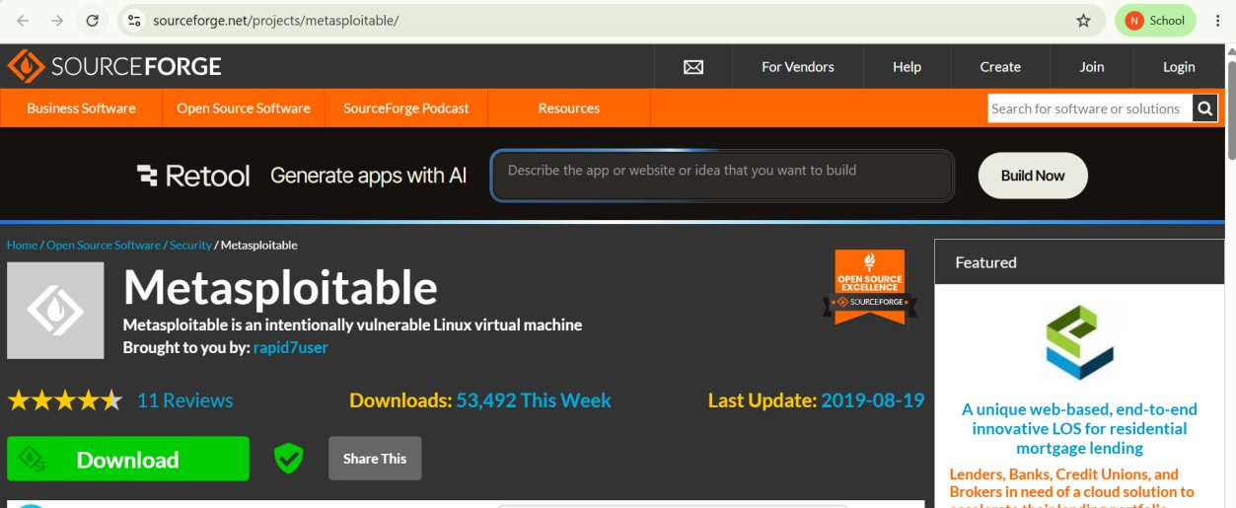
1. Go to: https://sourceforge.net/projects/metasploitable/

Step 2: Extract the ZIP File
After downloading:

- Right-click Metasploitable2-Linux.zip.
Select Extract All.
- After extraction, you should have a folder containing files such as:
- Metasploitable.vmdk Metasploitable.vmx

Steps to Import Metasploitable into Virtual box
In Virtual Box, click the new button at the top left.
A window titled Create Virtual Machine will appear. Fill in:
  - Name: Metasploitable
  - Folder: (leave the default)
  - ISO Image: Leave this field empty. (do not select anything)
  - Type: Linux
OS Distribution: Linux 2.6
  - Version: Ubuntu (32-bit) or Other Linux (32-bit)
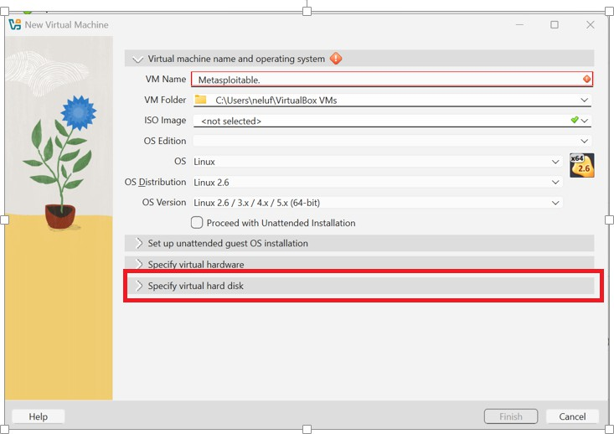

Next, expand Specify Virtual Hard Disk.
Click the small arrow next to Specify Virtual hard disk. You should see options like:

  - Create a Virtual hard disk now

  - Use an existing Virtual hard disk file
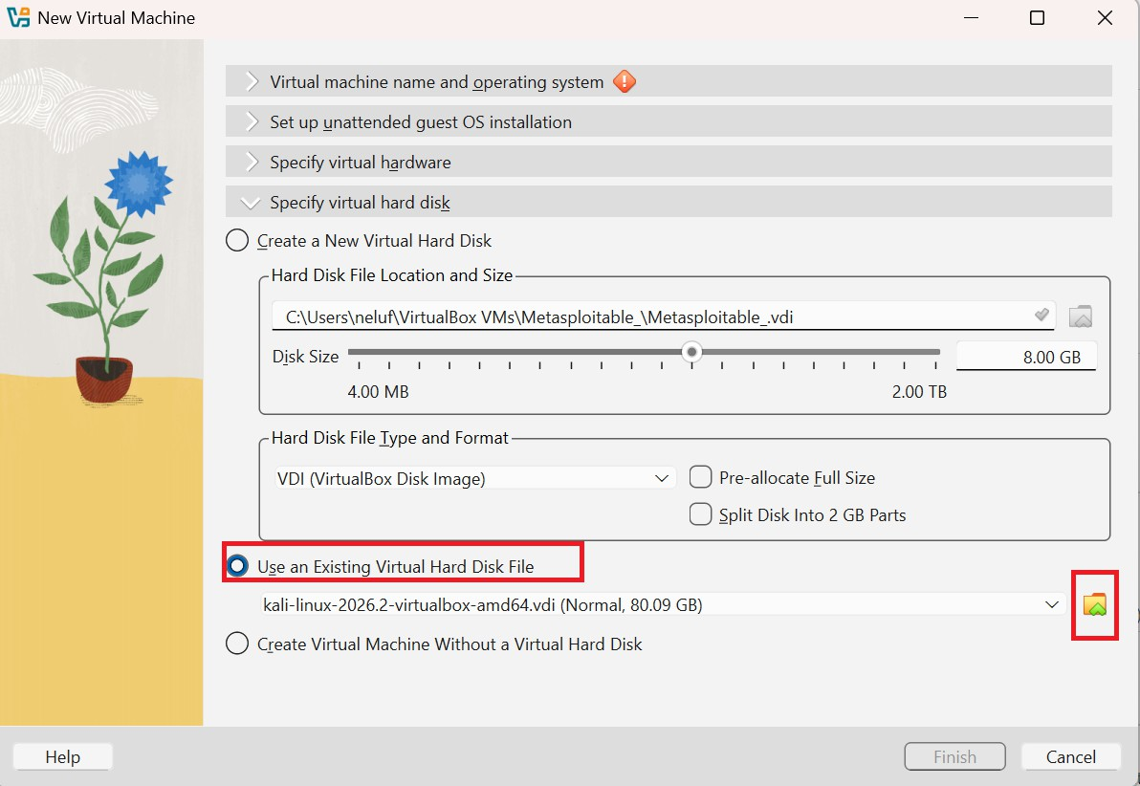

Choose Use an existing Virtual hard disk file, then browse and select:

Metasploitable.vmdk

(from the folder you extracted).

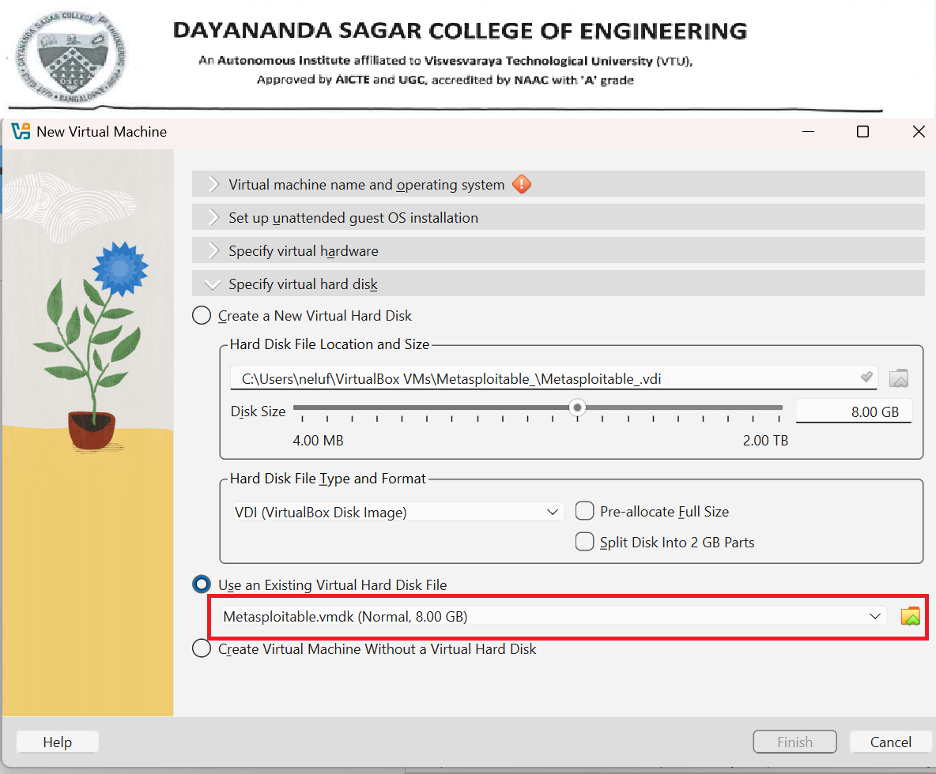
Click Finish.

You should now see Metasploitable listed on the left side of VirtualBox along with Kali.
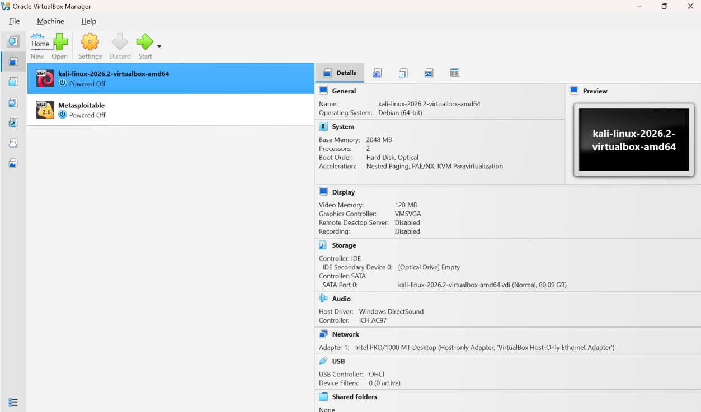

The next step is to configure the network so that Kali and Metasploitable can communicate. Step 1: Configure Metasploitable Network
- Select Metasploitable.
- Click Settings (gear icon).

Step 2: Go to Network

  - Click Network on the left.
  - Under Adapter 1, you'll see:

  - Attached to: Host-only Adapter

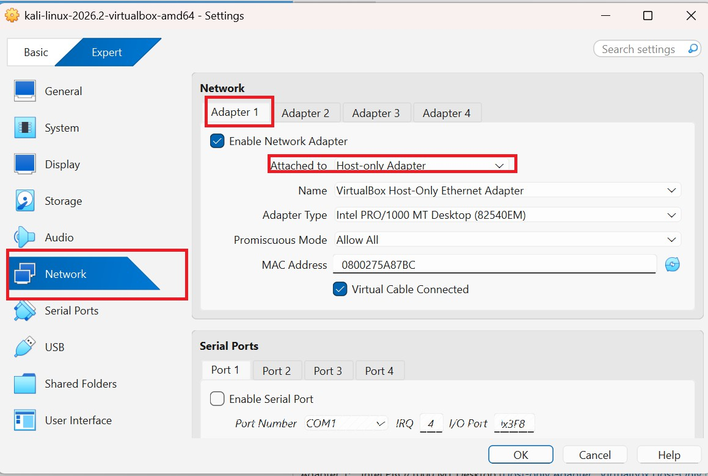

If you don't have a Host-only Adapter, choose Bridged Adapter for now (you can use the same adapter as Kali).

Step 3: Configure Kali the Same Way Select Kali Linux → Settings → Network.
Ensure Adapter 1 is set to the same network type as Metasploitable:

  - If Metasploitable uses Host-only Adapter, Kali should also use Host-only Adapter.

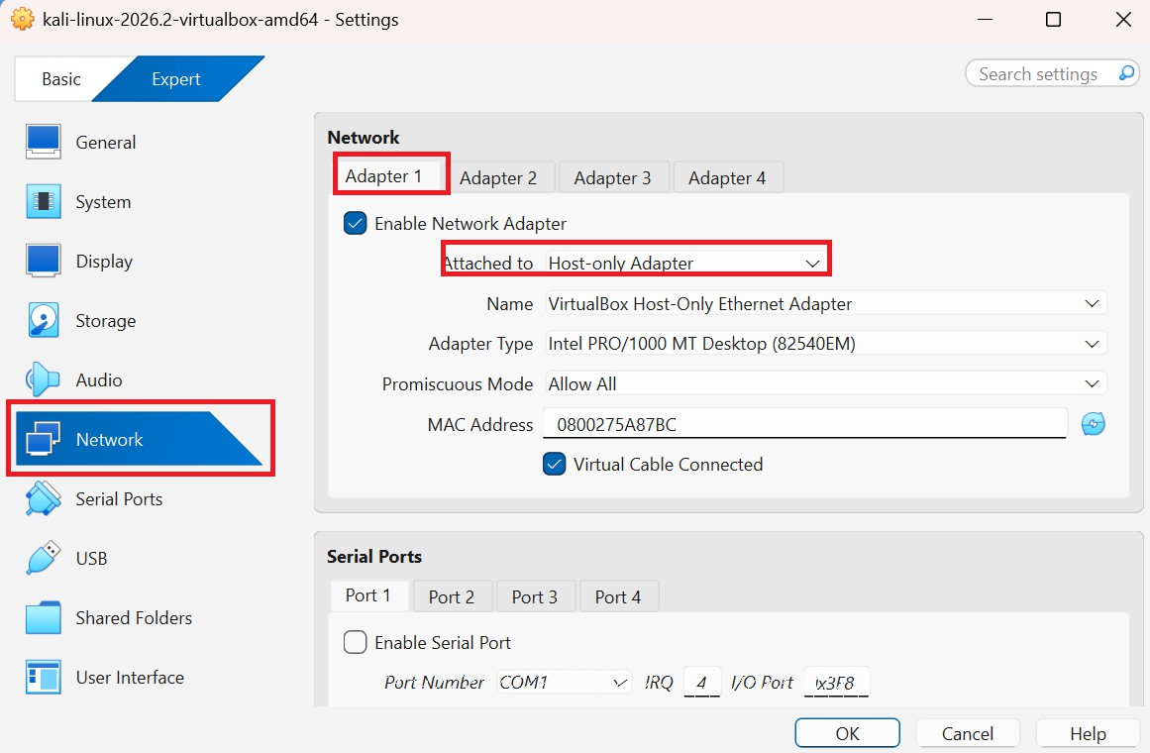
If Metasploitable uses Bridged Adapter, Kali should also use Bridged Adapter.
The network configuration is now complete. Now Start Both Virtual Machines
- Select Metasploitable → Click Start.

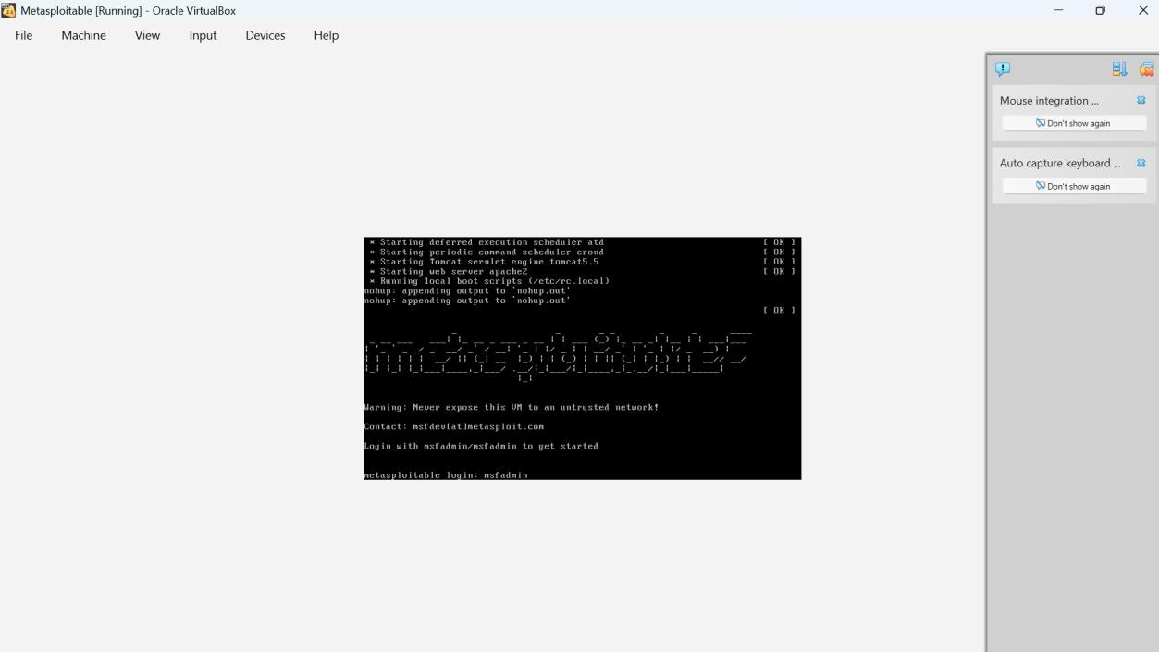
- Log in:

- Username: msfadmin
Password: msfadmin

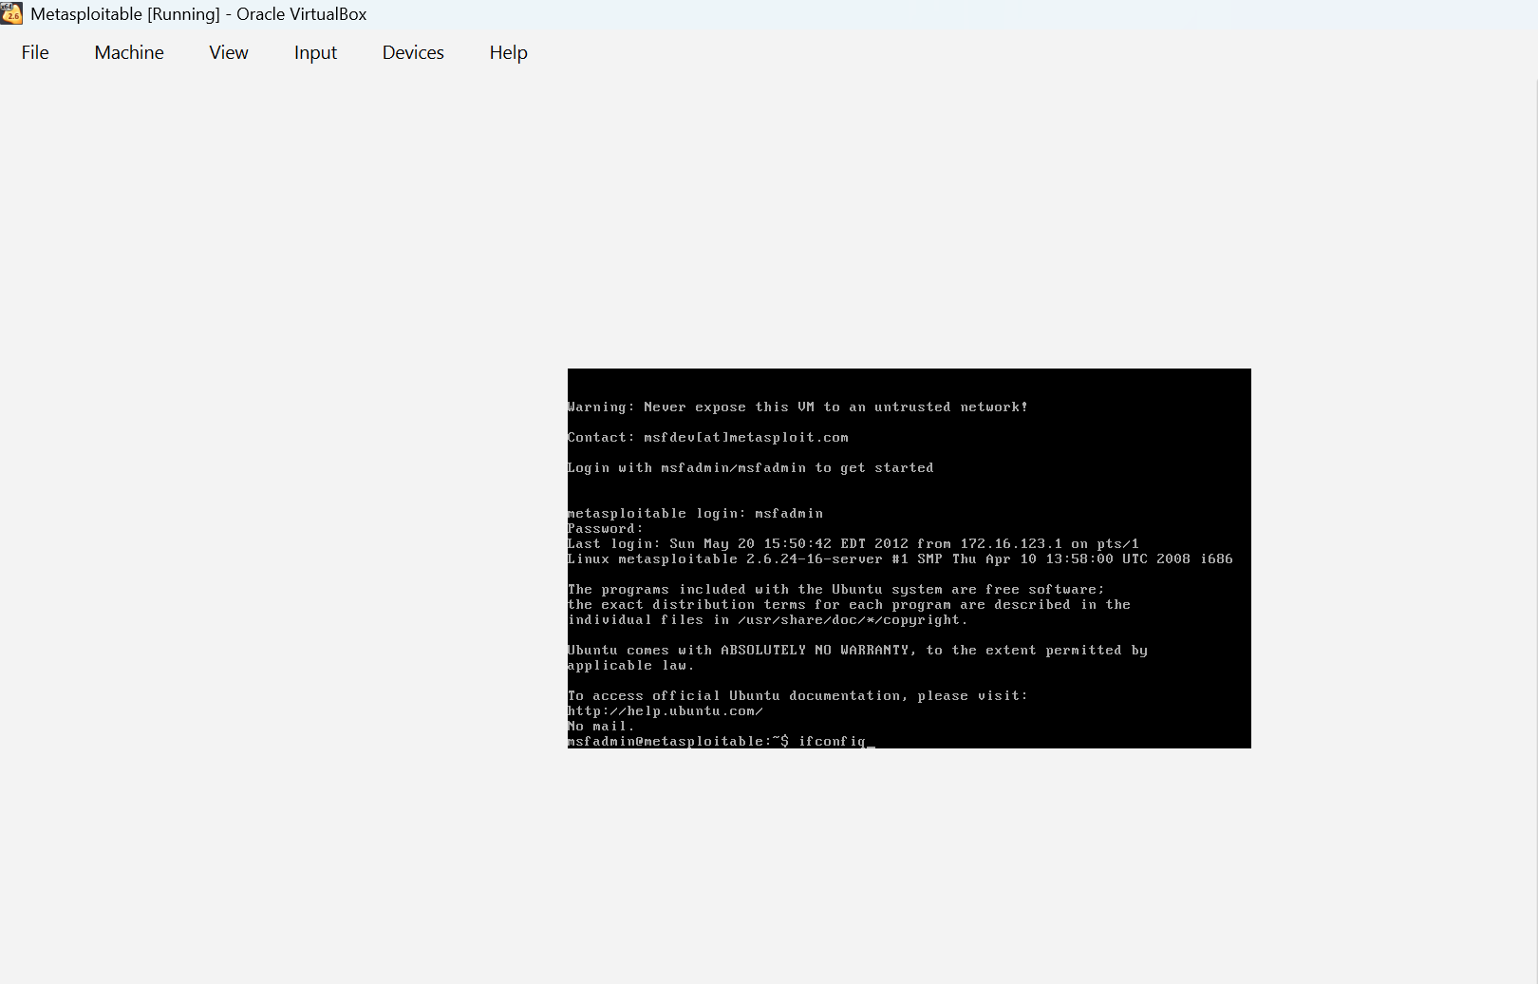
- After logging in, type: ifconfig

Look for the IP address under eth0, for example: 192.168.56.102 ((The IP address will vary depending on your machine.)
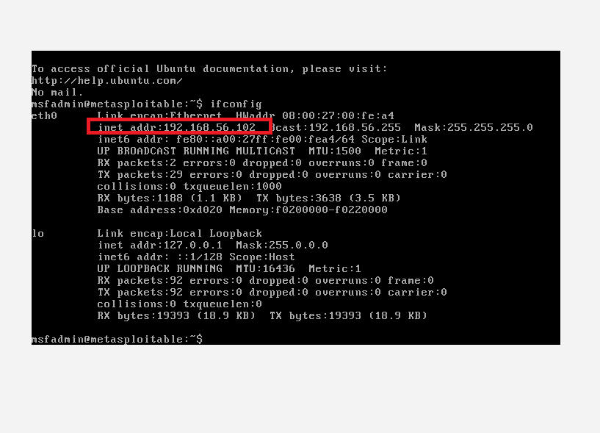
Note this IP address 192.168.56.102

Step 1: Start Kali Linux

Start your Kali Linux VM and log in.

Step 2: Test the Connection Open a terminal in Kali and type: ping 192.168.56.102


If
you
receive
replies,
the
connection
is
working.

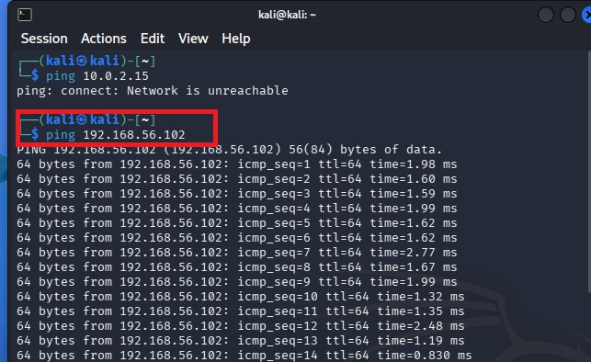
Step 3: Open DVWA Open Firefox in Kali.
In the address bar, enter:

http://192.168.56.102/dvwa

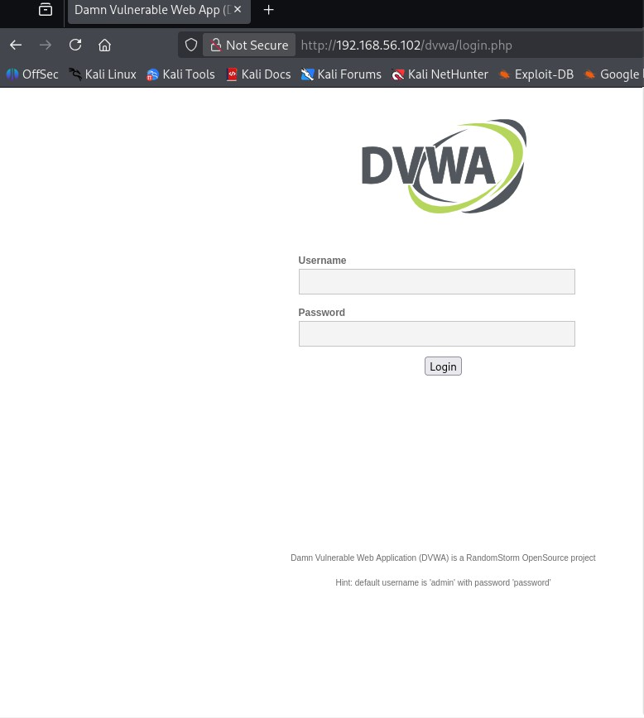

Step 4: Login to DVWA Use:
Username: admin
Password: password

If you see a Create/Reset Database button, click it first, then log in again.
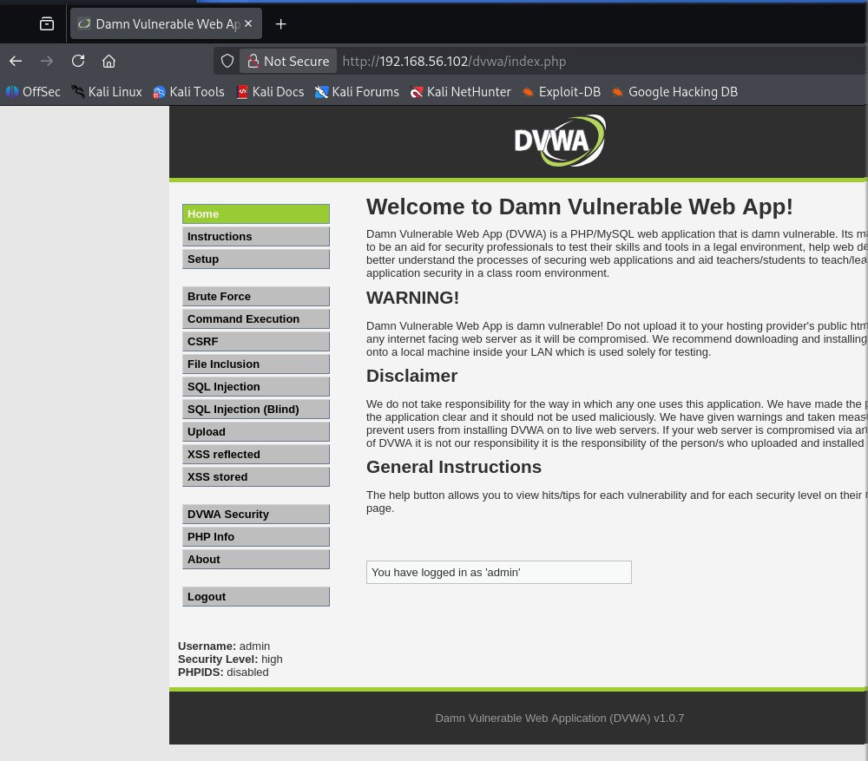
Step 5: Set Security to Low From the left menu:

DVWA Security → Select Low → Click Submit.
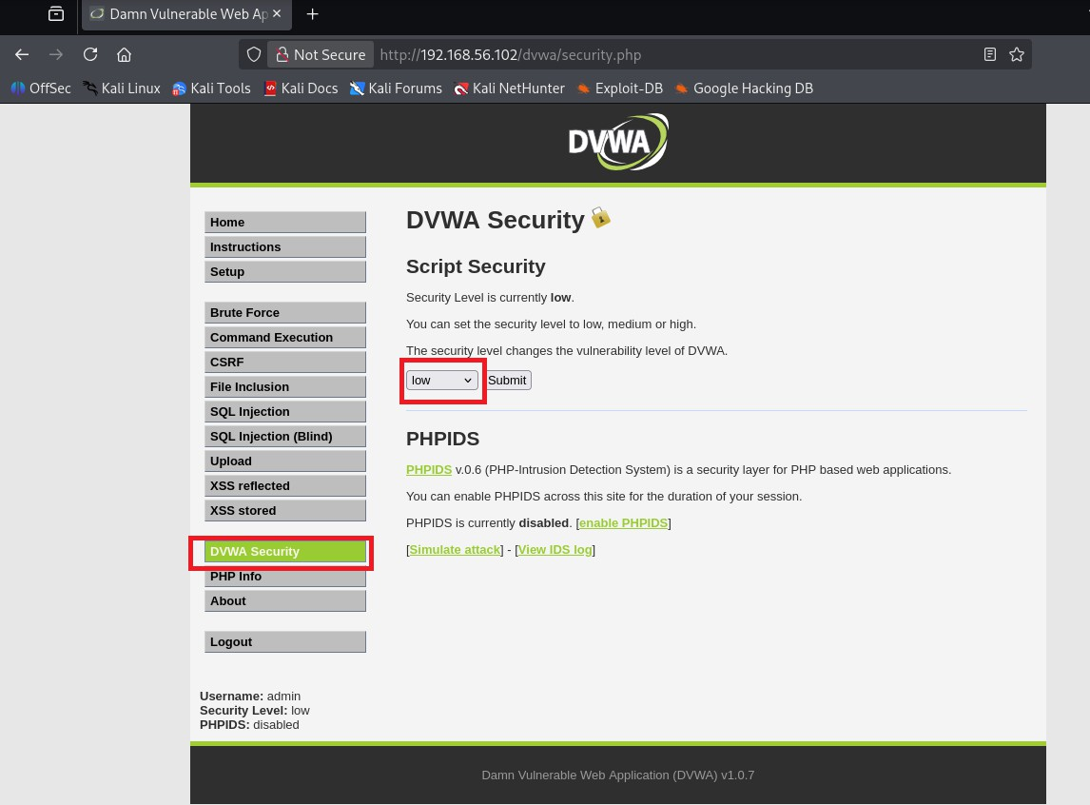

Step 6: Open Command Executio

Click Command Execution in the left menu. You'll see a text box asking for an IP address.

Step 7: Test the Application Enter: 127.0.0.1
Click Submit.

You should see the ping output.

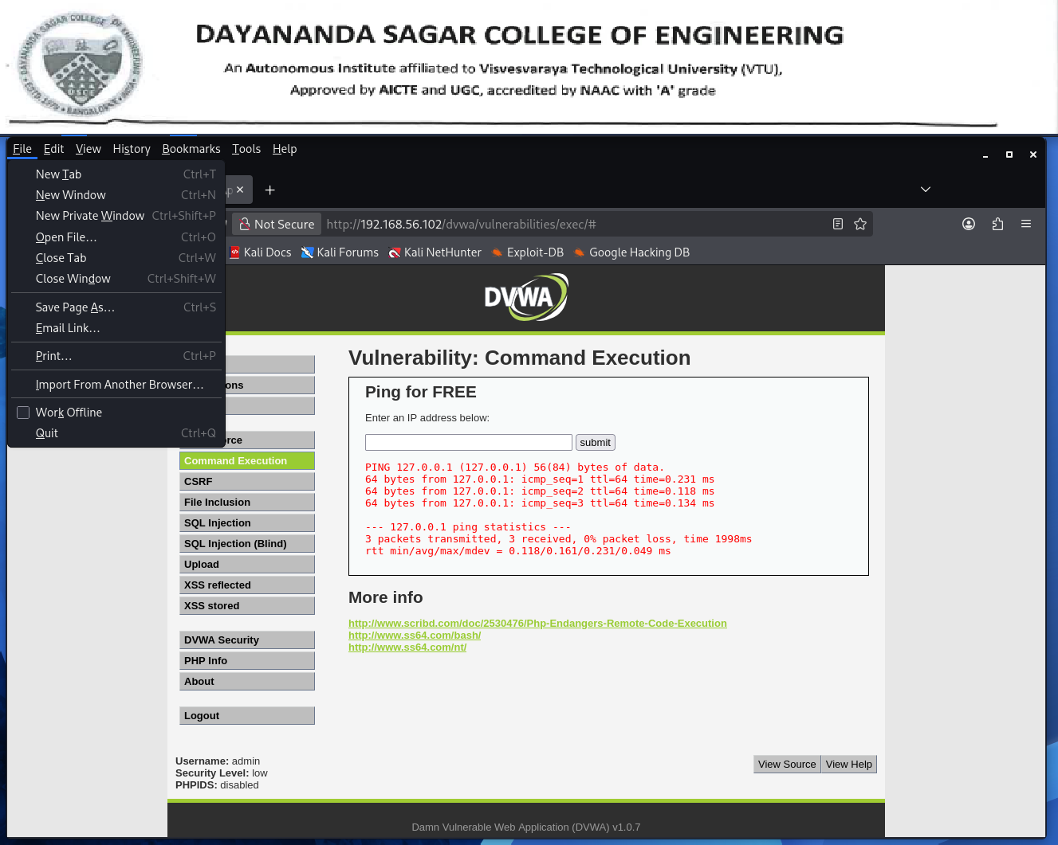

Step 8: Try Safe Command Execution Examples One at a time, enter:
127.0.0.1; ls

Click Submit.

Expected Output: A list of files and directories in the current folder.

Try the following commands:

127.0.0.1; pwd
output:

PING 127.0.0.1 (127.0.0.1) 56(84) bytes of data.
64 bytes from 127.0.0.1: icmp_seq=1 ttl=64 time=0.280 ms 64 bytes from 127.0.0.1: icmp_seq=2 ttl=64 time=0.298 ms 64 bytes from 127.0.0.1: icmp_seq=3 ttl=64 time=0.214 ms
--- 127.0.0.1 ping statistics ---
3 packets transmitted, 3 received, 0% packet loss, time 1999ms rtt min/avg/max/mdev = 0.214/0.264/0.298/0.036 ms
/var/www/dvwa/vulnerabilities/exec 127.0.0.1; whoami
127.0.0.1; ls -la

127.0.0.1; ifconfig

These demonstrate how the application executes additional commands because it doesn't properly validate user input.

