Cataloguing
The cataloguing subsystem serves as the central repository for all goods available across the marketplace. Because hundreds of independent merchants may list products on the platform, the catalog structure must organize items so that visitors can easily discover them while preventing merchants from accidentally overwriting or altering another seller's inventory.
Organizational Structure and Categorization
To maintain order across a vast array of goods, the system organizes products using a hierarchy:
- Categories and Subcategories: Items are grouped into broad classifications (such as Electronics or Clothing) and further divided into subcategories. This hierarchy allows buyers to narrow down their searches efficiently.
- Store Ownership: Every product listed on the platform is explicitly tied to a specific merchant store. While two merchants might sell identical items, each listing is treated as a distinct record associated with its respective store, maintaining independent pricing, stock levels, and store ratings.
- Product Variations: Items often come in multiple variations, such as different sizes, colors, or materials. The cataloguing model supports linking variants under a master item description so buyers can select their preferred option on a single product detail screen.
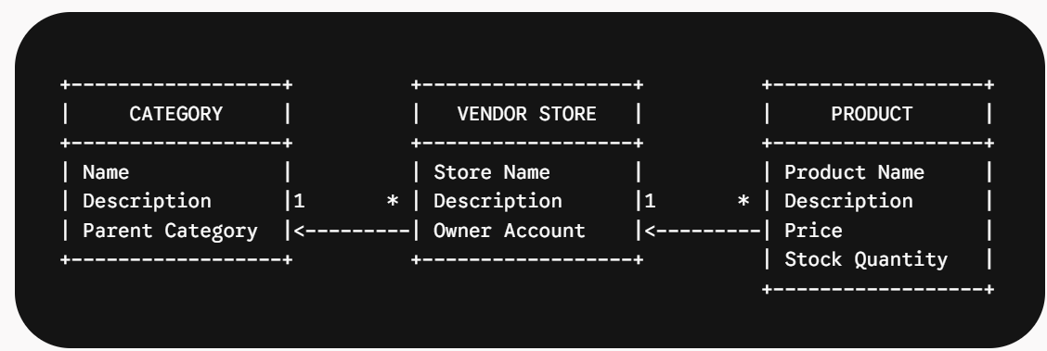
Experiences
The user experience layer defines how information is presented to visitors and how they interact with the system across different stages of their shopping or selling journey.
User Interface Layout Strategy
The user interface follows a clear layout structure designed for quick navigation:
- Global Navigation Bar: Present at the top of every page, containing the brand logo, search bar, category navigation menu, user account links, and a dynamic shopping cart indicator that updates in real time.
- Catalog and Search View: Features a multi-column layout with a filter panel on the side (allowing visitors to filter by category, price, store name, or customer rating) alongside a responsive grid of product cards displaying images, titles, prices, and vendor store names.
- Product Detail View: Focuses on presenting a comprehensive overview of a single item, including high-resolution imagery, description, stock status, seller store links, a purchase selection form, and customer feedback summaries.
- Management Dashboards: Dedicated operational panels tailored specifically for merchants to view sales summaries, add new product listings, update stock levels, and mark incoming orders as shipped.


