EnergyOps Platform
Smart Submeter Billing & Energy Monitoring System
Comprehensive Technical Documentation

1. Executive Summary
EnergyOps is a full-stack energy monitoring and billing platform designed to simulate smart-meter readings, generate automated invoices, and provide real-time analytics dashboards. The system is built using a modern microservice-friendly architecture with a .NET backend, SQLite database, and React frontend.

2. Problem Statement
Multi-tenant buildings require accurate submeter tracking and automated billing. Manual tracking leads to inaccuracies, delayed invoicing, and lack of analytics visibility. EnergyOps addresses this by automating readings simulation, billing calculations, and spike detection.

3. System Architecture
Frontend: React + Vite
Backend: ASP.NET Core Web API
Database: SQLite
Communication: REST APIs
Visualization: SVG + Matplotlib generated charts

4. Core Features
• Property and Unit Management
• Smart Meter Readings Simulation
• Automated Billing Engine
• Spike Detection Logic
• Interactive Dashboard with Charts
• Invoice Drill-Down View

5. Database Design
Entities:
• Property (Id, Name, Address)
• Unit (Id, PropertyId, UnitNumber, TenantName, RatePlanId)
• RatePlan (RatePerKwh, FixedFee)
• MeterReading (UnitId, Timestamp, UsageKwh)
• Invoice (UnitId, BillingMonth, TotalUsageKwh, TotalAmount)

6. Billing Logic
Invoice Total = (TotalUsageKwh × RatePerKwh) + FixedFee
Example:
408.94 kWh × $0.18 = $73.61
$73.61 + $12 Fixed Fee = $85.61

7. Spike Detection Logic
Spike detection is based on daily averages. If a day's consumption exceeds a defined threshold compared to the unit's average daily usage, the system flags it as a spike. This helps detect abnormal energy usage patterns.

8. Dashboard Visual Analytics
Monthly Usage per Unit:
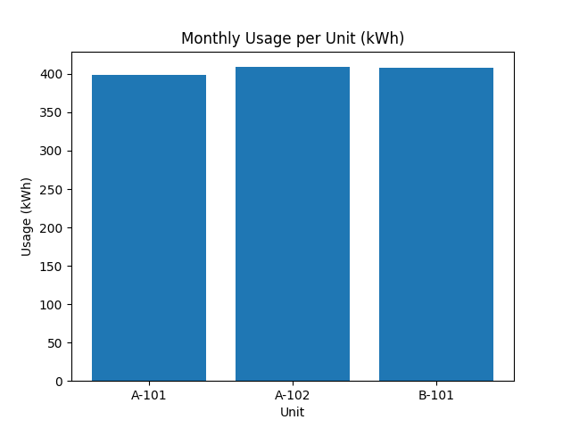
Invoice Distribution per Unit:
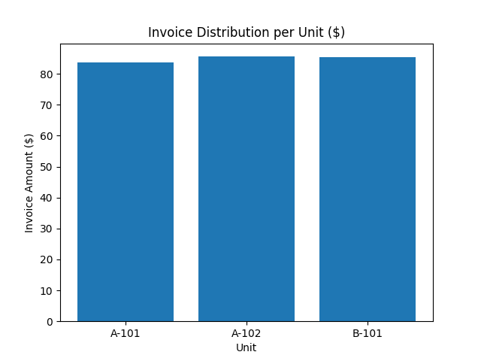

9. Performance & Scalability Considerations
• Optimized LINQ queries for aggregation
• Proper indexing strategy in relational databases
• Scalable architecture suitable for migration to PostgreSQL or SQL Server
• Frontend responsive layout for desktop and tablet use

10. Future Enhancements
• Role-based authentication
• Real smart meter IoT integration
• Payment gateway integration
• Cloud deployment with Docker
• Advanced anomaly detection using ML

11. Interview Talking Points
• Demonstrates full-stack capability
• Shows API design and relational modeling
• Implements real-world billing calculations
• Incorporates data visualization
• Explains scalability and system design thinking

Conclusion
EnergyOps is a realistic simulation of an energy submeter billing system that showcases backend engineering, database modeling, frontend development, and analytical thinking in a single cohesive platform.

