DECODELABS

Project 2: Exploratory Data Analysis (EDA)
Data Analytics Internship
Prepared by: Farah Shaikh
Tools: Python, Pandas, Matplotlib
Dataset: Cleaned dataset.xlsx

1. Project Objectives
The main objective of this project was to perform Exploratory Data Analysis (EDA) on a cleaned dataset to understand its structure, identify trends, detect potential outliers, and summarize important observations.
The specific objectives were:
- Inspect the dataset structure, column information, and missing values.
- Calculate basic statistics, including mean, median, and count.
- Analyze and visualize monthly total prices.
- Identify potential outliers using the Interquartile Range (IQR) method.
- Summarize key findings from the dataset.

2. Tools and Technologies
The following tools and libraries were used:
- Python: Used to perform data analysis.
- Pandas: Used for data loading, inspection, statistical calculations, grouping, and outlier detection.
- Matplotlib: Used to visualize monthly total price trends.
- Microsoft Excel: Used as the source format for the cleaned dataset.

3. Dataset Overview
The dataset contains 1,200 order records and 14 columns.
The columns include:
OrderID, Date, CustomerID, Product, Quantity, UnitPrice, ShippingAddress, PaymentMethod, OrderStatus, TrackingNumber, ItemsInCart, CouponCode, ReferralSource, and TotalPrice.

3.1 Data Quality Summary
The initial dataset inspection produced the following results:
- Total records: 1,200
- Total columns: 14
- Missing values: 0
- Numerical columns analyzed: Quantity, UnitPrice, and TotalPrice
- Date column: Converted to datetime format for trend analysis.
The inspection confirmed that all 14 columns contained 1,200 non-null values.

4. Methodology and Analysis

4.1 Data Inspection
The Excel dataset was loaded into Python using the pd.read_excel() function.
The following Pandas methods were used:
- head() displays the first five rows.
- shape returns the number of rows and columns.
- info() provides column data types and non-null counts.
- isnull().sum() identifies missing values in each column.
The inspection confirmed that the dataset contained 1,200 records, 14 columns, and no missing values.

4.2 Descriptive Statistical Analysis
Basic statistics were calculated for Quantity, UnitPrice, and TotalPrice using the mean, median, and count functions.
Column | Mean | Median | Count
Quantity | 2.95 | 3.00 | 1,200
UnitPrice | 356.41 | 364.21 | 1,200
TotalPrice | 1,053.97 | 823.615 | 1,200

Key observations:
- The average quantity per order was approximately 2.95 units.
- The median quantity was 3 units.
- The average unit price was approximately 356.41.
- The average total price per order was approximately 1,053.97.
These statistics provide an overview of the numerical characteristics of the dataset.

4.3 Monthly Trend Analysis
The Date column was converted into datetime format using pd.to_datetime(). Rows with missing or invalid dates were excluded from the trend calculation.
The dates were grouped into monthly periods, and the sum of TotalPrice was calculated for each month using Pandas groupby() and sum(). Matplotlib was then used to create a line graph showing changes in monthly total prices.
Analysis period: January 2023 – June 2025
Key findings:
- Highest monthly total price: June 2024 — 68,068.54
- Lowest monthly total price: April 2023 — 27,751.71
The monthly trend shows fluctuations in total prices throughout the analysis period. June 2024 recorded the highest monthly total, while April 2023 recorded the lowest.
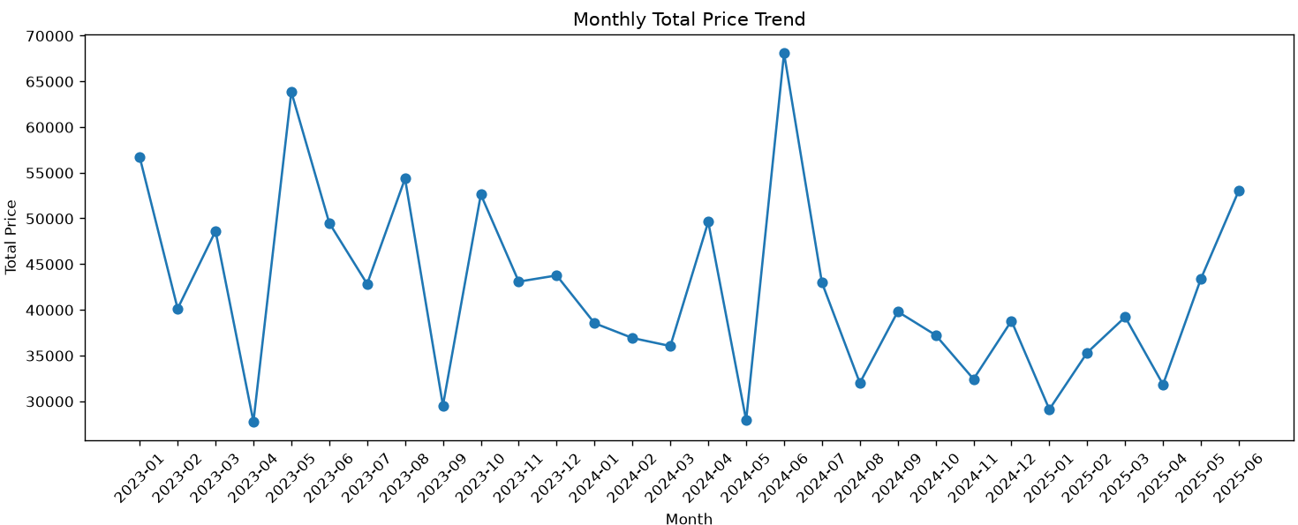Figure 1: Monthly Total Price Trend (January 2023 – June 2025)

4.4 Outlier Detection Using the IQR Method
The Interquartile Range (IQR) method was used to identify potential outliers in Quantity, UnitPrice, and TotalPrice.
The following formulas were applied:
- IQR = Q3 − Q1
- Lower Limit = Q1 − 1.5 × IQR
- Upper Limit = Q3 + 1.5 × IQR
Values below the lower limit or above the upper limit were classified as potential outliers.
Column | Q1 | Q3 | IQR | Potential Outliers
Quantity | 2.00 | 4.00 | 2.00 | 0
UnitPrice | 186.0625 | 521.57 | 335.5075 | 0
TotalPrice | 410.52 | 1,578.475 | 1,167.955 | 8
For TotalPrice, the lower limit was approximately -1,341.41, and the upper limit was approximately 3,330.41.
The eight potential outlier values identified in TotalPrice were:
3,353.75; 3,352.40; 3,370.20; 3,384.90; 3,390.80; 3,456.40; 3,334.00; and 3,390.95.
No potential outliers were detected in Quantity or UnitPrice.
These values were not removed because unusually high order totals may represent valid transactions rather than data errors. Further investigation would be required before making any changes.

5. Key Observations
The analysis produced the following observations:
- The dataset contains 1,200 orders and 14 columns, with no missing values reported during inspection.
- The average quantity per order is approximately 2.95 units, while the median is 3 units.
- The average unit price is 356.41, and the average total price is 1,053.97.
- The highest individual TotalPrice is 3,456.40, while the lowest is 11.39.
- Printer is the most frequently occurring product according to the mode calculation.
- Cancelled is the most frequent order status, with 250 records, while Delivered is the least frequent, with 231 records.
- June 2024 recorded the highest monthly total price of 68,068.54, while April 2023 recorded the lowest at 27,751.71.
- The IQR method identified eight potential outliers in TotalPrice and none in Quantity or UnitPrice.
These observations provide an overview of order quantities, pricing patterns, order statuses, monthly changes, and unusual order totals.

6. Conclusion
This project used Exploratory Data Analysis to examine a dataset containing 1,200 order records and 14 columns.
Python and Pandas were used to inspect the dataset, check missing values, and calculate descriptive statistics. Monthly aggregation and Matplotlib visualization helped identify changes in total prices over time. The IQR method detected eight potential outliers in TotalPrice, while no potential outliers were found in Quantity or UnitPrice.
The identified outliers were retained because they may represent valid transactions. Overall, the project demonstrates the practical use of Python, Pandas, and Matplotlib for data inspection, statistical analysis, trend visualization, and outlier detection.

7. Code Summary
Method / Function | Purpose
pd.read_excel() | Loads the Excel dataset.
head(), shape, info() | Inspects records, dimensions, and column information.
isnull().sum() | Counts missing values.
mean(), median(), count() | Calculates descriptive statistics.
pd.to_datetime() | Converts dates into datetime format.
groupby(), sum() | Calculates monthly total prices.
Matplotlib plotting functions | Visualizes monthly trends.
quantile() | Calculates Q1 and Q3.
IQR formulas | Identifies potential outliers.
max(), min(), mode(), value_counts() | Summarizes extreme and frequent values.

