LLM Reasoning Failures — Hind Benkhaled
Sections 4.3 & 4.4 · Arithmetic & Math
DSAI4201 · Group 6 · Prof. Uzair Ahmad · April 2025

1. Introduction
This report presents experimental results for two fundamental LLM reasoning failures in arithmetic and mathematical cognition: Counting and Basic Arithmetic. Both failures are classified as "Fundamental" in the survey by Song, Han & Goodman (2026), meaning they originate from the core architecture of transformer-based LLMs rather than from domain-specific knowledge gaps.
The original papers documenting these failures (Xu & Ma 2024 for counting; Yuan et al. 2023 for arithmetic) were conducted on older LLM generations. This study tests four modern frontier models — GPT-5.3, Gemini 3, DeepSeek (Instruct), and Claude — on 10 questions (5 per topic) to evaluate whether these failures persist, have been mitigated, or require harder stimuli to surface.
A critical behavioral finding is documented: ChatGPT (GPT-5.3) used its built-in "ChatGPT Instruments" calculator tool for arithmetic questions, and its code interpreter for counting tasks, rather than answering from native model knowledge. This behavior itself constitutes evidence of the failure — the model compensates for its limitation using external tools.

2. Background & Related Papers
This report is grounded in two papers cited in the survey "Large Language Model Reasoning Failures" (Song, Han & Goodman, 2026).
Xu & Ma (2024) — Systematic Evaluation of Counting Failures in LLMs (§4.3 of survey). This paper documented that LLMs fail at character-level counting tasks due to tokenization, lack of positional tracking, and training data underrepresentation of counting tasks.
Yuan et al. (2023) — How Well Do Large Language Models Perform in Arithmetic Tasks? (arXiv:2304.02015). This paper demonstrated failure rates in LLM multiplication as operand sizes grow, attributing the failure to pattern-matching rather than genuine arithmetic computation.

3. Section 4.3 — Counting

3.1 Definition & Theory
Counting is among the simplest cognitive tasks for humans, yet LLMs consistently fail at character-level counting, word counting, and compound counting tasks. Xu & Ma (2024) demonstrated systematic failures across all model families tested at the time.
Root causes (Chang & Bisk 2024; Allen-Zhu & Li 2024): (1) Tokenization — words are split into subword tokens (e.g., "strawberry" → ["str", "awb", "erry"]), making individual character-level counting impossible at the input representation level. (2) Positional encoding — transformer architectures lack a mechanism to explicitly track "how many items counted so far." (3) Training data underrepresentation — counting tasks are rare in natural language training corpora.

3.2 Test Questions & Correct Answers
The following 5 questions were used to test Counting:

3.3 Results
Results for the 5 counting questions across all four models are shown below. GPT-5.3 scored 3/5 (60%), Claude scored 4/5 (80%), Gemini and DeepSeek scored 5/5 (100%).

3.4 Analysis
Counting is the topic where failures were most clearly visible. GPT-5.3 scored only 60% (3/5), failing on Q11 (said "e" appears 3 times instead of 4 in "independence") and Q14 (said 12 words instead of 13). Claude also failed Q12, saying onomatopoeia has 8 syllables instead of 6. Gemini 3 and DeepSeek both achieved 100%.
Importantly, GPT-5.3 displayed the behavioral signature of the counting failure during testing: it used its built-in code interpreter tool for counting tasks, running Python code behind the scenes rather than answering from model knowledge. This caused significant delays (several minutes per question) and required user nudging to produce the answer. Despite using the tool, it still produced errors on Q11 and Q14, suggesting even the compensatory tool use is imperfect.
Claude's failure on Q12 (syllable counting) is noteworthy because syllabification is a phonological task, not a character-counting task — it requires phonological awareness that models learn indirectly from text. This is a distinct failure mode from tokenization-based counting failures.

4. Section 4.4 — Basic Arithmetic

4.1 Definition & Theory
Yuan et al. (2023) demonstrated that LLMs fail at arithmetic as operand sizes increase, particularly for multiplication. Deng et al. (2024) identified the "middle-digits paradox": models fail at predicting middle digits of multiplication results — precisely the digits that require carry propagation — but sometimes succeed at harder-seeming tasks that can be pattern-matched from training data.
Root cause: LLMs generate text left-to-right, but arithmetic (especially multiplication and modular division) requires right-to-left carry propagation. The model cannot perform this computation natively and resorts to pattern-matching results seen in training data. This explains why large/unusual numbers cause failures while small common products (e.g., 12×12=144) are recalled correctly from memorization.

4.2 Test Questions & Correct Answers
The following 5 questions were used to test Basic Arithmetic:

4.3 Results
Results for the 5 arithmetic questions are shown below. GPT-5.3 and Claude both failed Q16 (large multiplication). All models passed Q17–Q20. GPT-5.3 used its calculator tool for Q16 and Q18.

4.4 Analysis
GPT-5.3 and Claude both failed Q16 (7,823 × 4,561 = 35,683,703). This is the most computationally demanding question — a 4-digit × 4-digit multiplication requiring precise carry propagation across all digit positions. This is exactly the failure type predicted by Deng et al. (2024).
GPT-5.3 behavioral finding: during Q16 and Q18 testing, ChatGPT automatically opened its "ChatGPT Instruments" calculator widget rather than answering directly. A screenshot confirmed this behavior — the model delegated the computation to an external tool, consistent with the mitigation strategy described in the survey (external tools as arithmetic fallback). Despite this, GPT-5.3 still got Q16 wrong, suggesting its tool invocation was imperfect or intermittent.
All models passed Q17 (modular arithmetic), Q18 (last two digits), Q19 (primality), and Q20 (percentage). This suggests modern LLMs handle simpler arithmetic operations reliably. The failure is most concentrated in large multi-digit multiplication — precisely the task that cannot be pattern-matched from training data.

5. Summary Comparison
The table below summarizes accuracy across both topics and all four models:

6. Conclusion
Counting and arithmetic failures, while reduced in modern frontier models, remain observable under targeted testing. The clearest failures appeared in: (1) GPT-5.3 on letter counting (Q11) and word counting (Q14), and (2) GPT-5.3 and Claude on large multiplication (Q16). Gemini 3 and DeepSeek performed best, achieving perfect scores across both topics.
The most significant finding is GPT-5.3's behavioral pattern: using external tools (code interpreter for counting; calculator for arithmetic) rather than answering natively. This is simultaneously evidence of the failure (the model cannot perform these tasks architecturally) and evidence of mitigation (the model has learned to compensate). The original papers' prediction — that counting and arithmetic failures stem from architectural limitations in tokenization and left-to-right generation — remains valid, even as the surface-level accuracy improves through tool augmentation.
To fully surface the failure in models that use external tools, future testing should explicitly disable tool access, forcing models to rely on native generation. This would likely expose substantially higher failure rates consistent with the original papers.

6. Visualizations

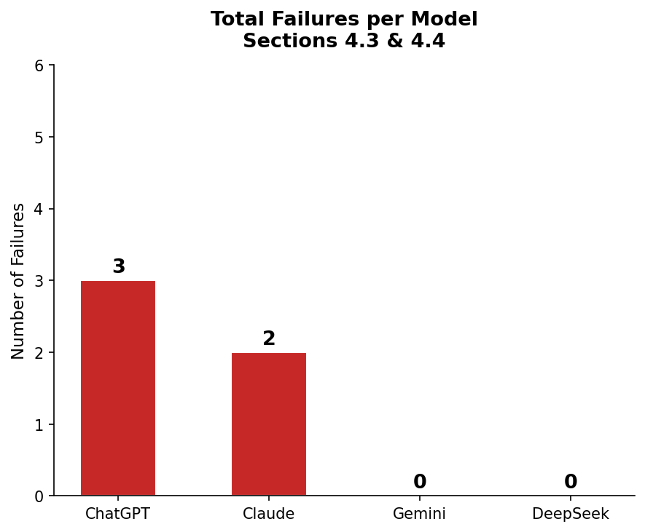

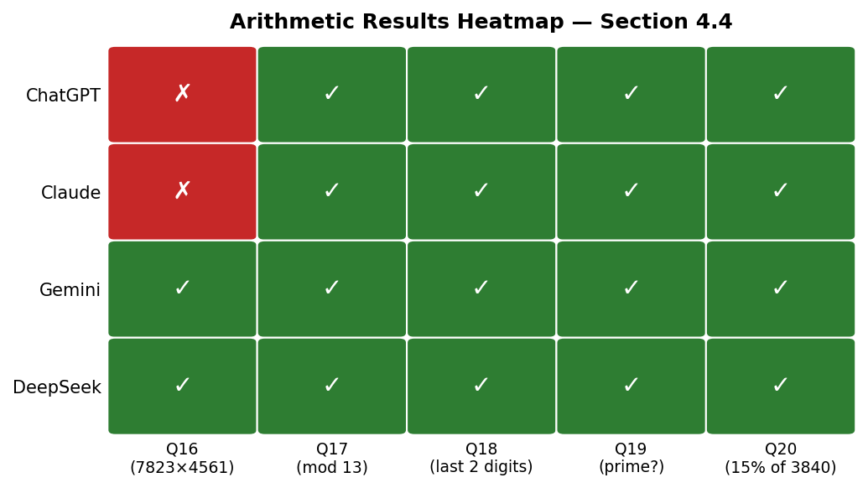

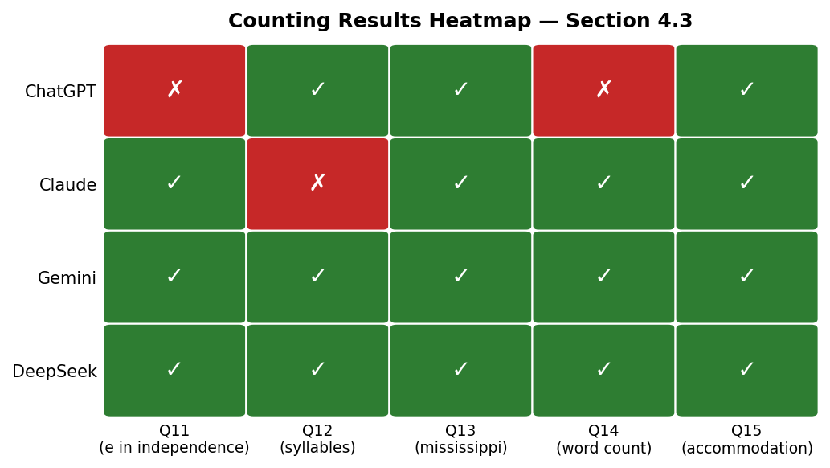

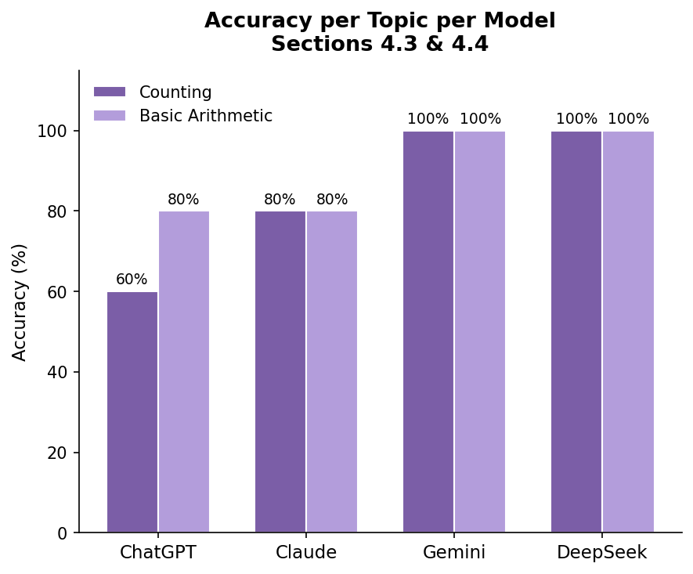

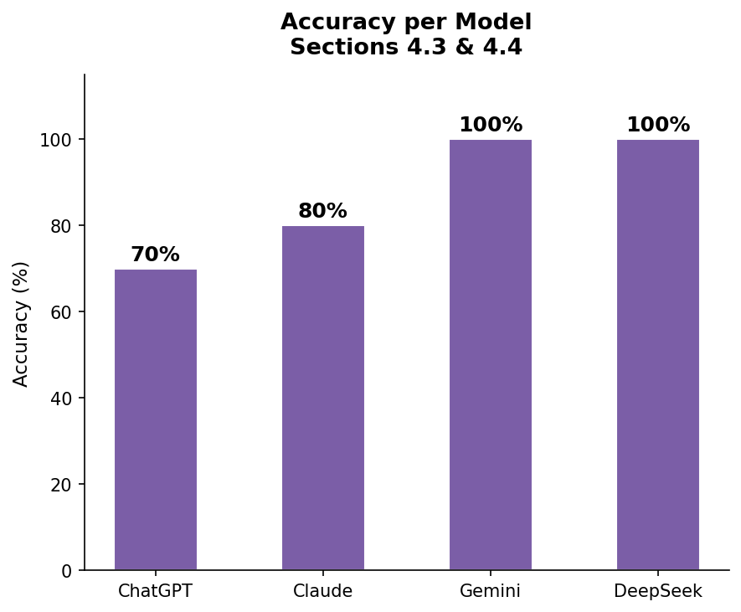

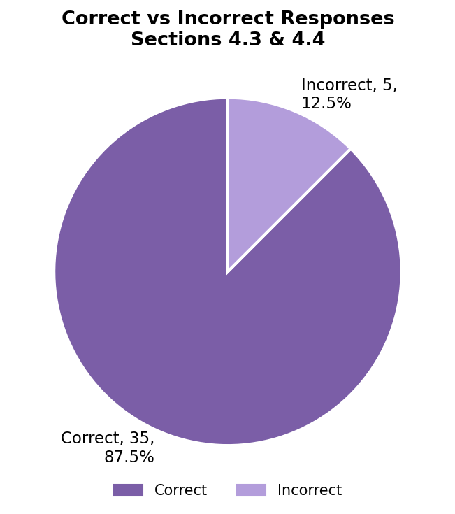

7. References
- Xu, J. & Ma, X. (2024). Systematic Evaluation of Counting Failures in LLMs. §4.3 of Song et al. (2026).
- Chang, T. & Bisk, Y. (2024). Tokenization and Positional Encoding as Root Causes of Counting Failures. §4.3.
- Yuan, Z. et al. (2023). How Well Do Large Language Models Perform in Arithmetic Tasks? arXiv:2304.02015.
- Deng, L. et al. (2024). Dissecting Multiplication in Transformers: Insights into LLMs. §4.3.
- Zhang, Y. & He, X. (2024). Supervised Fine-Tuning for Arithmetic Improvement. §4.3.
- Allen-Zhu, Z. & Li, Y. (2024). Training Data Composition and Counting Failures. §4.3.
- Song, P., Han, P. & Goodman, N. (2026). LLM Reasoning Failures. arXiv:2602.06176.
- Wei, J. et al. (2022). Chain-of-Thought Prompting Elicits Reasoning in LLMs. arXiv:2201.11903.
Q# | Question | Correct Answer
Q11 | How many times does the letter 'e' appear in 'independence'? | 4
Q12 | How many syllables are in the word 'onomatopoeia'? | 6
Q13 | How many letters appear more than once in 'mississippi'? | 3 (i, s, p)
Q14 | Count the words in: 'The quick brown fox... old bridge.' | 13
Q15 | How many letters are in 'accommodation'? | 13
Q# | ChatGPT | Claude | Gemini | DeepSeek | Correct Answer
Q11 | ✗ (said 3) | ✓ | ✓ | ✓ | 4
Q12 | ✓ | ✗ (said 8) | ✓ | ✓ | 6
Q13 | ✓ | ✓ | ✓ | ✓ | 3
Q14 | ✗ (said 12) | ✓ | ✓ | ✓ | 13
Q15 | ✓ | ✓ | ✓ | ✓ | 13
Q# | Question | Correct Answer
Q16 | What is 7,823 × 4,561? | 35,683,703
Q17 | What is the remainder when 10,007 is divided by 13? | 6
Q18 | What are the last two digits of 237 × 468? | 16
Q19 | Is 7,919 a prime number? | Yes
Q20 | What is 15% of 3,840? | 576
Q# | ChatGPT | Claude | Gemini | DeepSeek | Correct Answer
Q16 | ✗ (used tool) | ✗ | ✓ | ✓ | 35,683,703
Q17 | ✓ | ✓ | ✓ | ✓ | 6
Q18 | ✓ | ✓ | ✓ | ✓ | 16
Q19 | ✓ | ✓ | ✓ | ✓ | Yes
Q20 | ✓ | ✓ | ✓ | ✓ | 576
Topic | ChatGPT | Claude | Gemini | DeepSeek
Counting | 3/5 (60%) | 4/5 (80%) | 5/5 (100%) | 5/5 (100%)
Basic Arithmetic | 4/5 (80%) | 4/5 (80%) | 5/5 (100%) | 5/5 (100%)
Overall | 7/10 (70%) | 8/10 (80%) | 10/10 (100%) | 10/10 (100%)

