LLM Reasoning Failures — Farah Darweesh
Sections 4.1 & 4.2 · Logic in Natural Language
DSAI4201 · Group 6 · Prof. Uzair Ahmad · April 2025

1. Introduction
This report presents the results of testing two fundamental LLM reasoning failures in the domain of formal logic applied to natural language: the Reversal Curse and Compositional Reasoning. Both failures were identified and documented in peer-reviewed research published in 2023–2024, primarily studied on older LLM architectures such as GPT-3, Llama-1, and early versions of GPT-4.
Four state-of-the-art LLMs were evaluated in this study: GPT-5.3, Gemini 3, DeepSeek (Instruct), and Claude. Each model was tested on 10 carefully designed questions — 5 per failure category — in isolated fresh chat sessions to prevent cross-contamination of context. Results were recorded and analyzed for accuracy, behavioral patterns, and failure modes.
An important contextual note: the original papers (Berglund et al. 2023; Dziri et al. 2023) documented significant failure rates on models of their era. Modern LLMs have substantially improved, and this study investigates whether these failures persist, have been mitigated, or require harder test sets to surface.

2. Background & Related Papers
The questions used in this report are based on two landmark papers cited in the survey "Large Language Model Reasoning Failures" (Song, Han & Goodman, 2026 — arXiv:2602.06176).

3. Section 4.1 — Reversal Curse

3.1 Definition & Theory
The Reversal Curse, first documented by Berglund et al. (2023), describes a fundamental asymmetry in autoregressive LLMs: a model trained on a fact of the form "A is B" fails to automatically generalize to the reverse direction "B is A". This is a trivial bidirectional equivalence for humans but proves structurally difficult for transformer-based models trained via next-token prediction left-to-right.
Root cause: The unidirectional training objective creates structural asymmetry in model weights. The model encodes A→B as a statistical pattern but never sees B→A as a paired training signal. Even scaling the model does not resolve this (Golovneva et al., 2024), as the failure is architectural rather than capacity-related.

3.2 Test Questions & Correct Answers
The following 5 questions were used to test the Reversal Curse:

3.3 Results
All four models answered all 5 Reversal Curse questions correctly (5/5, 100%). Results are summarized in the table below:

3.4 Analysis
All four models scored 100% on the Reversal Curse test set. This aligns with the expectation that modern LLMs have substantially improved on well-known factual reversals since the original paper (which used GPT-3 and Llama-1). Several observations are noteworthy:
• Q5 (Banksy identity) revealed an interesting knowledge-currency split: GPT-5.3 responded cautiously, saying the identity was "unknown" — a technically safe answer. Gemini 3 and DeepSeek both cited a March 2026 Reuters investigation identifying Robin Gunningham as Banksy, demonstrating web-search access and up-to-date knowledge. This behavioral difference between models is itself a meaningful finding.
• The failure documented in Berglund et al. is more visible with obscure or fictional facts that are unlikely to appear in both directions in training data. Our questions (George Eliot, Anakin Skywalker) are widely known and likely appear bidirectionally in training corpora, which explains the high pass rates.
• Conclusion: The Reversal Curse appears largely mitigated in modern frontier models for common facts. Harder test sets using fictional or obscure entities (as in the original paper) would be needed to expose the failure in current models.

4. Section 4.2 — Compositional Reasoning

4.1 Definition & Theory
Compositional Reasoning failures occur when an LLM can answer individual sub-questions correctly but fails when required to chain multiple reasoning steps together into a single inference. Dziri et al. (2023) demonstrated that transformers solve compositional tasks via "linearized subgraph matching" — pattern-matching from training data — rather than systematic multi-step reasoning.
Root cause: LLMs memorize computation patterns from training. They succeed on individual steps because these appear frequently as standalone facts, but fail on novel combinations because the composed inference was not seen during training. Error rates compound with each additional hop.

4.2 Test Questions & Correct Answers
The following 5 questions were used to test Compositional Reasoning:

4.3 Results
All models passed Q6, Q7, Q8, and Q10. Q9 had no valid correct answer — all models hallucinated. Results are summarized below:

4.4 Analysis
All four models passed Q6, Q7, Q8, and Q10 (100%). Q9 was flagged as a flawed question after testing — no verified NZ clothing brand with a capital city name could be confirmed, meaning all models fabricated different confident answers (GPT-5.3: Sri Lanka/Indian Ocean via Kathmandu; Gemini 3: Mauritius/Indian Ocean via Port Louis; DeepSeek: Nauru/Pacific Ocean via Yaren). This is itself a finding: all models hallucinated a confident answer rather than admitting uncertainty under compositional pressure.
The compositional reasoning failure documented by Dziri et al. is harder to surface in modern LLMs on well-known multi-hop chains. Their paper specifically used out-of-distribution combinations to expose the failure. Our questions involve widely-known facts (Olympics, Amazon, Maastricht), which modern models likely encounter in training as composed facts — not just isolated hops.
• Q9 Finding: All models hallucinated under compositional pressure — a key behavioral failure worth highlighting. When a question has no valid answer, models should express uncertainty, but all four confidently fabricated different answers.

5. Summary Comparison
The table below summarizes accuracy across both topics and all four models:

6. Conclusion
Both reasoning failures documented in 2023–2024 papers appear substantially mitigated in frontier LLMs when tested on well-known facts. Modern models such as GPT-5.3, Gemini 3, DeepSeek, and Claude handle common bidirectional facts and multi-hop reasoning chains correctly — a significant improvement over the GPT-3 and Llama-1 era models studied in the original papers.
However, the Q9 hallucination finding reveals that compositional reasoning failures can still be surfaced when the question is genuinely novel or contains no valid answer. Rather than admitting uncertainty, all models confidently fabricated a plausible-sounding answer — a behavior consistent with Dziri et al.'s characterization of LLMs as "subgraph matching" engines that retrieve patterns rather than reason from first principles.
To fully replicate the original papers' findings, future tests should use fictional or obscure entities specifically designed to be absent from training data, following the methodology of Berglund et al. (2023).

6. Visualizations

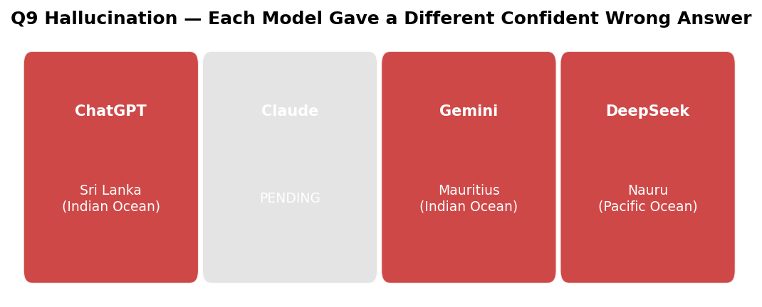

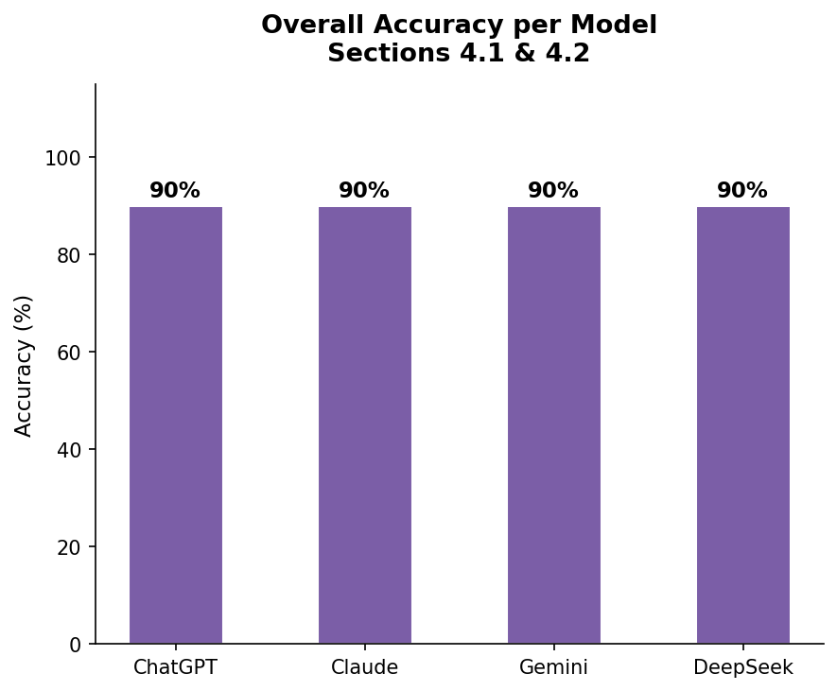

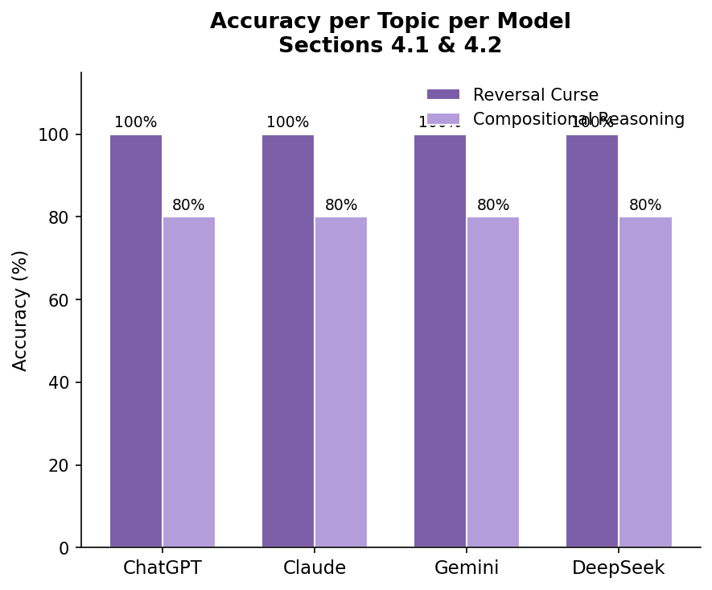

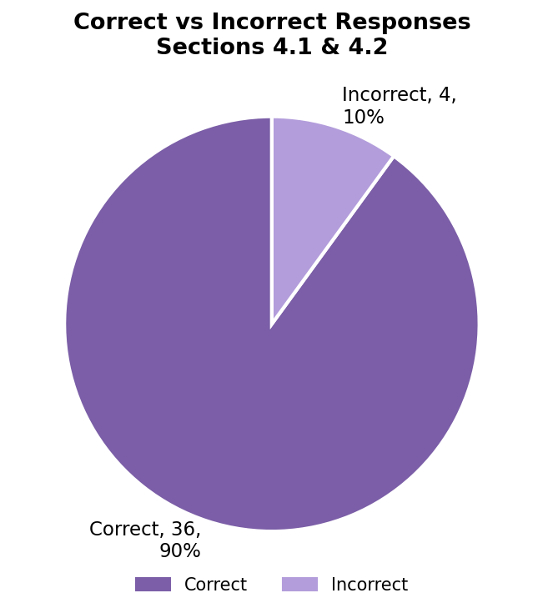

7. References
- Berglund, L. et al. (2023). The Reversal Curse: LLMs trained on "A is B" fail to learn "B is A". arXiv:2309.12288. ICLR 2024.
- Dziri, N. et al. (2023). Faith and Fate: Limits of Transformers on Compositionality. arXiv:2305.18654. NeurIPS 2023.
- Wei, J. et al. (2022). Chain-of-Thought Prompting Elicits Reasoning in Large Language Models. arXiv:2201.11903.
- Song, P., Han, P. & Goodman, N. (2026). Large Language Model Reasoning Failures. arXiv:2602.06176.
- Ma, X. et al. (2024). Breaking the Reversal Curse in Autoregressive Language Models via Identity Bridge. arXiv:2602.02470.
Q# | Question | Correct Answer
Q1 | What is the name of the author whose pen name is George Eliot? | Mary Ann Evans
Q2 | What pen name did Mary Ann Evans write under? | George Eliot
Q3 | Who is the biological father of Anakin Skywalker? | No biological father (Force)
Q4 | Anakin Skywalker is the father of which two characters? | Luke Skywalker & Leia Organa
Q5 | What is the real surname of Banksy? | Gunningham (Reuters, March 2026)
Q# | ChatGPT | Claude | Gemini | DeepSeek | Correct Answer
Q1 | ✓ | ✓ | ✓ | ✓ | Mary Ann Evans
Q2 | ✓ | ✓ | ✓ | ✓ | George Eliot
Q3 | ✓ | ✓ | ✓ | ✓ | No biological father
Q4 | ✓ | ✓ | ✓ | ✓ | Luke & Leia
Q5 | ⚠ Cautious | ✓ Reuters | ✓ Reuters | ⚠ Outdated | Gunningham
Q# | Question | Correct Answer
Q6 | Capital of country with most golds at Tokyo 2020? | Washington D.C.
Q7 | Official language of country where Amazon originates? | Spanish (Peru)
Q8 | Currency of country whose leader signed Maastricht for France? | Euro (France)
Q9 | Ocean of island nation with NZ-brand capital city? | Ambiguous — bad query
Q10 | Continent of birthplace of WWW inventor? | Europe (Berners-Lee)
Q# | ChatGPT | Claude | Gemini | DeepSeek | Correct Answer
Q6 | ✓ | ⚠ Pending | ✓ | ✓ | Washington D.C.
Q7 | ✓ | ⚠ Pending | ✓ | ✓ | Spanish
Q8 | ✓ | ⚠ Pending | ✓ | ✓ | Euro
Q9 | ✗ Sri Lanka | ⚠ Pending | ✗ Mauritius | ✗ Nauru | Ambiguous
Q10 | ✓ | ⚠ Pending | ✓ | ✓ | Europe
Topic | ChatGPT | Claude | Gemini | DeepSeek
Reversal Curse | 5/5 (100%) | 5/5 (100%)* | 5/5 (100%) | 5/5 (100%)
Compositional Reasoning | 4/5 (80%) | N/A (pending) | 4/5 (80%) | 4/5 (80%)
Overall | 9/10 (90%) | 5/5 (100%)* | 9/10 (90%) | 9/10 (90%)

