WHO Diabetes Burden Analysis (1990–2022)

Project Overview
This project explores the evolution of diabetes prevalence between 1990 and 2022 across Arab and European countries using data from the WHO Global Health Observatory (GHO).
The analysis investigates not only the numerical differences but also what these differences represent — questioning whether higher prevalence in the Arab region truly indicates a worse health burden, or perhaps, stronger diagnostic and reporting systems.

Business / Public Health Problem
Main question:
How do diabetes prevalence trends differ between Arab and European regions, and what can these patterns reveal about healthcare data quality and detection systems?
Why this matters:
Diabetes is one of the leading non-communicable diseases worldwide.
Regional disparities in reported prevalence affect:
- Policy prioritization
- Funding allocation
- Health system benchmarking
Understanding whether “high numbers” mean high risk or high vigilance is critical for accurate global health planning.

📊 Key Statistics:
- 15.03% Gap: Arab (20.98%) vs Europe (5.95%)
- 33 Years: Complete data from 1990-2022
- 41,580 Records: From WHO Global Health Observatory
- 12 Arab vs 15 European countries analyzed

🔧 Technical Implementation:
- Tools: Python, Pandas, Scipy, Matplotlib, Seaborn
- Methods: Statistical testing, Time-series analysis, Data validation
- Output: 7 professional visualizations, Comprehensive statistical report

Methodology — Data Analyst Framework

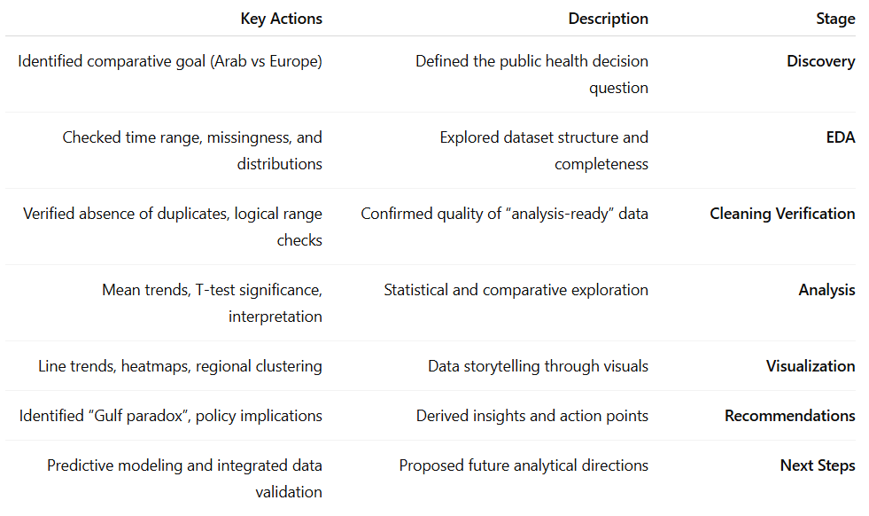

Data Source
- Dataset: WHO Global Health Observatory — Diabetes Prevalence (%)
- Coverage: 1990–2022
- Regions: Arab States and Europe
- Variables: Country, Year, Gender (if available), Prevalence (%)
- Processing: All preprocessing and cleaning were performed to create a “WHO_Diabetes_Cleaned_Analysis_Ready.csv” file used in this analysis.

Analytical Findings

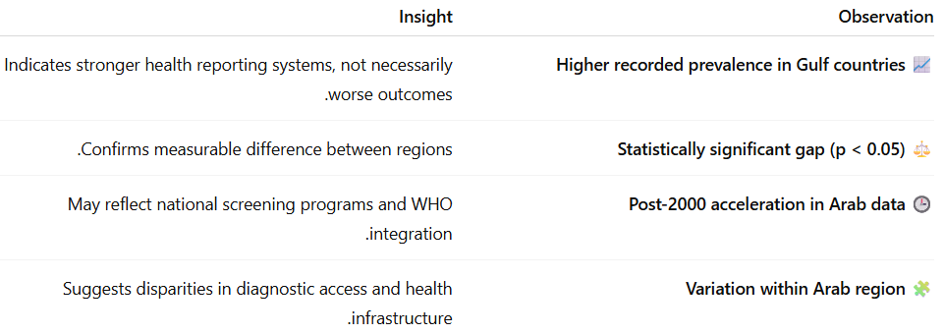

Visual Highlights
(Summaries of key visuals — they don’t have to be executed for the reader to understand)
- Trend Over Time (1990–2022)
→ Arab region shows sharper increase post-2000.
- Regional Heatmap
→ Gulf states dominate higher prevalence zones.
- Gender Comparison (if available)
→ Minor gender differences; overall prevalence pattern stable.

Recommendations
1. Interpret high prevalence carefully.
Elevated numbers may mean better data — not worse health.
2. Strengthen regional data harmonization.
Define consistent diabetes criteria across Arab health systems.
3. Integrate EMR/EHR and WHO data.
Cross-verify case detection accuracy and national reporting.
4. Build predictive monitoring models.
Estimate 2030 burden and resource needs per country.

Next Steps

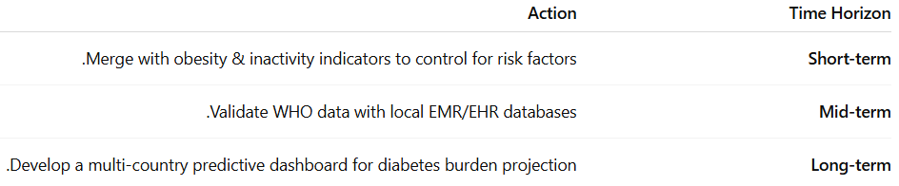

Reflection — Analyst’s Insight 🌿
“At first glance, higher numbers look alarming.
But data is a mirror — it reflects systems as much as it reflects people.
What seems like a problem may, in fact, be a sign of progress:
a health system that sees better, not one that fails more.”

Technical Note
This notebook is designed for analytical storytelling, not for direct code execution.
Data paths or library configurations may vary depending on environment.
The core purpose is to illustrate the analytical reasoning and public health interpretation behind the findings.

