
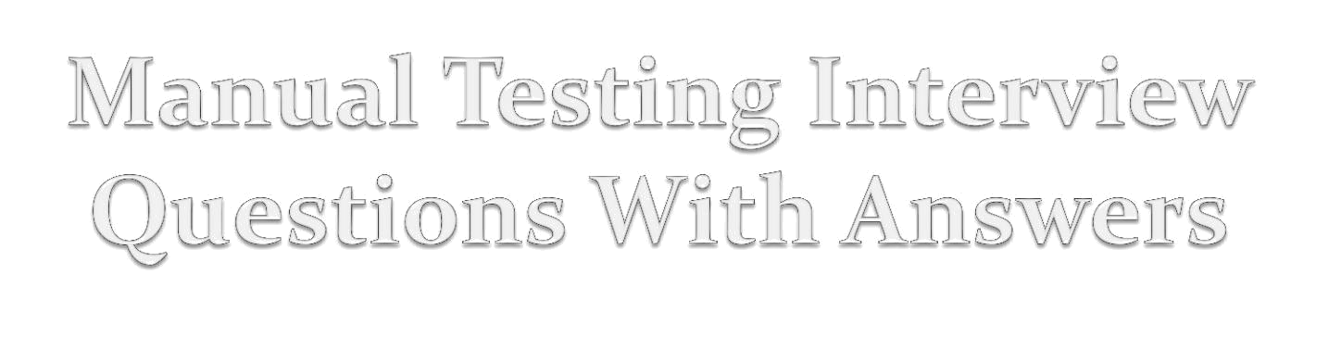

Sabiul Islam Rashed

- What is Software Development Life Cycle ?

SDLC is the overall process of developing information systems through a multistep process from investigation of initial requirements through analysis, planning, design, coding, testing, implementation and maintenance.
- What are the various models of SDLC?

- Waterfall Model (Linear Sequential Model)

- Prototype Model

- Rapid Application Development Model

- Spiral Model

- V - Model
3. What is Waterfall Model?

The waterfall model is a sequential design process, in which progress is seen as flowing downwards (like a waterfall) through the phases of analysis, design, code, testing, support and maintenance.

Waterfall Model
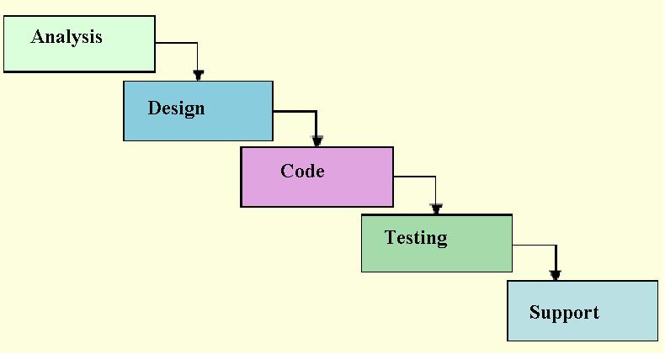
4. What is Spiral Model?

In Spiral Model, activities are organized into many cycles-
- Each cycle begins with the

  - Identification of objectives for that cycle

▪ Different alternatives that are possible achieving the objectives

for

  - Constraints that exist

- Different alternatives are evaluated based on the objectives and constraints

- All the products developed during this cycle are reviewed
- Further planning based on user comments is done.

Spiral Model
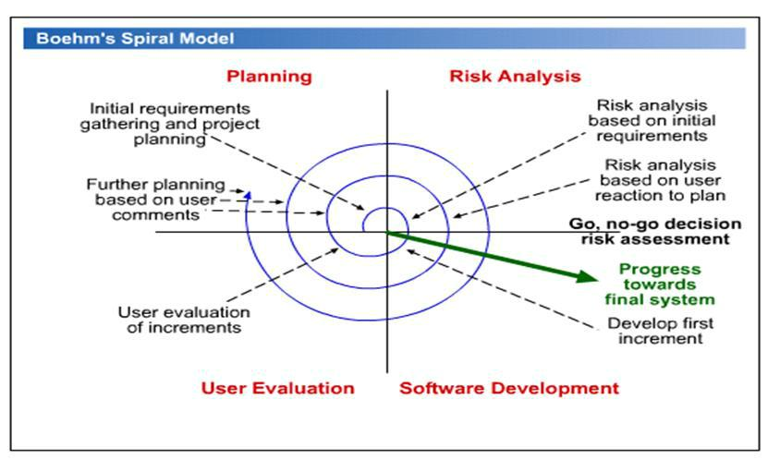
- What is Rapid Application Development (RAD) Model?

RAD model is a type of incremental model. In RAD model the components or functions are developed in parallel as if they were mini projects.

The phases in RAD model are:

- Business modeling: The information flow is identified between various business functions.

- Data modeling: Information gathered from business modeling is used to define data objects that are needed for the business.
Rapid Application Development Model

- Process modeling: Descriptions are created for adding, modifying, deleting or retrieving a data object.

- Application generation: Automated tools are used to convert process models into code and the actual system.

- Testing and turnover: Test new components and all the interfaces.

Rapid Application Development Model

Team #1 | Team #2 |  | Team #3
Business |  | Business |  | Business
modeling | modeling |  |  | modeling
Data |  | Data |  | Data
Modeling |  | modeling |  | modeling
 | Process |  | Process | Process
Modeling |  |  | modeling | modeling
 | Application |  | Application | Application
 | Modeling |  | Modeling | Modeling
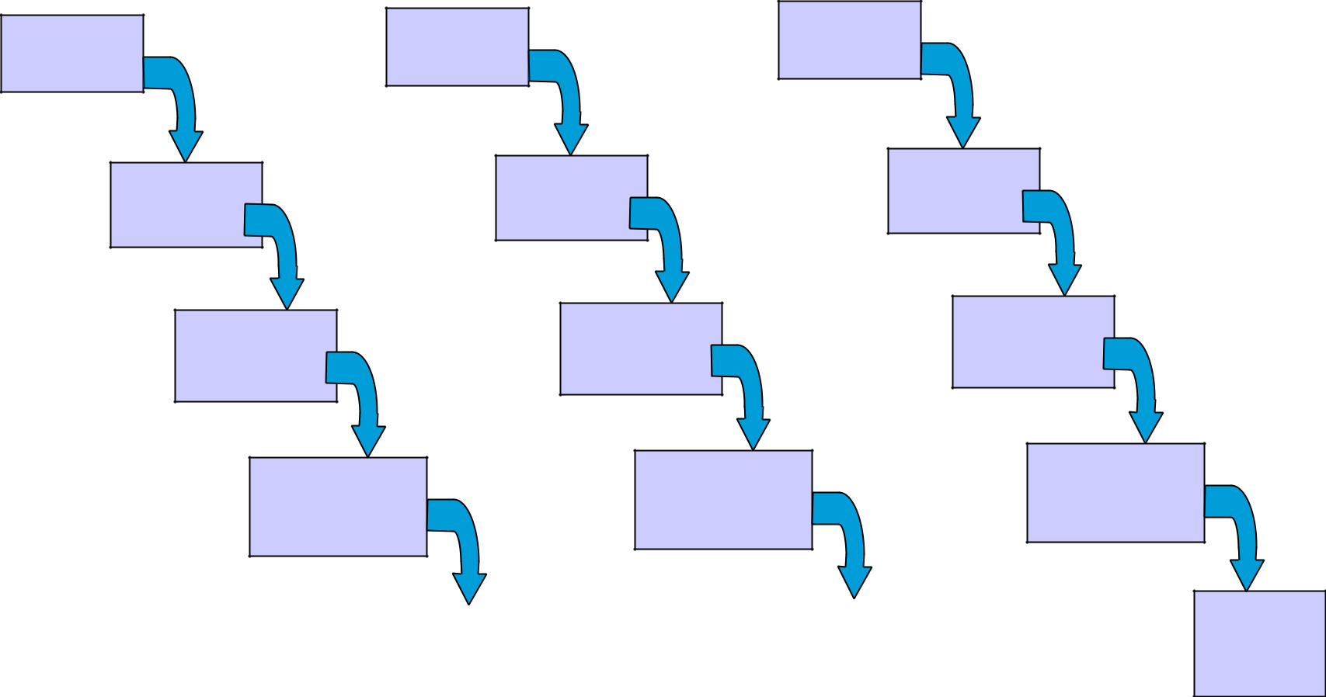

 |  | Test and
Test and |  | Test and
turnover |  | turnover

Test and turnover

6. What is V - Model?

- V- model is also called as Verification and Validation model.

- In V Model, project development and testing should go parallel. Verification phase should be carried out from SDLC where validation phase should be carried out from STLC .

V - Model
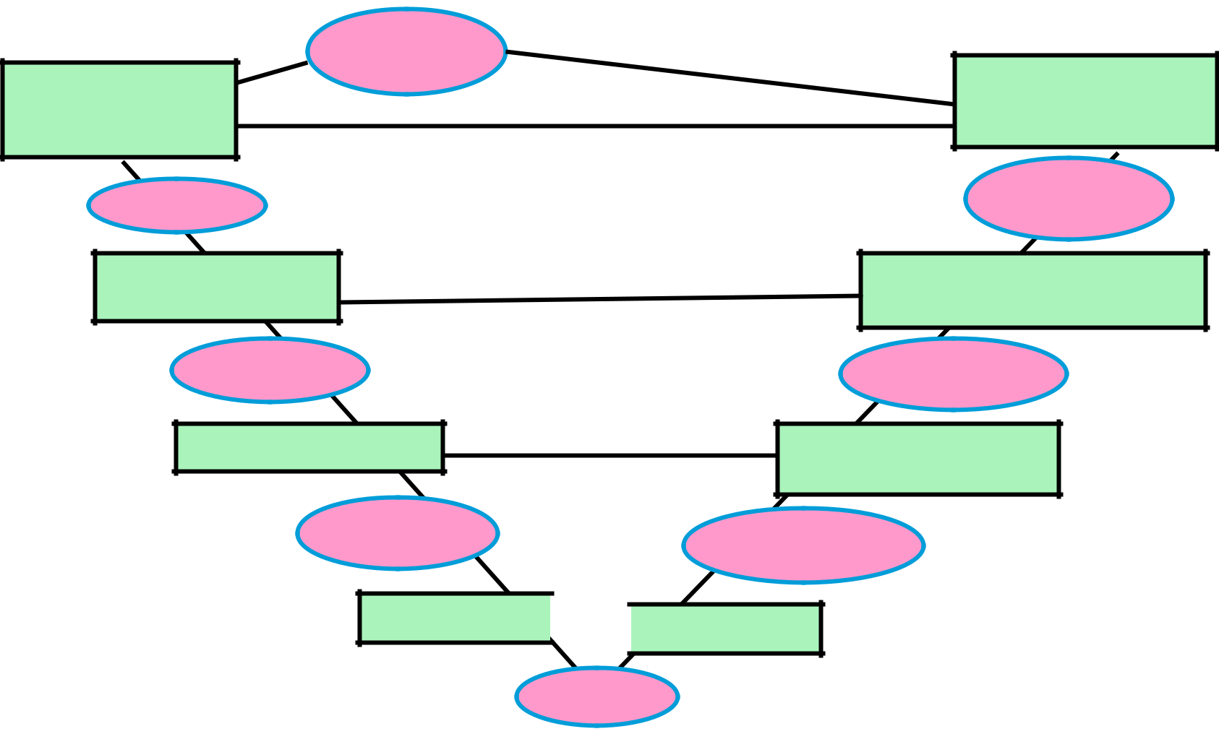

User Manual

Requirement
Specification

SRS

System Design

System
Design

Detailed Design

Module
Designs

Coding

System Test,

Acceptance Test

Tested
Software

System Integration
Test

Integrated
Software

Integration Test

Tested
Module

 Unit Test

Code

7. What is Unit Testing?

- This is the first level of testing.

- It involves checking that each feature specified in the ‘Component Design’ has been implemented in the component.

add(x=6,y=8){
Int x
Int y
Result =x+y
Return result
- Developers do it, as they are the people who understand how a component works.

8. What is Integration Testing?

- Tested components are linked together to check if they work with each other

- The tests are organized to check all the interfaces, until all the components have been built and interfaced to each other producing the whole system

9. What is System Testing?

- Once the entire system has been built, it is tested against system specification.

- System testing is not about checking the individual parts of the design, but about checking the system as a whole.

10. What is Acceptance Testing?

Checks that the system delivers what was requested.

Acceptance Testing is a level of the software testing where a system is tested for acceptability.

11. What is Verification?

Verification is the process of confirming that software meets its specification.

It involves reviews and meetings to evaluate documents, plans, code, requirements and specifications.

12. What is Validation?

Validation is the process of confirming that software meets the user’s requirements.

Validation typically involves actual testing and takes place after verifications are completed.

13. What is Test Scenario?

Test scenario is prepared before the actual testing starts.

it includes plans for testing product, number of team members, environmental condition, making test cases, making test plans and all the features that are to be tested for the product

14. What is Test Methodology?

Test methodology is a three step process - creating a test strategy,

creating a test plan, and executing tests.

15. What is Test Strategy?

Test strategy documents -

describes the roles, responsibilities and the resources required for the test and schedule.

tells us how the software product will be tested.

helps to review the test plan with the project team members executing tests.

16. What is Test Plan?

Test Plan is a document that describes the scope, approach, resources and schedules of internal testing activities.

17. What is Requirement Test Matrix?

is a project management tool for tracking and managing testing efforts based on requirements throughout the project lifecycle.

18. What is Test Case?

Test case is a documents which contains set of test inputs, execution conditions, and expected output

19. What is STLC?

Software Testing Life Cycle (STLC) is the testing process, in which different activities are carried out to improve the quality of the product.

Steps in STLC are-
- Requirement Analysis

- Test Planning

- Test Case Development

- Environment Setup

- Test Execution

- Test Cycle Closure

Software Testing Life Cycle(STLC)
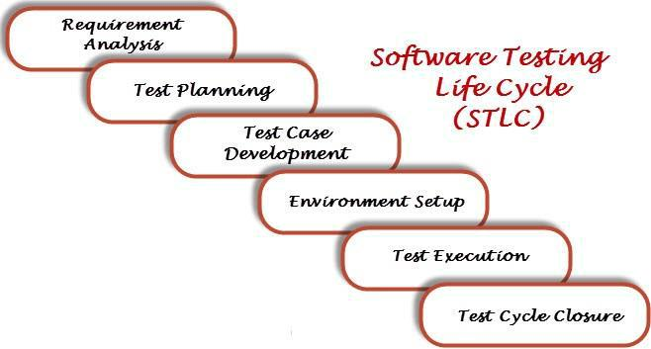
20. What is Bug Life Cycle?

- Bug life cycle, also known as Defect Life cycle is the journey of a defect cycle, which a defect goes through during its lifetime.

- It starts when defect is found and ends when a defect is closed, after ensuring it’s not reproduced.

21. What is Severity & Priority of a Bug?

Severity of a bug is, impact of the bug on the system.

Priority describes the importance and order in which the bug should be fixed.

22. Low Severity & High Priority Bug?

The spelling mistakes that happens on the cover page or heading or title of an application.

23. High Severity & Low Priority Bug?

application crashes after multiple use of any functionality (example--save Button use 200 times then that application will crash).

24. What is Black Box Testing?

In black-box testing the tester is concentrating on what the software does, not how it does it. tester would know the legal input and expected output.

Black box testing is also known as-Behavioral testing or Functional testing.

25. What is White Box Testing?

White box testing is a testing technique, that examines the program structure and derives test data from the program logic / code.

White box testing is also known as -glass box testing, clear box testing, open box testing, structural testing.

26. What is Grey Box Testing?

Grey box testing is a combination of white box and black box texting.

Grey Box testing is testing technique performed with limited information about the internal functionality of the system.

27. What is Retesting?

Retesting is testing of a particular bug after it has been fixed.

28. What is Regression Testing?

Regression testing is always done to verify that modified code does not break existing functionality of the application.

29. What is Smoke Testing?

Smoke testing is a cursory testing, it is a shallow and wide approach, whereby all areas of the application is tested, without getting into too deep.

30. What is Sanity Testing?

Sanity testing is a narrow regression testing that focus on one or few areas of functionality, and is usually narrow and deep.

31. What is Error, Fault, Defect?

Error: a human action that produces an incorrect result.

Fault: manifestation of an error in software also known as a defect or bug if executed, a fault may cause a failure

32. What is Alpha Testing?

Alpha testing is performed by in-house developers and software quality assurance people.

33. What is Beta Testing?

Beta testing is conducted by the customers in the absence of the developer team.

34. What is Negative & Positive Testing?

Negative Testing:- when we put in an invalid input and receives errors.

Positive Testing:- when we put in a valid input and expect some action to be completed in accordance with the specification.

35. What is Monkey Testing?

Monkey testing is a technique where the user tests system by providing random inputs and checking the behavior, or seeing whether the application or system will crash.

Monkey testing is usually implemented as random, automated unit tests.

36. What is Showstopper Defect?

A defect that does not allow to continue further testing is called a showstopper defect.

37. What is Disaster Recovery Testing?

Disaster Recovery Testing is testing how well the system recovers from the disasters, crashes, hardware failures and other catastrophic problems.

38. What is Performance Testing?

Performance Testing is performed to evaluate application performance under high load and stress condition.

It is generally measured in terms of response time for the user activity.

39. What is Load Testing?

Testing of an application under heavy loads, such as testing of a web site on a specific configuration under a range of loads such as number of users, number of transactions to determine at what point the system's response time degrades or fails.

40. What is Stress Testing?

Stress testing is performed as part of performance testing.

Stress testing is, to test the system behavior under extreme/non-normal conditions (low system resources, heavy load…).

41. What is Exploratory Testing?

- Exploratory testing means testing an application without a test plan and test script.

- In exploring testing test explore the application on the basis on his knowledge. The tester has no knowledge about the application previously.

- Tester explores the application like an end user and try to use it. While using the application his main motive is to find the bugs which are in the application.

42. What is Database Testing?

Database testing involves the retrieved values from the database by the web or desktop application.

Data in the User Interface should be matched as per the records are stored in the database.

- What is Different Black Box Test case Design Techniques?

The different black box test case design techniques are :
- Equivalence Class Partitioning(ECP).

- Boundary Value Analysis(BVA).()

- Decision Table.

- State Transition Testing

- Use Case Testing
44. What are Stubs & Drivers?

- Both stubs and drivers are part of incremental testing.

- Drivers are used in bottom up testing approach

- While Stub is used for top down testing approach.

- What are the different types of test coverage techniques?

Different types of test coverage techniques are :-

- Statement Coverage: It verifies that each line of source code has been executed and tested.

- Decision Coverage: It ensures that every decision in the source code is executed and tested.

- Path Coverage: It ensures that every possible route through a given part of code is executed and tested.
  - What is the difference between build and release?

- Build: It is a number given to Installable software that is given to testing team by the development team.

- Release: It is a number given to Installable software that is handed over to customer by the tester or developer.
- what is the meaning of Code Walk Through?

Code Walk Through is the informal analysis of the program source code to find defects and verify coding techniques
  - What is Agile testing and what is the importance of Agile testing?

- Agile testing is software testing, which involves the testing of the software from the customer point of view.

- importance of Agile testing - this testing does not wait for development team to complete the coding first and then doing testing. The coding and testing both goes simultaneously. It requires continuous customer interaction.
49. What is "use case testing"?

In order to identify and execute the functional requirement of an application from start to finish "use case" is used and the techniques used to do this is known as "Use Case Testing"

50. What is the purpose of exit criteria?


The purpose of exit criteria is to define when a test level is completed.

