Game Design Document

Fill up the Following document

1. Write the title of your project.

Destroy the virus

1. What is the goal of the game?

The goal is to eliminate the virus

1. Write a brief story of your game?

One day , the virus was accidently released from the planet china , saying that they were sorry ,they sent the weapon to destroy the virus “the might spatula” . now it is upto us to save earth.

1. Which are the playing characters of this game?

* Playing characters are the ones which respond to the user based on the input from the user
* Cars, monkeys, dinos, wizards etc, are the playing characters in the game.

|  |  |  |
| --- | --- | --- |
| Number | Character Name | What can this character do? |
| 1 | spatula | Destroy the virus |
| 2 |  |  |
| 3 |  |  |
| 4 |  |  |
| 5 |  |  |
| 6 |  |  |
| 7 |  |  |
| 8 |  |  |

1. Which are the Non Playing Characters of this game?

* Non Playing characters are the ones which don't have an action or a behaviour when the user interacts with the game.
* Hurdles, stones, bananas, coins, etc are non playing characters in the game.

|  |  |  |
| --- | --- | --- |
| Number | Character Name | What can this character do? |
| 1 | virus | Can kill anyone in they way |
| 2 |  |  |
| 3 |  |  |
| 4 |  |  |
| 5 |  |  |
| 6 |  |  |
| 7 |  |  |
| 8 |  |  |

Draw your imagination of this game. What does this game look like?

* Draw the game either on your computer or on paper,
* Add images of scenes of the game to show each of the playing and non-playing characters at least once.

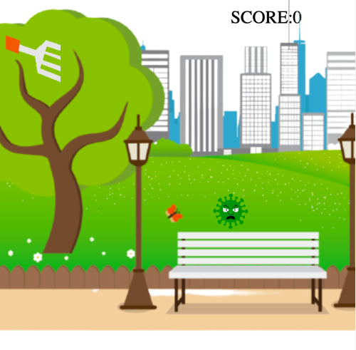

How do you plan to make your game engaging?

Adding wierd and funny noises with the virus in hit

Making the vius go on any speed to up the difficulty