The incredibles

Database class project 2020/2021

|  |  |  |  |  |
| --- | --- | --- | --- | --- |
| Student Name in English | Student Name in Arabic | Student ID | Section | Work percentage |
| Farah Touqan | فرح طوقان | 11923793 | 9:30-11 | 50% |
| Manal Al-Khalili | منال الخليلي | 11925863 | 9:30-11 | 50% |
|  |  |  |  |  |

9 May 2021

---------------------------------------------This section is intended for the Instructor---------------------------------------

|  |  |
| --- | --- |
| **Topic** | **Mark** |
| Project Requirements and Modeling |  |
| Correctness of Database mapping |  |
| Functional Dependency and Normalization |  |
| Project Tools |  |
| Project Discussion |  |
| Project Completeness |  |
| Project Output Results or reporting (JasperReport, charts, graphs, etc.) |  |
| Project Administration and Management |  |
| Project Report |  |
| Project Idea |  |
| Project Complexity |  |
| Team work |  |
|  |  |
|  |  |
|  |  |

Abstract :

We have created an application that facilitates the ordering food from restaurants instead of going to the restaurant .This makes it easier for people to go through the process of buying food.

|  |  |
| --- | --- |
|  | page |
| introduction | 3 |
| Project requirement |  |
| Functional dependency of the project |  |
| UML |  |
| BCNF |  |
| Tools used |  |
| conclusion |  |
| References |  |

Introduction:

We have created an application that facilitates the ordering food from restaurants instead of going to the restaurant , our project makes the customer can order food from the restaurant he wants easily and get his food very quickly, he can see what the food he is ordering on a table, the total amount to pay. As for the manager, he can see the customer’s information in a table also and edited what he wants. We depend on this project on a fast cartoon character called Dash {The Incredibles} .

Project requirement:

The Incredibles restaurants consist of manager ,customer , items and bills.

Each restaurant has an ID ,restaurant phone ,address and a name.

Each manager has username, password, first name, last name ,address, birth date, phone number, a gender and he belongs to a restaurant.

Each customer username, password ,first name, last name, birth date, address, phone number and a gender.

Each bill has an ID ,date ,price ,items name, items quantity and customer username.

Each item has a name and a price.

Tools used in the project:

1. IntelliJ as an IDE for java.
2. Oracle 18c as a database.
3. Draw.io for creating the initial database UML.
4. Scene Builder for creating the FXML files used inside the JavaFX project.
5. SQL Developer for connecting and creating the database tables and SQL testing.

discussion about your project GUI work, what each interface do:

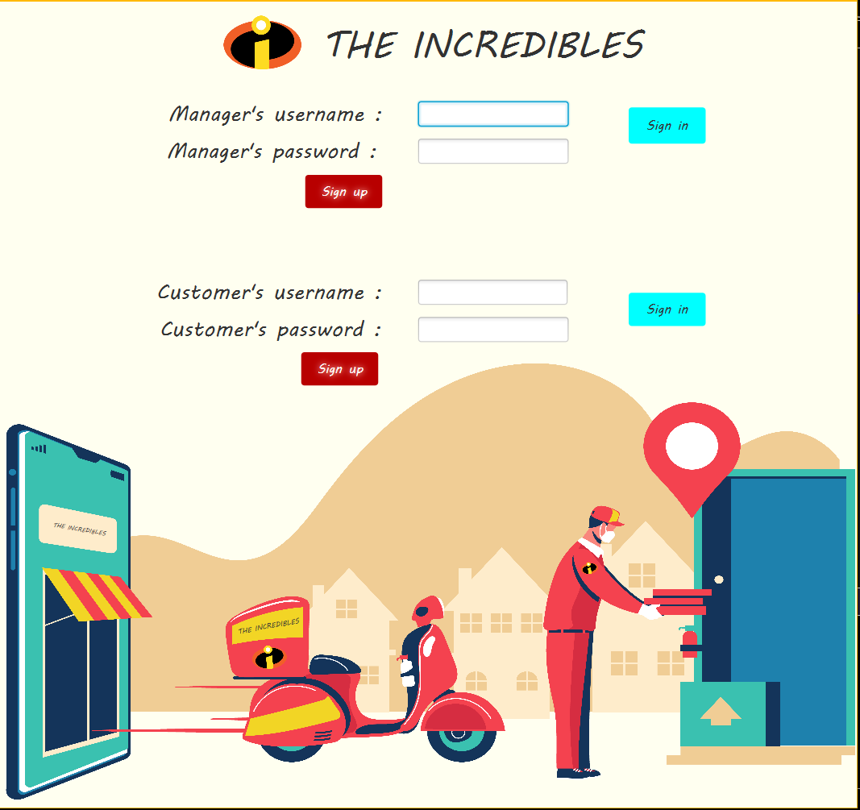

this is the sign in page ,the user(manager, customer)can log in to his account or he can sign up and create a new account .

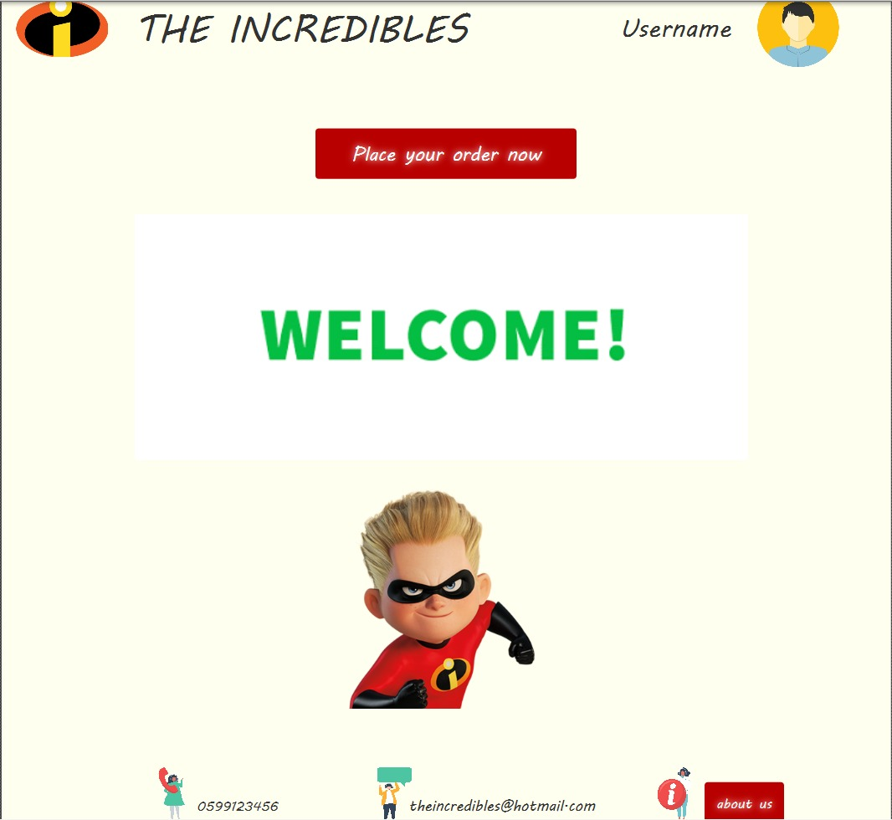

This interface is where a person can access the application

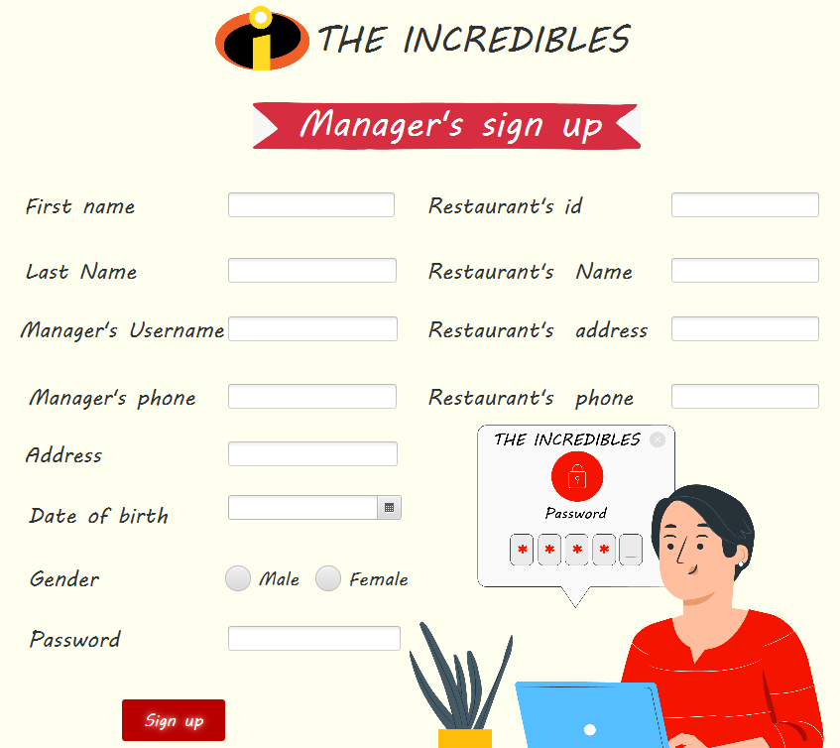signup for the manager he can insert all of his data on it and then save it

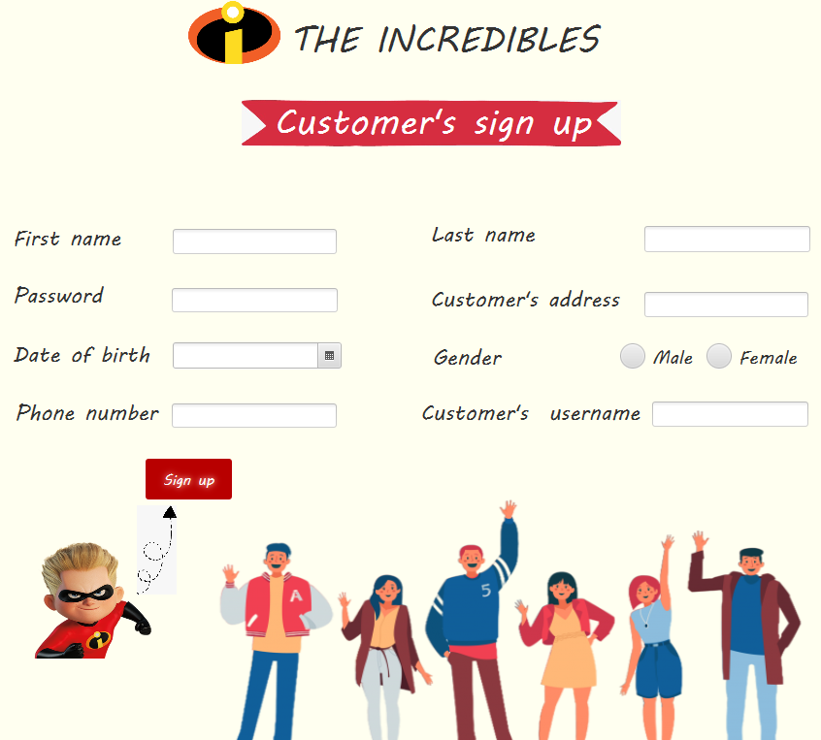

Sign up for the customer to insert all of his data to the system and save it

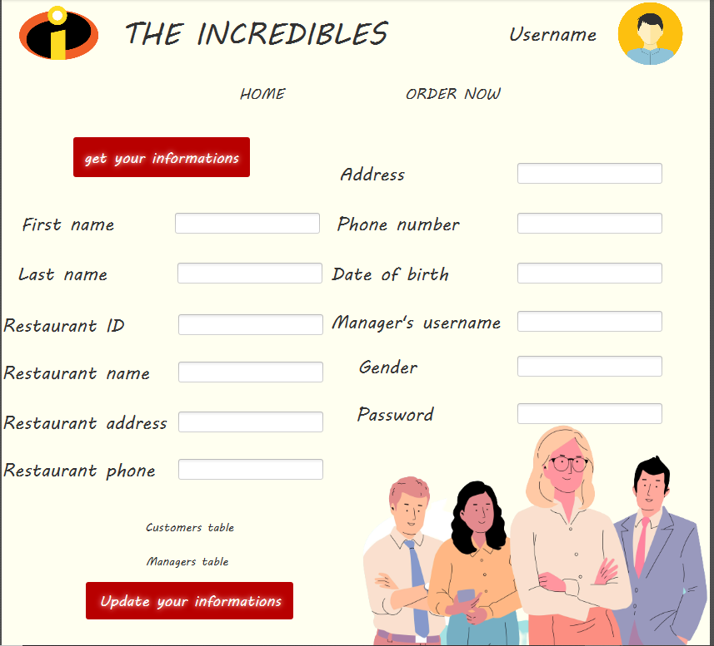

If the user is in manager and wants to see his personal page, he can come to this interface

`

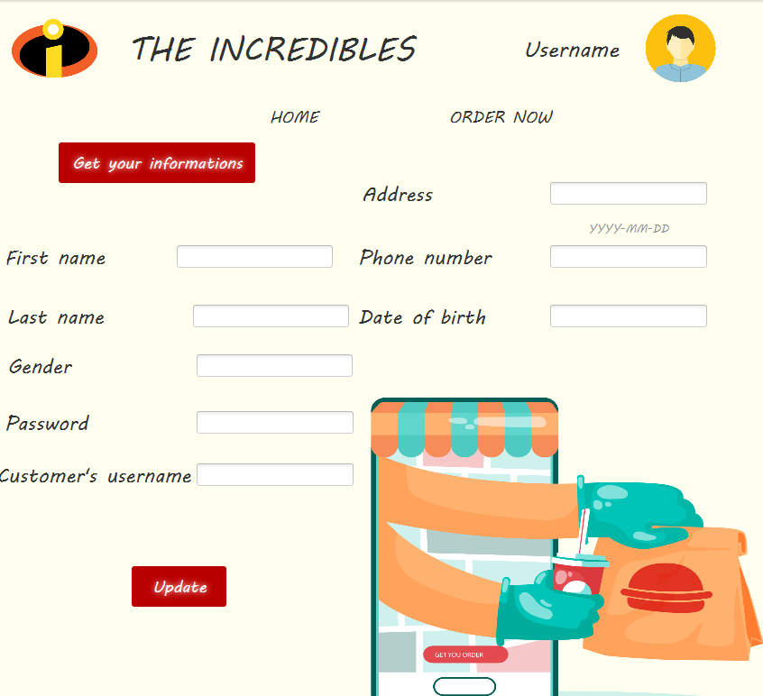

If the user is in customer and wants to see his personal page, he can come to this interface

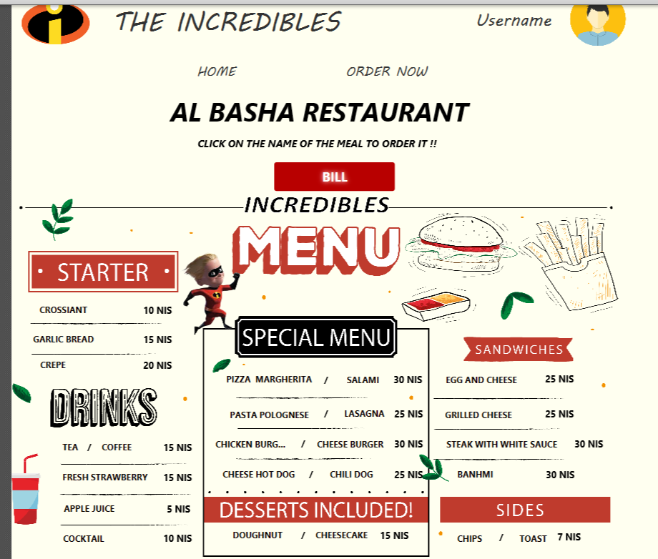

This interface enables a person, whether a manager or a buyer, to ask the restaurant for the meal he wants, and he can also go to the payment interface

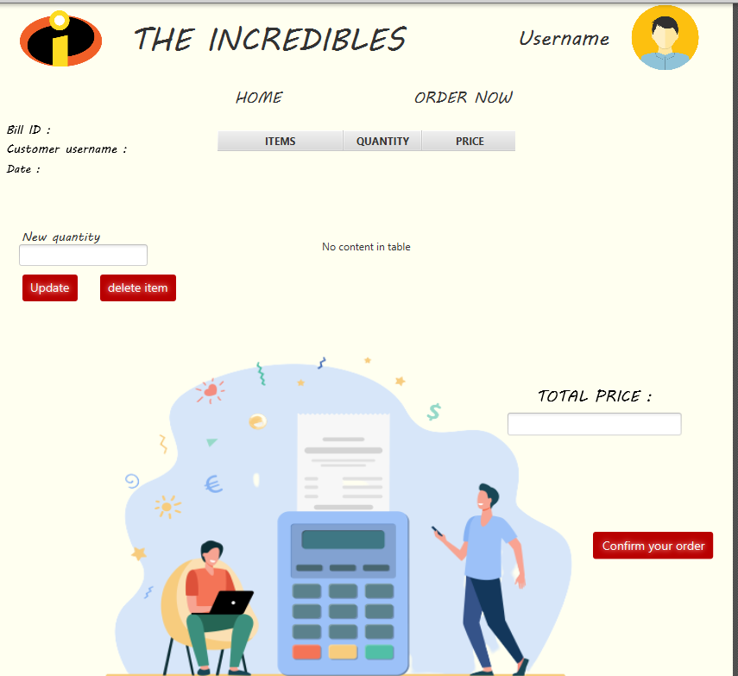

This interface can be a person, whether a manager or a buyer, to see his purchases and increase or decrease their quantity or delete them completely, and he can see the total payment for his purchases

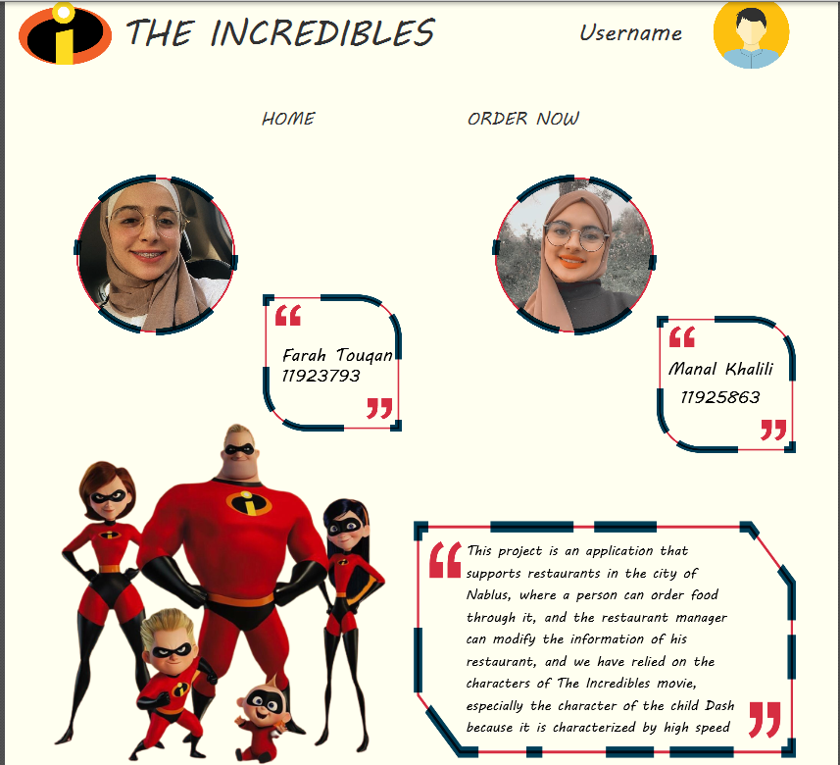

This interface enables a person to see information about who undertook the project and what the idea of ​​it is

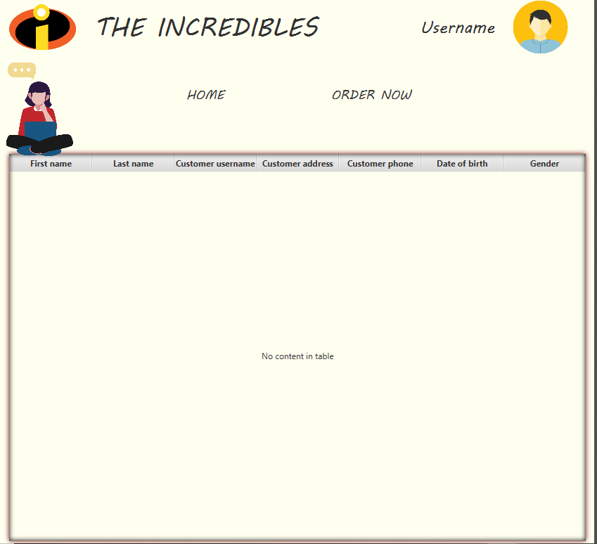

This interface can only be seen by the administrator who bought from him and what his information is arranged in a table

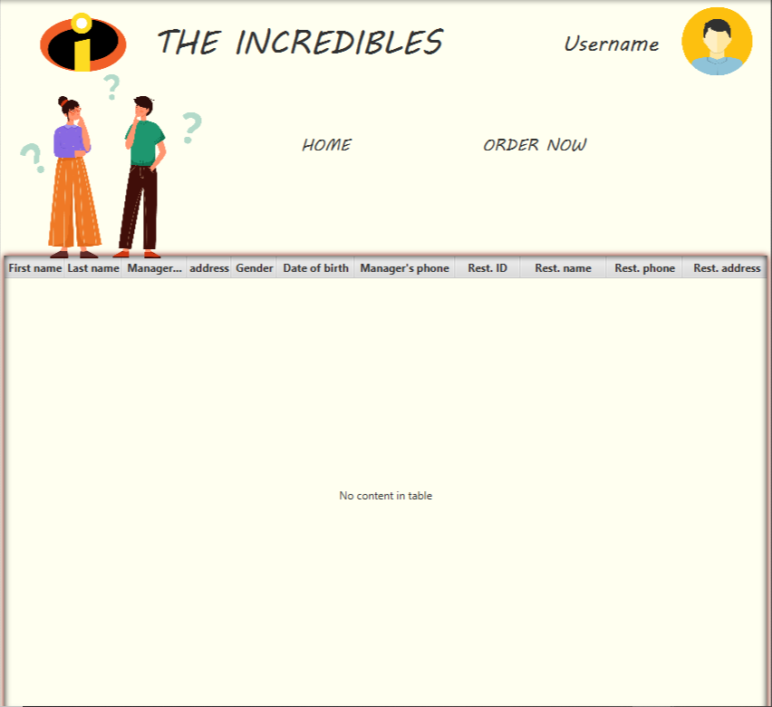

This interface can only be seen by the manager who is managing the restaurant with him and what his information is arranged in a table

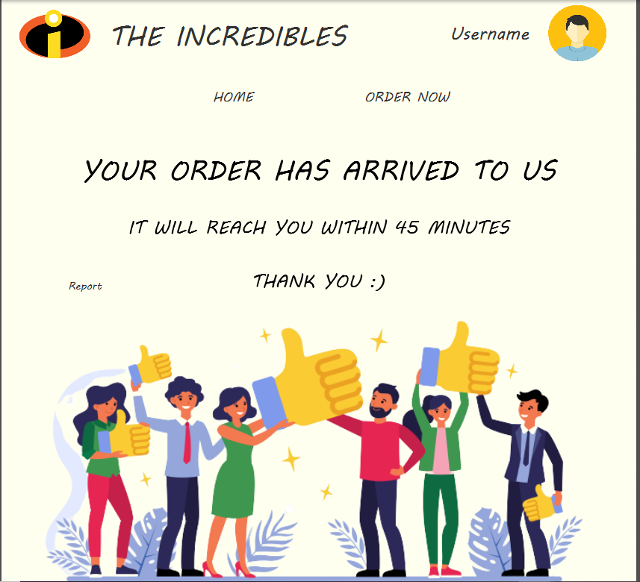

Checking if the Tables in 3NF

All tables are in 3NF.

1NF: they in which the intersection of every column and record contains only one value .

2NF: they don’t have any composite key.

3NF: there is no non primary key column is transitively dependent on the primary key.

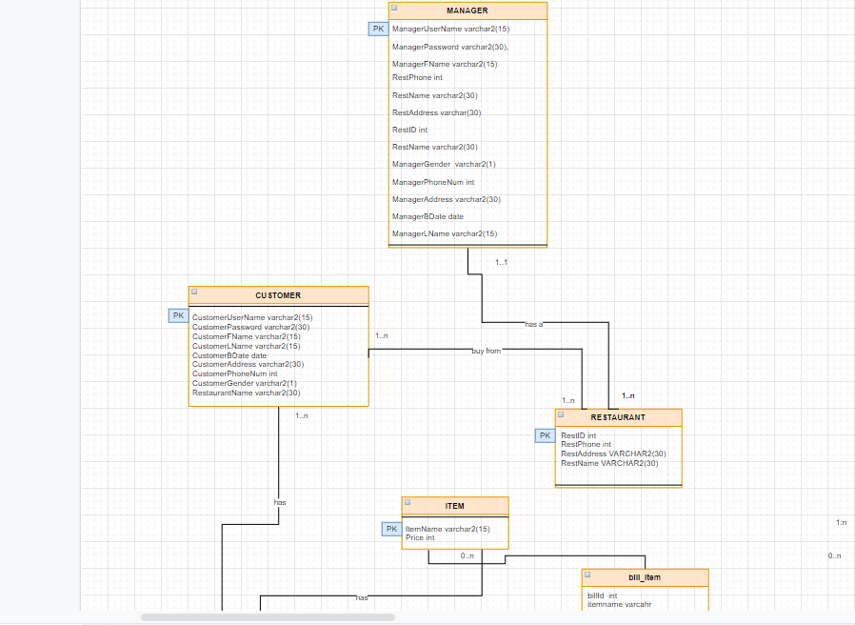

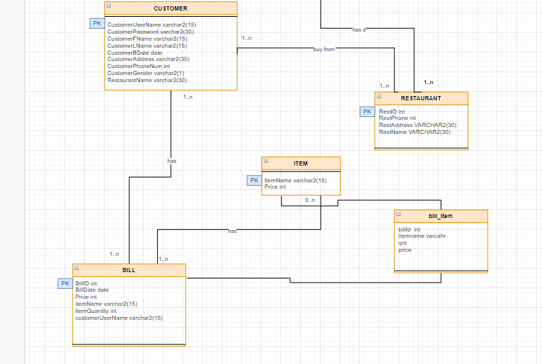

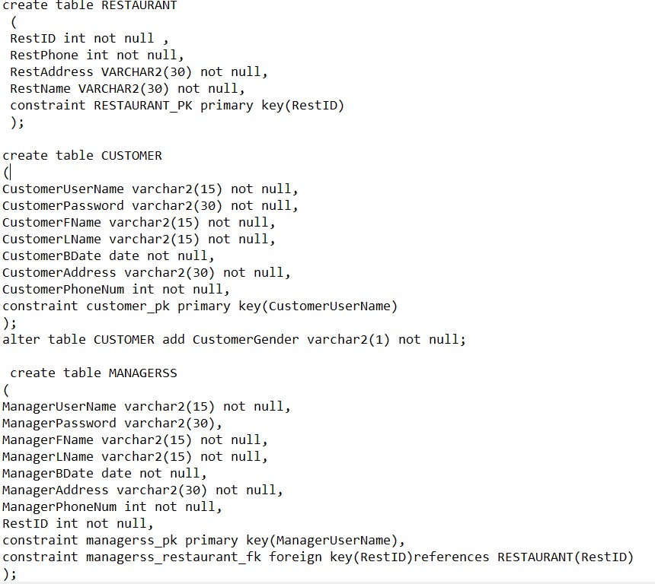

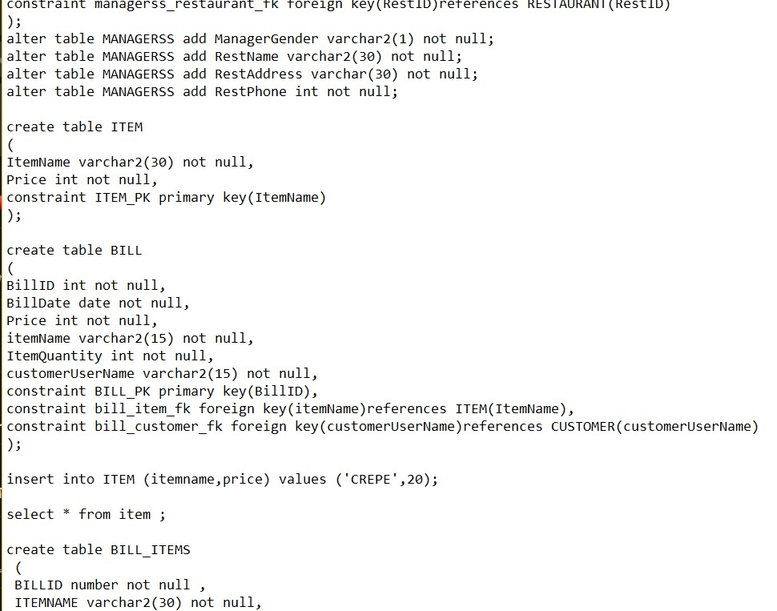

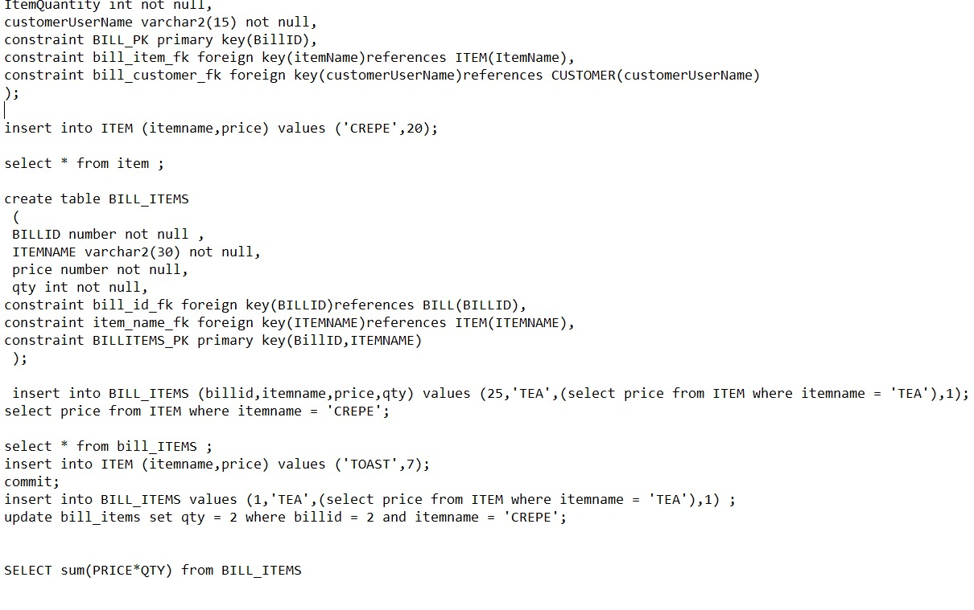

Conclusion:

This application helpfully will help the people to order food very quickly and the manager to know everything about this operation.

References:

<https://stackoverflow.com/>

<https://www.geeksforgeeks.org/>

https://www.w3schools.com/