Project
  - Deadline: Sunday 03/05/2026 @ 23:59
[Total Mark for this Project is 14]

Computer Networks
DS360

Student Details: CRN: 21406
Name: Farah Alhelal  Name: Fatima Almuallim  Name: Hanen Alsuwaidan  Name: Alkhnsaa Yaghmour |  | ID: S230032898  ID: 230016926  ID: 230035139  ID: S230026181

Instructions:
- You must submit two separate copies (one Word file and one PDF file) using the Assignment Template on Blackboard via the allocated folder. These files must not be in compressed format.
- It is your responsibility to check and make sure that you have uploaded both the correct files.
- Zero mark will be given if you try to bypass the SafeAssign (e.g., misspell words, remove spaces between words, hide characters, use different character sets, convert text into image or languages other than English or any kind of manipulation).
- Email submission will not be accepted.
- You are advised to make your work clear and well-presented. This includes filling your information on the cover page.
- You must use this template, failing which will result in zero mark.
- You MUST show all your work, and text must not be converted into an image, unless specified otherwise by the question.
- Late submission will result in ZERO mark.
- The work should be your own, copying from students or other resources will result in ZERO mark.
- Use Times New Roman font for all your answers.

Project
14 Marks
Learning Outcome(s):
CLO4: Demonstrate protocol configuration, network addressing schemes, and analyze packet transmission for local and wide area networks.

Objective:
The objective of this project is to become familiar with the Packet Tracer interface. Learn how to use existing topologies and build your own.
Introduction:
In this project, you will use Cisco Packet Tracer (PT) to design and implement a small office network. Packet Tracer is a network simulation tool that allows you to create networks with routers, switches, and PCs, configure devices, and test connectivity.
You are required to design a network for a small office with two departments: Sales and HR. Each department has 2 computers and a switch. Each department is connected to its own router. The department routers are connected through a central (backbone) router to enable communication between departments.
Tools:
Download tool and Material for Packet tracer,
https://www.netacad.com/courses/packet-tracer
Project Tasks (Using Packet Tracer)
- Create the network topology with:
- 3 Routers (R1 – Sales, R2 – HR, R0 – Backbone)
- 2 Switches (one per department)
- 4 PCs (2 per department)
- Assign IP addresses, default gateway, and DNS server to all devices.
- Connect devices:
- PCs to their department switch.
- Each switch to its department router.
- R1 and R2 to the backbone router (R0).
- Configure routing between the routers (Static routing or RIP).
- Test LAN connectivity:
- Verify communication between PCs within the Sales department.
- Verify communication between PCs within the HR department.
- Test inter-LAN connectivity:
- Verify communication between the Sales and HR departments.

Project
Learning Outcome(s):
CLO4: Demonstrate protocol configuration, network addressing schemes, and analyze packet transmission for local and wide area networks.

Guidelines:
- Commands and screenshots should be given in the answer for the appropriate task. Otherwise, marks will be deducted.
- Submit the Packet Tracer file (.pkt) with all configured devices.
- Group Size = Max 4 members.

Marking:
Marking Criteria | Marks
Creating the network topology | 3
Assigning Correct IP addresses | 2
Connecting devices with switch through correct interfaces | 2
Connecting switches with Router through correct interfaces | 2
Configure routing between the routers | 1
Making successful communication among the devices of LAN1 | 1
Making successful communication among the devices of LAN2 | 1
Making successful communication between two LANs | 2
Total | 14

Answer:

Test LAN connectivity:

Verify communication between PCs within the Sales department :
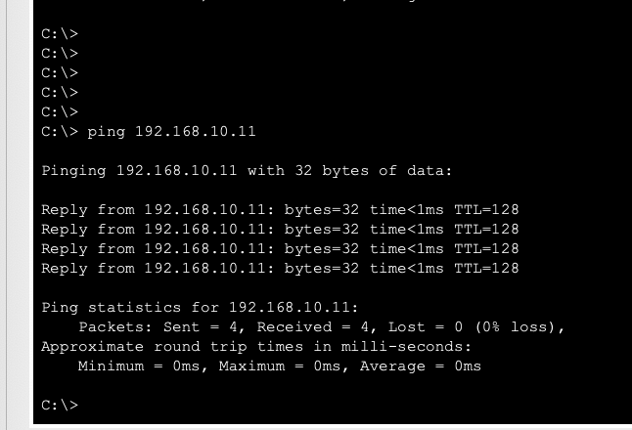

Verify communication between PCs within the HR department:
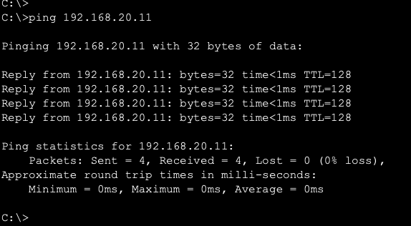

Test inter-LAN connectivity:

Verify communication between the Sales and HR departments:
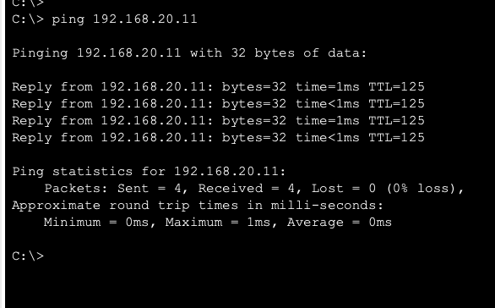

Configuration for R1 :
Router>
Router>enable
Router#conf t
Enter configuration commands, one per line. End with CNTL/Z.
Router(config)#ip route 192.168.20.0 255.255.255.0 192.168.2.2
^
% Invalid input detected at '^' marker.

Initializing memory for ECC
..
C1841 processor with 524288 Kbytes of main memory
Main memory is configured to 64 bit mode with ECC enabled

Readonly ROMMON initialized

Self decompressing the image :
########################################################################## [OK]
Restricted Rights Legend

Use, duplication, or disclosure by the Government is
subject to restrictions as set forth in subparagraph
(c) of the Commercial Computer Software - Restricted
Rights clause at FAR sec. 52.227-19 and subparagraph
(c) (1) (ii) of the Rights in Technical Data and Computer
Software clause at DFARS sec. 252.227-7013.

cisco Systems, Inc.
170 West Tasman Drive
San Jose, California 95134-1706

Technical Support: http://www.cisco.com/techsupport
Compiled Wed 18-Jul-07 04:52 by pt_team
Image text-base: 0x60080608, data-base: 0x6270CD50

This product contains cryptographic features and is subject to United
States and local country laws governing import, export, transfer and
use. Delivery of Cisco cryptographic products does not imply
third-party authority to import, export, distribute or use encryption.
Importers, exporters, distributors and users are responsible for
compliance with U.S. and local country laws. By using this product you
agree to comply with applicable laws and regulations. If you are unable
to comply with U.S. and local laws, return this product immediately.

A summary of U.S. laws governing Cisco cryptographic products may be found at:
http://www.cisco.com/wwl/export/crypto/tool/stqrg.html

If you require further assistance please contact us by sending email to
export@cisco.com.

Cisco 1841 (revision 5.0) with 114688K/16384K bytes of memory.
Processor board ID FTX0947Z18E
M860 processor: part number 0, mask 49
2 FastEthernet/IEEE 802.3 interface(s)
191K bytes of NVRAM.
63488K bytes of ATA CompactFlash (Read/Write)
Technical Support: http://www.cisco.com/techsupport
Compiled Wed 18-Jul-07 04:52 by pt_team

Router>enable
Router#
Router#configure terminal
Enter configuration commands, one per line. End with CNTL/Z.
Router(config-if)#
Router(config)#interface FastEthernet0/1
Router(config-if)#
Router(config-if)#exit
Router(config)#interface FastEthernet0/0
Router(config-if)#ip address 192.168.1.1 255.255.255.0
Router(config-if)#
%LINEPROTO-5-UPDOWN: Line protocol on Interface FastEthernet0/0, changed state to up

Router(config-if)#exit
Router(config)#router rip
Router(config-router)#
Router(config-router)#end
Router#configure terminal
Enter configuration commands, one per line. End with CNTL/Z.
%SYS-5-CONFIG_I: Configured from console by console
Router con0 is now available
Press RETURN to get started.
Router>en
Router#conf t
Enter configuration commands, one per line. End with CNTL/Z.
Router(config)#exit
Router#
%SYS-5-CONFIG_I: Configured from console by console
Router#wr
Building configuration...
[OK]
Router#
Configuration for R2 :
cisco Systems, Inc.
170 West Tasman Drive
San Jose, California 95134-1706

Technical Support: http://www.cisco.com/techsupport
Compiled Wed 18-Jul-07 04:52 by pt_team
Image text-base: 0x60080608, data-base: 0x6270CD50

This product contains cryptographic features and is subject to United
States and local country laws governing import, export, transfer and
use. Delivery of Cisco cryptographic products does not imply
third-party authority to import, export, distribute or use encryption.
Importers, exporters, distributors and users are responsible for
compliance with U.S. and local country laws. By using this product you
agree to comply with applicable laws and regulations. If you are unable
to comply with U.S. and local laws, return this product immediately.

A summary of U.S. laws governing Cisco cryptographic products may be found at:
http://www.cisco.com/wwl/export/crypto/tool/stqrg.html

If you require further assistance please contact us by sending email to
export@cisco.com.

Cisco 1841 (revision 5.0) with 114688K/16384K bytes of memory.
Processor board ID FTX0947Z18E
M860 processor: part number 0, mask 49
2 FastEthernet/IEEE 802.3 interface(s)
191K bytes of NVRAM.
63488K bytes of ATA CompactFlash (Read/Write)
Technical Support: http://www.cisco.com/techsupport
Compiled Wed 18-Jul-07 04:52 by pt_team

--- System Configuration Dialog ---

Would you like to enter the initial configuration dialog? [yes/no]:
Router>enable
Router#
Router#configure terminal
Enter configuration commands, one per line. End with CNTL/Z.
Router(config)#interface FastEthernet0/0
Router(config-if)#
Router(config-if)#exit
Router(config-if)#ip address 192.168.20.1 255.255.255.0
Router(config-if)#ip address 192.168.20.1 255.255.255.0
Router(config-if)#
Router(config-if)#
Router(config-if)#exit
Router(config)#interface FastEthernet0/0
Router(config-if)#no shutdown
Router(config-if)#
Router(config)#interface FastEthernet0/0
Router(config-if)#ip address 192.168.2.2 255.255.255.0
Router(config-if)#ip address 192.168.2.2 255.255.255.0
Router(config-if)#
Router(config-if)#
Router(config-if)#exit
Router(config)#router rip
Router(config-router)#network 192.168.1.0
Router(config-router)#network 192.168.2.0
Router(config-router)#network 192.168.10.0
Router(config-router)#network 192.168.20.0
Router(config-router)#end
Router#configure terminal
Enter configuration commands, one per line. End with CNTL/Z.
Router(config)#interface FastEthernet0/0
Router(config-if)#
%SYS-5-CONFIG_I: Configured from console by console
Router(config-if)#exit
Router con0 is now available
Router>en
Router#conf t
Enter configuration commands, one per line. End with CNTL/Z.
Router(config)#exit
Router#
Router con0 is now available
Press RETURN to get started.
Router>en
Router#conf t
Enter configuration commands, one per line. End with CNTL/Z.
Router(config)#exit
Router#
%SYS-5-CONFIG_I: Configured from console by console
Router#wr
Building configuration...
[OK]
Router#

Configuration for R0 :
Router>enable
Router#
Router#configure terminal
Enter configuration commands, one per line. End with CNTL/Z.
Router con0 is now available
Router#configure terminal
Enter configuration commands, one per line. End with CNTL/Z.
Router(config)#interface FastEthernet0/0
Router(config-if)#
Router(config-if)#exit
Router(config)#interface FastEthernet0/1
Router(config-if)#
Router(config-if)#exit
Router(config)#interface FastEthernet0/1
Router(config-if)#ip address 192.168.1.2 255.255.255.0
Router(config-if)#
Router(config-if)#ip address 192.168.2.1 255.255.255.0
Router(config-if)#ip address 192.168.2.1 255.255.255.0
Router(config-if)#
Router(config-if)#
Router(config-if)#
Router(config-if)#exit
Router(config)#router rip
Router(config-router)#network 192.168.1.0
Router(config-router)#network 192.168.20.0
Router(config-router)#network 192.168.2.0
Router(config-router)#network 192.168.10.0
Router(config-router)#
Router(config-router)#
Router(config-router)#end
Router#configure terminal
Enter configuration commands, one per line. End with CNTL/Z.
%SYS-5-CONFIG_I: Configured from console by console
Router(config-if)#exit
Router con0 is now available
Router con0 is now available
Enter configuration commands, one per line. End with CNTL/Z.
Router(config)#exit
Router#
%SYS-5-CONFIG_I: Configured from console by console
Router#wr
Building configuration...
[OK]
Router#

