Lab3
Search & Knowledge
EffatUniversity
•
DepartmentofComputerScience
CS3081–ArtificialIntelligence
•
Spring2026
Makkah
Jeddah
Taif
Riyadh
Madinah
Dammam
Instructor: | Dr. Naila Marir
Duration: | 2 Hours
Tools: | VS Code + Python 3
Files: | part1 search.py part2 knowledge.py | logic.py
Student Name: Farh Bukhari
Student ID: S23108441

1. Lab Overview
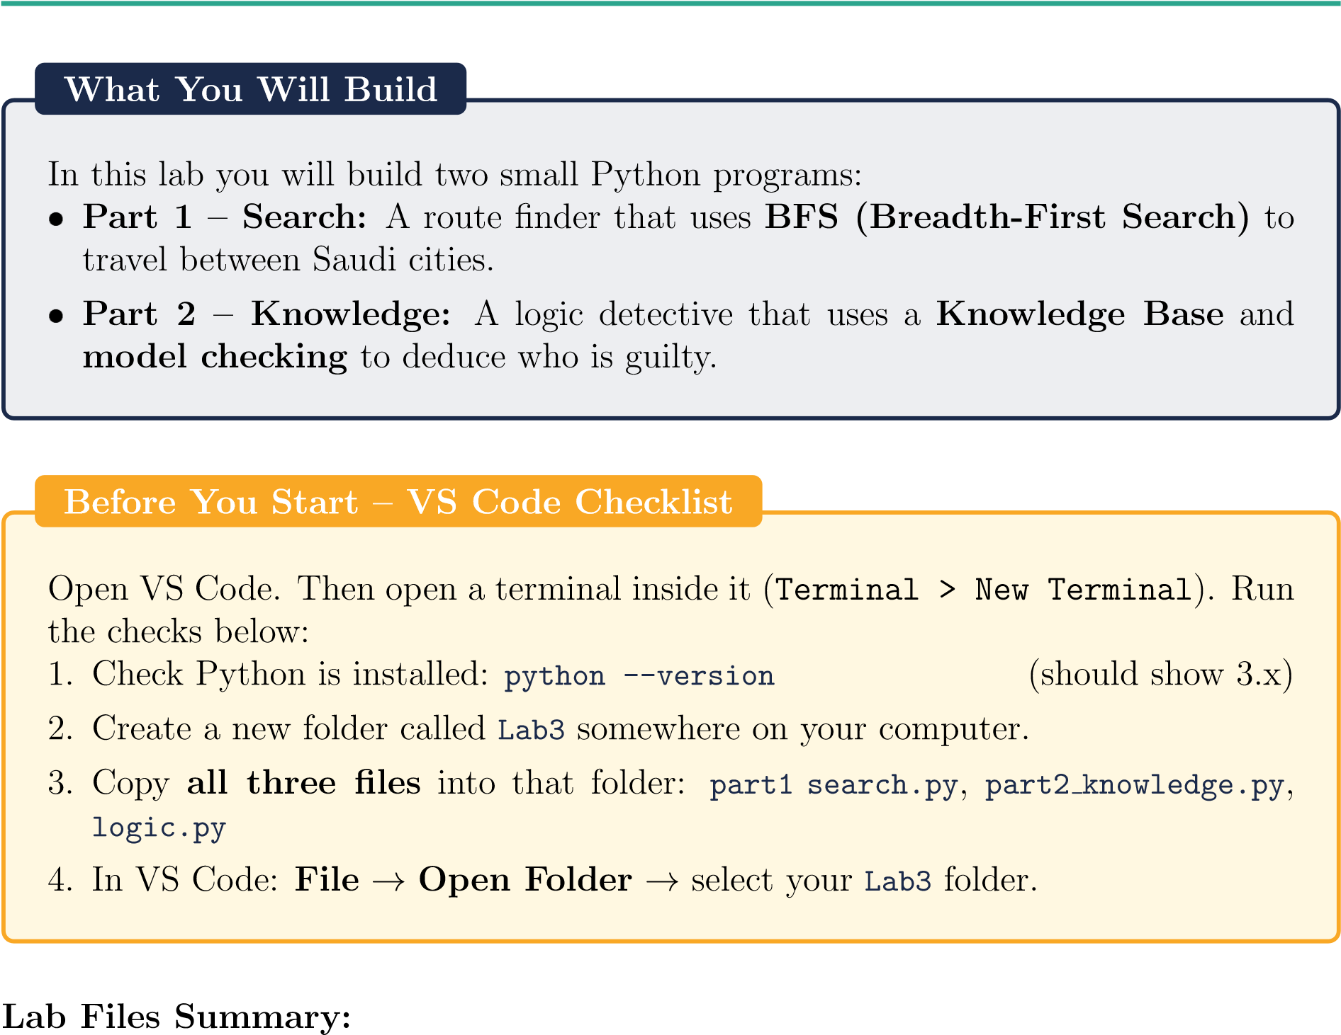

File | Description
part1 search.py | Your work for Part 1 – city graph and BFS
part2 knowledge.py | Your work for Part 2 – knowledge base and deduction
logic.py | Helper classes for Part 2 – do not edit this file

2. Part 1 – Search: Finding a Route with BFS

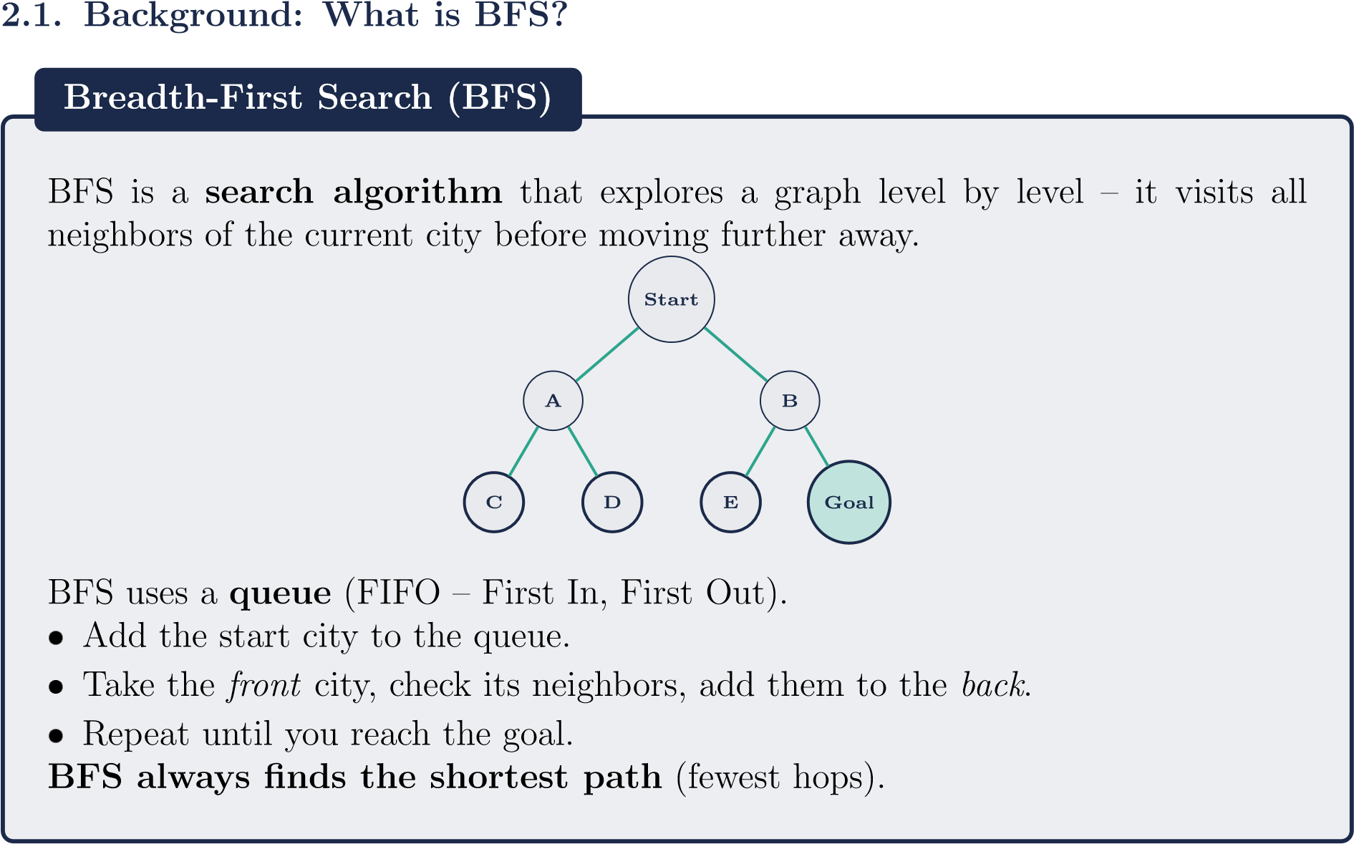

2.2. The City Map
Our map has 6 Saudi cities. Each city is connected to one or more neighbors.
Makkah
Jeddah
Taif
Riyadh
Madinah
Dammam
In Python, this map is stored as a dictionary:
1 | city_map = {
2 | "Makkah": ["Jeddah", |  | "Taif"],
3 | "Jeddah": ["Makkah", |  | "Riyadh", "Madinah"],
4 | "Taif": ["Makkah", |  | "Riyadh"],
5 | "Riyadh": ["Jeddah", |  | "Taif", "Dammam"],
6 |  | "Madinah": ["Jeddah"],
7  8 } |  | "Dammam": ["Riyadh"]
Listing 1: City map as a Python dictionary (part1 search.py lines 14–21)
ReadingaPythonDictionary
"Jeddah": ["Makkah", "Riyadh", "Madinah"]
means:
fromJeddahyoucanreach
Makkah,Riyadh,andMadinah
.

2.3. Step-by-Step Code Walkthrough
Open part1 search.py in VS Code. Read each section carefully.
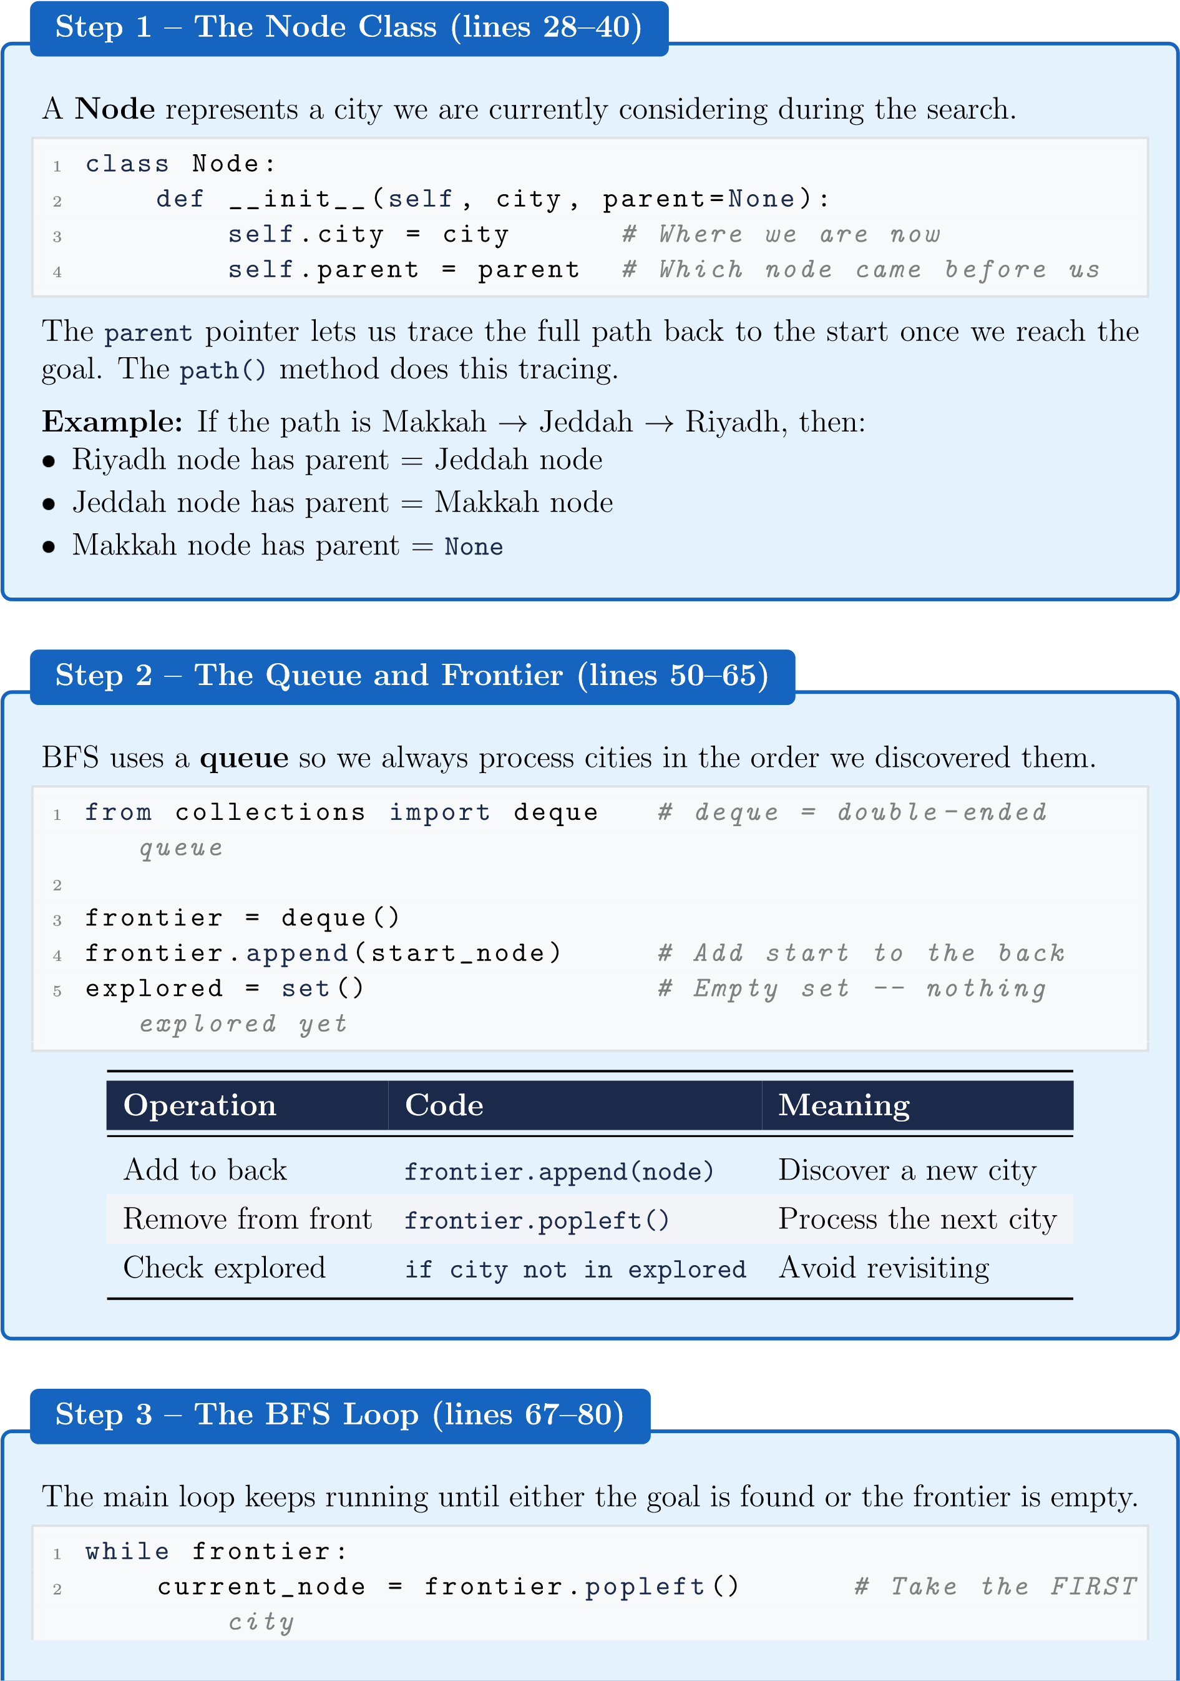
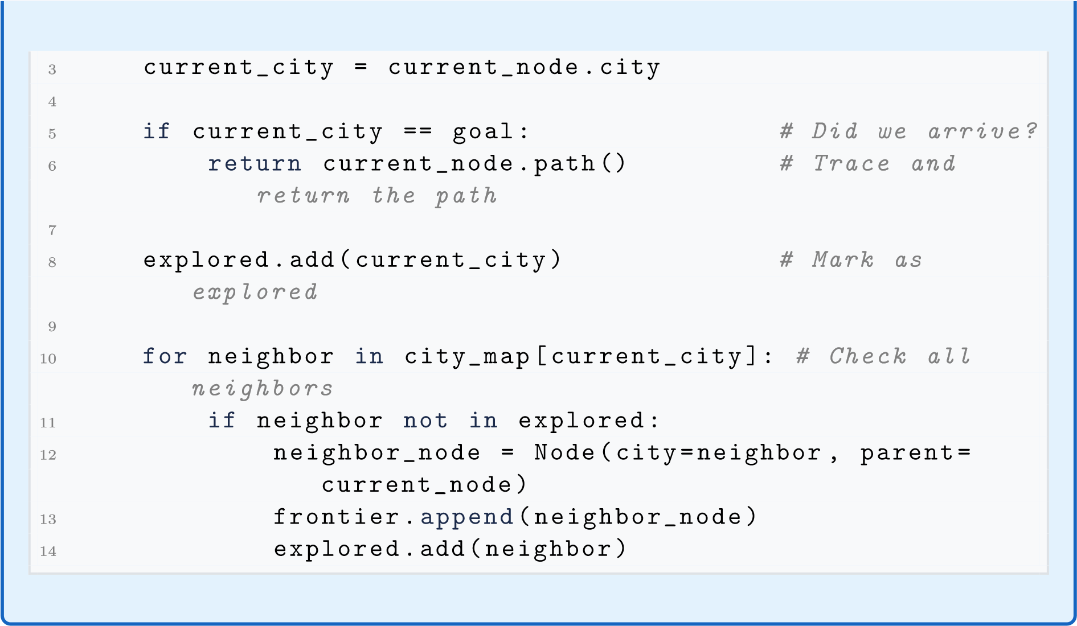

2.4. Run the Program
In the VS Code terminal, make sure you are inside the Lab3 folder:
cd Lab3 python part1_search.py
You should see output like this:
Searching from ’Makkah’ to ’Dammam’ using BFS...
Step 1: Visiting ’Makkah’
Step 2: Visiting ’Jeddah’
Step 3: Visiting ’Taif’
Step 4: Visiting ’Riyadh’
Step 5: Visiting ’Madinah’ Step 6: Visiting ’Dammam’ Goal reached! ’Dammam’ found.
Path found (4 steps):
Makkah -> Jeddah -> Riyadh -> Dammam
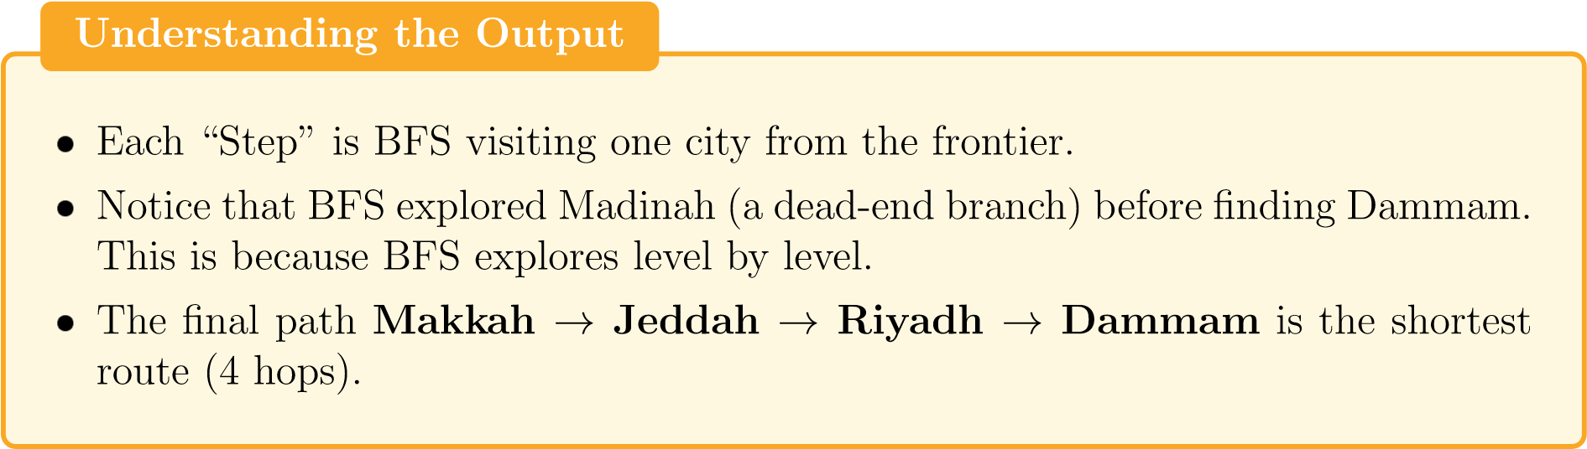
2.5.
Part1Exercises
Exercise1–ChangetheGoalCity
Atthebottomof
part1
search.py
(
:
line91–92),changethedestination
1
start_city =
"Makkah"
2
goal_city =
"Madinah"
#
<--
change
this
Runtheprogramagain.Answerthesequestionsinyourlabreport:
a.
HowmanystepsdidBFStaketoreachMadinah?
b.
Whatisthepathitfound?
c.
Isthistheshortestpath?Verifybylookingatthecitymapdiagram.

Output:
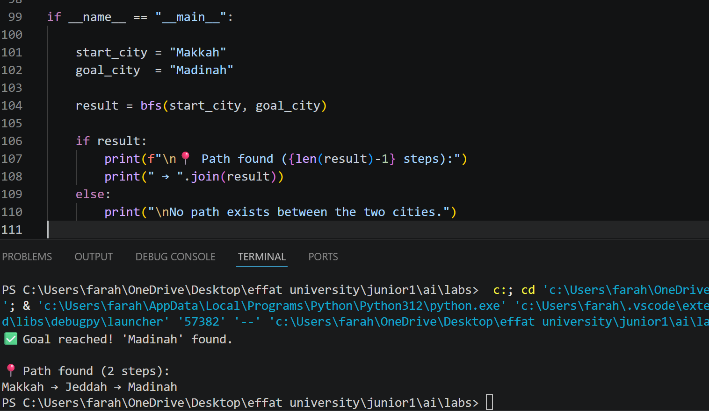

a. BFS took 5 steps to reach Madinah
b. The path found is: Makkah → Jeddah → Madinah
c. Yes, this is the shortest path because Jeddah is directly connected to both Makkah and Madinah, making it 2 hops which is the minimum possible.

Exercise2–AddaNewCity
Addanewcity
Abha
tothemap,connectedtoTaif:
a.
In
city
map
,add:
"Abha": ["Taif"]
b.
AlsoupdateTaif’slisttoincludeAbha.
c.
Set
goal
city = "Abha"
andrun.
d.
WritethepathBFSfoundfromMakkahtoAbha.

Output:

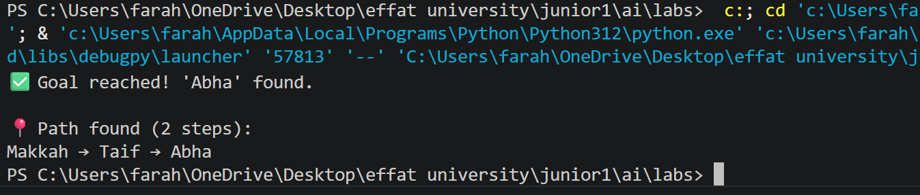
- Path found: Makkah → Taif → Abha
- BFS found it in 2 hops which is the shortest possible route since Taif is directly connected to both Makkah and Abha.

3. Part 2 – Knowledge: Logic Detective

3.1. Background: Propositional Logic and the Knowledge Base
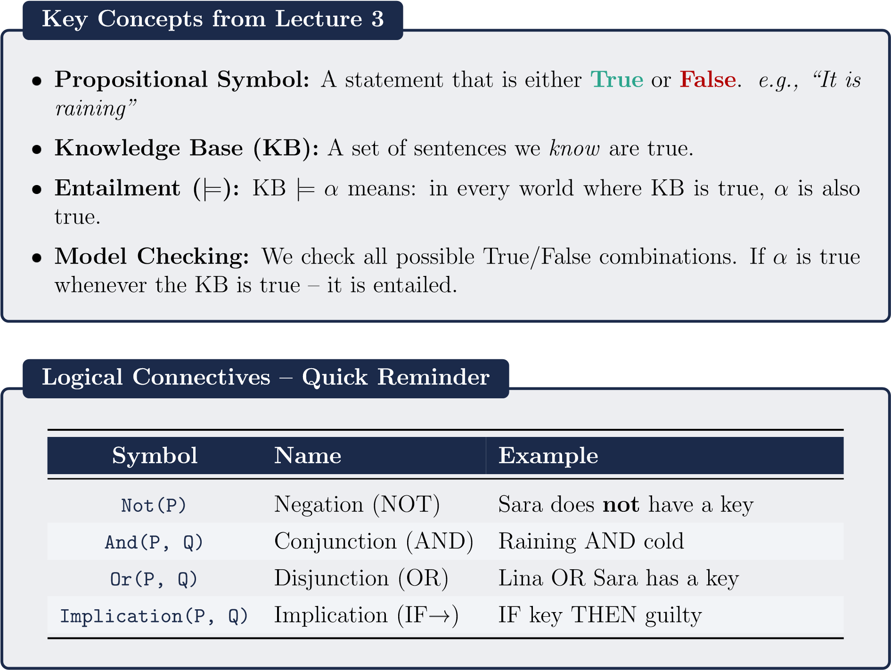

3.2. The Mystery Scenario
The Case: A valuable item went missing at Effat University.
Three suspects: Sara, Lina, Nora
The Clues (what our AI knows):
Clue 1: If Lina has a key → Lina is guilty.
Clue 2: Sara does not have a key.
Clue 3: Lina was seen near the room. (this is a known fact)
Clue 4: If Lina was seen near the room → Lina has a key.
The Question: Can our AI prove that Lina is guilty?

3.3. Step-by-Step Code Walkthrough
Open part2 knowledge.py in VS Code. Read each section carefully.
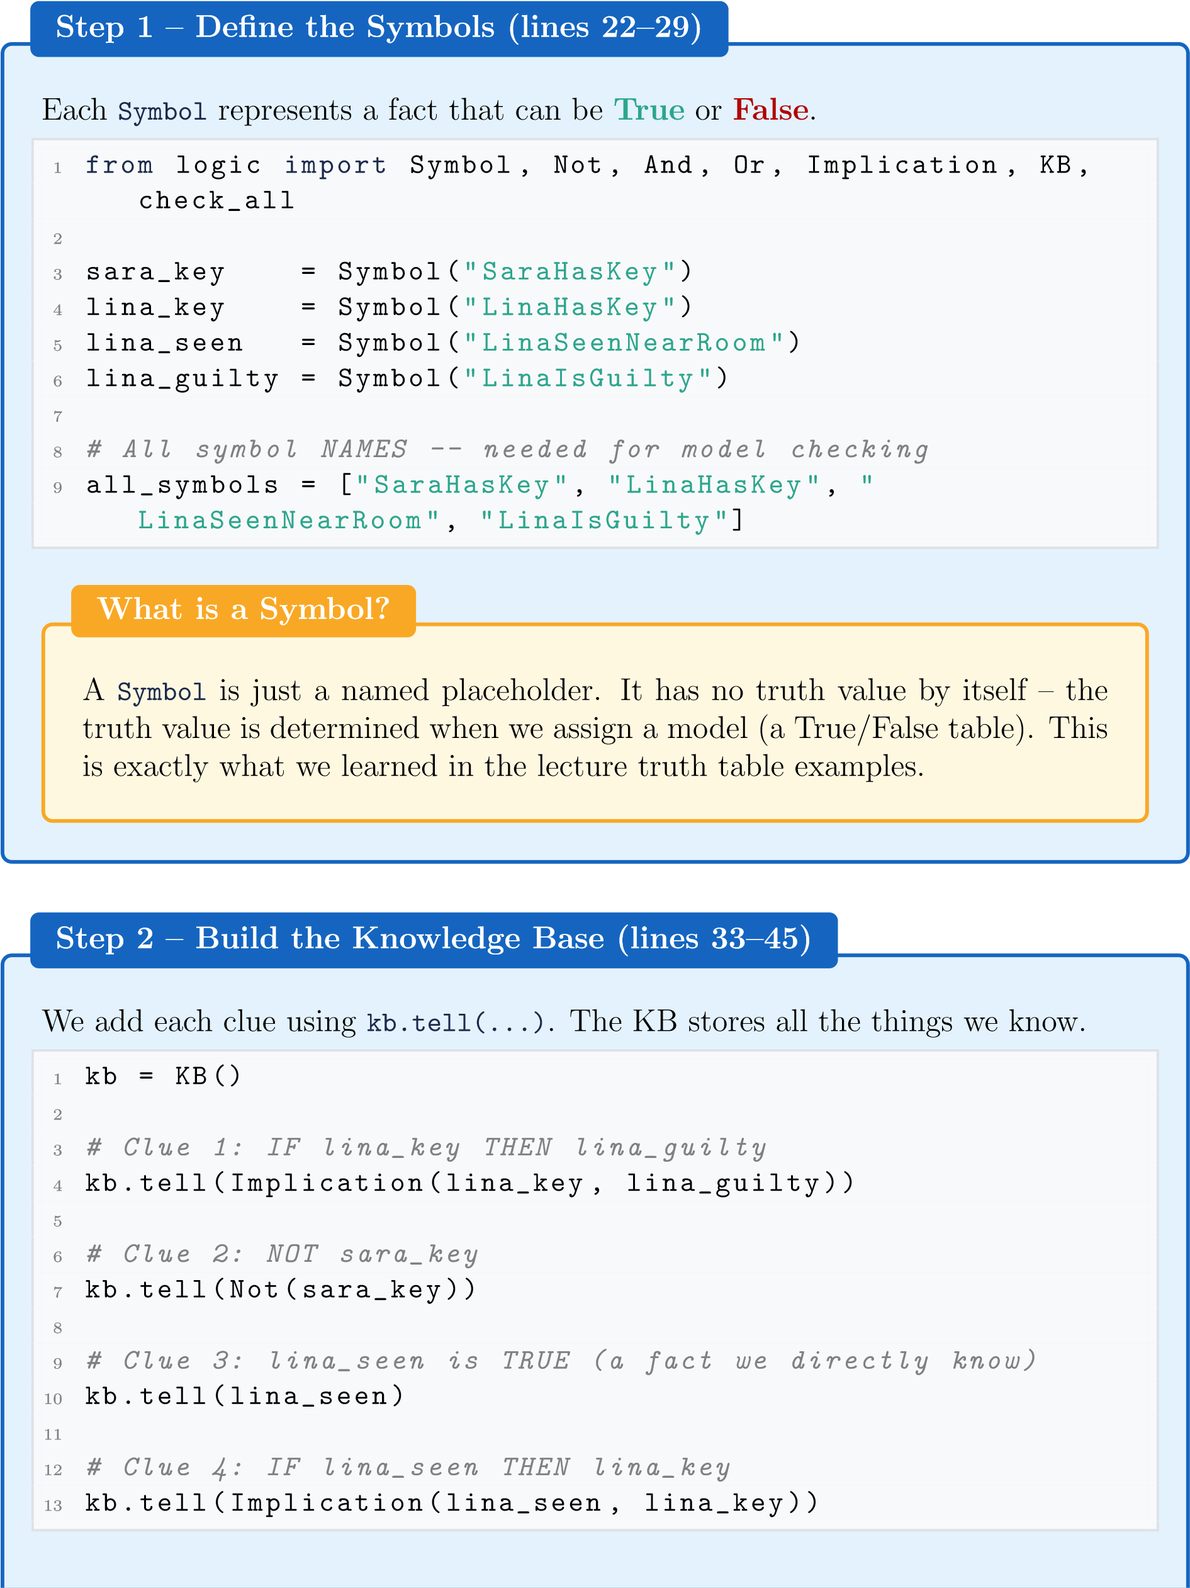
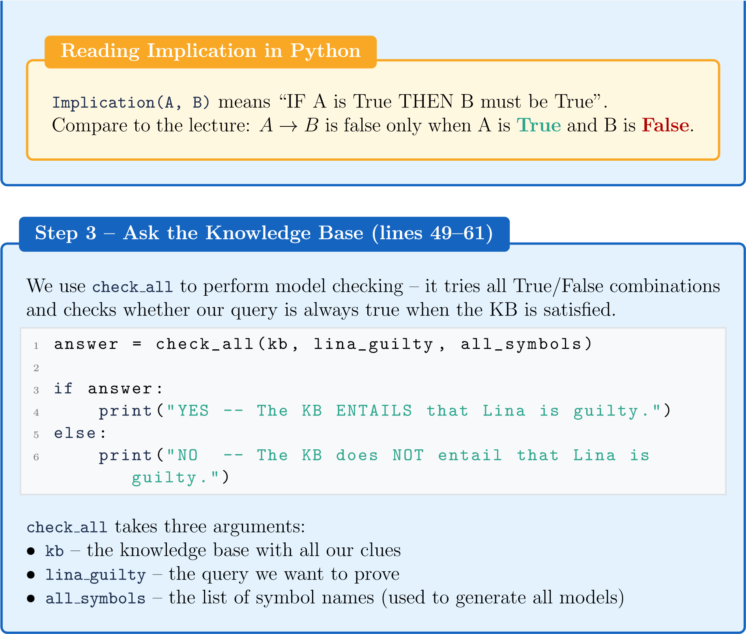

3.4. How Model Checking Works Internally
The check all function in logic.py tries all possible worlds. With 4 symbols, there are 2⁴ = 16 possible worlds (combinations of True/False).

SaraKey LinaKey LinaSeen LinaGuilty |  |  |  | KB True? | Query True?
False | False | False | False | False | (skip)
False | False | True | False | False | (skip)
··· | ··· | ··· | ··· | False | (skip)
False | True | True | True | True | True ✓

Only one model makes the KB true. In that model, LinaIsGuilty is also True. Therefore: KB |= LinaIsGuilty – the KB entails Lina is guilty.

3.5. Run the Program
In the VS Code terminal (make sure you are in the Lab3 folder):
python part2_knowledge.py
Expected output:
==================================================
CS3081 Lab 3 -- Knowledge Base Detective
==================================================
Query: Is Lina guilty?
YES -- The KB ENTAILS that Lina is guilty.
Query: Does Sara have a key?
NO -- The KB does NOT entail Sara has a key.
WhydoesSarahavingakeyreturnNO?
OurKBsays
Not(sara
key)
–meaningwe
know
Saradoes
not
haveakey.So
asking“doesSarahaveakey?”correctlyreturns
False
.TheKBprovesshedoes
nothaveone!
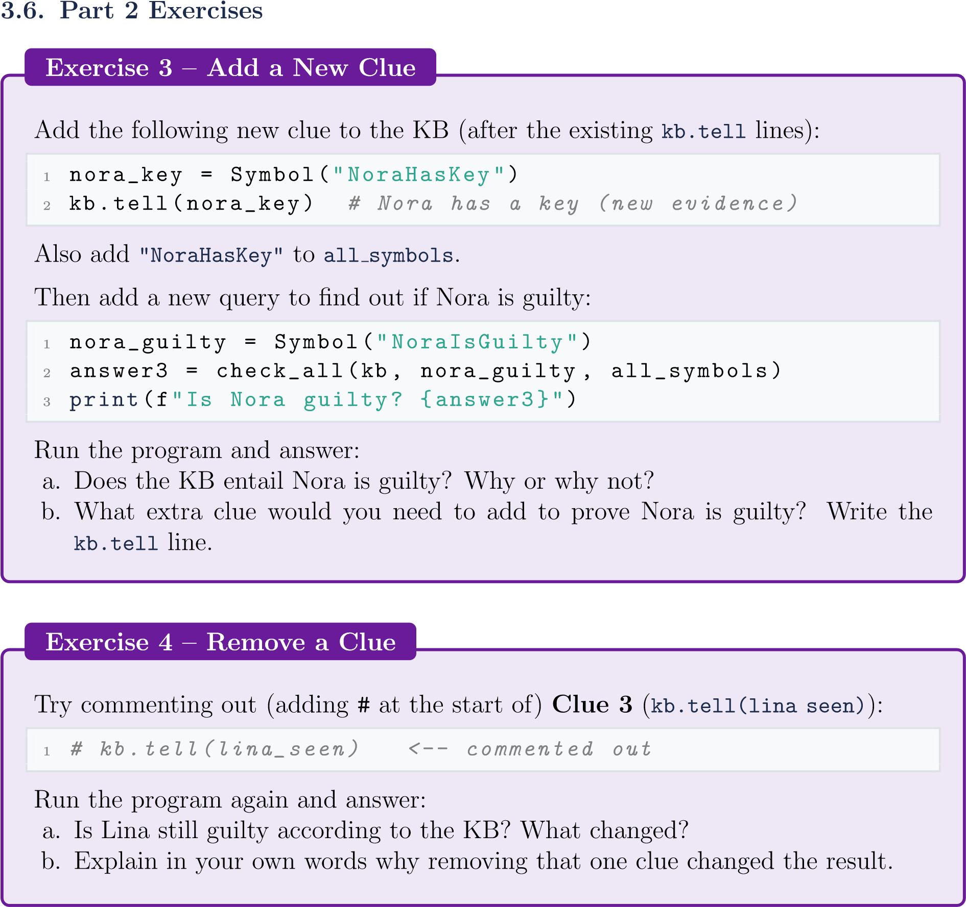

Ecersise3:
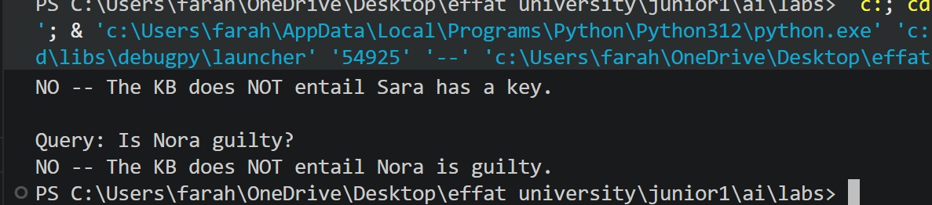

a. Does the KB entail Nora is guilty?
- NO — even though Nora has a key, there is no rule in the KB that says "if Nora has a key → Nora is guilty". The only implication connects Lina's key to Lina's guilt, not Nora's.
b. What extra clue would you need to prove Nora is guilty?
kb.tell(Implication(nora_key, nora_guilty))

Exercise 4:
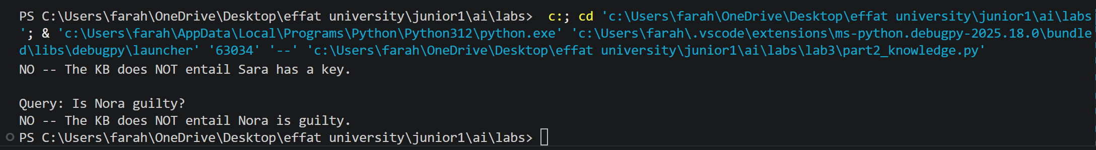

a. Is Lina still guilty according to the KB?
- NO — after removing Clue 3, the KB can no longer prove Lina is guilty.
b. Why did removing that one clue change the result?
- Clue 3 (lina_seen = True) was the starting fact that triggered the whole chain of reasoning:
- Clue 3 → Lina was seen near the room
- Clue 4 → Therefore Lina has a key
- Clue 1 → Therefore Lina is guilty
- Without Clue 3, the chain never starts. The KB has no fact to trigger Clue 4, so it can never prove Lina has a key, and therefore can never prove she is guilty. One missing fact broke the entire reasoning chain.

4. Discussion Questions

Answer these questions in your lab report. Full sentences, please.
Q1 — Why does BFS visit wrong cities? BFS explores level by level in all directions. It has no way of knowing which direction leads to the goal, so it visits every reachable city at each level including dead ends like Madinah. This is not a problem — it guarantees the shortest path is always found.
Q2 — BFS vs DFS for shortest path? BFS is better for finding the shortest path because it explores level by level and guarantees the fewest hops. DFS goes deep in one direction and may find a longer path first.
Q3 — What algorithm handles distances? Dijkstra's Algorithm or A Search*. These consider road distances (weights) instead of just counting hops, so they find the cheapest route not just the fewest stops.
Q4 — Implication vs Entailment?
- Implication (P → Q) is a single rule inside the KB. Example: "If Lina has a key, she is guilty."
- Entailment (KB |= α) means the entire KB guarantees α is true in every possible world. It is the conclusion drawn from all rules combined together.
Q5 — How many worlds for 10 symbols?
- 2¹⁰ = 1,024 worlds
- For very large problems this grows exponentially and becomes impractical. For example 100 symbols = 2¹⁰⁰ worlds which no computer could ever check.

SearchQuestions
1.
InPart1,BFSvisited
Madinah
eventhoughitisnotonthepathtoDammam.
WhydoesBFSvisit“wrong”cities,andisthisaproblem?
2.
CompareBFStoDFS(fromLab1).Forfindingthe
shortest
path,whichis
betterandwhy?
3.
Imagineyouadded
roaddistances
(
e.g.,JeddahtoRiyadh=900km).BFS
doesnotconsiderdistances–itjustcountshops.Whatkindofsearchalgorithm
couldusethosedistancestofinda
cheaper
route?
KnowledgeQuestions
4.
Inyourownwords,whatisthedifferencebetween
implication
(
P
→
Q
)
and
entailment
(
KB
|
=
α
)
?
5.
InPart2,modelcheckingtriedall2
4
=16
worlds.Ifwehad10symbolsinstead
of4,howmanyworldswouldneedtobechecked?Isthispracticalforverylarge
problems?

5. What to Submit
Submit
oneZIPfile
named
Lab3
YourName
ID.zip
containing:
Item Details
part1 search.py Your modified file with Exercises 1 & 2 completed
part2 knowledge.py | Your modified file with Exercises 3 & 4 completed
Screenshots | Terminal output for both parts (all exercises)
Lab Report (PDF or Word) | Answers to all discussion questions
ScreenshotTip
OnWindows:press
Win+Shift+S
totakearegionscreenshot.
PasteitdirectlyintoyourWordreportorsaveasanimagefile.
Grading
Component
Marks
Part1–Exercise1(changegoal,observations)
15
Part1–Exercise2(addnewcity)
15
Part2–Exercise3(addnewclue)
20
Part2–Exercise4(removeaclue)
20
DiscussionQuestions(5questions)
30
Total
100

Good luck! Think like an AI.
Dr. Naila Marir
CS3081 • Artificial Intelligence • Spring 2026

