Course: Mobile Computing

Name: Farah Shabbir Butt

Roll No: MCSF19A021

Intstructor’s Name: Sir Haq Nawaz

**Lecture 2 24 Feb,2021**

Step 1: Create a new Repository

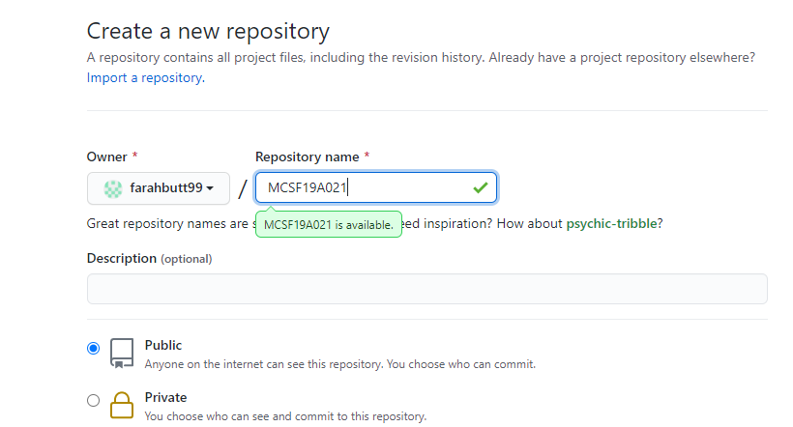

Step 2: Repository link:- https://github.com/farahbutt99/MCSF19A021.git

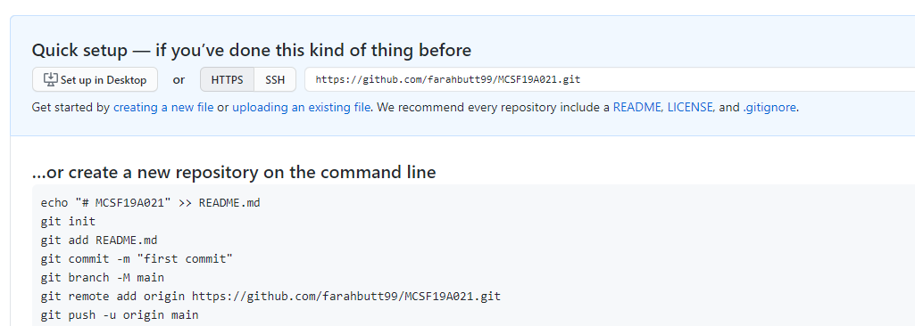

Path to clone a repository

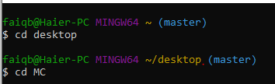

Step 3: Clone a repository

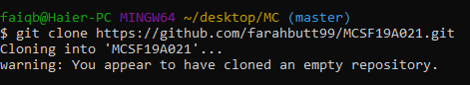

Step 4: Add a file to local repository

First of all I have created a MobileComputingNotebook.docx file in my local repository ("C:\Users\faiqb\Desktop\MC\MCSF19A021\MobileComputingNotebook.docx")

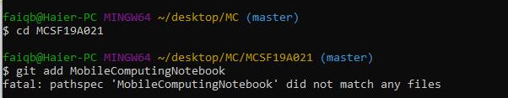

This error occurs due to the wrong file name. I have not added its extension .docx in the command.



Step 5: Commit

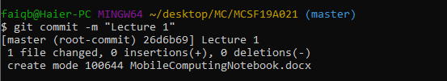

Git Status Command

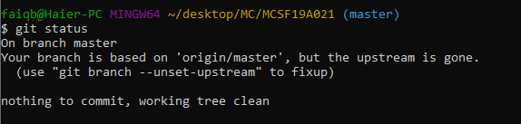

Step 6: Push

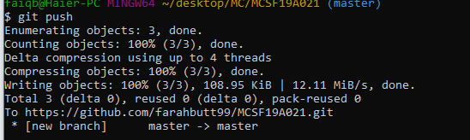

File is added to central repository

