Scalable Internship Management System using AWS RDS (MySQL)

1. Overview
This project implements a scalable and secure Internship Management System using Amazon RDS MySQL. The system is designed to efficiently store and manage intern application data while maintaining high performance, reliability, and security in a cloud environment.

2. Objective
- Build a cloud-based relational database using AWS RDS
- Improve performance using Read Replicas
- Secure database access using VPC and Security Groups
- Enable monitoring and automated backups

3. System Architecture
- Users access the system through a web application
- Application runs on an EC2 instance in a public subnet
- Database layer is deployed in private subnets
- Primary RDS MySQL handles write operations
- Read Replica handles read-only operations
- CloudWatch monitors database performance
This architecture ensures scalability, security, and high availability.

4. AWS Services Used
Service | Purpose
Amazon RDS (MySQL) | Managed relational database
Amazon EC2 | Application server
Amazon VPC | Network isolation
Security Groups | Access control

5. Database Design
Database: internship_db
Table: interns
Field | Description
id | Unique intern ID
name | Intern name
email | Intern email
university | University
status | Application status
applied_date | Application date

6. Implementation Summary
- Created a VPC with public and private subnets
- Configured Security Groups to restrict database access
- Deployed RDS MySQL as the primary database
- Created database schema for intern records
- Enabled Read Replica for scalability
- Connected application to primary DB (writes) and replica (reads)

7. Security & Scalability
- Database hosted in private subnets
- No public access to RDS
- Controlled access via Security Groups
- Read Replicas improve performance during high load

8. Conclusion
This project demonstrates a real-world AWS database architecture using RDS MySQL with Read Replicas. The system is secure, scalable, and easy to manage, making it suitable for production-level internship or application management systems.
The Outcomes are:

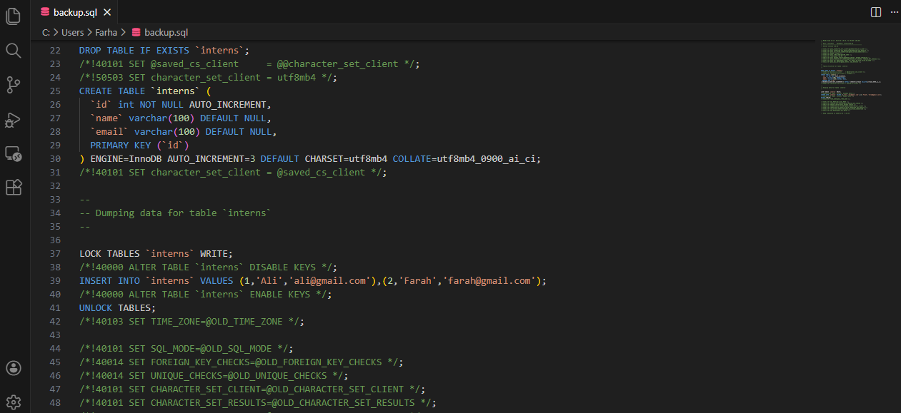

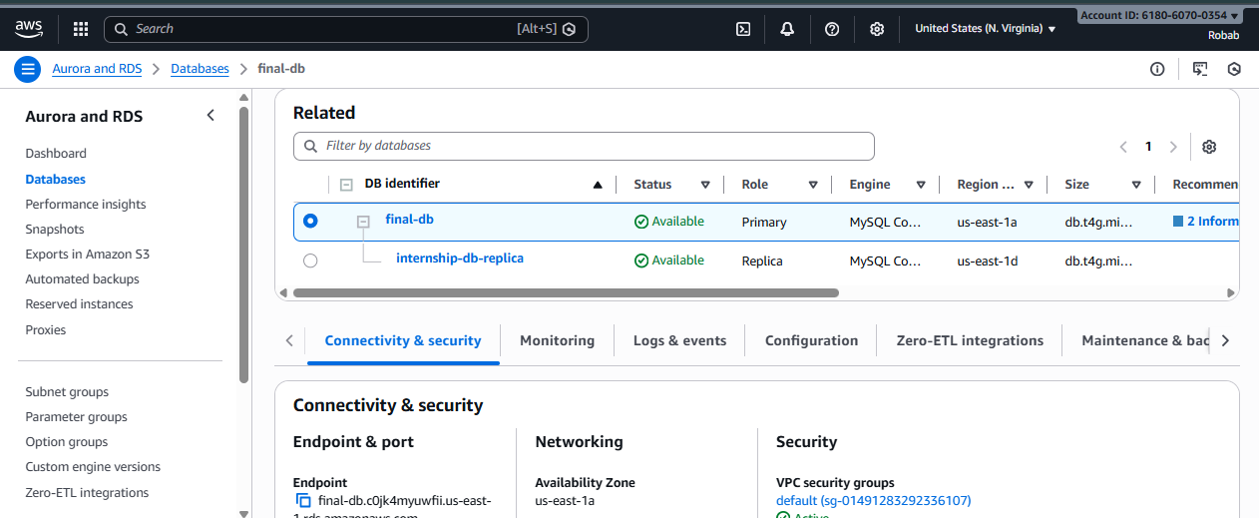

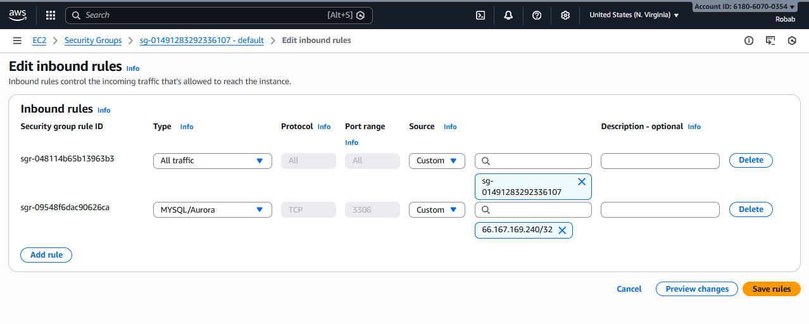

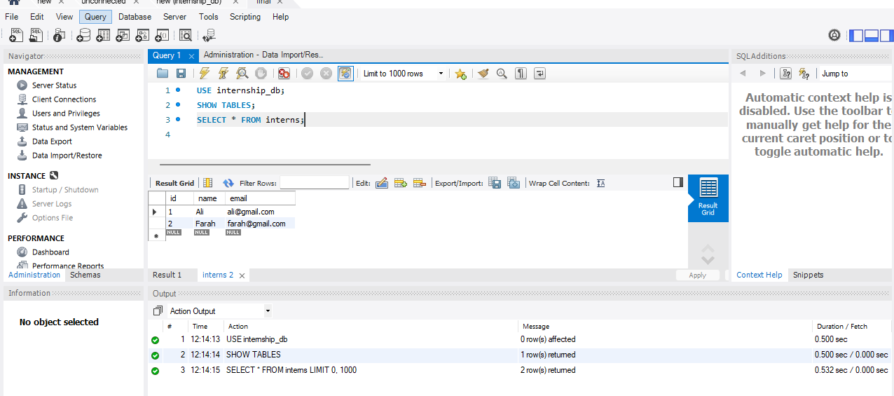

The Architecture Diagram :

