

Information Security Project

Screenshots

Team Members:

Farah Ahmed 37-3658

Mohamed Magdy Helal Mousa 37-6873

Menna Wael 37-7074

Nourhan Al-Gendy 37-6811

BI T-02

Supervised by:

Dr.: Mervat Abu Elkheir

TA: Mohamed Khaled

Authentication part made by Mohamed Magdy Helal Mousa:

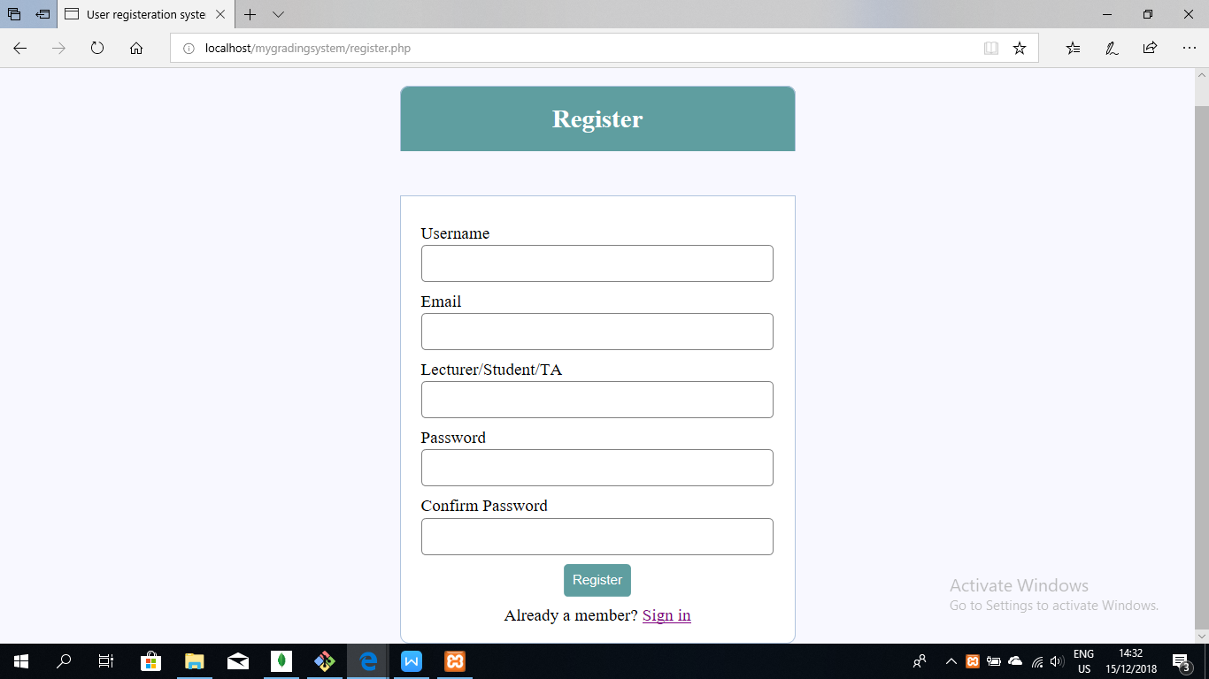

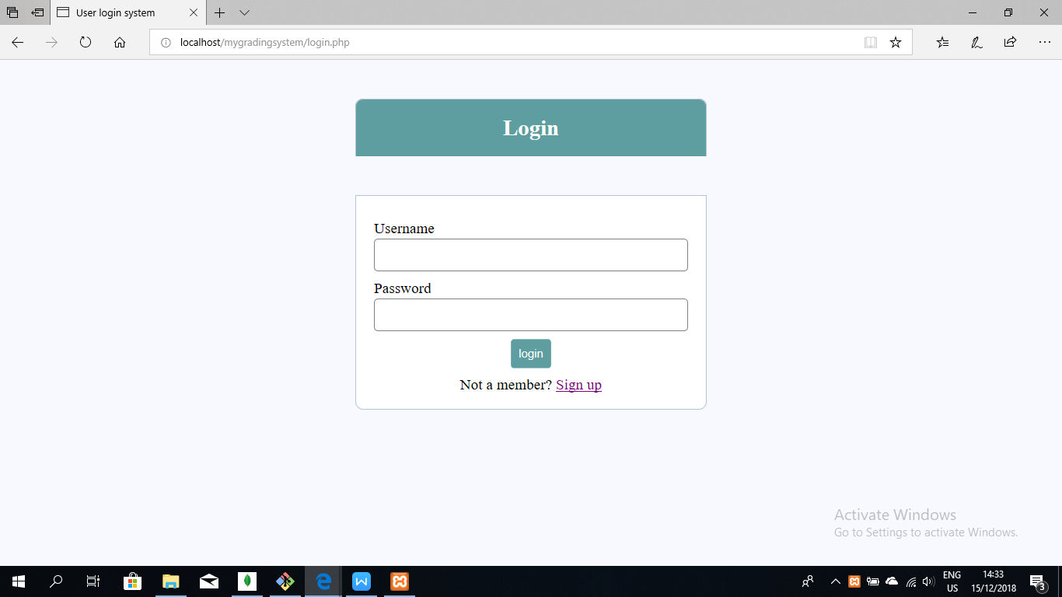

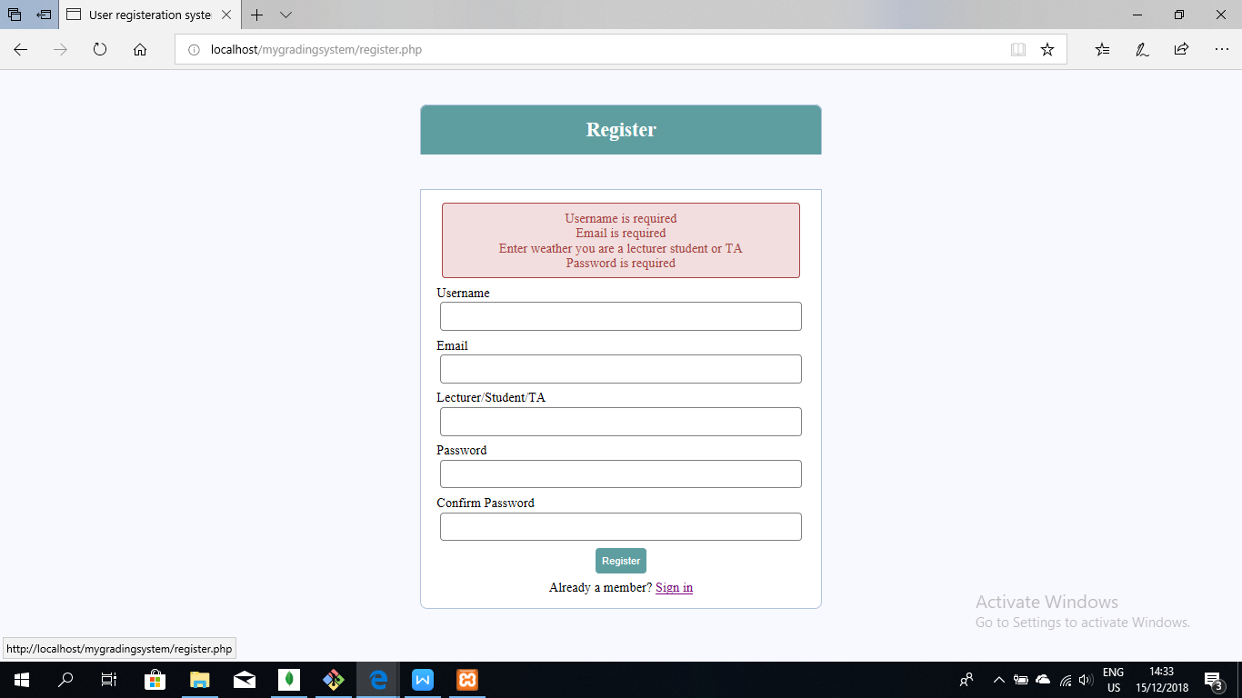

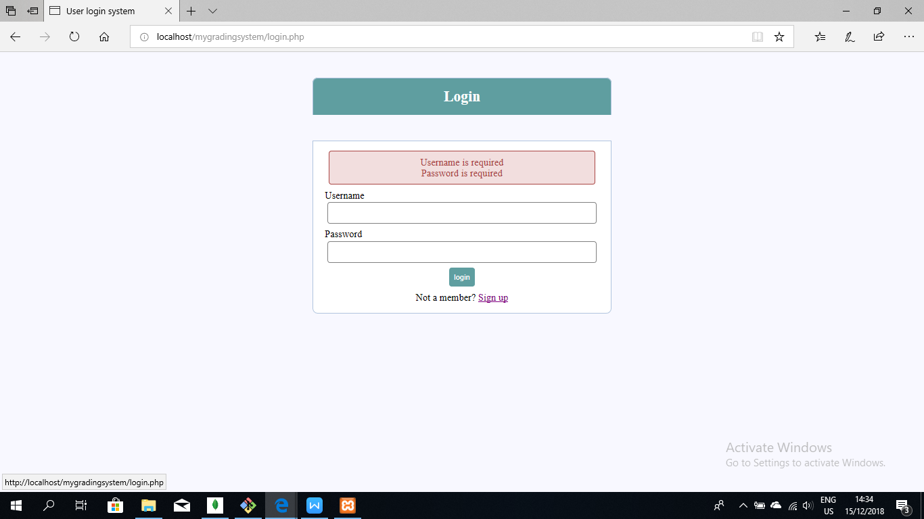

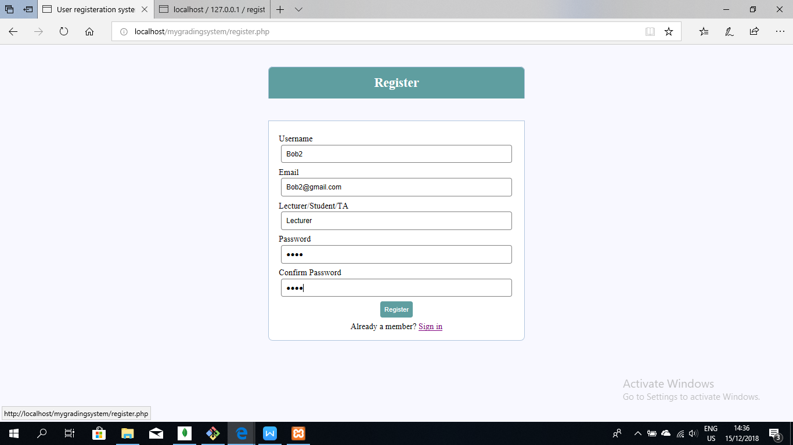

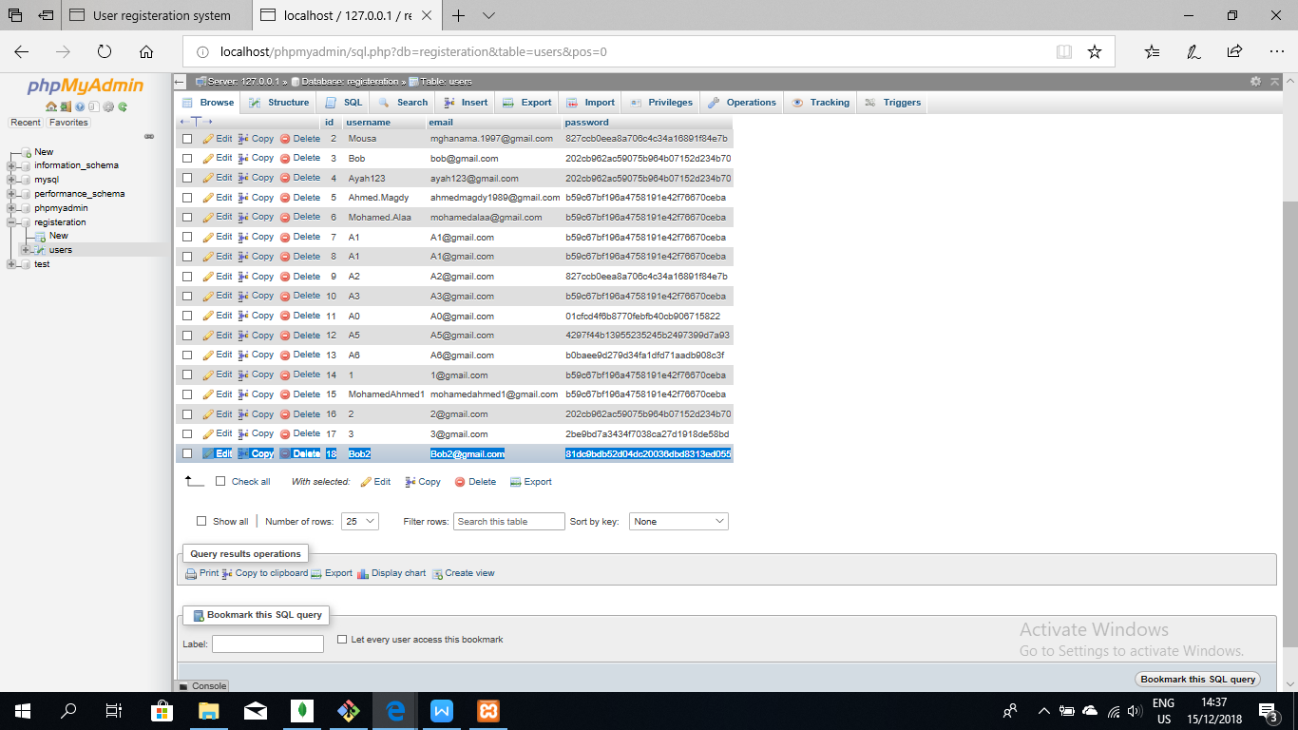

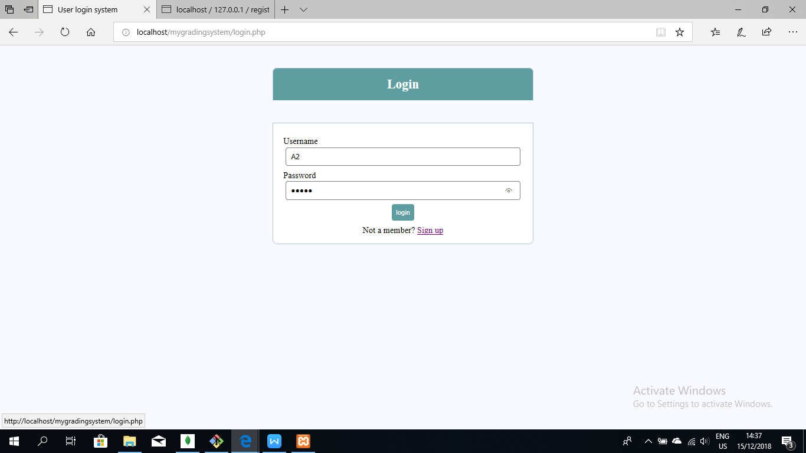

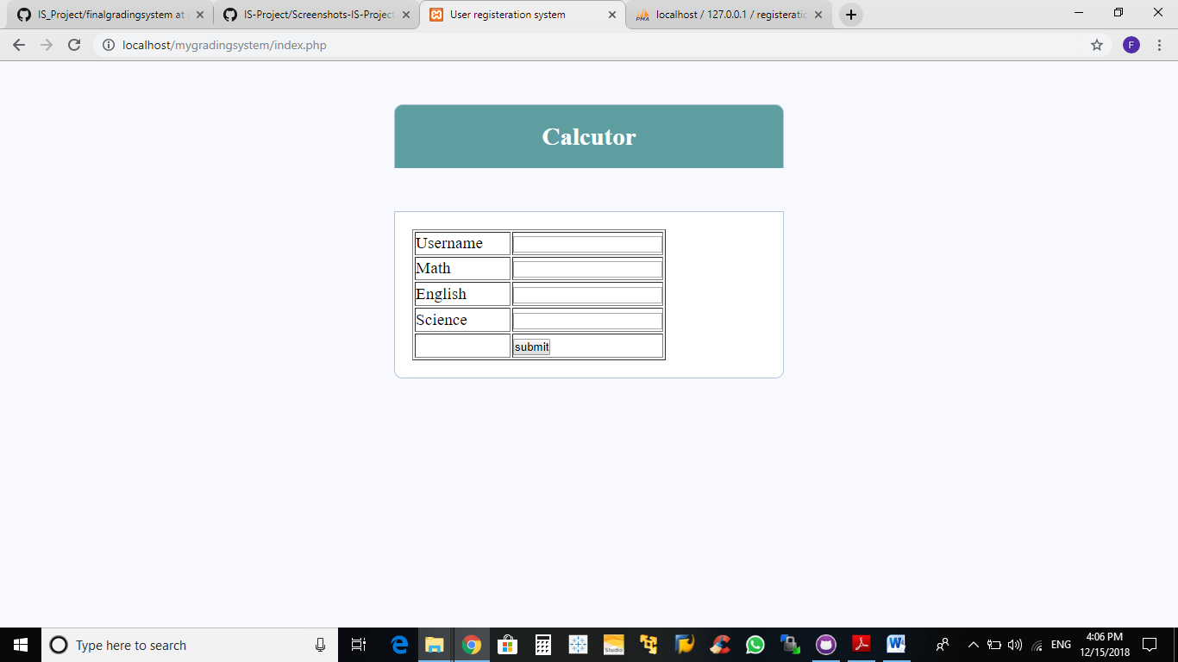

Tokens:

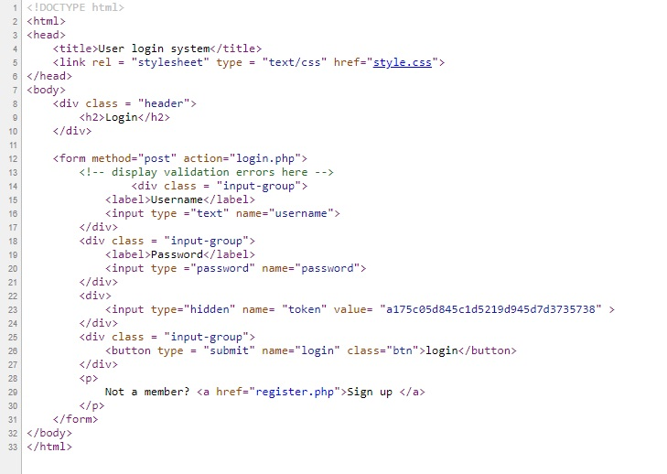

A Lecturer enters Students Grades:

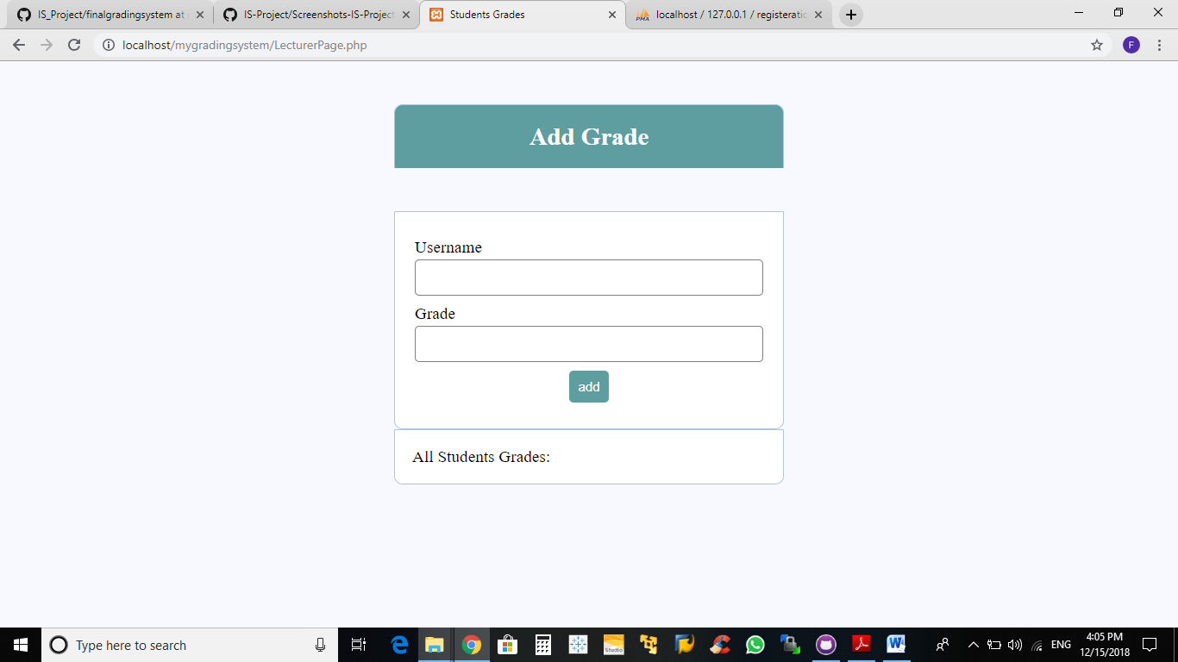

A TA views Students Grades:

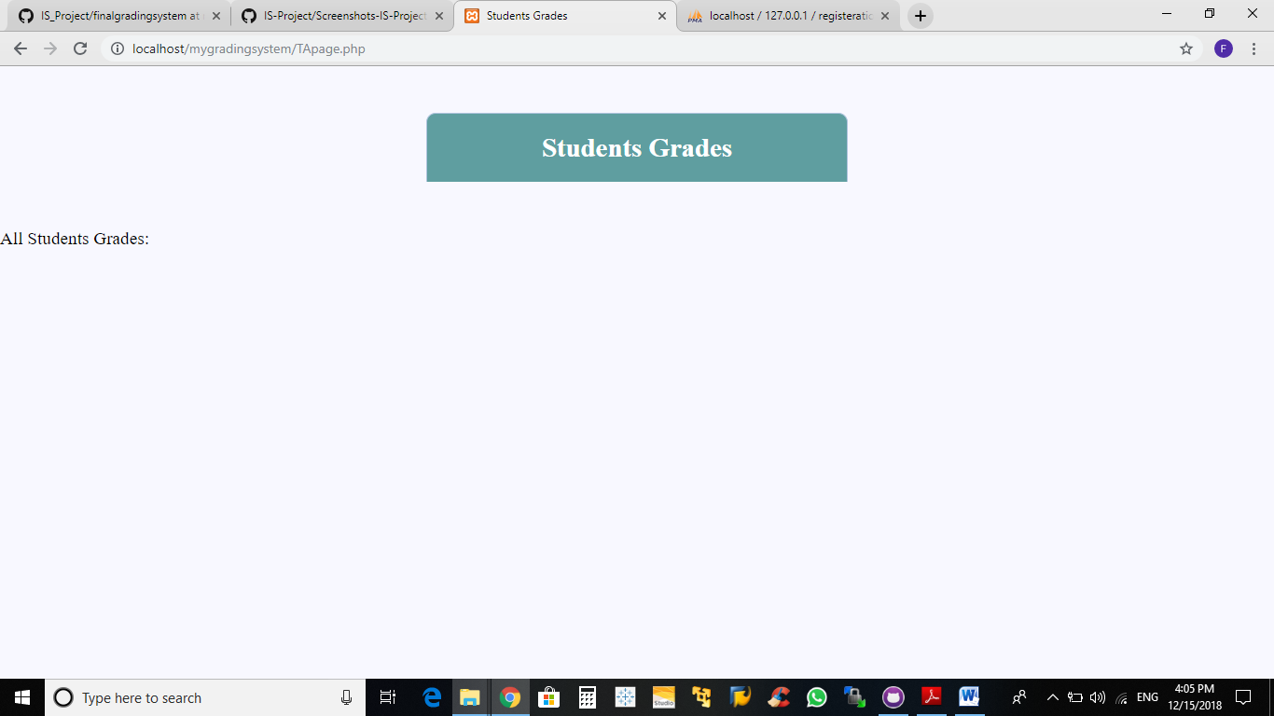

A Student views his Grades:

