**AutoInsight**

**Empowering companies with instant data analytics**

Under supervision of Dr.Eman Amin and TA.Verina Nashaat

**1- Our Team:**

فرح معتز محمد فؤاد عباس 202117393

مايا محمد محمد حلمى الطيب 2021170439

بيشوى سدره صابر سدره 2021170130

مازن مصطفى حنفى 2021170438

مازن رأفت عبد الحميد 2021170436

ماير سليمان هدية 2021170441

**2- Introduction:**

In the modern business landscape, **data analytics** plays a critical role in driving decision-making and strategic planning. According to recent studies, over **90% of large companies** report using data analytics to enhance their decision-making processes, leading to improved operational efficiency and profitability. **McKinsey & Company** suggests that data-driven organizations are **23 times more likely** to acquire customers, **6 times as likely** to retain customers, and **19 times as likely** to be profitable. The **global big data and analytics market** is projected to reach **$684 billion by 2030**, underscoring its importance in the corporate world.

**3- Problem Definition:**

Despite these benefits, many companies struggle with layoffs, restructuring, or budget constraints, limiting their ability to maintain dedicated data analytics teams. This creates a demand for automated data analytics solutions that can fill this gap.

* **Layoffs as a Common Corporate Practice:** In response to economic downturns, restructuring, or shifts in demand, layoffs have become a frequent occurrence. Companies across various industries are often forced to downsize to remain competitive and sustainable, affecting the ability to maintain analytics capabilities.
* **Challenges for Companies During Layoffs:** Layoffs can disrupt business operations, making it difficult to sustain productivity, manage inventory, or forecast future sales. Without reliable data analytics, businesses may face inefficiencies, leading to further losses.
* **Examples of Companies Facing Layoffs:**
* **Amazon**: Announced **27,000 layoffs** in 2023 due to declining demand after the pandemic​
* **Microsoft**: Cut **10,000 jobs** in January 2023, mainly because of reduced demand following pandemic-driven hiring
* **PayPal**: Laid off **2,000 employees** in early 2023 due to economic challenges
* **Dropbox**: Reduced its workforce by **16%**, citing a shift in focus towards AI as a significant factor.

**4- Objective:**

**Develop a solution :**

* The primary goal of AutoInsight is to create a platform that addresses the challenges companies face during layoffs.
* This solution will provide tools for data analysis, forecasting, and machine learning models, enabling businesses to make informed decisions quickly without relying on extensive human resources.

**Provide mutual benefits:**

* AutoInsight aims to establish a mutually beneficial arrangement where companies can maintain productivity by leveraging automated insights, while also reducing costs associated with layoffs. The platform ensures companies can navigate difficult periods with effective analysis and foresight.

**5- Related works:**

* **CSV Master:** This tool allows users to upload CSV files and create visualizations like charts and graphs. It is useful for basic data insights but lacks advanced features like forecasting or machine learning, which are crucial for companies.
* **Vizdium:** A free data visualization tool that generates visual models like bar charts. While it helps with basic visualizations, it doesn’t offer deep analytical capabilities that businesses need to handle complex challenges.

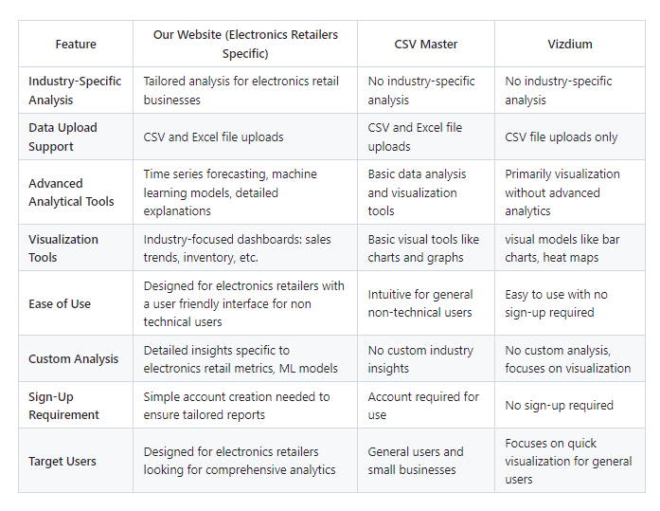

**6- Functional requirements:**

User Authentication & Authorization:

* The platform must include a secure user authentication system to verify users' identities before granting access. This will involve a login mechanism using usernames and passwords, with options for multi-factor authentication (MFA) for added security.
* Role-based access control (RBAC) should be implemented, allowing different levels of access based on user roles (e.g., admin, analyst, viewer). This ensures that users can only perform actions or view data that align with their permissions, maintaining data confidentiality and system integrity.

**User Interface**:

* The user interface must be intuitive and user-friendly, ensuring that even non-technical users can easily navigate the platform and understand the analysis results.
* It should feature a well-organized layout, with easy access to data upload, analysis results, report generation, and system settings. The interface should also be customizable, allowing users to personalize their dashboards according to their preferences.

**I- Industry-Specific Analysis**

● **Tailored Insights:** Focused exclusively on electronics retailers, generating insights related to sales trends, inventory management, customer preferences, and product performance.

● **Retail Metrics:** Analyze essential retail-specific metrics such as product turnover rates, customer loyalty trends, and price sensitivity analysis.

**II- Advanced Analytical Tools**

● **Time Series Forecasting:** Predict future sales trends, inventory needs, and market demands using robust time series analysis techniques.

● **Machine Learning Models:** Implement predictive models to identify patterns, forecast demand, and optimize pricing strategies, enhancing overall business performance.

**III- Custom Reports for Retailers**

● **Detailed Insights:** Generate tailored reports specific to electronic product categories, brands, or models. Identify top-selling products, seasonal trends, and optimize stock levels based on historical data.

**Historical Data Analysis**: Compare current data with historical trends to identify patterns over time.

**IV - Seamless Data Upload**

● **Easy Integration:** Upload CSV files containing sales, product, or customer data effortlessly. The system is equipped to handle standard datasets from Point-of-Sale (POS) systems or eCommerce platforms.

● **Data Preparation:** Automated data cleaning and normalization to ensure accurate and reliable analysis.

**7- software tools**

* **Figma:** For user interface design.
* **Node.js:** Backend development framework.
* **React.js:** Frontend development framework.
* **Bootstrap :** for responsive web design.
* **Colab:** For data analysis and machine learning model development.
* **Git and GitHub:** Version control and collaboration.

**8- References**

The data-driven enterprise of 2025 : <https://www.mckinsey.com/capabilities/quantumblack/our-insights/the-data-driven-enterprise-of-2025>

Keboola / 5 Stats That Show How Data-Driven Organizations Outperform Their Competition:

<https://www.keboola.com/blog/5-stats-that-show-how-data-driven-organizations-outperform-their-competition>

Techmonitor / All of the tech layoffs announced in 2023:

<https://www.techmonitor.ai/digital-economy/big-tech/tech-layoffs-2023>

Data analysis online with csv master:

<https://www.csv-master.com/en>

Visdium:

<https://vizdium.com/>