Subject: HOMEWORK #9 Advanced DataBase Name: Farah Kamw

[Fkamw@kent.edu](mailto:Fkamw@kent.edu) Aggrigation-MongoDB

1. For aggregation, I read the tutorial on the following two links:

<https://docs.mongodb.org/manual/core/aggregation-introduction/>

<https://docs.mongodb.org/manual/tutorial/aggregation-zip-code-data-set/>

1. I have downloaded the zips. Json file from the following link [media.mongodb.org/zips.json](http://media.mongodb.org/zips.json?_ga=1.84488607.707011121.1446516656).

Then I used mongo Import to import the zips file into mongo DB database. See the following two figures.

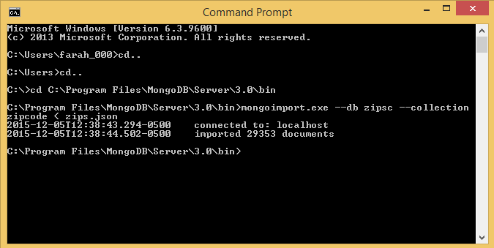

Figure 1

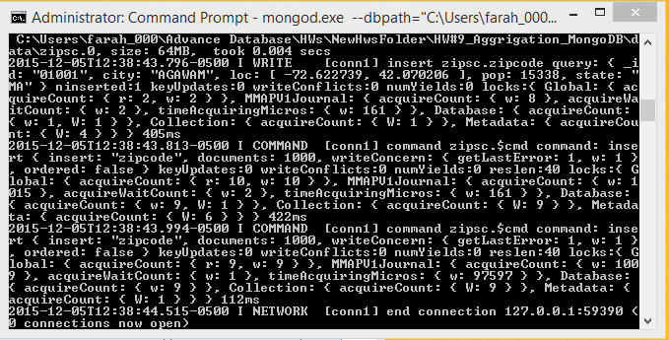

Figure2

# Then I have implemented the (Aggregation with the Zip Code Data Set example) on the mongo shell. First, I implemented the aggregate query to Return States with populations above 10 Million. Then, I implemented a multistage pipeline aggregate query to return average city population by State. See the following figure.

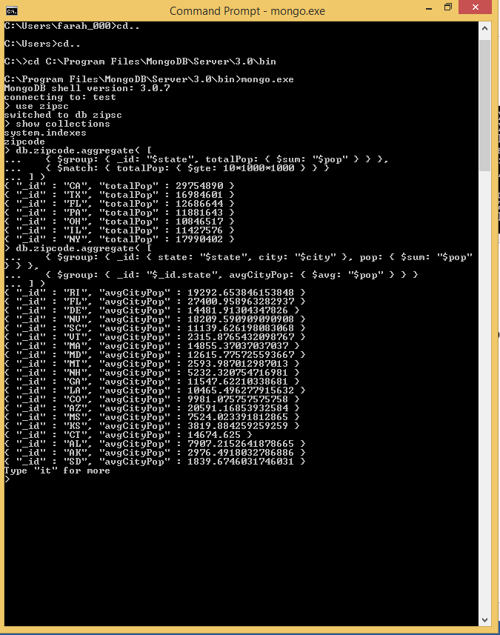

Figure 3

In addition to that, I have implemented a complicated aggregation query to return the smallest and largest cities by population for each state. See figure 4.

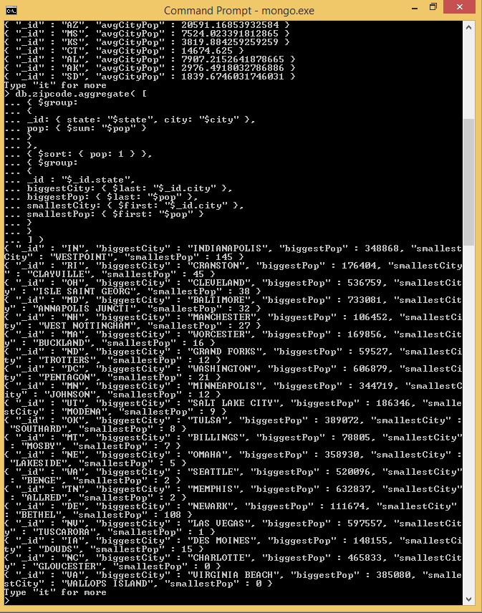

Figure 4

1. I have implemented the same things on python using PyMongo.py. See figure 5 for the python code.

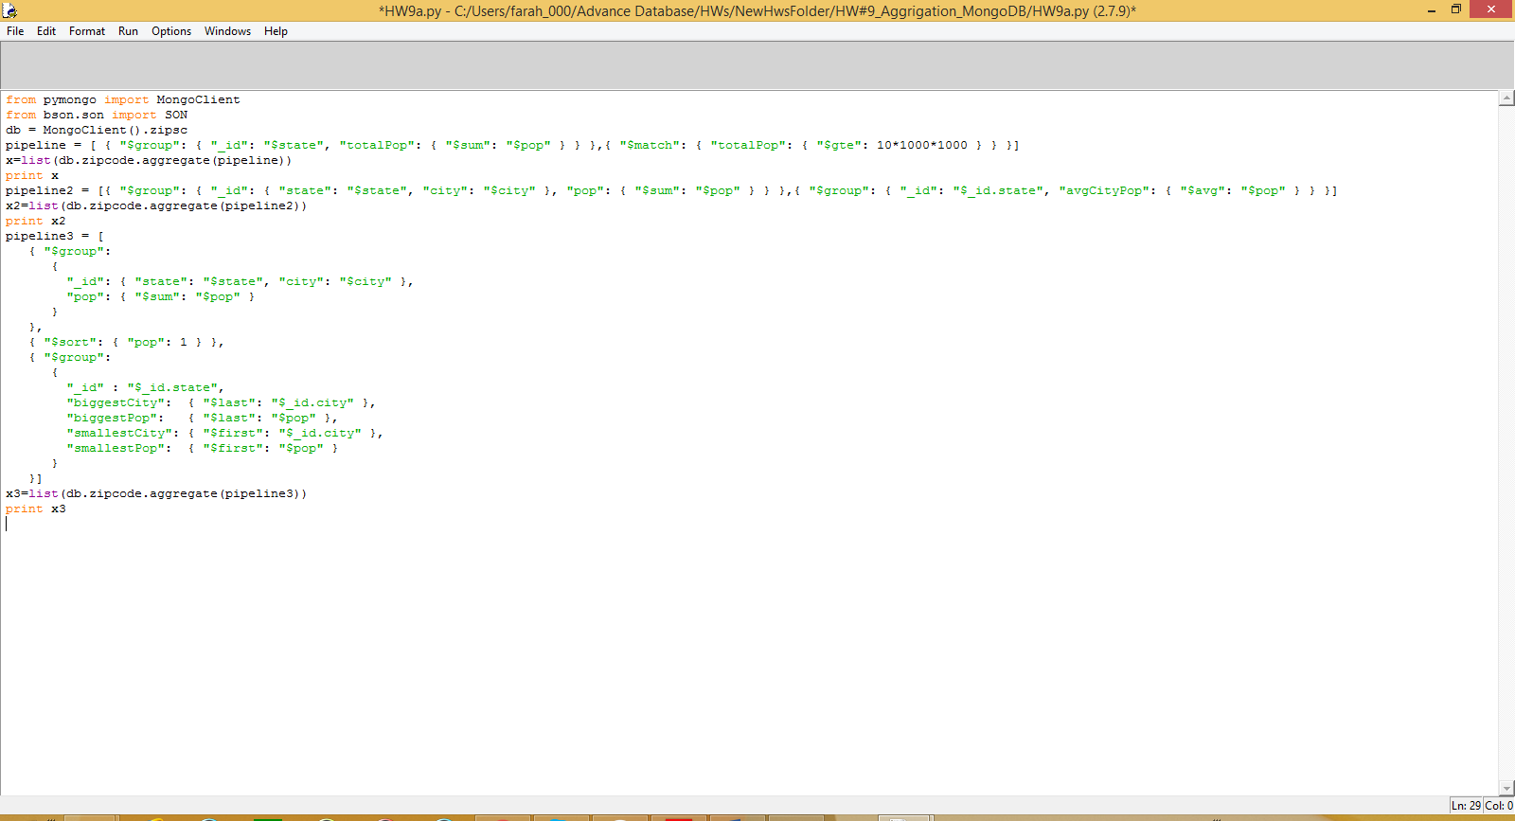

Figure 5

The following figures 6 and 7 show the results of implementation of the three aggregation queries in python shell.

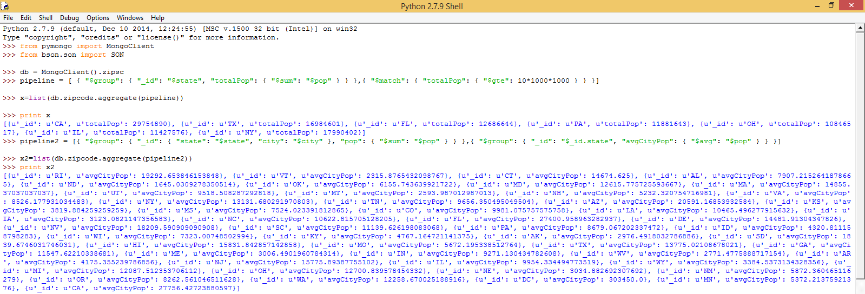

Figure 6

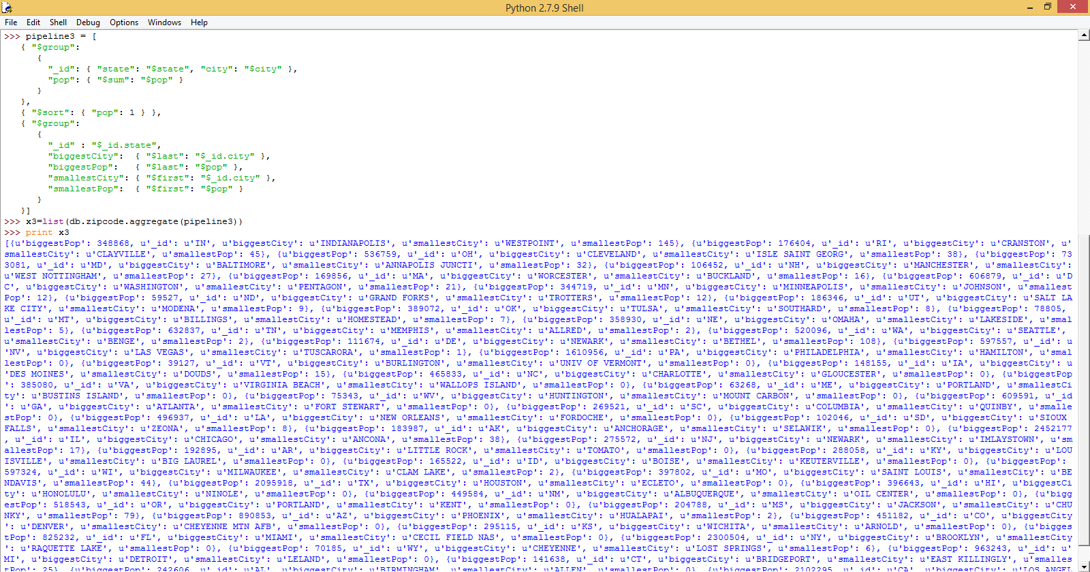

Figure 7

1. I have added a function to the To Do application (app.py) to count number of completed and not done tasks. See figures 8, 9, and 10.

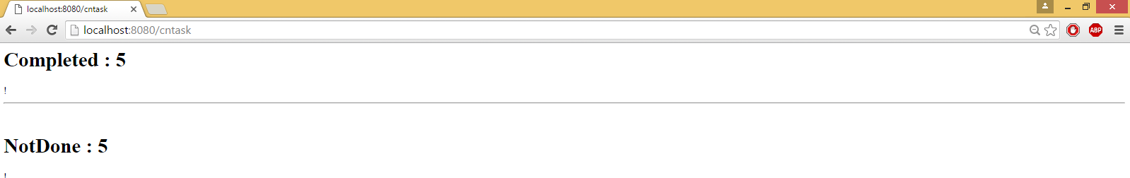

Figure 8

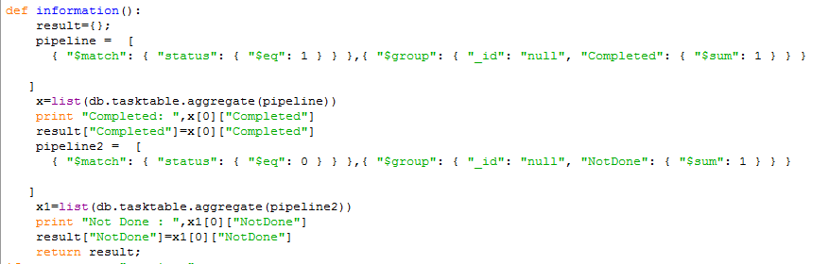

Figure 9

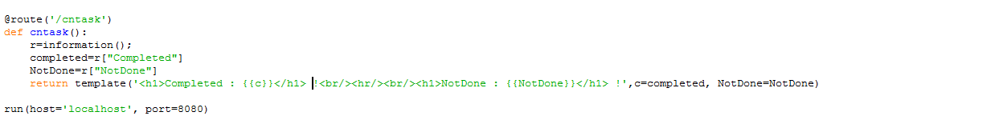

Figure 10

1. For the map reduce I have read and run the examples that you give us in the big data folder in GitHub repository.