TMF641 Elastic Logging LLD

Generated For: British Telecom Global

Project Name: 39346 BT GNV Global

Generated On: July 29, 24

Version: 0.1

Document Control

Authors : Mohsin Hassan

Change Authority : Juniper Networks Professional Services

Change Forecast : Medium

Revision History:

|  |  |  |  |  |
| --- | --- | --- | --- | --- |
| Version | Date Issued | Status | Author | Reason for Change |
| 0.1 | 26/07/2024 | Draft | Mohsin Hassan | Draft of the LLD |
|  |  |  |  |  |

Reviewers:

|  |  |  |
| --- | --- | --- |
| Department | Name | Approval Date |
| Juniper Professional Services | Kural O |  |
|  |  |  |
|  |  |  |

Intellectual Property Rights

This document contains valuable trade secrets and confidential information of Juniper Networks and its affiliates, subsidiaries and suppliers, and shall not be disclosed to any person, organization, or entity unless such disclosure is subject to the provisions of a written non-disclosure and proprietary rights agreement, or intellectual property license agreement approved by Juniper Networks. The distribution of this document does not grant any license in or rights, in whole or in part, to the content, the product(s), technology, or intellectual property described herein.

Table of Contents

1 Document Control 2

2 Table of Contents 3

3 List of Figures 4

4 List of Tables 4

5 Introduction 5

5.1 Purpose 5

5.2 Audience 5

5.3 External References 5

5.4 Alphabetical Index of Terms 5

6 Summary 6

7 Design Overview 7

7.1 Design Diagram 7

7.1.1 Kong Gateway 7

7.1.2 FluentD 8

7.1.3 Elastic 9

8 Sign Off 10

List of Figures

*Figure 1 TMF641 Logging* 7

List of Tables

*Table 1 Alphabetical Index of Terms* 5

# Introduction

## Purpose

This document is a Low-Level Design Document outlining the TMF 641 Elastic logging related Naas automation design components. The following design document was drafted utilizing best practices expertise and the experience of Juniper Professional Services based on reviewing of the British Telecom Global business and technical requirements.

## Audience

The primary audience for this design document is British Telecom network design and engineering team, network operations team and any other service personnel directly or indirectly involved in this project. Juniper Networks personnel such as Service Managers, JTAC engineers and other Professional Services consultants may also use this document as part of the service delivery process.

## External References

|  |  |  |  |
| --- | --- | --- | --- |
|  | External Reference | Version | Comment |
| 1 |  |  |  |
| 2 |  |  |  |

Table 2: External References

## Alphabetical Index of Terms

Following project specific terminology is used throughout this document to specify specific parts of the data network. These terminologies may also reflect the physical place and function of the equipment with respect to the overall project.

|  |  |
| --- | --- |
| Acronym | Description |
| BDD | Behaviour Driven Development |
| BT | British Telecom |
| CI | Continuous Integration |
| CD | Continuous Delivery or Deployment |
| HA | High Availability |
| HLD | High Level Design |
| HTTP | Hypertext Transfer Protocol. Method used to publish and receive information on the Web, such as text and graphic files. |
| HTTPS | Hypertext Transfer Protocol over Secure Sockets Layer. Similar to HTTP with an added encryption layer that encrypts and decrypts user page requests and pages that are returned by a Web server. Used for secure communication, such as payment transactions. |

*Table 1 Alphabetical Index of Terms*

# Summary

This document captures the TMF641 Elastic Logging specific NaaS implementations that are not covered by the generic NaaS high level design document.

# Design Overview

## Design Diagram

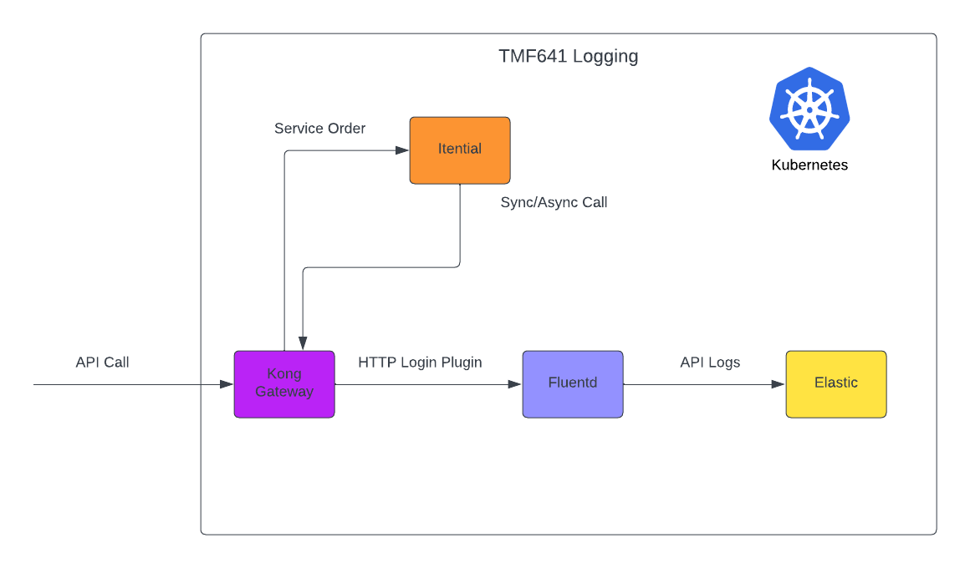

*Figure 1 TMF641 Logging*

### Kong Gateway

We will use the [Kong HTTP Plugin](https://docs.konghq.com/hub/kong-inc/http-log/), which sends API request and response logs to a HTTP ingestion point to FluentD.

For Kong we need to enable http plugin for TMF641 Service, and we can do that by updating ConfigMap of Kong like following

For TMF641 Service Orders

|  |
| --- |
| plugins:  - name: http-log  service: TMF641-Service-Orders  config:  http_endpoint: {{fluentD endpoint}}  method: POST  timeout: 1000  keepalive: 1000  flush_timeout: 2  retry_count: 15 |

For TMF641 Sync Notification

|  |
| --- |
| plugins:  - name: http-log  service: TMF641-Sync-Notification  config:  http_endpoint: {{fluentD endpoint}}  method: POST  timeout: 1000  keepalive: 1000  flush_timeout: 2  retry_count: 15 |

For TMF641 Async Notification

|  |
| --- |
| plugins:  - name: http-log  service: TMF641-Async-Notification  config:  http_endpoint: {{fluentD endpoint}}  method: POST  timeout: 1000  keepalive: 1000  flush_timeout: 2  retry_count: 15 |

### FluentD

For FluentD we need to create new endpoint for logging TMF641 messages and we do by applying following configuration

|  |
| --- |
| <source>  @id kong-api-http-logs  @type http  @log_level debug  @label @OUTPUT  port 9080  bind 0.0.0.0  body_size_limit 32m  keepalive_timeout 10s  tag tmf641-logs  </source>  # sending to elastic  <match kong-api-http-logs.>  @type elasticsearch  ssl_verify false  scheme https  validate_client_version true  verify_es_version_at_startup true  default_elasticsearch_version 7  host {{ output.es_host }}  port {{ output.es_port }}  user "#{ENV['esuser']}"  password "#{ENV['espassword']}"  index_name integration-tmf641  include_tag_key true  include_timestamp true  type_name log  tag_key @tmf641-logs  flush_interval 5s        </match> |

We need to create K8 service in FluentD namespace to expose the http port which will received Kong logs

|  |
| --- |
| ## Expose the service to ingest log from Kong via HTTP  service:  type: "ClusterIP"  annotations: {}  ports:  - name: "http"  protocol: TCP  containerPort: 9080 |

### Elastic

For elastic we need to create following resources

* Index
  + integration-tmf641-*
* Index alias which will be configured in FluentD
  + integration-tmf641
* Retention Period

# Sign Off

(Optional – remove this section in case the sign off is by email or on another document)

This final sign off is based on the understanding that formal review meetings have been conducted to present, explain and discuss the Low-Level Design document created. As per the observations made during these meetings, we have incorporated BT Global input and feedback in this document.

|  |  |
| --- | --- |
| Juniper Networks Inc | Customer |
| Approved YES  NO | Approved YES  NO |
| Name | Name |
| Signature | Signature |
| Position | Position |
| Date | Date |