FARAJ FRUIT SUPPLIER AND VENDOR
E-Commerce System
Wholesale & Retail Fruit Supply Platform

Student Name | Faraj Aman Athman______________________________
Admission Number | BBit\2024\56266___________________________
Course / Class | ______________________________
Unit Code | BIT3208
Unit Name | Advanced Web Design and Development
Lecturer Name | ______________________________
Semester / Academic Year | _3.2_____________________________

Project Title | Faraj Fruit Supplier and Vendor – E-Commerce System
Technologies | PHP + MySQL, HTML, CSS, JavaScript, XAMPP
GitHub / Portfolio | ______________________________

Git hub link: https://github.com/farajathman734/Faraj-fruit-supplier-and-vendor

Deployment link https://spree-uranium-pedicure.ngrok-free.dev/faraj/

TABLE OF CONTENTS
Faraj Fruit Supplier and Vendor – BIT3208

Week 1: Local Environment Setup ........................ 3
Overview & Project Description .................... 3
Required Evidence & Screenshot Guide .............. 3
Screenshot Evidence (Fig 1-5) ..................... 4
Student Reflection ................................ 5
Tools Used This Week .............................. 5
Lecturer Verification ............................. 6
Week 2: Wireframes and GUI Design ...................... 7
Overview .......................................... 7
Color Theme & Design System ....................... 7
Pages Designed in Excalidraw ...................... 8
Required Evidence & Screenshot Guide .............. 8
Screenshot Evidence (Fig 1-5) ..................... 9
Student Reflection ................................ 10
Week 3: JavaScript and PHP Basics ...................... 11
Overview .......................................... 11
Features Built This Week .......................... 11
Required Evidence & Screenshot Guide .............. 12
Screenshot Evidence (Fig 1-5) ..................... 12
Student Reflection ................................ 14
Week 4: Dynamic Content & Database Integration ......... 15
PHP Server-Side Processing Demo ................... 15
Registration Form Saving to DB .................... 15
Login with Session ................................ 16
Session Dashboard ................................. 16
Admin Dashboard ................................... 17
Week 5: Security, Sessions & Final Integration ......... 18
Task 1: Input Sanitization ........................ 18
Task 2: Password Hashing Demo ..................... 18
Task 3: Role-Based Access Control ................. 19
Task 4: Final System Integration .................. 19
Security Implementation Checklist ................. 20
Student Reflection ................................ 20
Final Project Summary ............................. 21

Week 1: Local Environment Setup
Title: Installation and Testing of Local Development Environment

Fig 1: Installation of XAMPP
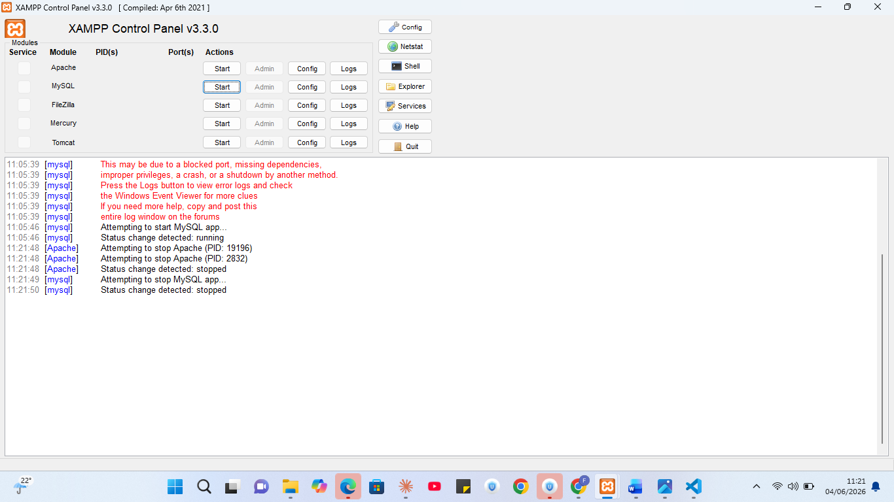 [ Fig 1: Screenshot goes here ]
Fig 1: XAMPP installation wizard showing successful setup on local machine

Fig 2: Apache and MySQL Services Running

[ Fig 2: Screensh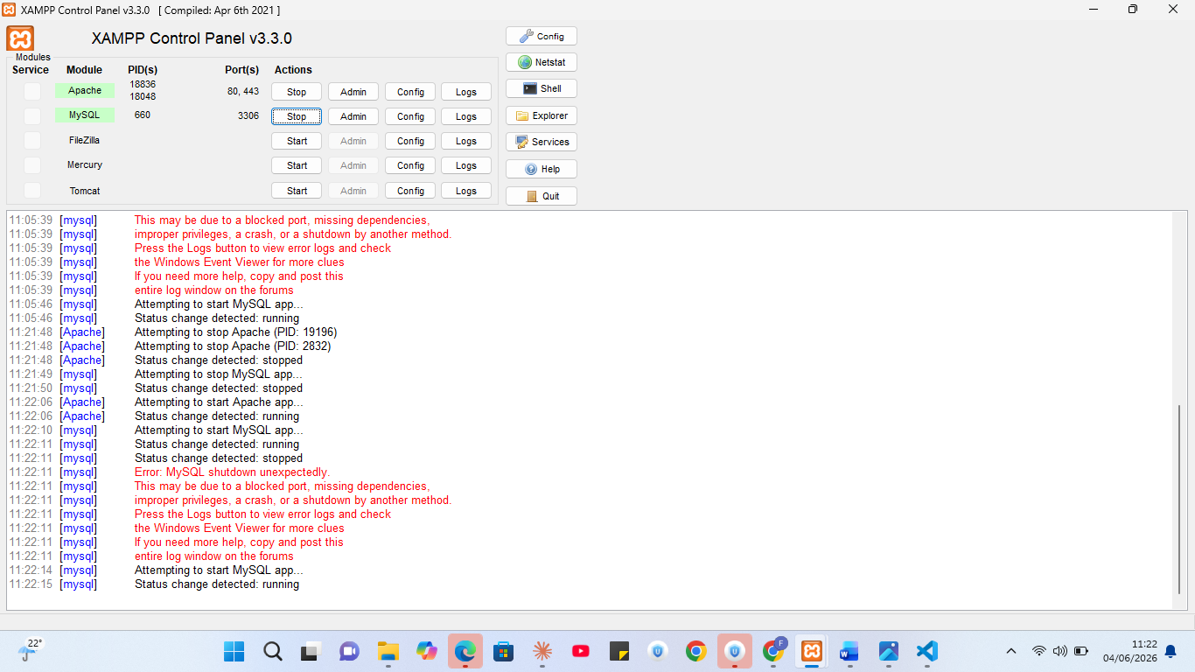ot goes here ]

Fig 3: Localhost Test Page
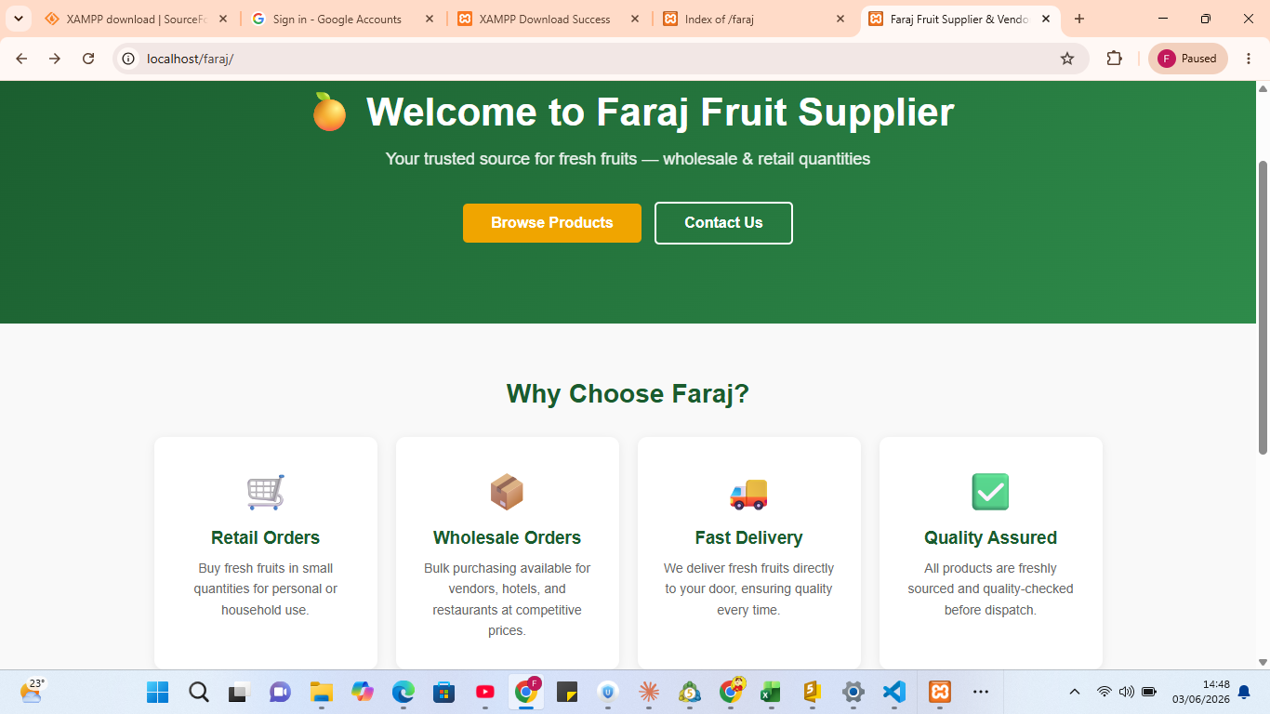

What Your Reflection Should Cover
- What you learned during environment setup
- Why XAMPP was chosen for this project (local server, PHP + MySQL support)
- Challenges encountered (e.g. port conflicts, firewall issues) and how you resolved them
- How this setup will support the Faraj Fruit e-commerce system going forward
- What each screenshot demonstrates in relation to your project

Tools Used This Week
Tool | Purpose in the Faraj Project
XAMPP | Local server environment for PHP execution and MySQL database
Apache | Web server to run PHP pages for the e-commerce frontend
MySQL / phpMyAdmin | Database management for products, users, and orders
VS Code | Code editor for writing PHP, HTML, CSS, and JavaScript
GitHub | Version control and portfolio hosting for the project
Browser (Chrome/Firefox) | Testing frontend pages served by localhost

Lecturer Verification
Lecturer Signature: ___________________ | Date: ___________________

BIT3208 – Advanced Web Design and Development | Faraj Fruit Supplier and Vendor

Week 2: Wireframes and GUI Design
Title: User Interface Planning and System Design for Faraj E-Commerce

Pages Designed (Wireframes)
The following 7 pages were wireframed in Excalidraw before development:
- Homepage – Hero, features, featured products, footer
- Login Page – Email, password fields, login button, register link
- Register Page – Name, email, phone, customer type, password fields
- Products Page – Filter buttons, product grid with prices
- Cart Page – Cart table, coupon code input, order summary
- Admin Dashboard – Sidebar, stat cards, recent orders table
- Contact Page – Contact info, message form

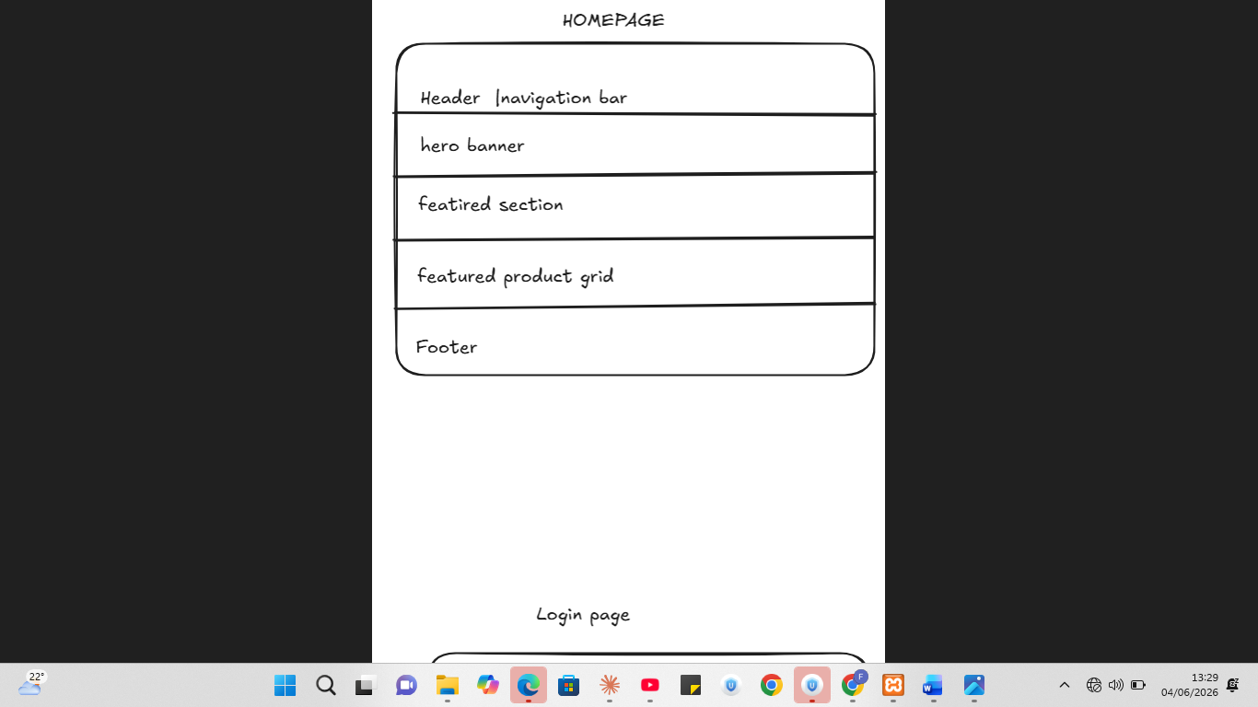

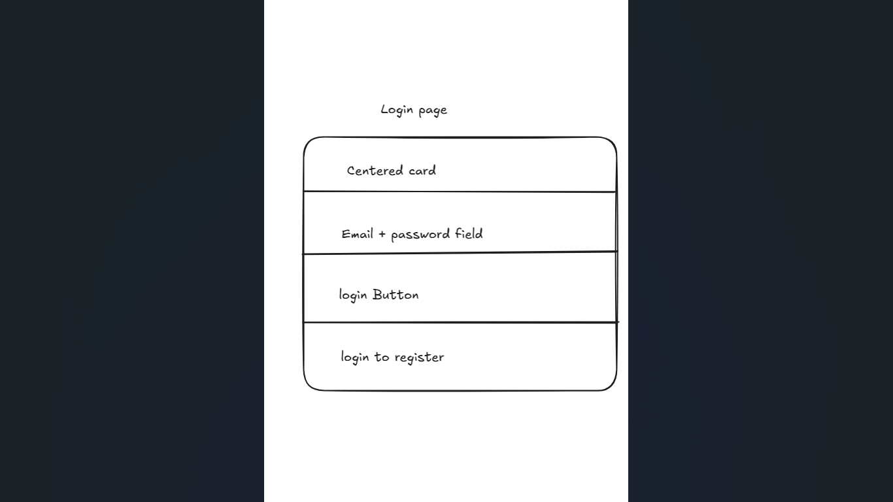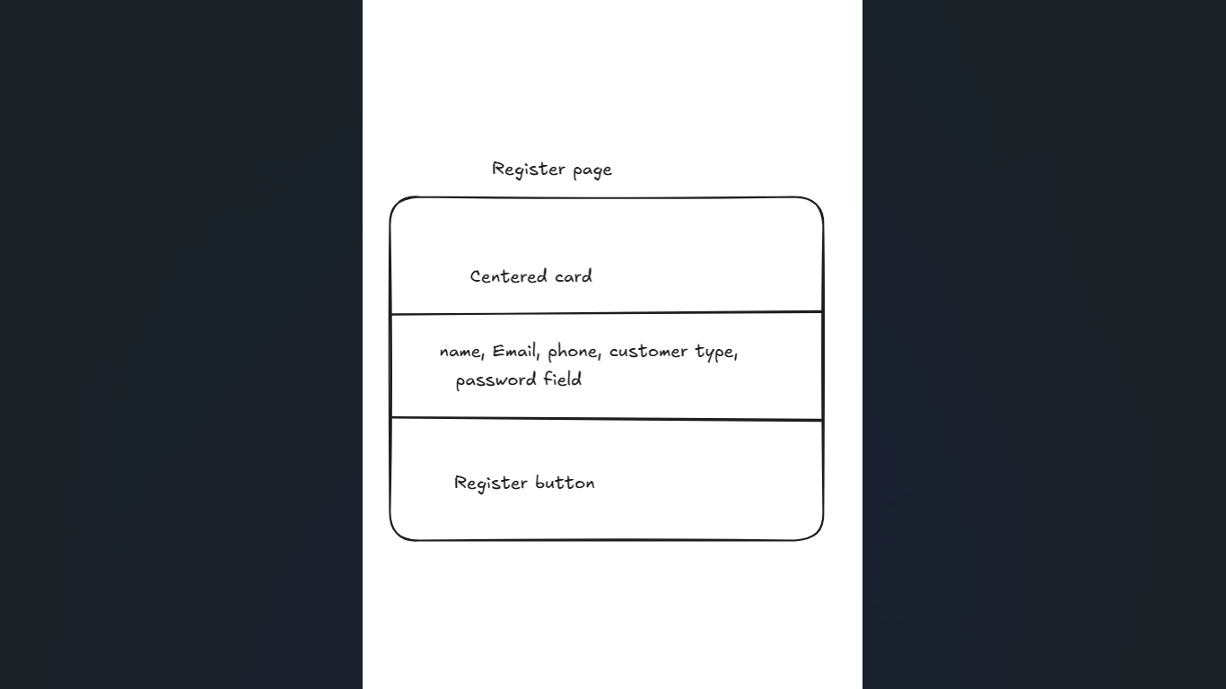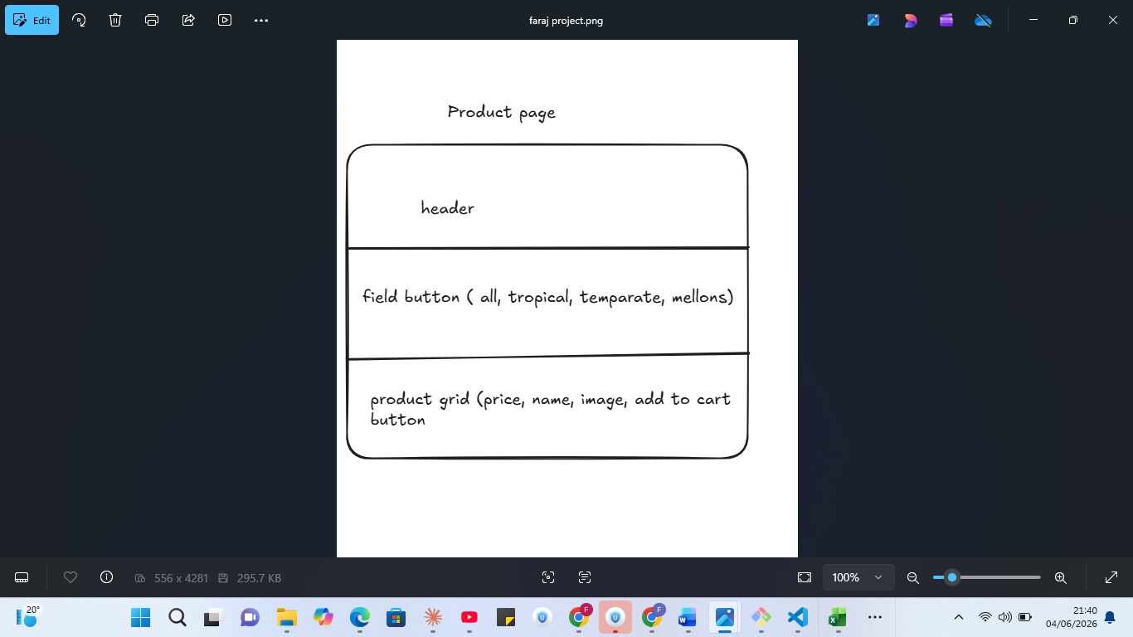

Dashboard layout design

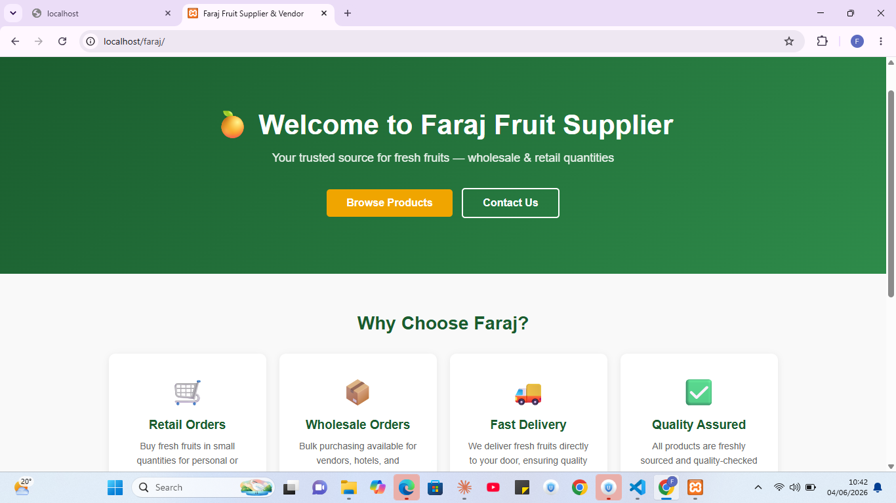

FARAJ FRUIT SUPPLIER AND VENDOR
BIT3208 – Advanced Web Design and Development

Week 3: JavaScript and PHP Basics
Title: Form Validation, PHP Scripting and Database Interaction

Features Built This Week
Feature | Description
JS Form Validation | Login, Register, Checkout forms validated using vanilla JavaScript before submission
PHP Login Handler | login.php processes POST data, queries users table, and creates session on success
PHP Register Handler | register.php hashes password using password_hash() and inserts user into DB
Live Product Search | search.js calls search_handler.php via fetch() returning JSON results as user types
Coupon Code System | cart.php sends coupon to coupon_handler.php which validates and returns discount amount
Checkout to DB | checkout.php saves order, order_items, and delivery records to MySQL in one transaction

Fig 1: JavaScript Validation Error on Login Form
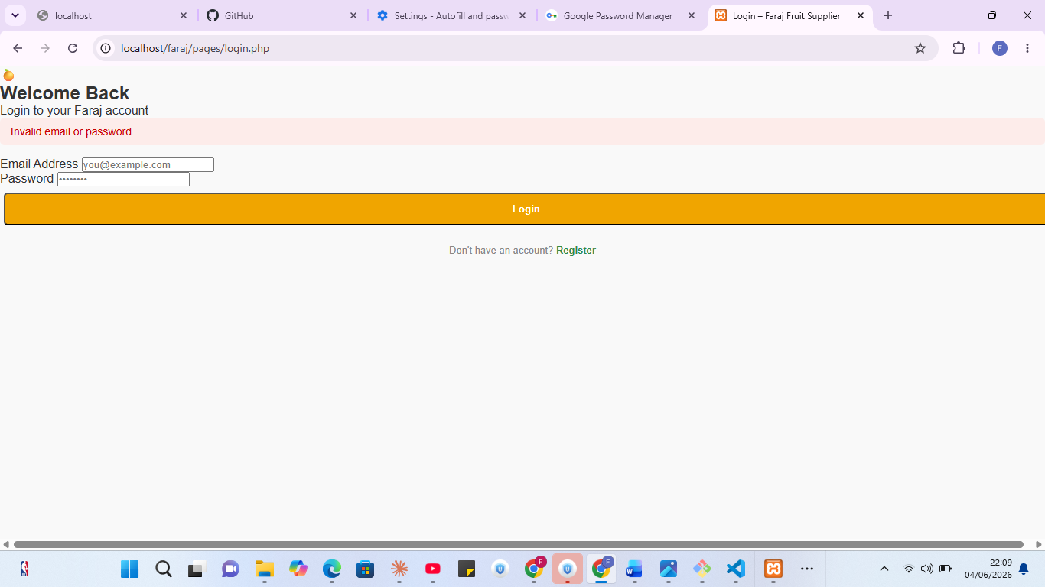

Fig 2: Successful User Registration in Database
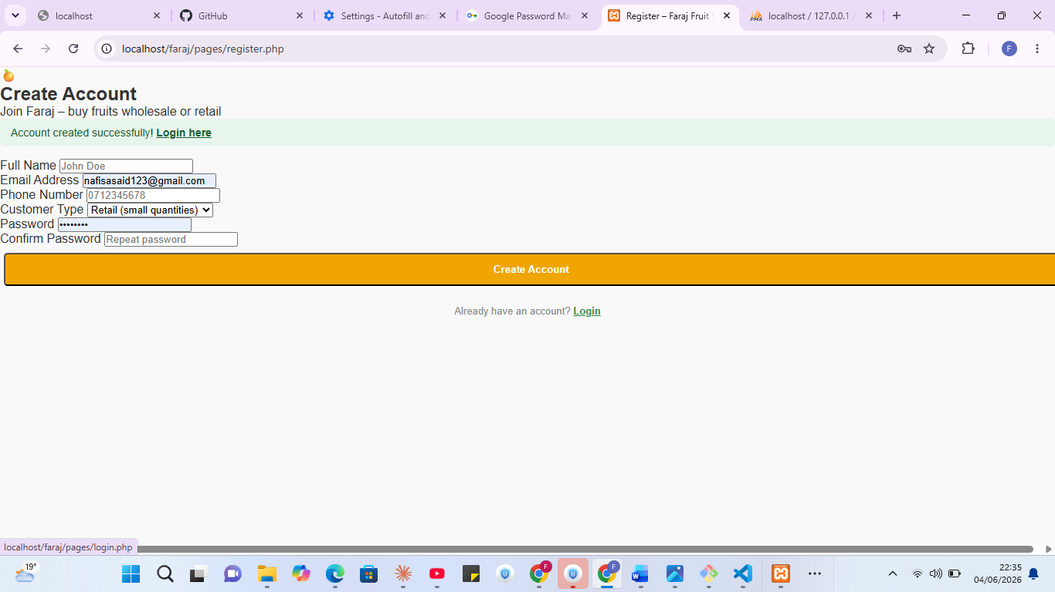

Fig 3: Live Product Search
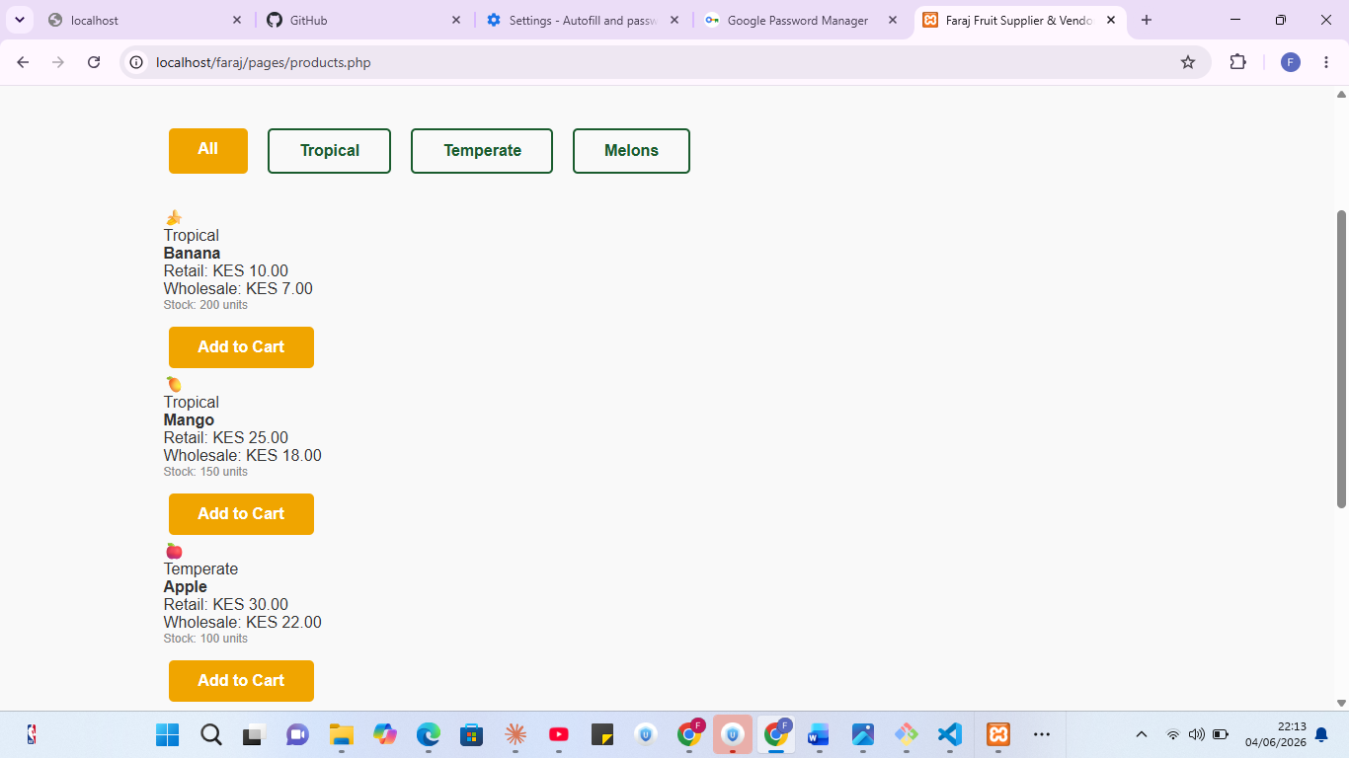

Fig 4: Coupon Code Applied in Cart
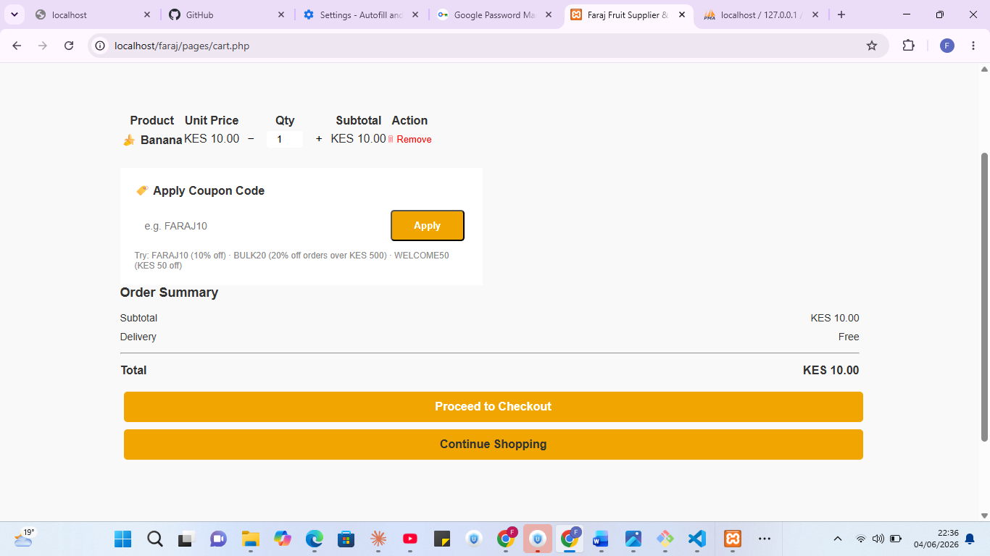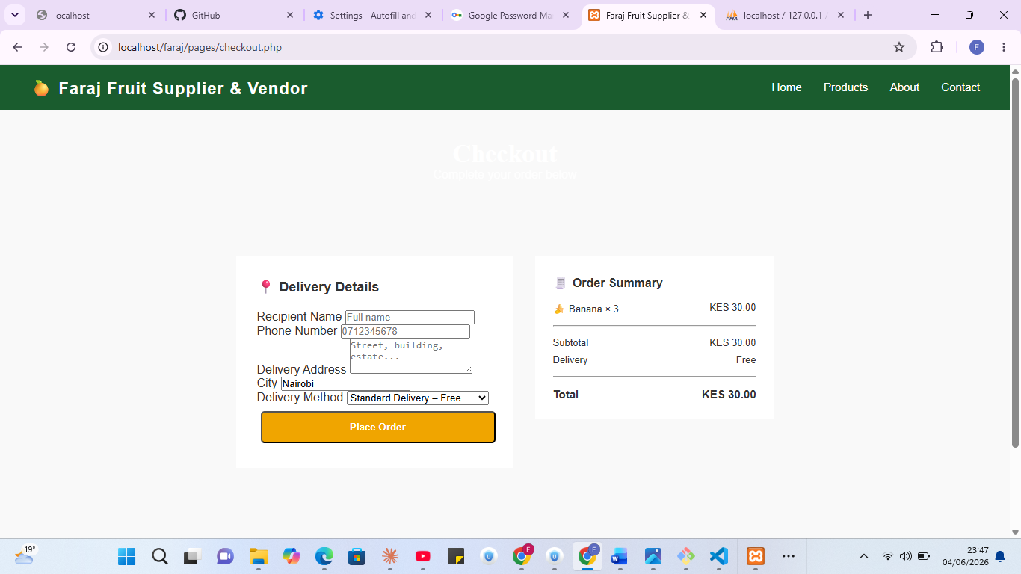

Fig 5: Order Saved to Database
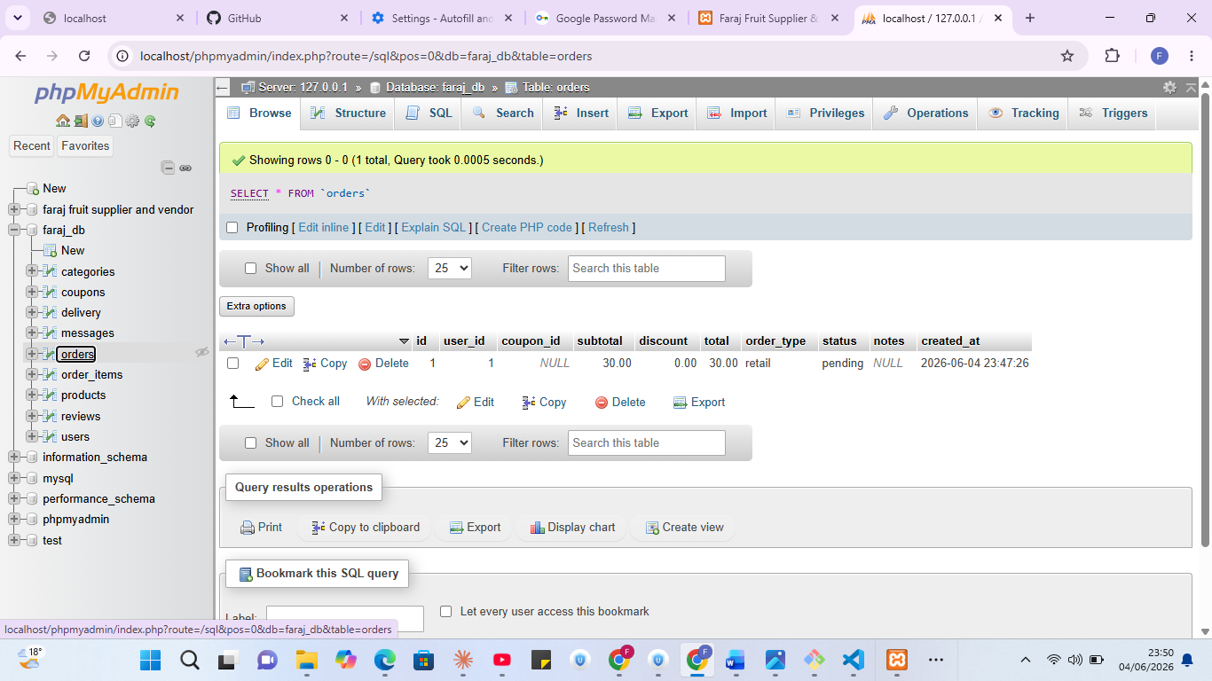

Week 4:

PHP Server-Side Processing

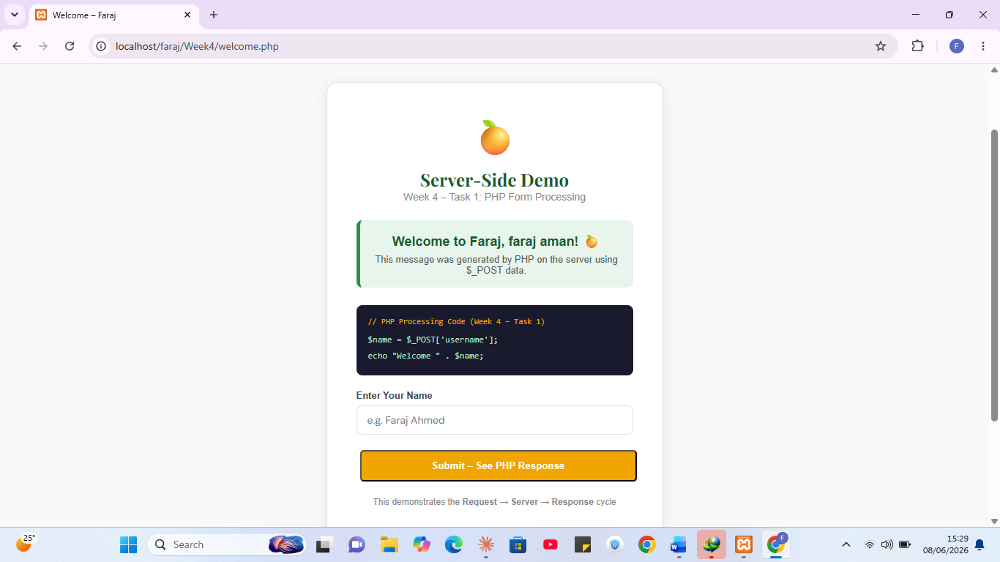

Registration Form Saving to Db

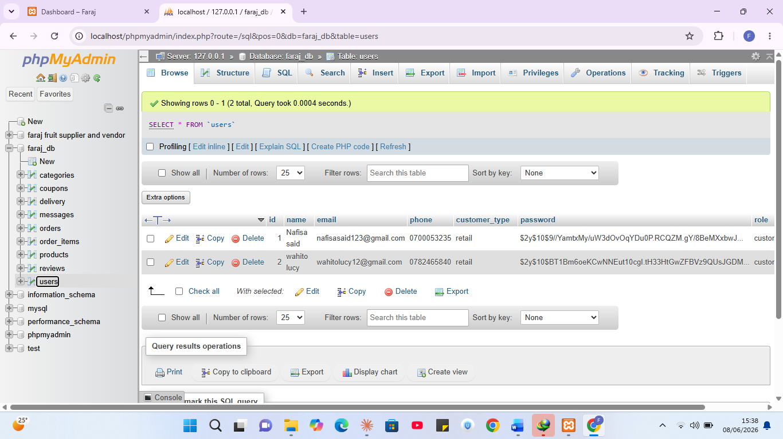

Session Dashboard

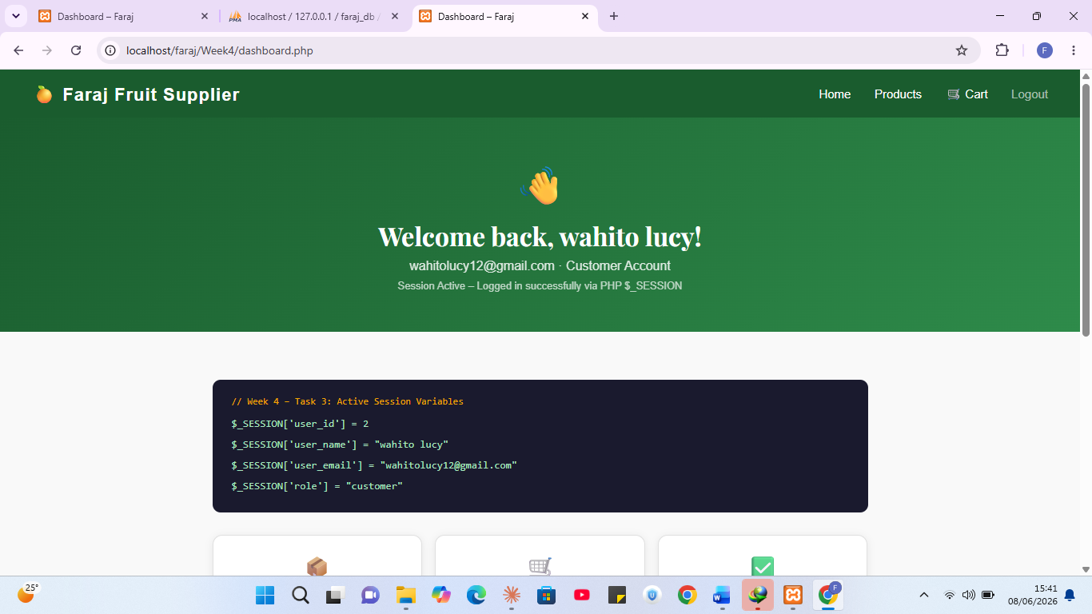

LOG IN SCREEN SHORT
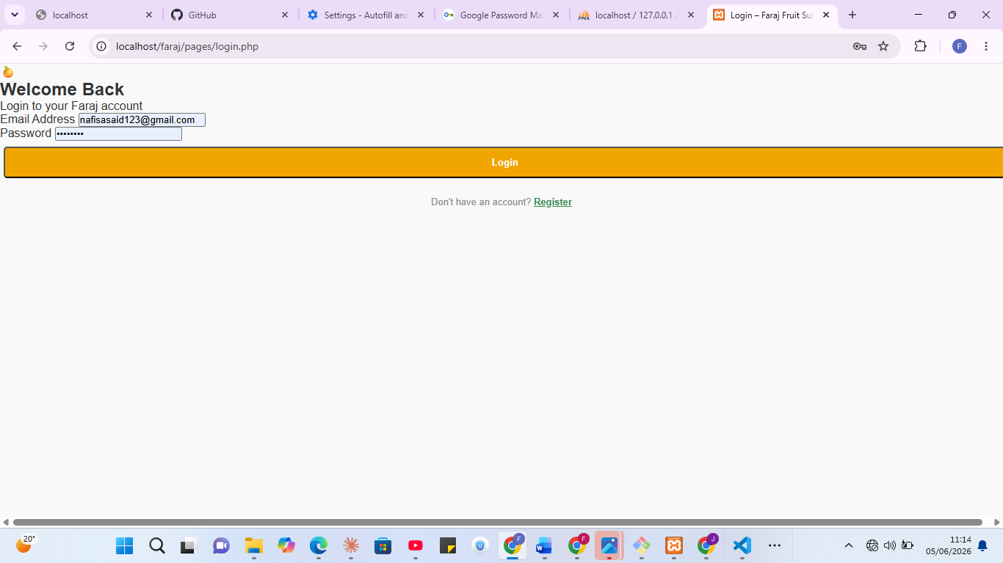

GIT BASH UPDATES
