Linux System Administrator Tasks – Explained

# Part 1: User & Group Permissions

## Task 1.1 – Create Users & Groups

Command(s):

sudo groupadd network_team  
sudo useradd -m -G network_team alice  
sudo useradd -m -G network_team bob

Explanation:

Creates a group called 'network_team' and adds users 'alice' and 'bob' to it with home directories.

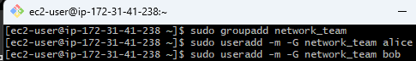

## Task 1.2 – Set Directory Permissions

Command(s):

sudo mkdir /opt/network_data  
sudo chown root:network_team /opt/network_data  
sudo chmod 770 /opt/network_data

Explanation:

Creates a shared directory for the group and grants full permissions to the group while denying access to others.

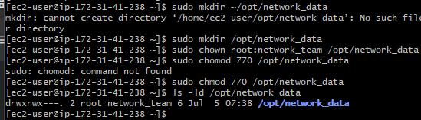

# Part 2: Network Tools & Real-Time Checks

## Task 2.1 – Check Connectivity to google.com

Command(s):

ping -c 4 google.com  
traceroute google.com  
mtr --report google.com

Explanation:

Performs ping, route trace, and MTR report to analyze network path and latency to google.com.

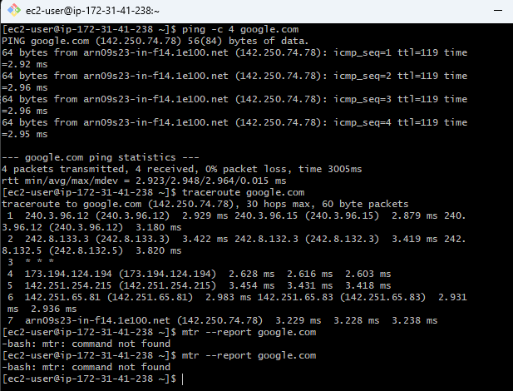

## Task 2.2 – Check Open Ports & Listening Services

Command(s):

sudo netstat -tuln  
sudo ss -tulwn

Explanation:

Lists all currently open and listening TCP/UDP ports and the services bound to them.

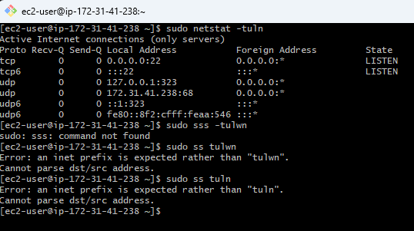

## Task 2.3 – Test Remote Port Connectivity

Command(s):

telnet google.com 443  
nc -zv google.com 443

Explanation:

Checks if port 443 on google.com is reachable using telnet or netcat.

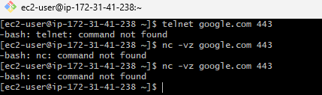

## Task 2.4 – Check Network Interfaces

Command(s):

ifconfig  
ip addr

Explanation:

Displays detailed network interface configuration and IP address assignments.

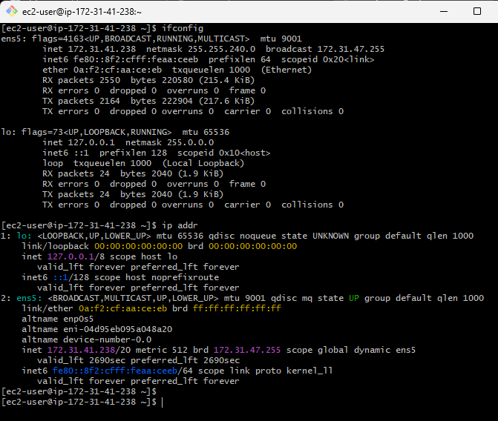

## Task 2.5 – DNS Lookup

Command(s):

nslookup google.com  
dig google.com

Explanation:

Performs DNS queries to retrieve domain information like IP addresses and response times.

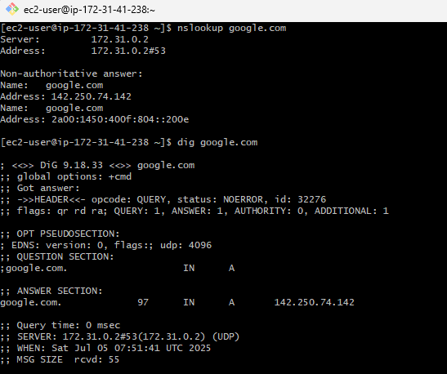

## Task 2.6 – Download Test File

Command(s):

wget https://example.com/testfile.txt  
curl -O https://example.com/testfile.txt

Explanation:

Downloads a test file from the internet using wget or curl for connectivity testing.

This command didn’t work because there wasn’t a static page with textfile availabel

## Task 2.7 – Monitor Bandwidth in Real Time

Command(s):

sudo iftop -i eth0  
sudo nload eth0

Explanation:

Monitors live network bandwidth usage on the specified network interface (eth0).

This command also didn’t work as I didn’t have an eth interface

# Part 3: Compression & Decompression

## Task 3.1 – Archive Directory

Command(s):

tar cvf network_data.tar /opt/network_data

Explanation:

Creates a tar archive file of the network_data directory.

## Task 3.2 – Compress Archive

Command(s):

gzip network_data.tar

Explanation:

Compresses the tar archive file using gzip format.

## Task 3.3 – Decompress Archive

Command(s):

gunzip network_data.tar.gz

Explanation:

Decompresses the gzip file to retrieve the original tar archive.

## Task 3.4 – Use bzip2 Compression

Command(s):

bzip2 network_data.tar  
bunzip2 network_data.tar.bz2

Explanation:

Compresses and decompresses files using bzip2, offering better compression than gzip.

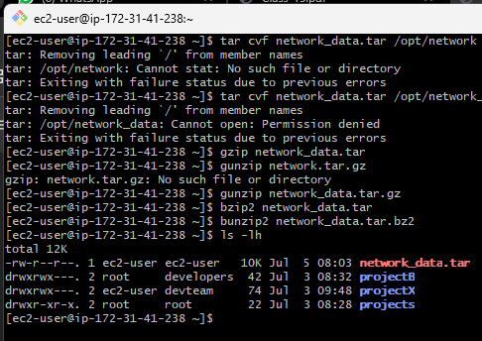

# Part 4: Text Processing with grep & awk

## Task 4.1 – Search for 'error' in Log Files

Command(s):

grep "error" /var/log/syslog

Explanation:

Searches the system log file for lines containing the word 'error'.

## Task 4.2 – Count Number of Errors

Command(s):

grep -c "error" /var/log/syslog

Explanation:

Counts how many lines contain the word 'error' in the log file.

## Task 4.3 – Extract Specific Fields from Error Logs

Command(s):

grep "error" /var/log/syslog | awk '{print $1, $2, $3, $5}'

Explanation:

Extracts timestamp and service name fields from error log entries.

## Task 4.4 – Filter and Summarize Unique Error Sources

Command(s):

grep "error" /var/log/syslog | awk '{print $5}' | sort | uniq -c | sort -nr

Explanation:

Summarizes how many times each service has reported errors by counting unique sources.