北京邮电大学2008——2009学年第一学期
《操作系统》期末考试试题（A）

考试注意事项 | 一、学生参加考试须带学生证或学院证明，未带者不准进入考场。学生必须按照监考教师指定座位就坐。  二、书本、参考资料、书包等物品一律放到考场指定位置。  三、学生不得另行携带、使用稿纸，要遵守《北京邮电大学考场规则》，有考场违纪或作弊行为者，按相应规定严肃处理。  四、学生必须将答题内容做在试题答卷上，做在草稿纸上一律无效。  五、学生的姓名、班级、学号、班内序号等信息由教材中心统一印制。  六、第1题须用英文应答，中文答对得一半分。
考试  课程 |  | 操作系统 |  |  | 考试时间 |  | 2009 年1 月6 日
题号 |  | 一 | 二 | 三 | 四 | 五 | 六 | 七 | 八 | 总分
满分 |  | 10 | 10 | 20 | 10 | 20 | 15 | 15
得分
阅卷
教师

- FILL IN BLANKS (10 points)
1.1 A _trap___ is a software-generated interrupt caused either by an error or by a specific request from a user program that an operating-system services be performed.
1.2 A ______ is used in Unix systems to notify a process that a particular event has occurred.
1.3 To manage the process executing, OS records the state and other information (e.g. the priority) of the process in .
1.4 The scheduling criteria include CPU utilization, throughput, turnaround time, waiting time, and response time .
1.5 For n concurrent processes that mutual exclusively use some resources, the code segmentations, in which the processes access the resources, are called deadlock .
1.6. The ___visual memory___ scheme enables users to run programs that are larger than actual physical memory, this allows the execution of a process that is not completely in memory.
1.7. The __FIFO___ page replacement algorithm associates with each page the time when that page was brought into memory. When a page must be replaced, the oldest page is chosen.
  - The file system resides permanently on , which is designed to hold a large amount of data permanently.
  - The file system itself is generally composed of many different levels, including the logical file system, the file-organization module, the
and the I/O control.
1.10 The kernel’s I/O subsystem provides numerous services. Among these are I/O scheduling, , caching, spooling, device reservation, and error handling, and name translation.

- CHOICE ( 10 points )
2.1 _____ operating systems have well defined, fixed time constraints. Processing must be done within the defined constrains, or the system will fail.
A. Multimedia B. Real-time C. Clustered D. Network

2.2 Which one of the following OS is implemented based on microkernel structure? _____
A. Ms-DOS B. UNIX C. Mach D. Linux

  - Considering m processes, which mutual exclusively use the resource type A of n instances (m>n). A semaphore S is designed to synchronize these processes. The maximum and minimal values are respectively.
A. n, -m + n B. m, -m + n C. m, n D. n, -m

  - Here are some statements about processes and threads,
i）The thread is the basic unit of memory allocation for program execution in computer systems.
ii) For process state transitions, the migration from waiting to running is impossible
iii) When CPU switch from process to process, the contents of CPU registers are not saved in PCB
iv) An I/O-bound process spends more of its time doing I/O operation than it spends doing computation.
, the correct descriptions are :
A. i), ii) B. ii), iv)
C. i), iii) D. iii), iv)

  - With respect to the following descriptions about CPU scheduling,
i) the Round Robin scheduling is fit for the interactive systems.
ii) with respect to the throughput for a given set of processes, SJF is optimal.
iii) the preemptive priority algorithm is starvation-free, guaranteeing that no process waits indefinitely for service.
iv) medium-term scheduling is responsible for process swapping.

, the wrong statements are
A. i), ii) B. iii), iv)
C. i), iv) D. ii), iii)

  - Considering the following statements,
i) the Banker Algorithm is used for deadlock prevention, applicable to the systems with multiple instances of each resources.
ii) the monitor is the high-level construct for process synchronization, and is characterized by shared variables and a set of programmer-defined operations on the shared variables.
iii) the current value of a counting semaphore S is -3, then there are 3 process waiting in the queue relevant to S.
iv) denying the mutual-exclusion condition is a good choice for deadlock prevention.

, the correct descriptions are :
A. i), ii) , iv) B. ii), iii), iv)
C. ii), iii) D. i), iii)

2.7 There are many solutions to satisfy a request of size n from a list of free holes. One way is _____. It allocates the first hole that is big enough. Searching can start either at the beginning of the set of holes or where the previous search ended.
A. best fit B. worst fit C. last fit D. first fit

2.8 Which of the following structures is in memory_____
A. The boot control block B. The per file FCB
C. The system open-file table D. The directory structure per file system

2.9 Which of the following operations does not deal with the data block of a file? _____
A. read B. write C. close D. delete

2.10 I/O Buffering is used for the following reason except_______
A. cope with a speed mismatch between the producer and consumer of a data stream.
B. adapt between devices that have different data-transfer size.
C. support copy semantics for application I/O.
D. improve the transfer rate of I/O devices.

- ESSAY QUESTIONS (20 points)
3.1 List the five basic functions of OS. (5 points)

3.2 Consider the following page table： (5 points)
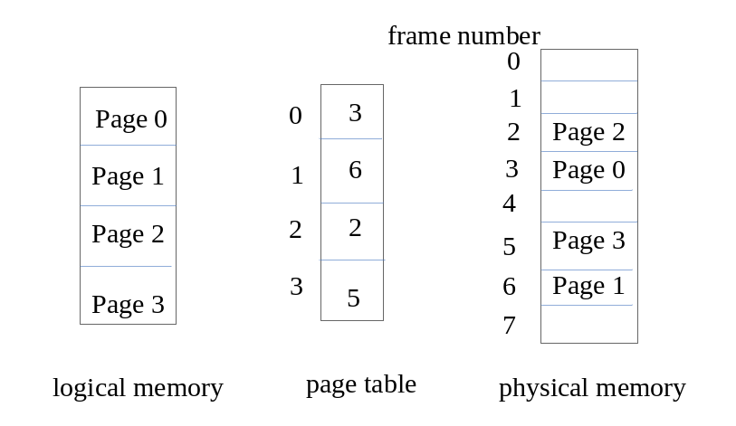
The page size is 1024 bytes. What are the physical addresses for the following logical addresses?
(1) 230 (2) 4094

3.3 Consider a paging system with the page table stored in memory.
a. If a memory reference takes 500 time unit, how long does it take to access an instruction or data in a page that has been paged into memory?
b. If we add TLB (translation look-aside buffers), and 70 percent of all page-table entries can be found in the TLB, what is the effective memory access time?
(Assume that finding a page-table entry in the associative registers takes 20 time unit, if the entry is there.) (5 points)

3.4 According to the following figure, answer the following questions:
(1) How many blocks are there in the file test?
(2) How to access the 100th byte in block 2 (A logical block number is an index relative to the beginning of the file, so the first logical block is block 0)?
(5 points)

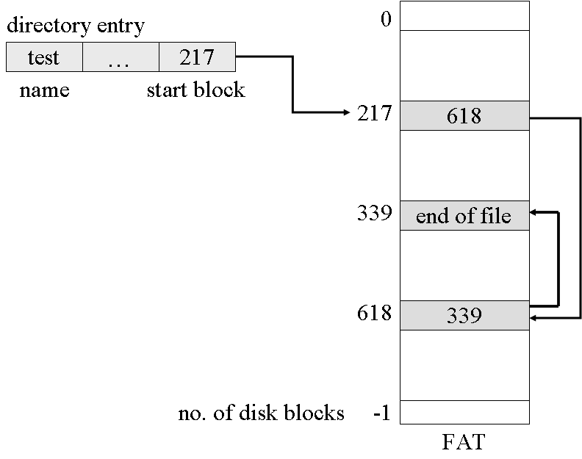

4. Consider the following page-reference string:
    - 2，3，6，4，7，3，2，1，4，7，5，6，5，2，1
How many page faults would occur for the LRU replacement algorithms，assuming that there are four frames available for each process in the system, and all frames are initially empty. (10 Points)

5. In a computer system, the users submit to the system their computational tasks as jobs, and all these jobs are then stored as the standby jobs on the disk.

The job scheduler selects standby jobs on the disk, creates new processes in memory for them, and then starts executing these processes. Each job’s ID is the same as that of the process created for it, for example, J_{i} and P_{i}.

When the number of concurrent processes in memory is lower than three, the job scheduler takes the FCFS algorithm to select a standby job on the disk to create a new process. Otherwise, the processes should wait in the disk.

For the processes in memory, the process scheduler takes the non-preemptive priority-based algorithm to select a process and allocates the CPU to it.

It is assumed the system costs resulting from job and process scheduling are omitted.

Consider the following set of Jobs J₁, J₂, J₃ , J₄ and J₅. For 1≤ i ≤5, the arrival time of each J_{i} , the length of the CPU burst time of each process P_{i}, and the priority number for each J_{i}/P_{i} are given as below, and a smaller priority number implies a higher priority.

Job Arrival Time Burst Time Priority Number

(minute)

J₁ 14:00 40 4

J₂ 14:20 30.01 2

J₃ 14:30 50.01 3

J₄ 14:50 20.01 5

J₅ 15:05 10.01 5

- Illustrate the execution of each job/process by charts.
- What is the turnaround time of each job?
- What is the waiting time of each job?

Note: The waiting time of a job includes the time it waits on the disk and that it waits in memory.
(20 Points)

6. As illustrated in the figure, on two sides of a one-plank bridge(独木桥), there are two groups of soldiers that are composed of m and n people respectively need to cross the bridge, but the narrow bridge allows only one group of the soldiers in the same direction to cross at the same time. One group of the soldiers is permitted to cross as long as there are no people on the bridge. Once one group of the soldiers begins walking on the bridge, the other group should be waiting to start crossing until all members of the first group have passed the bridge.
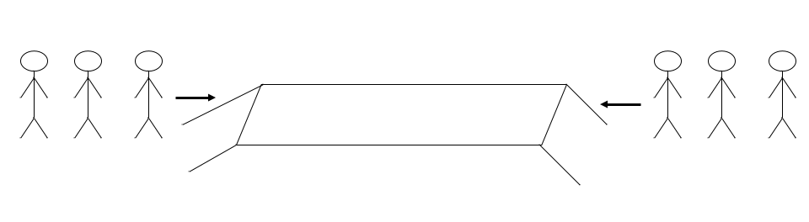
Please design two semaphore-based processes to describe the crossing actions of the soldiers in the two groups. It is required
(1) to define the semaphores and variables needed, explain their roles?, and give their initial values; and
(2) to illustrate the structures of processes for the soldiers in each group.
(15 Points)

7. Consider the following snapshot of a system
 | Allocation |  |  | Max |  |  | Need |  |  | Available
 | R₁ | R₂ | R₃ | R₁ | R₂ | R₃ | R₁ | R₂ | R₃ | R₁ | R₂ | R₃
P₁ | 1 | 0 | 0 | 3 | 2 | 2 |  |  |  | 2 | 1 | 2
P₂ | 4 | 1 | 1 | 6 | 1 | 3
P₃ | 2 | 1 | 1 | 3 | 1 | 4
P₄ | 0 | 0 | 2 | 4 | 2 | 2

(1) Fill in the contents of the matrix Need for each process in the space above.
(2) Is the system in a safe state? If it is safe, give the safe sequence.
(3) If both P₁ and P₂ make resource requests of <1, 0, 1>, how should we grant the requests while keeping the system in a safe state?
(15 Points)

