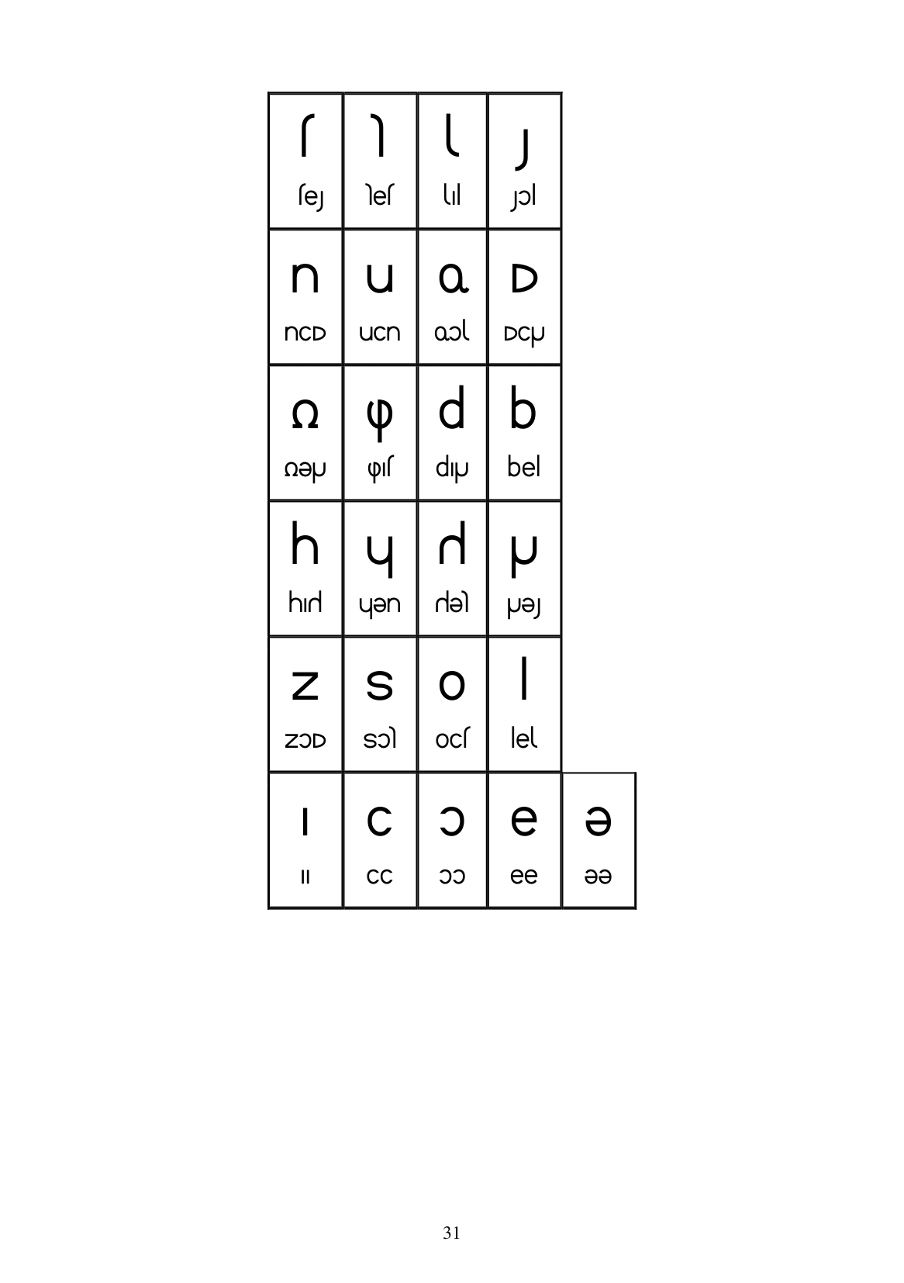

sh

se || Nes || || || Jol U O. D nCD | uCn | Qol | DCU a p d QepJ (pls dip

հ | Կ | Ր | Խ his Uen sle Ue Zso Z3D | S3) || Ocs │ │lel C O CC O3)

31