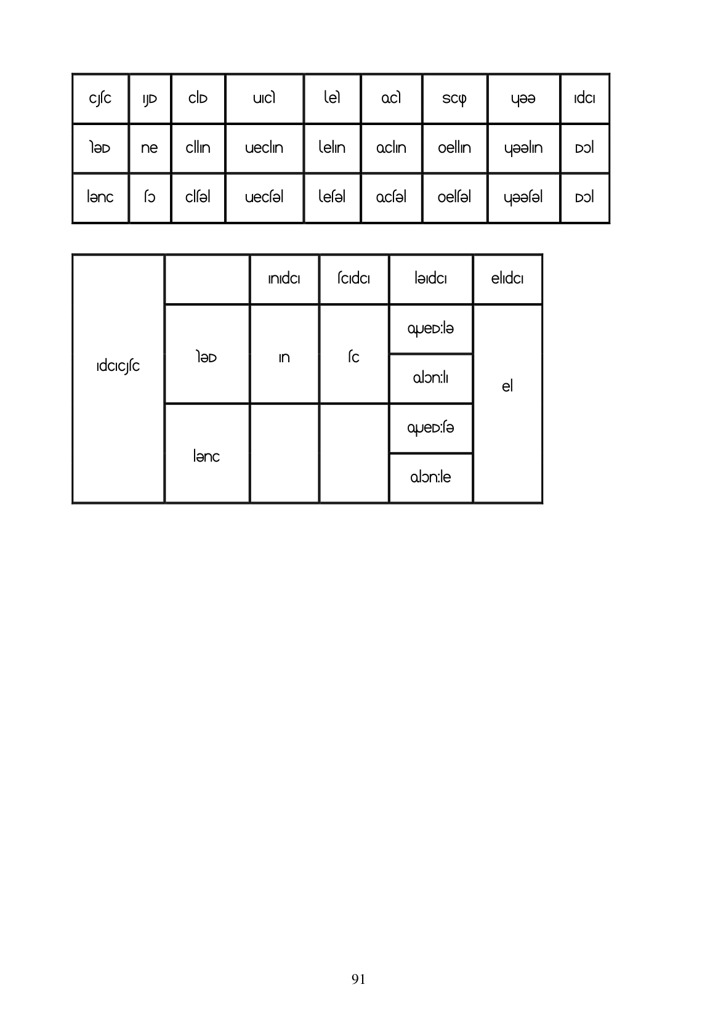

| |ndo | co | iodo eido

leD In sc IdcICjíc lenc

**91**