Create and Configure Cognito:

Create Pool, name it my-users-pool.

Create App client, name it my-users-pool-clients.

Write down the pool name, pool Id, client name and app clients id.

Notes

\* Enable MFA if needed.

\* You can use the trigger for more security

\* For development we will let user register themselves, on production you might restrict registration by the administrators only (on Policies -> check "Only allow administrators to create users").

\* If MFA enabled, a Role to allow Amazon Cognito to send SMS messages must be created.

Open Cognito from the Security, Identity, & Compliance group in AWS console

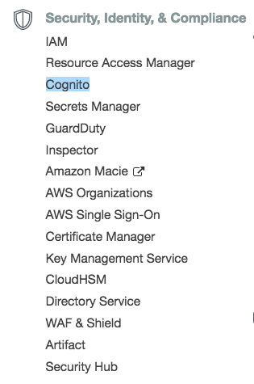

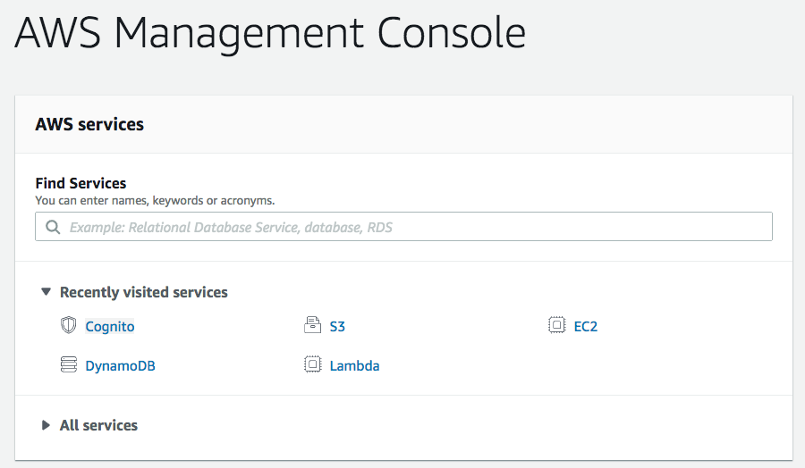

Select Manage User Pools

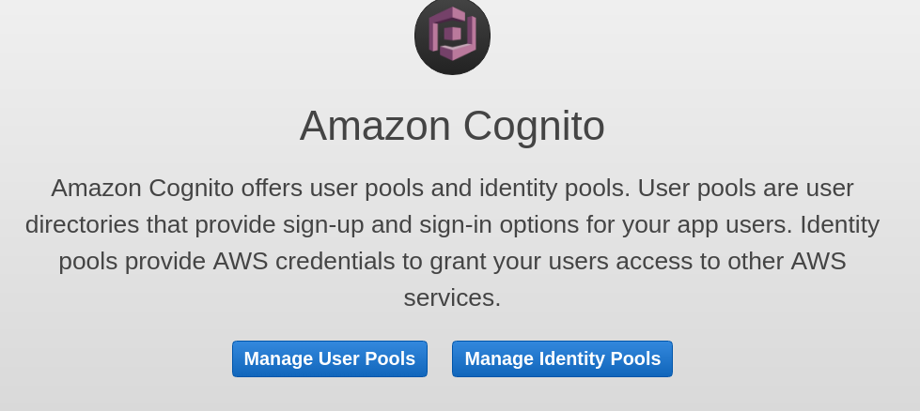

Select Create a user pool

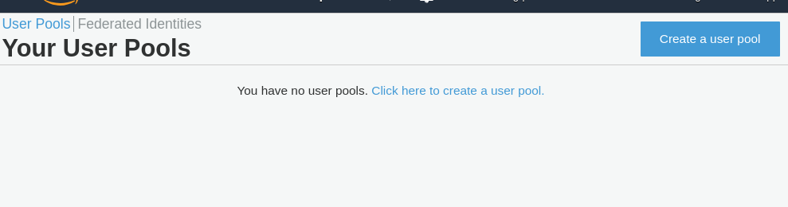Name the user poo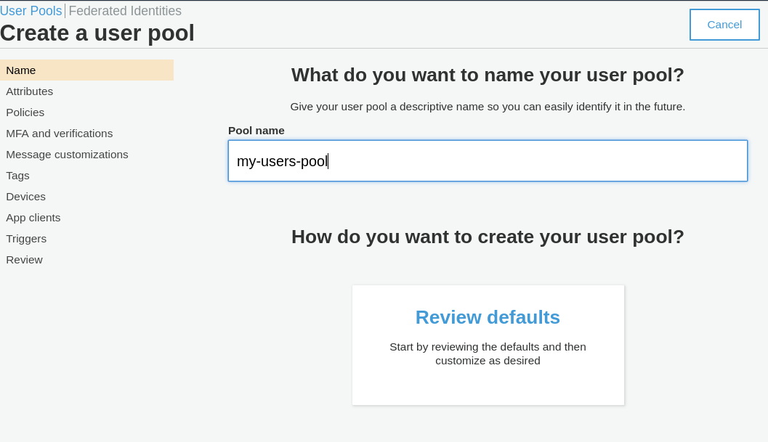l and review defaults

Choose the password strength desired and other sign in behavior.

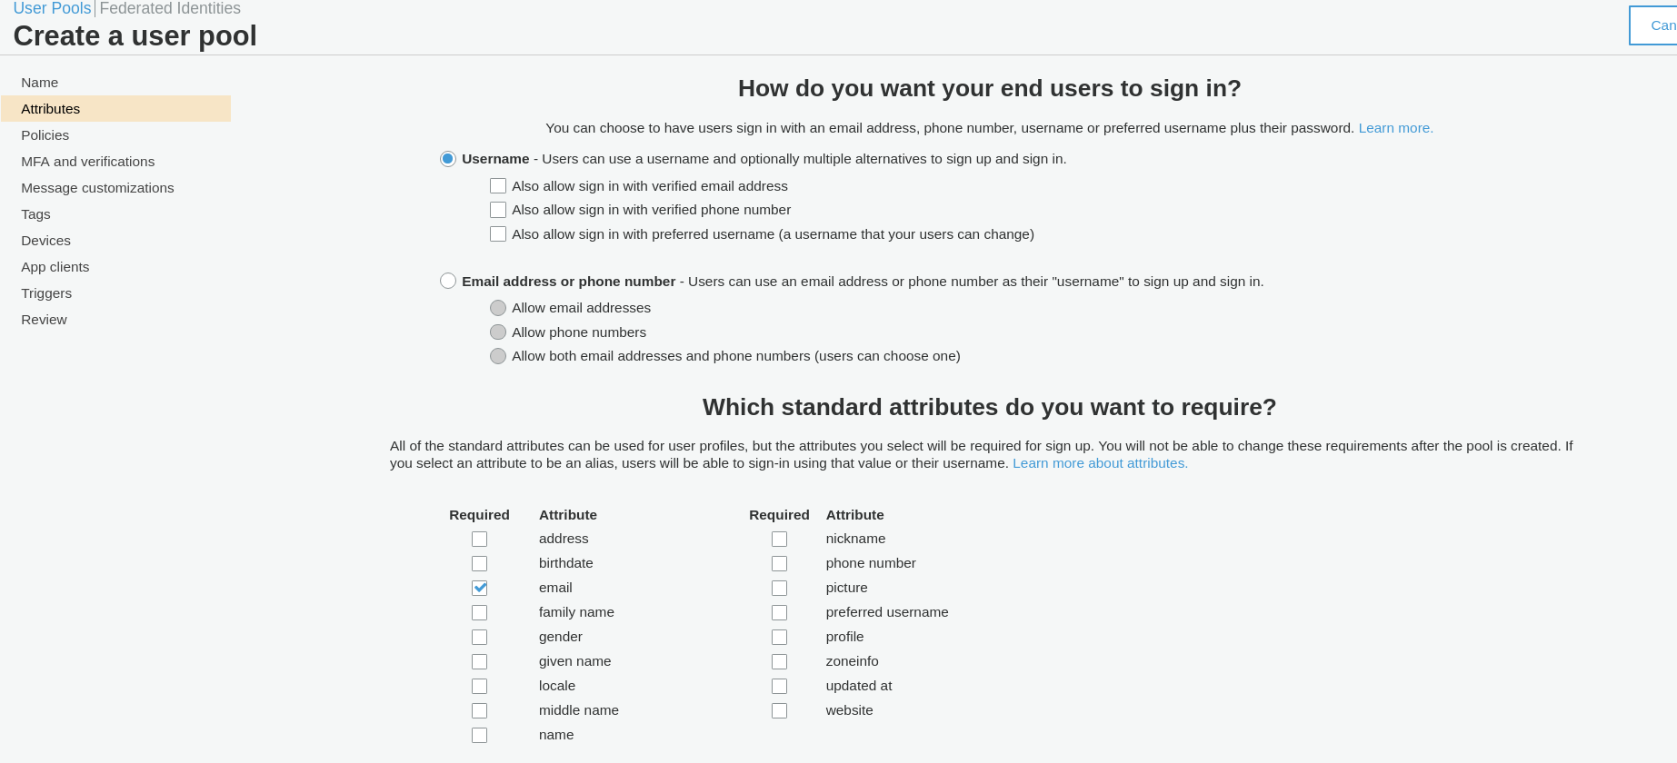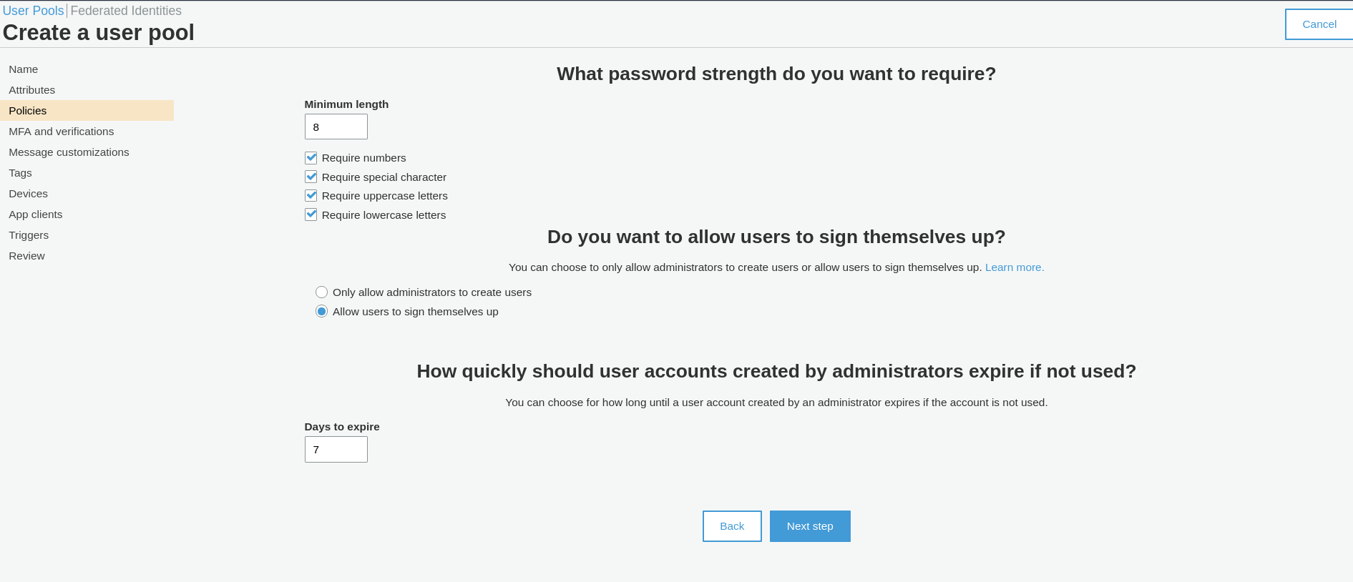Select Username to sign in with an email and select email attribute checkbox.

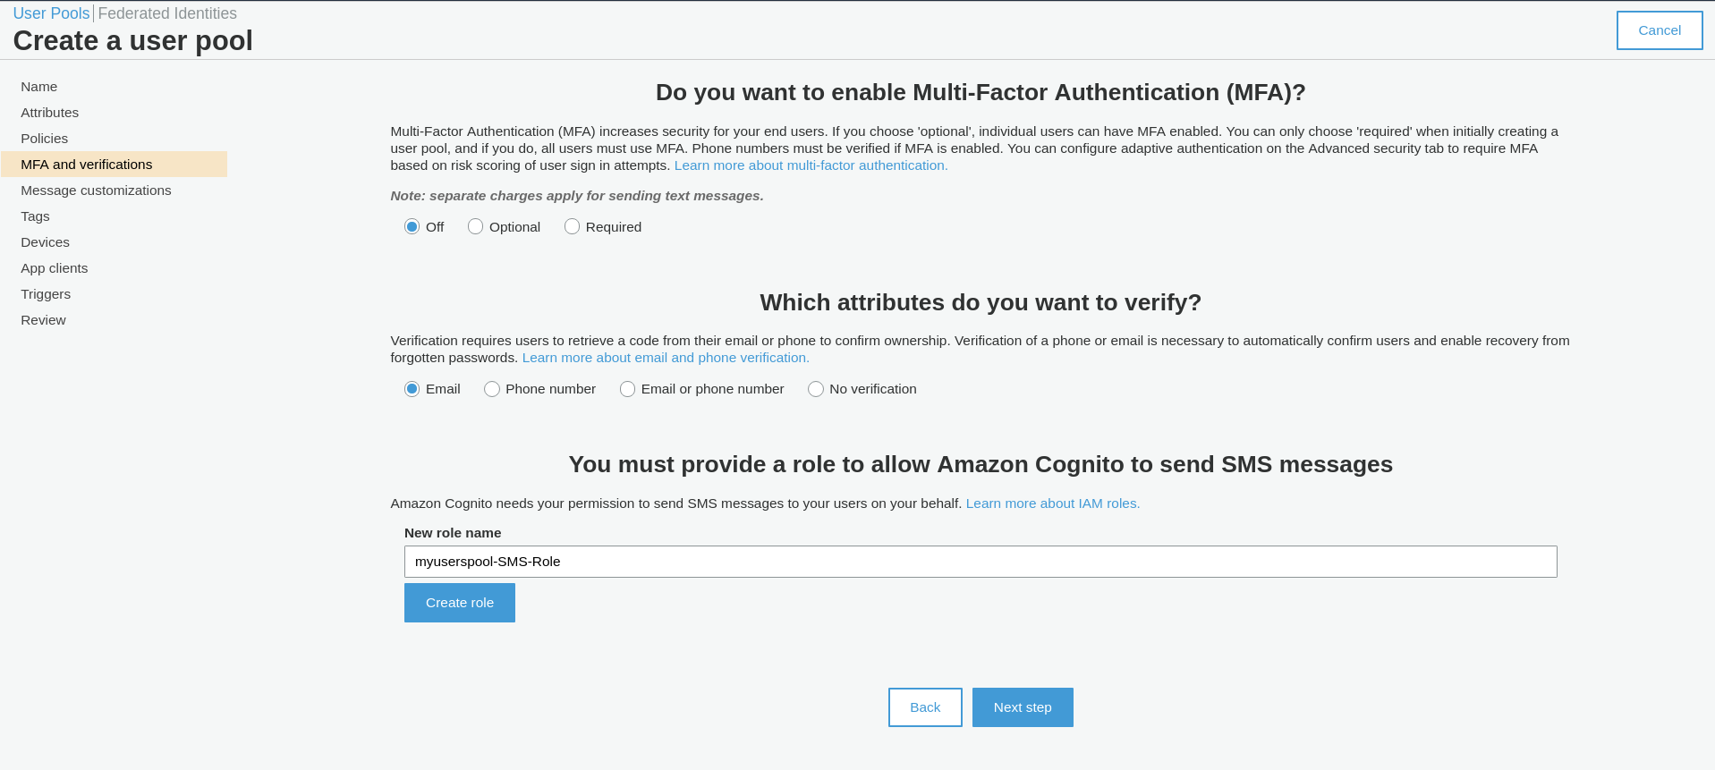Turn MFA off (optional) and select email for verification.

Review default and create the pool. Take a note of the Pool Id and Pool ARN which will be

required later. Also, note the region that your User Pool is created in.

Select App clients from the left panel,

Select Add an app client,

Enter App client name,

Un-select Generate client secret,

Select Create app client.

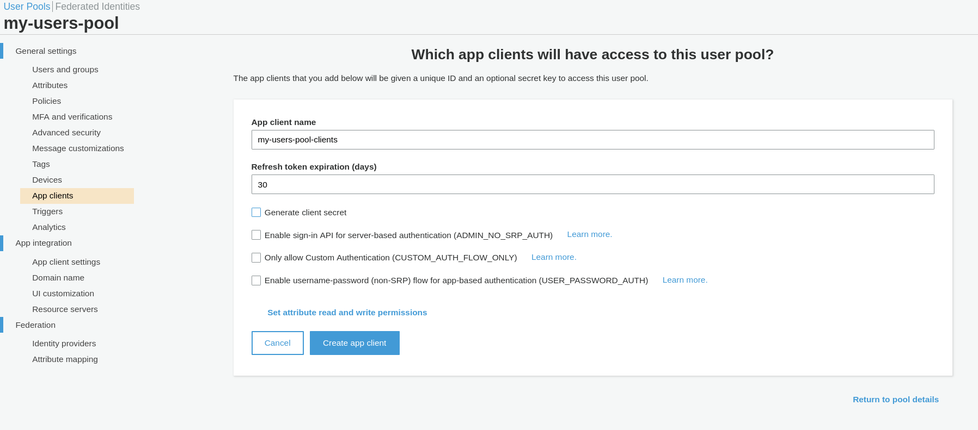

Take note of the App client id.