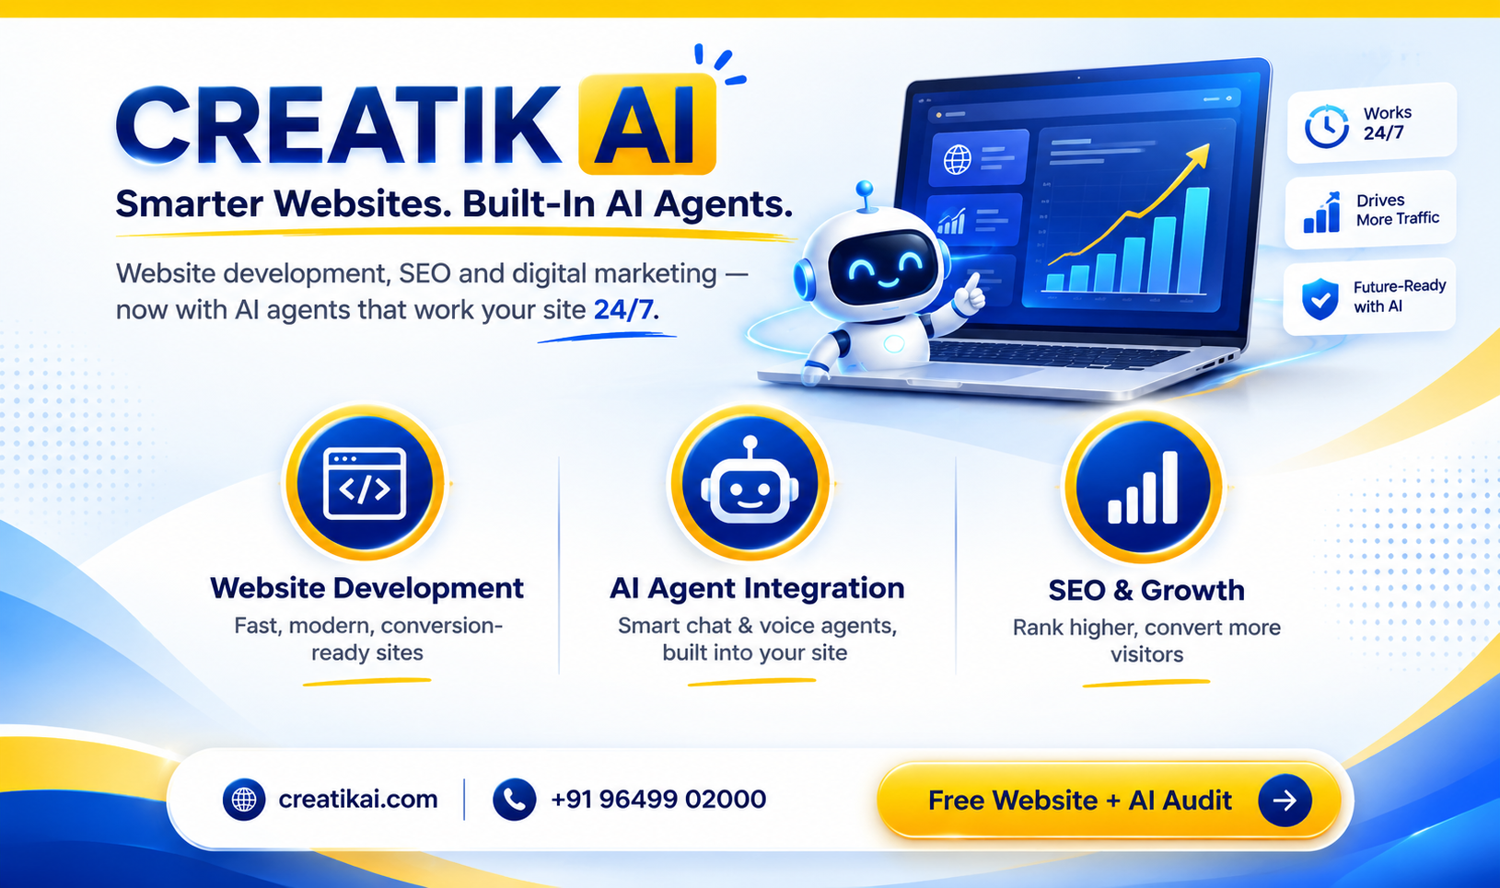
Hello [Customer Name ] Team,
We reviewed [URL ] to understand how effectively your current digital presence supports your [CustomerType ] and customer acquisition.
From the analysis, your website currently shows [OverallWebsiteScore]/100. We noticed several areas that could potentially strengthen your online presence and business-development journey.
Website Performance Snapshot
- Design: [DesignScore]/100
- Mobile Experience: [MobileScore]/100
- SEO: [SEOScore]/100
- Lead Generation: [LeadGenerationScore]/100
- AI & Automation: [AIAutomationScore]/100
- Overall: [OverallWebsiteScore]/100
The main opportunities we identified are [LackingWebDevelopment ], and [LackingSEO ]. For a business operating in [CustomerType ], improving these areas could help create a stronger journey from website visitors to make the website more conversion-focused and strengthen local search visibility .
At Creatikai, we can help with website optimization, local SEO, conversion-focused service pages, lead-generation systems, WhatsApp automation and AI-powered enquiry/lead-qualification agents.
There may also be an opportunity to create additional commercial value through [MonetizeArea ]. [improvementArea ]. These improvements could help make the website a more effective channel for [qualified enquiries / customer acquisition / bookings / sales / repeat business / lead nurturing].
We would be happy to share a practical improvement plan for [Business Name] based on the opportunities identified in the analysis.
Would you be open to a short discussion?
Best regards,
Creatikai Team
AI • Web • Digital Growth • Automation
https://creatikai.com

