

**Course Code: CSE214**

**Course Name: Algorithm Lab**

**Submitted To**

**SUBROTO NAG PINKU**

**Department of CSE Daffodil International University**

**Submitted By**

**Name: Faraz Ahmed**

**Id: 191-15-12948**

**Sec: 0-14**

**Full Tree Traversal**

Linear data structure like array, linked list has only one logical traversal method. Trees can be traversed in different ways. Following are the generally used ways for traversing trees.

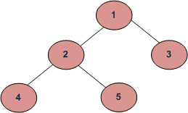

DFS Traversals:  
(a) Inorder (Left, Root, Right) : 4 2 5 1 3  
(b) Preorder (Root, Left, Right) : 1 2 4 5 3  
(c) Postorder (Left, Right, Root) : 4 5 2 3 1

BFS Traversal: 1 2 3 4 5

#include <iostream>

#include <stdlib.h>

using namespace std;

struct node { int data; struct node *left;

struct node *right;

};

struct node *newNode(int data) { struct node *temp = (struct node *) malloc(sizeof(struct node));

temp -> data = data; temp -> left = NULL; temp -> right = NULL;

return temp;

};

void insert_node(struct node *root, int n1, int n2, char lr) {

if(root == NULL) return;

if(root -> data == n1)

{

switch(lr) {

case 'l' :root -> left = newNode(n2);

break;

case 'r' : root -> right = newNode(n2);

break;

}

}

else {

insert_node(root -> left, n1, n2, lr);

insert_node(root -> right, n1, n2, lr);

}

}

void inorder(struct node *root) {

if(root == NULL)

return;

inorder(root -> left);

cout << root -> data << " ";

inorder(root -> right);

}

void preorder(struct node *root) { i

f(root == NULL)

return;

cout << root -> data << " ";

preorder(root -> left);

preorder(root -> right);

}

void postorder(struct node *root) {

if(root == NULL)

return;

postorder(root -> left);

postorder(root -> right);

cout << root -> data << " ";

}

int main()

{

struct node *root = NULL;

int n;

cout <<"\nEnter the number of edges : ";

cin >> n;

cout << "\nInput the nodes of the binary tree in order \n\nparent-childleft(or)right-\n\n";

while(n--) {

char lr;

int n1,n2;

cin >> n1 >> n2;

cin >>lr;

if(root == NULL)

{

root = newNode(n1);

switch(lr)

{ case 'l' :root -> left = newNode(n2);

break;

case 'r' : root -> right = newNode(n2);

break;

}

}

else

{

insert_node(root,n1,n2,lr);

}

}

cout <<"\nInorder Traversal : ";

inorder(root);

cout << endl;

cout <<"\nPreorder Traversal : ";

preorder(root);

cout << endl;

cout <<"\nPostorder Traversal : ";

postorder(root);

cout << endl;

return 0;

}

**Time Complexity:**O(n).

**Auxiliary Space:**If we don’t consider size of stack for function calls then O(1) otherwise O(n).

**Strongly Connected Components**

A directed graph is strongly connected if there is a path between all pairs of vertices. A strongly connected component (SCC) of a directed graph is a maximal strongly connected subgraph. For example, there are 3 SCCs in the following graph**.**

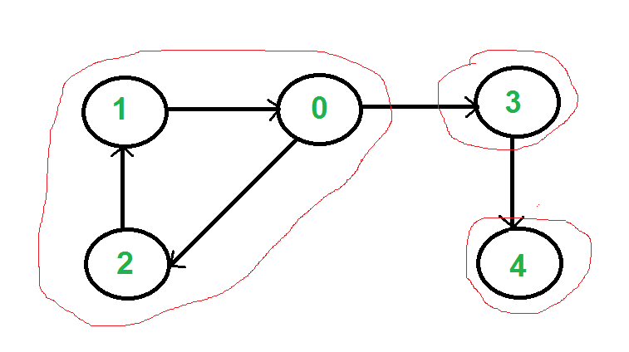

We can find all strongly connected components in O(V+E) time using Kosaraju’s algorithm. Following is detailed Kosaraju’s algorithm. 1) Create an empty stack ‘S’ and do DFS traversal of a graph. In DFS traversal, after calling recursive DFS for adjacent vertices of a vertex, push the vertex to stack. In the above graph, if we start DFS from vertex 0, weget vertices in stack as 1, 2, 4, 3, 0. 2) Reverse directions of all arcs to obtain the transpose graph. 3) One by one pop a vertex from S while S is not empty. Let the popped vertex be ‘v’. Take v as source and do DFS (call DFSUtil(v)). The DFS starting from v prints strongly connected component of v. In the above example, we process vertices in order 0, 3, 4, 2, 1 (One by one popped from stack). How does this work? The above algorithm is DFS based. It does DFS two times. DFS of a graph produces a single tree if all vertices are reachable from the DFS starting point. Otherwise DFS produces a forest. So DFS of a graph with only one SCC always produces a tree. The important point to note is DFS may produce a tree or a forest when there are more than one SCCs depending upon the chosen starting point. For example, in the above diagram, if we start DFS from vertices 0 or 1 or 2, we get a tree as output. And if we start from 3 or 4, we get a forest. To find and print all SCCs, we would want to start DFS from vertex 4 (which is a sink vertex), then move to 3 which is sink in the remaining set (set excluding 4) and finally any of the remaining vertices (0, 1, 2). So how do we find this sequence of picking vertices as starting points of DFS? Unfortunately, there is no direct way for getting this sequence. However, if we do a DFS of graph and store vertices according to their finish times, we make sure that the finish time of a vertex that connects to other SCCs (other that its own SCC), will always be greater than finish time of vertices in the other SCC (See this for proof). For example, in DFS of above example graph, finish time of 0 is always greater than 3 and 4 (irrespective of the sequence of vertices considered for DFS). And finish time of 3 is always greater than 4. DFS doesn’t guarantee about other vertices, for example finish times of 1 and 2 may be smaller or greater than 3 and 4 depending upon the sequence of vertices considered for DFS. So to use this property, we do DFS traversal of complete graph and push every finished vertex to a stack. In stack, 3 always appears after 4, and 0 appear after both 3 and 4. In the next step, we reverse the graph. Consider the graph of SCCs. In the reversed graph, the edges that connect two components are reversed. So the SCC {0, 1, 2} becomes sink and the SCC {4} becomes source. As discussed above, in stack, we always have 0 before 3 and 4. So if we do a DFS of the reversed graph using sequence of vertices in stack, we process vertices from sink to source (in reversed graph). That is what we wanted to

Articulation points or cut vertices in a graph

A vertex in an undirected connected graph is an articulation point or cut vertex if and only if removing it, and the edges connected to it, splits the graph into multiple components.

Hint: Apply Depth First Search on a graph. • Construct the DFS tree. • A node which is visited earlier is a "parent" of those nodes which are reached by it and visited later. • If any child of a node does not have a path to any of the ancestors of its parent, it means that removing this node would make this child disjoint from the graph. This means that this node is an articulation point. • There is an exception: the root of the tree. If it has more than one child, then it is an articulation point, otherwise not. Now for a child, this path to the ancestors of the node would be through a back-edge from it or from any of its children.

Complexity • Worst case time complexity: Θ(V+E) •

Average case time complexity: Θ(V+E) •

Best case time complexity: Θ(V+E) • Space complexity: Θ(V)

Topological sorting

Topological sorting of vertices of a Directed Acyclic Graph is an ordering of the vertices v1,v2,...vn

in such a way, that if there is an edge directed towards vertex vj from vertex vi, then vi comes before vj.

For example consider the graph given below:

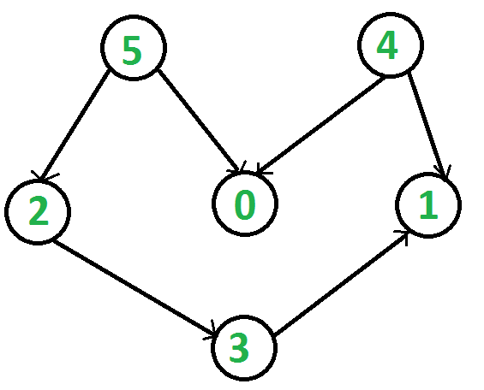

A topological sorting of this graph is: 1 2 3 4 5 There are multiple topological sorting possible for a graph. For the graph given above one another topological sorting is: 1 2 3 5 4 In order to have a topological sorting the graph must not contain any cycles. Inorder to prove it, let's assume there is a cycle made of the vertices v1,v2,v3...vn. That means there is a directed edge between vi and vi+1 (1≤i<n) and between vn and v1. So now, if we do topological sorting then vn must come before v1 because of the directed edge from vn to v1. Clearly, vi+1 will come after vi, because of the directed from vi to vi+1, that means v1 must come before vn. Well, clearly we've reached a contradiction, here. So topological sorting can be achieved for only directed and acyclic graphs.

Le'ts see how we can find a topological sorting in a graph. So basically we want to find a permutation of the vertices in which for every vertex vi, all the vertices vj having edges coming out and directed towards vi comes before vi. We'll maintain an array T that will denote our topological sorting. So, let's say for a graph having N vertices, we have an array in_degree[] of size N whose ith element tells the number of vertices which are not already inserted in T and there is an edge from them incident on vertex numbered i. We'll append vertices vi to the array T, and when we do that we'll decrease the value of in_degree[vj] by 1 for every edge from vi to vj. Doing this will mean that we have inserted one vertex having edge directed towards vj. So at any point we can insert only those vertices for which the value of in_degree[] is 0.