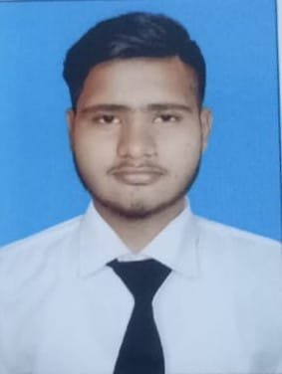

Faraz Alam
 +92 312 8738672
 alamfaraz141@gmail.com
As a passionate and ambitious individual with a keen interest in front-end web development, I bring a fresh perspective and a hunger to learn and grow in the dynamic world of coding. Although I may not have formal experience, my dedication to staying updated with the latest technologies and my commitment to mastering HTML, CSS, and JavaScript positions me as a promising front-end developer.

Experience
Frelance WEB DEVELOPER |Self Emploid

- Collaborated with clients to understand their requirements and developed custom websites tailored to their needs.

- Utilized HTML, CSS, and JavaScript to create responsive and visually appealing user interfaces.

- Implemented best practices for web development, including cross-browser compatibility and mobile responsiveness.

- Integrated third-party APIs to enhance website functionality and user experience.

Hobbies
- Coding challenge
- Open source contribution
- Blogging
- Learning new technologies
- Digital art creativity

Highlights
- Results-oriented
- Revenue generation
- Business development
- Effective marketing
- Organisational capacity
- Operability and commitment
- Ability to motivate staff and maintain good relations
- Resistance to stress
- Good manners
- Project management
- Strong decision maker
- Complex problem solver
- Creative design
- Innovative

Education
- MATRICULATION
In science group year 2018-20
- INTERMEDIAT
In pre-engineering 2020-22

