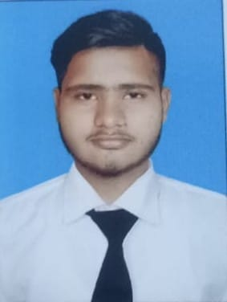

### Experience

Frelance WEB DEVELOPER |Self Emploid

* Collaborated with clients to understand their requirements and developed custom websites tailored to their needs.
* Utilized HTML, CSS, and JavaScript to create responsive and visually appealing user interfaces.
* Implemented best practices for web development, including cross-browser compatibility and mobile responsiveness.
* Integrated third-party APIs to enhance website functionality and user experience.

### Hobbies

* Coding challenge
* Open source contribution
* Blogging
* Learning new technologies
* Digital art creativity

As a passionate and ambitious individual with a keen interest in front-end web development, I bring a fresh perspective and a hunger to learn and grow in the dynamic world of coding. Although I may not have formal experience, my dedication to staying updated with the latest technologies and my commitment to mastering HTML, CSS, and JavaScript positions me as a promising front-end developer.

Faraz Alam

 +92 312 8738672

 alamfaraz141@gmail.com

### Highlights

* Results-oriented
* Revenue generation
* Business development
* Effective marketing
* Organisational capacity
* Operability and commitment
* Ability to motivate staff and maintain good relations
* Resistance to stress
* Good manners
* Project management
* Strong decision maker
* Complex problem solver
* Creative design
* Innovative

### Education

* **MATRICULATION**

In science group year 2018-20

* **INTERMEDIAT**

In pre-engineering 2020-22