# Question 1:

## Parts a, b:

# Question 2:

## Part a:

# Question 3:

## Part 0:

## Part 1:

* Sub Part 1:

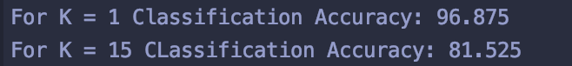

* Sub Part 2:
  + In case of ties, I have used the rounded mean of the results

* Sub Part 3:
  + After running 10-fold cross validation we get 96.44 for K =1 as the maximum accuracy

## Part 2:

* Please review q3_2and3.ipynb for implementations
* All models have been tuned by different hyperparameters and have been 10-fold cross validated

## Part 3:

Please review the same notebook for implementation details.

* MLP classifier report:

* SVM classifier report:

* AdaBoost classifier report:

* KNN classifier report:

* ROC curve digit-wise

