Performance and Efficiency Trade-offs in Deep Learning Architectures for Sugarcane Disease Detection

Faraz Ahmed
Department of Computer Science
Christ Deemed to be University
Bangalore, INDIA
xav3170@gmail.com

Varuna Gupta
Department of Computer Science
Christ Deemed to be University
Bangalore, INDIA
varunagupta.cs@gmail.com

Kamal Upreti
Department of Computer Science
Christ Deemed to be University
Bangalore, INDIA
kamalupreti1989@gmail.com

Abstract— Early and accurate detection of sugarcane leaf diseases is crucial for enhancing the productivity of crop and precision agriculture. This research compares the performance of six deep learning architectures namely Custom CNN, VGG16, ResNet50, MobileNetV2, MobileNetV3 and EfficientNet-B0 for multiclass classification of sugarcane leaf diseases. All models were trained in a common experimental framework, including five architectures that were trained using transfer learning with the ImageNet dataset, and a Custom CNN that was trained from scratch. The results were evaluated using Accuracy, Precision, Recall, F1-score, ROC-AUC, confusion matrices and computational efficiency metrics such as the number of parameters, GFLOPs, and inference latency. The experimental results indicate that in general, the transfer learning models have performed better than training the custom CNN, with the VGG16 model achieving the highest classification accuracy of 98.24%, the highest weighted F1-score of 98.24% and the highest macro-average AUC of 0.9997. EfficientNet-B0 and ResNet50 exhibited similar predictive accuracy, with EfficientNet-B0 being a good tradeoff between computational complexity and classification accuracy and MobileNetV3 being a light-weight option for deployment on resource-limited systems. The outcomes underscore the need to choose architectures that not only perform well in prediction but also meet the computational demands, offering valuable insights for creating AI-driven sugarcane disease diagnosis systems for real-world precision agriculture scenarios.
Keywords—Sugarcane Leaf Disease, Deep Learning, Transfer Learning, Convolutional Neural Network, Precision Agriculture, Plant Disease Classification.
- INTRODUCTION
Sugarcane is one of the most important commercial crops in the world and has a major contribution in sugar production, production of biofuels, and in the agriculture economy of many countries. It is however, highly susceptible to leaf diseases (Red Rot and Yellow Leaf Disease) which cause considerable economic losses and reduce the productivity of the crop and also affect the quality of the sugar. Thus early detection of disease is essential for timely action and successful crop management. Traditional disease diagnosis is mainly based on visual inspection by the agricultural experts. This is a common practice, but is time-consuming, subjective and not easily scalable to large plantations. Moreover, the fact that symptoms can be similar in the early stages of infection can lead to inconsistent diagnosis, delaying treatment and facilitating the spread of the disease, which has led to the development of automated disease detection systems based on computer vision and artificial intelligence. In recent years, the accuracy of plant disease classification has been greatly improved with the development of deep learning, especially convolutional neural networks (CNNs). This has been further sped up by the use of transfer learning, which allows pretrained models to adapt to agricultural datasets with few annotated images. The architectures like VGG16, ResNet50, MobileNet and EfficientNet-B0 have achieved remarkable results for different plant disease recognition problems because of their outstanding feature extraction ability and computational efficiency. While these advances have been made, there remain a number of research challenges. Previous research typically focuses on a small number of architectures and mainly on the predictive accuracy, with computational efficiency and feasibility of deployment given relatively less attention. In addition, limited comparisons of heavy weight and lightweight transfer learning models can be found in the same experimental conditions, which makes it hard to determine which one is best suited for practical precision agriculture applications. To overcome these shortcomings, the study compares and evaluates six architectures of deep learning for multiclass classification of sugarcane leaf diseases: Custom CNN, VGG16, ResNet50, MobileNetV2, MobileNetV3, and EfficientNet-B0. The experimental setup is the same for all models, including data splitting, training algorithms, and evaluation process, although some preprocessing is done according to the architecture. The accuracy, precision, recall, F1-score, ROC-AUC, and confusion matrix are used for assessing the performance, and the parameter count, GFLOPs, and inference latency are used for analyzing the computational efficiency. This work has the following main contributions:
- A detailed comparison of 6 deep learning architectures (both heavyweight and lightweight) for the classification of sugarcane leaf diseases.
- Confusion matrices for investigation of model behavior.
- The analysis and evaluation of the computational efficiency using various quantitative metrics.
- Suggestions on choosing appropriate deep learning architectures to be practically applied in precision agriculture.
This paper continues in the following manner. The related literature is reviewed in Section II. The methodology proposed is discussed in Section III. The experimental results and discussion are given in Section IV. Lastly, Section V concludes the paper and outlines future research directions.
- LITERATURE REVIEW
The early efforts on automatic plant disease detection were based on image processing and handcrafted features, and then pattern-recognition or machine-learning techniques [1]. These methods worked well under laboratory conditions where lighting, leaf angle, background complexity were controlled, but were not robust to lighting changes, leaf angle and complex backgrounds and were not suitable for real agricultural conditions [2]. The limitations led to the adoption of more advanced deep learning techniques for plant disease detection. Automated plant disease diagnosis has been greatly improved by the introduction of deep convolutional neural networks (CNNs) that learn hierarchical features directly from images. Krizhevsky et al. [3] showed that deep convolutional neural networks (DCNNs) are successful in large-scale image classification and that CNNs are a useful method for image-based recognition tasks. Mohanty et al. [4] attained 99.35% accuracy on PlantVillage dataset, and Ferentinos [5] also showed the efficacy of deep CNNs with a larger dataset with 58 disease classes. These studies have shown that CNNs are the most popular technique for plant disease classification and have consistently outperformed traditional machine learning techniques when enough training data is available.
However, because of the lack of annotated datasets for crop diseases, transfer learning has become a popular method for agricultural image classification. It is common to fine-tune an ImageNet-pretrained model to obtain high classification accuracy with fewer data and training time [6]. According to Kamilaris and Prenafeta-Boldú [7] the most frequently used architectures in most deep learning studies in agriculture are VGG16 and ResNet. Cassava disease detection using field-acquired images was proven to be effective by Ramcharan et al. [8] and could be applicable for mobile deployment. Picon et al. [9] further investigated crop disease classification using images captured by mobile devices and demonstrated the feasibility of disease detection under field conditions. Additionally, Barbedo [10] highlighted several factors that influence the effectiveness of deep learning for plant disease recognition, including dataset characteristics, image background, and the challenges associated with realistic field conditions.
In recent years, many efforts have been focused on creating lightweight deep learning architectures for mobile and edge devices. To reduce the computational cost without sacrificing performance, MobileNet adopted depthwise separable convolutions [11]. To make it more efficient to compute, MobileNetV2 introduced inverted residual blocks and linear bottlenecks [12] and MobileNetV3 even made it more efficient by applying neural architecture search and light-weight design [13]. EfficientNet proposed compound scaling to scale the depth, width and input resolution of the network together to find a better balance between accuracy and network efficiency [14]. Das et al. [15] applied transfer learning and ensemble-based classification for sugarcane leaf disease detection and Mauya et al. [16] proposed a multiscale attention-based architecture to enhance the classification of diseases and the resistance to domain variability. Pugazhendi et al. [17] on the other hand enhanced the predictability of the field by introducing an uncertainty-aware MobileNetV3 framework.
Although tremendous strides have been made with deep learning and transfer learning, there are still some research gaps. The majority of the current research focuses on a small subset of architectures and mostly on accuracy of prediction. There are very few comparative studies done between heavy weight and lightweight models using similar experimental settings along with computational efficiency measures such as complexity of the model and inference time.
To address these limitations, this paper provides a comparison of six deep learning architectures: a custom CNN, VGG16, ResNet50, MobileNetV2, MobileNetV3 and EfficientNet-B0 with the same experimental setup. The proposed evaluation takes into account not only the predictive performance but also the computational efficiency, in order to give practical guidance for deployment-oriented applications in precision agriculture.
- METHODOLOGY
3.1 Dataset and Preprocessing
The experiments were carried out using a publicly available dataset on Kaggle for sugarcane leaf disease with 1493 RGB images of three classes: Healthy (470), RedRot (518), and Yellow (505). The dataset was divided into training, validation, and test subsets using an approximately 70:15:15 split, resulting in 1044, 222, and 227 images respectively. The images were resized to 224 × 224 pixels and loaded with the TensorFlow's ImageDataGenerator. Data augmentation was only performed on the training set, such as random rotation, horizontal flipping, width shifting, height shifting, shear transformation and zooming, to enhance the generalization of the model. The images were not altered, as they were used to test the performance of the models on unseen images for both validation and testing. Since the input requirements varied across the different pre-trained architectures, different pre-processing functions were used for each architecture, while the custom CNN applied pixel-value normalization.

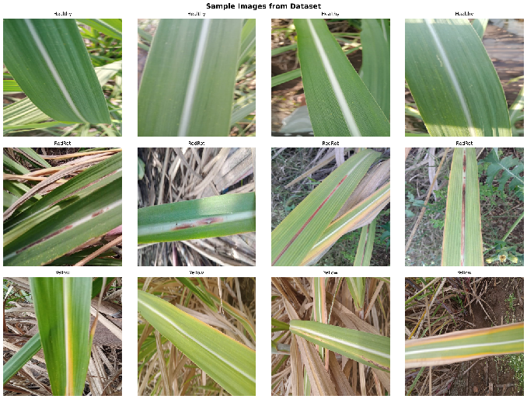

Fig. 1. Representative sugarcane leaf images from the Healthy, RedRot, and Yellow classes.

  - Proposed Framework
The overall flow of the proposed methodology is shown in Fig. 2. The framework begins with the sugarcane leaf dataset which is split into training, validation and testing sets. Then, image resizing and label encoding are applied, and data augmentation is only applied to the training subset. The model is then trained after an architecture-specific preprocessing. Then, six deep learning architectures, which include a custom CNN and five ImageNet-pretrained transfer learning models (VGG16, ResNet50, MobileNetV2, MobileNetV3 and EfficientNet-B0) are developed. The pretrained models are fine-tuned in two steps, the custom CNN is trained from scratch. Finally, all models are tested with classification and computational efficiency metrics and the performance of the models is comparatively analyzed to find the most appropriate model architecture for the classification of sugarcane leaf disease.

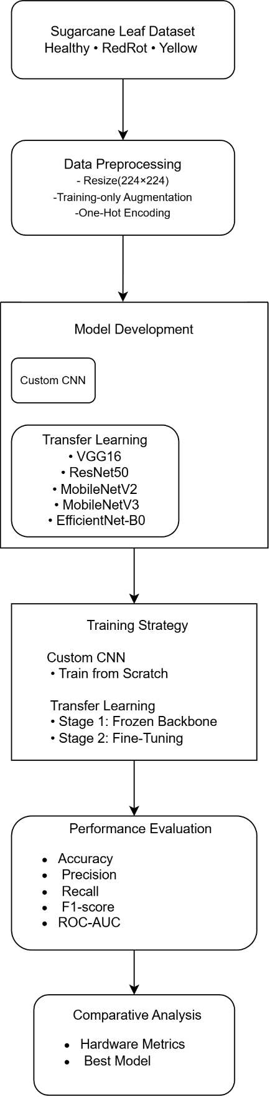
Fig. 2. Proposed framework for sugarcane leaf disease classification using six deep learning architectures.

3.3 Deep Learning Architectures
In order to practically deploy the CNN in agriculture, six CNN architectures were chosen that represent both conventional deep networks and lightweight networks. The models evaluated are a Custom CNN, VGG16, ResNet50, MobileNetV2, MobileNetV3 and EfficientNet-B0. The classification head for all the pretrained models consisted of the global average pooling, fully connected layers, dropout regularization, and a three class softmax output layer. The main features of the architectures studied are given in Table I.
Table I. Summary of Evaluated Deep Learning Architectures
Model | Backbone | Key Characteristic | Fine-Tuned Layers
Custom CNN | Custom | Four convolutional blocks trained from scratch | All layers
VGG16 | ImageNet | Sequential deep CNN | Last 4 layers
ResNet50 | ImageNet | Residual learning | Last 10 layers
MobileNetV2 | ImageNet | Lightweight depthwise separable CNN | Last 20 layers
MobileNetV3 | ImageNet | NAS-based lightweight architecture with SE modules | Last 20 layers
EfficientNet-B0 | ImageNet | Compound scaling for parameter efficiency | Last 20 layers

The architectures selected are very different, ranging from the classic deep CNN to the lightweight architectures which are computationally efficient. This enables comparison of the predictive accuracy and deployment efficiency in detail and allows experiments to be conducted under the same conditions.

3.4 Training Strategy
The Adam optimizer and categorical cross-entropy loss were used to train all models with a batch size of 32. The custom CNN was trained from scratch for 40 epochs while the pretrained CNN architectures used a two-stage transfer learning approach. During the first phase, the convolutional backbone was frozen and only the newly added classifier was trained. The final backbone layers were then selectively unfrozen and fine-tuned in the second stage, with a lower learning rate to fine-tune the learned representations for the sugarcane disease classification. To avoid overfitting and enhance the convergence of the training process, the following techniques were employed: Early Stopping, ReduceLROnPlateau and Model Checkpointing. The best model that had the best validation accuracy was restored for final evaluation. A fixed random seed (42) was used to improve the experimental reproducibility. The summary of the complete training configuration is shown in Table II.
Table II. Training Configuration
Parameter | Value
Optimizer | Adam
Learning Rate (Stage 1) | 0.001
Learning Rate (Stage 2) | 0.0001
Batch Size | 32
Training Epochs | 40 (10 + 30)
Loss Function | Categorical Cross-Entropy
Early Stopping | Enabled
ReduceLROnPlateau | Enabled
Model Checkpoint | Best Validation Accuracy
Random Seed | 42
Hardware Platform | Google Colab (NVIDIA T4 GPU)

3.5 Evaluation Metrics
In addition to classification accuracy, the number of model parameters, approximate GFLOPs, and mean single-image inference latency on an NVIDIA Tesla T4 GPU were used to assess computational efficiency. A batch size of one was used for latency measurement. All models had a warm-up run of 50 inferences, followed by 200 inference runs for latency measurement under the same conditions. The entire measurement process was repeated five times and the five repetition means were averaged to report the final inference latency. Reported latency represents the steady-state inference time of the model, excluding overhead from image acquisition, file I/O, and network communication. These metrics provide a fair comparison of the predictive performance and computational requirements, and enable the assessment of each architecture for practical application in precision agriculture.
- RESULTS AND ANALYSIS
Classification accuracy, Precision, Recall, F1-score, ROC-AUC, confusion matrices and computational efficiency were applied to evaluate the performance of the six deep learning architectures evaluated. The training and testing conditions were kept the same for all models for a fair comparison.

4.1 Performance Comparison
Table III. Performance Comparison of the Evaluated Deep Learning Models
Model | Accuracy (%) | Precision (%) | Recall (%) | F1 Score (%) | Macro- AUC
Custom CNN | 69.60 | 75.56 | 69.60 | 69.44 | 0.9290
VGG16 | 98.24 | 98.26 | 98.24 | 98.24 | 0.9997
ResNet50 | 97.36 | 97.41 | 97.36 | 97.36 | 0.9990
MobileNetV2 | 91.19 | 91.28 | 91.19 | 91.22 | 0.9880
MobileNetV3 | 92.07 | 93.57 | 92.07 | 92.22 | 0.9950
EfficientNet-B0 | 97.80 | 97.80 | 97.80 | 97.79 | 0.9990
Note: Precision, Recall, and F1-score are reported using weighted averaging.

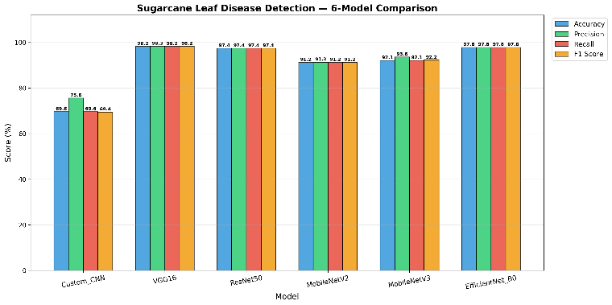
Fig. 3. Comparative performance of the evaluated deep learning models using accuracy, precision, recall, and F1-score.

The results are compared with the results obtained by training a CNN from scratch, showing the clear advantage of transfer learning. The custom CNN yielded the poorest results with accuracy of 69.60% and macro-AUC of 0.9290, suggesting that the model may not be capturing all the features from the provided data set. Among the pretrained models, VGG16 had the best classification performance with an accuracy of 98.24%, weighted F1 score of 98.24% and macro-average AUC of 0.9997. EfficientNet-B0 and ResNet50 performed close to each other with a slight decrease in accuracy, whereas the performance of MobileNetV3 and MobileNetV2 was competitive with significantly reduced computational complexity.
4.2 Training Convergence Analysis
Figures 4 and 5 present the validation accuracy and validation loss curves of the evaluated deep learning models during training.

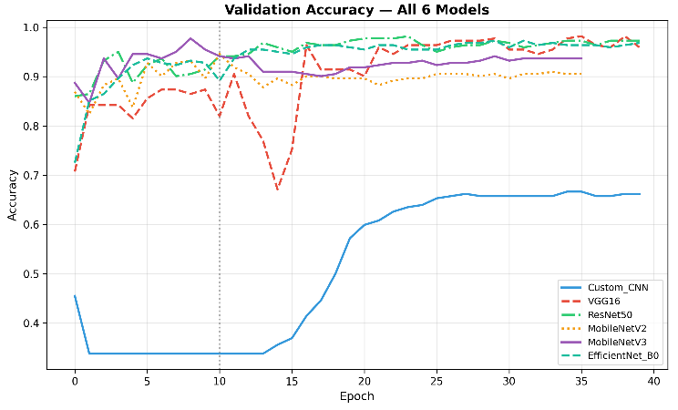
Fig. 4. Validation accuracy curves of the evaluated deep learning models during training.

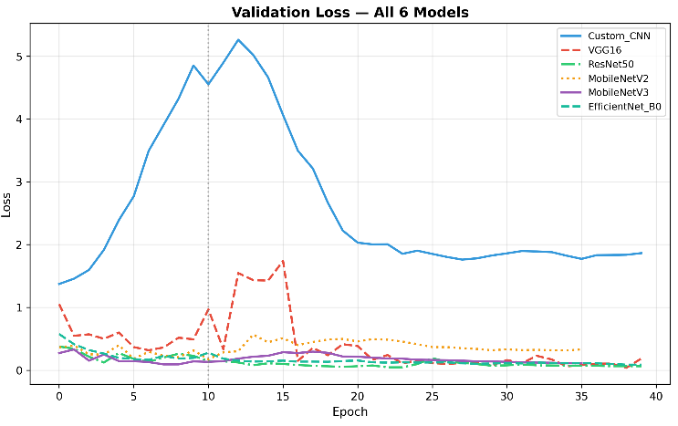
Fig. 5. Validation loss curves of the evaluated deep learning models during training.

The curves of validation accuracy and validation loss of the models evaluated are shown in figures 4 and 5 respectively. The pretrained architectures were able to converge rapidly and exhibited stable learning behavior, with consistent validation accuracy and low validation loss, and little signs of overfitting. The custom CNN converged at a slower pace and achieved a lower performance when compared to the other models, with VGG16, EfficientNet-B0 and ResNet50 converging the most consistently. The validation accuracy curve and loss curve are very close, suggesting that the training strategy used was effective in reducing overfitting.
4.3 ROC-AUC Analysis
In order to evaluate the discriminative performance of the models evaluated, the traditional classification metrics were complemented with Receiver Operating Characteristic (ROC) analysis. The ROC curves of all the deep learning architectures tested with the test set are presented in Figure 6.
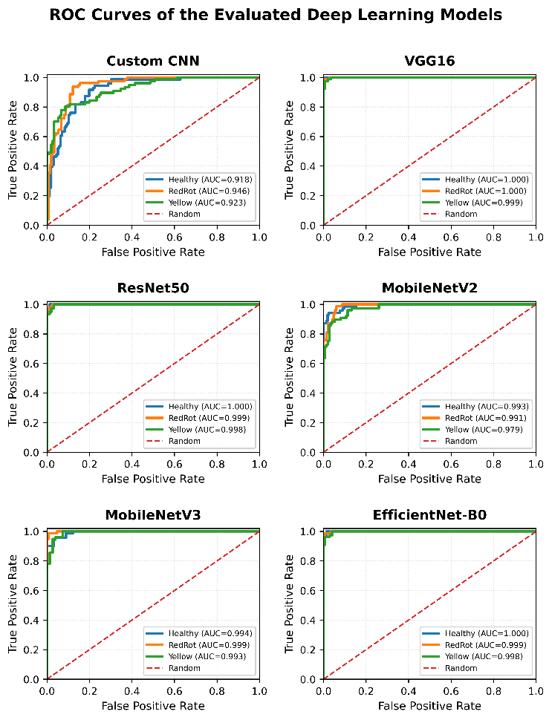

Fig. 6. ROC curves of the evaluated deep learning models on the testdataset.
The transfer learning architectures performed very well in terms of classification, with macro-average AUC ranging from 0.9880 to 0.9997. VGG16 had the best macro-average AUC of 0.9997, EfficientNet-B0 and ResNet50 had an AUC of 0.9990, which showed very good discrimination between the Healthy, RedRot and Yellow leaf classes. Macro-average AUC values for MobileNetV3 and MobileNetV2 were 0.9950 and 0.9880, respectively. The custom CNN, on the other hand, had the lowest macro-average AUC of 0.9290, further emphasizing the benefits of transfer learning for sugarcane leaf disease classification. The results show that the pretrained architectures were capable of providing better class separability than the CNN trained from scratch on the evaluated test set.

4.4 Confusion Matrix Analysis
The confusion matrices for the three models with the highest accuracy are shown in Figures 7 - 9. In all three models, most test samples were correctly classified with only a few misclassified samples occurring between disease classes that are visually similar, especially Yellow and RedRot in early disease stages.
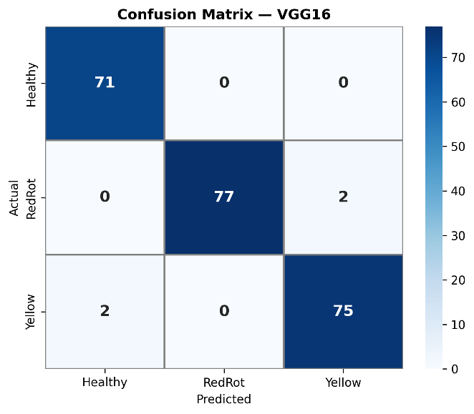

Fig. 7. Confusion matrix of the VGG16 model on the test dataset.

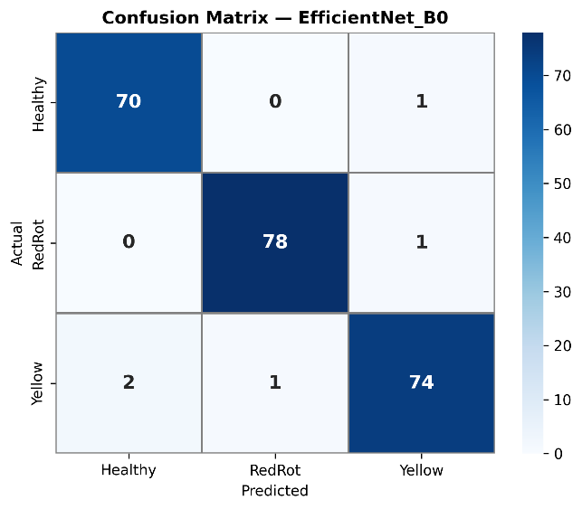
Fig. 8. Confusion matrix of the EfficientNet-B0 model on the test
Dataset

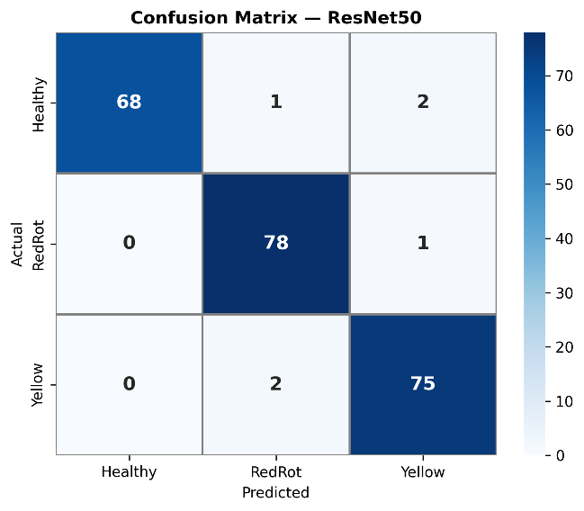
Fig. 9. Confusion matrix of the ResNet50 model on the test dataset.

VGG16 had the least classification errors followed closely by EfficientNet-B0 and ResNet50, which also had high classification consistency. The results indicate that the transfer learning models were able to learn discriminative disease-specific features and were able to give reliable multiclass classification performance.
4.5 Computational Efficiency and Deployment Analysis
Computational efficiency is an important consideration for deploying deep learning models in real-world agricultural scenarios, in addition to classification performance. Thus, the evaluated architectures were compared with regard to model size, computational complexity (GFLOPs), and measured latency for single-image inference. These metrics provide complementary information about the trade-off between predictive performance and computational cost. The models evaluated are summarized by their computational characteristics and are shown in Figs. 10-12.
Table IV. Computational Efficiency Comparison of the Evaluated Models
Model | Parameters (M) | GFLOPs | Inference Latency (ms)
Custom CNN | 0.46 | 1.49 | 2.203
VGG16 | 15.11 | 30.71 | 8.548
ResNet50 | 24.77 | 7.75 | 10.561
MobileNetV2 | 3.05 | 0.61 | 6.212
MobileNetV3 | 3.62 | 0.44 | 7.238
EfficientNet-B0 | 4.84 | 0.39 | 8.849

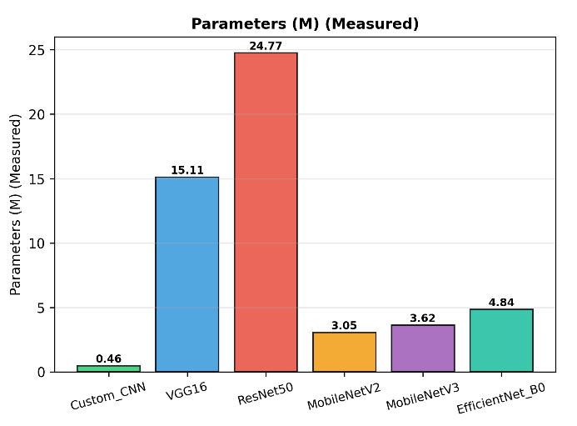
Fig. 10. Comparison of the number of parameters of the evaluated deep learning models.

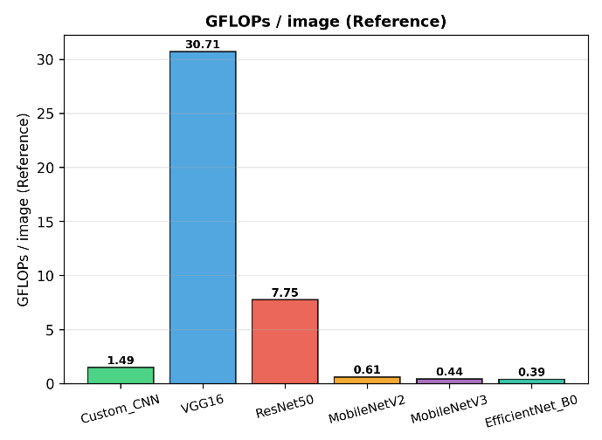
Fig. 11. Comparison of computational complexity (GFLOPs per input image) of the evaluated deep learning models.

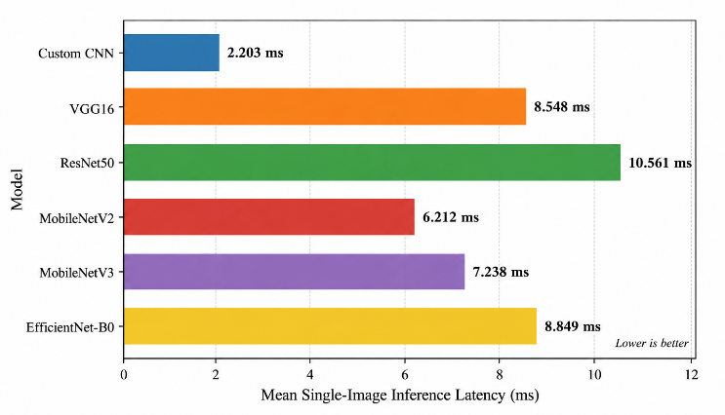

Fig. 12. Mean single-image inference latency of the evaluated deep learning models on an NVIDIA Tesla T4 GPU

Although VGG16 performed best in terms of predictive accuracy (98.24%), it is also crucial for practical use to consider the computational efficiency. The mobile architectures, MobileNetV2 and MobileNetV3, needed significantly fewer parameters and GFLOPs, and were able to attain accuracies of 91.19% and 92.07%, respectively. The model EfficientNet-B0 offered a good balance of predictive accuracy and model size, with 97.80% accuracy and just 4.84 million parameters and 0.39 GFLOPs per image. The results show that lightweight architectures can substantially reduce computational requirements while maintaining competitive classification performance.
The measured inference latency on the NVIDIA Tesla T4 GPU also shows that there are differences in runtime efficiency between the architectures. VGG16, EfficientNet-B0 and ResNet50 had mean single-image latencies of 8.548 ms, 8.849 ms and 10.561 ms, respectively. These measurements show that the theoretical computational complexity and the measured runtime latency do not necessarily follow the same ranking on a GPU, and thus, the deployment suitability of a system should be judged based on both GFLOPs and empirical inference latency.
VGG16 achieves the best classification accuracy while EfficientNet-B0 has a good classification accuracy-to-computational complexity ratio. Compared to MobileNetV2, MobileNetV3 is also competitive in terms of light weight, with higher classification accuracy and lower GFLOPs, but with slightly higher number of parameters and higher measured inference latency.
Table V. Overall Comparison and Deployment Characteristics of the Evaluated Models
Model | Remarks
VGG16 | Highest classification performance
EfficientNet-B0 | Favorable balance between accuracy and computational complexity
ResNet50 | High classification performance with higher computational cost
MobileNetV3 | Lightweight alternative with higher accuracy than MobileNetV2
MobileNetV2 | Lightweight architecture with low latency
Custom CNN | Baseline trained from scratch with lowest accuracy
- CONCLUSION
A relatively balanced dataset of three sugarcane leaf classes (Healthy, RedRot, and Yellow) was used in this study to compare six deep learning architectures for automated sugarcane leaf disease classification. A custom convolutional neural network (CNN) and five ImageNet-pretrained transfer learning models-VGG16, ResNet50, MobileNetV2, MobileNetV3, and EfficientNet-B0 were trained and evaluated under the same experimental framework, using consistent data splitting and architecture-specific preprocessing where required.
Experimental results showed that the transfer learning models generally performed better than the CNN trained from scratch. VGG16 demonstrated the best classification accuracy (98.24%), weighted F1 score (98.24%) and macro-average AUC (0.9997), showing strong discriminative performance for all three disease classes. EfficientNet-B0 and ResNet50 also performed well in terms of classification accuracy, at 97.80% and 97.36%, respectively. In comparison, MobileNetV2 and MobileNetV3 had accuracies of 91.19% and 92.07%, respectively, and needed significantly fewer parameters and GFLOPs compared to the larger conventional architectures.
The computational analysis also showed that the selection of the model is dependent on the deployment scenario that is intended. Custom CNN's single-image inference latency was the lowest measured at 2.203 ms, whereas MobileNetV2 and MobileNetV3 had latencies of 6.212 ms and 7.238 ms respectively. EfficientNet-B0 offered a good tradeoff between accuracy and computational complexity, with 97.80% accuracy, 4.84 million parameters and 0.39 GFLOPs per image. The results show that theoretical computational complexity is not always the same as runtime latency, and thus both should be taken into account when choosing a model for practical application.
In general, the findings showed that the pretrained deep learning architectures have great potential in the field of automated sugarcane leaf disease classification and the need to choose an architecture based on the needs of the application. VGG16 is better for high classification accuracy, EfficientNet-B0 for a good balance of accuracy and complexity, and MobileNet for resource-limited applications.
However, this study has a number of limitations. The experiments were performed with a single publicly available dataset that includes three disease classes, so the generalization to different real-world agricultural settings is yet to be proven. In future work, the models will be evaluated on larger and multi-source field datasets, including additional sugarcane diseases, to assess their generalization in diverse agricultural settings. Attention-based architectures and explainable artificial intelligence (XAI) techniques will also be explored to enhance model interpretability and facilitate trusted decision-making in real-world precision agriculture applications.

References
- S. Phadikar and J. Sil, “Rice disease identification using pattern recognition techniques,” 11th International Conference on Computer and Information Technology, 2008, pp. 420-423.
- J. G. A. Barbedo, “Digital image processing techniques for detecting, quantifying and classifying plant diseases,” SpringerPlus, vol. 2, no. 1, p. 660, 2013.
- A. Krizhevsky, I. Sutskever, and G. E. Hinton, “ImageNet classification with deep convolutional neural networks,” Advances in Neural Information Processing Systems, vol. 25, 2012.
- S. P. Mohanty, D. P. Hughes, and M. Salathé, “Using deep learning for image-based plant disease detection,” Frontiers in Plant Science, vol. 7, p. 1419, 2016.
- K. P. Ferentinos, “Deep learning models for plant disease detection and diagnosis,” Computers and Electronics in Agriculture, vol. 145, pp. 311-318, 2018.
- E. C. Too, L. Yujian, S. Njuki, and L. Yingchun, “A comparative study of fine-tuning deep learning models for plant disease identification,” Computers and Electronics in Agriculture, vol. 161, pp. 272-279, 2019.
- A. Kamilaris and F. X. Prenafeta-Boldú, “Deep learning in agriculture: A survey,” Computers and Electronics in Agriculture, vol. 147, pp. 70-90, 2018.
- A. Ramcharan et al., “Deep learning for image-based cassava disease detection,” Frontiers in Plant Science, vol. 8, p. 1852, 2017.
- A. Picon et al., “Deep convolutional neural networks for mobile capture device-based crop disease classification in the wild,” Computers and Electronics in Agriculture, vol. 153, pp. 280-290, 2018.
- J. G. A. Barbedo, “Factors influencing the use of deep learning for plant disease recognition,” Biosystems Engineering, vol. 172, pp. 84-91, 2018.
- A. G. Howard et al., “MobileNets: Efficient convolutional neural networks for mobile vision applications,” arXiv preprint arXiv:1704.04861, 2017.
- M. Sandler, A. Howard, M. Zhu, A. Zhmoginov, and L.-C. Chen, “MobileNetV2: Inverted residuals and linear bottlenecks,” Proceedings of the IEEE Conference on Computer Vision and Pattern Recognition (CVPR), pp. 4510-4520, 2018.
- A. Howard, M. Sandler, G. Chu, L.-C. Chen, B. Chen, M. Tan, W. Wang, Y. Zhu, R. Pang, V. Vasudevan, Q. V. Le, and H. Adam, “Searching for MobileNetV3,” Proceedings of the IEEE/CVF International Conference on Computer Vision (ICCV), pp. 1314-1324, 2019.
- M. Tan and Q. V. Le, “EfficientNet: Rethinking Model Scaling for Convolutional Neural Networks,” Proceedings of the 36th International Conference on Machine Learning (ICML), pp. 6105-6114, 2019.
- B. Das et al., “Transfer Learning Boosts Ensembles for Precise Sugarcane Leaf Disease Detection,” Journal of Applied Data Sciences, vol. 5, no. 4, 2024.
- J. Mauya et al., “Improved multiscale attention based deep learning for automated sugarcane leaf disease detection using BSRI data,” Scientific Reports, vol. 15, no. 1, Art. no. 45474, 2025.
- P. Pugazhendi et al., “Uncertainty-Aware Deep Learning for Sugarcane Leaf Disease Detection Using Monte Carlo Dropout and MobileNetV3,” AgriEngineering, vol. 8, no. 1, p. 31, 2026.

