**LAB-04**

**BROWSER OBJECT MODEL(BOM)**

**OBJECTIVE:**

**To learn what is BOM and the APIs is available for manipulating them .**

**Lab TASK CODE:**

1. Copy the L*ogin Form* created in Lab#1 and update its OK button to
   1. Create a *cookie* if *Remember Me* is set and save Student Id and Name
   2. Show wait image on Login Form OK button click
   3. Redirect to the *Student Profile* page after 2 seconds and remove the wait image

**Code:**

1. **Cookies Remember**

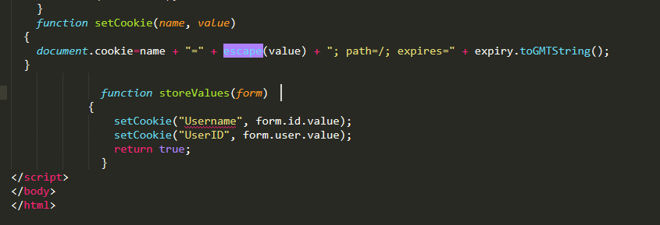

1. **Wait Image**

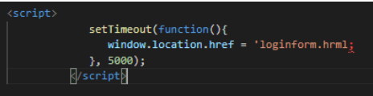

**Output:**

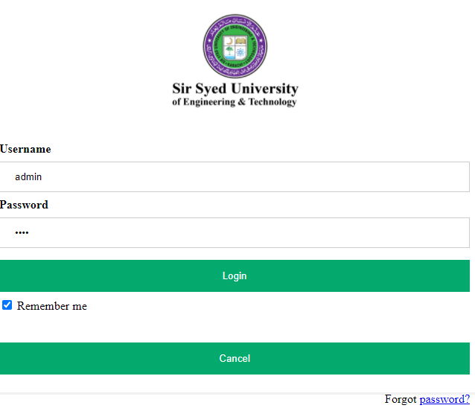

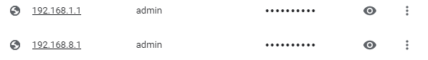



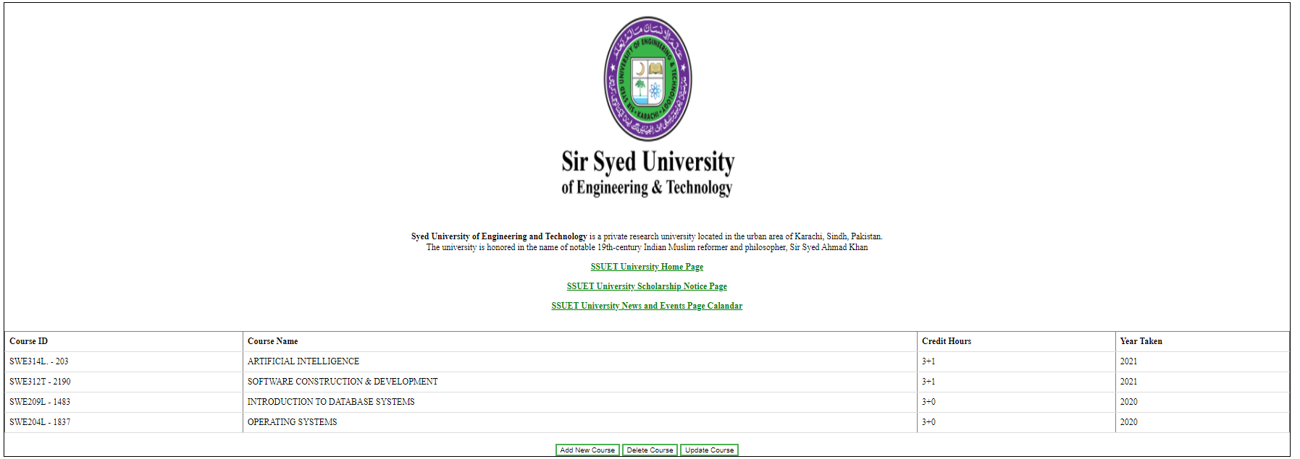

**HOOME TASK CODE:**

1. Update the Student Profile page
   1. If cookie is present
      1. Retrieve the cookie and show student Name on top-right of the page
      2. Set the background page color to be light green, otherwise light gray
   2. Add a new button alongside other buttons under the table called *Remove All New* for removing all the newly created courses (rows).
   3. Create a *ul* list and using *window.history* API, find all the previous URLs visited and list them down using *li* items
      1. If the URL of each history item contains the text Lab#2, highlight using green color, otherwise blue

**Code:**

1. **Cookies Present:**

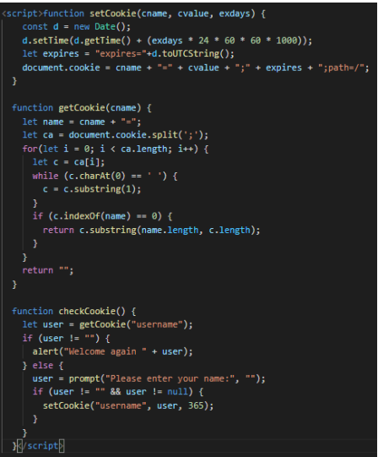

**b)Remove All Courses:**

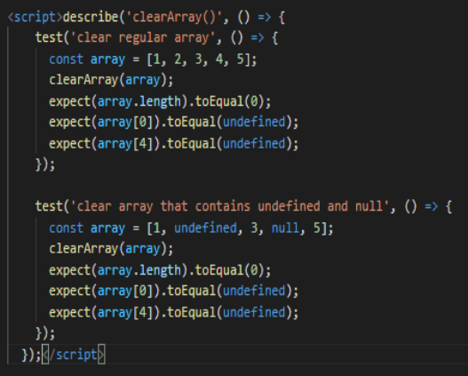

1. **Windows History:**

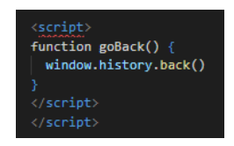

**Output:**





