**LAB-01**

**HTML AND CSS FUNDAMENTALS**

**OBJECTIVE:-**

**To get familiar with HTML, and CSS fundamentals.**

**TASK 01 CODE:**

**<html>**

**<head>**

**<title>FINAL PROJECT OF HTML</title>**

**<link rel="stylesheet" href="finalproject.css">**

**</head>**

**<body bgcolor="pink">**

**<table border="3" align="center" width="90%" cellspacing="0">**

**<tr>**

**<th>SIR SYED UNIVERSITY OF ENGINEERING AND TECHNOLOGY </th>**

**<th>HOME </th>**

**<th>ABOUT </th>**

**<th>CONTACT </th>**

**</tr>**

**</table>**

**<table height="30%" border="3" align="center" width="90%">**

**<tr>**

**<td ><img src="C:\Users\AhsanComputers\OneDrive\Desktop\images/sir1.jpg" alt="image not found" title="sir syed university" align="center" width="50%"  id="image1" ></td>**

**</tr>**

**</table >**

**<table border="3" align= "center" width="90%" height="30%"  cellspacing="0">**

**<tr>**

**<th align="left">HISTORY OF SIR SYED UNIVERSITY**

**<p align="left"><span>Sir Syed University of Engineering and Technology is based on the heritage of Sir Syed Ahmed Khan and of the Aligarh Movement. An education and social reformer, Sir Syed emerged on the scene in the sub-continent towards the middle of the 19th century. In the spirit of the Aligarh Movement, AMUOBA (Aligarh Muslim University Old Boys Association) focused attention on furthering education in Pakistan, especially science and technology. An achievement in this field has been the establishment of Sir Syed University of Engineering and Technology (SSUET). SSUET came into being on 8 October 1993, and its Charter formalities were completed by an Act passed by the Sindh Assembly on 17 September 1995. The founder of this University is Z.A. Nizami.</span></p></th>**

**<th align="left" width="30%">FACULTY**

**</br>**

**<ul >**

**<li>bs sofware engineering</li>**

**<li>bs biomedical engineering</li>**

**<li>bs in computer science</li>**

**<li>BBA</li>**

**<li>bs mathematics</li>**

**</ul>**

**</th>**

**</tr>**

**<table border="3" cellspacing="0" height="10%">**

**<tr >**

**<th  width="40%">ABOUT**

**<p>The Career Planning and Placement Bureau is aimed at establishing liaison between the engineers/graduates and employers, and provides internships go-ahead forms only to organizations. The objective is to have a department that sets a platform to provide job opportunities for students and employees for the firms, so far the resources at disposable are rudimentary and great amount of efforts and dedication is needed to fulfill its responsibilities </p>**

**</th>**

**<th align="left"  width="30%" height="20%" >CONTACT**

**<ol>**

**<li >ssuet.edu.pk</li>**

**<li> (021) 34988000</li>**

**<li>ST-16 Main University Rd, Block 5 Gulshan-e-Iqbal, Karachi, Karachi City, Sindh</li>**

**<ol>**

**</th>**

**<td  width="10%" height="10%">SOCIAL LINKS**

**<a href="https://twitter.com/i/flow/login" target="_blank"><img src = "C:\Users\AhsanComputers\OneDrive\Desktop\images/icon1.png" title="TWITTER" width="50px"></a>**

**<a href="https://www.facebook.com/" target="_blank"><img src = "C:\Users\AhsanComputers\OneDrive\Desktop\images/icon2.png" title="FACEBOOK" width="50px"></a>**

**<a href="https://www.instagram.com/" target="_blank"><img src = "C:\Users\AhsanComputers\OneDrive\Desktop\images/icon3.png" title="INSTAGRAM" width="50px"></a>**

**<a href= "https://www.youtube.com/"target="_blank"><img src = "C:\Users\AhsanComputers\OneDrive\Desktop\images/icon4.png" title="YOUTUBE" width="50px" ></a>**

**</td>**

**</tr>**

**</table>**

**<table border="3"   width="90%" align="center" >**

**<tr>**

**<th align="center">&copy copyright2022 to 2202</th>**

**</tr>**

**</table>**

**</body>**

**</html>**

**Css:**

**\*{**

**background-color: rgb(255, 183, 95);**

**font-weight: bold;**

**}**

**#image1{**

**border-width: 3px;**

**border-style: solid;**

**border-color:black;**

**margin-left:270px;**

**}**

**span{**

**color:black ;**

**border-width: 3px;**

**border-style: solid;**

**border-color:black;**

**}**

**RESULT:-**

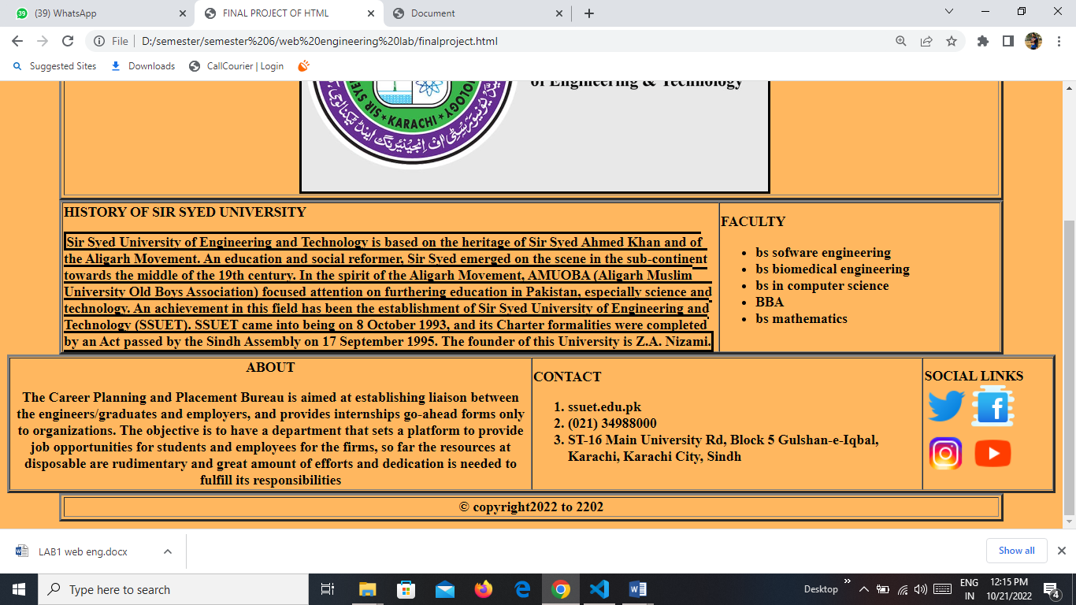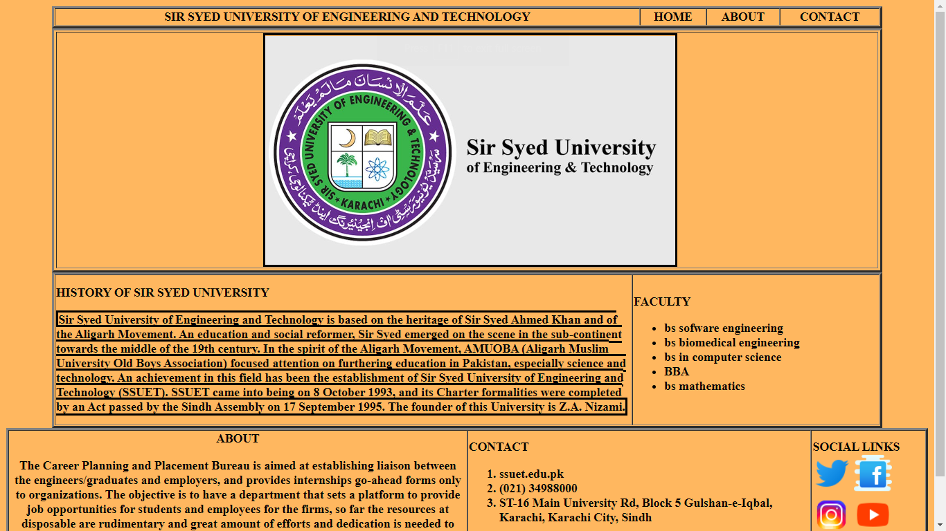

**TASK 02 CODE:**

**<!DOCTYPE html>**

**<html lang="en">**

**<head>**

**<meta charset="UTF-8">**

**<meta http-equiv="X-UA-Compatible" content="IE=edge">**

**<meta name="viewport" content="width=device-width, initial-scale=1.0">**

**<title>my resume</title>**

**<link rel="stylesheet" href="external.css">**

**</head>**

**<div id="body">**

**<hr color="blue"><h1 align="center" id="firstheading">MUBASSHIR AHMED ---- RESUME </h1><hr color="blue" >**

**<br>**

**<span>OBJECTIVE</span> <hr color="blue">**

**<p class="firstpara">To work in a challenging environment as an sofware engineer.To work in a career oriented organization where job is focused on hard work, honesty, sincerity and I can apply my experience and knowledge, and groom my professional career in the best of interest the organization. </p>**

**<br>**

**<div>**

**<span>EDUACATION</span> <hr color="blue">**

**<p class="secondpara">**

**<ul>**

**<li>Bachelor In Software Engineering , Sir Syed University Of Engineering And Technology (on going)</li>**

**<br><br>**

**<li>Secured 3.22 CGPA in 5th Semester</li>**

**<br><br>**

**<li>2019 INTERMEDIATE , GOVT.DEGREE COLLEGE SRE MAJEED STADIUM ROAD </li>**

**<br><br>**

**Secured 65%**

**<br><br>**

**<li>2017 MATRICULATION , NASRA SCHOOL</li>**

**<br> <br>**

**<li> Secured  83% </li>**

**</ul>**

**</p>**

**</div>**

**<div id="imagecon">**

**<h4 class="contact">CONTACT INFORMATION</h4><hr width="100%" color="blue">**

**<p>**

**<b>ADDRESS: R-100 BAGH E MALIR BLOCK C MALIR KARACHI KALABOARD</b>**

**<br>**

**<b>CONTACT : 03192445630</b>**

**<br>**

**<b>EMAIL:mubashirahmed755@gmail.com</b>**

**</p>**

**</div>**

**<span>CERTIFIED COURCES</span> <hr color="blue">**

**<p class="thirdpara">**

**<ol>**

**<li>Artificial intelligence (on going) at PIAIC</li>**

**<br><br>**

**<li>Artificial intelligence at COURSERA</li>**

**</ol>**

**</p>**

**<span>SKILLS</span> <hr color="blue">**

**<p class="fourthpara">**

**<ol>**

**<li>MICROSOFT OFFICE </li>**

**<br><br>**

**<li>  PYTHON BASIC LEVEL </li>**

**<br><br>**

**<li>    WORKING ON DATABASE </li>**

**<br><br>**

**<li>   DATAENTRY  </li>**

**<br><br>**

**<li>WEB DEVOLOPMENT</li>**

**</ol>**

**</p>**

**</div>**

**</html>**

**CSS:**

**\*{**

**font-weight:bold ;**

**}**

**#firstheading{**

**color: blue;**

**}**

**span{**

**color: blue;**

**}**

**#imagecon{**

**width: 290px;**

**height:200px;**

**background-color: white;**

**margin-left: 730px;**

**margin-top: -260px;**

**margin-bottom: 90px;**

**border-width: 4px;**

**border-style: solid;**

**border-color: black;**

**}**

**.contact{**

**color: blue;**

**}**

**#body{**

**margin-right: 200px;**

**}**

**RESULT:-**

