**LAB-03**

**DOCUMENT OBECT MODEL(DOM)**

**OBJECTIVE:**

**To learn what is DOM and the APIs is available for manipulating them .**

**Lab Task :**

**Code:**

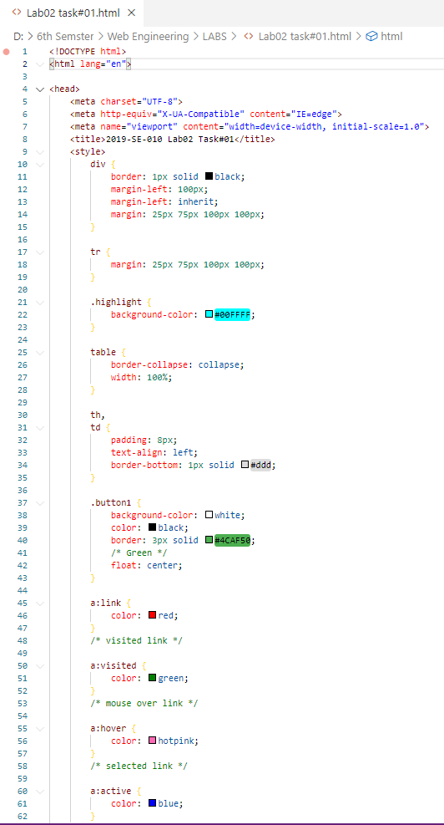

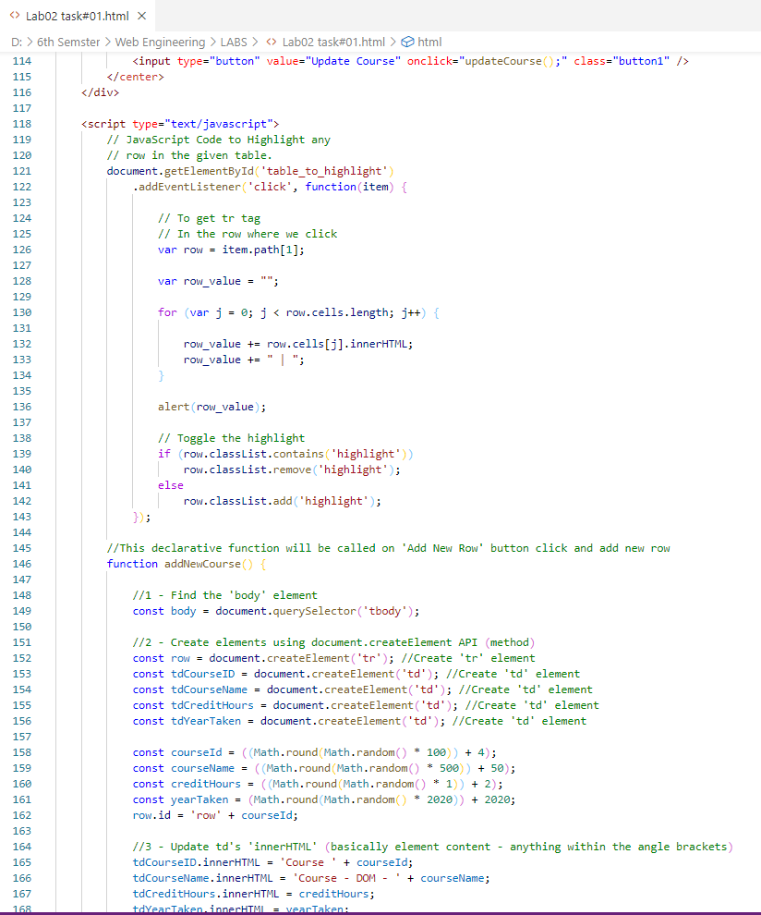

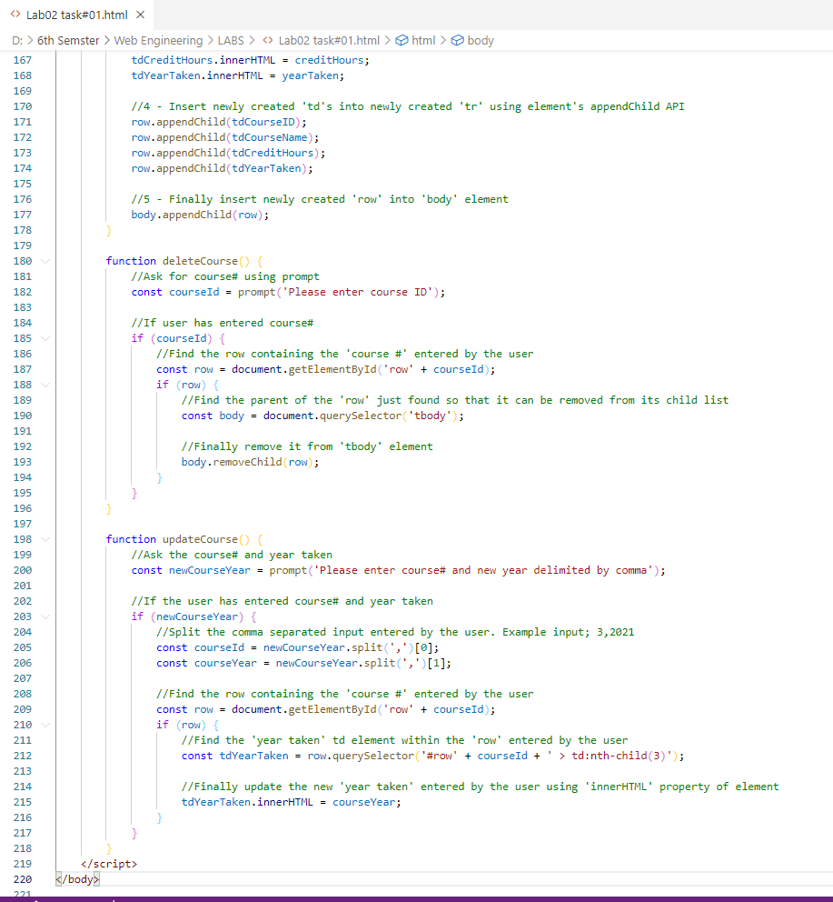

**Output:**

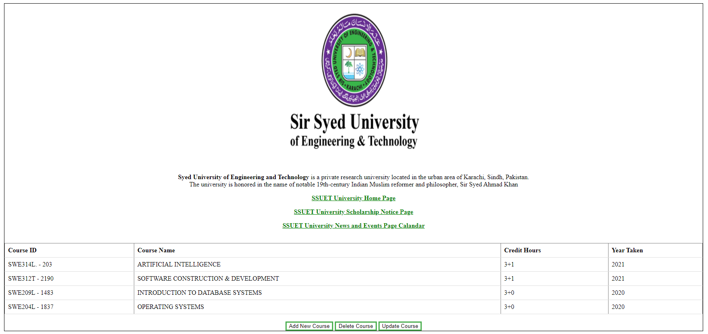

**Add New Course:**

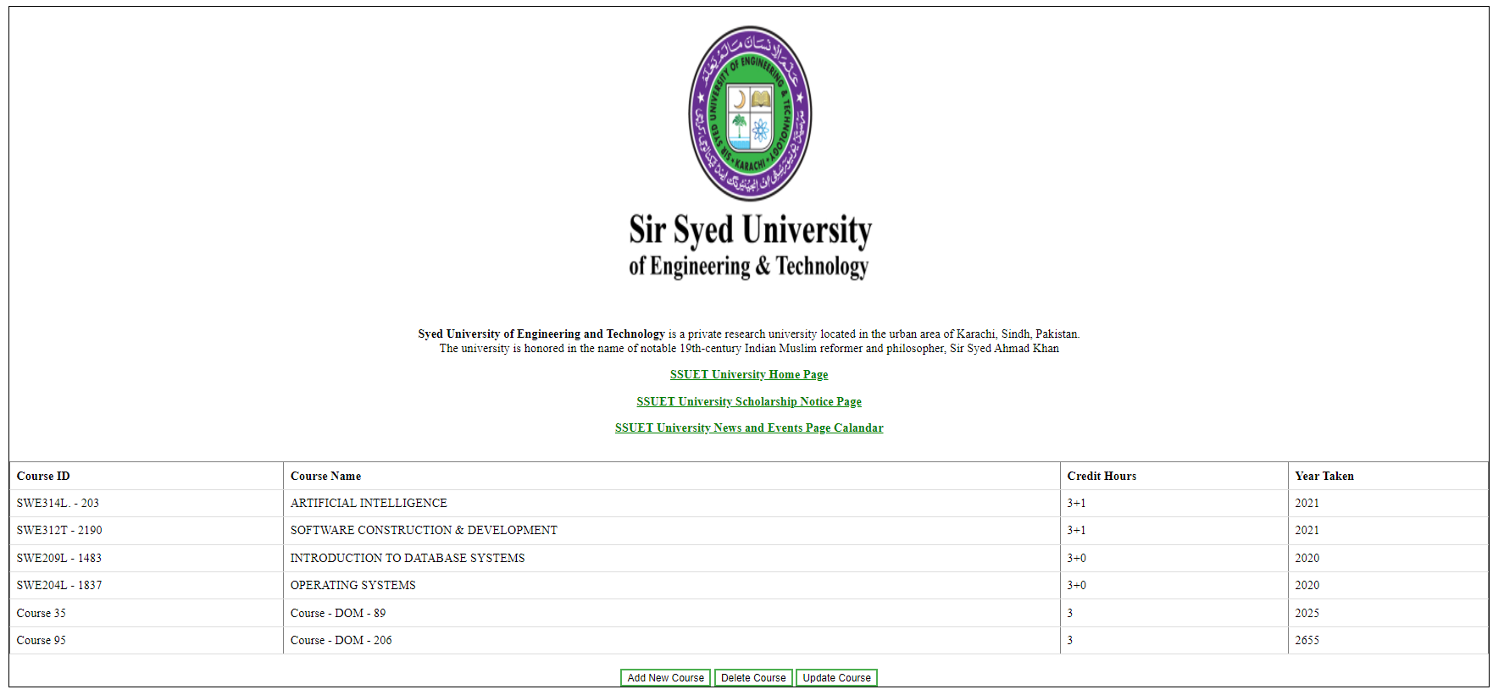

**Delete Course:**

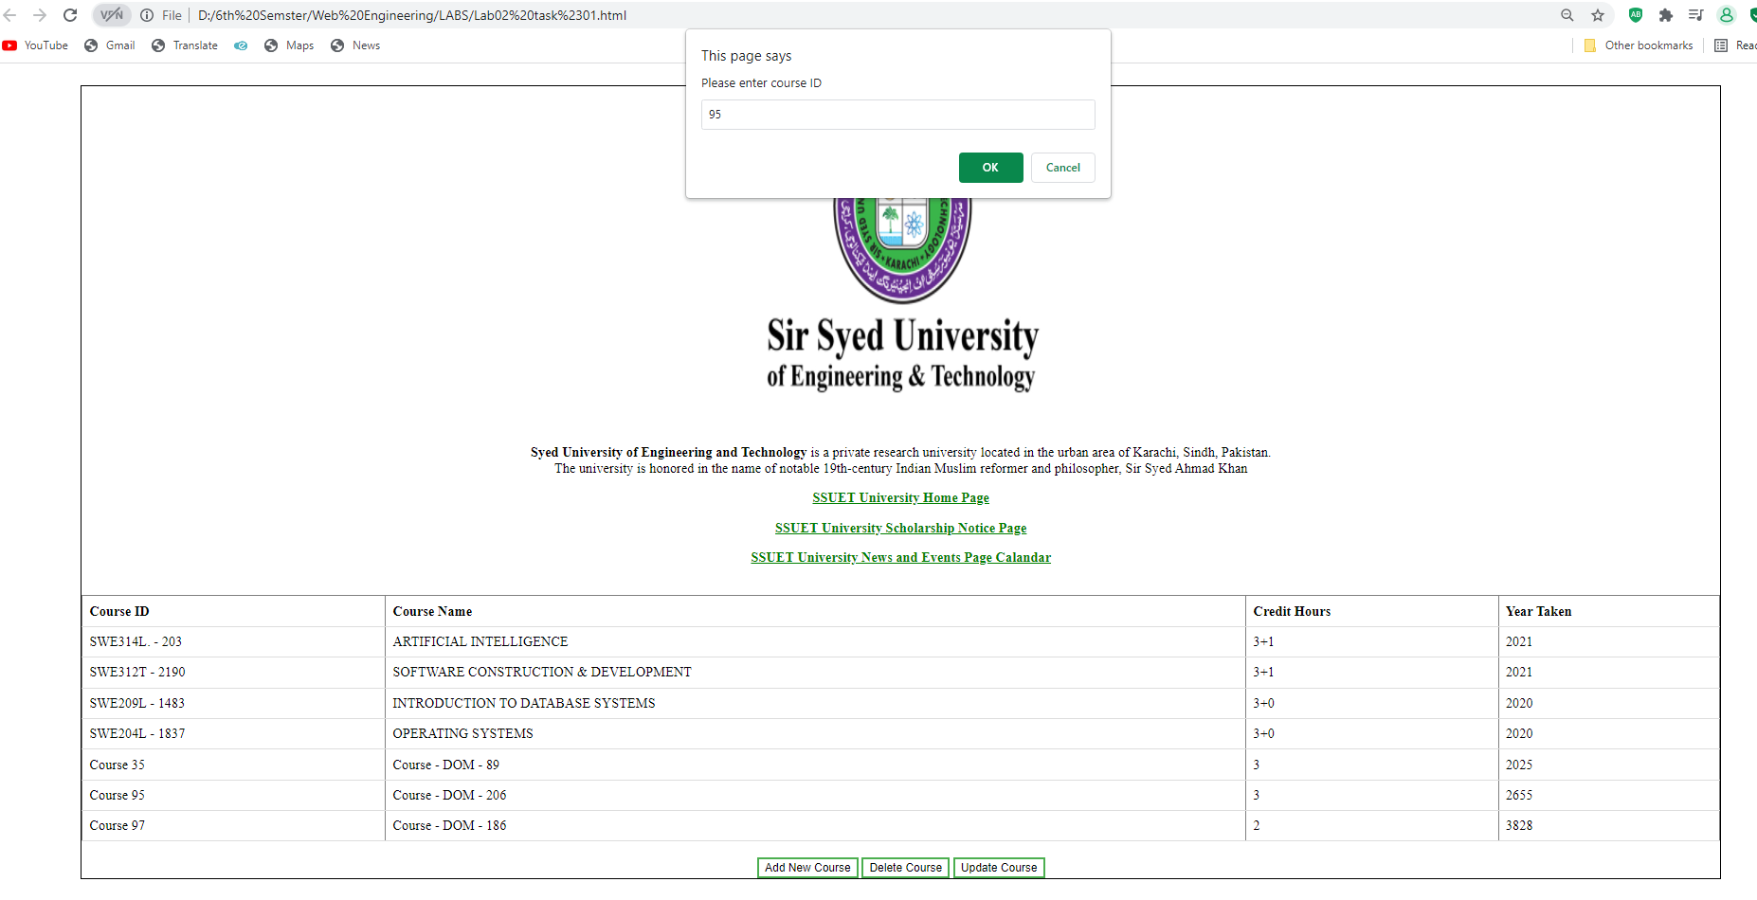

**Update Course:**

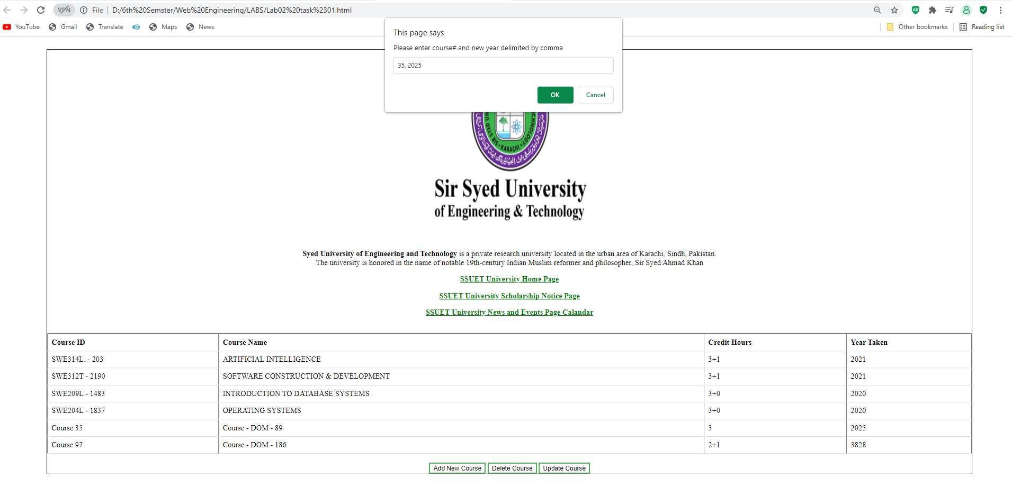

**Home Task**

**Code:**

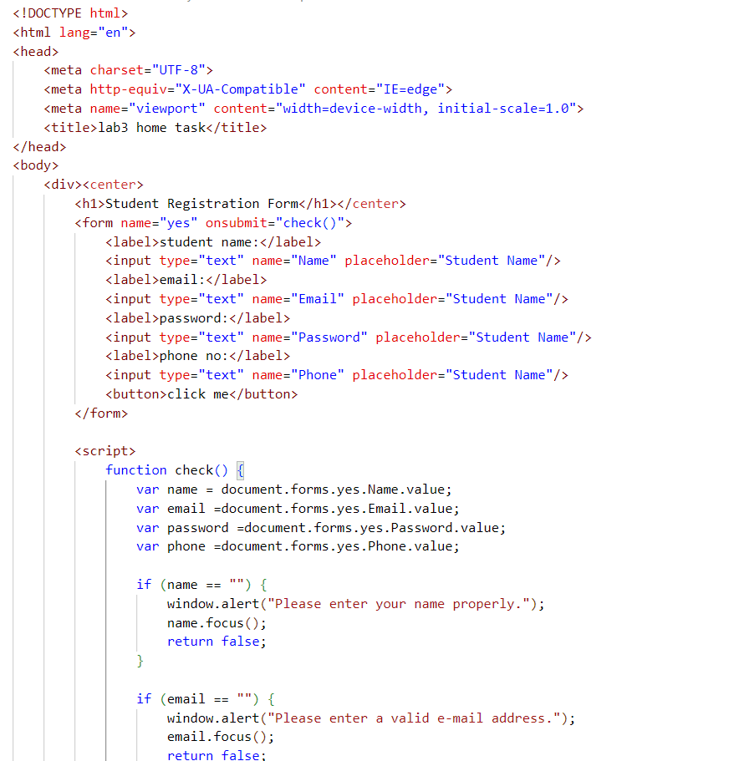

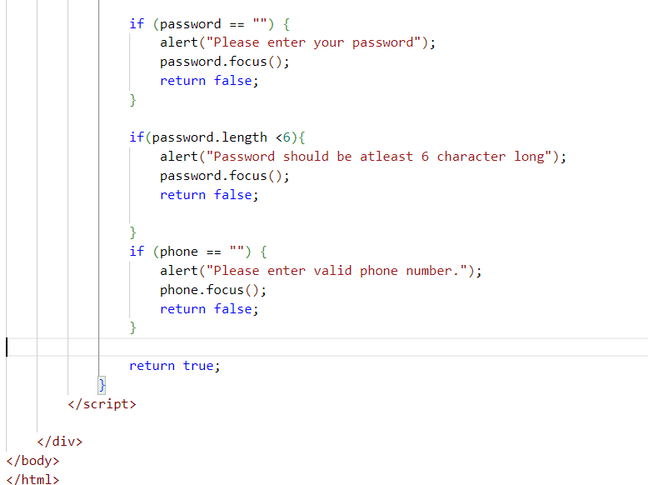

**Output:**

